Additional Figures – Results of MR analysis

Figure S1. MR leave-one-out sensitivity analysis for mitochondria-associated proteins on overall breast cancer.

Figure S2. MR leave-one-out sensitivity analysis for mitochondria-associated proteins on ER- breast cancer.

Figure S3. MR leave-one-out sensitivity analysis for mitochondria-associated proteins on ER+ breast cancer.

Figure S4. MR leave-one-out sensitivity analysis for inflammatory factors on overall breast cancer.

Figure S5. MR leave-one-out sensitivity analysis for inflammatory factors on ER- breast cancer.

Figure S6. MR leave-one-out sensitivity analysis for inflammatory factors on ER+ breast cancer.

Figure S7. MR leave-one-out sensitivity analysis for mitochondria-associated proteins on inflammatory factors.

Figure S8. Scatter plots for the effect of mitochondria-associated proteins on overall breast cancer.

Figure S9. Scatter plots for the effect of mitochondria-associated proteins on ER- breast cancer.

Figure S10. Scatter plots for the effect of mitochondria-associated proteins on ER+ breast cancer.

Figure S11. Scatter plots for the effect of inflammatory factors on overall breast cancer.

Figure S12. Scatter plots for the effect of inflammatory factors on ER- breast cancer.

Figure S13. Scatter plots for the effect of inflammatory factors on ER+ breast cancer.

Figure S14. Scatter plots for the effect of mitochondria-associated proteins on inflammatory factors.

Figure S15. Forest plots for the effect of mitochondria-associated proteins on overall breast cancer.

Figure S16. Forest plots for the effect of mitochondria-associated proteins on ER- breast cancer.

Figure S17. Forest plots for the effect of mitochondria-associated proteins on ER+ breast cancer.

Figure S18. Forest plots for the effect of inflammatory factors on overall breast cancer.

Figure S19. Forest plots for the effect of inflammatory factors on ER- breast cancer.

Figure S20. Forest plots for the effect of inflammatory factors on ER+ breast cancer.

Figure S21. Forest plots for the effect of mitochondria-associated proteins on inflammatory factors.

Figure S1. MR leave-one-out sensitivity analysis for mitochondria-associated proteins on overall breast cancer.
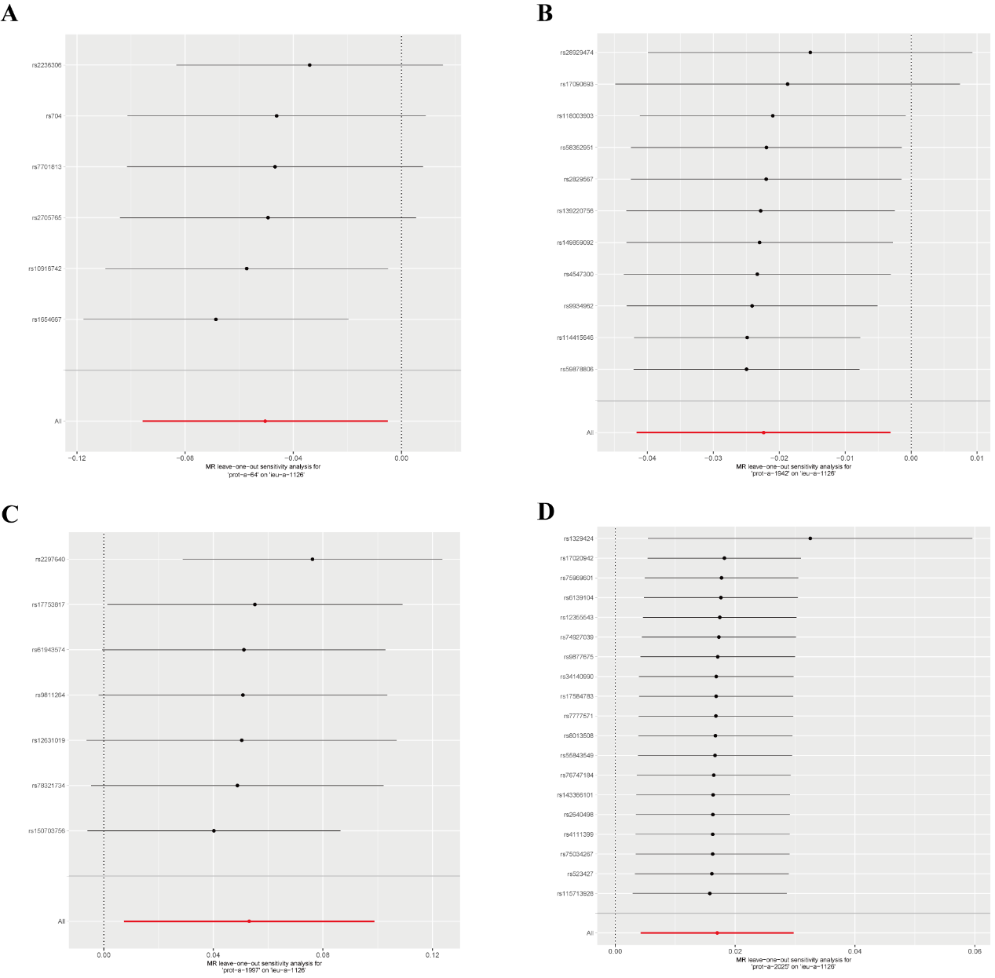
- Analysis for "prot-a-64" on "overall breast cancer"
- Analysis for "prot-a-1942" on "overall breast cancer"
- Analysis for "prot-a-1997" on "overall breast cancer"
- Analysis for "prot-a-2025" on "overall breast cancer"

Figure S2. MR leave-one-out sensitivity analysis for mitochondria-associated proteins on ER- breast cancer.
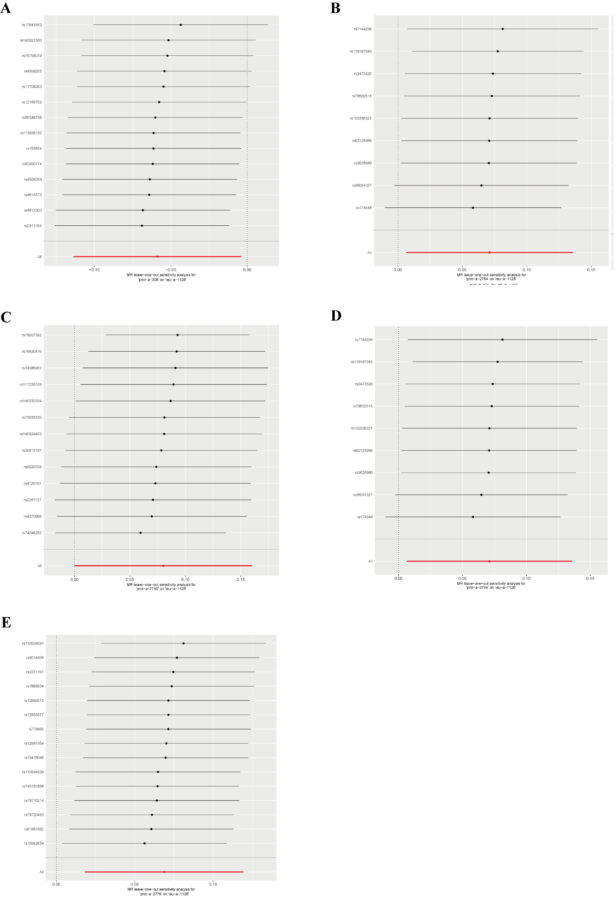
- Analysis for “prot-a-308” on “ER- breast cancer”
- Analysis for “prot-a-847” on “ER- breast cancer”
- Analysis for “prot-a-2749” on “ER- breast cancer”
- Analysis for “prot-a-2764” on “ER- breast cancer”
- Analysis for “prot-a-2776” on “ER- breast cancer”

Figure S3. MR leave-one-out sensitivity analysis for mitochondria-associated proteins on ER+ breast cancer.
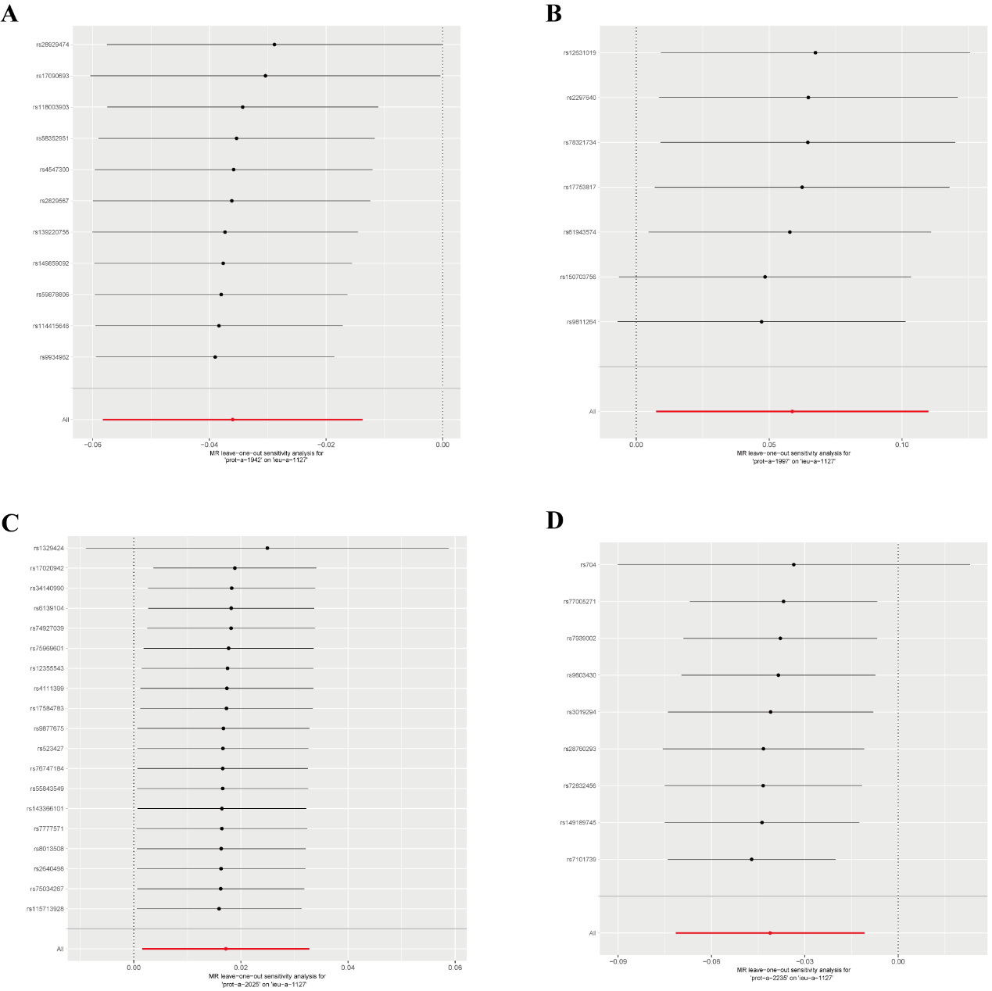
- Analysis for “prot-a-1942” on “ER+ breast cancer”
- Analysis for “prot-a-1997” on “ER+ breast cancer”
- Analysis for “prot-a-2025” on “ER+ breast cancer”
- Analysis for “prot-a-2235” on “ER+ breast cancer”

Figure S4. MR leave-one-out sensitivity analysis for inflammatory factors on overall breast cancer.
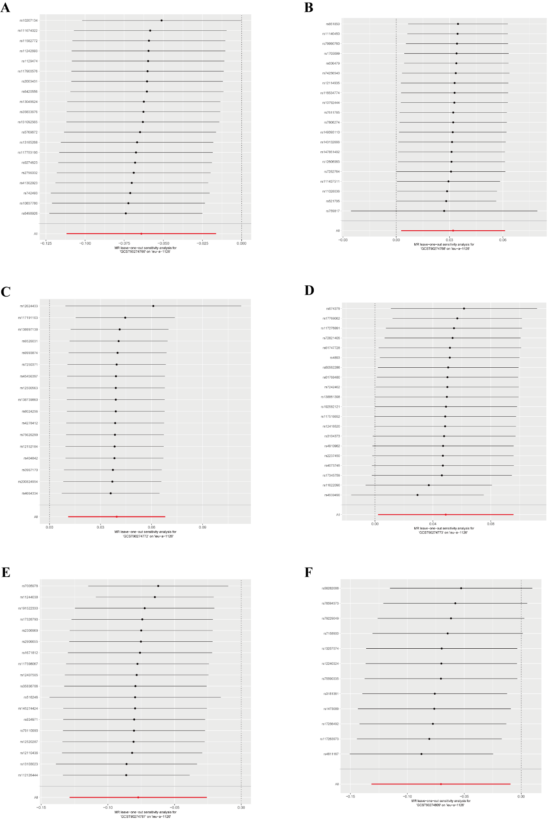
- Analysis for “GCST90274766” on “overall breast cancer”
- Analysis for “GCST90274768” on “overall breast cancer”
- Analysis for “GCST90274772” on “overall breast cancer”
- Analysis for “GCST90274773” on “overall breast cancer”
- Analysis for “GCST90274787” on “overall breast cancer”
- Analysis for “GCST90274809” on “overall breast cancer”

Figure S5. MR leave-one-out sensitivity analysis for inflammatory factors on ER- breast cancer.
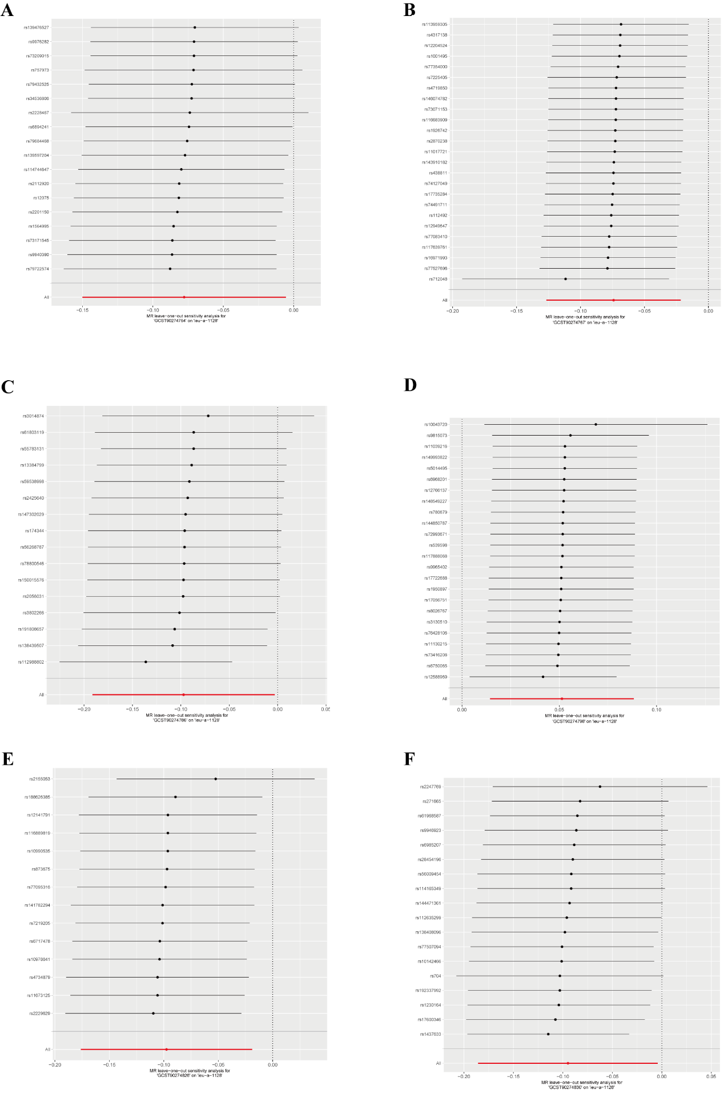
- Analysis for “GCST90274764” on “ER- breast cancer”
- Analysis for “GCST90274767” on “ER- breast cancer”
- Analysis for “GCST90274786” on “ER- breast cancer”
- Analysis for “GCST90274798” on “ER- breast cancer”
- Analysis for “GCST90274826” on “ER- breast cancer”
- Analysis for “GCST90274830” on “ER- breast cancer”

Figure S6. MR leave-one-out sensitivity analysis for inflammatory factors on ER+ breast cancer.
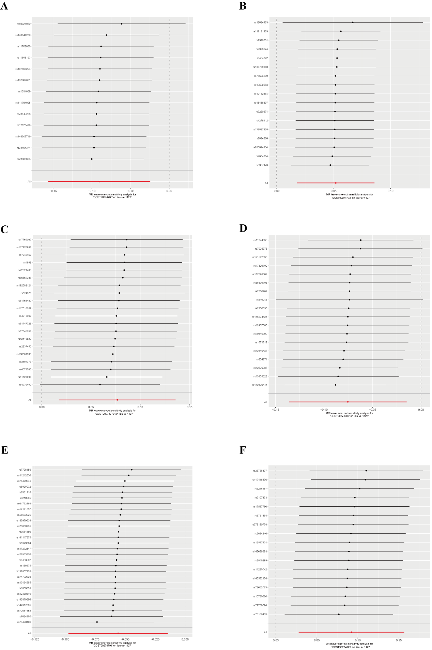
- Analysis for “GCST90274763” on “ER+ breast cancer”
- Analysis for “GCST90274772” on “ER+ breast cancer”
- Analysis for “GCST90274773” on “ER+ breast cancer”
- Analysis for “GCST90274787” on “ER+ breast cancer”
- Analysis for “GCST90274791” on “ER+ breast cancer”
- Analysis for “GCST90274829” on “ER+ breast cancer”

Figure S7. MR leave-one-out sensitivity analysis for mitochondria-associated proteins on inflammatory factors.
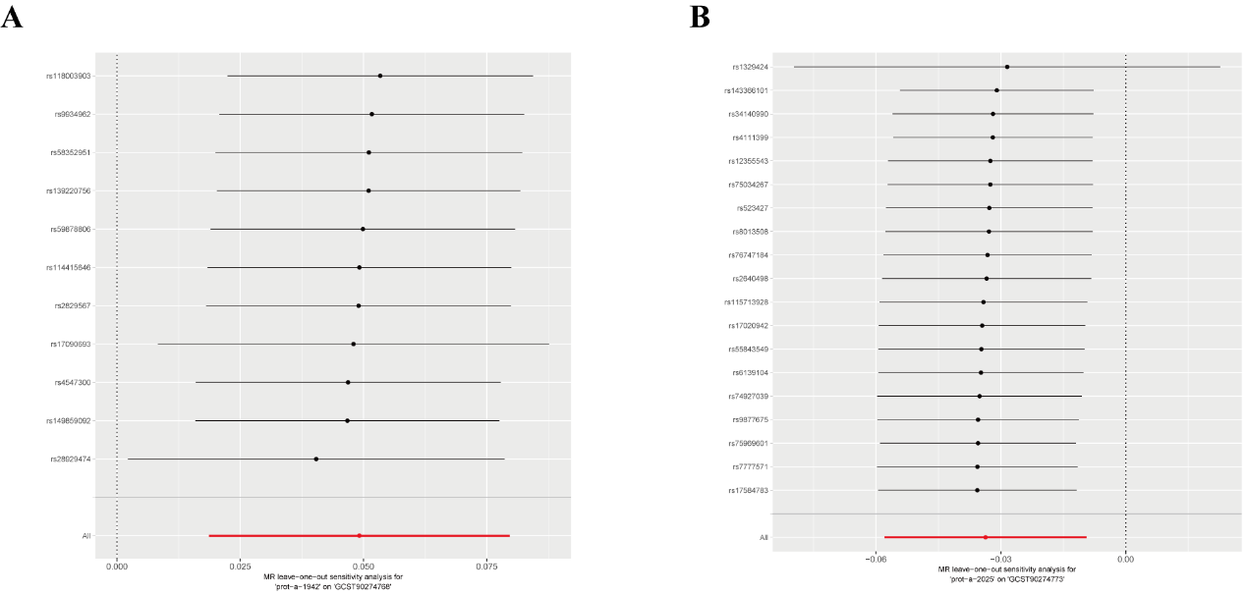
- Analysis for “prot-a-1942” on “GCST90274768”
- Analysis for “prot-a-2025” on “GCST90274773”

Figure S8. Scatter plots for the effect of mitochondria-associated proteins on overall breast cancer.
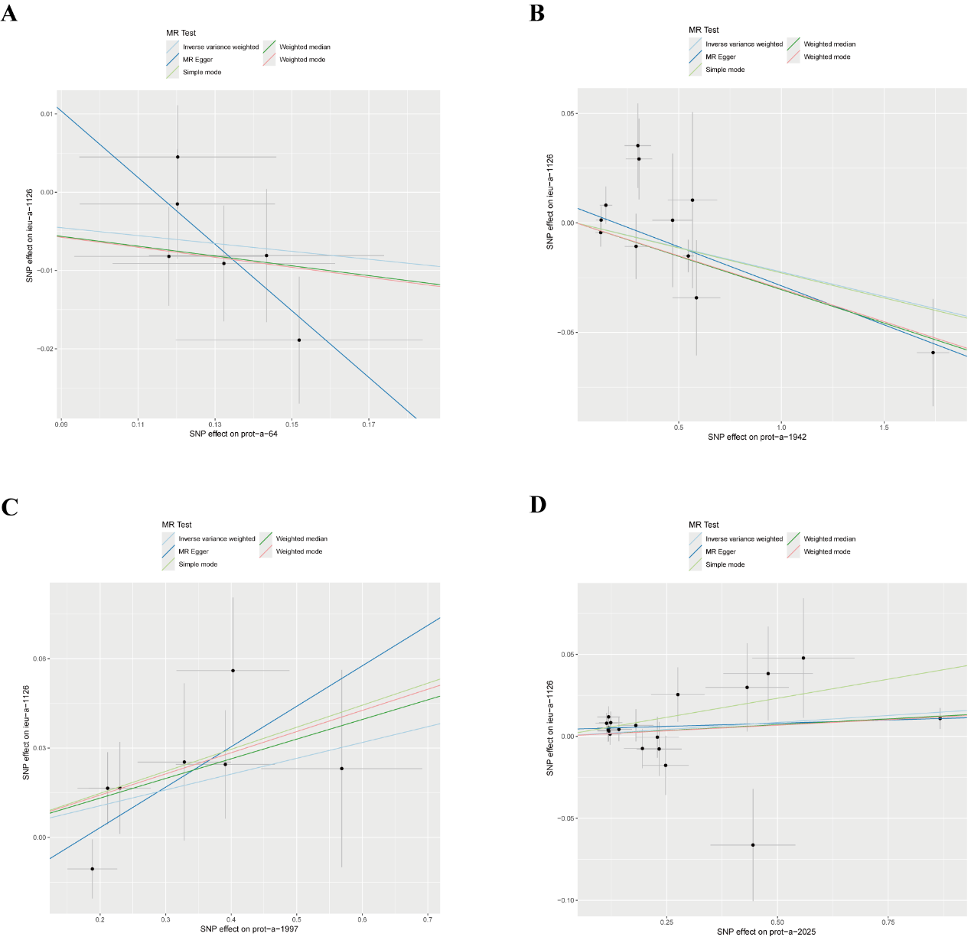

Figure S9. Scatter plots for the effect of mitochondria-associated proteins on ER- breast cancer.
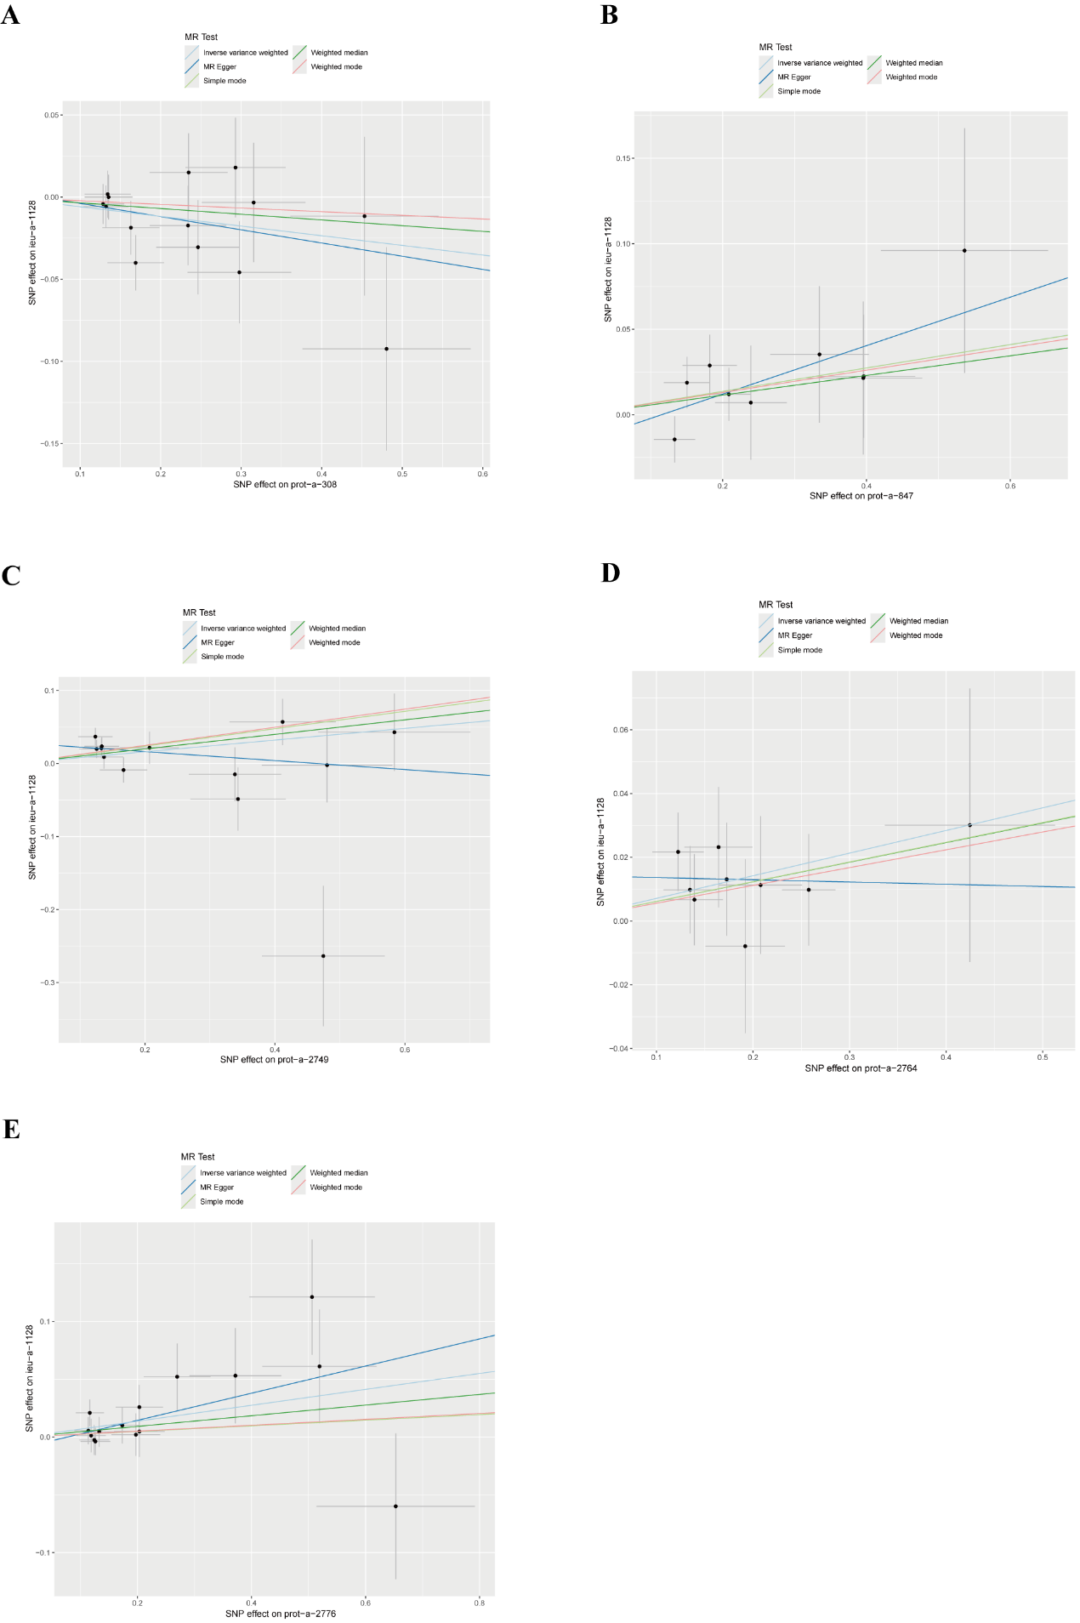

Figure S10. Scatter plots for the effect of mitochondria-associated proteins on ER+ breast cancer.
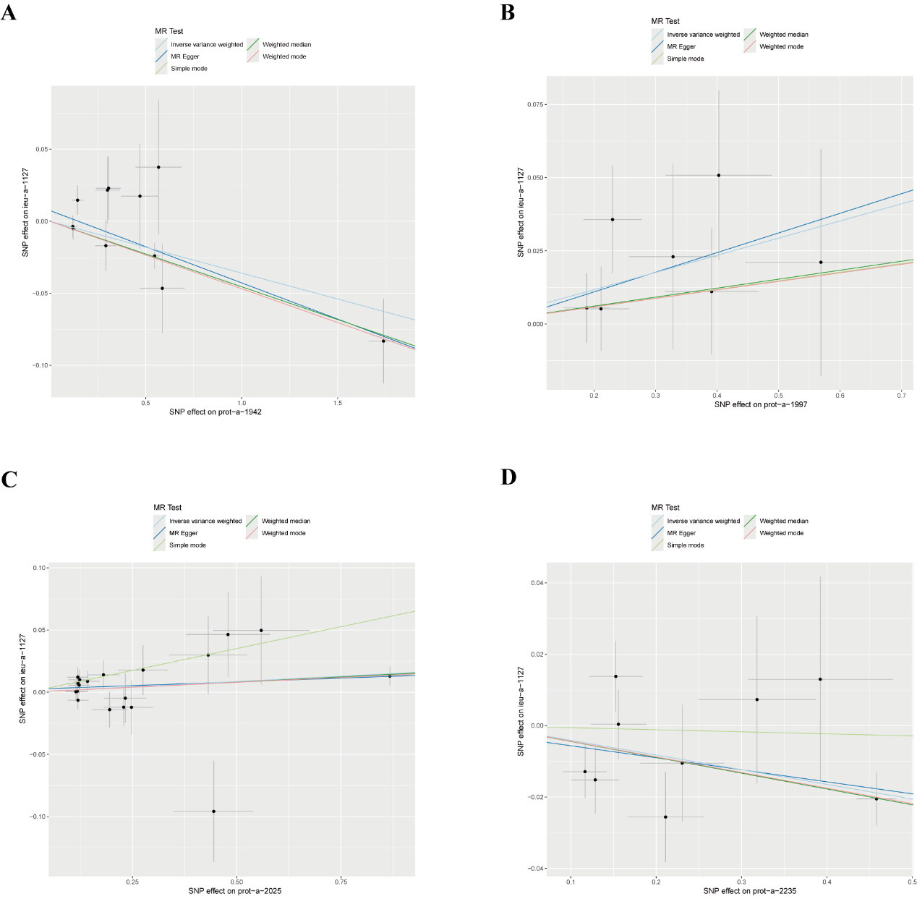

Figure S11. Scatter plots for the effect of inflammatory factors on overall breast cancer.
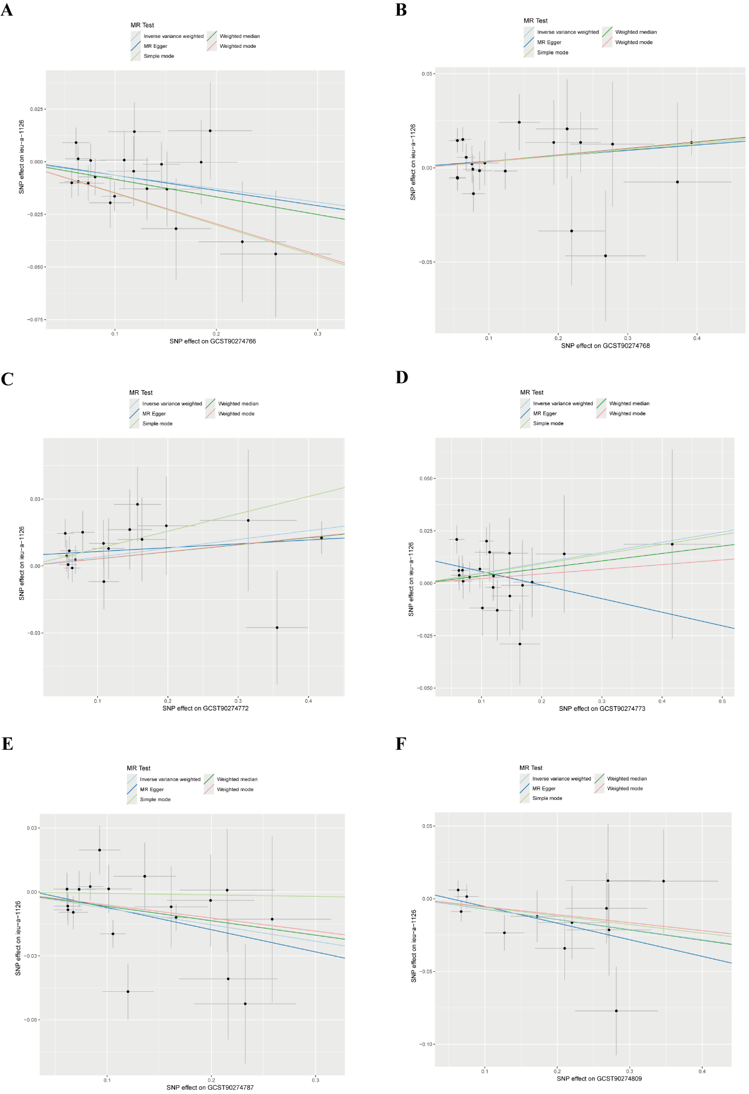

Figure S12. Scatter plots for the effect of inflammatory factors on ER- breast cancer.
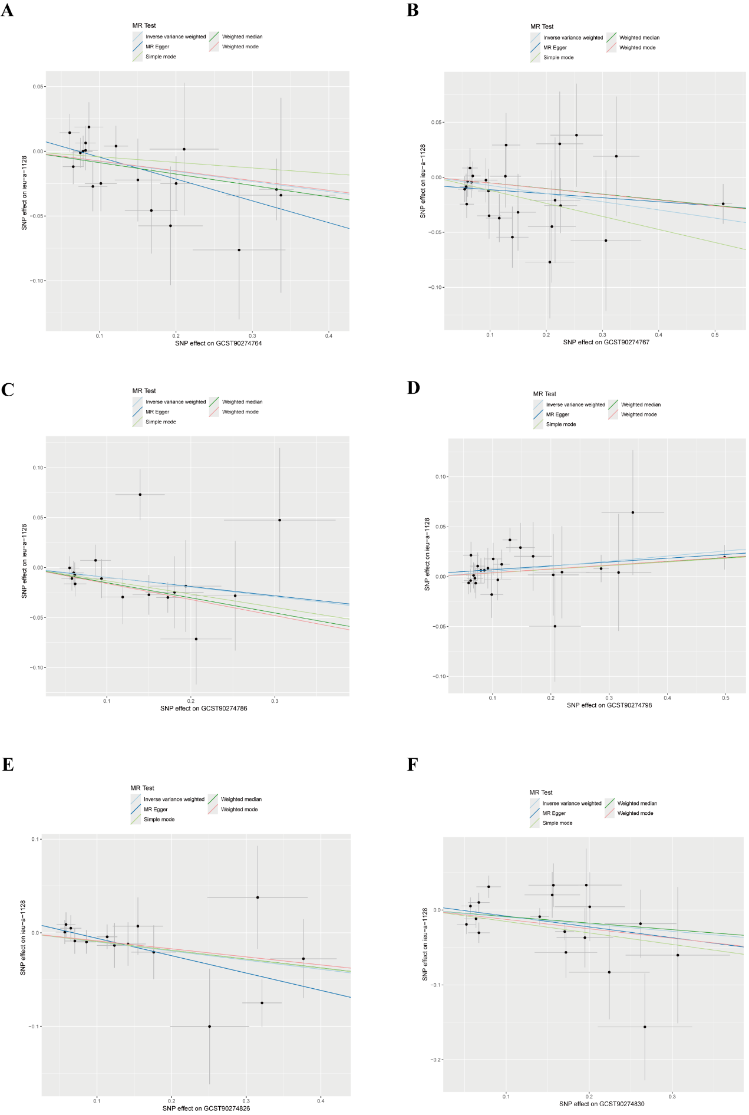

Figure S13. Scatter plots for the effect of inflammatory factors on ER+ breast cancer.
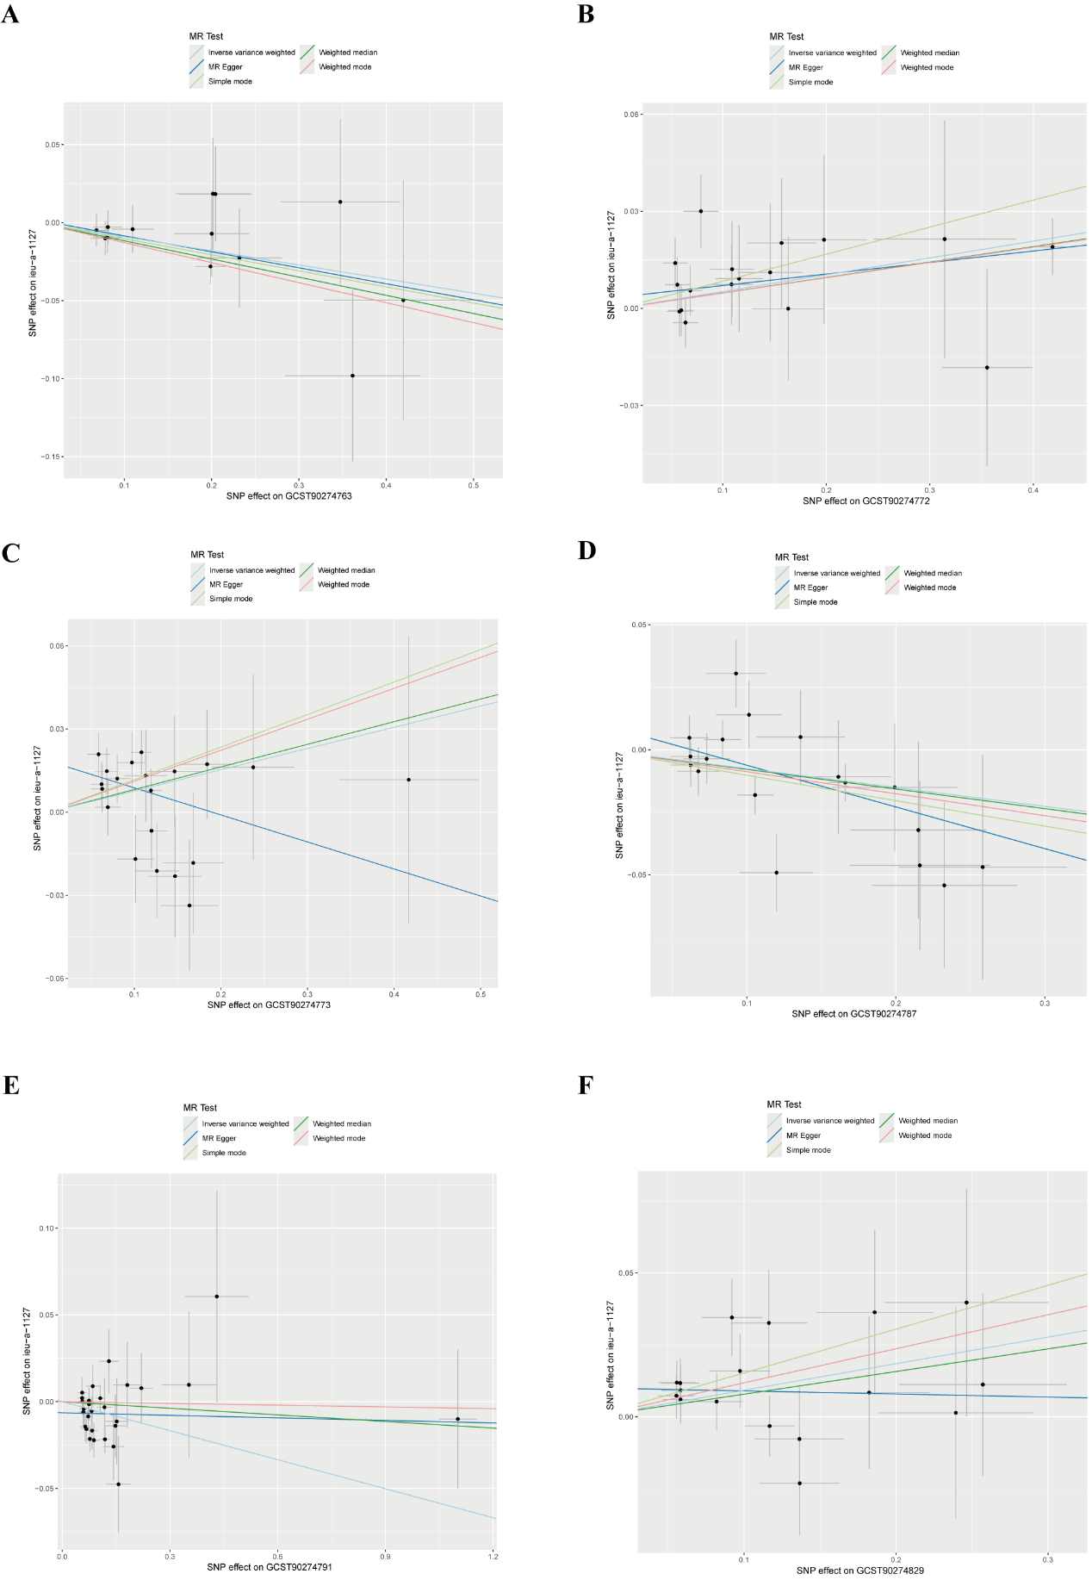

Figure S14. Scatter plots for the effect of mitochondria-associated proteins on inflammatory factors.
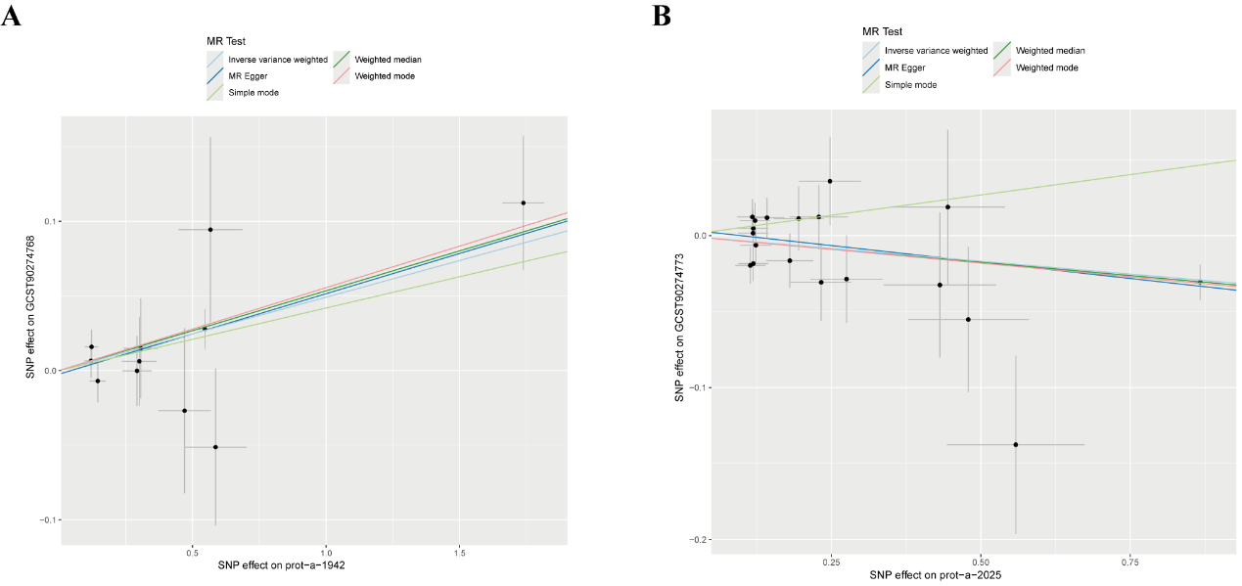

Figure S15. Forest plots for the effect of mitochondria-associated proteins on overall breast cancer.
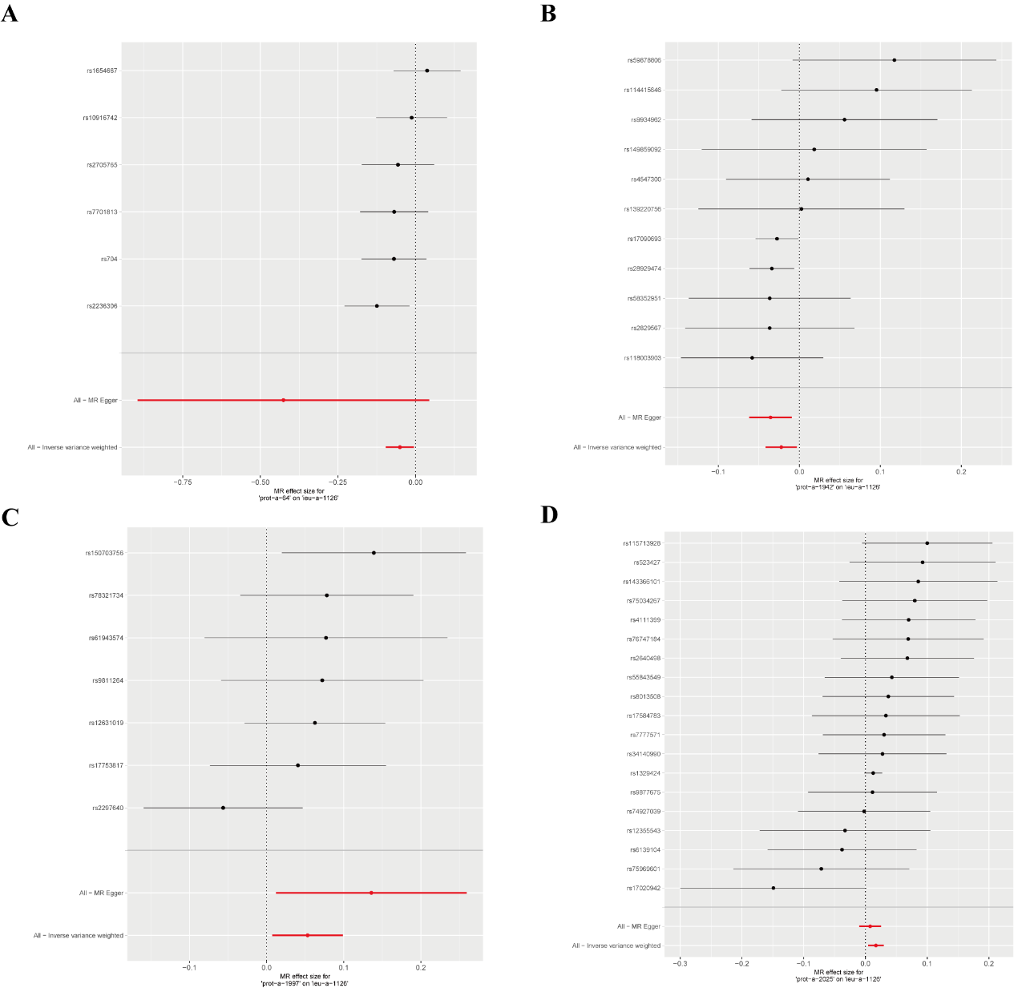
- MR effect size for "prot-a-64" on "overall breast cancer"
- MR effect size for "prot-a-1942" on "overall breast cancer"
- MR effect size for "prot-a-1997" on "overall breast cancer"
- MR effect size for "prot-a-2025" on "overall breast cancer"

Figure S16. Forest plots for the effect of mitochondria-associated proteins on ER- breast cancer.
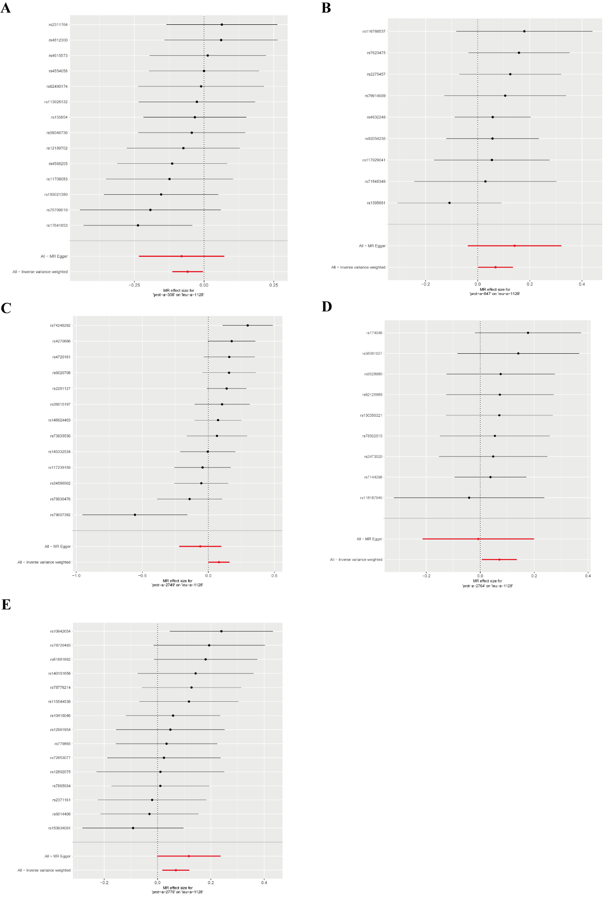
- MR effect size for “prot-a-308” on “ER- breast cancer”
- MR effect size for “prot-a-847” on “ER- breast cancer”
- MR effect size for “prot-a-2749” on “ER- breast cancer”
- MR effect size for “prot-a-2764” on “ER- breast cancer”
- MR effect size for “prot-a-2776” on “ER- breast cancer”

Figure S17. Forest plots for the effect of mitochondria-associated proteins on ER+ breast cancer.
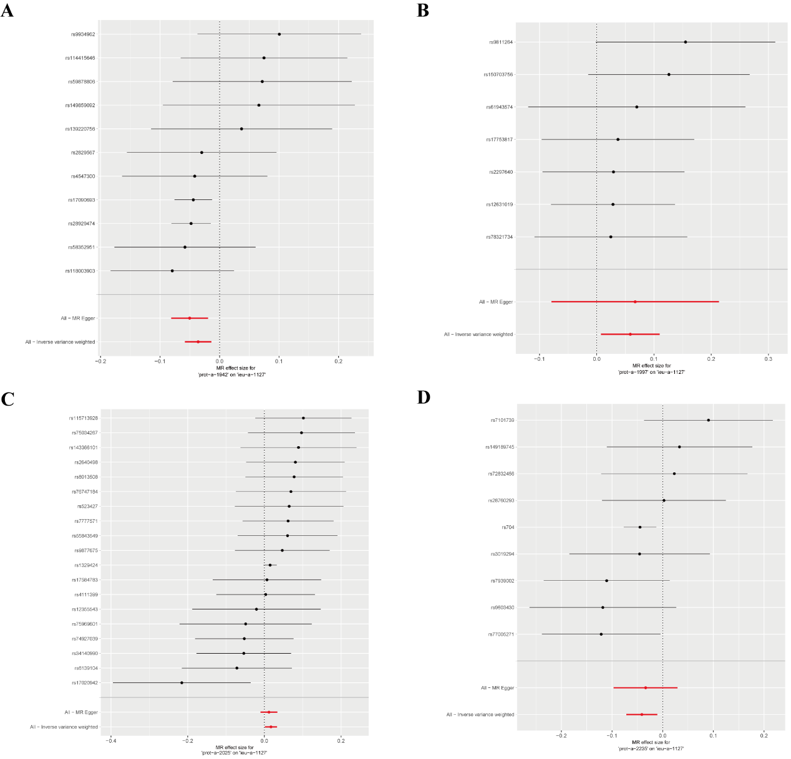
- MR effect size for “prot-a-1942” on “ER+ breast cancer”
- MR effect size for “prot-a-1997” on “ER+ breast cancer”
- MR effect size for “prot-a-2025” on “ER+ breast cancer”
- MR effect size for “prot-a-2235” on “ER+ breast cancer”

Figure S18. Forest plots for the effect of inflammatory factors on overall breast cancer.
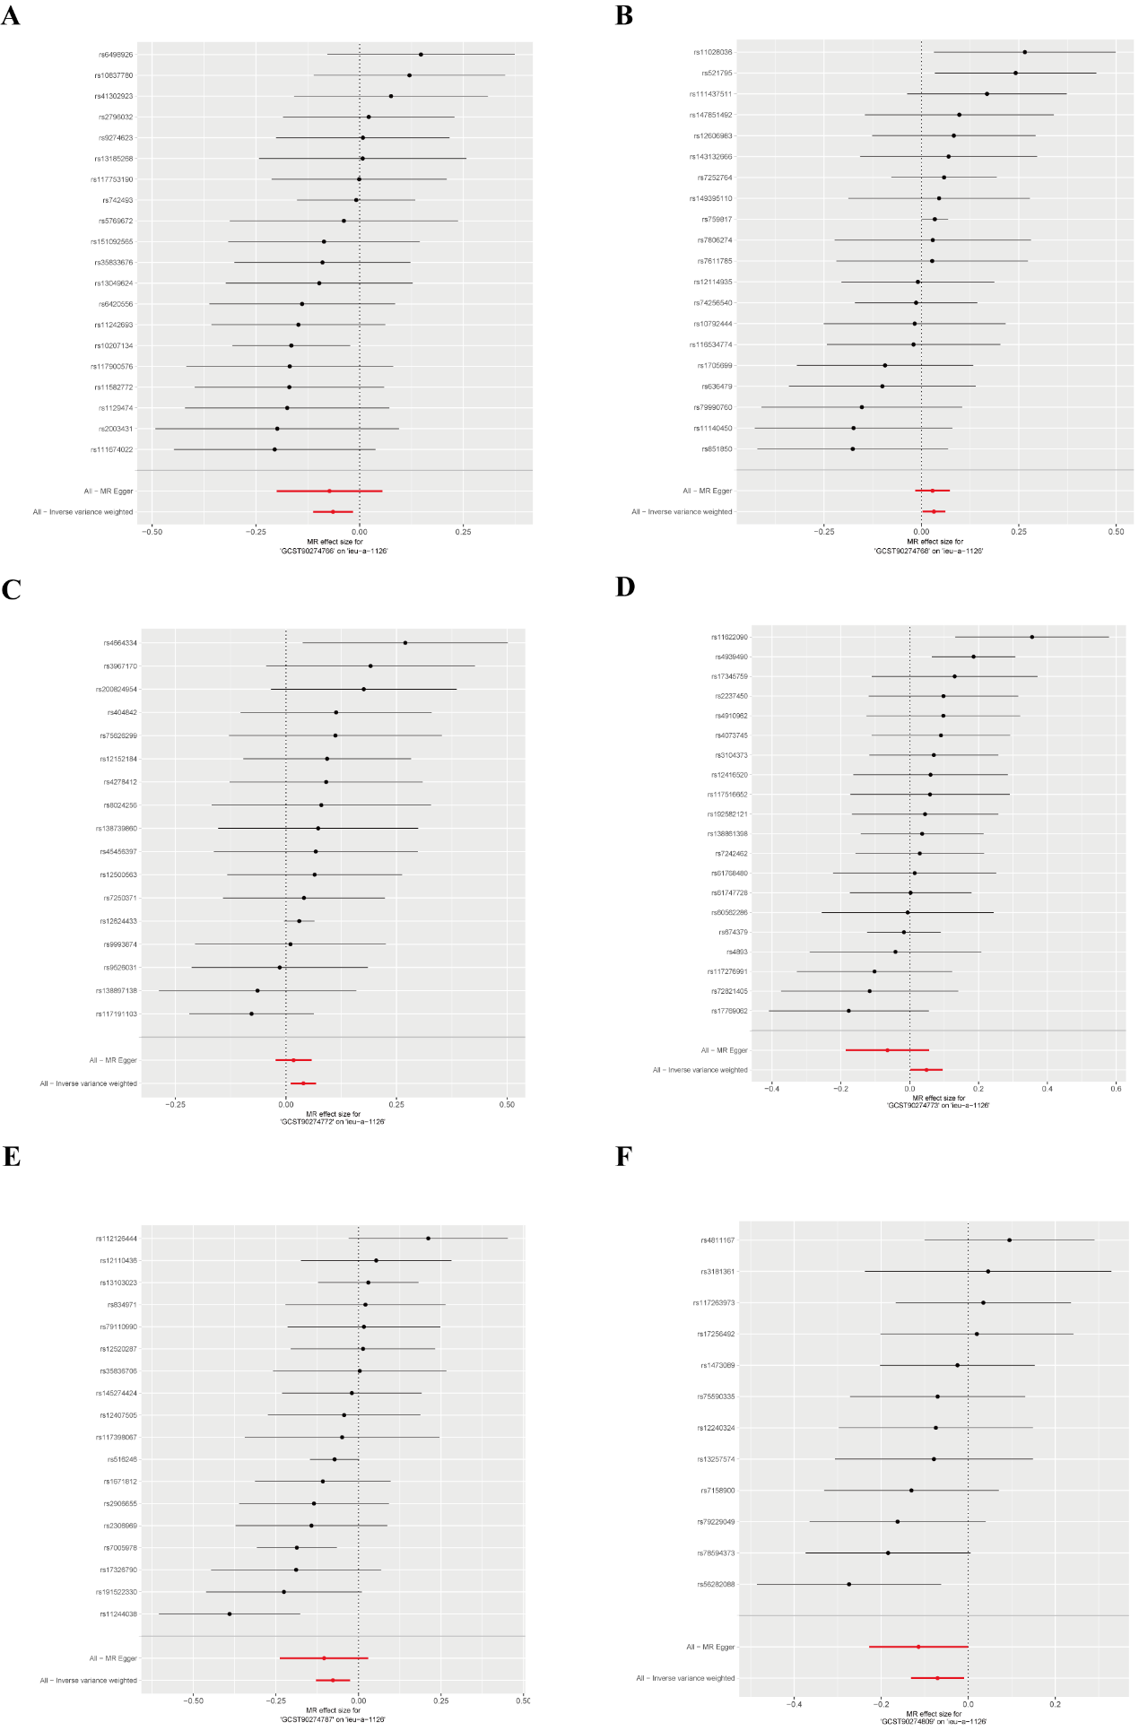
- MR effect size for “GCST90274766” on “overall breast cancer”
- MR effect size for “GCST90274768” on “overall breast cancer”
- MR effect size for “GCST90274772” on “overall breast cancer”
- MR effect size for “GCST90274773” on “overall breast cancer”
- MR effect size for “GCST90274787” on “overall breast cancer”
- MR effect size for “GCST90274809” on “overall breast cancer”

Figure S19. Forest plots for the effect of inflammatory factors on ER- breast cancer.
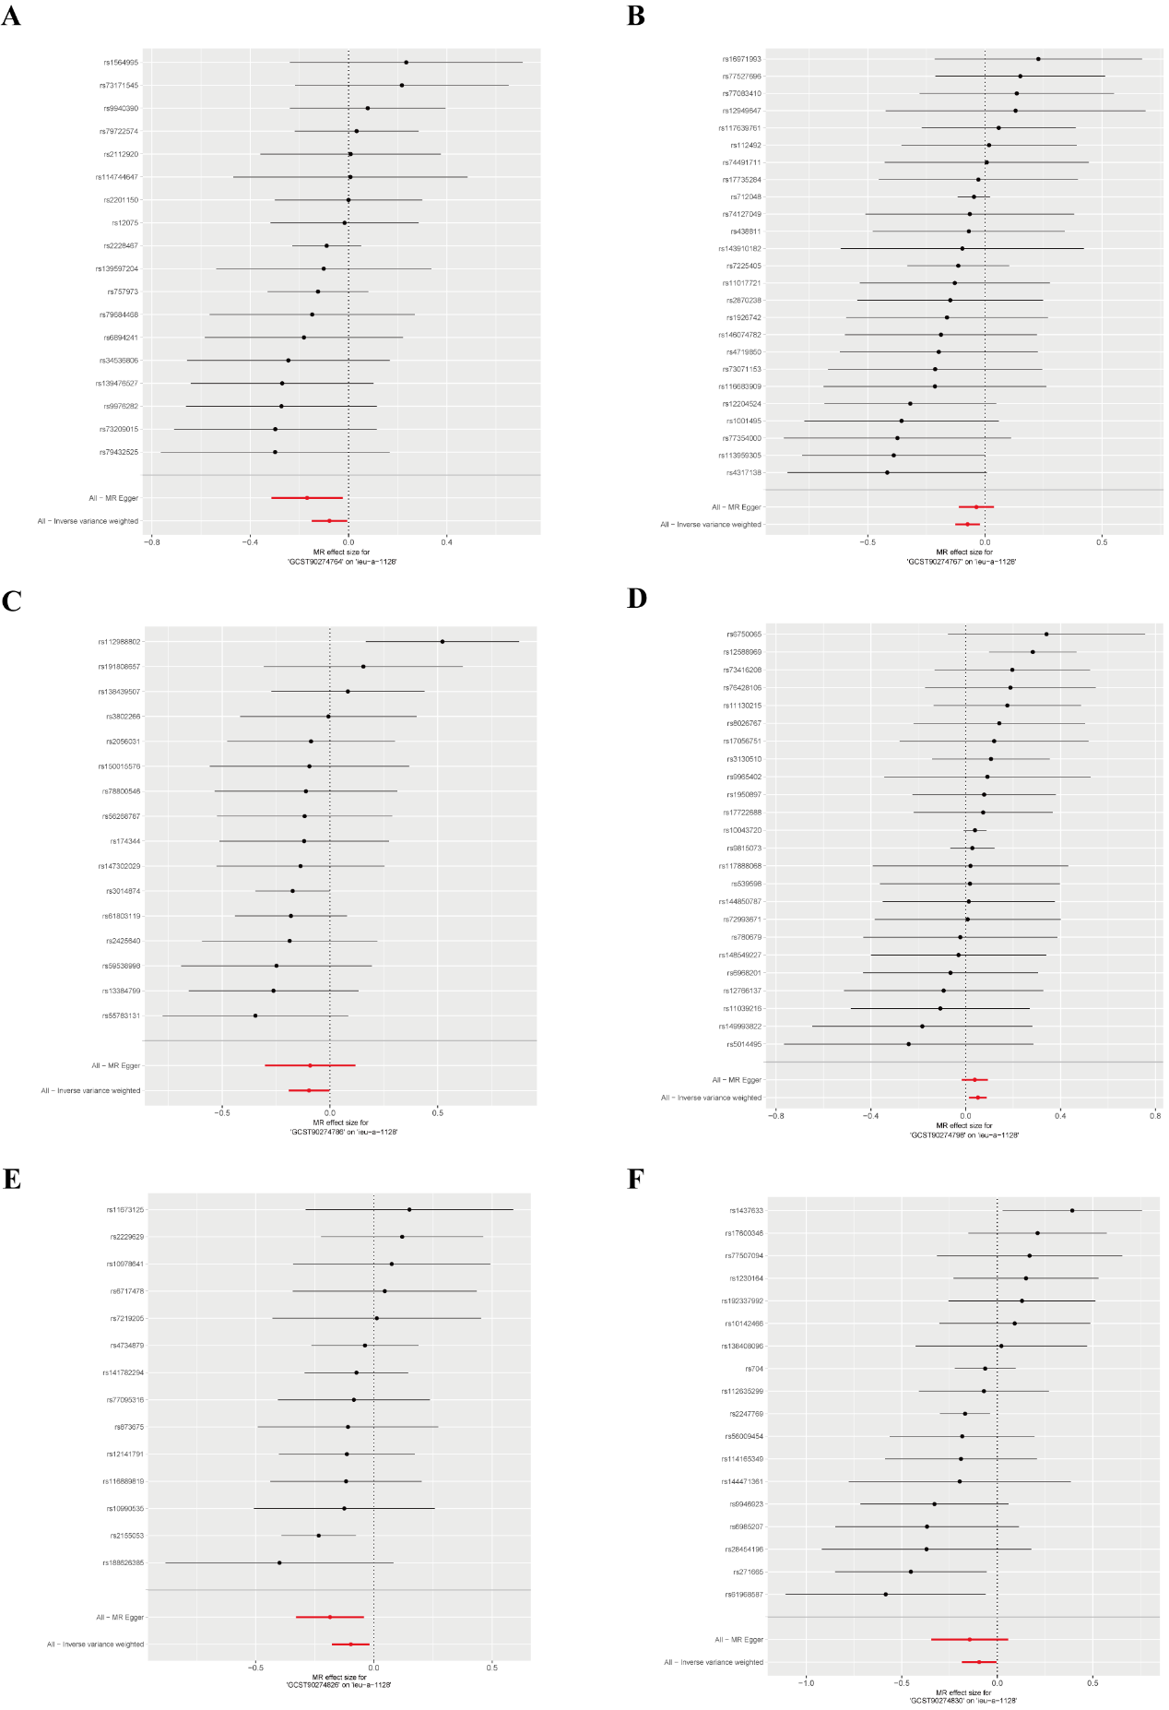
- MR effect size for “GCST90274764” on “ER- breast cancer”
- MR effect size for “GCST90274767” on “ER- breast cancer”
- MR effect size for “GCST90274786” on “ER- breast cancer”
- MR effect size for “GCST90274798” on “ER- breast cancer”
- MR effect size for “GCST90274826” on “ER- breast cancer”
- MR effect size for “GCST90274830” on “ER- breast cancer”

Figure S20. Forest plots for the effect of inflammatory factors on ER+ breast cancer.
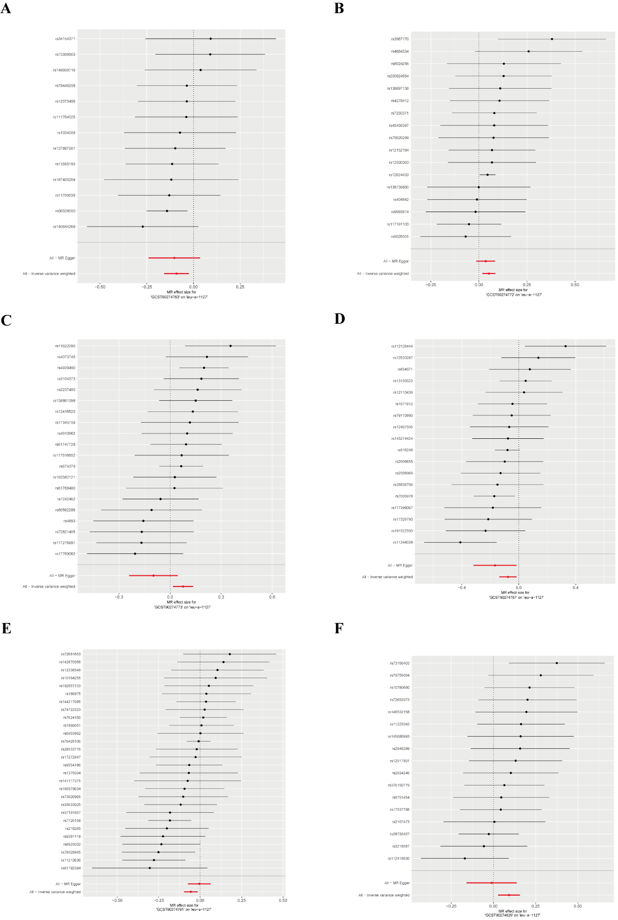
- MR effect size for “GCST90274763” on “ER+ breast cancer”
- MR effect size for “GCST90274772” on “ER+ breast cancer”
- MR effect size for “GCST90274773” on “ER+ breast cancer”
- MR effect size for “GCST90274787” on “ER+ breast cancer”
- MR effect size for “GCST90274791” on “ER+ breast cancer”
- MR effect size for “GCST90274829” on “ER+ breast cancer”

Figure S21. Forest plots for the effect of mitochondria-associated proteins on inflammatory factors.
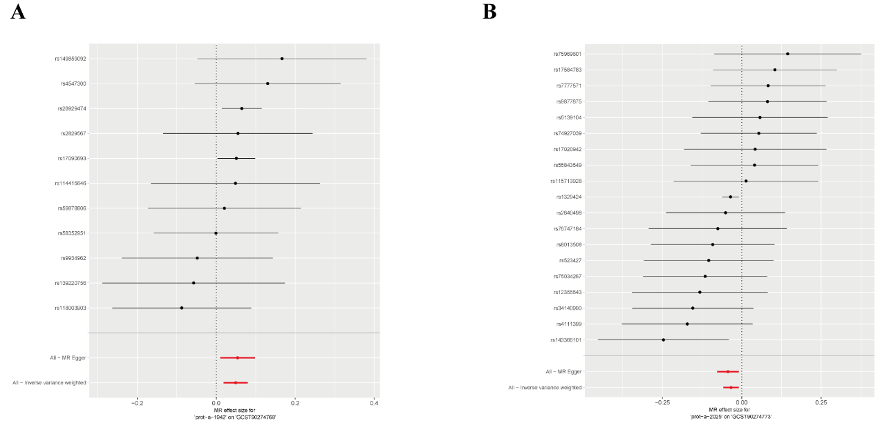
- MR effect size for “prot-a-1942” on “GCST90274768”
- MR effect size for “prot-a-2025” on “GCST90274773”

