­­

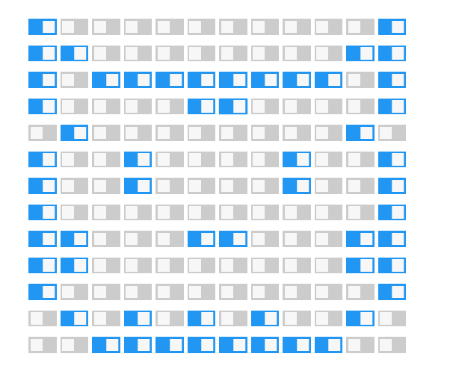

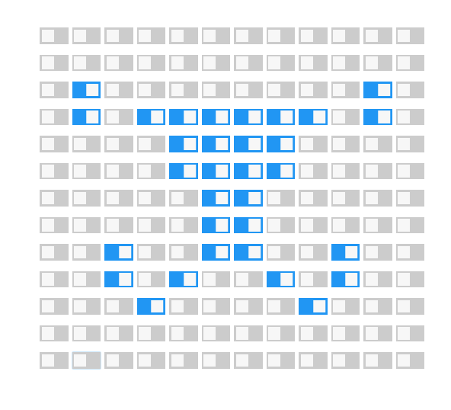half dog?

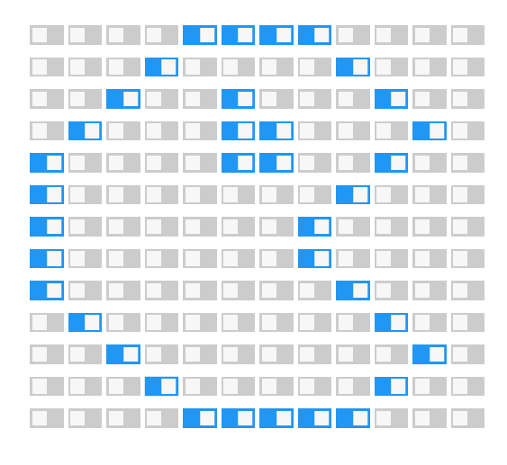

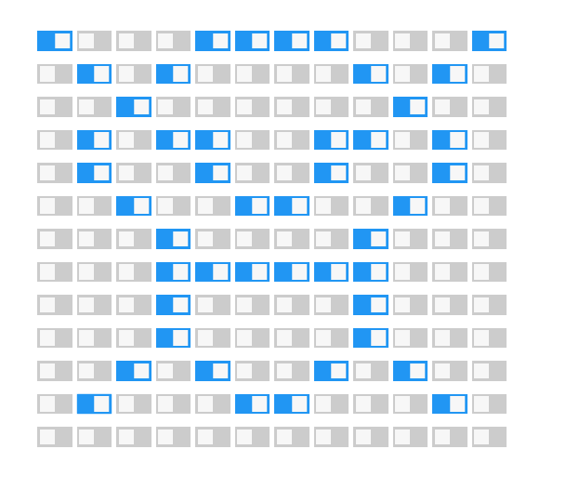

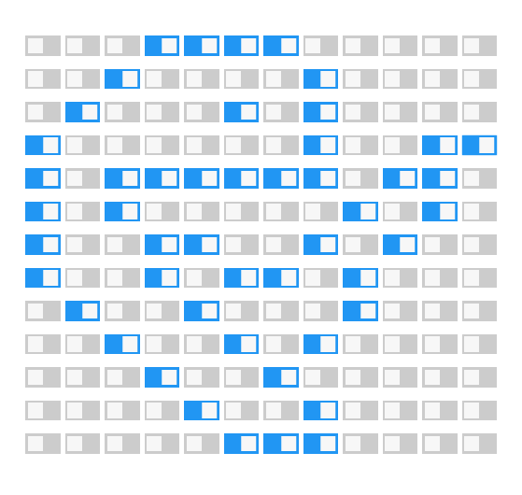Venom

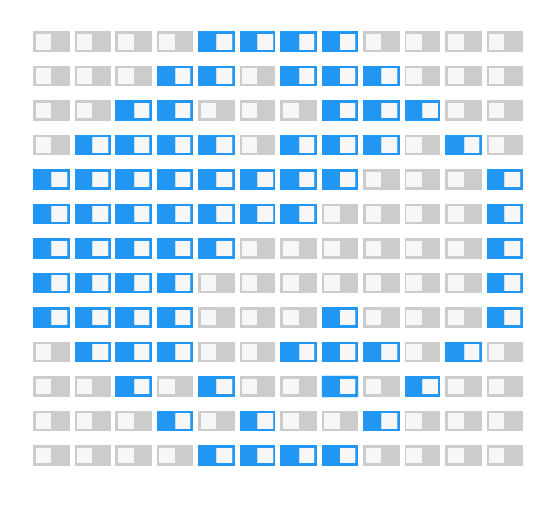

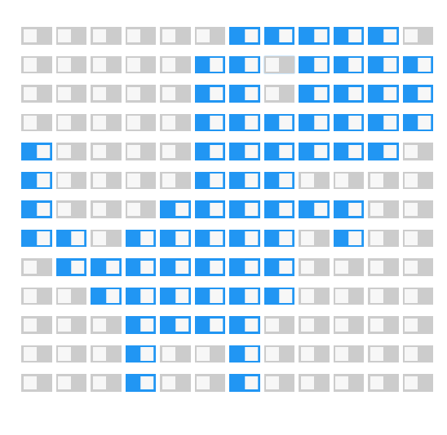

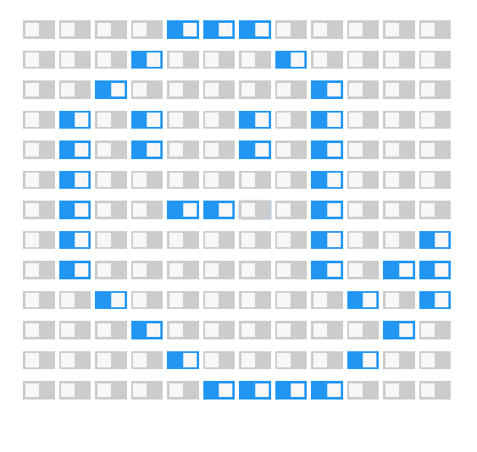

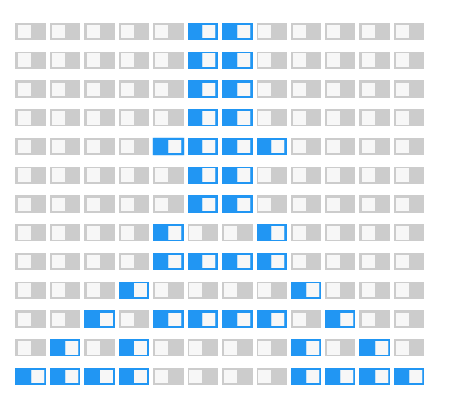

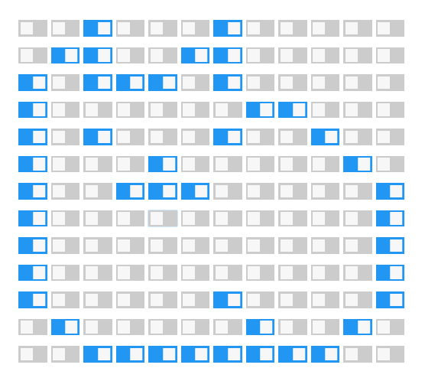

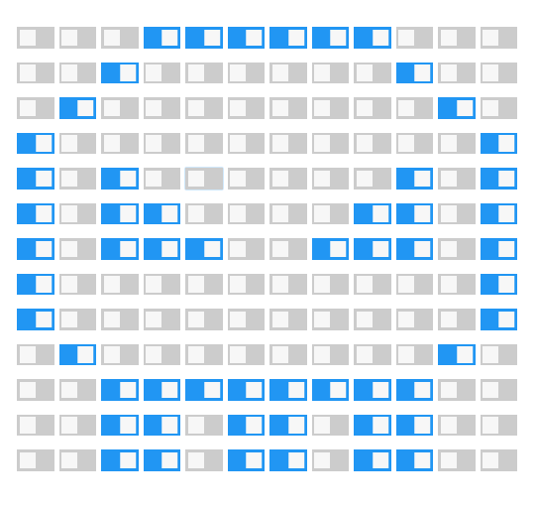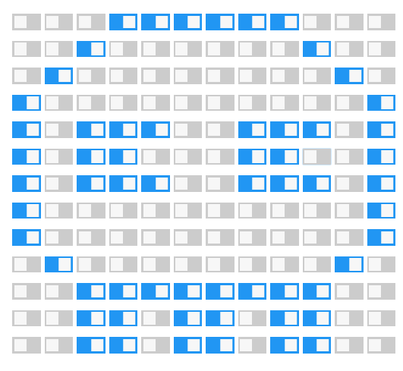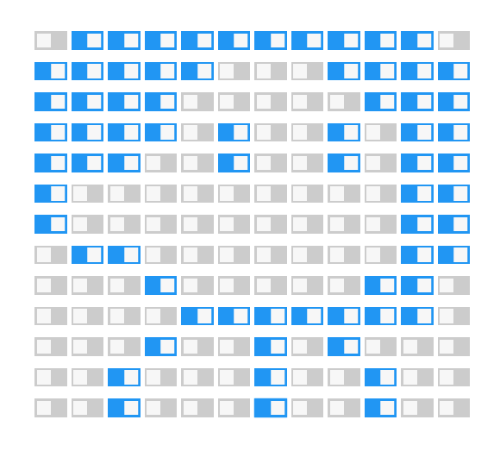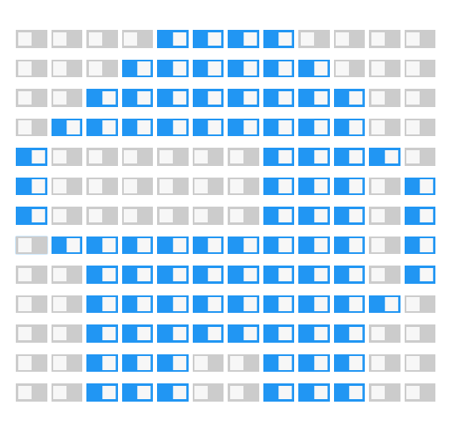

<script>

function displayRandomImages()

{

//array of images with image location, height, and width

var imageArray = [

{

//address URL of the image

src: "https://wi.wallpapertip.com/wsimgs/15-155208_desktop-puppy-wallpaper-hd.jpg",

//size for the image to be display on webpage

width: "280",

height: "200"

},

{

src: "https://wi.wallpapertip.com/wsimgs/156-1564365_golden-retriever-puppy-desktop-wallpaper-desktop-wallpaper-puppy.jpg",

width: "320",

height: "195"

},

{

src: "https://wi.wallpapertip.com/wsimgs/156-1564140_free-puppy-wallpapers-for-computer-wallpaper-cave-cute.jpg",

width: "320",

height: "195"

},

{

src: "https://wi.wallpapertip.com/wsimgs/156-1566650_cute-puppies-desktop-wallpaper-cute-puppies.jpg",

width: "350",

height: "250"

} ];

//find the length of the array of images

var arrayLength = imageArray.length;

var newArray = [];

for (var i = 0; i < arrayLength; i++) {

newArray[i] = new Image();

newArray[i].src = imageArray[i].src;

newArray[i].width = imageArray[i].width;

newArray[i].height = imageArray[i].height;

}

// create random image number

function getRandomNum(min, max)

{

// generate and return a random number for the image to be displayed

imgNo = Math.floor(Math.random() * (max - min + 1)) + min;

return newArray[imgNo];

}

// 0 is first image and (preBuffer.length - 1) is last image of the array

var newImage = getRandomNum(0, newArray.length - 1);

// remove the previous images

var images = document.getElementsByTagName('img');

var l = images.length;

for (var p = 0; p < l; p++) {

images[0].parentNode.removeChild(images[0]);

}

// display the new random image

document.body.appendChild(newImage);

}

</script>