**Species List Pre-Processing Tutorial**

This tutorial is a guide to acquiring all of the necessary hardware and installations on your local machine for processing species lists and updated taxonomy tables before they go into the dodobase. It includes steps to connect with the remote FSU server and how to install Python and download the Python modules you need to run the species list processing code on your.

1. Install Python: Go to <http://www.python.org/getit/> and download the latest version of Python 2.7 for Windows. For further download instructions and information about python you can go to the FSU wiki and look at the Python resources under the Data Resources menu. This will also give you instructions and a link to download  [**Wing 101**](http://www.google.com/url?q=http%3A%2F%2Fwingware.com%2Fdownloads%2Fwingide-101&sa=D&sntz=1&usg=AFrqEzfFVVeoV4VQT-b1kYV0uLx0VyeEEg) a free python integrated development environment. I would recommend reading through some of the literature on both python and wing before starting.
   1. Before you start using python you need to set up a python path so your machine can navigate to your python executable:
      1. Open your start menu and right click on computer🡪properties
      2. In the control panel window click on advanced system settings on the left .
      3. Click on Environment variables. In the pop up window under “system variables” scroll to “path” and double click to edit.
      4. At the end of the path add ;C:\\python27. The path should look something like this: C:\Program Files\Common Files\Microsoft Shared……….\;C:\\python27. What you just did is make is so that your machine when you type “python” in your command line will look in your python directory.
      5. Open your command shell by opening your start menu, right click on command prompt and “run as administrator”. Type “python” in your window and it should start running python:

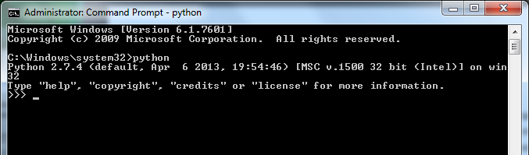

* + 1. If you instead get an error message check your python path or navigate to the python executable with the following command: cd C:\\python27 python.
  1. After you have installed and configured python you will also need to download certain modules that perform different functions using python in order to process the species list scripts.
  2. The first one you need to download is called set up tools which includes a module called easy install that allows you to install other python modules from your command line. Go to <https://pypi.python.org/pypi/setuptools> and follow the download instructions.
  3. After the module has downloaded you should be able to see the module files located in C:\Python27\Lib\site-packages. The easy install executable will be installed here: C:\Python27\Scripts.
  4. To use easy install open your windows command shell and navigate to the easy install executable “ cd C:\Python27\Scripts” and type easy_install ‘name of module’

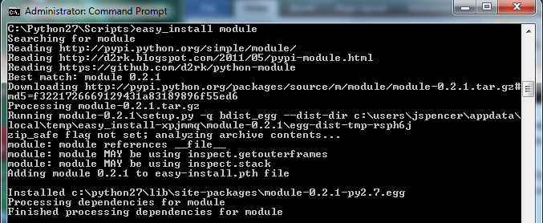

* 1. Here is the list of modules you will need to install: mechanize, pyquery, oauth2, cssselect, lxml, httplib2. If you have missed a package you need as you are running the species list processing script on your local machine (see species list processing tutorial) it will give an error telling you if there is a module you need to install on your machine.

1. Download the File Transfer Protocol software Filezilla <https://filezilla-project.org/>. Make sure to download the Filezilla Client package. Once you have downloaded the software open the steps for installation, you don’t have to change any of the settings. When the program starts you need to connect to the NEON FSU server. Make sure the information in the connection window is as follows: The password is fsu.

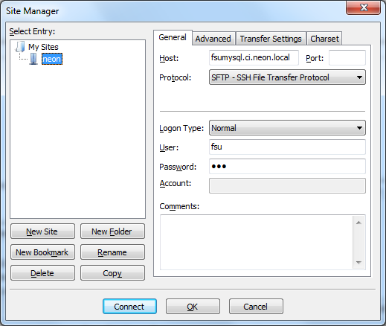

1. Download putty (<http://www.chiark.greenend.org.uk/~sgtatham/putty/download.html>). This is a secure shell that will communicate with the neon sever on filezilla. The server is running on a linux machine. Download the putty.exe program for windows. When you download putty and open the program a configuration window should appear. Type in the Host Name below and fill the window with the following settings.

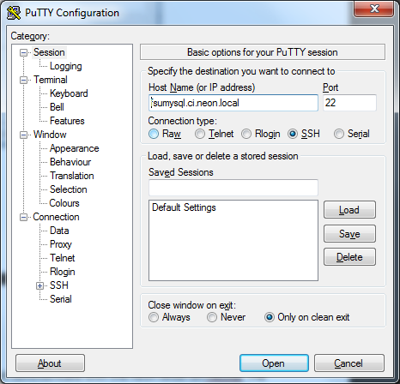

Now you are ready to process the species lists.