This tutorial briefly reveals how to clone an online repository (which sets up a local version on your machine), how to make changes to files and add, commit, and push those changes to the online repository using the Git bash terminal window.

You are assumed to have setup an account on Github, to have joined the NEON group, and to have Git bash and Microsoft Excel installed on their computer. Git bash is a basic command line tool for interacting with Git (the version control system) and Github (the web-based hosting service for projects that use Git). Other command line or graphical user interfaces will work, but we can’t provide a tutorial for each. Git bash is minimalistic and can be installed as an option when installing Git.

If you have downloaded, but not set up Git, you are referred to <https://help.github.com/articles/set-up-git> for those instructions.

With Git downloaded, installed, and setup, open the Git bash shell (look for an icon on your desktop):

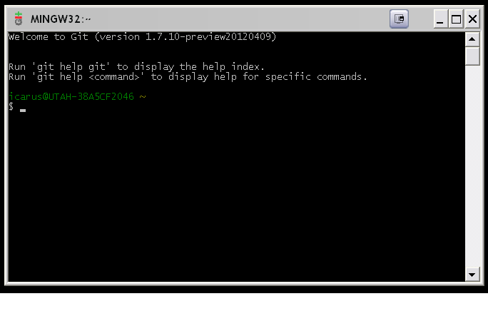

If you haven’t yet created a clone of the repository on your local machine, then navigate to the folder where you want to create your clone of the Git repository:

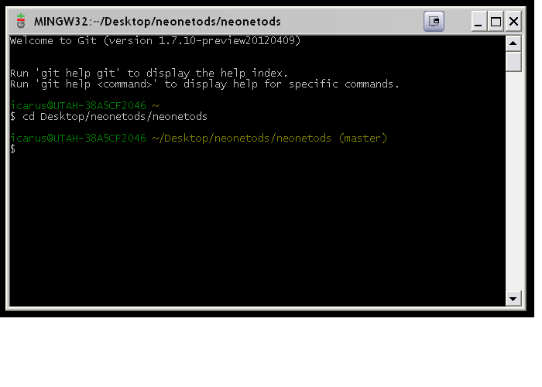

and type

git@github.com:your_groups_directory/your_requestd_repository.git

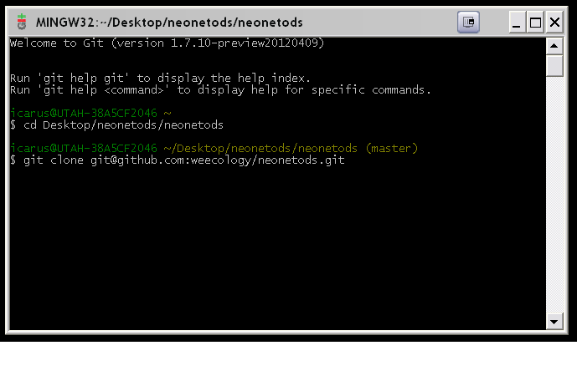

If you’ve already created the Git clone as a local repository on your machine, then navigate to that folder and type ‘git pull’ to pull the latest version from Github. You’ll need to enter the passphrase you chose when you set up Git:

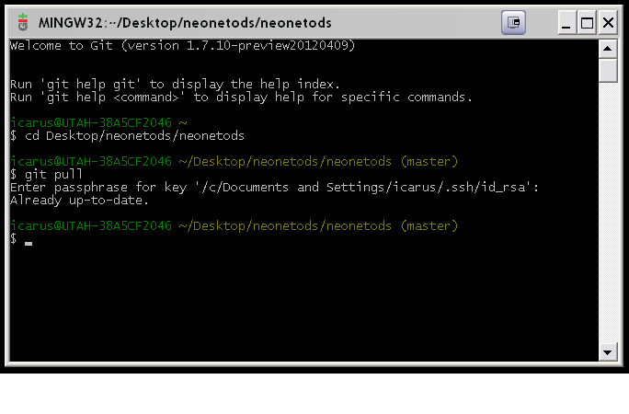

Once you have an updated version of the repository, you are free to open files (e.g. activities.csv) and modify them. Here, the activities.csv file has been changed to reflect that books.google.com has no useful links to species information for the DEJU site.

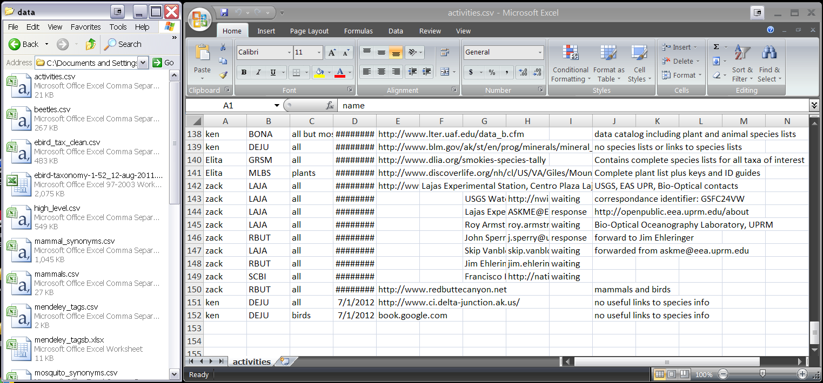

Once you’ve added your desired changes, you’ll want to save them. When you do this with .csv files in Excel you may be asked whether you want to keep the Excel workbook in the .csv format. choose ‘Yes’:

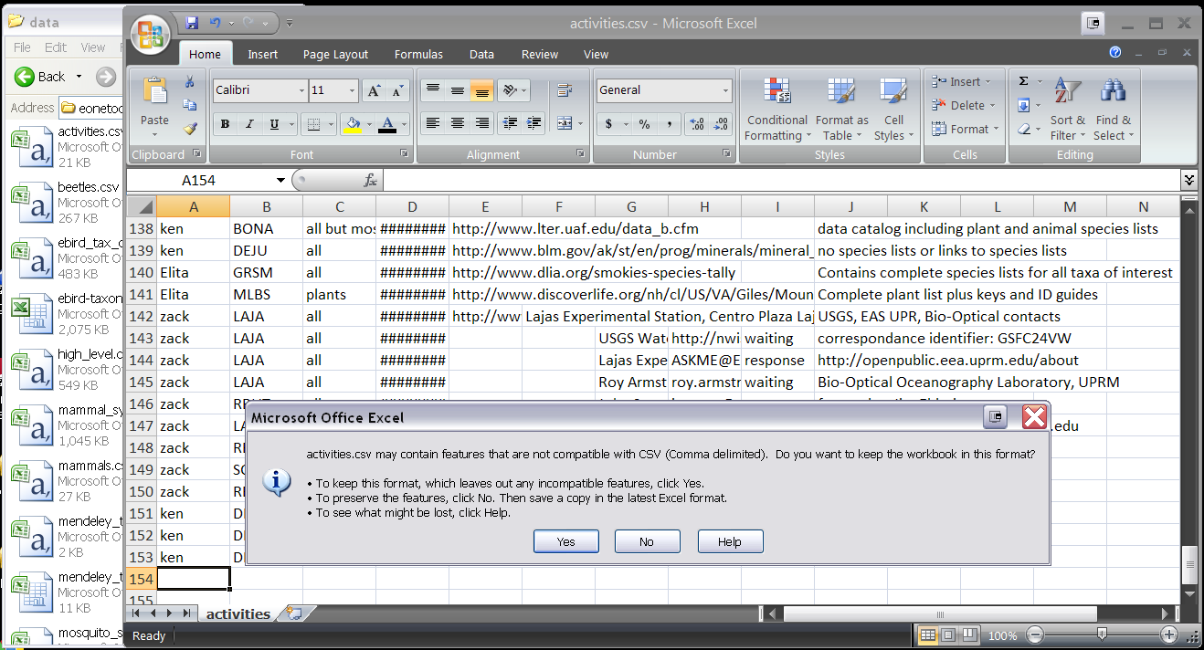

Note that saving your changes to the file does not add or commit them to your local repository.

When closing the file, you may be asked whether you want to save your changes. Choose ‘Yes’. You may be told that the file already exists and asked whether you want to replace it. Choose ‘Yes’. Afterwards, you may be asked, once more, whether you want to keep the file in the .csv format. Choose ‘Yes’:

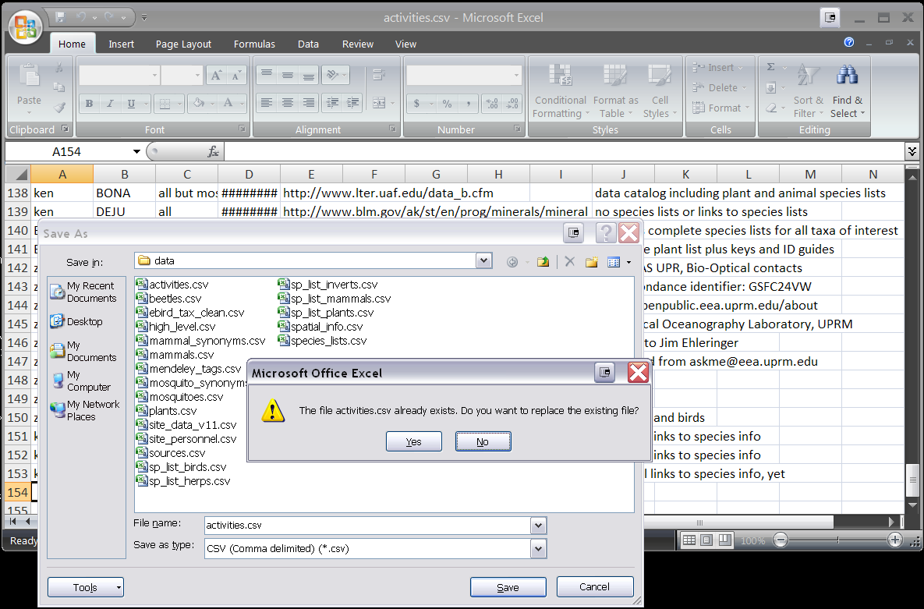

The file will close and your changes will be saved. However, you’ll need to add the changes to your local version of the repository.

Go to your Git bash terminal window, ensure that you are in the folder containing your local repository, and type:

git add .

The ‘.’ option adds changes made to all files in the repository. Using this option will help you avoid repository conflicts. Without the ‘.’ option, you’ll have to specify the file you want changes added to. Once you’ve added your changes, you must commit them to your local repository (i.e. your clone).

To commit your changes, type:

git commit –m “a short message of what you did”

then press enter.

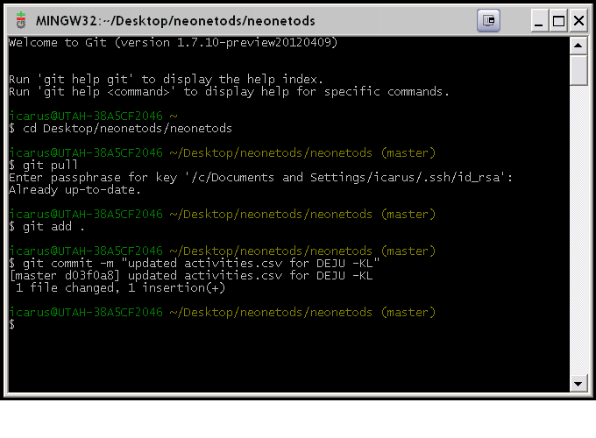

You will receive a statement of your changes.

Next, you must pull from the Github repository once more to ensure that you are about to push your committed changes to the most updated version. This will help you to avoid conflicts when Git attempts to merge your local changes with the web-based repository. Type:

git pull

You will be asked for your passphrase

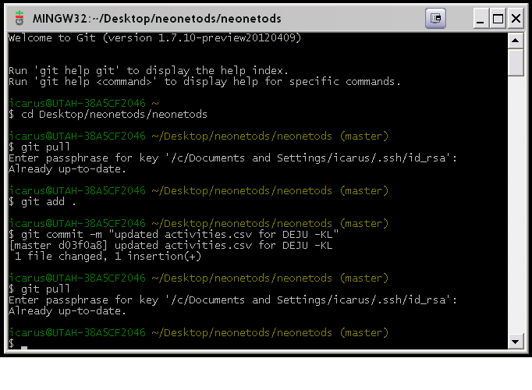

Now, you are ready to push your local changes to the online repository; type:

git push

You will be asked for your passphrase again.

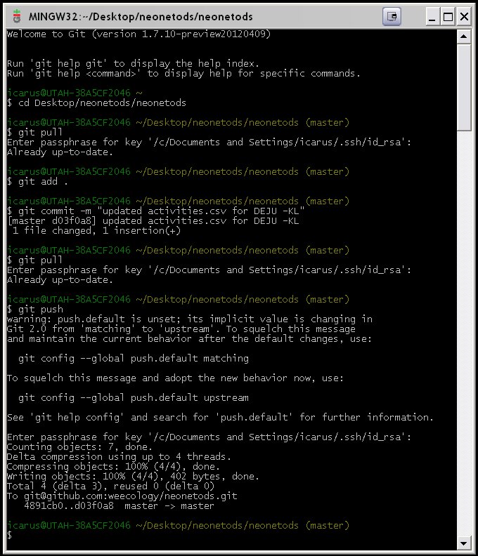

You may be given a warning that push.default is unset. This does not prevent your changes from being committed. You will be asked for your passphrase. Git will then commit your changes to the online repository. The changes to your local repository (i.e. clone) are now added to the online version. Note that this final window includes all standard operations when updating the local repository (git pull), making changes to files (git add, git commit) and pushing them to the online repository (git pull, git push).

**Important**: If you are updating a file that requires a source url from the online Mendeley library (e.g. a reference for recent entries into the sp_list_mammals.csv for a particular site), then you will need to obtain that source’s url from the online Mendeley library, and then proceed with saving your changes, adding and committing them to the local repository, and pushing them to the online version. Obtaining source url’s from the online library is covered in the Mendeley tutorial.