This tutorial shows how to add documents (e.g. pdf’s, webpages, text documents) to your Mendeley Desktop, edit their details, and upload them to an online library.

It is assumed that you have already set up a Mendeley account, joined a group, and downloaded and installed the Mendeley Desktop. Ensure that the Mendeley Dashboard bookmark has been added to the bookmarks toolbar on your internet browser:

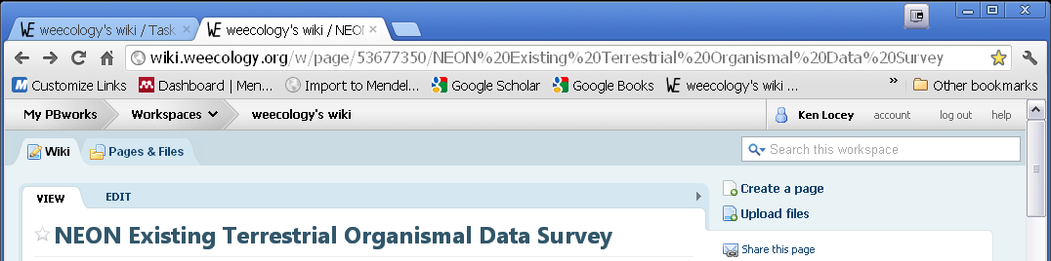

You will also want the ‘Import to Mendeley’ add-on (see portion of tutorial covering webpages).

You will use your Mendeley Desktop to add sources (e.g. pdf’s saved on your computer) to your group’s documents. The following tutorial shows you how.

First, open the Mendeley Desktop. There may be an icon on your Desktop window. Once opened, the desktop will display your library, groups to which you belong, and a list by which to filter documents by Authors, etc. You will see a window displaying three tabs (Overview, Documents, Members) in the center. Select Documents.

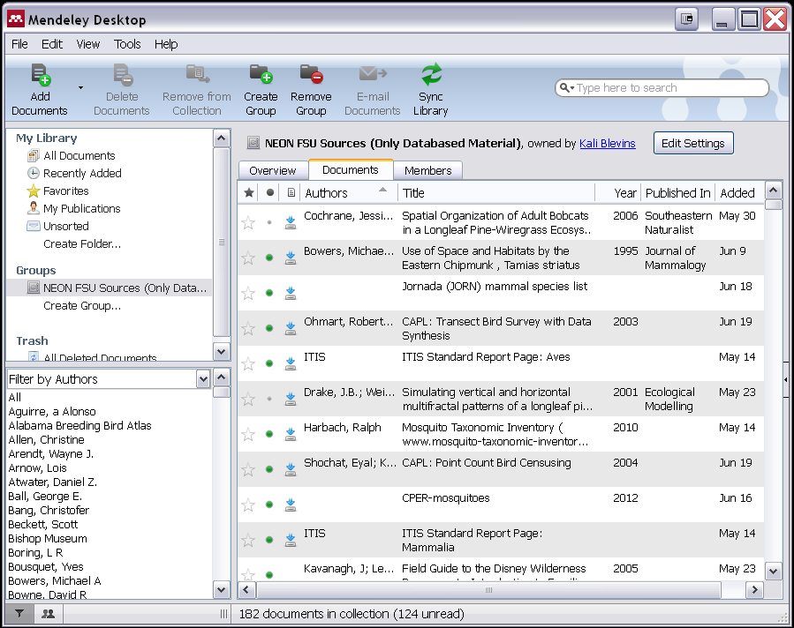

To import sources you have saved on your local machine, simply drag and drop documents from a folder into the Mendeley Desktop:

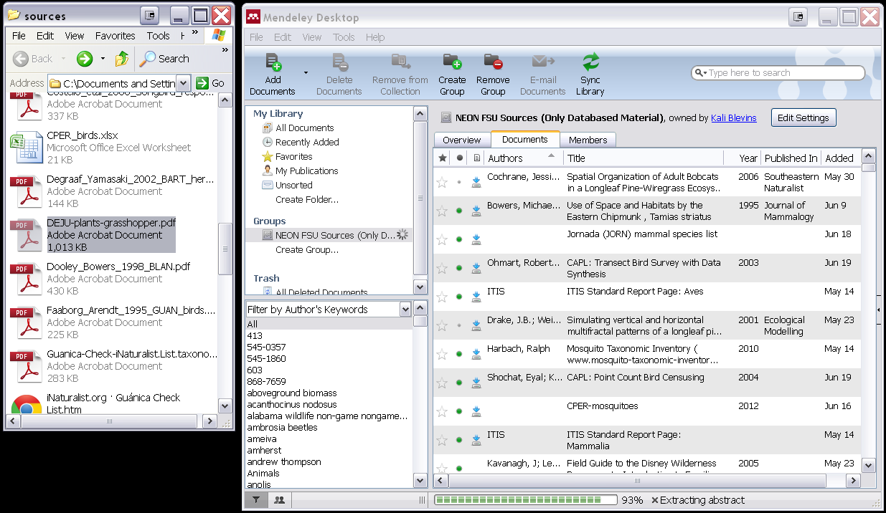

Next, and before syncing the library on your local machine with the online library (hosted by Mendeley) you will need to edit the document details. The Details and Notes tabs will typically appear on right side of Mendeley Desktop upon opening, and will appear after dropping a document into the Mendeley Desktop. Here, you should ensure that the title, authors, date, journal, and other source related information is correct. If it is not, you can edit it by clicking on the respective field. You should ensure that the appropriate tags have been given (e.g. habitat type, source type). You should have been given a list of tags to identify that will allow the source to be queried.

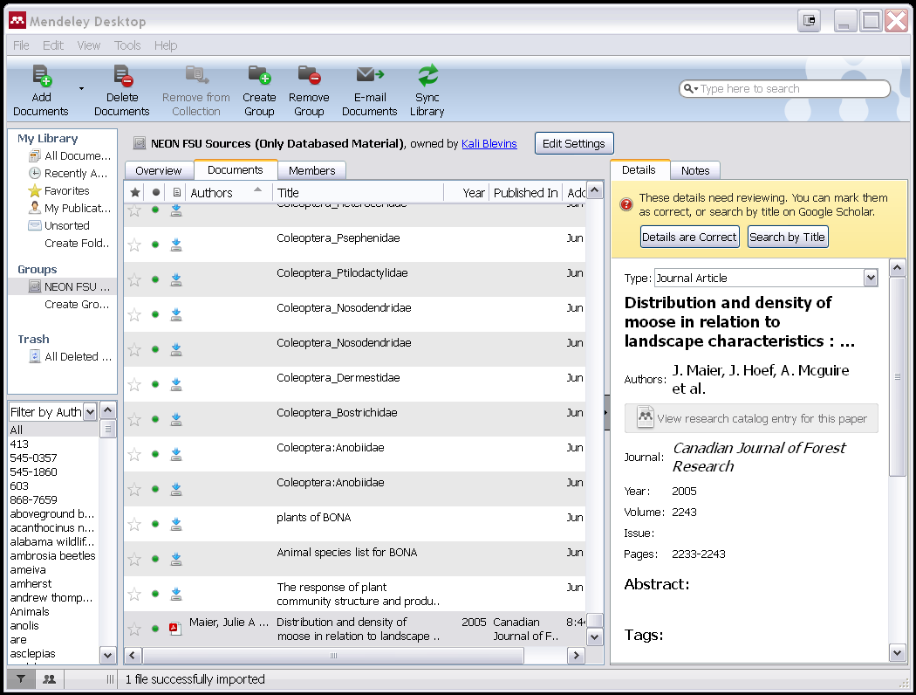

Once the source details are correct, confirm they are correct and select the ‘sync library’ button on the Mendeley Desktop toolbar. This will update the group’s online Mendeley library. Note, if you change the title or authors after syncing, you will have to sync again to reflect these changes in the online library.

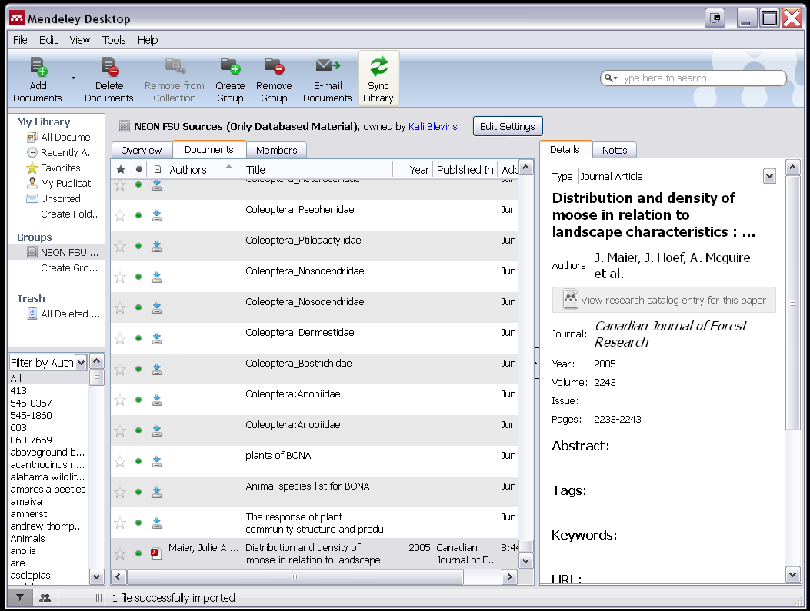

If you are uploading a source because you are listing it in a data file alongside records (e.g. bird species accounts in the sp_list_birds.csv) then you are also interested in getting the Mendeley library url, which is a column in the data tables of files such as sp_list_birds.csv. You can access the online version of the source located in the group’s Mendeley library by clicking on the ‘Dashboard|Mendeley’ bookmark. This will take you to your online Mendeley page:

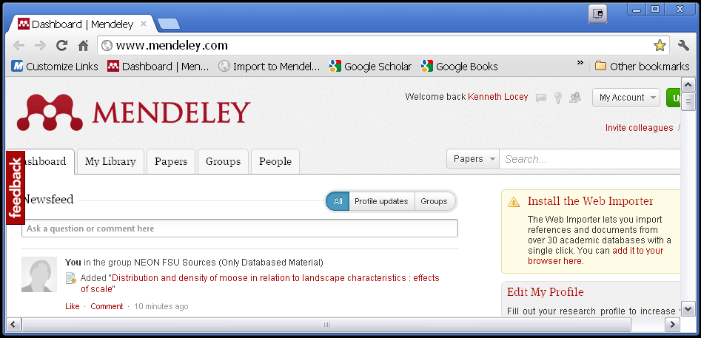

From here, you can access papers in your group’s online library by clicking on the Groups tab, and then selecting your group:

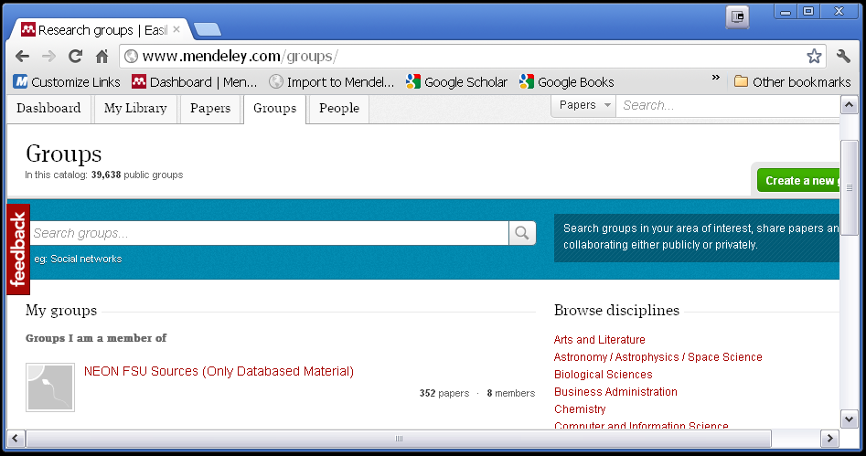

Then click on the Papers tab, located on the left side of the window:

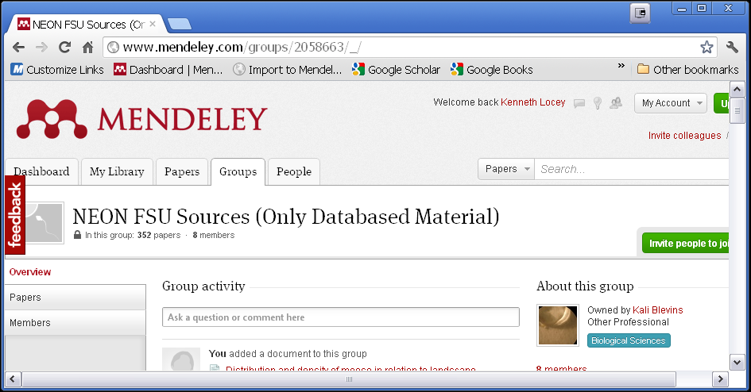

This will bring you to the groups online library and a list of recently added sources. The source you just added will likely be at the top of the list. Clicking on it will take you to that source’s Mendeley library page where you can copy the url and paste it into the data file of your choice:

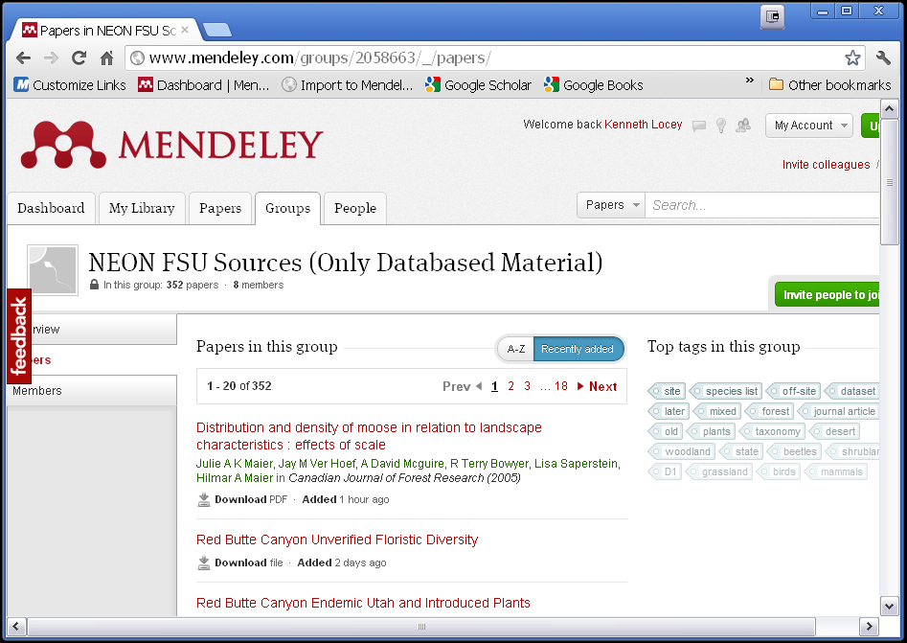



Once you have the source’s url, you can paste it into the appropriate data file (e.g. sp_list_herps.csv).

You can also import webpages (e.g. a webpage containing a species list) into Mendeley directly from within your browser, by installing the Web Importer. This will create a bookmark labeled ‘Import to Mendeley’ on your bookmarks toolbar.

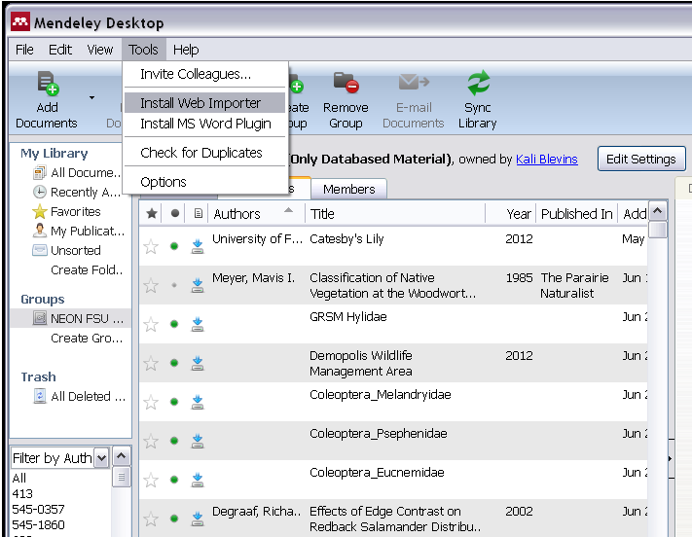

After Installing the Web Importer add-on, you can import a web-page directly into your personal library or the group’s online library by simply clicking on the bookmark. This will bring up a window named ‘Import documents to Mendeley’. There, you can choose which library to add the web-page to, edit details, and add tags and notes:

