Sheridan Dela Cruz
Garrett Woods
Megan Mosier
Garvin Stewart
May 13, 2026
Module 10.1, Milestone 3

Report 1: Equipment Sales vs Rentals
Business Decision Supported:
Do enough customers buy equipment to keep equipment sales?

Description of the Report
This report compares:
- How many customers rent equipment
- How many customers buy equipment
- How many customers do both
- Total number of rental transactions vs sale transactions
This helps determine whether equipment sales are worth continuing or whether Outland Adventures should shift toward a rental-focused model.

Python Output
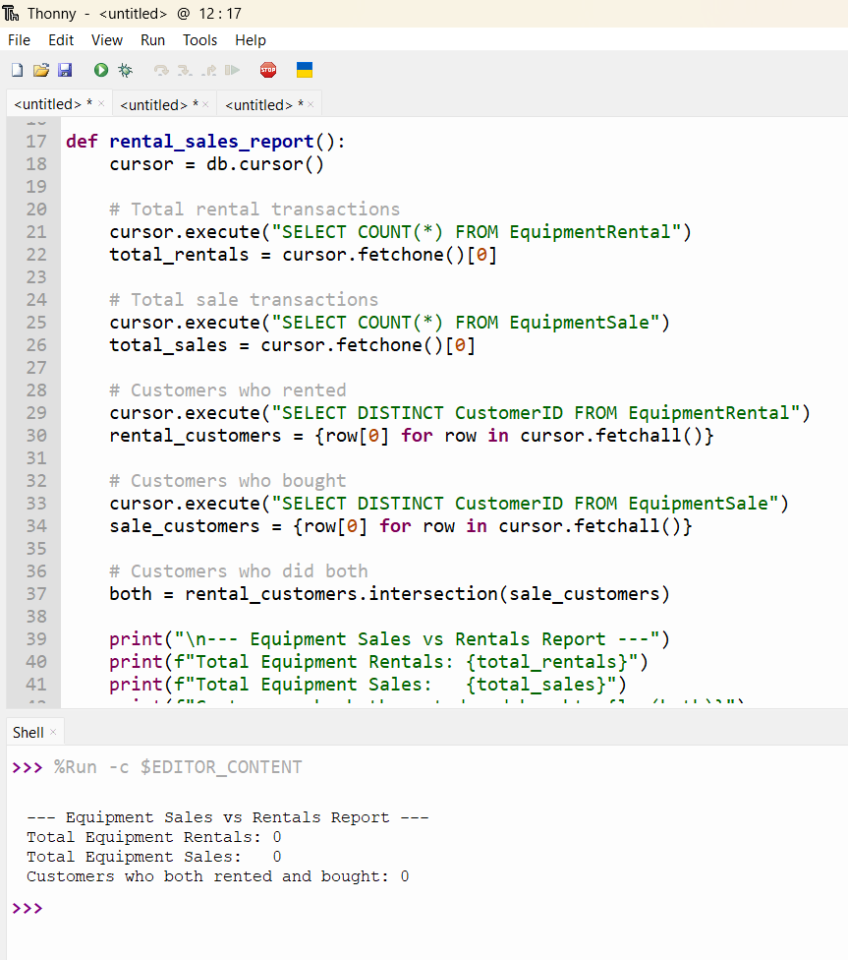

Report 2: Booking Trends by Region
Business Decision Supported:
Is any region (Africa, Asia, Southern Europe) showing a downward trend in bookings?

Description of the Report
This report analyzes booking activity across all regions where Outland Adventures operates. It summarizes:
- Total bookings per region
- Total bookings per year
- Allows you to visually identify upward or downward trends
Python Output
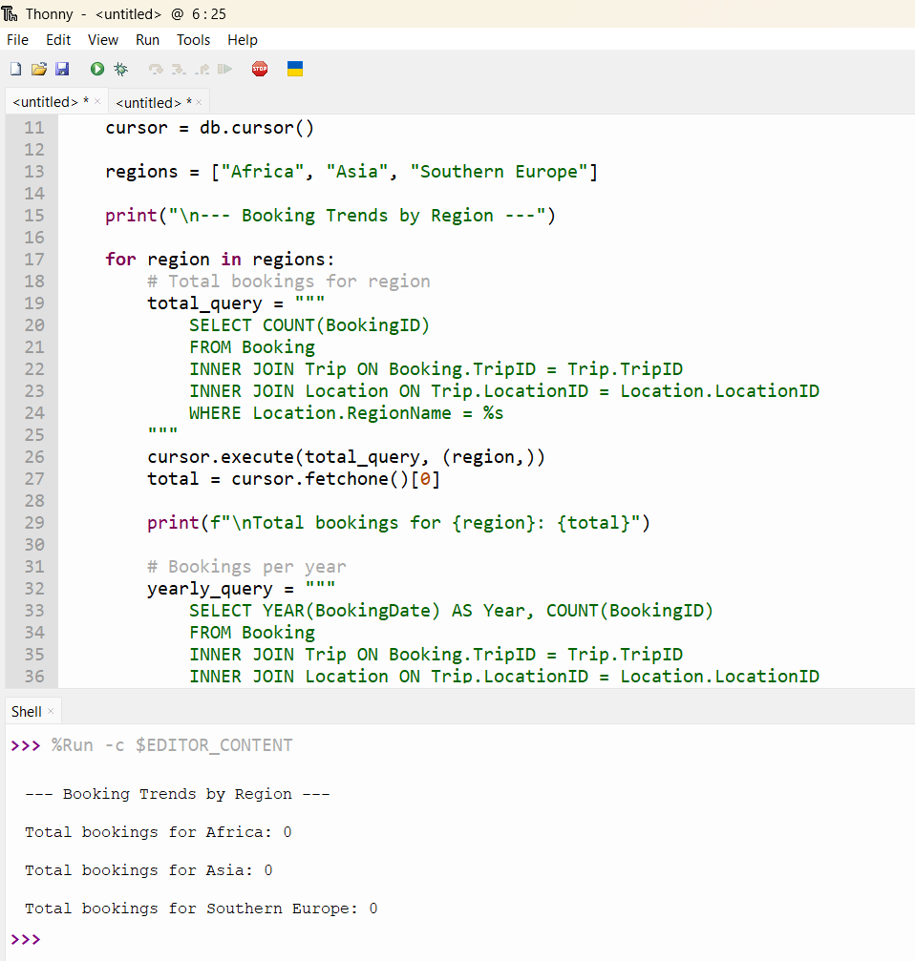
Report 3: Aging Inventory Report
Business Decision Supported:
Are there inventory items that are over five years old?

Description of the Report
This report identifies:
- Equipment items older than 5 years
- Their condition
- Their purchase date
- Quantity available
This helps determine what needs replacing.
Python Output
