Garvin Stewart
CSD-310 — Module 4.2 Assignment

Part 1 — Initial MySQL Connection
The screenshot below shows the initial successful connection to the MySQL database server via the terminal.

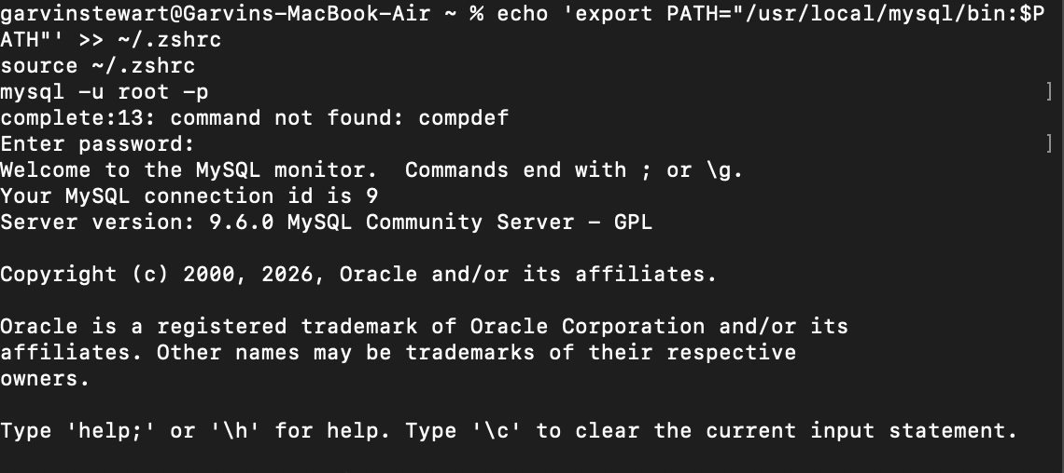

Part 2 — Create and Verify the movies Database
Command executed:
CREATE DATABASE movies;

Verification command:
SHOW DATABASES;

The screenshot below confirms that the movies database was successfully created and appears in the database list.

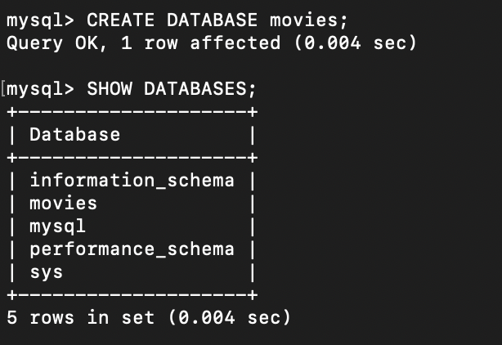

Part 3 — MySQL Function Demonstrations
Three MySQL functions were selected from W3Schools for experimentation. Each entry includes a use-case explanation, a column alias, the SQL statement, and a screenshot of the result.

Function 1 — COUNT()
When to Use:
COUNT() returns the number of rows that match a specified condition. It is used when you need to determine how many records exist in a table or satisfy a WHERE clause — for example, counting how many customers placed an order, or how many movies belong to a given genre.

Column Alias:
total_movies

SQL Statement:
SELECT COUNT(*) AS total_movies
FROM film;

Result Screenshot:
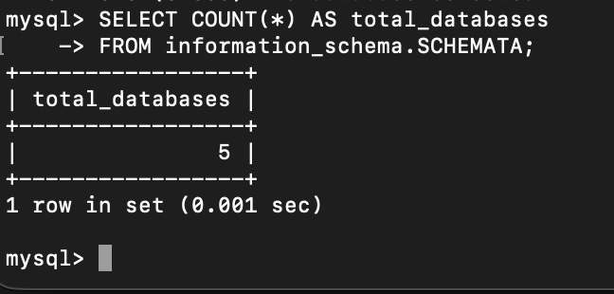

Function 2 — UPPER()
When to Use:
UPPER() converts all characters in a string column to uppercase. It is useful when normalizing data for display or comparison — for example, formatting movie titles consistently for a report, or ensuring case-insensitive matching during a search.

Column Alias:
title_uppercase

SQL Statement:
SELECT UPPER(title) AS title_uppercase
FROM film
LIMIT 10;

Result Screenshot:
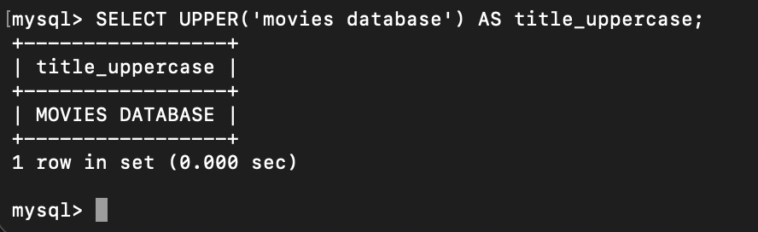

Function 3 — NOW()
When to Use:
NOW() returns the current date and time at the moment the query executes. It is commonly used to timestamp records on insert or update operations, or to calculate how much time has elapsed since a stored date — for example, finding rentals that are currently overdue by comparing a due-date column against NOW().

Column Alias:
current_timestamp

SQL Statement:
SELECT NOW() AS current_timestamp;

Result Screenshot:
