Garvin Stewart
CSD 310 – Module 4.3 Assignment
April 19, 2026

Entity Relationship Diagram – Film Studio Database

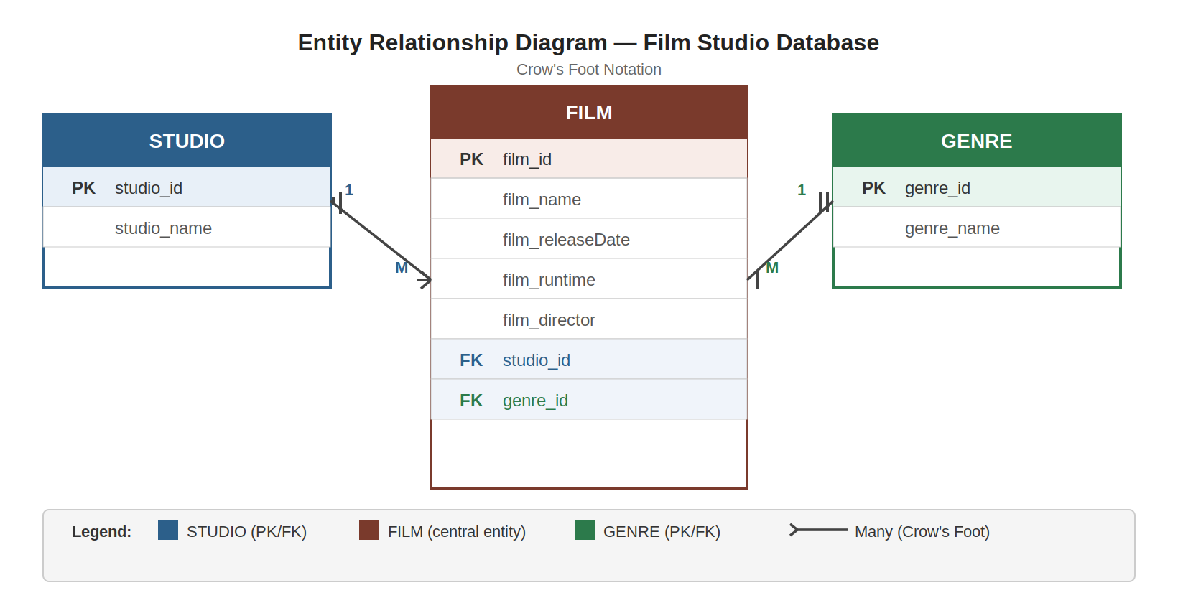

Figure 1: ERD for Film Studio Database (Crow's Foot Notation)

Business Rules
1. One STUDIO can produce many FILMs (one-to-many relationship).
2. One FILM is described using one GENRE (many-to-one relationship).

Entity Descriptions
STUDIO: Represents a film production company, identified by studio_id (PK) and studio_name.
GENRE: Represents a film category, identified by genre_id (PK) and genre_name.
FILM: Central entity storing film details including film_id (PK), film_name, film_releaseDate, film_runtime, and film_director. References studio_id (FK) and genre_id (FK) to enforce relational integrity.

