Garvin Stewart
CSD-310 | Module 5.2 Assignment

Part 1 — Run db_init_2022.sql
The SQL script was executed in the MySQL command-line client using the following command:
source /Users/garvinstewart/csd/csd-310/db_init_2022.sql
The script performed the following operations in sequence:
- Dropped and recreated the movies_user database user.
- Granted all privileges on the movies database to movies_user.
- Dropped and recreated the studio, genre, and film tables.
- Inserted seed records for studios, genres, and films.
Screenshot of the terminal output after running the script:

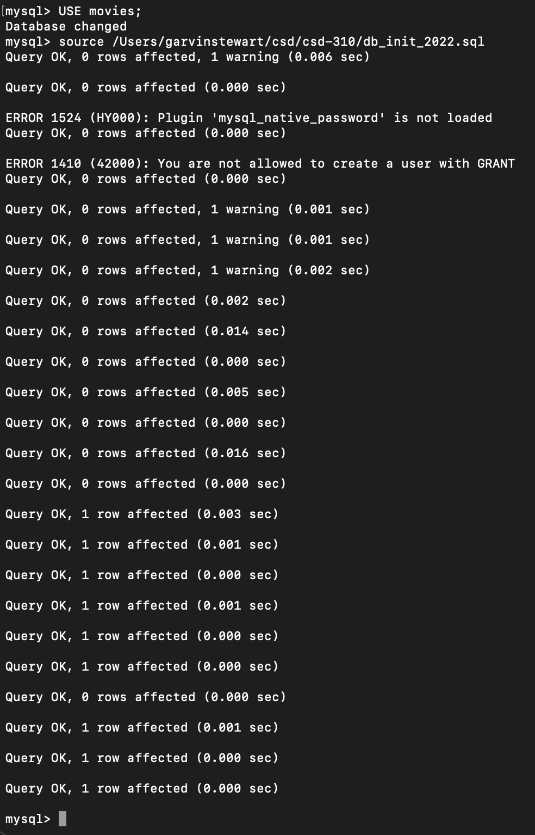

Part 2 — SHOW TABLES
After activating the movies database, the following commands were run to verify the tables were created:
USE movies;
SHOW TABLES;
The result confirmed three tables exist in the movies database: film, genre, and studio.

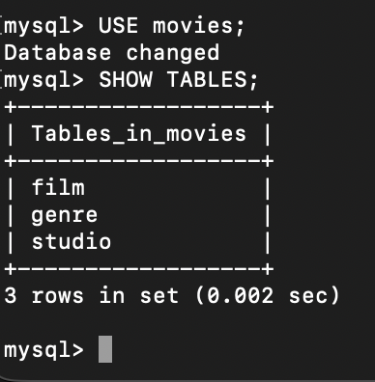

Part 3 — Python Connector (mysql_test.py)

Setup
The mysql-connector-python and python-dotenv packages were installed using pip:
pip install mysql-connector-python
pip install python-dotenv

Credential Security (.env)
A .env file was created in the module-5 directory to store login credentials. This file is excluded from Git tracking via .gitignore, preventing credentials from being pushed to a public repository. Contents of the .env file:
USER=movies_user
PASSWORD=popcorn
HOST=localhost
DATABASE=movies
RAISE_ON_WARNINGS=True

mysql_test.py — Code Overview
The script imports mysql.connector and dotenv, loads credentials from the .env file into a config dictionary, then attempts a connection. On success it prints the connected user, host, and database. On failure it catches error codes for invalid credentials (ER_ACCESS_DENIED_ERROR) and missing database (ER_BAD_DB_ERROR), and closes the connection in the finally block.

Script Execution Result
The script was run from the module-5 directory. The expected output is:
Database user movies_user connected to MySQL on host localhost with database movies

