The diagram below models the control flow of Module_10_Assignment.py. It covers class definitions, object instantiation, setter population, grouping, roster output, and the isinstance() branch inside display_employee().

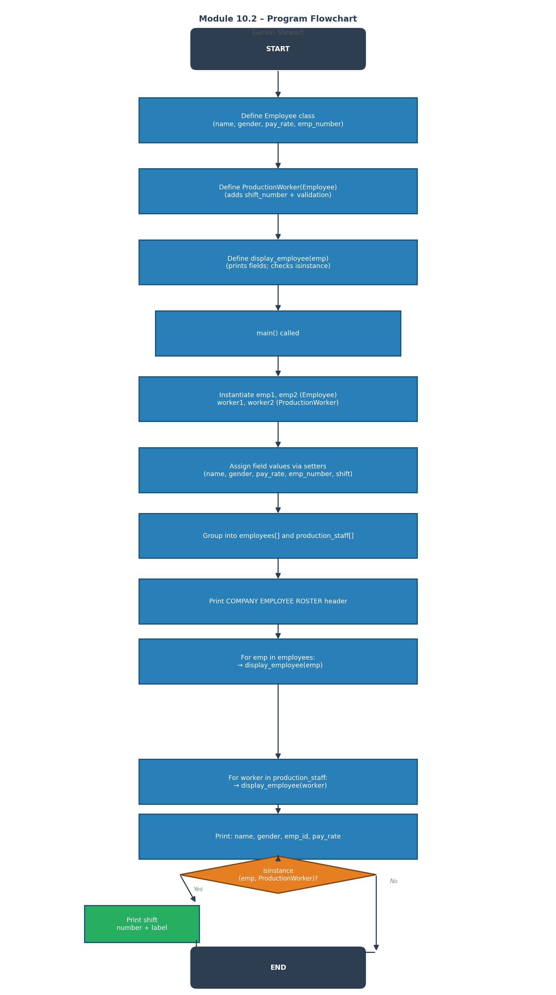

Debugging Session

The following screenshots document the debugging process for Module_10_Assignment.py using PyCharm's built-in Python debugger.

Step 1 — Breakpoint Set & Debug Started
A breakpoint was placed at the first setter call inside main() (emp1.set_name). The debugger was launched in PyCharm using Shift+F9 (or the Debug button). The program paused at the breakpoint, exposing the call stack in the Frames panel and local variable scope in the Variables panel of the Debug tool window.

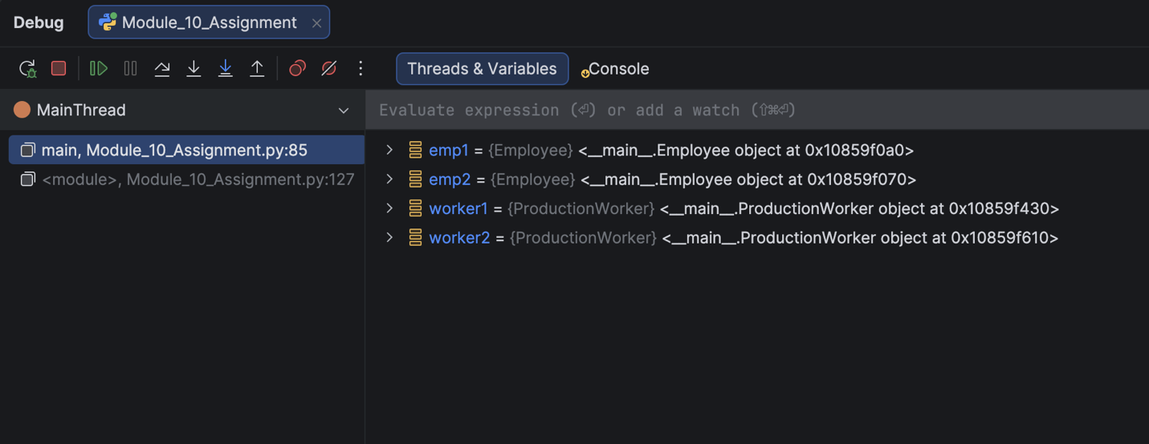

Step 2 — Step Into Function
Using F7 (Step Into) in PyCharm, execution entered the set_name() method of the Employee class. The current line indicator moved to the assignment self.__name = name, and the 'name' parameter was visible in the Variables panel of the Debug tool window.

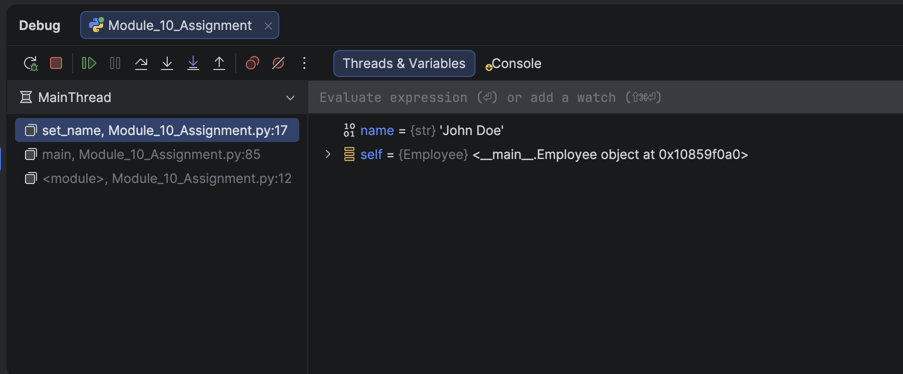

Step 3 — Inspecting the isinstance() Branch
Execution was advanced to display_employee() for worker1. A watch expression was added via the Watches section of the Debug tool window for isinstance(emp, ProductionWorker). PyCharm evaluated it inline, confirming True for the ProductionWorker instance and demonstrating the conditional shift output path.

