Garvin Stewart — Module 3 Assignment
Cho-Han Program Flowchart
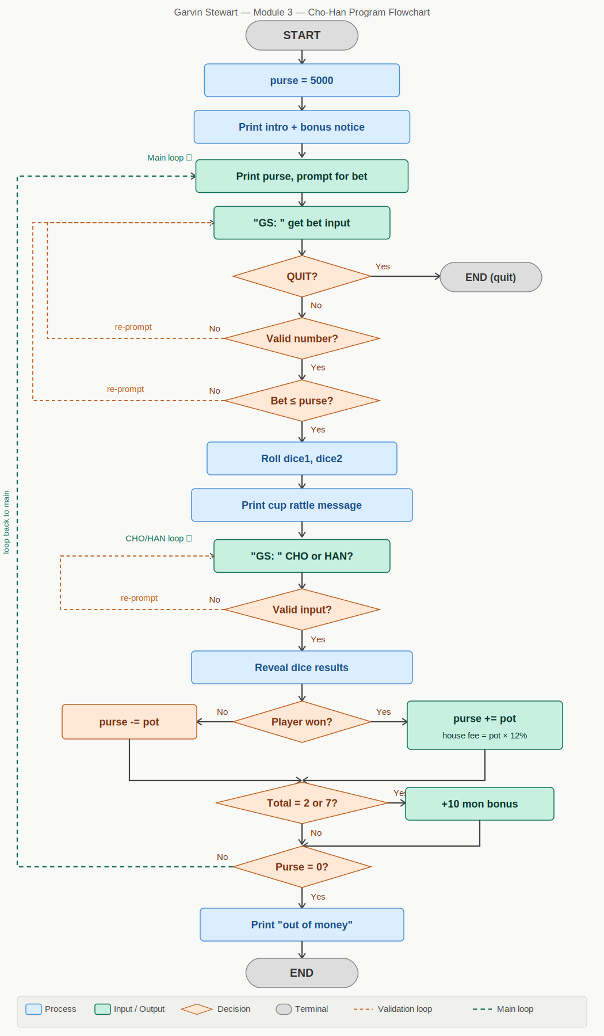
Program Modifications
1. Input Prompt — Changed to "GS:"
All input() calls were updated from '> ' to 'GS: ' to reflect the initials of the student.
2. House Fee — Changed from 10% to 12%
The house fee deduction was updated. The original expression purse - (pot // 10) was replaced with purse - (pot * 12 // 100) to correctly compute a 12% integer fee.
3. Bonus Notice Added to Introduction
The game introduction now includes the line: "BONUS NOTICE: If the dice roll totals 2 or 7, you receive a 10 mon bonus!" so the player is informed before play begins.
4. Dice-Total Bonus Logic Implemented
After each round resolves, the program checks whether dice1 + dice2 equals 2 or 7. If true, a message is printed stating the roll total and the 10 mon award, and the purse is incremented by 10.

