Garvin Stewart
Module 4.2 Assignment

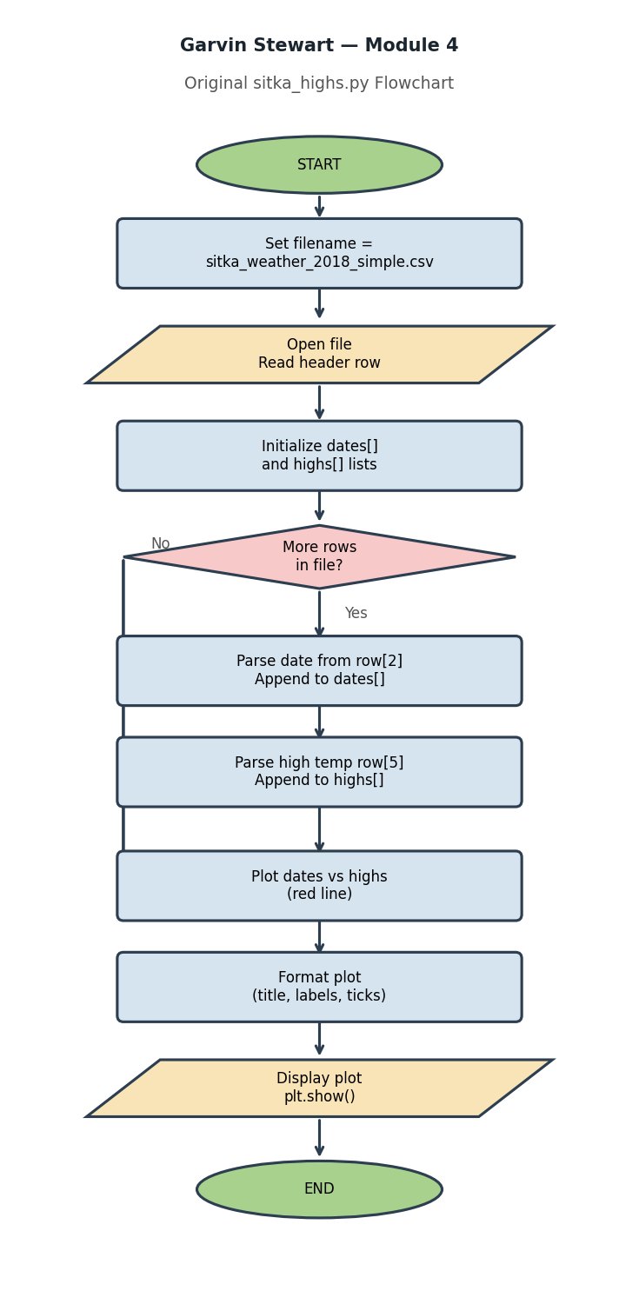

Part 2: Modified Program — sitka_high_low_gs.py

Summary of Changes
• Added sys import for clean program exit via sys.exit(0).
• Wrapped all logic in a main() function and a while True loop to allow repeated use.
• Added a display_menu() function that prints the Highs / Lows / Exit options on program start and each iteration.
• Added load_weather_data() function that reads both TMAX (col 5) and TMIN (col 6) into separate lists.
• Added plot_lows() function that renders the low temperature data as a blue line graph.
• Retained the original plot_highs() logic with red coloring.
• Added input validation: any entry other than H, L, or E prints an error and re-displays the menu.
• Exit path prints a goodbye message before calling sys.exit(0).
• Saved as sitka_high_low_gs.py per the naming convention.

Key Code Sections
Menu display function:
def display_menu(): print('H - View High Temperatures') print('L - View Low Temperatures') print('E - Exit')
Main program loop:
while True: display_menu() choice = input('Enter H / L / E: ').strip().upper() if choice == 'H': plot_highs(dates, highs) elif choice == 'L': plot_lows(dates, lows) elif choice == 'E': sys.exit(0) else: print('Invalid selection.')

Part 3: Revised Program Flowchart
