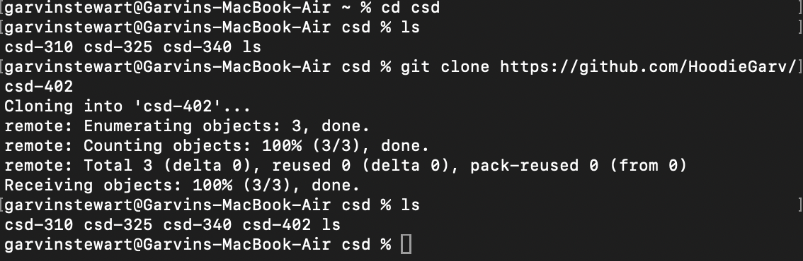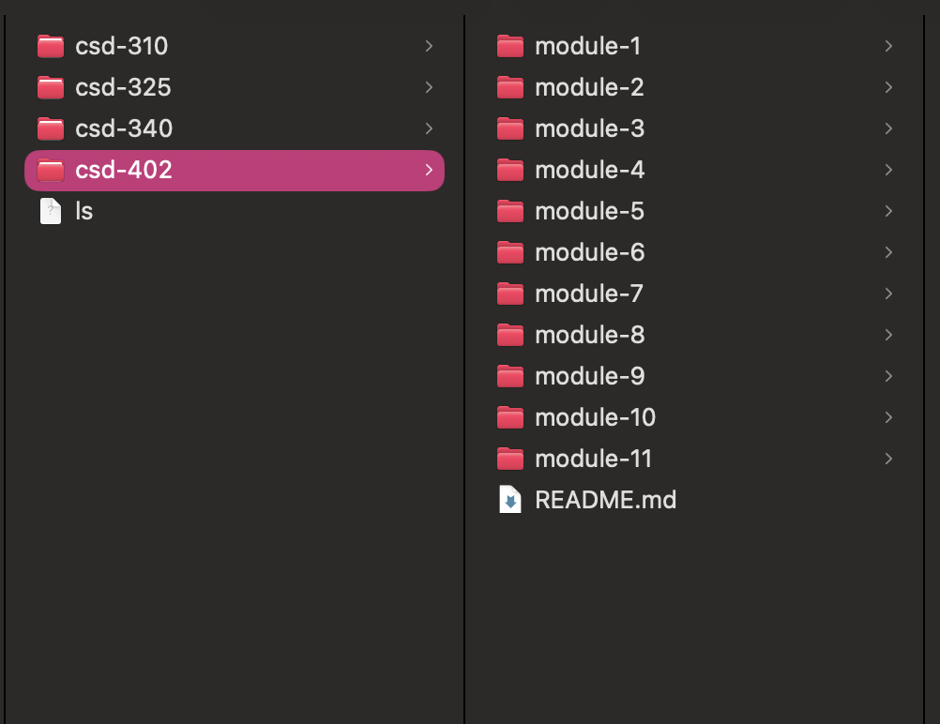https://github.com/HoodieGarv/csd-402

