Garvin Stewart
CSD 420
11 October 2026

Jackson: A Java JSON API

Introduction
JSON (JavaScript Object Notation) is a lightweight text format for exchanging structured data, and Java has no built-in JSON library in the standard JDK. Developers, therefore, choose a third-party API. For this paper, I selected Jackson, maintained by FasterXML, because it is the most complete of the common options and is the default JSON library in widely used frameworks such as Spring. Its own project page notes that Jackson "has been known as 'the Java JSON library'" (FasterXML, 2026a). This paper covers a short history of the API, the options it offers, the features and processes it supports, and where to download its JAR files.

A Short History of Jackson
Tatu Saloranta wrote Jackson and has been in development since 2007 (Oracle, n.d.). The project has gone through three major versions, and each one moved to a new Java package name so that old and new versions can sit on the same classpath without conflicts (FasterXML, 2026a).
Version 1.x lived in the org.codehaus.jackson package. It is now deprecated, and its final release, 1.9.13, shipped on July 14, 2013. Version 2.0 arrived in 2012 and moved the code to com. fasterxml.Jackson (Saloranta, 2025). The 2.x line still receives updates; 2.22.0 was released on May 31, 2026, and as of mid-2026, it remains the most widely adopted version (FasterXML, 2026a).
Jackson 3.0.0 reached general availability on October 3, 2025, after several years of planning. Saloranta (2025) describes the goal as giving the project "a clean foundation for long-term development." Version 3 moved to the tools. Jackson package, raised the minimum Java version from 8 to 17, and removed every feature that had been marked deprecated in 2.x. Jackson 3.1 followed as a long-term support release in February 2026, and 3.2.0 was released on June 8, 2026 (FasterXML, 2026a). The project is open source under the Apache License 2.0 (Oracle, n.d.).

Options Available in the API
Jackson is split into three core modules, and a project only needs the ones it uses (FasterXML, 2026a):
Module (JAR) | Role
jackson-core | The low-level streaming parser and generator; everything else builds on it
jackson-annotations | Standard annotations such as @JsonProperty and @JsonIgnore
jackson-databind | Converts between JSON and Java objects; depends on the other two
On top of those modules, Jackson gives the programmer three ways to process JSON (FasterXML, 2026b):
- Data binding. An ObjectMapper reads JSON straight into a plain Java object (POJO) with readValue() and writes it back with writeValue(). This is the most common approach and needs the least code.
- Tree model. readTree() loads JSON into a tree of JsonNode objects that can be searched and edited without writing a matching Java class. This suits data whose structure changes or is unknown in advance.
- Streaming. JsonParser and JsonGenerator read and write one token at a time. The other two models are built on this layer, and it is the fastest and most memory-efficient option for very large files.
These models can be combined in a single program. For example, a program can read a document as a tree and then convert just one of its branches into a Java object.

Features and Processes Supported
The two core processes Jackson supports are serialization (turning Java objects into JSON) and deserialization (turning JSON back into objects). Around those, it offers several features that matter in real programs.
Annotations. Developers control the mapping with annotations instead of extra code. @JsonProperty renames a field in the output, @JsonIgnore leaves a field out, and @JsonCreator tells Jackson which constructor to call, so classes do not need a no-argument constructor and can stay immutable (FasterXML, 2026b).
Configuration features. Behavior is turned on or off via named settings. Examples include INDENT_OUTPUT for readable, pretty-printed JSON and FAIL_ON_UNKNOWN_PROPERTIES, which decides whether an unexpected field causes an error (FasterXML, 2026b). In Jackson 3, that second setting is off by default, and mappers are built once through a builder and cannot be changed afterward, which makes them safe to share between threads (Saloranta, 2025).
Generic collections. Jackson can read JSON directly into a List or Map. Because Java erases generic type information at run time, the programmer passes a TypeReference to tell Jackson the full type, such as Map<String, ResultValue> (FasterXML, 2026b). This ties directly to the generics topic covered earlier in this course.
Conversions. convertValue() converts one Java type into another, such as an object into a Map, without ever producing a JSON string (FasterXML, 2026b).
Other data formats. Because databinding sits on top of the streaming layer, add-on modules let the same code read and write XML, YAML, CSV, CBOR, Smile, Avro, Protobuf, TOML, and Java properties files (FasterXML, 2026a).
Error handling and size options. Jackson 3 changed its exceptions to unchecked ones that extend JacksonException, which works better with lambdas and streams (Saloranta, 2025). Jackson 3.1 added a reader that collects all data errors in a document at once, rather than stopping at the first one (FasterXML, 2026b). For small or memory-limited programs, the separate Jackson jr library offers a much smaller API that skips databind entirely (FasterXML, 2026a).

Downloading the JAR Files
Jackson is published to the Maven Central Repository, which the project recommends as the source for its releases (FasterXML, 2026a). Projects that use Maven or Gradle only need to declare jackson-databind; the build tool automatically pulls in the other two JARs. Projects without a build tool must download all three JARs by hand (FasterXML, 2026b).
The base download directory for the Jackson 2.x core modules is https://repo1.maven.org/maven2/com/fasterxml/jackson/core/. The three JARs for the current 2.x release are:
JAR | Direct download
jackson-core 2.22.0 | jackson-core-2.22.0.jar
jackson-annotations 2.22 | jackson-annotations-2.22.jar
jackson-databind 2.22.0 | jackson-databind-2.22.0.jar
Starting with version 2.20, jackson-annotations uses a two-part version number (2.22 rather than 2.22.0), which is why its file name differs from the other two (FasterXML, 2026a). Jackson 3.x JARs are under the new group path, https://repo1.maven.org/maven2/tools/jackson/core/, and still use the 2.x annotations JAR (Saloranta, 2025).
Maven Central serves each JAR separately and does not offer a combined archive. The three files above are therefore zipped together into a single file, jackson-2.22-jars.zip, which is attached to this submission.

Conclusion
Jackson has grown over nearly two decades from a single JSON parser into a family of modules for data processing in Java. Its three processing models let a developer trade convenience for control: data binding for everyday object mapping, the tree model for unpredictable data, and streaming for large files. The main cost is choice. With 2.x and 3.x both maintained, a new project must pick a version, and Jackson 3 requires Java 17. For a course project on a current JDK, either line works, and the 2.x JARs listed above remain the safest match for most tutorials and existing code.
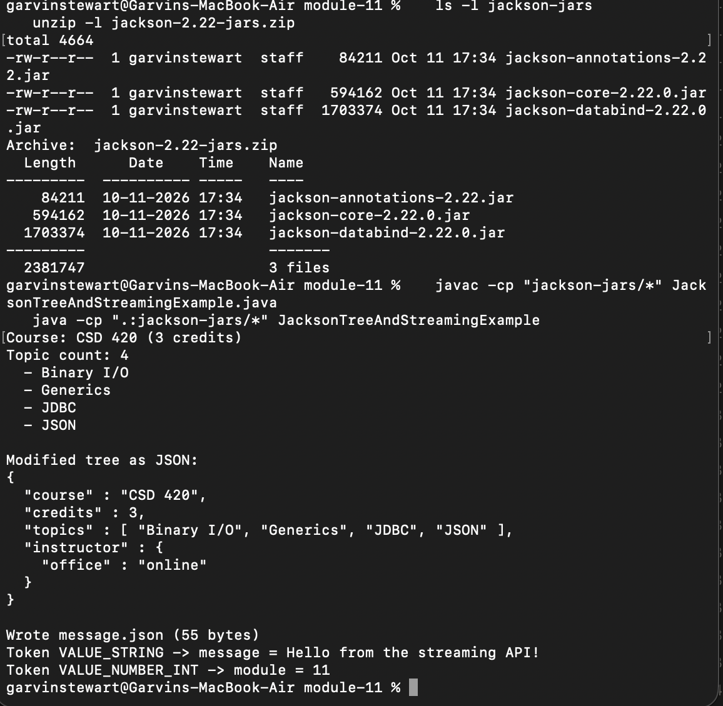

References
FasterXML. (2026a). Jackson project home @github [Computer software documentation]. GitHub. https://github.com/FasterXML/jackson
FasterXML. (2026b). Jackson-databind [Computer software documentation]. GitHub. https://github.com/FasterXML/jackson-databind
Maven Central Repository. (n.d.). com/fasterxml/jackson/core [Software repository]. Retrieved October 11, 2026, from https://repo1.maven.org/maven2/com/fasterxml/jackson/core/
Oracle. (n.d.). FasterXML, LLC - Jackson Core license. Retrieved October 11, 2026, from https://docs.oracle.com/cd/G27582_01/oemli/fasterxml-llc---jackson-core-license.html
Saloranta, T. (2025, October 10). Jackson 3.0.0 (GA) released. Medium. https://cowtowncoder.medium.com/jackson-3-0-0-ga-released-1f669cda529a

