CSD 430 Module 1: Installation & Configuration
Garvin Stewart
CSD 430 Server-Side Development, Bellevue University
October 26, 2026

Environment Summary
Java: OpenJDK 21.0.13 (Homebrew). Servlet container: Apache Tomcat 10.1.61 (Servlet 6.0, JSP 3.1). IDE: Eclipse IDE for Enterprise Java and Web Developers. Platform: macOS (Apple Silicon). The JSP application files (index.jsp and WEB-INF/web.xml) are attached separately.

1. Java Installation
Terminal output confirming the Java runtime and compiler versions, the Tomcat version and the JVM Tomcat runs on, and the Eclipse installation.
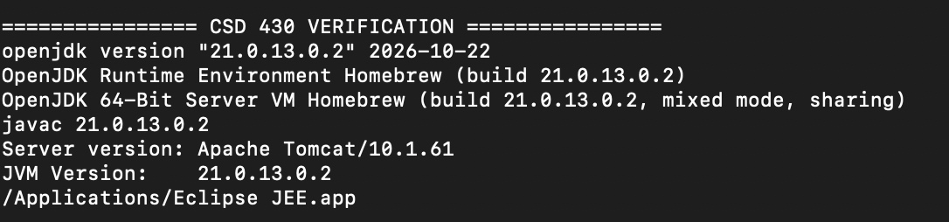
Figure 1. java -version, javac -version, and Tomcat version.sh output.

2. Apache Tomcat Configuration
Tomcat 10.1 configured as a server runtime in Eclipse, started, and synchronized with the CSD430Module project.
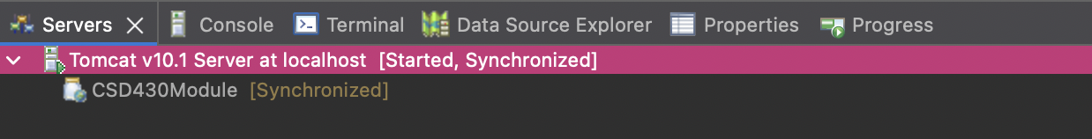
Figure 2. Eclipse Servers view showing Tomcat v10.1 [Started, Synchronized].
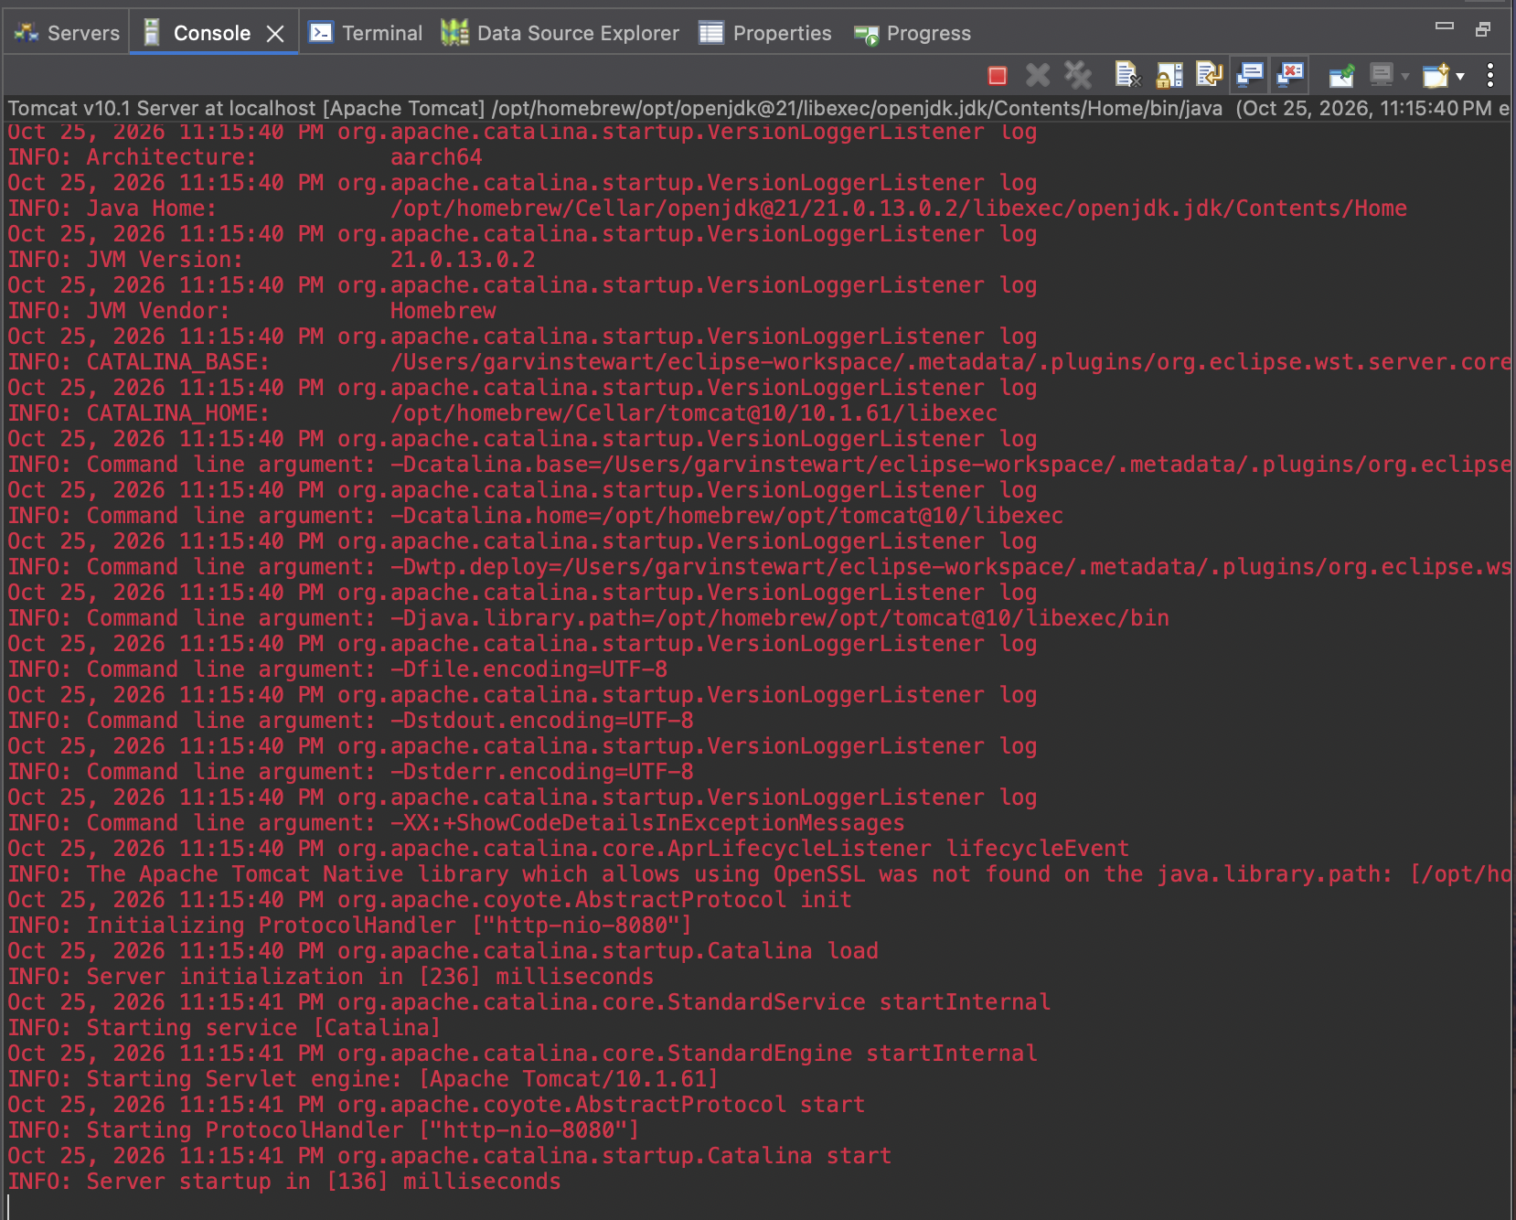
Figure 3. Tomcat startup log: Java 21 home, Apache Tomcat/10.1.61, and "Server startup in [136] milliseconds." Eclipse displays Tomcat’s standard-error stream in red; every entry is INFO-level.

3. Eclipse IDE Setup
The Dynamic Web Project open in Eclipse with index.jsp in the editor and the Problems view reporting zero errors.
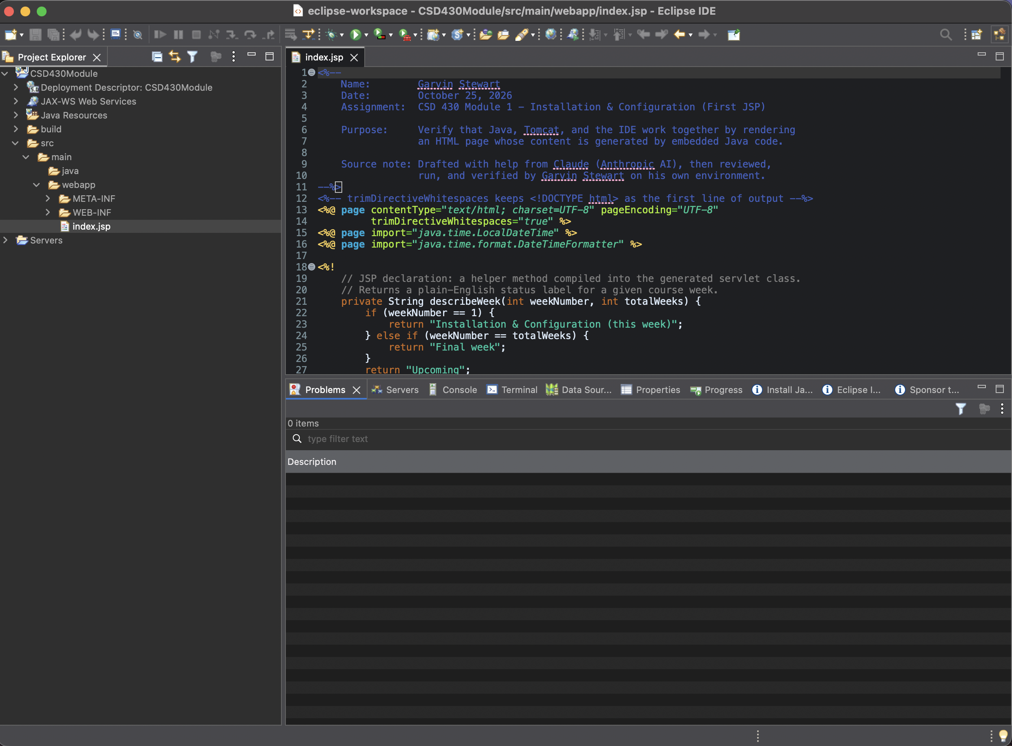
Figure 4. Eclipse IDE with the CSD430Module project, index.jsp open, and 0 problems.

4. JSP Running in the Browser
index.jsp served by Tomcat at http://localhost:8080/CSD430Module/. The runtime table is produced by Java code in the JSP (scriptlet and expressions), and the Course Weeks table is generated by a Java for-loop that writes HTML table rows.
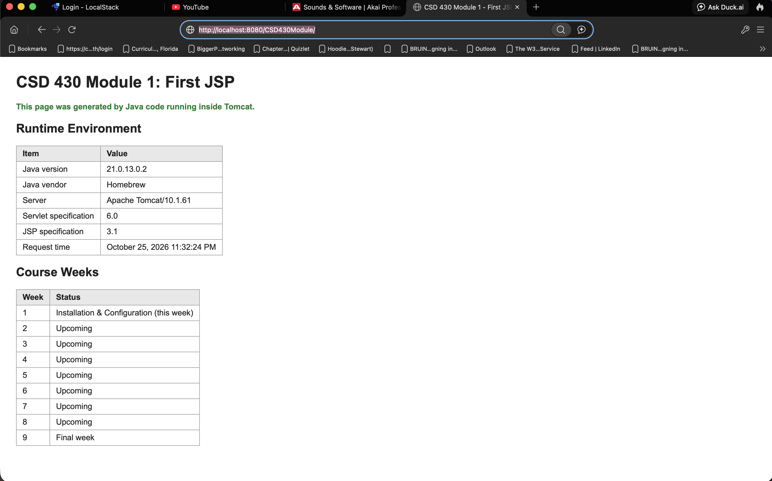
Figure 5. index.jsp rendered in the browser, reporting Java 21.0.13.0.2 and Apache Tomcat/10.1.61.

