Hello!
Welcome to my course project install instruction.
To run this project you need:
1.Intellij idea ultimate
2.Mysql workbench
3. apache-tomcat-9.0.34
After doing all steps you will be able to login as admin or customer.
I hope everything will work well. The project already has the admin and one user as a customer.
Admin. To get to login page choose administration then type
Login: Admin1
Password: Admin12345678

Customer.
Email:askar@gmail.com
Password: Zz123456789!

Let’s start
Step1.
Follow the link:https://github.com/Hook10/courseproject
Then push the "clone" button -> Download Zip
Extract zip archive to C:\java_projects\courseproject
delete -master in courseproject-master to get the same path as in the example

Step2.
Please, Open the IDE (Intellij Idea), choose open or import
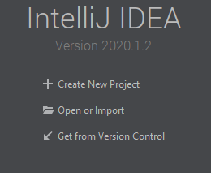

Choose courseproject folder
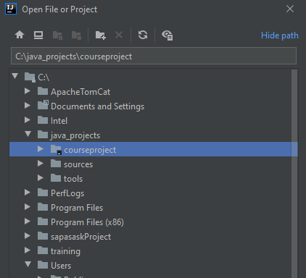
After indexing maven dependencies IDE will open project

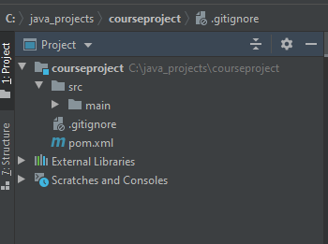

Step 3.
Open MySql workbench.
Open Local Instance MySql
Then choose server -> Data Import -> choose import from Self-Contained File.
Path should be the same
Then push start import
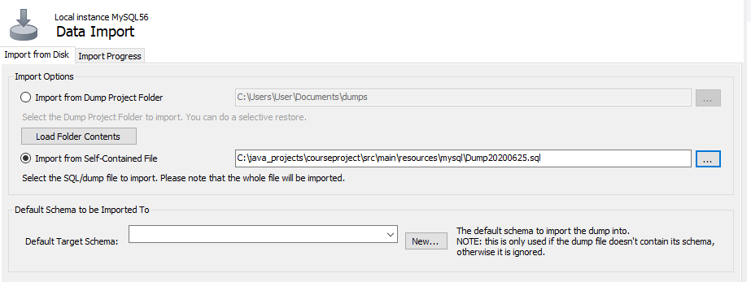
Then you will get espp database in the left navigator menu.

Step 4. Connecting database to the courseproject
Please open IDE(intellij idea), on the right bar push to database, then push “+” sign -> Data Source -> MySQL
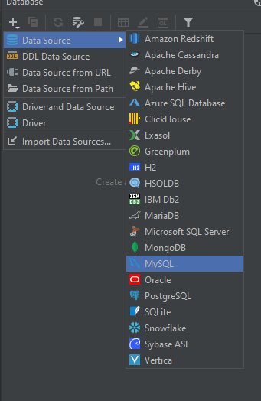
After this add this url jdbc:mysql://localhost:3306/espp?useUnicode=true&serverTimezone=UTC
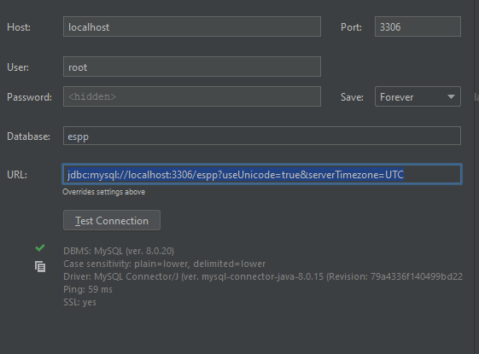
After all, please check the connection via pushing “Test connection” button.
If connection ok push apply and close.
If you push to database->schemas-> espp you get the same tables
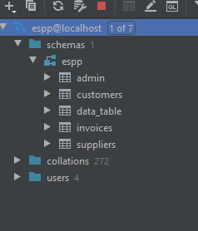
If you will have some issues with timezone when project works your should open database console and set time zone. Look at the pic bellow.
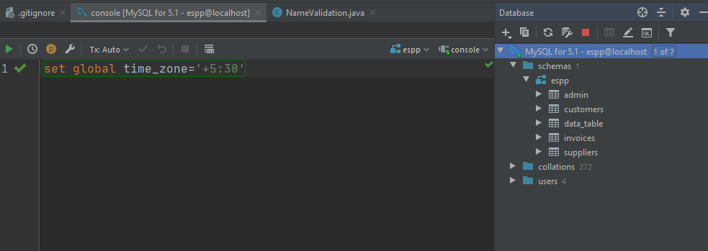
Step 5. Add tomcat
Open add configurations
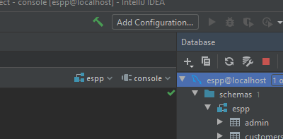

Choose tomcat local
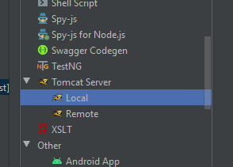
Application server, push configure
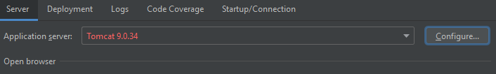
choose tomcat existing folder
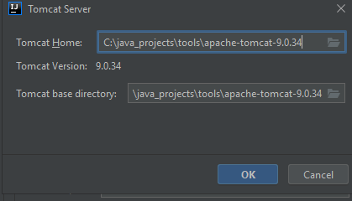
For instance
Then press ok
Then delete the build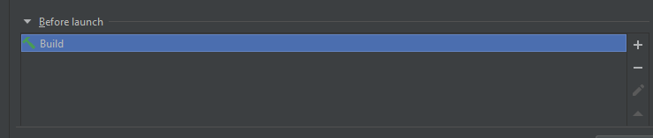

Then push the Deployment
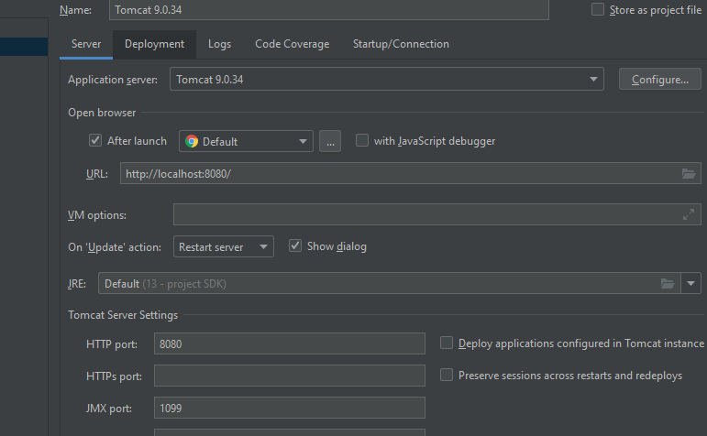
Push “+” sign and choose exploded artifact
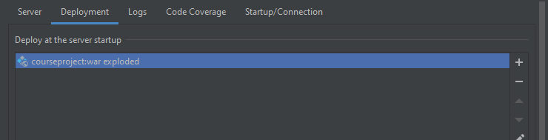
In the application context delete _war_exploded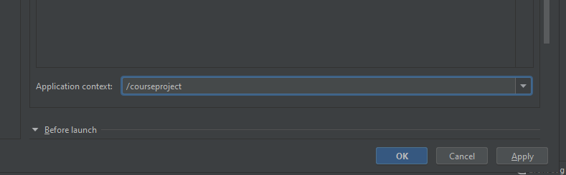

Step 6. Maven.
Push the maven button then clean and package.
Then run tomcat
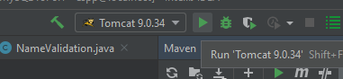

I hope everything works well. The project already has the admin and one user as a customer.
Admin. To get to login page choose administration then type
Login: Admin1
Password: Admin12345678

Customer.
Email:askar@gmail.com
Password: Zz123456789!
If you have any questions please feel free to email me
sapasask@gmail.com
P.S. If you won’t make the same project path as I suggest to you, be informed that, you should to point out the correct path to property file to manage correct working of connection pool.

