Hooklet3D  
Odin One Development

Monticello, MN 55362

**MEMORANDUM**

**Date:** March 19, 2017

**To:** Community

**From:** Hooklet Development Team

**Subject:** Cross Beam Assembly

**Summary** – The Cross Beam Assembly is the gantry for the x-axis, this consists of two large 3d printed end caps connecting two 2020 Aluminum Extrusions. These aluminum extrusions provide the linear motion and stabilization for lateral extruder movement.

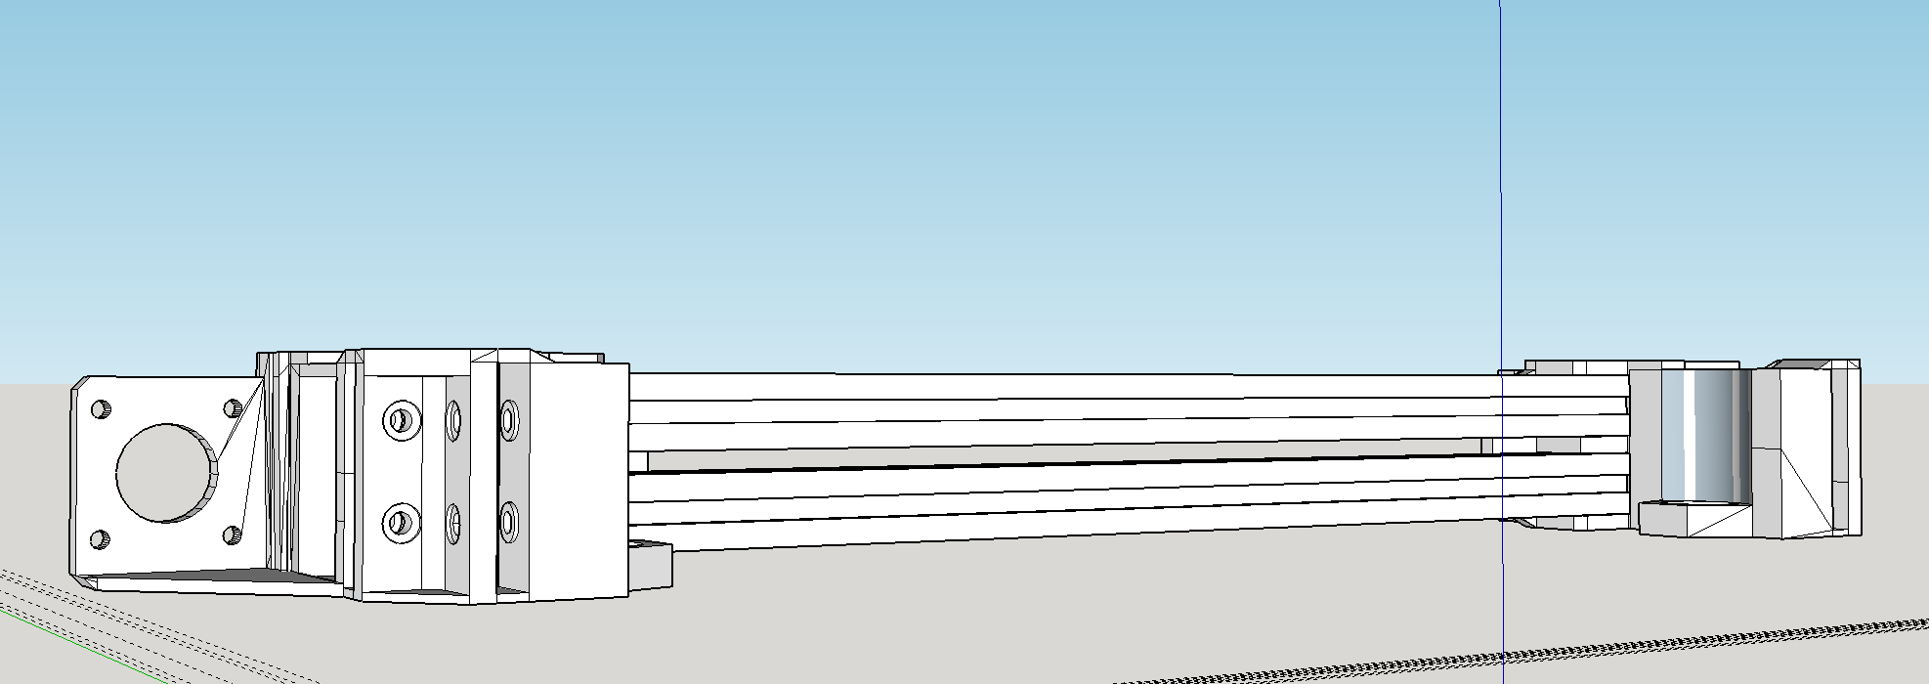

In addition to movement, the Cross Beam Assembly provides mounting for the motor, drive system, and end-stop for x-axis movement. X-axis movement is driven by a GT2 belt, 16 tooth GT2 idler pulley and a flange bearing set. This open belt system drives the extruder assembly across the x-axis.

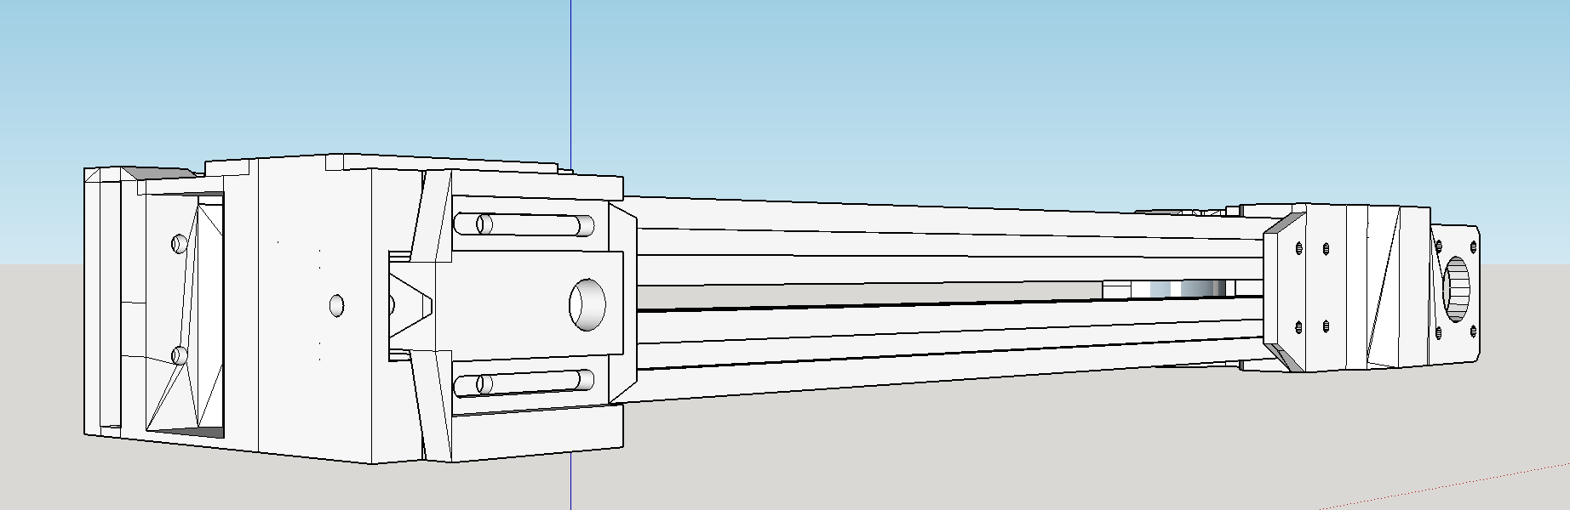

The end cap parts also house the nut for the z-axis lead screws. The lead screws drive the z-axis along 2020 aluminum uprights. Embedded nylon roller wheels provide smooth movement; the nylon roller wheels do not require lubrication and provide superior longevity and quite movement when compared to conventional thrust bearings.

**Printed Parts** –

X1 – UnicapIdle

X1 – UnicapNEMA

X1 – X-Idle Face

Notes:

*These are the settings Hooklet uses internally; you may need to adjust these to meet your own needs/machine requirements.*

***All parts printed in PET-G.***

**UnicapIdle:**

|  |  |
| --- | --- |
| **Layer** | .2mm |
| **Speed** | 45mm/s |
| **Infill** | 35% |
| **Support** | Yes |
| **Temp** | |  |  | | --- | --- | | **Extruder** | **Bed** | | 235c | 65c | |

*Notes: The Unicap parts take some time to print, given their size make sure you begin printing with a well-calibrated z-axis.*

**UnicapNEMA:**

|  |  |
| --- | --- |
| **Layer** | .2mm |
| **Speed** | 45mm/s |
| **Infill** | 35% |
| **Support** | Yes |
| **Temp** | |  |  | | --- | --- | | **Extruder** | **Bed** | | 235c | 65c | |

*Notes: The Unicap parts take some time to print, given their size make sure you begin printing with a well-calibrated z-axis.*

**X-Idle Face**

|  |  |
| --- | --- |
| **Layer** | .2mm |
| **Speed** | 45mm/s |
| **Infill** | 35% |
| **Support** | No |
| **Temp** | |  |  | | --- | --- | | **Extruder** | **Bed** | | 235c | 65c | |

**Non-Printed Parts:**

**Fasteners**:

* M3x12
* M3x14
* M4x10
* M5x25 Countersunk
* M4 Hammer Nut
* M3 Nylock
* M5 Nylock

**Electronics**

* NEMA 17

**Other**

* GT2 Belt
* X2 Flange Bearing
* Nylon Roller Wheel

**Concerns**:

Although it’s completely functional as is, it would be beneficial to reduce the weight of the crossbeam. The most logical area to reduce would be the Unicap parts, this would also reduce machine print time and material cost.