Hooklet3D  
Odin One Development

Monticello, MN 55362

**MEMORANDUM**

**Date:** March 27, 2017

**To:** Community

**From:** Hooklet Development Team

**Subject:** Z Probe Wiring

**Summary**:

The Z Probe used for the MK1 ABL system requires a voltage divider to function properly. This document outlines the procedure for wiring the Z Probe.

**Background:**

The Z Probe has 3 main wires (signal, ground, 12v) these wires are unfinished, to finish the z probe we need to add two resistors and DuPont connectors.

One of these wires connects to an available 12v auxiliary output on the control board and the other two are connected to the z min end stop’s signal and ground pins.

**Wiring:**

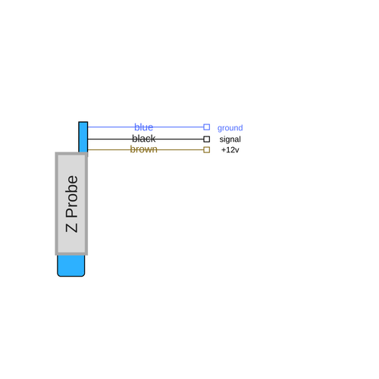

Be aware of the color-coding of the probe wires, as it is possible to damage the board by reversing any of these wires.

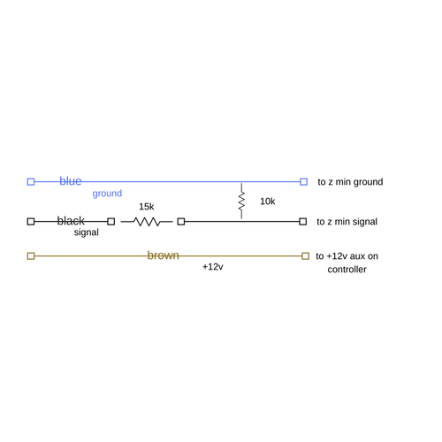

To create the voltage divider, we place a 15k resistor on the signal line (in line) and then bridge the signal line to the ground line using a 10k resistor.

The 12v power is run directly to the auxiliary pin of the control board.

**Connecting**

The signal and ground wires are terminated to a 2 pin female DuPont connector and connected to the Z Min pins (signal and ground). **Do not connect this to the 5v (third) pin on the Z Min pin out.**

The 12v power is terminated to a single pin female DuPont connection and plugged into an available 12v auxiliary pin.

**Notes:**

Make sure all wires and splices are covered using electrical tape, shrink-wrap or both. It is very important that these do not short.