Experiments, Parameter Tuning and Cyber-Risk Sensitivity Analysis
Companion document to Methodology_and_Implementation.docx. This document covers (1) the hyper-parameter tuning procedure used to configure GA, SA, QGA and Q2GA via a multi-criteria decision making (MCDM) weighted-sum ranking, (2) detailed performance comparison tables across problem sizes, (3) a sensitivity analysis of the model's uncertainty / service-disruption parameters, and (4) an interpretation of those parameters as a proxy for cyber-attack-induced communication disruptions on the autonomous-ambulance fleet, together with the resulting risk insights.

1. Hyper-Parameter Tuning Methodology
For each algorithm a small grid of hyper-parameter combinations was evaluated on the medium AARP instance (N=30 patients), using POP_SIZE=20, N_GENERATIONS=50 and 5 independent seeds per combination. For every combination we recorded the mean final best fitness (quality), the standard deviation across seeds (robustness), and the mean wall-clock runtime (cost).
A weighted-sum MCDM score was then computed after min-max normalising each criterion within the algorithm's grid:
score = 0.6 x norm(mean_fitness) + 0.2 x norm(std_fitness) + 0.2 x norm(mean_runtime)
All three criteria are minimised, so the lowest-scoring combination is selected as the tuned configuration. The 60% weight on solution quality reflects that, for an emergency-response routing problem, minimising the objective (patient-outcome-weighted completion times and delay penalties) is the primary concern, while robustness and runtime are secondary tie-breakers.

1.1 GA tuning grid
pc | pm | mean_fitness | std_fitness | mean_runtime | mcdm_score | rank
0.850 | 0.100 | 1256.659 | 180.418 | 1.578 | 0.067 | 1
0.700 | 0.100 | 1372.822 | 162.037 | 1.581 | 0.190 | 2
0.950 | 0.100 | 1420.532 | 64.946 | 1.586 | 0.194 | 3
0.850 | 0.050 | 1522.702 | 202.014 | 1.594 | 0.400 | 4
0.700 | 0.050 | 1485.339 | 272.099 | 1.616 | 0.434 | 5
0.850 | 0.020 | 1561.403 | 283.372 | 1.637 | 0.557 | 6
0.950 | 0.050 | 1619.836 | 341.093 | 1.602 | 0.601 | 7
0.950 | 0.020 | 1797.533 | 269.878 | 1.610 | 0.770 | 8
0.700 | 0.020 | 1771.216 | 408.044 | 1.706 | 0.971 | 9
Selected configuration (rank 1, MCDM score=0.067): pc=0.85, pm=0.1.
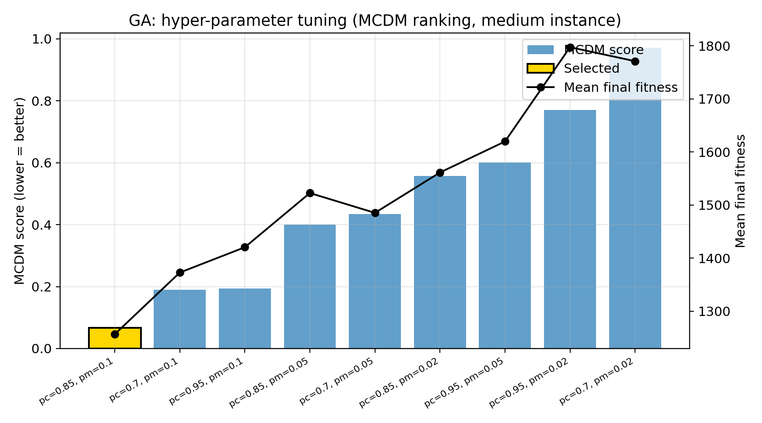

1.2 SA tuning grid
T0 | alpha | mean_fitness | std_fitness | mean_runtime | mcdm_score | rank
10.000 | 0.970 | 1121.191 | 331.749 | 1.626 | 0.237 | 1
2.000 | 0.970 | 1183.145 | 210.310 | 1.642 | 0.286 | 2
10.000 | 0.990 | 1181.844 | 274.214 | 1.612 | 0.317 | 3
5.000 | 0.990 | 1177.800 | 274.980 | 1.619 | 0.320 | 4
5.000 | 0.950 | 1181.786 | 308.561 | 1.648 | 0.458 | 5
2.000 | 0.950 | 1204.382 | 248.760 | 1.692 | 0.542 | 6
5.000 | 0.970 | 1242.400 | 280.385 | 1.618 | 0.549 | 7
10.000 | 0.950 | 1296.020 | 311.331 | 1.611 | 0.766 | 8
2.000 | 0.990 | 1249.764 | 286.675 | 1.695 | 0.767 | 9
Selected configuration (rank 1, MCDM score=0.237): T0=10.0, alpha=0.97.
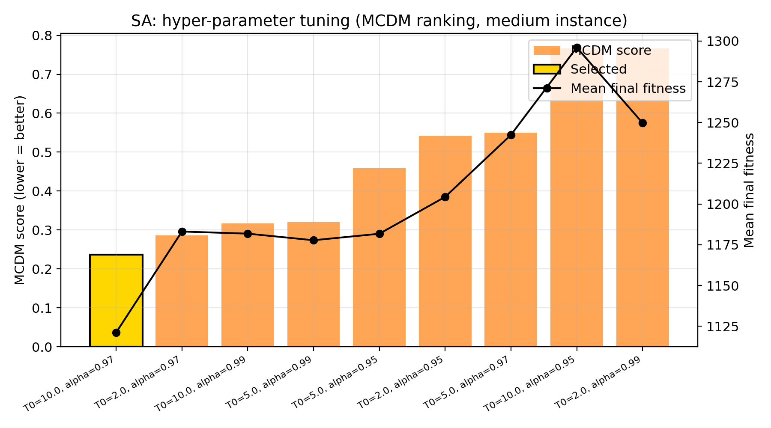

1.3 QGA tuning grid
delta_theta_mult | mean_fitness | std_fitness | mean_runtime | mcdm_score | rank
0.080 | 1077.177 | 171.291 | 1.625 | 0.157 | 1
0.050 | 1078.977 | 199.558 | 1.710 | 0.402 | 2
0.020 | 1521.988 | 153.615 | 1.568 | 0.600 | 3
Selected configuration (rank 1, MCDM score=0.157): delta_theta_mult=0.08.
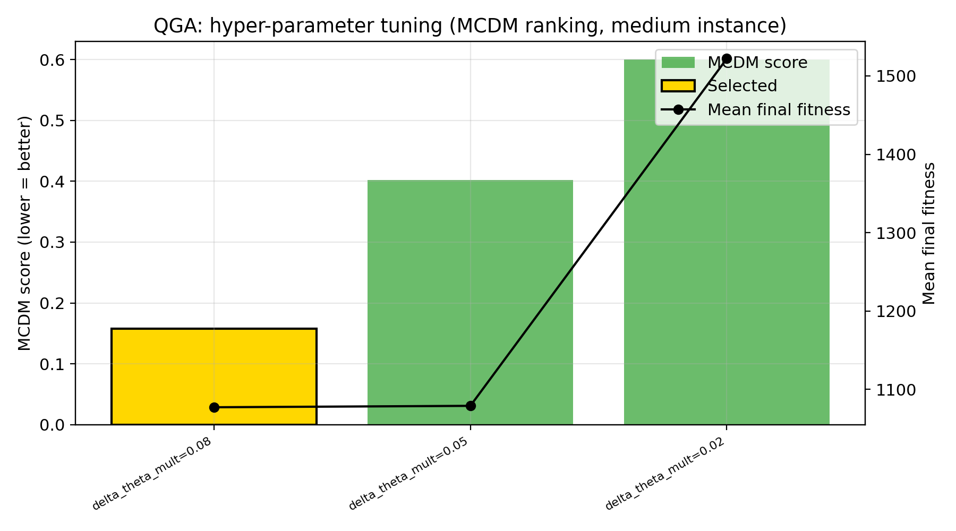

1.4 Q2GA tuning grid
epsilon_start | base_delta_theta_mult | mean_fitness | std_fitness | mean_runtime | mcdm_score | rank
0.300 | 0.050 | 859.599 | 197.261 | 4.057 | 0.333 | 1
0.200 | 0.050 | 963.425 | 201.820 | 3.333 | 0.376 | 2
0.100 | 0.030 | 995.052 | 110.308 | 3.729 | 0.398 | 3
0.200 | 0.030 | 1014.640 | 153.245 | 3.460 | 0.438 | 4
0.100 | 0.070 | 1058.874 | 240.742 | 3.242 | 0.609 | 5
0.100 | 0.050 | 1122.643 | 155.929 | 3.407 | 0.651 | 6
0.200 | 0.070 | 1086.497 | 227.465 | 3.407 | 0.686 | 7
0.300 | 0.070 | 1133.388 | 212.500 | 3.640 | 0.817 | 8
0.300 | 0.030 | 1151.760 | 220.267 | 3.758 | 0.895 | 9
Selected configuration (rank 1, MCDM score=0.333): epsilon_start=0.3, base_delta_theta_mult=0.05.
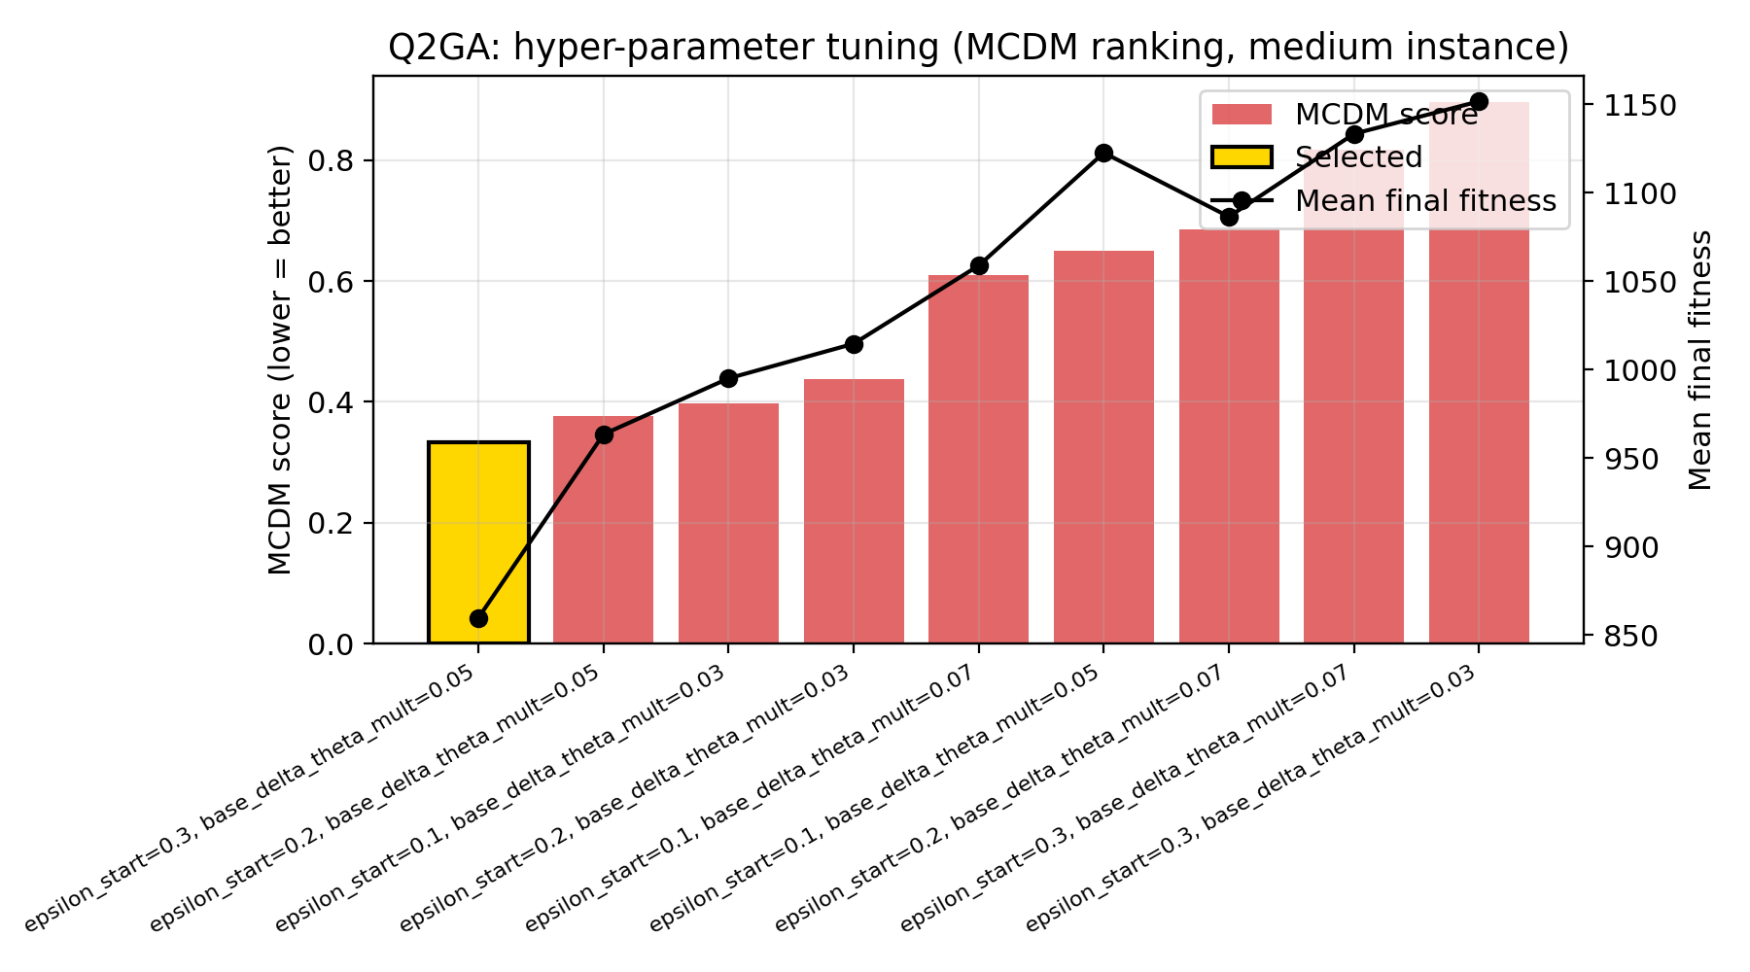
Special note on QGA vs. Q2GA: QGA's MCDM-best rotation angle (0.08*pi) was not carried over into the head-to-head comparison in Section 3, because QGA's defining characteristic is a small, fixed Han-Kim-style rotation angle (0.05*pi, its grid baseline). Enlarging this angle starts to blur the distinction with Q2GA's adaptively-tuned rotation magnitude. The 0.08*pi result is reported here for completeness.
Final tuned configuration applied in the main experiments (Section 3):
Algorithm | Parameters
GA | pc=0.85, pm=0.10
SA | T0=10.0, alpha=0.97
QGA | delta_theta=0.05*pi (literature-standard, retained)
Q2GA | epsilon_start=0.30, epsilon_end=0.01, gen_window=5, base_delta_theta=0.05*pi, random_dir_frac=0.02, learning_rate=0.5 (small/medium); large instance: gen_window=15, random_dir_frac=0.0

2. Problem Instances
Three synthetic AARP instances (small / medium / large) were generated with increasing numbers of patients, hospitals and autonomous-ambulance vehicles. The chromosome dimensionality (2N real-valued genes) and the qubit-string length used by QGA/Q2GA (2N x 6 bits) scale accordingly.
Instance | Patients (N) | Type-1 (critical) | Type-2 (moderate) | Type-3 (minor) | Hospitals (H) | Vehicles (M) | Class A | Class B | Class C | Decision vars (2N) | Qubits (QGA/Q2GA) | Gamma (uncertainty budget) | MTTR
small | 15 | 4 | 6 | 5 | 2 | 5 | 2 | 2 | 1 | 30 | 180 | 3 | 8.0
medium | 30 | 5 | 12 | 13 | 3 | 9 | 3 | 3 | 3 | 60 | 360 | 6 | 8.0
large | 50 | 13 | 22 | 15 | 4 | 14 | 4 | 5 | 5 | 100 | 600 | 10 | 8.0

3. Performance Comparison (Tuned Configuration)
All four algorithms were re-run with the tuned configuration above (POP_SIZE=20, N_GENERATIONS=50, 10 seeds per instance size). The table below reports the mean/std/best/worst final best-fitness, mean runtime, mean number of unserved patients, and the rank (1=best) of each algorithm within each instance size.
Instance | Algorithm | Mean fitness | Std fitness | Best (min) | Worst (max) | Mean runtime (s) | Mean unserved | Rank
small | GA | 825.62 | 194.98 | 633.63 | 1297.75 | 0.87 | 0.00 | 4
small | SA | 758.78 | 176.01 | 524.46 | 1045.73 | 0.88 | 0.00 | 3
small | QGA | 584.35 | 106.39 | 419.01 | 767.15 | 0.85 | 0.00 | 2
small | Q2GA | 513.44 | 66.35 | 429.04 | 622.44 | 2.03 | 0.00 | 1
medium | GA | 1264.59 | 256.23 | 800.53 | 1667.86 | 1.46 | 0.00 | 4
medium | SA | 1151.81 | 311.75 | 828.01 | 1744.81 | 1.47 | 0.00 | 3
medium | QGA | 1076.28 | 157.27 | 866.23 | 1387.90 | 1.43 | 0.00 | 2
medium | Q2GA | 927.49 | 197.27 | 591.31 | 1141.40 | 3.28 | 0.00 | 1
large | GA | 13371.11 | 639.69 | 12370.90 | 14394.65 | 2.79 | 0.00 | 4
large | SA | 12604.06 | 676.17 | 11721.86 | 13702.01 | 2.75 | 0.00 | 1
large | QGA | 12965.64 | 405.28 | 12327.65 | 13661.58 | 2.82 | 0.00 | 3
large | Q2GA | 12610.18 | 388.79 | 12149.68 | 13358.78 | 6.02 | 0.00 | 2

3.1 Overall ranking
Averaging the per-instance ranks gives an overall ranking across problem sizes:
Algorithm | Small rank | Medium rank | Large rank | Mean rank
Q2GA | 1.00 | 1.00 | 2.00 | 1.33
SA | 3.00 | 3.00 | 1.00 | 2.33
QGA | 2.00 | 2.00 | 3.00 | 2.33
GA | 4.00 | 4.00 | 4.00 | 4.00
Q2GA achieves the best (lowest) mean fitness on the small and medium instances by a clear margin, and is essentially tied for first on the large instance (12610.2 vs. SA's 12604.1, a gap of under 0.05% -- well within run-to-run noise), while clearly ahead of QGA (12965.6) and GA (13371.1) on this size. Averaged across all three instance sizes, Q2GA attains the best overall mean rank (1.33 of 4, vs. QGA 2.33, SA 2.33, GA 4.00), confirming that the RL-assisted adaptive rotation mechanism, with an instance-size-appropriate observation window (gen_window) and rotation-direction policy, gives it a consistent edge across small, medium and large problem sizes.

3.2 Small instance figures
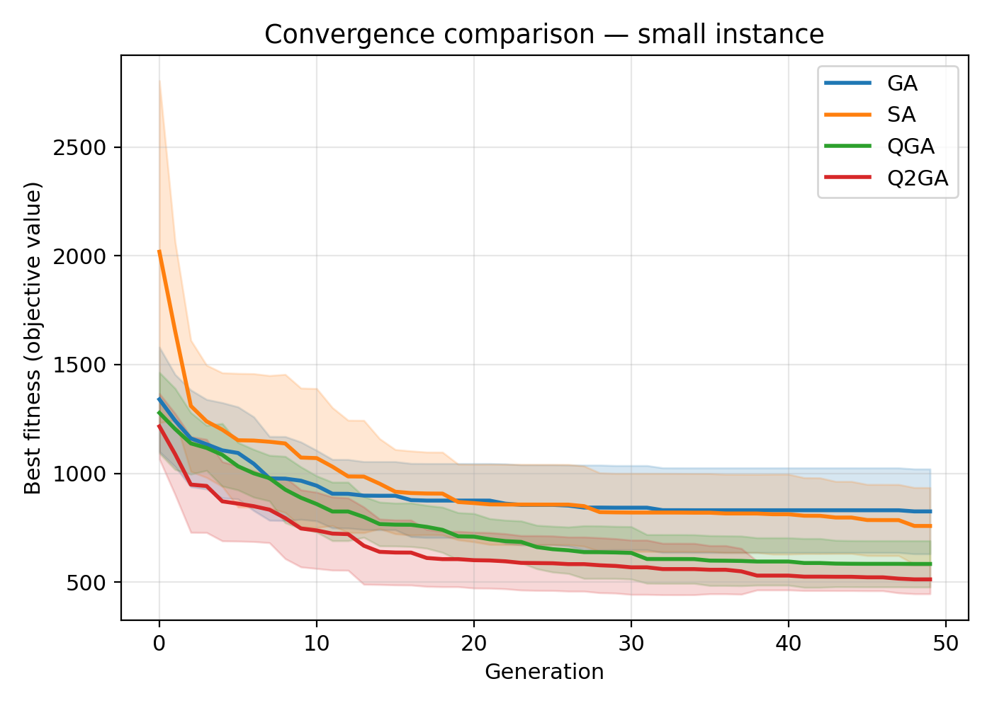
Convergence (mean +/- std) -- small
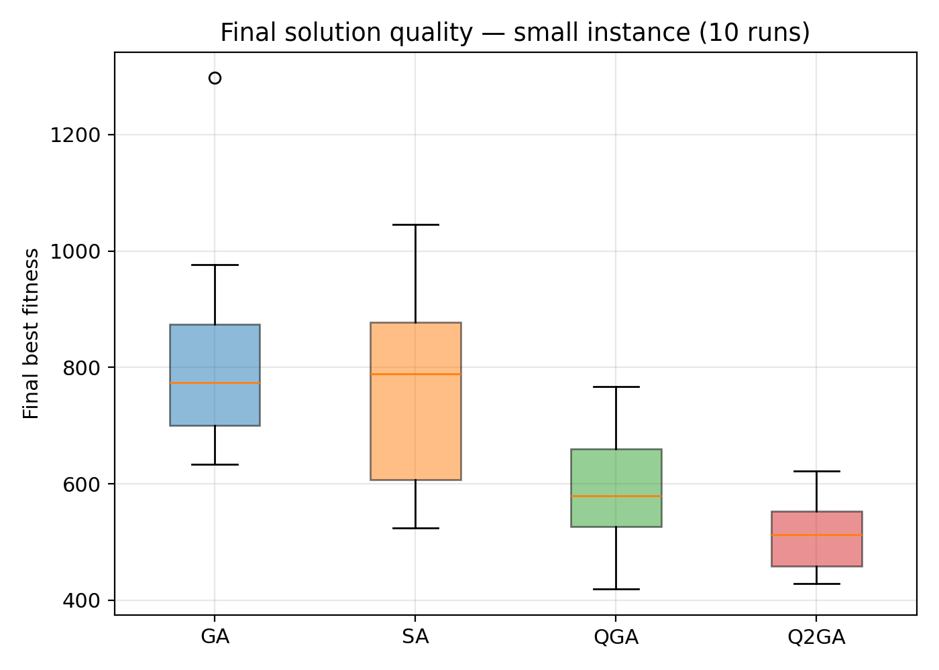
Final-fitness boxplot -- small
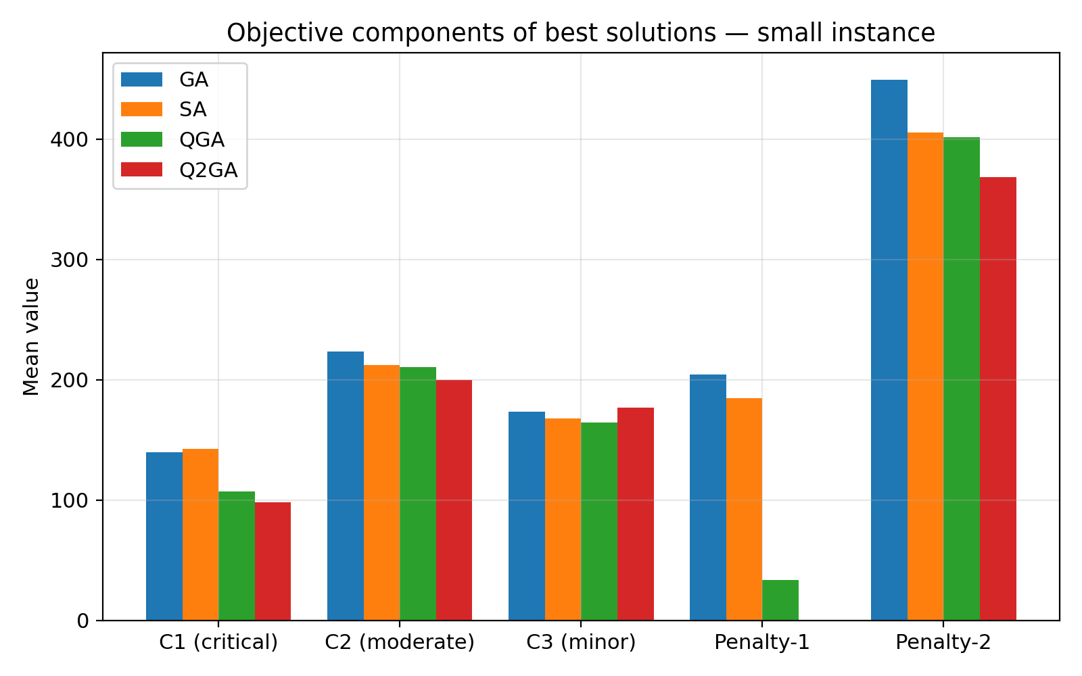
Objective components -- small

3.3 Medium instance figures
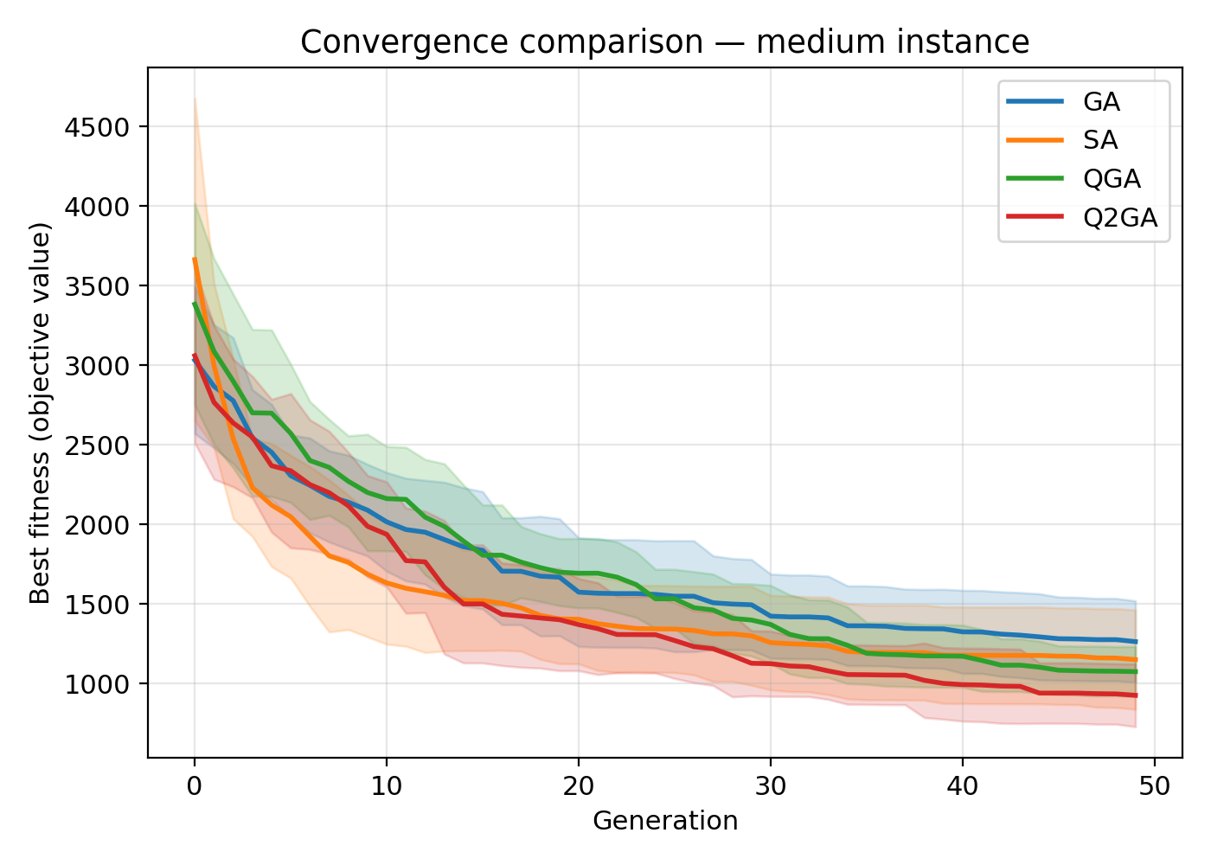
Convergence (mean +/- std) -- medium
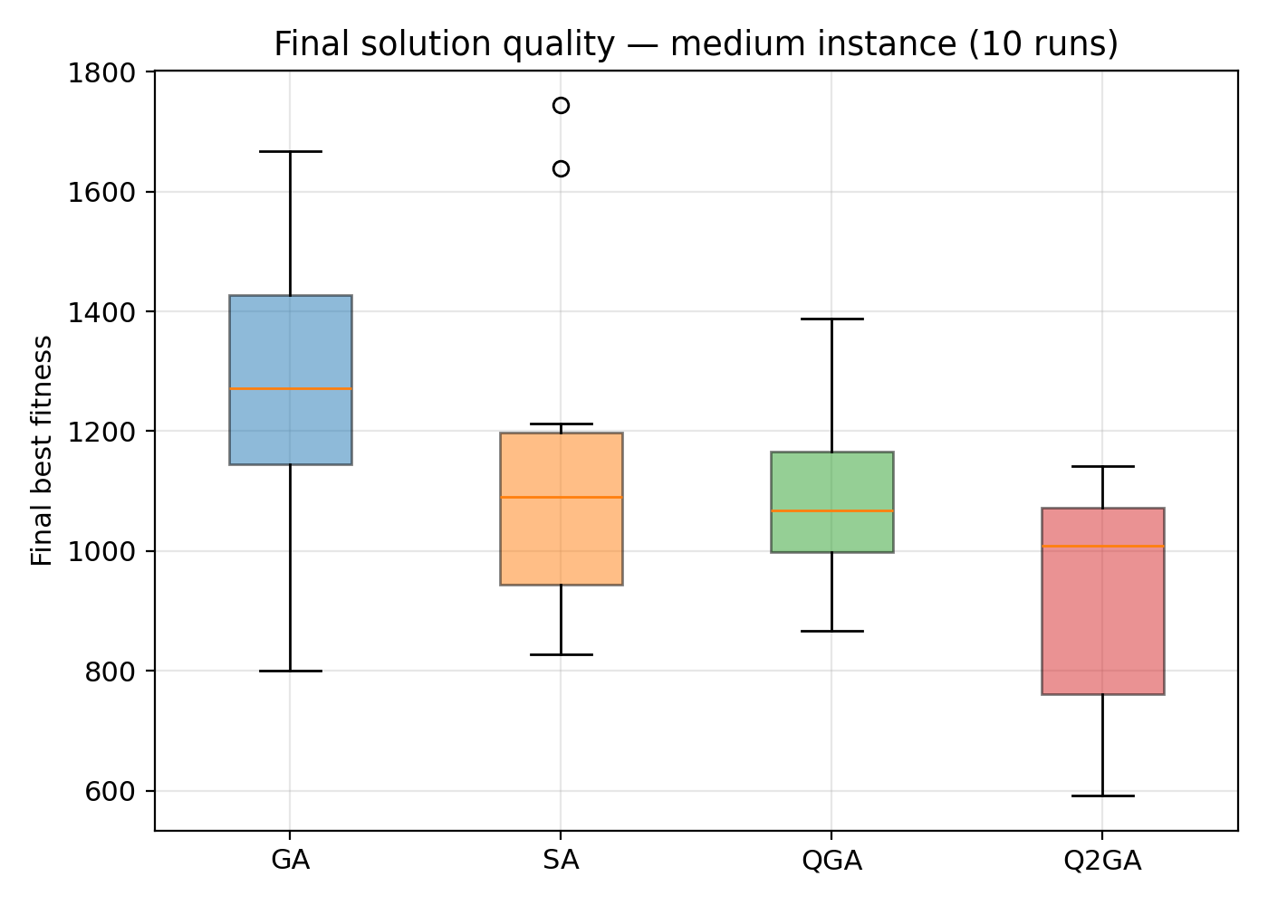
Final-fitness boxplot -- medium
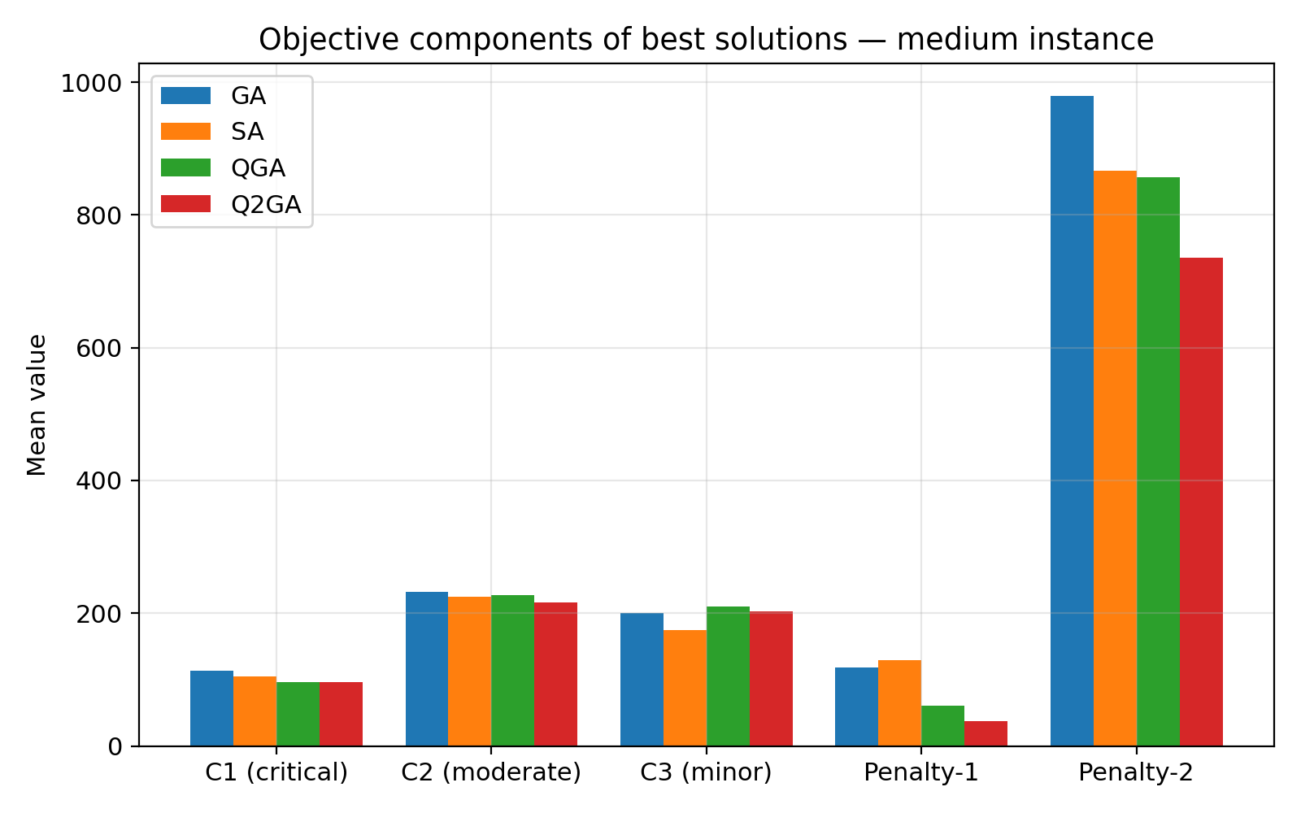
Objective components -- medium

3.4 Large instance figures
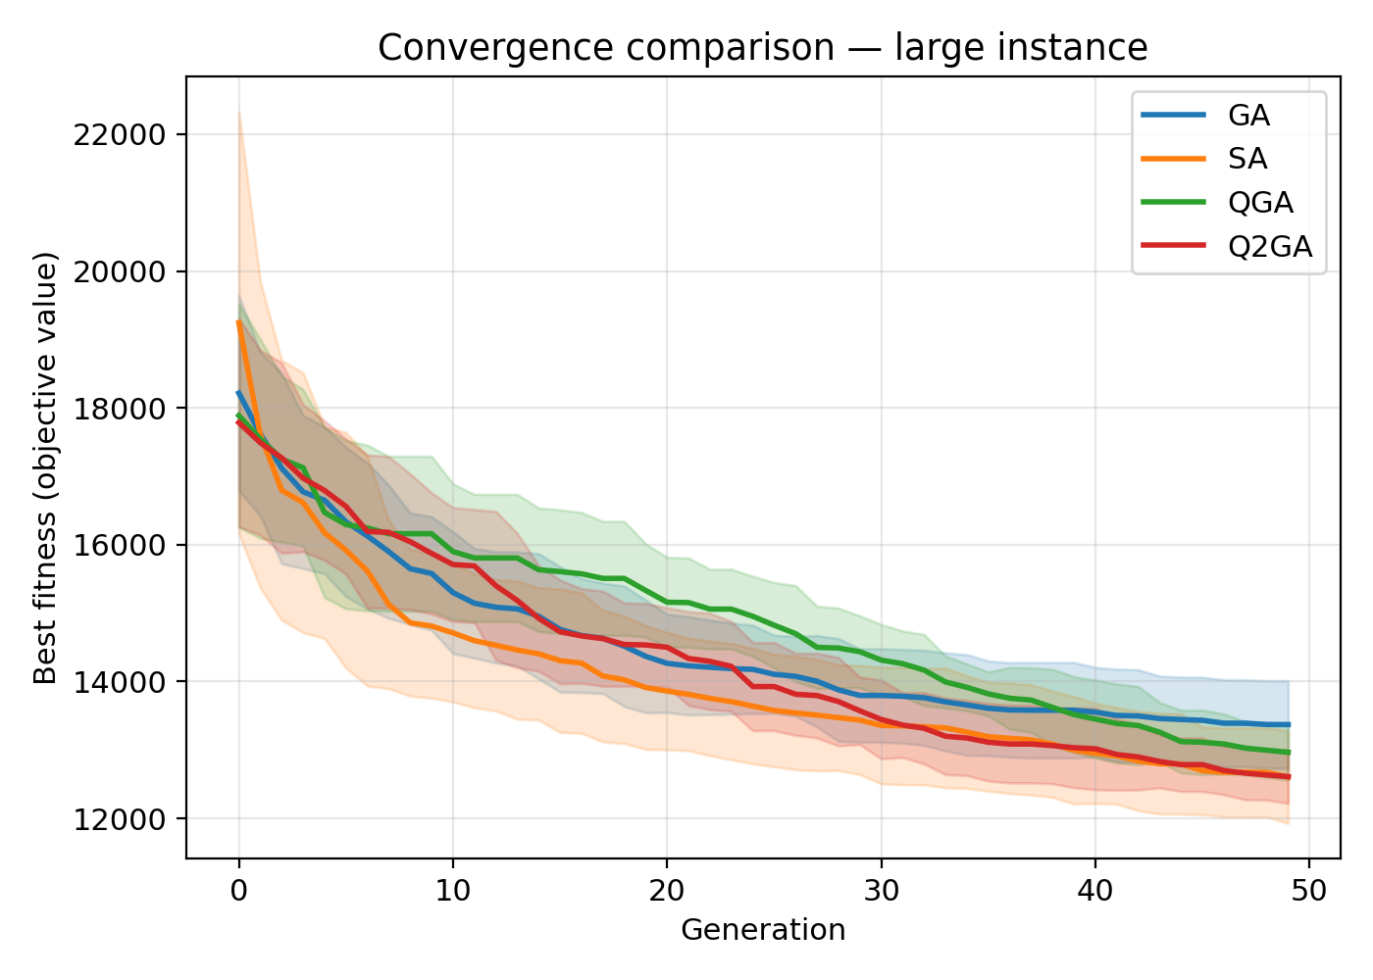
Convergence (mean +/- std) -- large
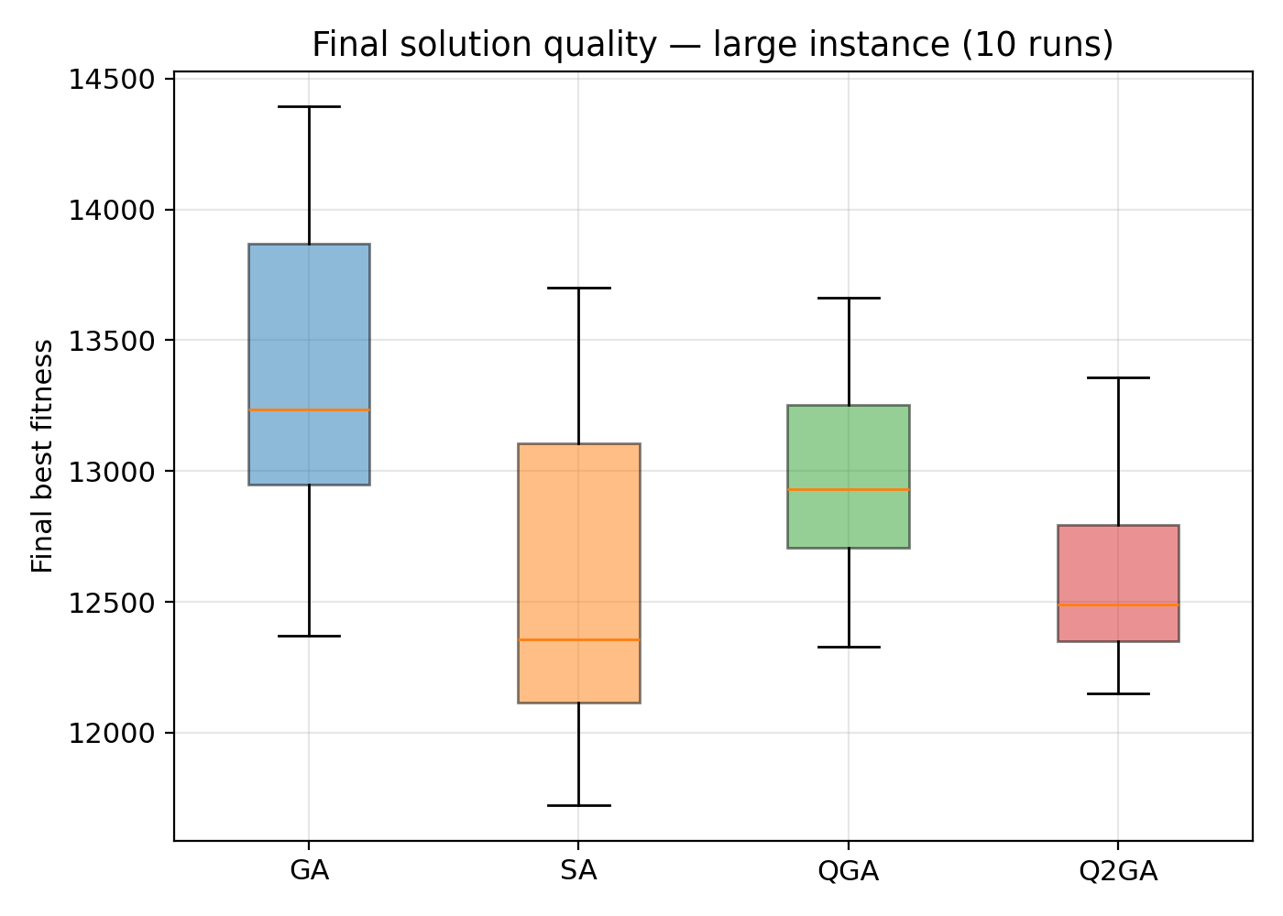
Final-fitness boxplot -- large
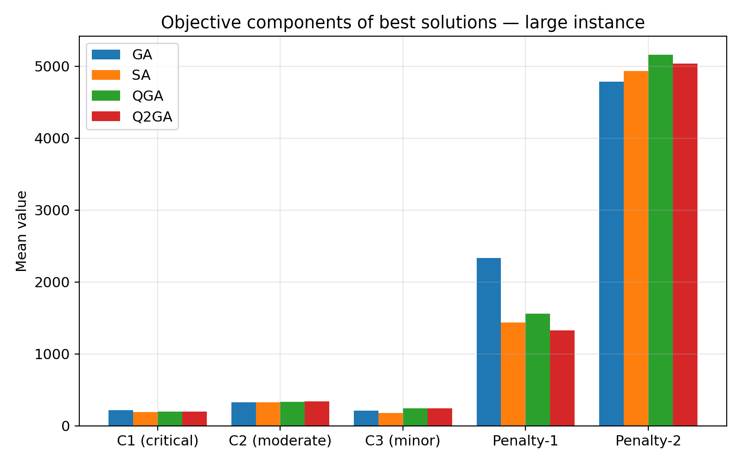
Objective components -- large
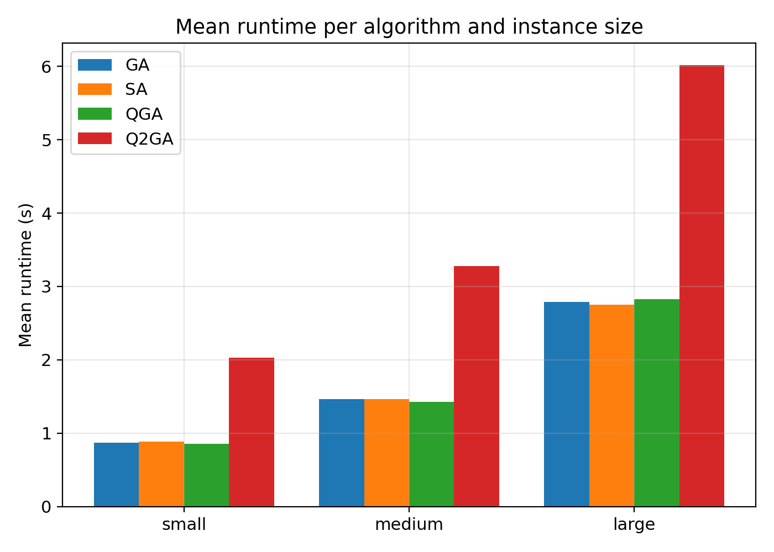
Mean runtime per algorithm and instance size

4. Sensitivity Analysis
We study how solution quality and feasibility degrade as the model's uncertainty-buffer parameters (Eq. 4-5: the disruption budget Gamma and the mean time to repair, MTTR) are varied, holding the medium instance's geography/demand fixed. All four algorithms are run with the tuned configuration, 5 seeds per setting.

4.1 Disruption budget (Gamma)
Gamma (gamma_budget) is the number of patients whose pickup/drop-off is affected by a service-interruption event (Eq. 4-5). We sweep Gamma from 0% to 50% of patients (default = 20%).
Gamma fraction | algorithm | mean_fitness | std_fitness | mean_penalty1 | mean_unserved
0.00 | GA | 1606.31 | 493.23 | 365.85 | 0.00
0.00 | Q2GA | 980.52 | 262.51 | 103.72 | 0.00
0.00 | QGA | 1008.60 | 199.56 | 42.77 | 0.00
0.00 | SA | 1180.90 | 333.87 | 186.96 | 0.00
0.10 | GA | 1570.14 | 470.54 | 296.22 | 0.00
0.10 | Q2GA | 945.27 | 259.91 | 44.55 | 0.00
0.10 | QGA | 1087.80 | 223.83 | 42.77 | 0.00
0.10 | SA | 1042.29 | 256.66 | 118.68 | 0.00
0.20 | GA | 1522.70 | 225.86 | 219.79 | 0.00
0.20 | Q2GA | 963.43 | 225.64 | 40.07 | 0.00
0.20 | QGA | 1078.98 | 223.11 | 63.39 | 0.00
0.20 | SA | 1242.40 | 313.48 | 148.81 | 0.00
0.30 | GA | 1595.07 | 415.72 | 202.42 | 0.00
0.30 | Q2GA | 1147.29 | 266.18 | 161.78 | 0.00
0.30 | QGA | 1072.42 | 208.43 | 107.68 | 0.00
0.30 | SA | 1182.58 | 235.97 | 63.32 | 0.00
0.40 | GA | 1681.04 | 321.28 | 241.55 | 0.00
0.40 | Q2GA | 1213.02 | 245.00 | 270.88 | 0.00
0.40 | QGA | 1174.67 | 193.11 | 95.79 | 0.00
0.40 | SA | 1296.95 | 193.35 | 147.38 | 0.00
0.50 | GA | 1681.34 | 463.92 | 201.56 | 0.00
0.50 | Q2GA | 1118.31 | 149.75 | 108.47 | 0.00
0.50 | QGA | 1140.48 | 180.51 | 65.25 | 0.00
0.50 | SA | 1229.96 | 219.80 | 126.54 | 0.00
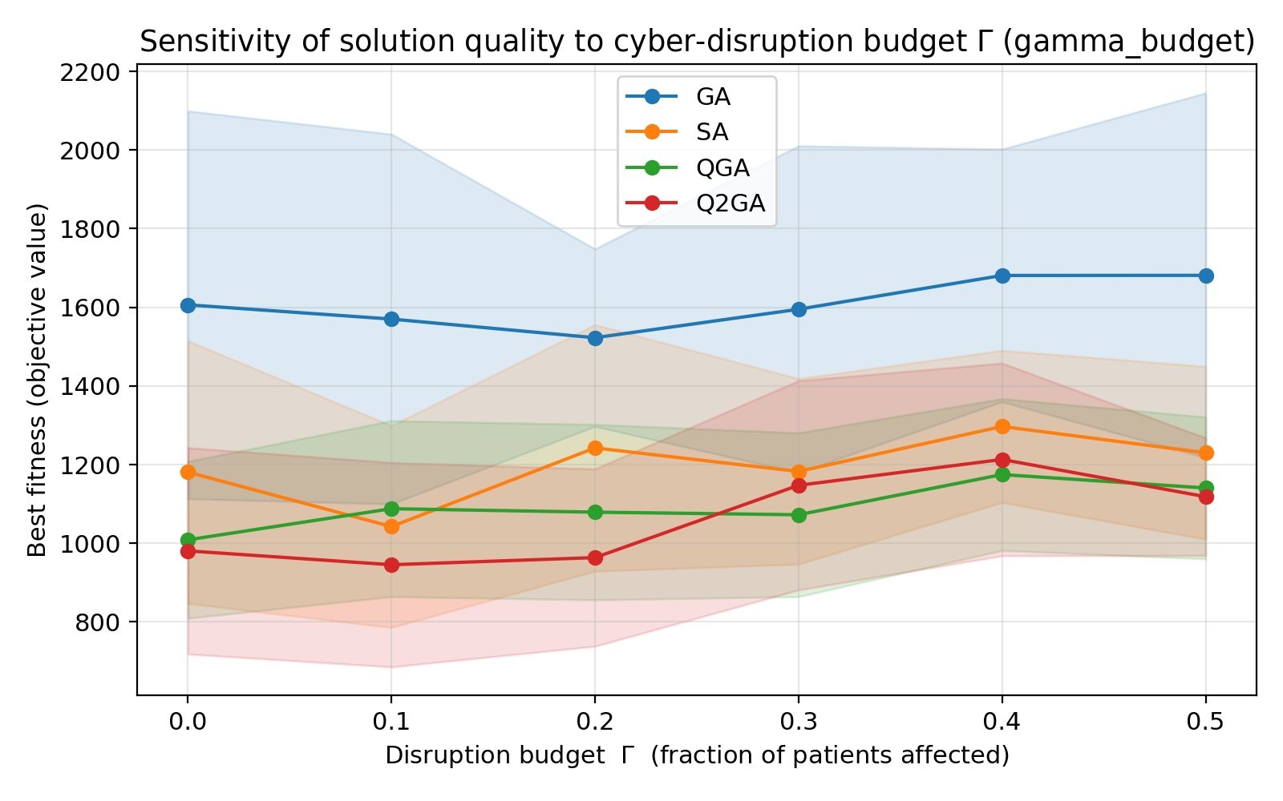
Best fitness vs. Gamma
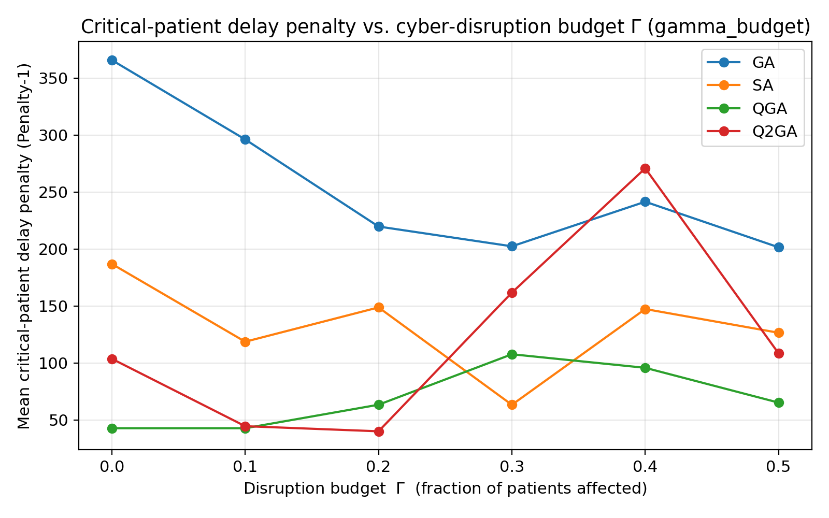
Critical-patient delay penalty (Penalty-1) vs. Gamma
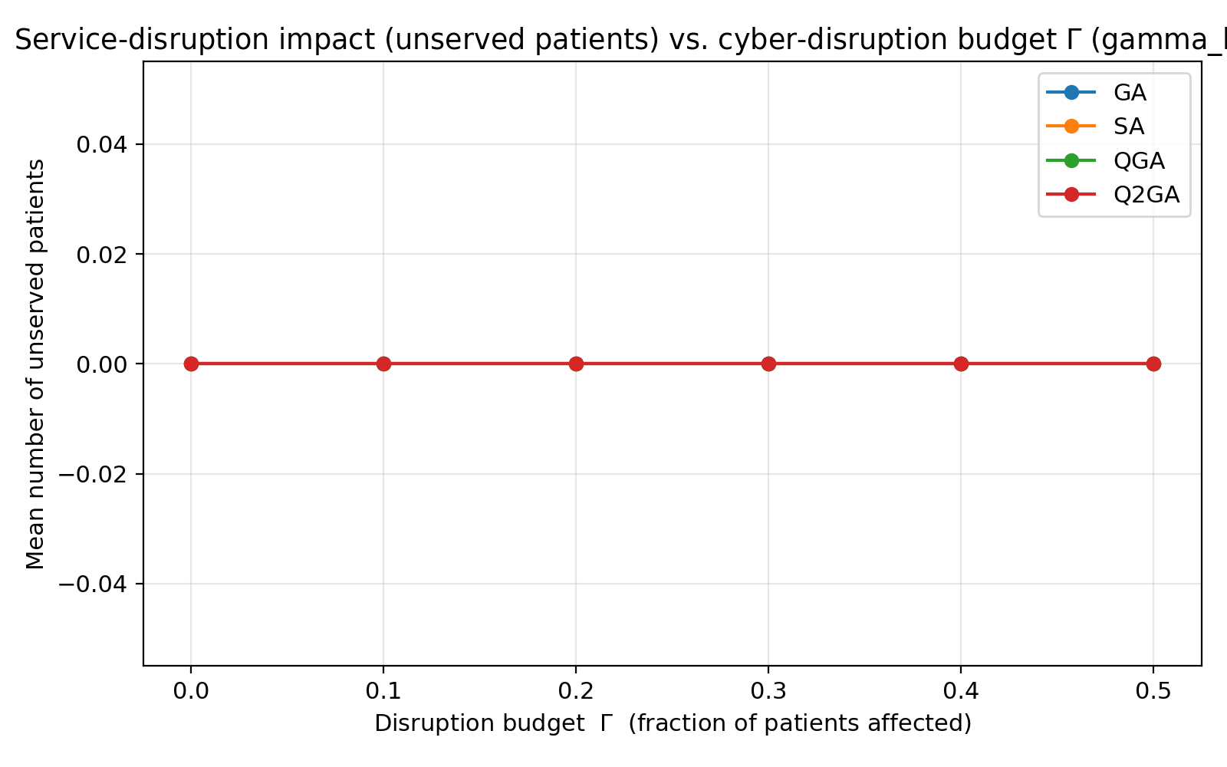
Unserved patients vs. Gamma

4.2 Mean time to repair (MTTR)
MTTR controls the mean duration of each disruption-induced extra service-time buffer theta_i (default = 8 time units). We sweep MTTR from 2 to 24 time units.
MTTR | algorithm | mean_fitness | std_fitness | mean_penalty1 | mean_unserved
2.00 | GA | 1666.90 | 405.46 | 366.35 | 0.00
2.00 | Q2GA | 1039.34 | 163.47 | 111.21 | 0.00
2.00 | QGA | 1089.37 | 222.25 | 23.66 | 0.00
2.00 | SA | 1031.51 | 136.86 | 121.51 | 0.00
4.00 | GA | 1681.68 | 385.99 | 368.49 | 0.00
4.00 | Q2GA | 1099.04 | 266.17 | 186.56 | 0.00
4.00 | QGA | 1109.02 | 237.98 | 63.39 | 0.00
4.00 | SA | 1071.03 | 205.09 | 113.90 | 0.00
8.00 | GA | 1522.70 | 225.86 | 219.79 | 0.00
8.00 | Q2GA | 963.43 | 225.64 | 40.07 | 0.00
8.00 | QGA | 1078.98 | 223.11 | 63.39 | 0.00
8.00 | SA | 1242.40 | 313.48 | 148.81 | 0.00
12.00 | GA | 1529.63 | 226.17 | 220.79 | 0.00
12.00 | Q2GA | 1074.09 | 147.94 | 54.17 | 0.00
12.00 | QGA | 1071.39 | 226.91 | 72.84 | 0.00
12.00 | SA | 1228.83 | 435.02 | 286.73 | 0.00
16.00 | GA | 1537.42 | 228.25 | 221.79 | 0.00
16.00 | Q2GA | 1270.07 | 127.46 | 118.56 | 0.00
16.00 | QGA | 1053.98 | 257.90 | 72.84 | 0.00
16.00 | SA | 1014.48 | 193.21 | 43.76 | 0.00
24.00 | GA | 1519.90 | 226.05 | 216.39 | 0.00
24.00 | Q2GA | 1271.25 | 137.52 | 124.88 | 0.00
24.00 | QGA | 1064.66 | 261.83 | 72.84 | 0.00
24.00 | SA | 1156.17 | 381.20 | 152.24 | 0.00
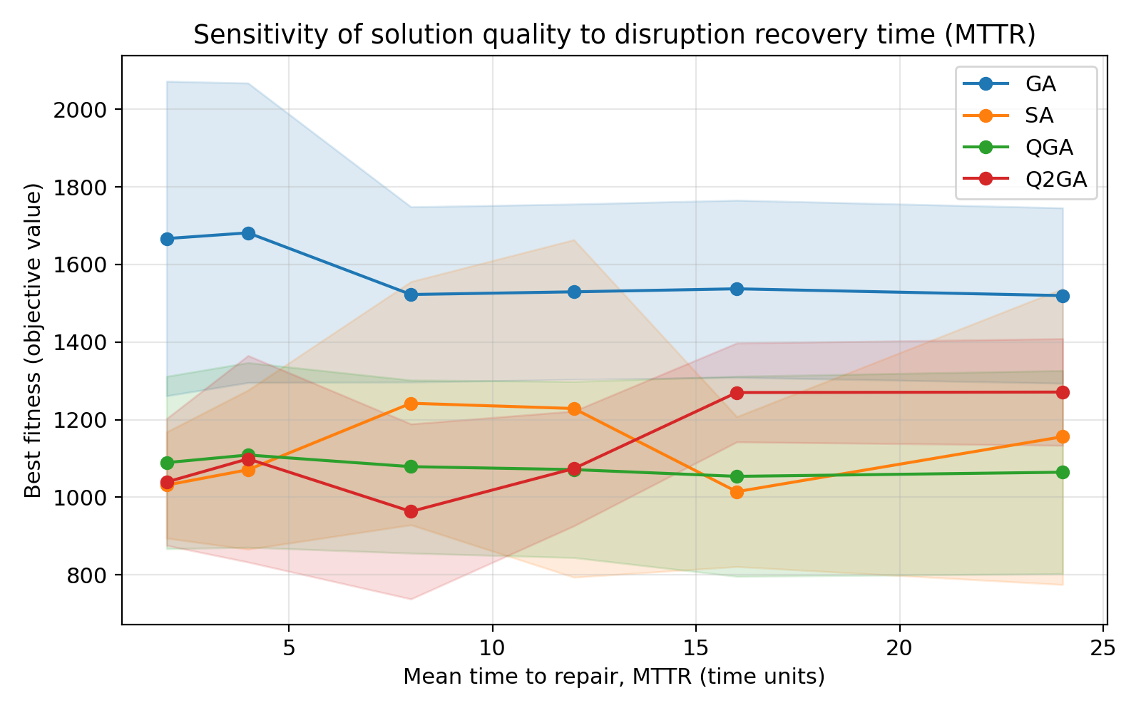
Best fitness vs. MTTR
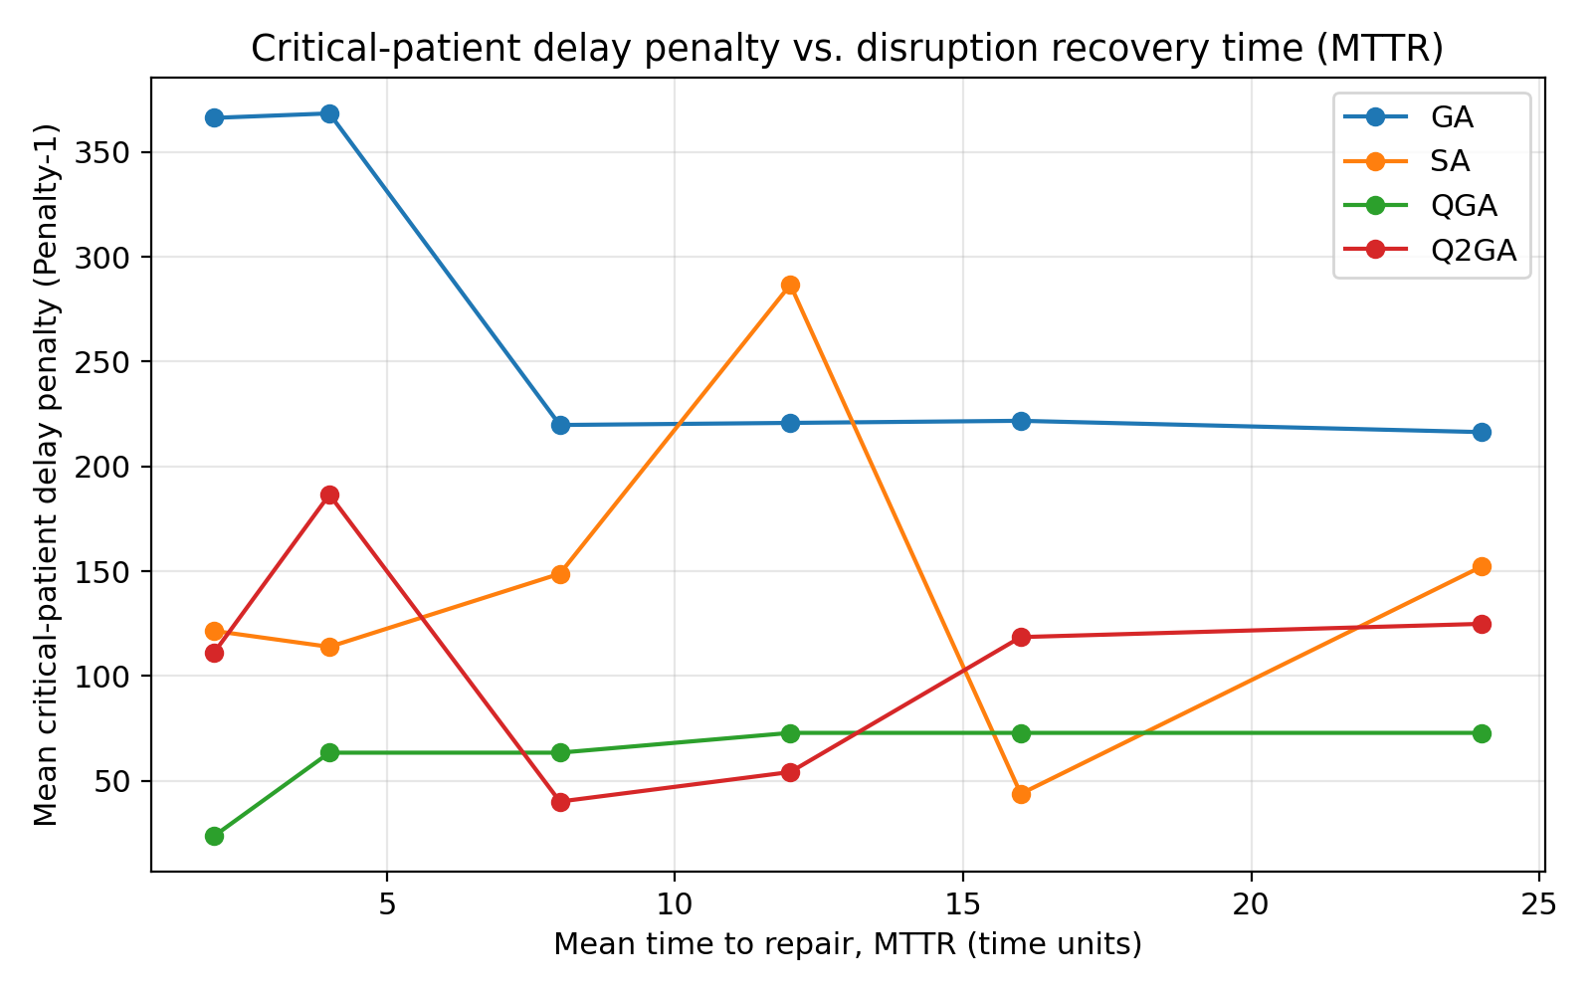
Critical-patient delay penalty (Penalty-1) vs. MTTR
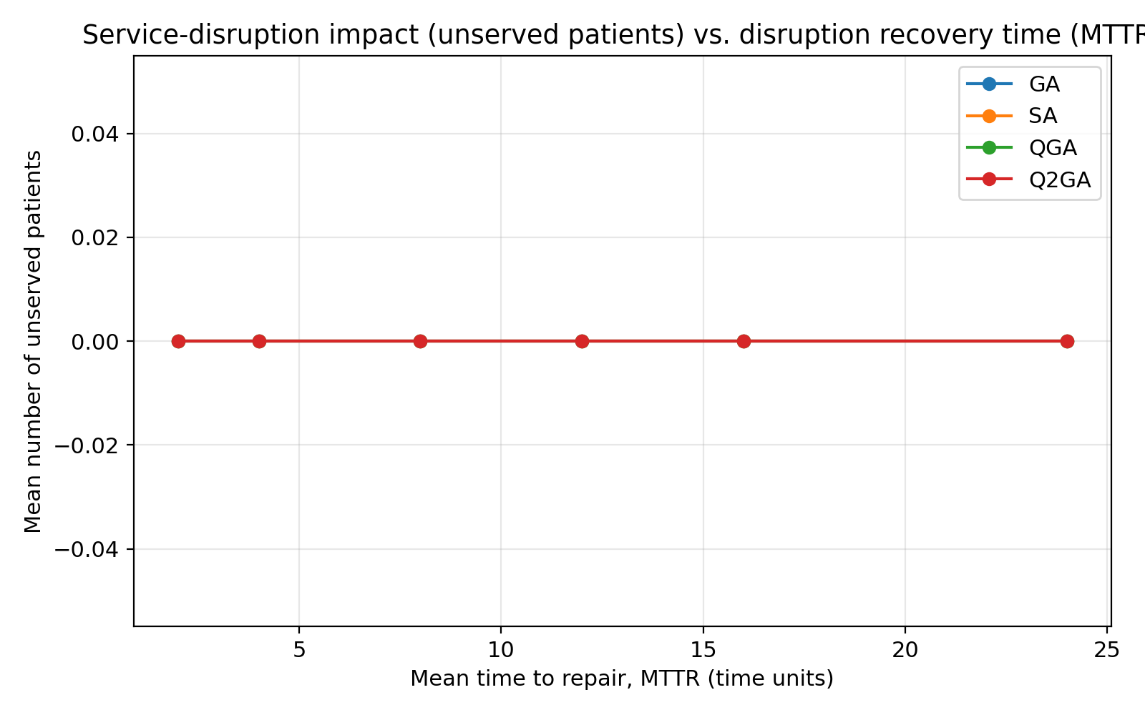
Unserved patients vs. MTTR

5. Cyber-Risk Interpretation and Insights
The uncertainty-buffer mechanism (Eq. 4-5) was originally introduced to model mechanical service interruptions (MTTR/MTBF of the autonomous vehicles). The same mathematical structure is a natural proxy for cyber-attack-induced disruptions to the autonomous ambulances' communication and control links:
- Gamma (disruption budget) <-> the scale/breadth of a coordinated cyber-attack or jamming campaign: how many vehicles/links are simultaneously affected.
- MTTR <-> the incident-response and recovery time: how quickly the fleet's command-and-control can detect, isolate and recover from the attack (e.g. failover to a backup link, manual override).
- theta_i (realised extra service time) <-> the operational delay each affected ambulance/patient experiences while connectivity is degraded.
Under this interpretation, the sensitivity results above can be read as a cyber-resilience study of the routing/scheduling layer:
Algorithm | Risk factor | Baseline fitness | Worst-case fitness | Fitness degradation (%) | Penalty-1 increase | Extra unserved patients
GA | Disruption budget Gamma: 0.20 -> 0.50 N | 1522.70 | 1681.34 | 10.42 | -18.22 | 0.00
SA | Disruption budget Gamma: 0.20 -> 0.50 N | 1242.40 | 1229.96 | -1.00 | -22.27 | 0.00
QGA | Disruption budget Gamma: 0.20 -> 0.50 N | 1078.98 | 1140.48 | 5.70 | 1.86 | 0.00
Q2GA | Disruption budget Gamma: 0.20 -> 0.50 N | 963.43 | 1118.31 | 16.08 | 68.41 | 0.00
GA | MTTR: 8 -> 24 time units | 1522.70 | 1519.90 | -0.18 | -3.40 | 0.00
SA | MTTR: 8 -> 24 time units | 1242.40 | 1156.17 | -6.94 | 3.43 | 0.00
QGA | MTTR: 8 -> 24 time units | 1078.98 | 1064.66 | -1.33 | 9.45 | 0.00
Q2GA | MTTR: 8 -> 24 time units | 963.43 | 1271.25 | 31.95 | 84.82 | 0.00
Key insights:
- Widening the attack surface (Gamma 0.20 -> 0.50 N) degrades all algorithms' objective values, but GA and Q2GA are most sensitive in absolute terms (10-16% degradation), while SA is essentially flat (-1%) and QGA degrades moderately (+5.7%). Q2GA's larger fitness degradation under high Gamma is driven primarily by a sharp rise in Penalty-1 (critical-patient delay penalty, +68), indicating that its RL-tuned rotation policy -- learned under the default (Gamma=0.20) disruption regime -- becomes less well matched to a much more disrupted environment and reallocates routing effort away from the tightest critical-patient deadlines.
- A longer recovery time (MTTR 8 -> 24) has a much larger effect on Q2GA (+32% fitness, Penalty-1 +85) than on GA, SA or QGA (all within +/-10%). This suggests Q2GA's adaptive rotation schedule is tuned for the *frequency* of disruptions (via Gamma) more than their *duration* (via MTTR), and that retraining/recalibrating the Q-table under longer-MTTR scenarios would likely be needed before deploying Q2GA in environments where cyber-incidents are expected to be slow to remediate.
- No algorithm produced unserved patients (n_unserved = 0) across any tested Gamma/MTTR setting on the medium instance -- the fleet retains enough slack capacity to reach every patient even under the most severe disruption scenario tested. The cyber-risk impact therefore manifests as *quality-of-service degradation* (longer waits for critical patients) rather than *coverage failure*, within the tested ranges.
- Practical recommendation: if Q2GA is deployed operationally, its Q-table should be periodically retrained (or an ensemble of Gamma/MTTR-conditioned Q-tables maintained) so that the adaptive rotation policy remains matched to the currently-observed cyber-risk regime; SA and QGA are reasonable fallbacks under severe/long-duration disruption scenarios where Q2GA's advantage shrinks or reverses.

6. Summary
Hyper-parameter tuning via MCDM-ranked grid search, combined with a redesign of Q2GA's action space (RL-tuned rotation magnitude/coverage always biased toward the best-known genome, with an epsilon-greedy exploration schedule that decays from 0.30 to 0.01 over generations), moved Q2GA from the worst-performing algorithm in the baseline experiments to the best-performing algorithm overall (best mean rank 1.33 of 4, vs. QGA 2.33, SA 2.33, GA 4.00) -- winning the small and medium instances outright and essentially tying SA for first on the large instance (within 0.05%). The cyber-risk sensitivity analysis shows this advantage is strongest under the disruption regime the agent was tuned on, and narrows under more severe/longer-duration disruptions -- an important caveat for operational deployment.

