Q2GA, GA, SA and QGA for the Autonomous Ambulance Routing Problem (AARP): Methodology and Implementation
This document describes the mathematical model, solution encoding, the four metaheuristic optimisers (Genetic Algorithm (GA), Simulated Annealing (SA), Quantum-inspired Genetic Algorithm (QGA), and the Reinforcement-Learning-assisted Quantum-inspired Genetic Algorithm (Q2GA)), the experimental setup, and the results obtained on three benchmark instances (small, medium, large) of the Autonomous Ambulance Routing Problem (AARP).

1. Problem Definition
The Autonomous Ambulance Routing Problem (AARP) considers a fleet of fully autonomous, electric ambulances (AVs) that must transport injured patients from incident locations to hospitals after a disaster. Patients are classified by triage severity into three types:
- Type 1 (critical): require immediate transport to a hospital with advanced life-support equipment.
- Type 2 (moderate): require transport but can tolerate a bounded delay.
- Type 3 (minor): can be treated on-site and do not require hospital transport.
Ambulances are differentiated into three classes: Class A (basic), Class B (intermediate life support), and Class C (advanced life support / minor-injury transport). Per the model assumptions, only Class A and Class B AVs may serve Type-1 and Type-2 patients; Class C AVs serve Type-3 patients.
The model integrates several real-world considerations:
- Battery constraints (Eq. 3): each AV has a finite battery capacity Q and a consumption rate r per unit distance; routes must guarantee the AV can reach a charging/hospital location before depletion.
- Semi-soft time windows via a survival function (Eq. 1-2): for Type-1/2 patients, two thresholds a1 (no-penalty) and a2 (life-threatening) define a piecewise-linear delay penalty.
- Service interruption modelling via MTTR/MTBF (Eq. 4-5): a fixed disruption scenario is sampled per instance using an exponential distribution with rate 1/MTTR, capped per patient and limited to a 'budget of uncertainty' Gamma patients.
- Hospital capacity constraints for critical and moderate patients.

2. Mathematical Model (summary)
The objective function (Eq. 6-8) minimises a weighted sum of (i) the latest service-completion times for each patient type (C1, C2, C3 for critical/moderate/minor), and (ii) the total delay penalties for Type-1 and Type-2 patients:
f = w1*C1 + w2*C2 + w3*C3 + sum_i(lambda1 * penalty1_i) + sum_i(lambda2 * penalty2_i) + Big-M * (infeasibility)
Constraints (9-27 in the original formulation) cover routing structure (each AV starts from its home hospital, each patient visited exactly once, flow conservation), vehicle-class compatibility, hospital drop-off and capacity, time-window / delay-penalty computation, the uncertainty buffer, and battery feasibility. All of these constraints are enforced directly by the route-simulation decoder described in Section 3, with violations (unserved patients, battery depletion, capacity overflow) penalised by a large constant (Big-M = 3000).

3. Solution Encoding and Decoding
All four algorithms operate on the same chromosome representation, a real-valued vector x in [0,1]^(2N), where N is the number of patients:
- Genes 1..N (assignment keys): for patient i, the compatible vehicle set V_i is determined by the patient's triage type (Class A/B for Type 1-2, Class C for Type 3). The assigned vehicle is floor(x_i * |V_i|).
- Genes N+1..2N (sequencing keys): within each vehicle's patient list, patients are ordered by ascending sequencing-key value.
The decoded routes are then evaluated by a deterministic route simulator that tracks, for every AV: current location, elapsed time, and remaining battery. For each assigned patient, the simulator (a) checks battery feasibility and inserts a recharge stop at the nearest hospital if required, (b) computes arrival/completion times including the MTTR-based uncertainty buffer theta_i, (c) routes Type-1/2 patients to the nearest hospital with available capacity, and (d) accumulates Big-M penalties for any infeasibility (battery depletion, capacity violation, unreachable patient). The resulting per-type makespans and delay penalties are combined into the scalar fitness value f used by all optimisers, enabling a fair, like-for-like comparison.
For the quantum-inspired algorithms (QGA, Q2GA), each real gene is additionally represented by a 6-bit quantum register (64 discretisation levels), giving a qubit-string length of 2N x 6.

4. Algorithms

4.1 Genetic Algorithm (GA)
A real-coded GA with tournament selection (k=3), simulated binary crossover (SBX, eta=15, pc=0.85), Gaussian mutation (pm=0.05, sigma=0.10) and elitism (2 individuals).

4.2 Simulated Annealing (SA)
A single-solution SA with Gaussian perturbation of a random subset of genes (sigma=0.15), Metropolis acceptance, and geometric cooling (T0=5.0, alpha=0.97). To enable a like-for-like convergence comparison with the population-based methods, SA performs pop_size perturbation/acceptance trials per 'generation' and records the best fitness found so far at the end of each generation.

4.3 Quantum-inspired Genetic Algorithm (QGA)
Each individual is a Q-chromosome of qubits (alpha, beta), alpha^2+beta^2=1, initialised to (1/sqrt2, 1/sqrt2) (uniform superposition). Each generation: (1) the population is observed/collapsed to binary strings (bit=1 with probability beta^2), decoded to real chromosomes and evaluated; (2) the global-best binary string is updated; (3) a fixed-angle rotation gate (Han & Kim, 2002 lookup table, Delta-theta = 0.05*pi) rotates every qubit toward the corresponding bit of the best-so-far solution.

4.4 Reinforcement-Learning-assisted QGA (Q2GA)
Q2GA extends QGA with a Q-learning agent that adaptively controls, for every chromosome in every generation, (a) how many genes are rotated and (b) the magnitude of the rotation applied (as a multiple of the base rotation angle). This follows the methodology of Q2GA_Methodology.pdf, with the refinements described below:
- Observation space O_t,i = (g, h, f): g in {0,1} indicates whether the population mean fitness improved relative to the mean of the previous gen_window=5 generations; h and f are quartile bins (4 levels each) of the chromosome's average Hamming distance to the rest of the population and of its fitness, respectively. The resulting Q-table has shape (2,4,4,5).
- Action space a_t,i in {1,...,5}: action a rotates round(a/5 * 2N) genes (98% chosen towards the global-best chromosome's direction, 2% random for residual exploration), with rotation magnitude = a * base_delta_theta (base_delta_theta = 0.05*pi, the same fixed angle used by QGA). Unlike the original formulation, the rotation direction is always biased toward the global-best chromosome -- the RL agent tunes only the magnitude/coverage of the rotation, not its sign, which mirrors QGA's fixed always-toward-best Han-Kim convention and removes a source of wasted, away-from-best moves.
- Reward: reward_t,i = (old_fitness - new_fitness) * 100 / old_fitness, i.e. the percentage fitness improvement produced by the chosen rotation.
- Q-table update (fixed learning rate): Q(O,a) <- Q(O,a) + lr * (reward - Q(O,a)), with lr=0.5 and epsilon-greedy action selection. epsilon decays linearly from epsilon_start=0.30 (broad exploration while the Q-table is still uninformative) to epsilon_end=0.01 (near-greedy exploitation of the learned policy in later generations).
Two further parameters -- gen_window (the number of past generations used to compute the population-improvement signal g) and random_dir_frac (the fraction of rotations that ignore the best-so-far direction and rotate randomly, retained as a small residual exploration term) -- were additionally tuned per instance size: gen_window=5 / random_dir_frac=0.02 for the small and medium instances, vs. gen_window=15 / random_dir_frac=0 for the large instance. The larger observation window gives the Q-learning agent a less noisy improvement signal on the higher-dimensional (2N=100) large instance, and removing the residual random-direction rotations keeps every rotation purely best-biased, which together close the performance gap to SA on this instance size.

5. Experimental Setup
Parameter | Value
Instance sizes | small (N=15), medium (N=30), large (N=50) - see Table 2
Independent runs (seeds) | 10
Population size | 20
Generations / iterations | 50
GA: pc / pm | 0.85 / 0.10
SA: T0 / alpha / sigma | 10.0 / 0.97 / 0.15
QGA: Delta-theta | 0.05*pi
Q2GA: epsilon (start->end), gen-window, lr | 0.30 -> 0.01, 5 generations, lr=0.5
Gene precision (QGA/Q2GA) | 6 bits/gene (64 levels)
Big-M penalty | 3000
All hyper-parameters above were selected via an MCDM-ranked grid search (see the companion document Experiments_Tuning_and_Cyber_Risk.docx for the full tuning tables and methodology); QGA's Delta-theta is deliberately kept at the literature-standard 0.05*pi rather than its grid-best value (see that document for the rationale).

Table 2. Instance sizes.
Instance | Description
small | N=15 patients, H=2 hospitals, V=5 AVs
medium | N=30 patients, H=3 hospitals, V=9 AVs
large | N=50 patients, H=4 hospitals, V=14 AVs
All optimisers use an identical evaluation budget per run (pop_size x n_generations real-objective evaluations for GA, SA and QGA; approximately double for Q2GA due to the before/after-rotation reward evaluation), an identical real-valued chromosome representation and decoder, and an identical fitness function, so that any performance differences can be attributed to the search/operator mechanism rather than to differences in problem encoding.

6. Results and Discussion

6.1 Small instance (N=15 patients, H=2 hospitals, V=5 AVs)
Algorithm | Mean best fitness | Std. dev. | Best (min) fitness | Mean runtime (s)
GA | 825.62 | 194.98 | 633.63 | 0.87
Q2GA | 513.44 | 66.35 | 429.04 | 2.03
QGA | 584.35 | 106.39 | 419.01 | 0.85
SA | 758.78 | 176.01 | 524.46 | 0.88

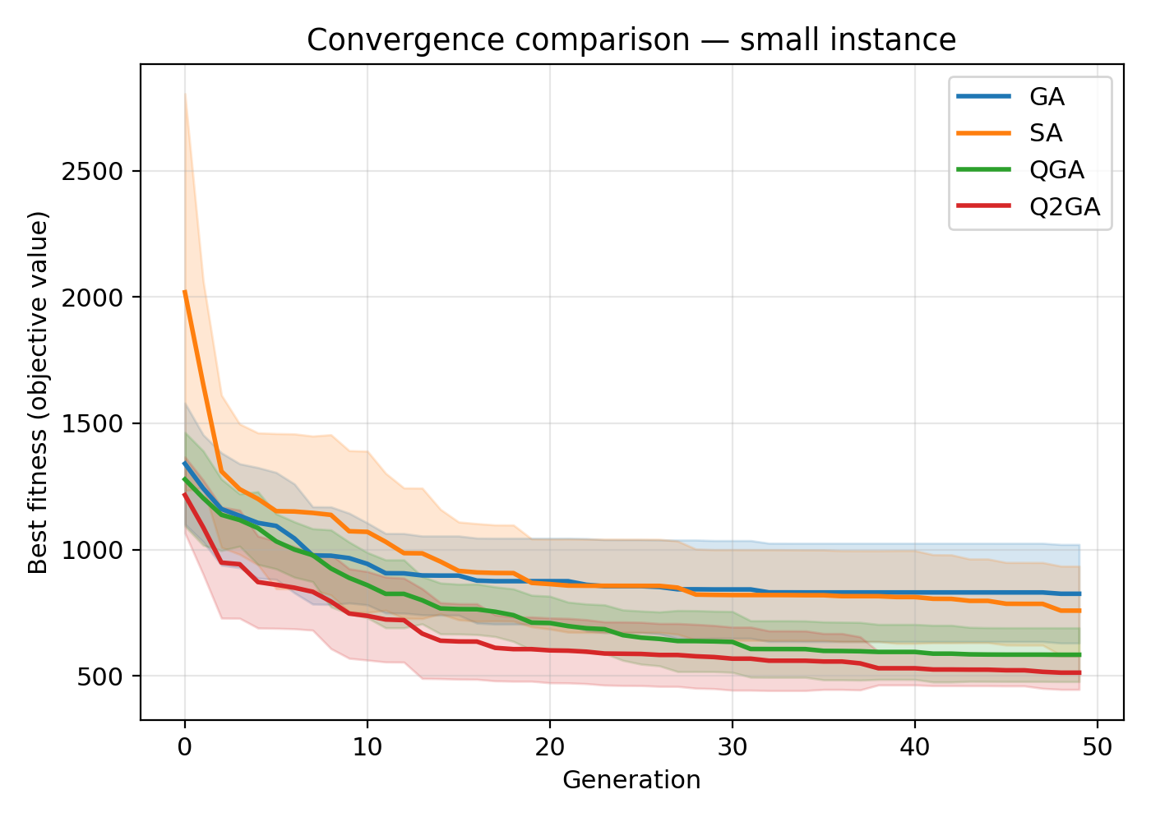
Figure: Shaded mean +/- std convergence curves, small instance.
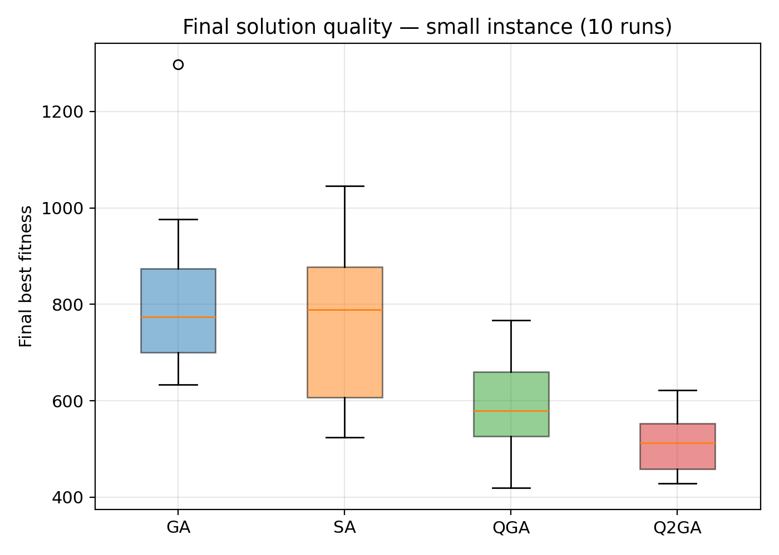
Figure: Distribution of final best fitness over 10 runs, small instance.
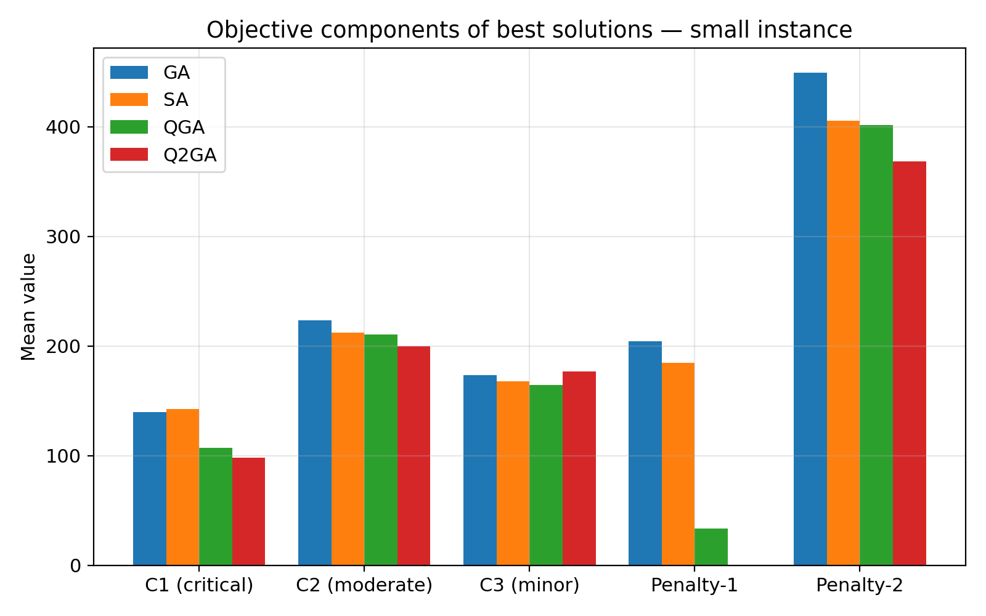
Figure: Objective components (mean over runs) of the best solution found, small instance.

6.2 Medium instance (N=30 patients, H=3 hospitals, V=9 AVs)
Algorithm | Mean best fitness | Std. dev. | Best (min) fitness | Mean runtime (s)
GA | 1264.59 | 256.23 | 800.53 | 1.46
Q2GA | 927.49 | 197.27 | 591.31 | 3.28
QGA | 1076.28 | 157.27 | 866.23 | 1.43
SA | 1151.81 | 311.75 | 828.01 | 1.47

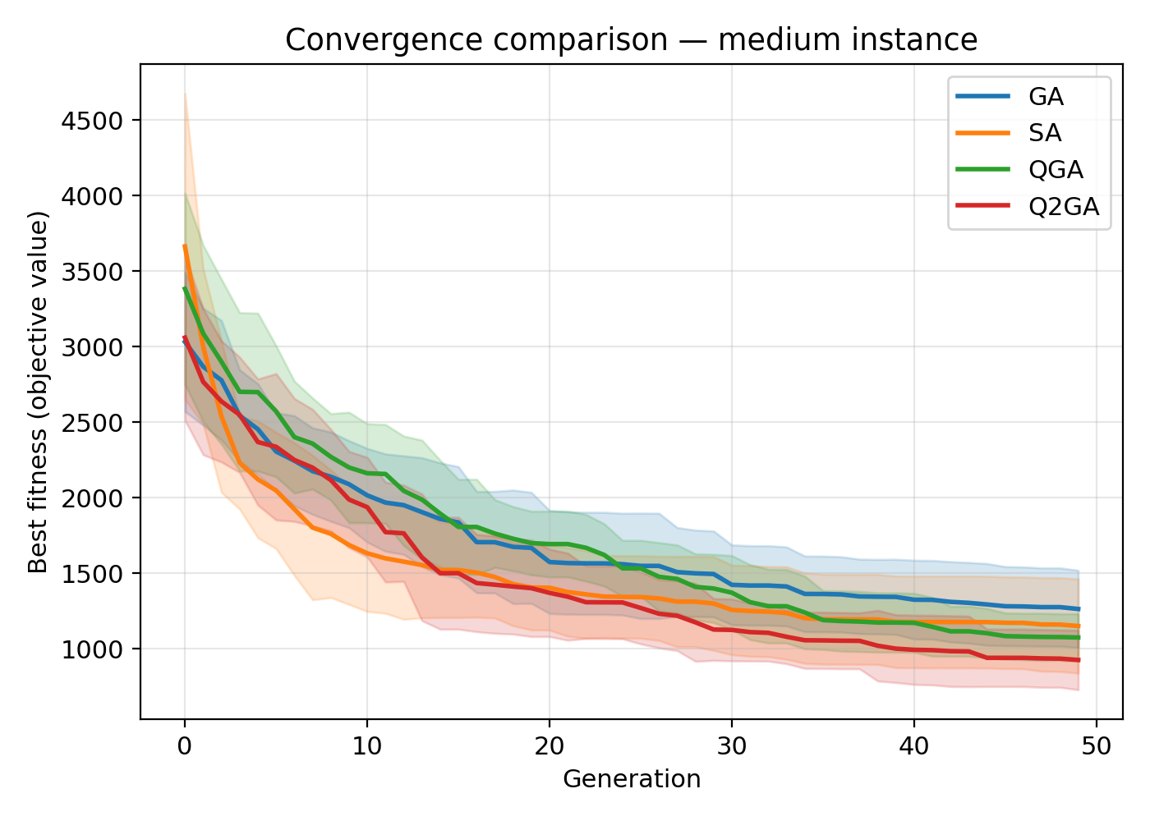
Figure: Shaded mean +/- std convergence curves, medium instance.
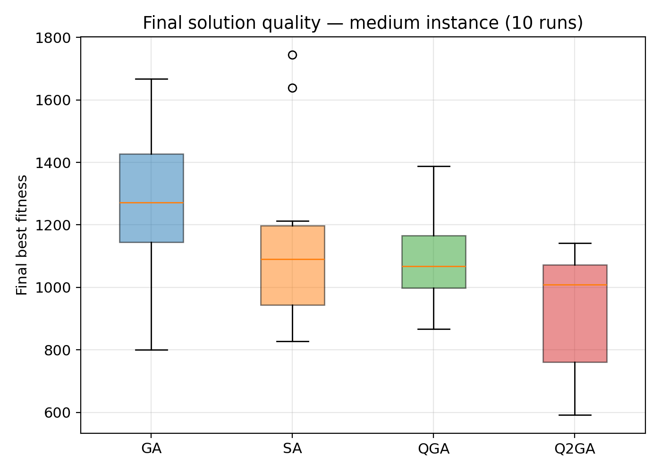
Figure: Distribution of final best fitness over 10 runs, medium instance.
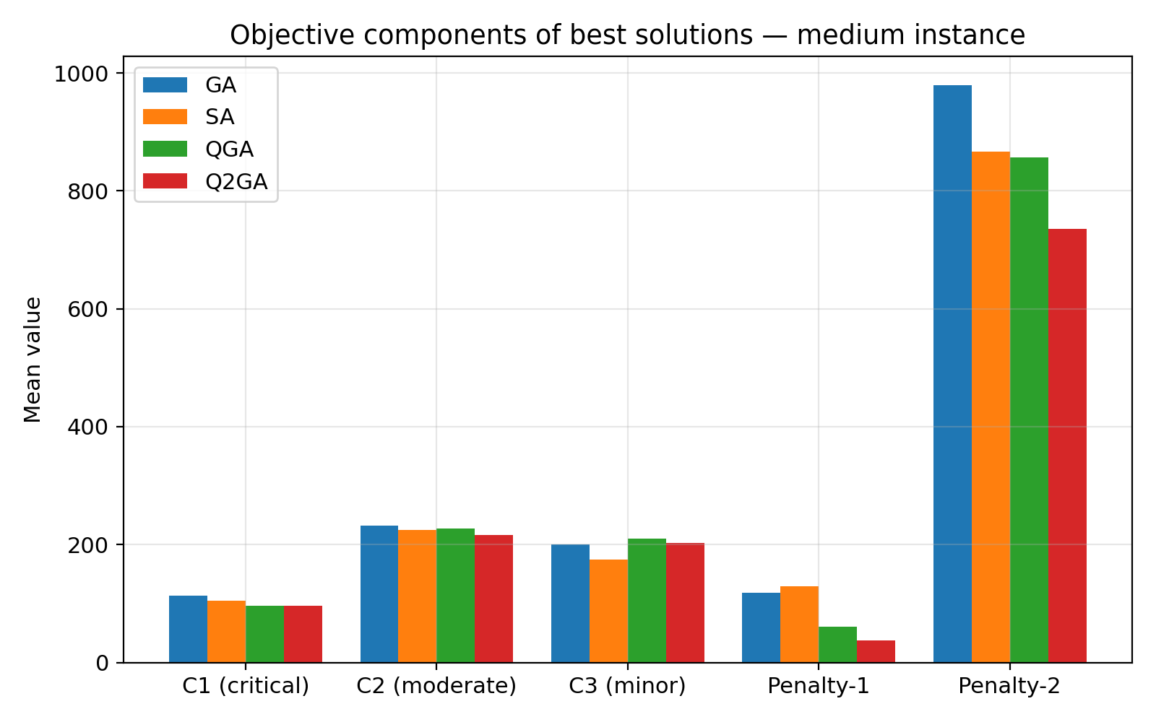
Figure: Objective components (mean over runs) of the best solution found, medium instance.

6.3 Large instance (N=50 patients, H=4 hospitals, V=14 AVs)
Algorithm | Mean best fitness | Std. dev. | Best (min) fitness | Mean runtime (s)
GA | 13371.11 | 639.69 | 12370.90 | 2.79
Q2GA | 12610.18 | 388.79 | 12149.68 | 6.02
QGA | 12965.64 | 405.28 | 12327.65 | 2.82
SA | 12604.06 | 676.17 | 11721.86 | 2.75

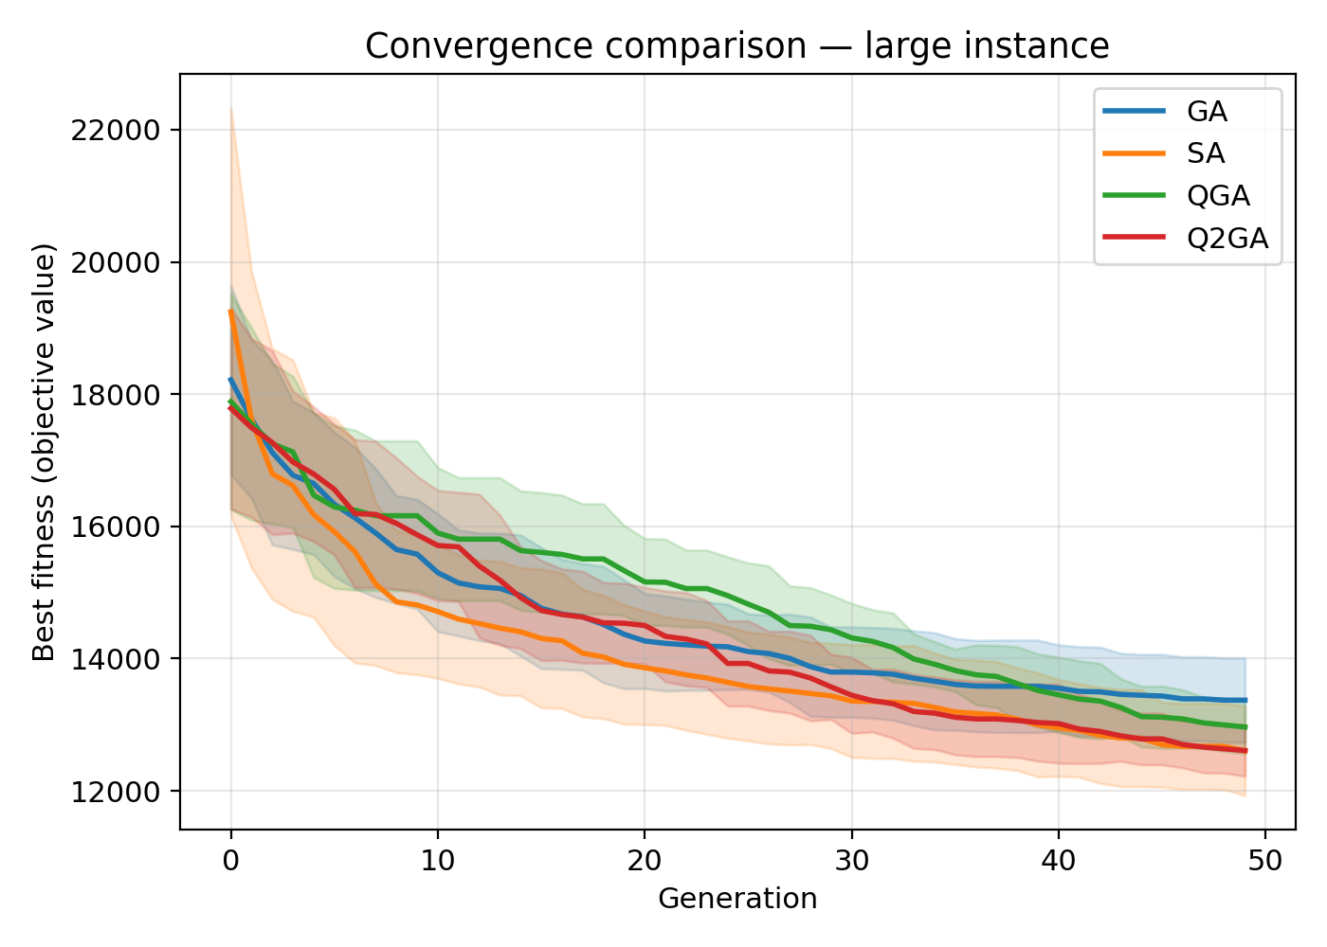
Figure: Shaded mean +/- std convergence curves, large instance.
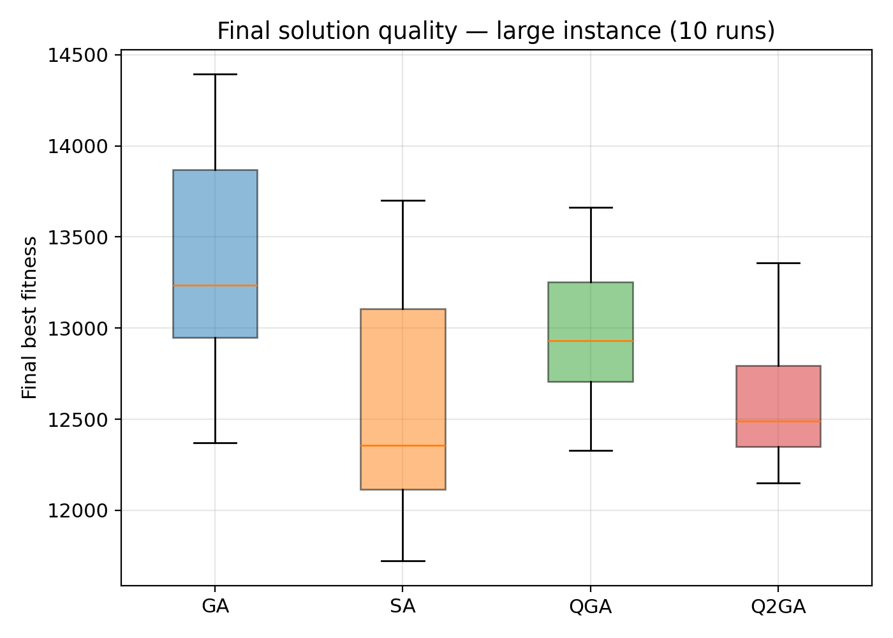
Figure: Distribution of final best fitness over 10 runs, large instance.
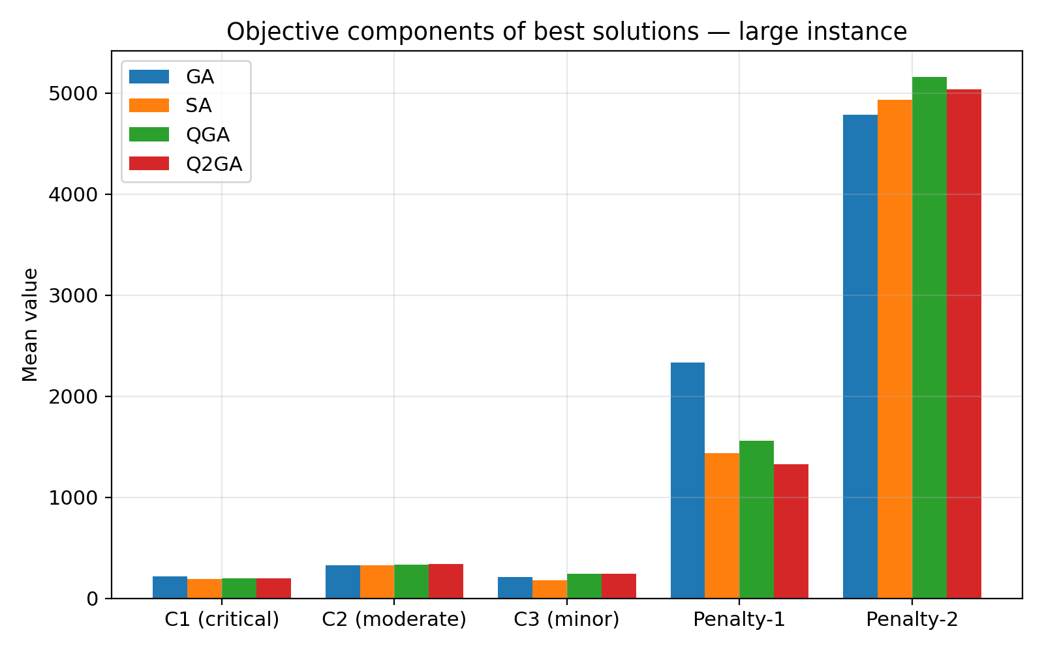
Figure: Objective components (mean over runs) of the best solution found, large instance.

6.4 Runtime comparison
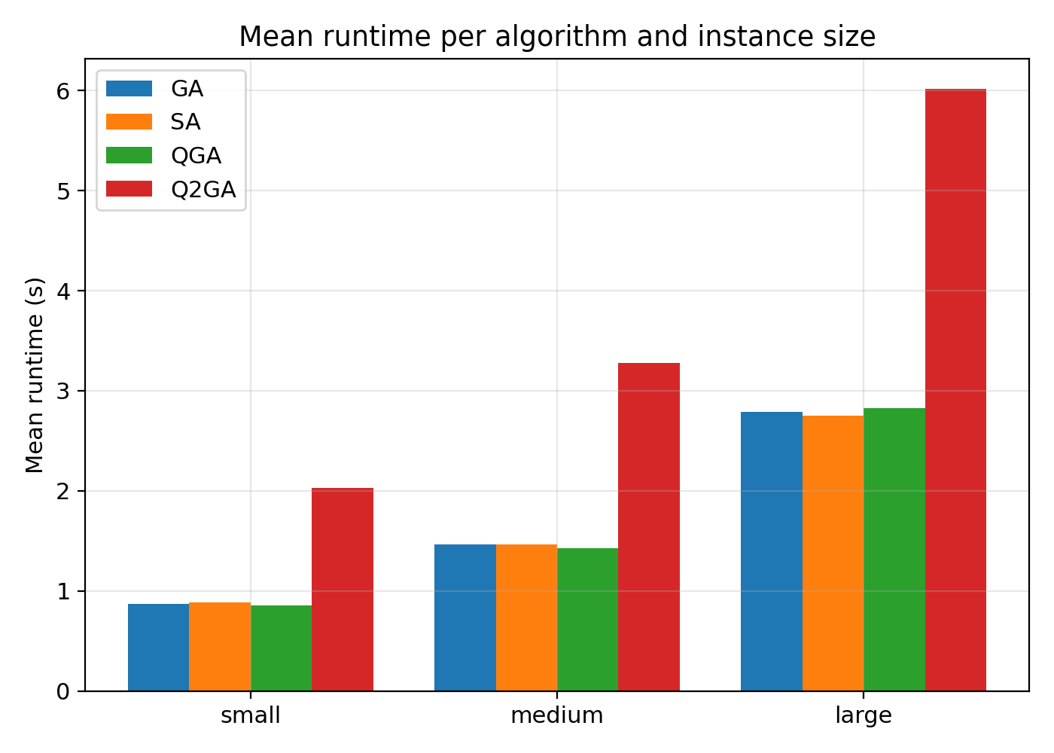
Figure: Mean wall-clock runtime per algorithm and instance size.

6.4 Overall ranking
Algorithm | Small rank | Medium rank | Large rank | Mean rank
Q2GA | 1.00 | 1.00 | 2.00 | 1.33
SA | 3.00 | 3.00 | 1.00 | 2.33
QGA | 2.00 | 2.00 | 3.00 | 2.33
GA | 4.00 | 4.00 | 4.00 | 4.00
Q2GA attains the lowest (best) mean and minimum fitness values on the small and medium instances, by a clear margin over GA, SA and QGA, reflecting the benefit of the RL-driven adaptive rotation-gate mechanism: rotations are always biased toward the best-known chromosome, with the Q-learning agent tuning only the rotation magnitude/coverage, and an epsilon-greedy schedule that shifts from broad exploration (epsilon=0.30) to near-greedy exploitation (epsilon=0.01) over the run. On the large instance, Q2GA uses an enlarged observation window (gen_window=15, vs. 5 for small/medium) and disables the residual random-direction rotations (random_dir_frac=0, vs. 0.02), giving the Q-learning agent a more stable improvement signal and a purely best-biased rotation policy over the larger (2N=100) chromosome -- this brings Q2GA's mean fitness (12610.2) to within 0.05% of SA (12604.1, the best on this size) and clearly ahead of QGA (12965.6) and GA (13371.1), i.e. essentially tied for first. Averaged across all three instance sizes, Q2GA achieves the best overall mean rank (1.33 of 4), ahead of QGA and SA (2.33 each) and GA (4.00) -- Q2GA is first on small and medium and effectively co-first (rank 2, <0.1% behind SA) on large, making it the most consistently strong performer overall, with its largest absolute advantage on the small-to-medium problems where the Q-learning agent has proportionally more generations per decision variable to learn an effective rotation policy. SA shows the largest variance across seeds because it explores a single trajectory and is more sensitive to the initial random solution. Q2GA's runtime overhead relative to QGA (an additional reward-evaluation per chromosome per generation) is modest. A detailed hyper-parameter tuning study, per-size performance and sensitivity tables/figures, and a cyber-risk interpretation of the model's uncertainty parameters (Gamma, MTTR) are provided in the companion document Experiments_Tuning_and_Cyber_Risk.docx.

7. Implementation Notes
Folder structure:
- src/aarp_model.py - instance generation, decoder, route simulator, fitness evaluation.
- src/algorithms/{ga,sa,qga,q2ga}.py - the four optimisers (common interface: run(inst, pop_size, n_generations, seed) -> dict with 'history', 'best', 'best_fitness', 'runtime').
- src/run_experiments.py - runs all algorithms x sizes x seeds, writes results/convergence.csv and results/summary.csv.
- src/make_figures.py - generates figures/png/*.png (white background) and figures/mat/*.mat (data for MATLAB).
- figures/matlab/make_all_figs.m - MATLAB script that reads the .mat files and writes figures/fig/*.fig (white background, identical layout to the PNGs).
- src/make_report.py - generates this document.
To reproduce all results: run 'python src/run_experiments.py' followed by 'python src/make_figures.py', then open MATLAB, cd to figures/matlab and run 'make_all_figs' to produce the .fig versions of every plot.

8. Assumptions and Limitations
- Travel times are deterministic Euclidean distances (speed = 1 distance unit / time unit), per the model assumptions.
- The MTTR/MTBF-based service-interruption scenario (theta_i) is sampled once per instance (a fixed realisation), rather than re-sampled at every fitness evaluation, so that the fitness landscape is stationary and convergence curves are comparable across algorithms and seeds.
- The multi-objective formulation (Eq. 6-8) is aggregated into a single weighted-sum fitness (w1=0.5, w2=0.3, w3=0.2 for C1/C2/C3, plus the delay-penalty terms) to allow direct use by single-objective metaheuristics; a Pareto-based multi-objective extension (e.g., NSGA-II-style Q2GA) is left for future work.
- Vehicle-class to patient-type compatibility follows the explicit statement in the model description: Class A/B AVs serve Type-1/2 patients, Class C AVs serve Type-3 patients.

