- 打开开关：
https://developer.huawei.com/consumer/cn/doc/best-practices/bpta-stability-hwasan-detection
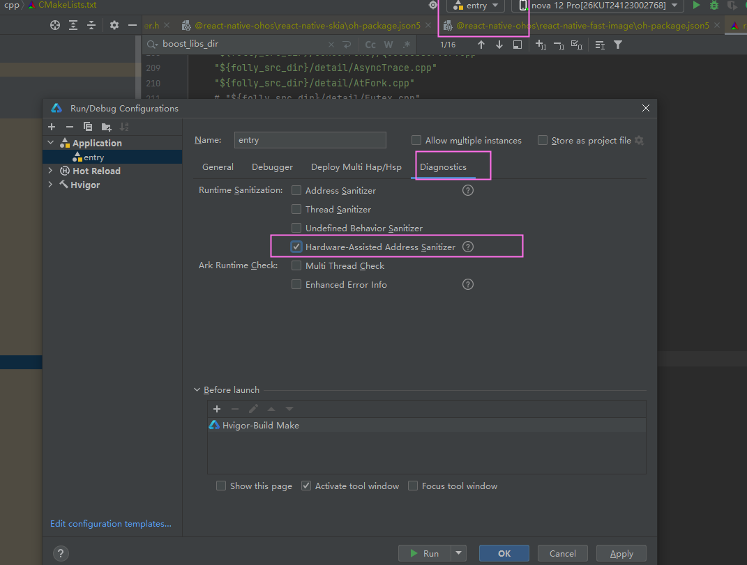

- 修改配置：
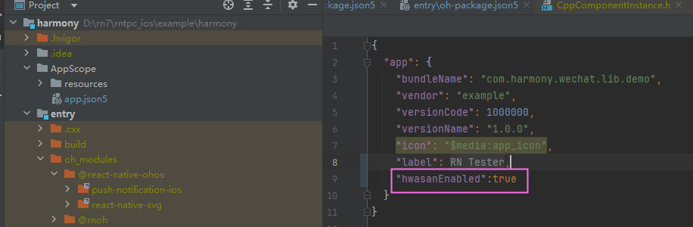
{
"app": {
"bundleName": "com.harmony.wechat.lib.demo",
"vendor": "example",
"versionCode": 1000000,
"versionName": "1.0.0",
"icon": "$media:app_icon",
"label": "$string:app_name",
"hwasanEnabled":true
}
}
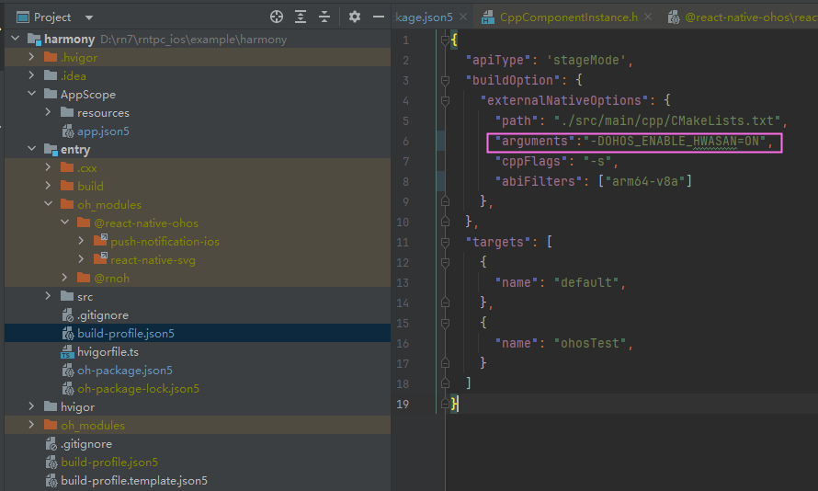

{
"apiType": 'stageMode',
"buildOption": {
"externalNativeOptions": {
"path": "./src/main/cpp/CMakeLists.txt",
"arguments":"-DOHOS_ENABLE_HWASAN=ON",
"cppFlags": "-s",
"abiFilters": ["arm64-v8a"]
},
},
"targets": [
{
"name": "default",
},
{
"name": "ohosTest",
}
]
}

- 如果还是报错找不到hwasan的so,那手动在Cmakelists.txt里面加上：
target_link_libraries(rnoh PUBLIC "D:\\601\\DevEco Studio\\sdk\\default\\openharmony\\native\\llvm\\lib\\clang\\15.0.4\\lib\\aarch64-linux-ohos\\libclang_rt.hwasan.so")

