Importing Installed Server Role Configuration Baseline into System Center Configuration Manager



Importing Installed Server Role Configuration Baseline

Prepared for

Microsoft Employees

2/21/2020

Prepared by

**Matt Novitsch**

Microsoft Premier Field Engineer

Matt.Novitsch@Microsoft.com

Version 1.0

Revision and Signoff Sheet

Change Record

| Date | Author | Version | Change Reference |
| --- | --- | --- | --- |
| 02/18/2020 | Matt Novitsch | 1 | Initial version |
|  |  |  |  |
|  |  |  |  |
|  |  |  |  |
|  |  |  |  |

Reviewers

| Name | Version Approved | Position | Date |
| --- | --- | --- | --- |
|  |  |  |  |
|  |  |  |  |
|  |  |  |  |

1. Background
   1. Synopsis

Importing the Installed Server Roles Compliance Baseline to System Center Configuration Manager (SCCM) to track roles that are on servers in your environment.

1. Importing the Configuration Baseline into Configuration Manager
   1. Steps required
2. Download Installed Server Roles.cab
3. Open SCCM Console

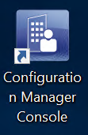

1. Navigate to \Assets and Compliance\Overview\Compliance Settings\Configuration Baselines

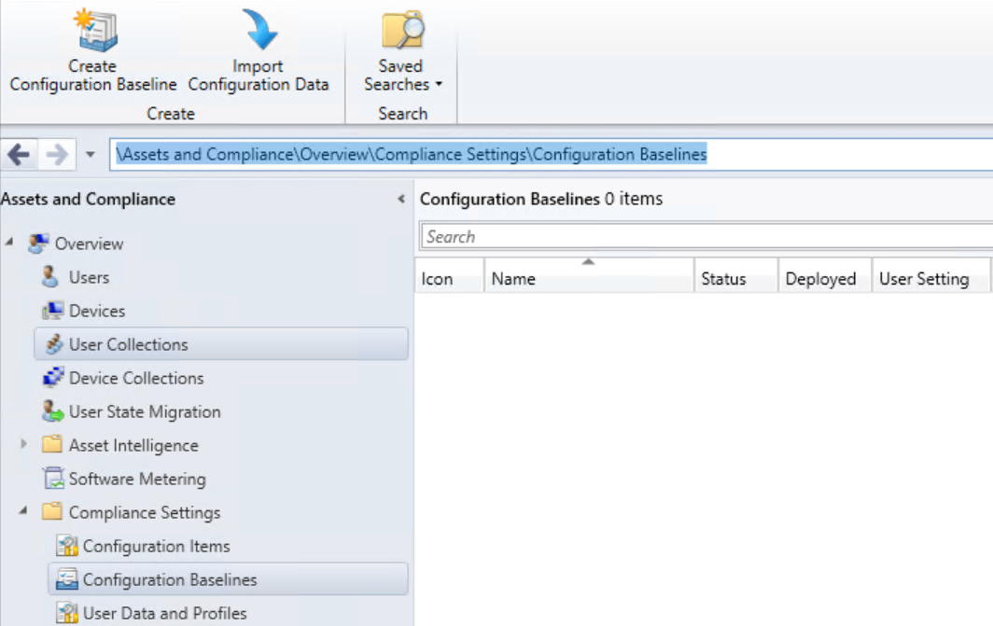

1. Click Import Configuration Data

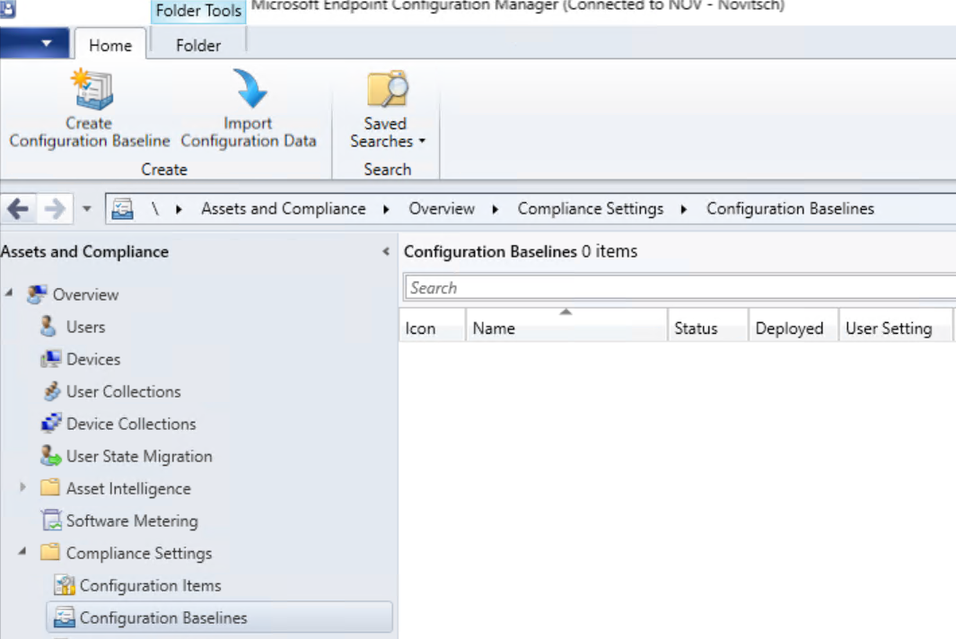

1. Click Add…

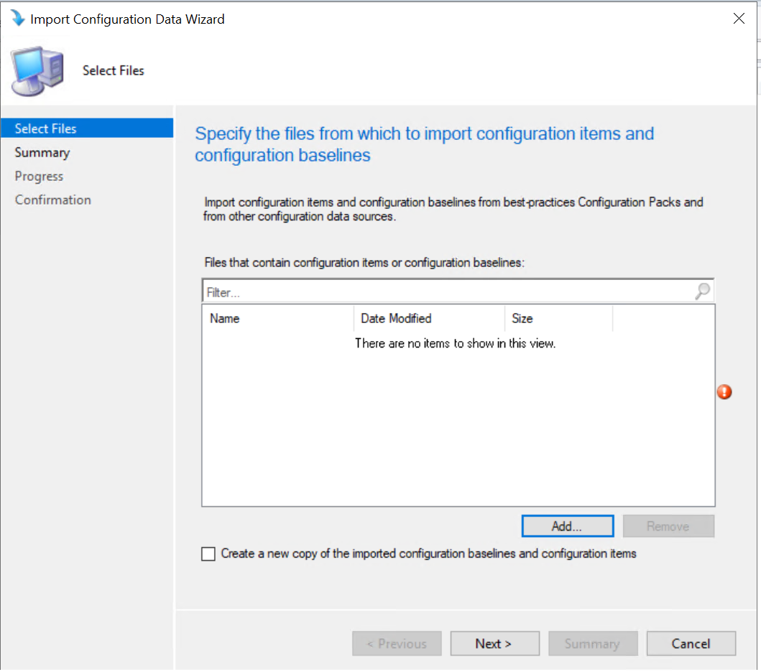

1. Navigate to the location of the “Installed Server Roles.cab” file you downloaded from step 1

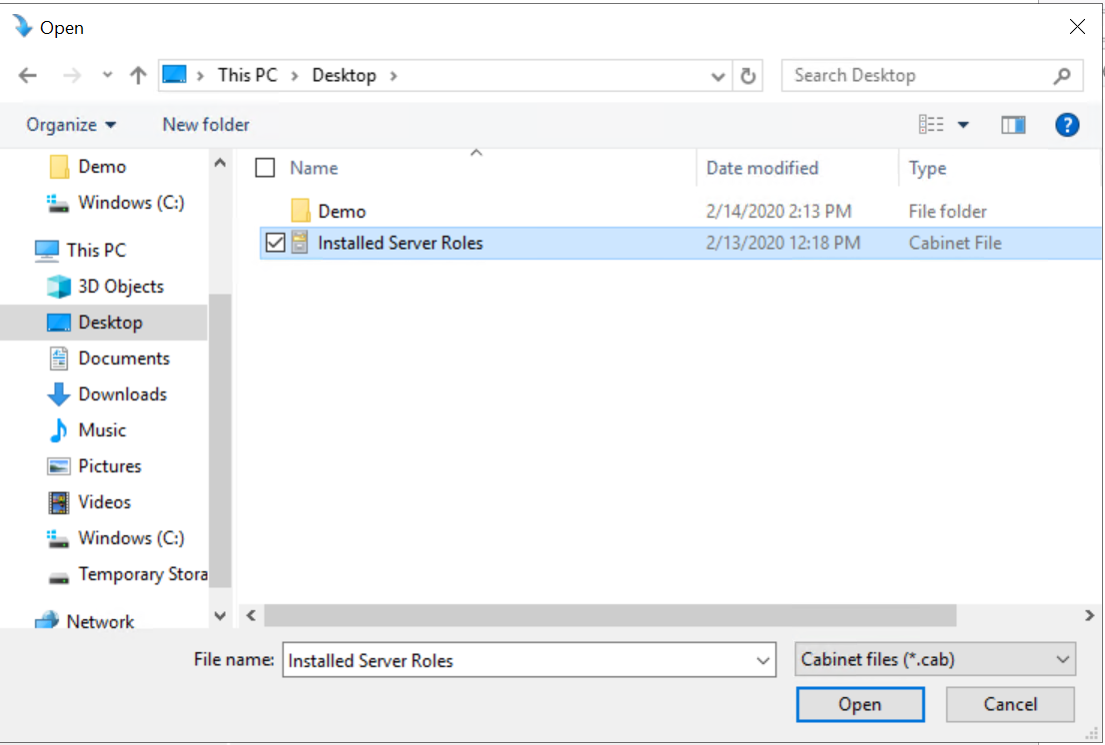

1. Click Open once you have found “Installed Server Roles.cab”



1. Click Yes on the warning about “Installed Server Roles.cab” not being able to verify

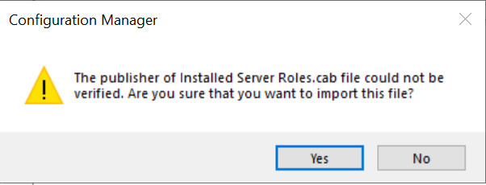

1. Click Next after you verify the Installed Server Roles.cab was added

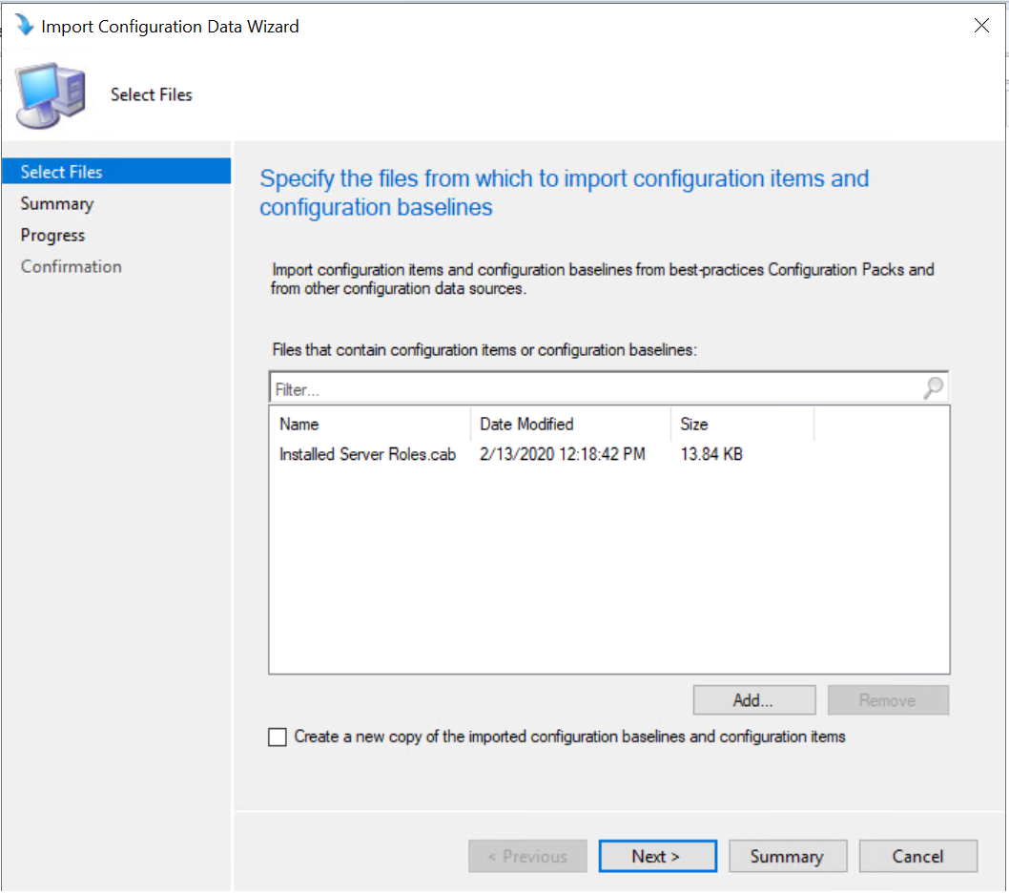

1. The summary will tell you that there is one configuration baseline and thirty-one configuration items

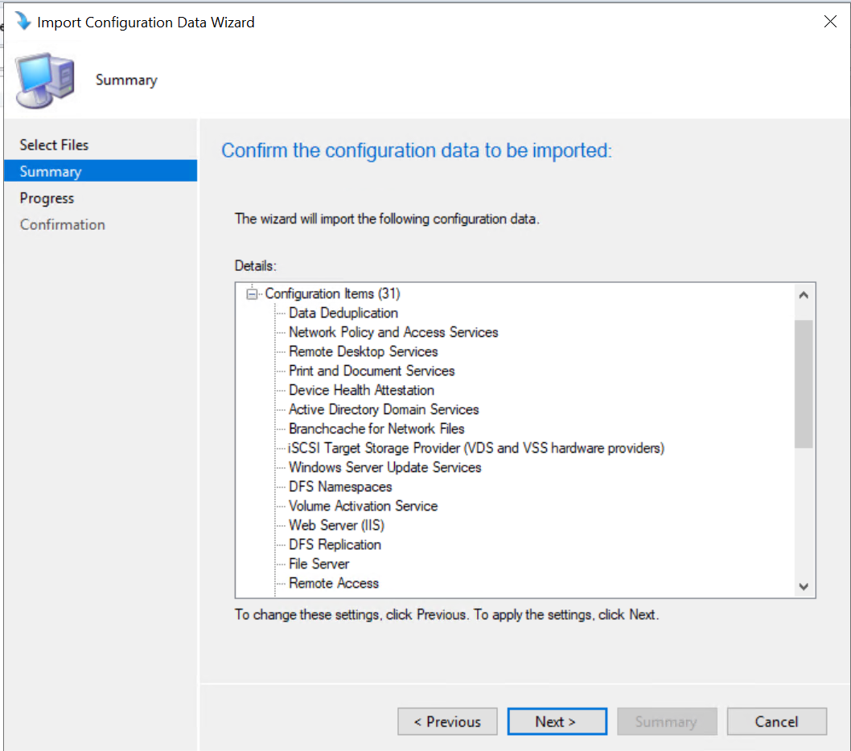

1. Click Next to start the import process



1. Wait for the import process to complete.
   1. **Please note this may take several minutes depending on what you have going on in your current environment**

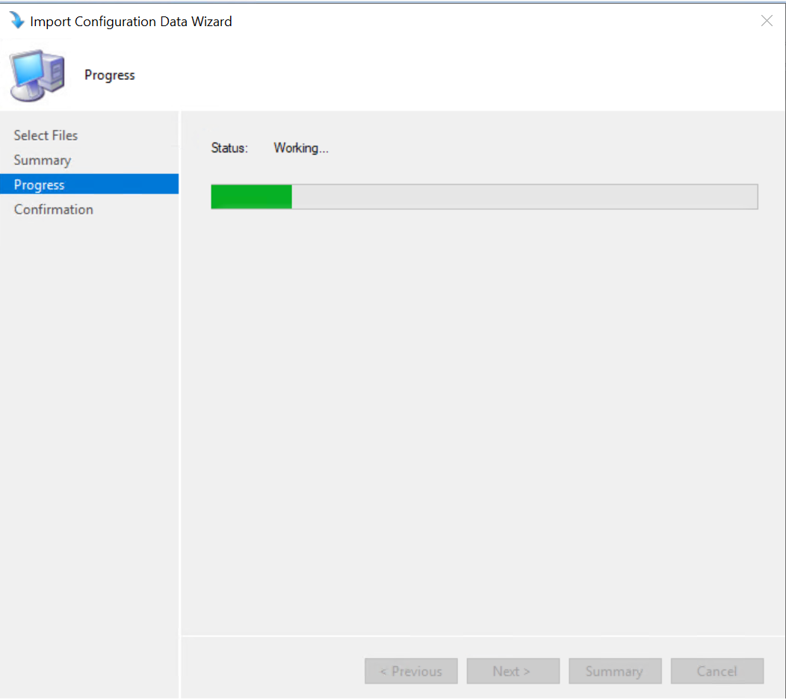

1. Once the import is complete, verify there was no errors during the import process. Everything should be green and once again you see there is one configuration baseline and thirty-one configuration items

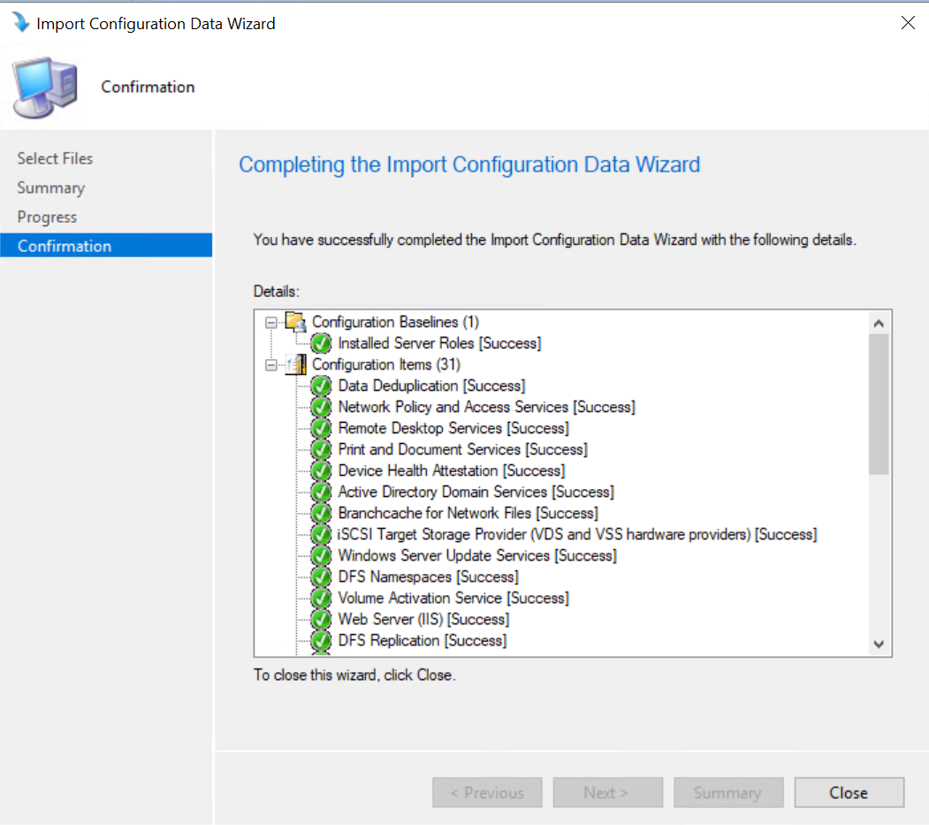

1. Click Close to complete



1. Verify the Configuration Baseline is in the Configuration baseline section in SCCM Console

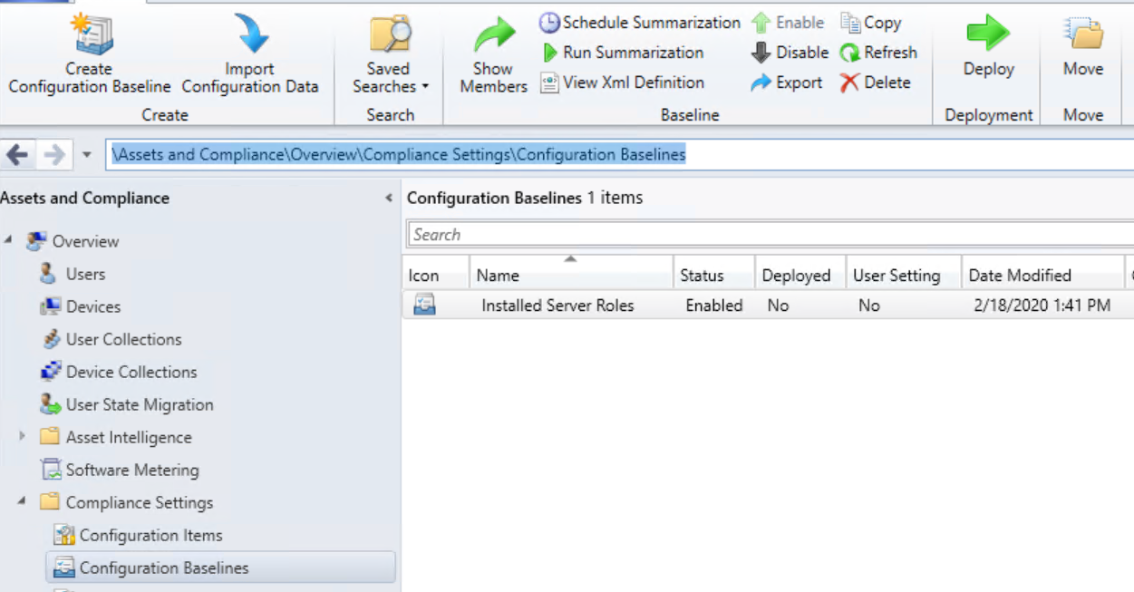

1. Verify the thirty-one Configuration Items are in the Configuration Baseline section in SCCM Console (List of Items to look for are in the reference section of the document)

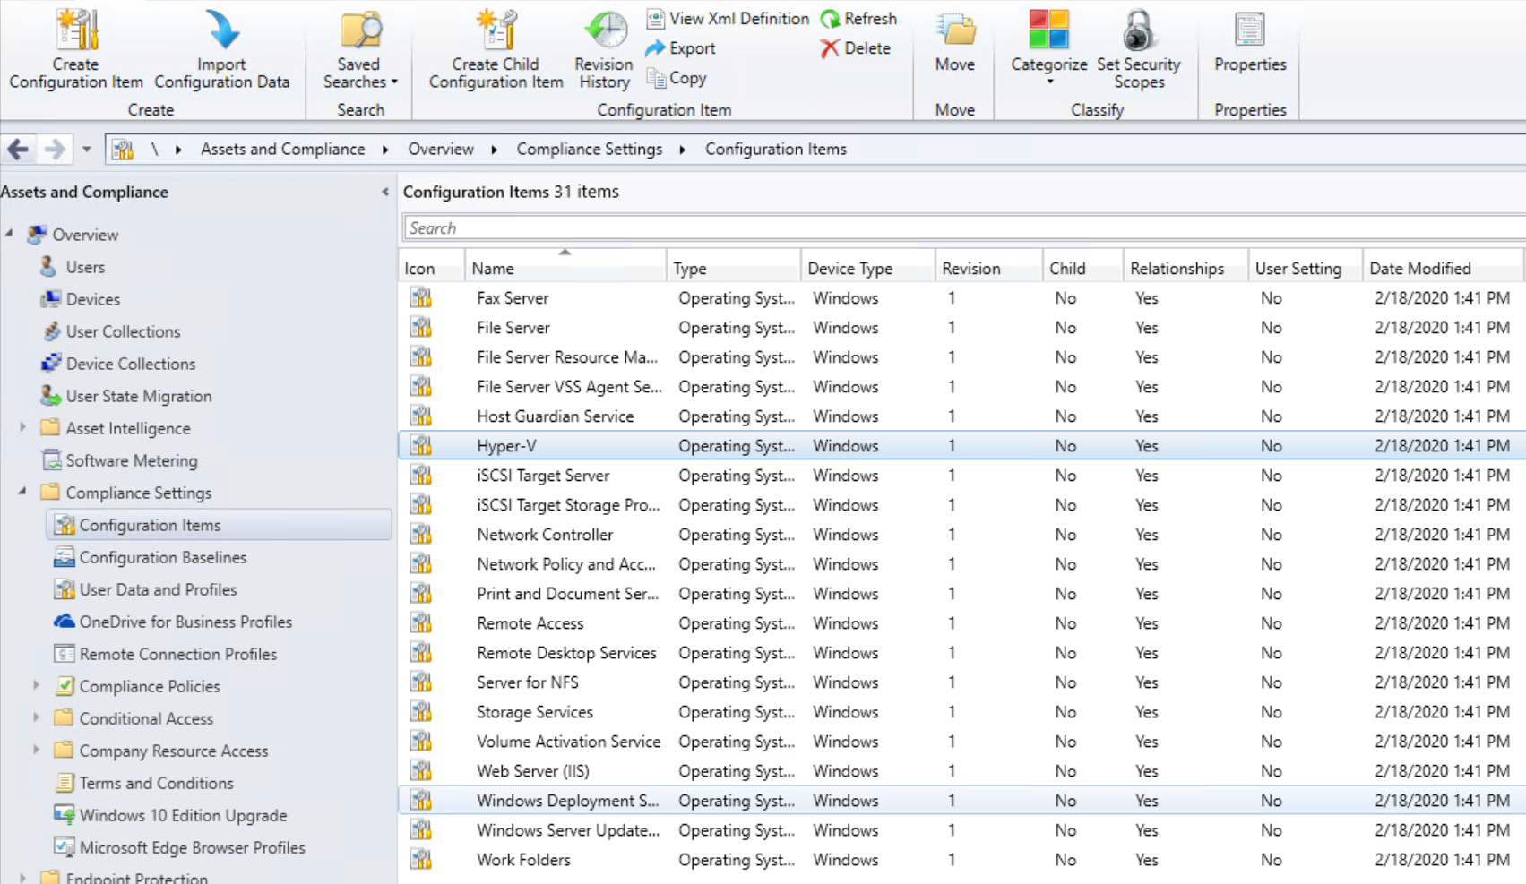

1. Navigate to \Assets and Compliance\Overview\Compliance Settings\Configuration Baselines



1. Select Installed Server Roles

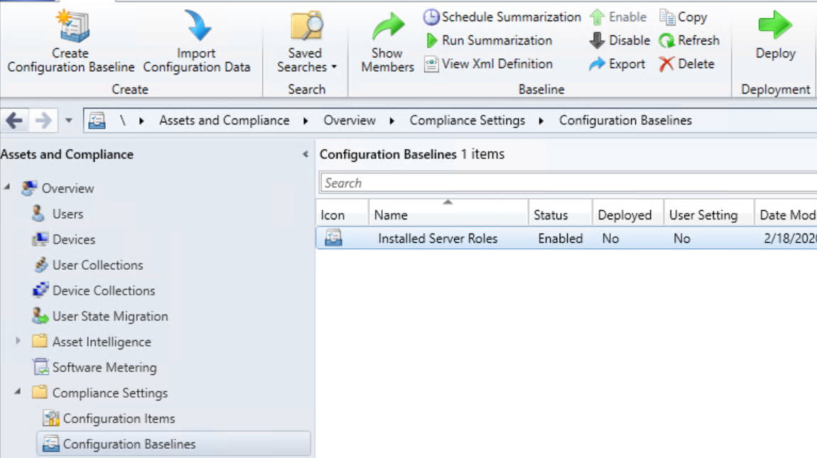

1. Click Deploy



1. Click Browse next to Collection section of the deployment wizard

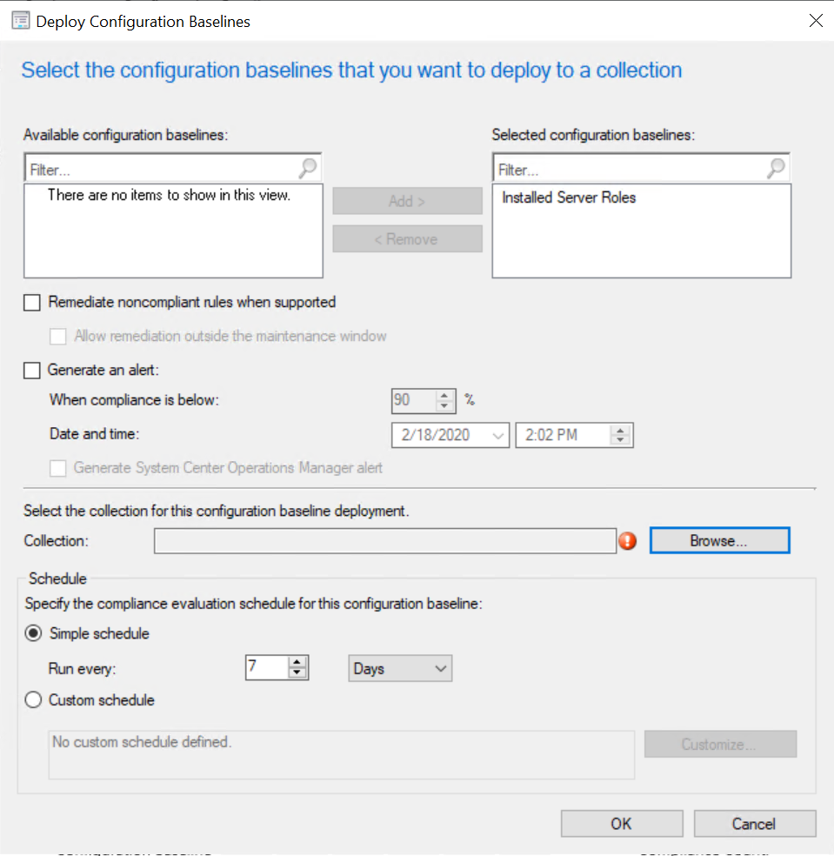

1. Change the User Collection to Device Collection

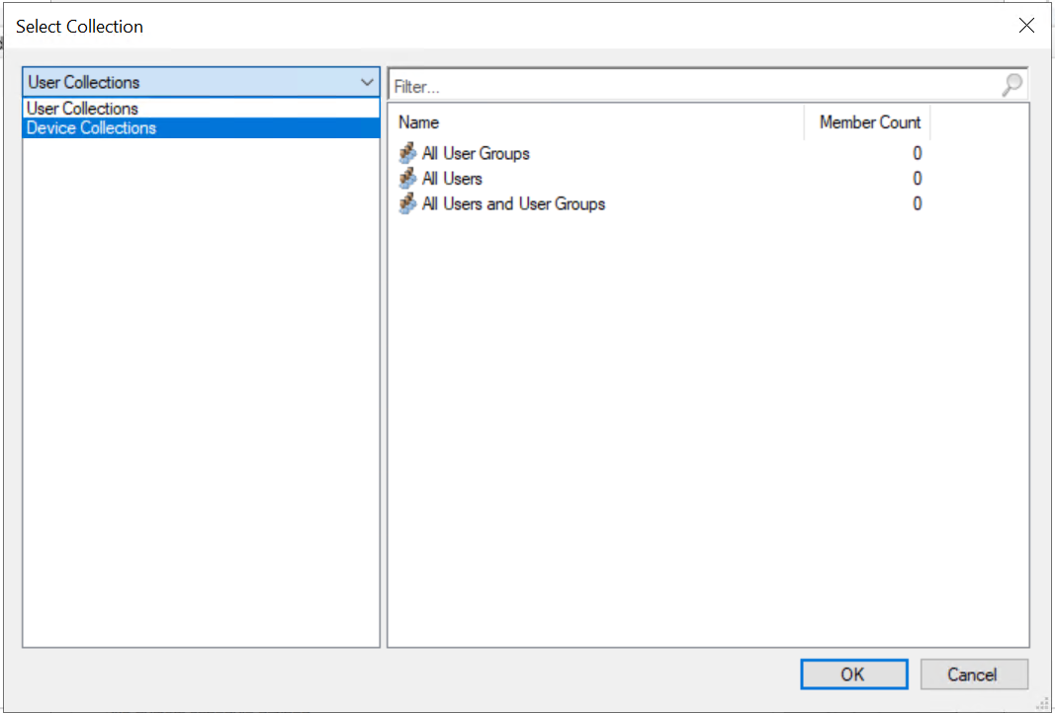

1. Find and select the Collection named **All Desktop and Server Clients** or another collection that contains all your servers in it

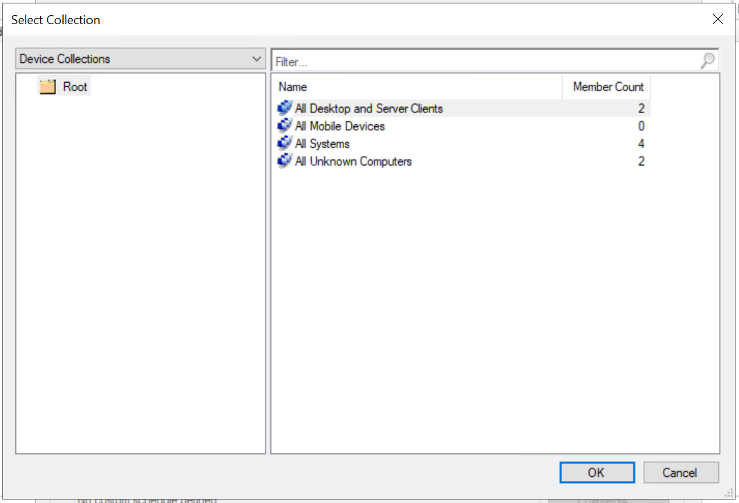

1. Click Ok to continue



1. Click Ok on the Deploy Configuration Baselines Wizard

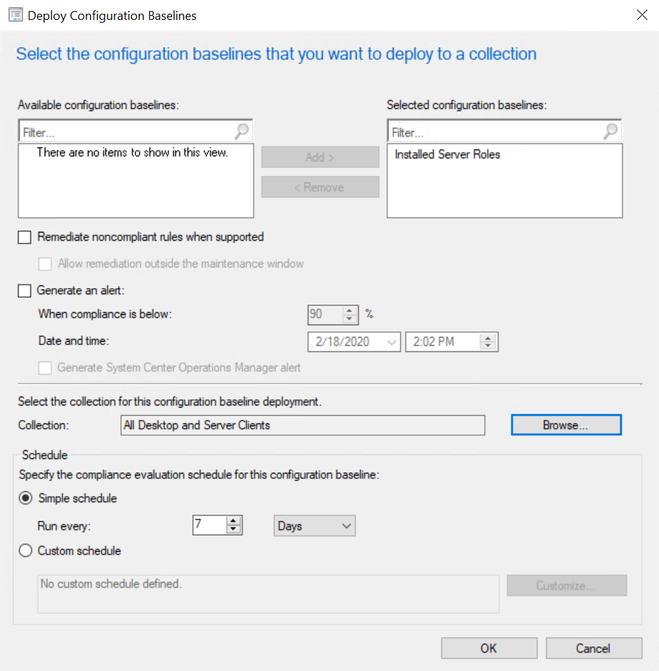

Please allow 7 days of running before checking the report, if you changed the simple schedule in the deployment then allow the number of days you changed the setting to.

1. References
   1. Configuration Baseline
2. Installed Server Roles
   1. Configuration Items
3. Server for NFS
4. Active Directory Certificate Services
5. Active Directory Domain Services
6. Active Directory Federation Services
7. Active Directory Rights Management Services
8. Branchcache for Network Files
9. Data Deduplication
10. Device Health Attestation
11. DFS Namespaces
12. DFS Replication
13. DHCP Server
14. DNS Server
15. Fax Server
16. File Server
17. File Server Resource Manager
18. File Server VSS Agent Service
19. Host Guardian Service
20. Hyper-V
21. iSCSI Target Server
22. iSCSI Target Storage Provider (VDS and VSS hardware providers)
23. Network Controller
24. Network Policy and Access Services
25. Print and Document Services
26. Remote Access
27. Remote Desktop Services
28. Storage Services
29. Volume Activation Service
30. Web Server (IIS)
31. Windows Deployment Services
32. Windows Server Update Services
33. Work Folders
    1. Download Configuration Baseline

1. <https://github.com/mattnovitsch/SCCM/blob/master/Installed%20Server%20Roles.cab>