CITY DRIVE
سيتي درايف
The Gulf's first AI-powered rental-car delivery service
أول خدمة لتوصيل سيارات الإيجار بالذكاء الاصطناعي في الكويت والخليج

Prepared for: City Drive leadership
Scope: Client website · Operations CRM · Mobile app · Proposal
Market: Kuwait-first, GCC-ready · Currency KWD · KNET payments
Status: Interactive bilingual prototypes — ready to review
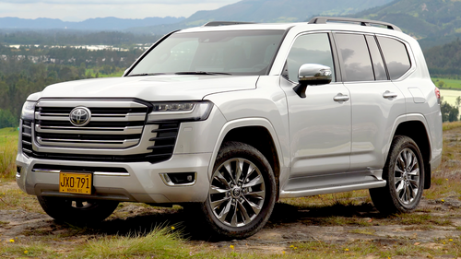 | 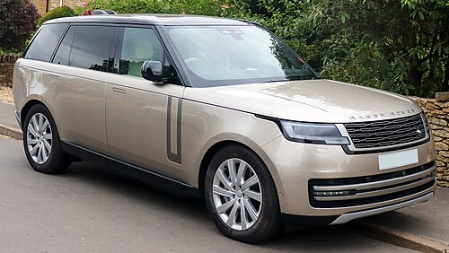
Real fleet — Toyota Land Cruiser · Range Rover · Mercedes · BMW · Nissan · Hyundai · Geely

Executive summary
This proposal accompanies three working, interactive prototypes for City Drive — a Kuwait-based car-rental company built around one promise: the first AI-powered car-delivery experience in the Gulf. Members discover and book vehicles in Arabic or English, a smart assistant guides every step, and the car is delivered to their door.
Everything is clickable right now in a browser — no servers, accounts, or installation. The goal of this phase is to turn the idea into something tangible you can react to before committing to a full build.

What's new in this version
- City Drive — rebranded from the original concept to a Kuwait-first identity.
- Bilingual — full Arabic & English with true right-to-left layout, Arabic-first by default.
- AI assistant — a 24/7 chat assistant plus interest-based notifications — the headline differentiator.
- Reserve flow — a complete 8-step booking journey from ID upload to KNET payment.
- Admin — managers can now add vehicles and staff through real validated forms.
- Photos — the entire fleet now uses real photography across seven brands.

The three prototypes

1 · Client website
The member-facing storefront. A cinematic hero tells the AI-delivery story, followed by a searchable, filterable fleet of real cars priced in KWD. Members register in one step (name, email, Kuwait address) and immediately move into a logged-in experience with rewards and an AI concierge.
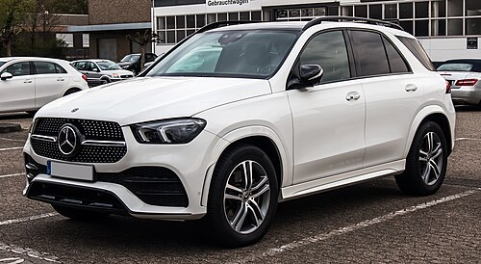
Mercedes GLE — one of the luxury models in the bilingual fleet grid.

2 · Mobile app
A phone-framed preview of the planned native iOS and Android app: home, search, an AI assistant tab, notifications, registration, and the full reserve flow — all bilingual with RTL tab navigation.

3 · Operations CRM
The internal console, with role-based access for Manager, Accountant, and Support. Two new processes were added this round: a validated Add-vehicle form that registers a car into the live fleet, and an Add-staff form that creates a teammate with a role and access scope. Finance, bookings, and WhatsApp/SMS + AI engagement automations are all in KWD with Kuwaiti data.

The reserve-car journey
The core of the platform — a guided, gated 8-step flow that keeps the customer's documents secure and the rental compliant with Kuwait requirements:
- Account: guests are prompted to register; only members can book.
- Civil ID: upload the National Civil ID (skipped if already on file).
- Licence: upload a valid local driver licence; validity checked by number (mock API ready for the real PACI / licence integration).
- Period: choose the car and period — minimum 1 day (24h), maximum 3 months — with live pricing.
- Summary: total amount plus included features: full insurance, free delivery, 24/7 assistance, AI tracking.
- Terms: scrollable Terms & Conditions with required agreement.
- Verification: digital signature pad plus a selfie with licence and Civil ID.
- Payment: KNET, Visa/Mastercard, or PayPal (mock gateway), then confirmation and an AI delivery notification.

AI assistant & smart notifications
- Chat assistant — recommends the right car, books it, and tracks delivery — in Arabic and English, on web and app.
- Notifications — learns from activity and favourites to send timely offers ("Based on your interest in SUVs…").
- Smart delivery — AI plans the fastest delivery route and gives a live arrival time to the customer's door.

Built for the Gulf
- Culture — Arabic-first interface with genuine right-to-left layout (not a flipped translation), Cairo & Tajawal typography sized for legibility.
- Local — KWD pricing, Kuwait governorates and cities, KNET as a first-class payment method.
- Compliance — Civil ID and local-licence checks, age 21+ and licence-held rules reflected in the flow.
- Trust — security and insurance reassurances placed right at the decision points, as Gulf users expect.
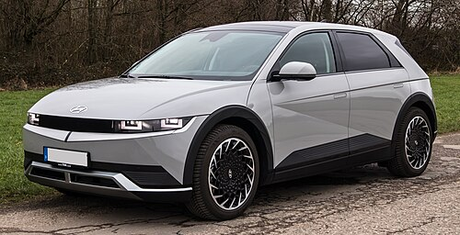
Hyundai Ioniq 5 — the electric option, reflecting eco-forward demand.

How it maps to your requirements
Every feature requested is represented. "Built" means interactive in the prototype; "Demonstrated" means the interface is complete with the underlying processing to be connected during production.
Requirement | Where it lives | Status
Client registration / sign-up | Web + app — name, email, address; logged-in state | Built
Arabic & English (full RTL) | All pages — AR-default toggle, Cairo/Tajawal fonts | Built
AI assistant & smart notifications | Chat widget + interest-based alerts, web & app | Built
Real car photos (7 brands) | Toyota, Nissan, Hyundai, Geely, Mercedes, BMW, Range Rover | Built
8-step reserve-car flow | Gated wizard: ID → licence → period → pay | Built
Admin: add new car | Operations CRM — validated modal form | Built
Admin: add new staff member | Operations CRM — role + access assignment | Built
KNET / Visa / PayPal payment | Reserve flow, step 8 (mock gateway) | Demonstrated
Civil ID & licence verification | Reserve flow, steps 2–3 (mock API) | Demonstrated

Technical notes & next steps
The prototypes are lightweight, self-contained HTML — no build step, no backend. All external services (Civil ID and licence verification, KNET/Visa/PayPal payment, notifications) are clearly marked mock functions, designed so a real backend can slot straight in.
- Production phase 1 — connect identity (PACI / licence) and KNET payment gateways.
- Production phase 2 — add a real database for accounts, bookings, and fleet.
- Production phase 3 — replace prototype photography with owned/licensed imagery before launch.
Prototypes are illustrative: fleet, pricing, and member data are sample content, ready to swap once real identity and inventory are confirmed.

