GACHENA
Detect · Protect · Control Your Digital Footprint

Project Documentation

Built during MLH Hackathon by:
Abdi Megersa • Eba Alemu • Osama Hasan
July 2026

Table of Contents
[Right-click the table of contents and select 'Update Field' to refresh page numbers.]

1. Executive Summary
Gachena is an innovative web application designed to empower individuals to take control of their personal data by automating GDPR (General Data Protection Regulation) compliance requests. In an era where companies routinely collect, process, and monetize user data, Gachena provides a streamlined, AI-powered solution that bridges the gap between privacy rights and practical enforcement.
The application connects to a user's Gmail account, scans their inbox using Google Gemini AI to identify companies that hold personal data, discovers those companies' privacy policies through FireCrawl web scraping, extracts GDPR contact email addresses, and then automates the process of sending legally-compliant data access, modification, or erasure requests. The entire workflow is orchestrated through an intuitive Streamlit-based web interface that requires no technical knowledge to operate.
Gachena was developed by a three-person team during the MLH (Major League Hacking) Hackathon. The project leverages a modern tech stack including Python, Google Gemini 1.5 Flash via Vertex AI, the Gmail API, FireCrawl, and Streamlit, all containerized with Docker for easy deployment to platforms like Google Cloud Run. The name 'Gachena' reflects the Amharic word for 'your right,' emphasizing the application's core mission of helping users exercise their data privacy rights.

2. Project Overview

2.1 Problem Statement
Under the GDPR, EU citizens have the right to know what personal data companies hold about them (Article 15), the right to correct inaccurate data (Article 16), and the right to request deletion (Article 17). However, exercising these rights is notoriously difficult in practice. Most users do not know which companies hold their data, cannot easily find the correct GDPR contact email for each company, and lack the legal knowledge to compose properly formatted requests. The process of sending individual requests to dozens of companies is tedious and time-consuming, leading most people to simply give up on their privacy rights.

2.2 Solution
Gachena automates the entire GDPR compliance request workflow. By connecting to the user's Gmail account, the application scans incoming emails to build a comprehensive map of companies that have interacted with the user. Using AI-powered analysis, each email is classified and company information is extracted automatically. The application then discovers each company's privacy policy page, extracts the relevant GDPR contact email address, and provides pre-built legal templates that the user can send with a single click. The result is a tool that transforms a multi-hour manual process into a few minutes of guided interaction.

2.3 Key Features
Google OAuth Authentication: Secure sign-in with granular Gmail read/send permission scopes and cookie-based session persistence.
AI-Powered Email Analysis: Gemini 1.5 Flash classifies emails as 'interacted' or 'not interacted' and extracts company names and websites.
Privacy Policy Discovery: FireCrawl API automatically finds privacy policy URLs from company domains.
GDPR Contact Extraction: AI extracts data privacy contact emails from discovered privacy policy pages.
Interactive Dashboard: Streamlit data editor with checkboxes, dropdowns, company logos, and filtering.
Automated Email Sending: Bulk or individual sending of GDPR requests (Access, Modify, Erase) via Gmail API.
Demo Mode: Toggle to use pre-loaded sample data for testing and demonstration without API calls.

3. System Architecture
Gachena follows a linear pipeline architecture where each stage builds on the output of the previous one. The system is designed as a client-side Streamlit application that communicates with multiple external APIs (Google, Gemini, FireCrawl, Logo.dev) to perform its core functions. No server-side database is used; all data is processed in memory during the session and discarded when the session ends, ensuring maximum privacy for the user.

3.1 Architecture Diagram
The following diagram illustrates the end-to-end data flow from Gmail inbox scanning through to automated GDPR request sending:
User -> Google OAuth Login -> Streamlit UI -> Scan Inbox -> Gmail API (fetch emails) -> Gemini 1.5 Flash (classify emails, extract company info) -> FireCrawl API (find privacy policy URLs) -> Gemini 1.5 Flash (extract GDPR contact emails from policies) -> Logo.dev API (fetch company logos) -> Interactive Data Table (user selects companies) -> Gmail API (send GDPR compliance emails)

3.2 Technology Stack
Layer | Technology | Purpose
Frontend | Streamlit 1.30+ | Interactive web UI with data editor, dialogs, and fragments
Language | Python 3.11+ | Core application logic and API orchestration
AI Model | Google Gemini 1.5 Flash | Email classification, company extraction, GDPR email extraction
AI Platform | Vertex AI | Cloud-based model hosting with service account auth
Email API | Gmail API (Google) | Reading user emails and sending GDPR requests
Web Scraping | FireCrawl API | Discovering privacy policy URLs from company domains
Logos | Logo.dev API | Retrieving company logos for the dashboard
Authentication | Google OAuth 2.0 + JWT | User login and persistent cookie sessions
Containerization | Docker | Reproducible deployment with non-root user
Deployment | Google Cloud Run | Serverless hosting platform

3.3 Data Flow
The data flow through Gachena can be broken down into four major phases. In the first phase, Authentication, the user signs in with their Google account using OAuth 2.0, granting the application read-only access to their Gmail and the ability to send emails on their behalf. A JWT cookie is set for session persistence so users do not need to re-authenticate on every visit.
In the second phase, Inbox Scanning, the application fetches emails from the user's Promotions and Updates categories within a configurable date range. Each email's plain text content (with HTML fallback) is extracted and passed to the Gemini AI model for classification. The AI identifies the company name, categorizes the interaction type, and infers the company website from the email content. A progress bar keeps the user informed during this potentially long-running operation.
In the third phase, Privacy Discovery, when the user selects a company and clicks 'Run Bot,' the application queries the FireCrawl API to find privacy policy pages on the company's domain. Once a valid privacy URL is found, the page content is scraped using UnstructuredURLLoader, and Gemini AI extracts the GDPR-specific contact email address from the text.
In the final phase, Request Sending, the application composes a GDPR-compliant email using one of three pre-built templates referencing specific GDPR articles (Article 15 for Access, Article 16 for Modification, Article 17 for Erasure). The user can preview the email in a dialog before sending, or send requests in bulk to multiple companies at once. All emails are sent through the user's own Gmail account via the Gmail API, ensuring a verifiable chain of communication.

4. Application Screenshots
The following screenshots illustrate the Gachena user interface at different stages of the workflow. The application uses a dark theme with a green accent color (#77dd77) consistent with the Gachena branding. The landing page features an interactive particles.js animation that creates a visually engaging first impression.

4.1 Landing Page
Before signing in, users are greeted with a full-screen landing page featuring a particle animation background and a typewriter effect that cycles through the words 'Access,' 'Erase,' and 'Modify.' The tagline reads 'Your Data, Your Right to' with the cycling word completing the phrase. This communicates the application's purpose immediately upon loading.
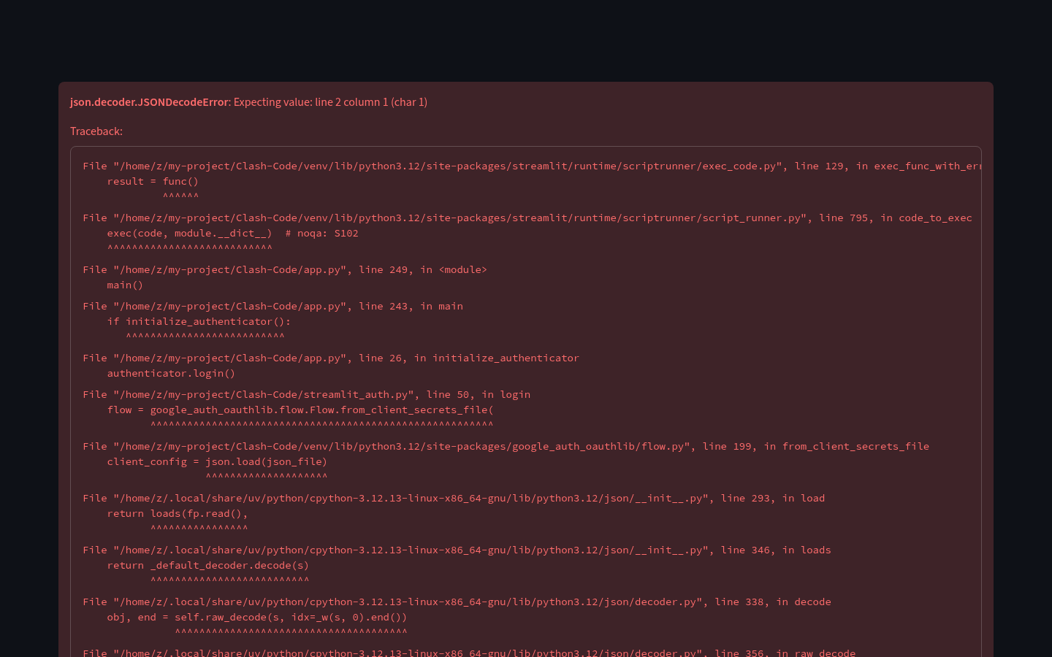
Figure 1: Gachena Landing Page with Particle Animation

4.2 Main Dashboard
After authentication, the main dashboard is displayed. It provides a four-step guide explaining how to use the application: Scan Inbox, Adjust Advanced Settings, Review and Select companies, and Run the Bot. The Scan Inbox button triggers the email analysis pipeline, and a Demo Mode toggle allows users to explore the interface with pre-loaded sample data without making actual API calls.
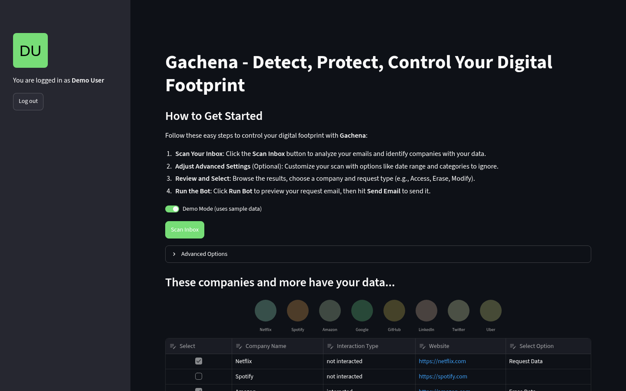
Figure 2: Main Dashboard with Step-by-Step Guide

4.3 Company Data Table
The results of an inbox scan are displayed in an interactive data editor table. Each row represents a detected company with columns for Company Name, Interaction Type (interacted or not interacted), Website (as a clickable link), a Select checkbox, and a Select Option dropdown. The dropdown offers three GDPR request types: Request Data, Modify Data, and Erase Data. Users select the companies they want to contact and choose the appropriate request type for each.
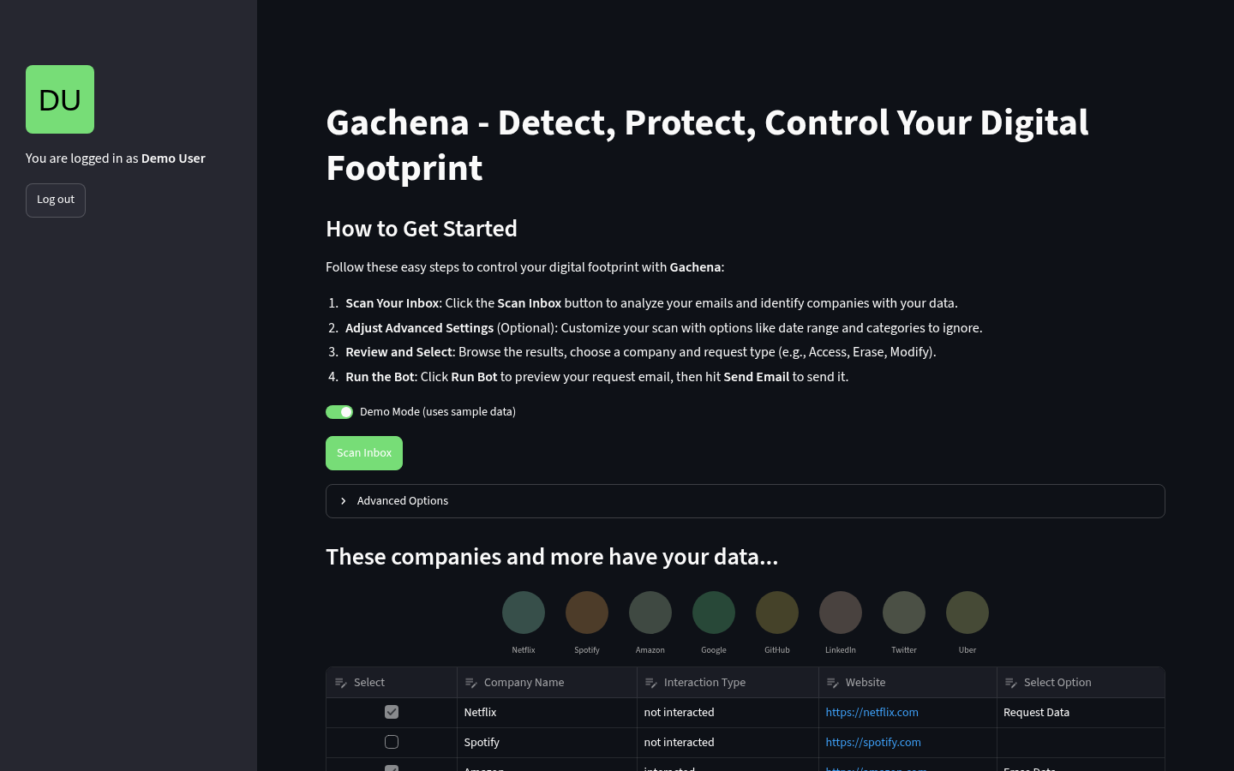
Figure 3: Interactive Company Data Table with Selection Controls

4.4 Sidebar Navigation
The sidebar displays the authenticated user's profile picture and name, along with a Log out button. The Google Sign-in button (visible before authentication) uses the official Google branding with a blue background and white text. Session persistence is handled through JWT cookies, so returning users do not need to re-authenticate within the cookie expiry period.

Figure 4: Sidebar with User Profile and Navigation

5. Setup and Installation Guide

5.1 Prerequisites
- Python 3.11 or higher installed on your system
- A Google Cloud Platform (GCP) project with billing enabled
- Gmail API enabled in the GCP project's API Library
- Vertex AI API enabled in the GCP project
- A FireCrawl API key (sign up at firecrawl.dev)
- A Logo.dev API key (request access at logo.dev)
- Google OAuth 2.0 credentials (client ID and client secret)
- A Vertex AI service account key (JSON file)
- Docker (optional, for containerized deployment)

5.2 Clone and Install
Clone the repository and install the Python dependencies:
git clone https://github.com/Hope0351/Clash-Code.git
cd Clash-Code
pip install -r requirements.txt

5.3 Environment Configuration
Copy the included .env.example file to .env and fill in your actual credentials. The .env file is git-ignored and will never be committed to the repository.
cp .env.example .env
# Then edit .env with your actual API keys and credentials
The following table describes each environment variable:
Variable | Required | Default | Description
FIRECRAWL_API_KEY | Yes | - | FireCrawl API key for privacy policy discovery
LOGODEV_API_KEY | Yes | - | Logo.dev API key for company logo retrieval
SERVICE_ACCOUNT_PATH | Yes | service_acc.json | Path to Vertex AI service account JSON
VERTEX_PROJECT | Yes | - | Your Google Cloud project ID
COOKIE_KEY | Yes | - | JWT signing secret (use a strong random string)
GOOGLE_REDIRECT_URI | No | http://localhost:8501/ | OAuth redirect URI
GEMINI_MODEL | No | gemini-1.5-flash-001 | Vertex AI model name
MAX_GEMINI_RETRIES | No | 3 | Maximum retries on API rate limit (429)
GEMINI_RETRY_DELAY | No | 60 | Base delay in seconds between retries
COOKIE_EXPIRY_DAYS | No | 30 | Days until auth cookie expires

5.4 Google OAuth Setup
To set up Google OAuth 2.0 authentication, follow these steps in the Google Cloud Console:
- Go to Google Cloud Console (console.cloud.google.com) and select your project
- Navigate to APIs & Services > Credentials
- Click 'Create Credentials' > 'OAuth client ID'
- Select 'Web application' as the application type
- Add http://localhost:8501 to the 'Authorized redirect URIs' list
- Download the OAuth credentials JSON and save it as credentials.json in the project root
- For Vertex AI: Create a service account, grant it 'Vertex AI User' role, and download the key as service_acc.json

5.5 Running the Application
Start the application with the following command:
streamlit run app.py
Then open your browser and navigate to http://localhost:8501

6. User Guide

6.1 Step 1: Sign In
When you first open Gachena, you will see the landing page with a particle animation. In the sidebar, click the 'Sign in with Google' button. You will be redirected to Google's consent screen where you can review and approve the requested permissions (Gmail read-only, Gmail send, and basic profile information). After approving, you will be redirected back to Gachena and your profile picture and name will appear in the sidebar.

6.2 Step 2: Scan Your Inbox
On the main dashboard, click the 'Scan Inbox' button to begin analyzing your emails. By default, the application scans the last 7 days of emails from the Promotions and Updates categories. You can customize this by expanding the 'Advanced Options' section to adjust the date range (up to 60 days), exclude specific categories, and control the maximum number of emails to fetch per category. A progress bar will show the scanning status as each email is processed through the AI pipeline.

6.3 Step 3: Review and Select Companies
After scanning, the detected companies are displayed in an interactive table. Each row shows the company name, the interaction type (whether the email was triggered by a user action or is a marketing email), and the company website as a clickable link. Use the Select checkbox to choose which companies you want to send GDPR requests to. Then use the Select Option dropdown to choose the request type: 'Request Data' (Article 15), 'Modify Data' (Article 16), or 'Erase Data' (Article 17). You can select multiple companies for bulk sending.

6.4 Step 4: Run the Bot
Click the 'Run Bot' button to initiate the GDPR request process. If 'Preview Email' is enabled (the toggle on the right), and you have selected exactly one company, a preview dialog will open showing the composed email with the recipient address, subject line, and full body. Review the email and click 'Send Email' to confirm. If 'Preview Email' is disabled, the application will send requests to all selected companies without previewing. For each company, Gachena will: (1) find the privacy policy URL using FireCrawl, (2) extract the GDPR contact email using AI, and (3) compose and send the GDPR request email through your Gmail account.

6.5 Demo Mode
For testing and demonstration purposes, you can enable 'Demo Mode' using the toggle on the main dashboard. In demo mode, clicking 'Scan Inbox' loads pre-loaded sample email data from the gemini_processed_emails.json file instead of connecting to your real Gmail inbox. This allows you to explore the full interface including the data table, company selection, and email preview without requiring valid API keys or a Google Cloud project.

7. API Integration Details

7.1 Gmail API
The Gmail API is used for two purposes: reading the user's emails and sending GDPR request emails. For reading, the application uses the users.messages.list endpoint with query parameters to filter by date range and category labels (CATEGORY_PROMOTIONS, CATEGORY_UPDATES). The users.messages.get endpoint retrieves individual email content, with support for both plain text and HTML MIME parts. For sending, the application composes a MIMEText message, base64-encodes it, and sends it via the users.messages.send endpoint. The application requests gmail.readonly and gmail.send scopes, which are the minimum permissions needed for its functionality.

7.2 Google Gemini (Vertex AI)
Gemini 1.5 Flash is used for two distinct AI tasks. The first is email classification, where the model receives an email's text content and returns a structured JSON object containing the company name, an interaction type classification (interacted or not interacted), and the company website. This uses Vertex AI's structured output feature with a defined response schema to ensure consistent, parseable results. The second task is GDPR contact email extraction, where the model analyzes the full text of a company's privacy policy page and returns the data privacy or GDPR contact email address. Both tasks use temperature=0 for deterministic output. The application implements exponential backoff retry logic (configurable via MAX_GEMINI_RETRIES and GEMINI_RETRY_DELAY) to handle rate limiting (HTTP 429) gracefully.

7.3 FireCrawl API
The FireCrawl API (api.firecrawl.dev/v1/map) is used to discover privacy policy pages on company domains. The application sends a POST request with the company's website URL and a search query of 'privacy' to find relevant pages. The API returns a list of URLs, and the application iterates through them to find the first one that returns a successful HTTP 200 response. This URL is then passed to the GDPR contact extraction pipeline. The API requires an API key passed as a Bearer token in the Authorization header.

7.4 Logo.dev API
The Logo.dev API provides company logo images based on domain names. For each detected company, the application constructs a Logo.dev URL by cleaning the company website (removing https://, www., and trailing slashes) and appending it to the Logo.dev image endpoint with the API token. The logos are displayed in a randomized grid layout on the dashboard, giving users a visual overview of the companies that hold their data.

8. Project File Structure
The project consists of the following files:
File | Description
app.py | Main Streamlit application entry point. Handles authentication, UI layout, email scanning trigger, and bot execution.
utils.py | Core business logic including Gmail API calls, Gemini AI classification, FireCrawl privacy discovery, GDPR email templates, and authentication setup.
streamlit_auth.py | Google OAuth 2.0 authentication module. Manages the OAuth flow, token exchange, and session state.
streamlit_auth_cookie.py | JWT cookie handler for persistent sessions. Encodes/decodes user info in signed JWT tokens.
index.html | Landing page with particles.js animation and typewriter effect. Displayed before user authentication.
requirements.txt | Pinned Python dependencies with version ranges for reproducible installs.
Dockerfile | Docker container configuration using python:3.12-slim, non-root user, and system dependency installation.
.dockerignore | Excludes secrets, media, docs, and dev files from Docker build context.
.env.example | Template for environment variables with documentation for each variable.
.gitignore | Git exclusions for secrets, credentials, Python cache, IDE files, and OS files.
diagnostic.py | Utility script to verify OAuth credentials.json has the correct redirect URIs.
gemini_processed_emails.json | Sample pre-processed email data used by Demo Mode.
LICENSE | MIT open-source license.
docs/screenshots/ | Application screenshots for README and documentation.

9. Security Considerations
Gachena handles sensitive user data (emails, authentication tokens, personal information) and communicates with multiple external APIs. The following security measures are implemented:

9.1 Authentication and Session Security
- Google OAuth 2.0 with minimal permission scopes (gmail.readonly, gmail.send, userinfo)
- JWT-signed cookies for session persistence with configurable expiry (default 30 days)
- Configurable cookie signing key loaded from environment variable (never hardcoded)
- Token refresh logic for expired OAuth credentials

9.2 Data Privacy
- No data storage: all email content is processed in memory and never persisted to disk or database
- End-to-end HTTPS encryption for all API communications
- credentials.json and service_acc.json are git-ignored and excluded from Docker builds
- .env file is git-ignored and excluded from Docker builds via .dockerignore

9.3 Container Security
- Docker image uses python:3.12-slim base (reduced attack surface)
- Application runs as non-root user ('appuser') inside the container
- Secrets are injected via environment variables at runtime, never baked into the image
- .dockerignore prevents credentials, media, and development files from entering the image

10. Deployment

10.1 Docker Deployment
Build and run the Docker container:
docker build -t gachena-app .
docker run -p 8501:8080 \
-v $(pwd)/credentials.json:/app/credentials.json:ro \
-v $(pwd)/service_acc.json:/app/service_acc.json:ro \
-e FIRECRAWL_API_KEY=your_key \
-e LOGODEV_API_KEY=your_key \
-e VERTEX_PROJECT=your-project \
-e COOKIE_KEY=your_random_secret \
gachena-app

10.2 Google Cloud Run
Deploy to Google Cloud Run for serverless hosting:
gcloud builds submit --tag gcr.io/your-project/gachena
gcloud run deploy gachena \
--image gcr.io/your-project/gachena \
--platform managed \
--region us-central1 \
--allow-unauthenticated \
--set-env-vars="FIRECRAWL_API_KEY=$KEY,VERTEX_PROJECT=$PROJECT,COOKIE_KEY=$SECRET"

11. Troubleshooting
Issue | Cause | Solution
'Sign in with Google' button does nothing | OAuth redirect URI mismatch | Ensure http://localhost:8501 is in your Google Cloud Console authorized redirect URIs
'credentials.json' not found | Missing OAuth file | Download OAuth credentials from Google Cloud Console and save as credentials.json
Rate limit errors during scan | Gemini API quota exceeded | Increase GEMINI_RETRY_DELAY or reduce MAX_EMAILS_SCAN in .env
'No email available' when running bot | Privacy policy has no GDPR contact | Some companies don't publish GDPR contacts; this is expected for some companies
Logo images not loading | Missing or invalid LOGODEV_API_KEY | Verify your Logo.dev API key is set and active
ModuleNotFoundError for vertexai | Missing dependency | Run pip install -r requirements.txt in your virtual environment
Docker build fails on unstructured | Missing system libraries | The Dockerfile installs build-essential and libxml2-dev; ensure you're using the updated Dockerfile

12. Future Improvements
While Gachena is a functional hackathon prototype, several enhancements could significantly improve its robustness and user experience:
Multi-language Privacy Policy Support: Currently the GDPR email extraction assumes English privacy policies. Adding multilingual support through Gemini's language capabilities would make the tool useful for companies worldwide.
Request Tracking Dashboard: Implement a local database (SQLite or Firestore) to track sent GDPR requests, company responses, and follow-up deadlines, giving users a complete audit trail.
Batch Rate Limiting: Instead of processing all emails sequentially, implement a queue-based system with configurable concurrency to speed up the scanning process for users with large inboxes.
Email Template Customization: Allow users to edit the GDPR email templates directly in the UI, add custom fields, and save multiple template variants for different use cases.
Multi-provider Support: Extend beyond Gmail to support Outlook, Yahoo, and other email providers through their respective APIs or IMAP.
GDPR Article 20 (Data Portability): Add support for data portability requests, where users can request their data in a machine-readable format.
Automated Follow-up: Implement scheduled follow-up emails when companies do not respond within the GDPR-mandated 30-day timeframe.

13. License and Credits
Gachena is released under the MIT License. The project was developed during the MLH Hackathon by a team of three:
- Abdi Megersa - Backend and AI Integration
- Eba Alemu - Frontend and UI Design
- Osama Hasan - DevOps and Deployment
The project builds upon several open-source tools and services, including Streamlit, Google Gemini, FireCrawl, Logo.dev, and the particles.js animation library. The authentication module was inspired by the Streamlit-Authenticator package by mkhorasani.

