CENTRAL UNIVERSITY OF TECHNOLOGY
Faculty of Engineering, Built Environment & Information Technology

Work Integrated Learning 2026
Group S

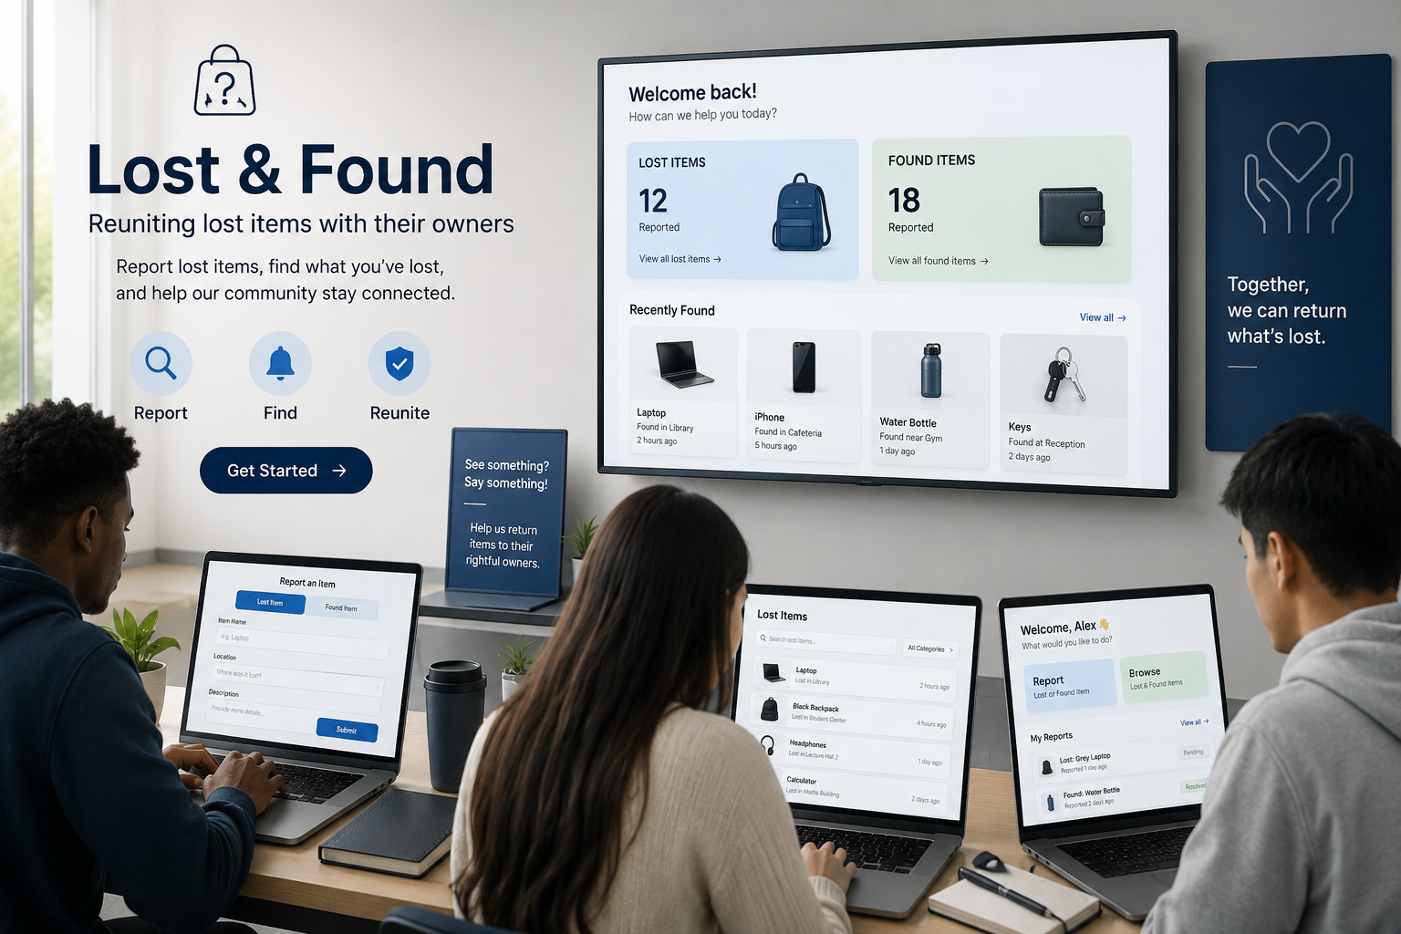

Group Members Details
NH Khosa: 222002087
AJ Katu: 220044317
EB Mmakola: 224031692
SM Zungu: 224066331
CT Zikalala: 224047638
BL Makwele: 219013255

TABLE OF CONTENTS

- Introduction…………………………………………………………………………………………………………………………………….1
  - Project Background…………………………………………………………………………………………...............................1
  - Problem Statement……………………………………………………………………………………………………………………….1
  - Purpose of the project……………………………………………………………………………………….............................1
  - Project Objectives………………………………………………………………………………………………………………………...1
  - Stakeholder Information……………………………………………………………………………………………………………….1
  - Project Scope………………………………………………………………………………………………...................................2
- Current Lost & Found Processes………………………………………………………………………………………………..…….2
  - Overview of the current process…………………………………………………………………………...........................2
  - How Found Items Are Currently Handled………………………………………………………………………………………2
  - Role of Protection Services……………………………………………………………………………………………………………2
  - Problems with the Current Manual Process………………………………………………………………………………….2
  - Impact on Students & Staff…………………………………………………………………………………………………………..3
  - Limitations of the Existing System………………………………………………………………………………………………..3
- Proposed Solution…………………………………………………………………………………………………………………………..3
  - Proposed System………………………………………………………………………………………………………………………….3
  - System Overview…………………………………………………………………………………………………………………..……..3
  - Student Mobile Application…………………………………………………………..……………………………………………..3
  - Protection Services Staff Dashboard…………………………………………………………………………………………….4
  - How the Proposed System address the current challenges……………………………………………..…………..4
- System Technologies……………………………………………………………………………………………………………………...4
  - Flutter………………………………………………………………………………………………………………………………………….4
  - ASP.NET……………………………………………………………………………………………………………………………………….5
  - Supabase……………………………………………………………………………………………………...................................5
  - Integration between these components………………………………………………………………………………………5
  - Reason for technologies selections……………………………………………………………………….........................5
- Deliverables & Acceptance Criteria………………………………………………………………………………..……………….5
- Requirements……………………………………………………………………………………………………………………..………….6
  - Functional Requirements……………………………………………………………………………………………………………..6
  - Non-Functional Requirements……………………………………………………………………………………………………..6
  - System Requirements……………………………………………………………………………………….............................6
  - Integration Requirements…………………………………………………………………………………………………………….6
- Exclusions & Constraints …………………………………………………………………………….………………………………….6
- Assumptions…………………………………………………………………………………….…………………………….……………...7
- Feasibility Study……………………………………………………………………………………………………………………………..7
- Project Risk Register………………………………………………………………………………………………………………………8
- Stakeholder Evidence……………………………………………………………………………………………………………………..9
- GitHub Repository Link…………………………………………………………………………………………………………………….9
- Conclusion………………………………………………………………………………………………………………………………………9

INTRODUCTION
Background of the project
The Central University of Technology (CUT) experiences significant movement of students and staff on campus, leading to frequent loss of personal belongings such as student cards, identification cards, and phones. The current Lost and Found process is managed manually through Protection Services, where lost items are handed in and stored until claimed by the owner. This manual approach poses challenges, including limited visibility of lost items, unnecessary administrative burdens, and unclaimed items due to owners' lack of awareness. Additionally, there is insufficient digital tracking of items processed by Protection Services, leading to inefficiencies. To improve this process, DevCore proposes a digital CUT Lost & Found System, incorporating a mobile application for students and a web-based dashboard for staff. The student app will enable users to report found items, search and claim lost belongings, while the staff dashboard will facilitate management of reported items, claims verification, and confirmation of collected items. This system aims to enhance accessibility, organization, and transparency of the Lost and Found process. It allows students to check for their items remotely before visiting the office, while providing Protection Services with an improved tracking system from reporting to collection, ensuring efficient retrieval of lost belongings.
Problem Statement
The Lost and Found process at Central University of Technology (CUT) is primarily manual, leading to inefficiencies. When lost items are found by students or staff, they are submitted to the Protection Services office, which lacks a digital system for checking on lost belongings remotely. This results in students wasting time trying to locate their items, and many remain unclaimed because students are unaware of the items returned. Additionally, Protection Services has limited digital records to track items’ history, creating challenges for both students and staff. A need arises for a centralized, accessible system enabling students to report and search for lost or found items while allowing Protection Services to manage, verify claims, and record collections efficiently. DevCore proposes a digital CUT Lost & Found System featuring a mobile application for students and a staff dashboard linked to a shared database, enhancing visibility, organization, and tracking of lost-and-found items while supporting Protection Services' verification role.
Purpose of the Project
The CUT Lost & Found System aims to enhance the management of lost and found items at the Central University of Technology (CUT) by replacing the manual process. It will feature a mobile app for students to search for and report found items, alongside a web-based dashboard for Protection Services staff to manage and verify claims. Students can view items and submit claims, while staff will oversee the verification and collection process. This system will centralize and streamline records of lost-and-found items, minimizing the need for in-person visits to inquire about belongings. It serves as a prototype to showcase digital improvements while maintaining staff accountability.
Project Objectives
The main objective of the CUT Lost & Found System is to develop a realistic prototype that improves the current manual process of managing lost and found items at the Central University of Technology (CUT). The specific objectives of the project are to:
- Develop a mobile application that allows CUT students to securely access the Lost & Found system.
- Allow students to report found items by providing information such as the item's description, photograph and location where it was found.
- Allow students to search and browse reported items so that they can remotely check whether their lost belongings have been handed in.
- Allow students to submit claims for items they believe belong to them through the mobile application.
- Develop a staff dashboard that enables Protection Services to view, manage and update reported lost-and-found items.
- Provide a claim verification process where Protection Services staff can verify ownership before releasing an item to a claimant.
- Track the status of each item from when it is reported, through the claim process, until it is collected by the verified owner.
- Maintain a centralised record of lost-and-found items so that students and Protection Services can access consistent, updated information.
- Reduce unnecessary physical enquiries by allowing students to check the system before visiting the Protection Services office.
- Demonstrate the feasibility of a digital Lost & Found process through a working prototype that integrates the student mobile application, staff web dashboard and shared backend.
Stakeholder Information
Organization: CUT Protection Services
Stakeholder: Mr Relibile Mofokeng
Role: Director of Protection Services
Main Activities: Campus security, lost and found management, incident reporting and access control
Reason for Selection: Direct access to the stakeholder and opportunity to improve an existing manual process.
1
Project Scope
The scope of the CUT Lost & Found System covers the development of a prototype mobile application for students and a web-based dashboard for Protection Services staff. The item workflow will follow three main stages: Logged, Claim Pending and Collected.
Student mobile application:
- Student registration and login.
- Reporting of found items.
- Adding an item description, photograph and location.
- Searching and browsing reported items.
- Viewing item details.
- Submitting a claim for an item.
- Viewing the status of a submitted claim.
Protection Services dashboard:
- Viewing all reported items.
- Managing item information.
- Viewing pending claims.
- Verifying ownership before releasing an item.
- Confirming when an item has been collected.
- Maintaining the history and status of items.

CURRENT LOST & FOUND PROCESSES
Overview of the Current Process
At the Central University of Technology (CUT), the process of reporting and recovering lost property is largely dependent on manual communication between students, staff members, and Protection Services. When a student or staff member loses an item, they generally need to physically enquire with Protection Services or other relevant university personnel to determine whether the item has been found. Similarly, when someone finds an item on campus, the item is usually handed to Protection Services or another responsible staff member for safekeeping. The owner then has to make enquiries to determine whether their property has been recovered. Because there is no centralised digital Lost and Found platform, information about lost and found items may not be immediately visible to everyone on campus. This can make the recovery process slower and more difficult.
How Found Items Are Currently Handled
When an item is found on university premises, the person who discovers it is expected to hand it over to an appropriate university official or Protection Services. The item is then kept in a secure location until its owner can be identified or comes forward to claim it. A student who believes that an item belongs to them may need to contact or visit Protection Services and provide information that proves ownership. The responsible staff member can then compare the description provided by the student with the available found property before releasing the item. However, because this process is primarily manual, students may not know whether their item has already been handed in without directly making an enquiry.
Role of the Protection Services
Protection Services plays an important role in managing lost and found property on campus. Their responsibilities may include receiving found items, keeping them secure, record relevant information, assisting students and staff with enquiries, and returning property to its rightful owner. Protection Services also has an important responsibility to prevent unauthorised individuals from claiming items that do not belong to them. Therefore, ownership verification is an important part of the recovery process. In the proposed Lost and Found system, Protection Services would continue to perform these responsibilities but would be supported by a centralised digital platform. Staff members would be able to record found items, update their status, verify claims, and maintain a more organised record of recovered property.
Problems with the existing system
- Limited access of information – Students cannot easily view a central list of items that have been found.
- Difficult match – Manually comparing descriptions of lost and found items can be difficult, particularly when many items are being handled.
- Risk of lost records – Paper-based or informal records can be misplaced, damaged, or contain incomplete information.
- Duplicate enquiries – Repeated enquiries about the same item because students have no centralised way to check its status.
- Limited tracking – It can be difficult to determine the current status of an item, such as whether it is newly found, under verification, claimed, or still in storage.
- Security and accountability challenges – Maintaining accurate records of who submitted, handled, verified, and collected an item is more difficult when the process is entirely manual
2
Impact on Students and Staff
The existing process can have a negative impact on both students and staff. Students may experience frustration and uncertainty when trying to recover important belongings such as student cards, wallets, keys, electronic devices, bags, or academic materials. Students may also spend considerable time travelling to Protection Services or making enquiries without knowing whether their property has been found. This can be particularly inconvenient when students have busy academic schedules. For Protection Services and other staff members, the manual process can increase administrative workload. Staff may need to answer repeated enquiries, search through stored items, maintain records, verify ownership, and update information manually. As the number of students and lost-property reports increases, managing the process manually can become increasingly difficult and inefficient.
Limitations of the existing system
- No centralized platform – Lost & found information is not available through one dedicated digital system
- Limited real-time information - Users may not know immediately when an item has been found or its current status.
- Scalability - A manual process becomes increasingly difficult to manage as the number of students and reported items grows.
- Inconsistent information - Manually recorded information may be incomplete or inconsistent.
PROPOSED SOLUTION
The Proposed solution is a CUT Lost & Found System, a centralised digital platform designed to improve the way lost and found property is reported, managed, searched for, and returned at the Central University of Technology (CUT). The system will consist of a student mobile application and a Protection Services staff dashboard, both connected to a shared database. Students will be able to report lost or found items, search for items, submit claims, and receive updates. Protection Services staff will be able to manage reported items, verify claims, update item statuses, and maintain accurate records. The system is intended to reduce the dependence on manual enquiries and provide a faster, more transparent, and organised Lost & Found process.
System Overview
The proposed system will operate as a centralised platform connecting students, Protection Services, and the Lost & Found database. The basic structure of the system can be represented as:
Student >> Mobile Application >> Application >> Shared Database << Protection Services << Protection Services Staff
The student application will provide the front-end interface through which students interact with the system. The Protection Services dashboard will provide authorised staff with management functionality. When a student reports a lost or found item, the information will be submitted to the system and stored in the shared database. Protection Services will then be able to view and manage the report.
Student Mobile Application
The student mobile application will provide students with an accessible way to interact with the Lost & Found system using their mobile devices.
Main Student functions
  - Register & Login - Students will be able to access the system using their CUT-related account details or approved registration process. Authentication will help ensure that users are identifiable and that their information is protected.
  - Report a lost item - Students will be able to submit details about an item they have lost. The report may include: Item name, description, location, photograph & additional identifying information
  - Report a found item - A student who finds property can also submit a Found Item report. This allows the university to become aware of property that has been discovered on campus. Depending on the university's procedures, the physical item can then be handed to Protection Services for secure storage.
  - Submit a claim - When a student identifies an item that they believe belongs to them, they can submit a claim. The student may be required to provide additional information that demonstrates ownership. The claim will then be reviewed by Protection Services.
  - Track report status - Students will be able to see the status of their reports and claims. Possible statuses include: Reported, claim submitted, approved, rejected & returned

3

Protection Services Staff Dashboard
The Protection Services dashboard will provide authorised staff with a central location for managing the Lost & Found process. The dashboard will be designed for staff rather than students and will provide additional administrative functionality.

*View reported items - Staff will be able to view all lost and found reports submitted through the system. Reports can be filtered according to:
- Lost or found status.
- Date.
- Location.
- Current item status.

*Record found property - When an item is physically handed to Protection Services, staff can create or update the corresponding record. The system can store information such as:
- Item description.
- Location found.
- Person who handed in the item.
- Item status.

*Manage claims - Staff will be able to review student claims and compare the information provided by the claimant with the information recorded for the item. The claim can then be approved or rejected based on the verification process.

*Update item status - Staff will be able to update the status of an item as it moves through the process.
e.g Found → Stored → Claim Submitted → Verified → Returned

*Manage users - Authorised administrators can manage user accounts and access permissions where required. Different roles can be implemented, such as: Students, Protection Services Staff & System Administrator

How the Proposed System Address the Current Challenges
Current Challenge | Proposed Solution | Expected Benefit
Students rely on manual enquiries | Online/mobile reporting and searching | Students can access information more conveniently
No centralised Lost & Found platform | Shared digital database | All relevant information is stored in one location
Manual record keeping | Digital item records | Records are easier to maintain and retrieve
Difficult to search for items | Search and filtering functionality | Items can be found more quickly
Repeated enquiries to Protection Services | Online item status and search | Reduces unnecessary enquiries

SYSTEM TECHNOLOGIES

Flutter

Flutter will be used to develop the student mobile application. Flutter is a software development framework that allows developers to build applications from a single codebase. It uses the Dart programming language and provides widgets that can be used to create the application's user interface. Flutter is particularly suitable because the application is intended to be accessed through mobile devices. Its widget-based approach also makes it possible to create a consistent and user-friendly interface. For the CUT Lost & Found System, Flutter will be responsible for the student-facing features, including:
- Student registration and login.
- Home/dashboard screen.
- Reporting lost items.
- Reporting found items.
- Searching for found items.
- Viewing item details.
- Submitting claims.
- Tracking the status of reports and claims.
- Receiving notifications.

ASP.NET
ASP.NET Core will be used to develop the backend/API component of the system. It is a Microsoft web development framework that supports the development of web applications and RESTful APIs using languages such as C#. In the proposed system, ASP.NET Core will act as the communication layer between the Flutter application, Protection Services dashboard, and Supabase services.
The backend will be responsible for functions such as:
4
- Processing requests from the mobile application.
- Validating submitted information.
- Managing authentication and authorisation.
- Processing lost and found reports.
- Managing claims.
- Applying business rules.
- Controlling staff access.
- Communicating with the database.
- Returning appropriate responses to the Flutter application and staff dashboard.
Supabase
Supabase will be used as the backend data platform and database service for the proposed system. It provides services including a PostgreSQL database, authentication, file storage, and APIs. These features are useful for a Lost & Found application because the system needs to store structured information as well as potentially store photographs of lost and found items. Supabase Storage can also be used to store images uploaded with lost or found reports. Supabase can therefore provide the system with a central location for storing and retrieving Lost & Found information.
The database can contain tables such as:
- Users
- Items
- LostReports
- FoundReports
- Claims
- ItemStatusHistory
- Returns

Integration between Components
The different technologies will be integrated to create one complete Lost & Found system. The Flutter mobile application will communicate with the ASP.NET Core backend through APIs. ASP.NET Core will process requests and communicate with Supabase to store and retrieve information. The Protection Services dashboard will also connect to the backend, allowing staff to access and manage the same information submitted by students.
The basic flow will be:
Flutter Mobile App → ASP.NET Core API → Supabase Database
This integration ensures that when a student submits a report, the information can be processed, stored, and made available to authorised Protection Services staff. Updates made by staff can then be reflected in the student's application.
Reason for the selected Technologies
These technologies were selected because they provide a suitable combination of usability, reliability, scalability, and maintainability for the proposed system. Flutter is suitable for creating a user-friendly student mobile application, while ASP.NET Core provides a strong backend for processing system operations and managing communication between components. Supabase provides a convenient and structured way to store system data, manage authentication, and store item images.
Together, these technologies provide a modern architecture that can support the current requirements of the CUT Lost & Found System while also allowing future improvements. Additional features such as advanced item matching, notifications, analytics, multiple campuses, and improved reporting could be added as the system develops.

Deliverable | Acceptance Criteria
Flutter Mobile Application | Students can report lost/found items, search for items, and submit claims
ASP.NET Web Dashboard | Control room officers can view all items, manage claims, verify ownership, and mark items as returned
Supabase Backend (shared Database) | All item data, user information, and claims are stored in a shared database accessible to both applications
Item Status Tracking | Every item has a clear status: Logged → Claim Pending → Collected
Remote Visibility | Students can check item status without visiting the security office
Audit Trail | Full history is maintained for every item
5
REQUIREMENTS
Functional Requirements
ID | Functional Requirement
FR1 | The system shall allow students to register and log in using their CUT email and password.
FR2 | The system shall allow students to report found items by entering a description, location and photograph.
FR3 | The system shall allow students to search and browse reported items to find their lost belongings.
FR4 | The system shall allow students to submit a claim for an item they believe belongs to them.
FR5 | The system shall allow Protection Services staff to review claims, verify ownership and confirm when an item has been collected.

Non-Functional Requirements
ID | Non-Functional Requirement
NFR1 | The system shall have a simple and user-friendly interface that students and Protection Services staff can understand easily. (Usability)
NFR2 | The system shall protect user information by requiring secure authentication and authorised access to staff functions. (Security)
NFR3 | The system should respond to normal user actions, such as searching for an item, within a reasonable amount of time. (Performance)
NFR4 | The system should be available whenever students need to search for or report lost-and-found items, subject to internet and service availability. (Availability)
NFR5 | The system shall maintain accurate and consistent item information so that students and Protection Services see the correct item status. (Reliability)

System Requirements
ID | System Requirement
SR1 | The system shall require a mobile device and internet connection for students using the mobile application.
SR2 | The student application shall be developed using Flutter.
SR3 | The Protection Services dashboard shall be developed using ASP.NET.
SR4 | The system shall use Supabase as the shared backend for storing and managing Lost & Found information.
SR5 | The system shall provide appropriate access for students and Protection Services staff, with staff having additional management functions.

Integration Requirements
ID | Integration Requirement
IR1 | The Flutter mobile application shall connect to the shared backend to submit and retrieve Lost & Found information.
IR2 | The ASP.NET staff dashboard shall connect to the shared backend to manage items and claims.
IR3 | Information submitted through the Flutter application shall be stored in Supabase and made available to authorised staff.
IR4 | Changes made by Protection Services through the ASP.NET dashboard shall be reflected in the student application.
IR5 | The Flutter application, ASP.NET dashboard and Supabase backend shall work together to maintain a consistent item status, such as Logged → Claim Pending → Collected.

Exclusion | -No real time GPD tracking of items  -No financial transactions  -No Artificial Intelligence  - No AI image recognition of matching items
Constraints | -Project must be complete within one semester  -Only CUT email address (@cut.ac.za) can register or sign up  -Must use Flutter + ASP.NET + Supabase stack  -Stakeholder availability for check-ins is limited 6
Assumptions | - Stakeholder will be available for selected meetings  - Control room officers will have access to computers for the web dashboard  - Students have smartphones to access the mobile app  - Supabase free tier will be sufficient for the prototype

FEASIBILITY STUDY
Technical Feasibility: Technically feasible with some limitations
The system can be developed using technologies such as Flutter for the mobile application, ASP.NET Core for the backend/API, and Supabase for storing user and lost-and-found information. The project requires computers capable of running the required development software, internet access, and suitable development environments such as Visual Studio Code or Visual Studio. The group has skills in programming, database development, web/mobile development, and system design. However, integrating Flutter, ASP.NET Core, and Supabase may require additional learning and testing. Limitation/Required change: The prototype should focus on the most important features first, such as user registration, reporting lost/found items, viewing items, searching, and updating item status.

Operational Feasibility: Operational feasible
The proposed system is suitable for a university Lost and Found environment because students and staff frequently move around campus and may lose or find personal belongings. The system can provide a central platform where users can report lost items, report found items, search existing reports, and receive information about possible matches. Staff can also manage reports and verify that items have been returned. The main challenge is ensuring that students and staff actually use the system instead of relying on informal methods such as WhatsApp groups or physically asking around. The system should have a simple and user-friendly interface so that users can quickly report an item without needing technical knowledge. Clear instructions should also be provided.

Economic Feasibility: Economically feasible for the prototype
The project is economically feasible for a prototype because the group can use existing computers and development tools. Many of the required software tools and development frameworks are available at little or no cost for educational development. The prototype does not require expensive physical infrastructure but full deployment would require a separate budget. Limitation/Required change: If the system were deployed across the entire university, additional costs could arise from hosting, maintenance, security, support, and increased database/storage requirements. The main resources required include: computers, internet access, development software, Flutter SDK, ASP.NET, Supabase/database services, time and skills from group members and testing devices such as smartphones
Legal Feasibility: Legally feasible with appropriate privacy and access control
The system will handle personal information such as names, student details, contact information, descriptions of lost items, and potentially photographs. Therefore, the system must comply with applicable privacy and information-protection requirements, particularly South Africa's Protection of Personal Information Act (POPIA). Users should be informed about what information is collected and why it is required. Access to personal information should also be restricted to authorised users. The system should avoid unnecessarily displaying sensitive personal information publicly. Limitation/Required change: The prototype should implement basic access controls and avoid exposing unnecessary student information. A full production system would require a more detailed privacy and security review.
Ethical Feasibility: Ethically feasible if appropriate verification, privacy and moderation procedures are implemented
The system must treat students and staff fairly and responsibly. Lost-and-found information should only be used for its intended purpose of helping return items to their rightful owners. The system should not allow users to falsely claim items or misuse another person's information. Staff should verify ownership before an item is released. The system should also provide equal access to users and avoid unfairly prioritising certain users. Limitation/Required change: A verification process should be included before an item is marked as returned. Users should also be able to report suspicious or incorrect information.
Schedule Feasibility: Schedule feasible with proper planning and prioritisation.
The project can realistically be completed within the available semester if the group divides the work among members and follows a clear development schedule. The main schedule risk is attempting to implement too many features within the semester. Limitation/Required change: The group should prioritise the core Lost and Found functionality and leave advanced features for future development. 7
Requirements gathering > System & interface design > Database development > Flutter application development > Backend development > Integration > Testing > Documentation > Final presentation
Overall decision: FEASIBLE WITH CHANGES The CUT Lost and Found System is considered feasible with changes. The project can be technically developed, used by the intended stakeholders, and completed within the semester using the available resources. However, the group should limit the prototype to its essential functionality and consider privacy, security, verification, and user adoption carefully.

PROJECT RISK REGISTER – CUT LOST & FOUND SYSTEM
Based on your current project, the proposed system consists of a Flutter student app, an ASP.NET staff dashboard, and a shared Supabase backend. The main process is that items are logged, claims are submitted, and staff verify and confirm collection.

Risk Rating Scale
- Likelihood: 1 = Very Low, 2 = Low, 3 = Medium, 4 = High, 5 = Very High
- Impact: 1 = Very Low, 2 = Low, 3 = Medium, 4 = High, 5 = Very High
- Risk Score: Likelihood × Impact
- 1–4: Low, 5–9: Medium, 10–15: High, 16–25: Critical

ID | Risk | Category | Likelihood | Impact | Score/Level | Mitigation | Contingency | Owner | Status
R01 | Flutter, ASP.NET and Supabase may not connect properly. | Technical | 4 | 5 | 20 – critical | Test integration early. | Use sample data if needed. | Technical Lead | Monitoring
R02 | A student may falsely claim an item. | Secutity | 3 | 5 | 15 – High | Staff verify ownership. | Reject the claim. | Admin Lead | Monitoring
R03 | Student information may be accessed by the wrong person. | Legal / Security | 3 | 5 | 15 – High | Use secure login and access control. | Restrict access and fix permissions. | Backend Lead | Monitoring
R04 | The group may not finish the project on time. | Schedule | 4 | 4 | 16 – Critical | Follow the project schedule. | Remove non-essential features. | Project Manager | Monitoring
R05 | Students may not use the new system. | Operational | 3 | 4 | 12 – High | Make the app simple. | Use it alongside the manual process. | Stakeholder | Monitoring
R06 | Incorrect information may be entered. | Data | 3 | 4 | 12 – High | Use required fields. | Staff correct the information. | Admin Lead | Open
R07 | App and dashboard may show different item statuses. | Technical | 3 | 4 | 12 – High | Test shared database updates. | Staff correct the status. | Backend Lead | Monitoring
R08 | Too many features may delay the project. | Scope | 4 | 4 | 16 - Critical | Focus on core features. | Remove extra features. | Project Manager | Monitoring
3 Highest Project Risks
R01 – Flutter, ASP.NET and Supabase may not connect properly – 20 Critical
R04 – The group may not finish the project on time – 16 Critical
R08 – Too many features may delay the project – 16 Critical

8
Stakeholder Evidence
GitHub Repository Link: https://github.com/Hope3780/lost-and-found--app
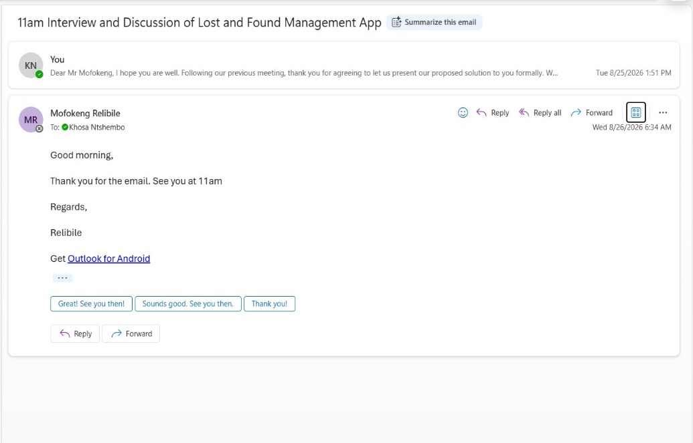 | 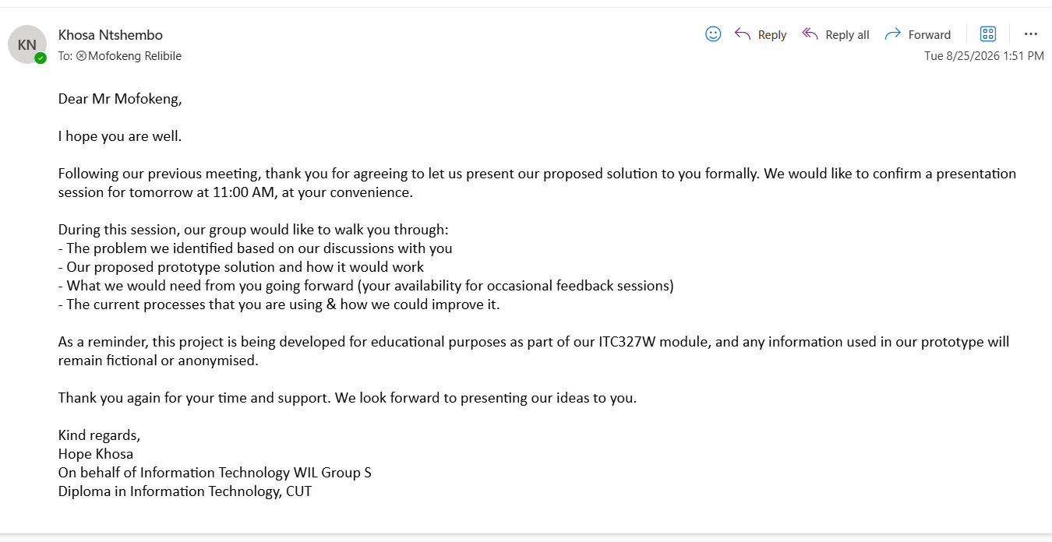
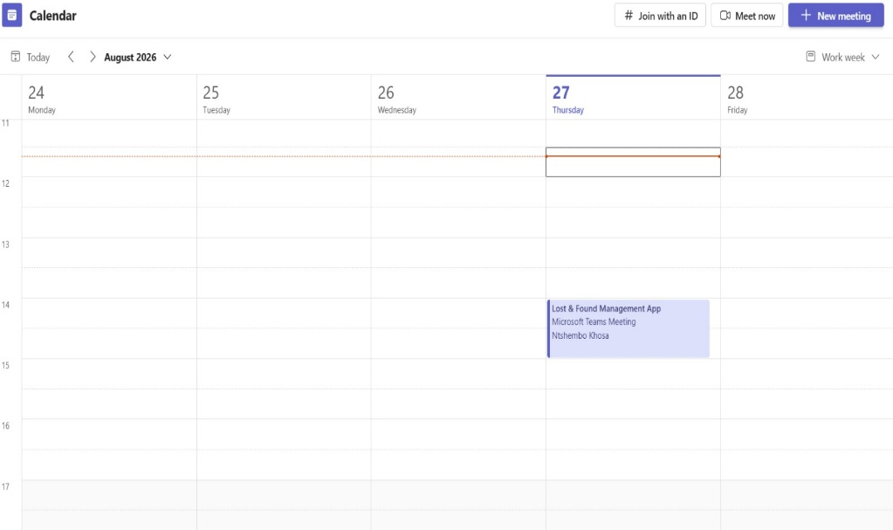 | 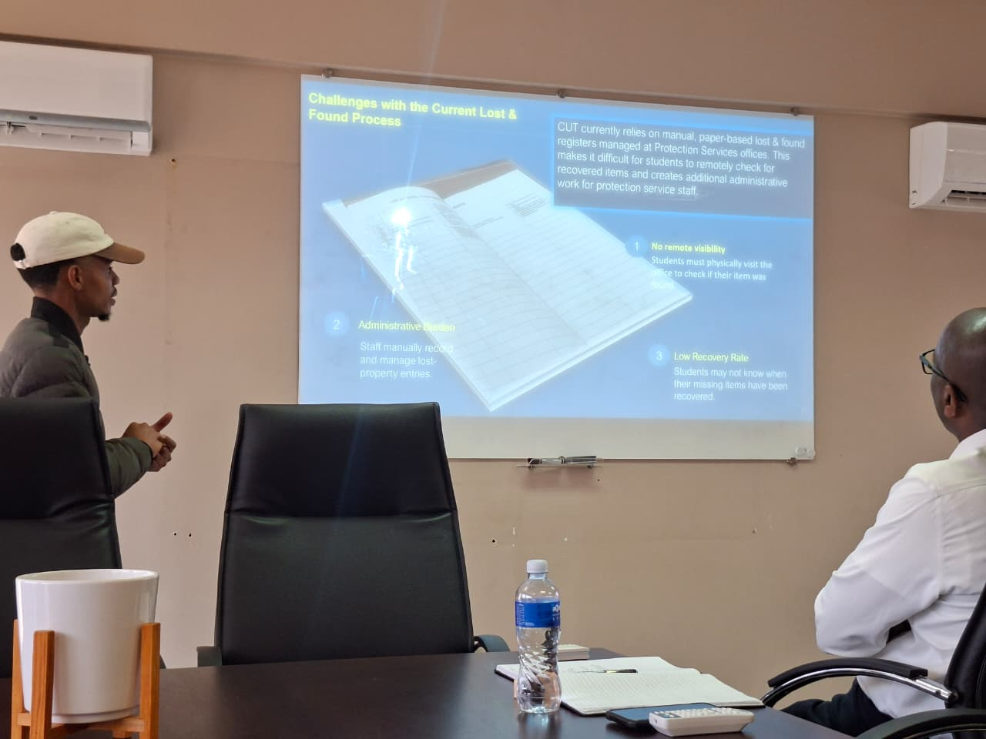

Conclusion
The CUT Lost and Found System is proposed as a comprehensive digital solution to address the limitations associated with the current manual management of lost and found property at the university. The existing process may result in inefficiencies, delays in communication, difficulties in maintaining accurate records, and challenges in effectively matching lost items with their rightful owners. The proposed system seeks to address these challenges by introducing a centralised platform for the systematic reporting, recording, tracking, verification, and management of lost and found items. The system will provide students with a convenient and accessible platform through which they can report lost property, view items that have been found, submit claims, and receive updates regarding the status of their reports.
Protection Services will be provided with appropriate functionality to record found items, manage item information, review and verify ownership claims, update item statuses, and maintain reliable records. This centralised approach will improve the overall organisation of lost and found information while supporting more effective communication between students and Protection Services. The proposed implementation will utilise Flutter, ASP.NET, and Supabase to provide an integrated and scalable technological solution. Flutter will be used to develop the student-facing mobile application, ASP.NET will support the backend services, business logic, and system operations, while Supabase will provide database and data management functionality. The integration of these technologies will contribute towards the development of a system that is reliable, maintainable, secure, and accessible to its intended users.
In conclusion, the CUT Lost and Found System has the potential to significantly improve the efficiency and effectiveness of the university's lost and found process. By replacing fragmented and predominantly manual procedures with a centralised digital platform, the system can improve information management, communication, accountability, and accessibility. Furthermore, the system can increase the likelihood of lost property being successfully recovered and returned to its rightful owners. Therefore, the proposed solution represents a practical and sustainable approach to modernising the management of lost and found property at CUT while providing meaningful benefits to both students and Protection Services.
9

