CENTRAL UNIVERSITY OF TECHNOLOGY
Faculty of Engineering, Built Environment & Information Technology

Work Integrated Learning 2026
Group S

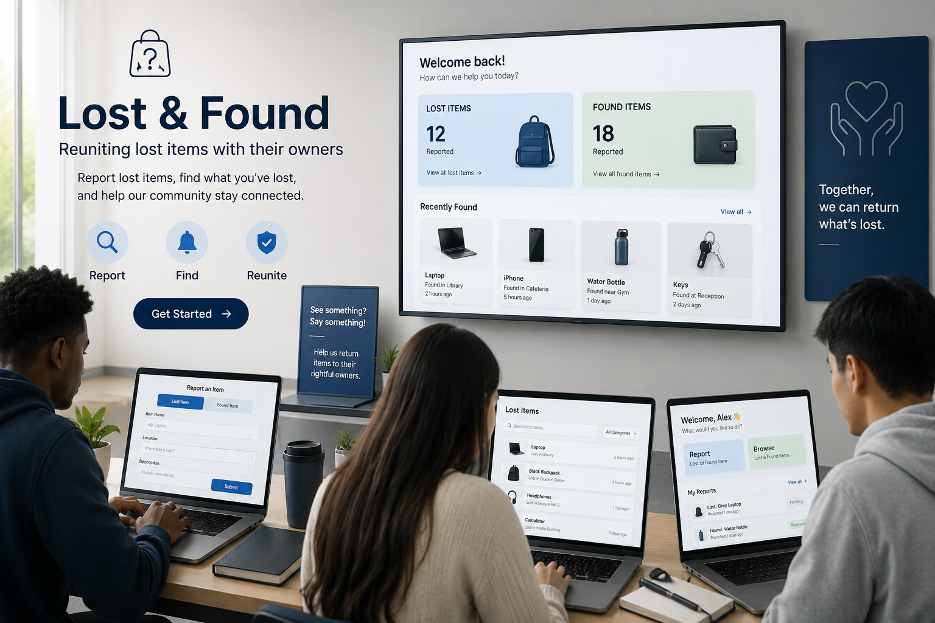

Group Members Details
NH Khosa: 222002087
AJ Katu: 220044317
EB Mmakola: 224031692
SM Zungu: 224066331
CT Zikalala: 224047638
BL Makwele: 219013255

TABLE OF CONTENTS

- Introduction…………………………………………………………………………………………………………………………………….1
  - Project Background…………………………………………………………………………………………...............................1
  - Problem Statement……………………………………………………………………………………………………………………….1
  - Purpose of the project……………………………………………………………………………………….............................1
  - Project Objectives………………………………………………………………………………………………………………………...1
  - Stakeholder Information……………………………………………………………………………………………………………….1
  - Project Scope………………………………………………………………………………………………...................................2
- Current Lost & Found Processes………………………………………………………………………………………………..…….2
  - Overview of the current process…………………………………………………………………………...........................2
  - How Found Items Are Currently Handled………………………………………………………………………………………2
  - Role of Protection Services……………………………………………………………………………………………………………2
  - Problems with the Current Manual Process………………………………………………………………………………….2
  - Impact on Students & Staff…………………………………………………………………………………………………………..3
  - Limitations of the Existing System………………………………………………………………………………………………..3
- Proposed Solution…………………………………………………………………………………………………………………………..3
  - Proposed System………………………………………………………………………………………………………………………….3
  - System Overview…………………………………………………………………………………………………………………..……..3
  - Student Mobile Application…………………………………………………………..……………………………………………..3
  - Protection Services Staff Dashboard…………………………………………………………………………………………….4
  - How the Proposed System address the current challenges……………………………………………..…………..4
- System Technologies……………………………………………………………………………………………………………………...4
  - Flutter………………………………………………………………………………………………………………………………………….4
  - ASP.NET……………………………………………………………………………………………………………………………………….5
  - Supabase……………………………………………………………………………………………………...................................5
  - Integration between these components………………………………………………………………………………………5
  - Reason for technologies selections……………………………………………………………………….........................5
- Deliverables & Acceptance Criteria………………………………………………………………………………..……………….5
- Requirements……………………………………………………………………………………………………………………..………….6
- Exclusions & Constraints …………………………………………………………………………….………………………………….6
- Assumptions…………………………………………………………………………………….…………………………….……………...7
- Feasibility Study……………………………………………………………………………………………………………………………..7
- Project Risk Register………………………………………………………………………………………………………………………8
- System Architecture & Design…………………………………………………………………………………………………………9
  - System Architecture………………………………………………………………………………………………………..…………..9
  - Use Case Diagram……………………………………………………………………………………………………………….……..10
  - ERD/Database Design………………………………………………………………………………………………………...........11
  - Sequence Diagrams……………………………………………………………………………………………………………..…….12
- User Interface Design………………………………………………………………………………………………………………….…13
  - Flutter Mobile Application Interface………………………………………………………………………………….……….13
  - ASP.NET Admin Dashboard Interface…………………………………..……………………………………..………………14
- Implementation and Final Prototype……………………………………………………………………………………………….…15
  - Overview………………………………………………………………………………….....................................................15
  - Final Flutter Mobile Application………………………………………………………………………………………………….15
  - Final ASP.NET Core Admin Dashboard – Interface and Changes………………………………………………….16
  - Shared Supabase Backend and Data Flow…………………………………………………………………………………..16
  - Requirement-to-Implementation Traceability…………………………………………………………………………….17
  - Final Prototype Demonstration Plan…………………………………………………………………………………………..17
- Github Repository Link………………………………………………………………………………………………………………….18
- Microsoft Project Schedule Update…………….……………………………………………………………………….……..…18
- Stakeholder Evidence………………………………………………………………………………………………………….…….….18
- Conclusion………………………………………………………………………………………………………………………………..…..19

INTRODUCTION
Background of the project
The Central University of Technology (CUT) experiences significant movement of students and staff on campus, leading to frequent loss of personal belongings such as student cards, identification cards, and phones. The current Lost and Found process is managed manually through Protection Services, where lost items are handed in and stored until claimed by the owner. This manual approach poses challenges, including limited visibility of lost items, unnecessary administrative burdens, and unclaimed items due to owners' lack of awareness. Additionally, there is insufficient digital tracking of items processed by Protection Services, leading to inefficiencies. To improve this process, DevCore proposes a digital CUT Lost & Found System, incorporating a mobile application for students and a web-based dashboard for staff. The student app will enable users to report found items, search and claim lost belongings, while the staff dashboard will facilitate management of reported items, claims verification, and confirmation of collected items. This system aims to enhance accessibility, organization, and transparency of the Lost and Found process. It allows students to check for their items remotely before visiting the office, while providing Protection Services with an improved tracking system from reporting to collection, ensuring efficient retrieval of lost belongings.
Problem Statement
The Lost and Found process at Central University of Technology (CUT) is primarily manual, leading to inefficiencies. When lost items are found by students or staff, they are submitted to the Protection Services office, which lacks a digital system for checking on lost belongings remotely. This results in students wasting time trying to locate their items, and many remain unclaimed because students are unaware of the items returned. Additionally, Protection Services has limited digital records to track items’ history, creating challenges for both students and staff. A need arises for a centralized, accessible system enabling students to report and search for lost or found items while allowing Protection Services to manage, verify claims, and record collections efficiently. DevCore proposes a digital CUT Lost & Found System featuring a mobile application for students and a staff dashboard linked to a shared database, enhancing visibility, organization, and tracking of lost-and-found items while supporting Protection Services' verification role.
Purpose of the Project
The CUT Lost & Found System aims to enhance the management of lost and found items at the Central University of Technology (CUT) by replacing the manual process. It will feature a mobile app for students to search for and report found items, alongside a web-based dashboard for Protection Services staff to manage and verify claims. Students can view items and submit claims, while staff will oversee the verification and collection process. This system will centralize and streamline records of lost-and-found items, minimizing the need for in-person visits to inquire about belongings. It serves as a prototype to showcase digital improvements while maintaining staff accountability.
Project Objectives
The main objective of the CUT Lost & Found System is to develop a realistic prototype that improves the current manual process of managing lost and found items at the Central University of Technology (CUT). The specific objectives of the project are to:
- Develop a mobile application that allows CUT students to securely access the Lost & Found system.
- Allow students to report found items by providing information such as the item's description, photograph and location where it was found.
- Allow students to search and browse reported items so that they can remotely check whether their lost belongings have been handed in.
- Allow students to submit claims for items they believe belong to them through the mobile application.
- Develop a staff dashboard that enables Protection Services to view, manage and update reported lost-and-found items.
- Provide a claim verification process where Protection Services staff can verify ownership before releasing an item to a claimant.
- Track the status of each item from when it is reported, through the claim process, until it is collected by the verified owner.
- Maintain a centralised record of lost-and-found items so that students and Protection Services can access consistent, updated information.
- Reduce unnecessary physical enquiries by allowing students to check the system before visiting the Protection Services office.
- Demonstrate the feasibility of a digital Lost & Found process through a working prototype that integrates the student mobile application, staff web dashboard and shared backend.
Stakeholder Information
Organization: CUT Protection Services
Stakeholder: Mr Relibile Mofokeng
Role: Director of Protection Services
Main Activities: Campus security, lost and found management, incident reporting and access control
Reason for Selection: Direct access to the stakeholder and opportunity to improve an existing manual process.
1
Project Scope
The scope of the CUT Lost & Found System covers the development of a prototype mobile application for students and a web-based dashboard for Protection Services staff. The item workflow will follow three main stages: Logged, Claim Pending and Collected.
Student mobile application:
- Student registration and login.
- Reporting of found items.
- Adding an item description, photograph and location.
- Searching and browsing reported items.
- Viewing item details.
- Submitting a claim for an item.
- Viewing the status of a submitted claim.
Protection Services dashboard:
- Viewing all reported items.
- Managing item information.
- Viewing pending claims.
- Verifying ownership before releasing an item.
- Confirming when an item has been collected.
- Maintaining the history and status of items.

CURRENT LOST & FOUND PROCESSES
Overview of the Current Process
At the Central University of Technology (CUT), the process of reporting and recovering lost property is largely dependent on manual communication between students, staff members, and Protection Services. When a student or staff member loses an item, they generally need to physically enquire with Protection Services or other relevant university personnel to determine whether the item has been found. Similarly, when someone finds an item on campus, the item is usually handed to Protection Services or another responsible staff member for safekeeping. The owner then has to make enquiries to determine whether their property has been recovered. Because there is no centralised digital Lost and Found platform, information about lost and found items may not be immediately visible to everyone on campus. This can make the recovery process slower and more difficult.
How Found Items Are Currently Handled
When an item is found on university premises, the person who discovers it is expected to hand it over to an appropriate university official or Protection Services. The item is then kept in a secure location until its owner can be identified or comes forward to claim it. A student who believes that an item belongs to them may need to contact or visit Protection Services and provide information that proves ownership. The responsible staff member can then compare the description provided by the student with the available found property before releasing the item. However, because this process is primarily manual, students may not know whether their item has already been handed in without directly making an enquiry.
Role of the Protection Services
Protection Services plays an important role in managing lost and found property on campus. Their responsibilities may include receiving found items, keeping them secure, record relevant information, assisting students and staff with enquiries, and returning property to its rightful owner. Protection Services also has an important responsibility to prevent unauthorised individuals from claiming items that do not belong to them. Therefore, ownership verification is an important part of the recovery process. In the proposed Lost and Found system, Protection Services would continue to perform these responsibilities but would be supported by a centralised digital platform. Staff members would be able to record found items, update their status, verify claims, and maintain a more organised record of recovered property.
Problems with the existing system
- Limited access of information – Students cannot easily view a central list of items that have been found.
- Difficult match – Manually comparing descriptions of lost and found items can be difficult, particularly when many items are being handled.
- Risk of lost records – Paper-based or informal records can be misplaced, damaged, or contain incomplete information.
- Duplicate enquiries – Repeated enquiries about the same item because students have no centralised way to check its status.
- Limited tracking – It can be difficult to determine the current status of an item, such as whether it is newly found, under verification, claimed, or still in storage.
- Security and accountability challenges – Maintaining accurate records of who submitted, handled, verified, and collected an item is more difficult when the process is entirely manual
2
Impact on Students and Staff
The existing process can have a negative impact on both students and staff. Students may experience frustration and uncertainty when trying to recover important belongings such as student cards, wallets, keys, electronic devices, bags, or academic materials. Students may also spend considerable time travelling to Protection Services or making enquiries without knowing whether their property has been found. This can be particularly inconvenient when students have busy academic schedules. For Protection Services and other staff members, the manual process can increase administrative workload. Staff may need to answer repeated enquiries, search through stored items, maintain records, verify ownership, and update information manually. As the number of students and lost-property reports increases, managing the process manually can become increasingly difficult and inefficient.
Limitations of the existing system
- No centralized platform – Lost & found information is not available through one dedicated digital system
- Limited real-time information - Users may not know immediately when an item has been found or its current status.
- Scalability - A manual process becomes increasingly difficult to manage as the number of students and reported items grows.
- Inconsistent information - Manually recorded information may be incomplete or inconsistent.
PROPOSED SOLUTION
The Proposed solution is a CUT Lost & Found System, a centralised digital platform designed to improve the way lost and found property is reported, managed, searched for, and returned at the Central University of Technology (CUT). The system will consist of a student mobile application and a Protection Services staff dashboard, both connected to a shared database. Students will be able to report lost or found items, search for items, submit claims, and receive updates. Protection Services staff will be able to manage reported items, verify claims, update item statuses, and maintain accurate records. The system is intended to reduce the dependence on manual enquiries and provide a faster, more transparent, and organised Lost & Found process.
System Overview
The proposed system will operate as a centralised platform connecting students, Protection Services, and the Lost & Found database. The basic structure of the system can be represented as:
Student >> Mobile Application >> Application >> Shared Database << Protection Services << Protection Services Staff
The student application will provide the front-end interface through which students interact with the system. The Protection Services dashboard will provide authorised staff with management functionality. When a student reports a lost or found item, the information will be submitted to the system and stored in the shared database. Protection Services will then be able to view and manage the report.
Student Mobile Application
The student mobile application will provide students with an accessible way to interact with the Lost & Found system using their mobile devices.
Main Student functions
  - Register & Login - Students will be able to access the system using their CUT-related account details or approved registration process. Authentication will help ensure that users are identifiable and that their information is protected.
  - Report a lost item - Students will be able to submit details about an item they have lost. The report may include: Item name, description, location, photograph & additional identifying information
  - Report a found item - A student who finds property can also submit a Found Item report. This allows the university to become aware of property that has been discovered on campus. Depending on the university's procedures, the physical item can then be handed to Protection Services for secure storage.
  - Submit a claim - When a student identifies an item that they believe belongs to them, they can submit a claim. The student may be required to provide additional information that demonstrates ownership. The claim will then be reviewed by Protection Services.
  - Track report status - Students will be able to see the status of their reports and claims. Possible statuses include: Reported, claim submitted, approved, rejected & returned

3

Protection Services Staff Dashboard
The Protection Services dashboard will provide authorised staff with a central location for managing the Lost & Found process. The dashboard will be designed for staff rather than students and will provide additional administrative functionality.

*View reported items - Staff will be able to view all lost and found reports submitted through the system. Reports can be filtered according to:
- Lost or found status.
- Date.
- Location.
- Current item status.

*Record found property - When an item is physically handed to Protection Services, staff can create or update the corresponding record. The system can store information such as:
- Item description.
- Location found.
- Person who handed in the item.
- Item status.

*Manage claims - Staff will be able to review student claims and compare the information provided by the claimant with the information recorded for the item. The claim can then be approved or rejected based on the verification process.

*Update item status - Staff will be able to update the status of an item as it moves through the process.
Example: Found → Stored → Claim Submitted → Verified → Returned

*Manage users - Authorised administrators can manage user accounts and access permissions where required. Different roles can be implemented, such as: Students, Protection Services Staff & System Administrator

How the Proposed System Address the Current Challenges
Current Challenge | Proposed Solution | Expected Benefit
Students rely on manual enquiries | Online/mobile reporting and searching | Students can access information more conveniently
No centralised Lost & Found platform | Shared digital database | All relevant information is stored in one location
Manual record keeping | Digital item records | Records are easier to maintain and retrieve
Difficult to search for items | Search and filtering functionality | Items can be found more quickly
Repeated enquiries to Protection Services | Online item status and search | Reduces unnecessary enquiries

SYSTEM TECHNOLOGIES

Flutter

Flutter will be used to develop the student mobile application. Flutter is a software development framework that allows developers to build applications from a single codebase. It uses the Dart programming language and provides widgets that can be used to create the application's user interface. Flutter is particularly suitable because the application is intended to be accessed through mobile devices. Its widget-based approach also makes it possible to create a consistent and user-friendly interface. For the CUT Lost & Found System, Flutter will be responsible for the student-facing features, including:
- Student registration and login.
- Home/dashboard screen.
- Reporting lost items.
- Reporting found items.
- Searching for found items.
- Viewing item details.
- Submitting claims.
- Tracking the status of reports and claims.
- Receiving notifications.

ASP.NET
ASP.NET Core will be used to develop the backend/API component of the system. It is a Microsoft web development framework that supports the development of web applications and RESTful APIs using languages such as C#. In the proposed system, ASP.NET Core will act as the communication layer between the Flutter application, Protection Services dashboard, and Supabase services.
The backend will be responsible for functions such as:
4
- Processing requests from the mobile application.
- Validating submitted information.
- Managing authentication and authorisation.
- Processing lost and found reports.
- Managing claims.
- Applying business rules.
- Controlling staff access.
- Communicating with the database.
- Returning appropriate responses to the Flutter application and staff dashboard.
Supabase
Supabase will be used as the backend data platform and database service for the proposed system. It provides services including a PostgreSQL database, authentication, file storage, and APIs. These features are useful for a Lost & Found application because the system needs to store structured information as well as potentially store photographs of lost and found items. Supabase Storage can also be used to store images uploaded with lost or found reports. Supabase can therefore provide the system with a central location for storing and retrieving Lost & Found information.
The database can contain tables such as:
- Users
- Items
- LostReports
- FoundReports
- Claims
- ItemStatusHistory
- Returns

Integration between Components
The different technologies will be integrated to create one complete Lost & Found system. The Flutter mobile application will communicate with the ASP.NET Core backend through APIs. ASP.NET Core will process requests and communicate with Supabase to store and retrieve information. The Protection Services dashboard will also connect to the backend, allowing staff to access and manage the same information submitted by students.
The basic flow will be:
Flutter Mobile App → ASP.NET Core API → Supabase Database
This integration ensures that when a student submits a report, the information can be processed, stored, and made available to authorised Protection Services staff. Updates made by staff can then be reflected in the student's application.
Reason for the selected Technologies
These technologies were selected because they provide a suitable combination of usability, reliability, scalability, and maintainability for the proposed system. Flutter is suitable for creating a user-friendly student mobile application, while ASP.NET Core provides a strong backend for processing system operations and managing communication between components. Supabase provides a convenient and structured way to store system data, manage authentication, and store item images.
Together, these technologies provide a modern architecture that can support the current requirements of the CUT Lost & Found System while also allowing future improvements. Additional features such as advanced item matching, notifications, analytics, multiple campuses, and improved reporting could be added as the system develops.

Deliverable | Acceptance Criteria
Flutter Mobile Application | Students can report lost/found items, search for items, and submit claims
ASP.NET Web Dashboard | Control room officers can view all items, manage claims, verify ownership, and mark items as returned
Supabase Backend (shared Database) | All item data, user information, and claims are stored in a shared database accessible to both applications
Item Status Tracking | Every item has a clear status: Logged → Claim Pending → Collected
Remote Visibility | Students can check item status without visiting the security office
Audit Trail | Full history is maintained for every item
5
REQUIREMENTS
Functional Requirements
ID | Functional Requirement
FR1 | The system shall allow students to register and log in using their CUT email and password.
FR2 | The system shall allow students to report found items by entering a description, location and photograph.
FR3 | The system shall allow students to search and browse reported items to find their lost belongings.
FR4 | The system shall allow students to submit a claim for an item they believe belongs to them.
FR5 | The system shall allow Protection Services staff to review claims, verify ownership and confirm when an item has been collected.

Non-Functional Requirements
ID | Non-Functional Requirement
NFR1 | The system shall have a simple and user-friendly interface that students and Protection Services staff can understand easily. (Usability)
NFR2 | The system shall protect user information by requiring secure authentication and authorised access to staff functions. (Security)
NFR3 | The system should respond to normal user actions, such as searching for an item, within a reasonable amount of time. (Performance)
NFR4 | The system should be available whenever students need to search for or report lost-and-found items, subject to internet and service availability. (Availability)
NFR5 | The system shall maintain accurate and consistent item information so that students and Protection Services see the correct item status. (Reliability)

System Requirements
ID | System Requirement
SR1 | The system shall require a mobile device and internet connection for students using the mobile application.
SR2 | The student application shall be developed using Flutter.
SR3 | The Protection Services dashboard shall be developed using ASP.NET.
SR4 | The system shall use Supabase as the shared backend for storing and managing Lost & Found information.
SR5 | The system shall provide appropriate access for students and Protection Services staff, with staff having additional management functions.

Integration Requirements
ID | Integration Requirement
IR1 | The Flutter mobile application shall connect to the shared backend to submit and retrieve Lost & Found information.
IR2 | The ASP.NET staff dashboard shall connect to the shared backend to manage items and claims.
IR3 | Information submitted through the Flutter application shall be stored in Supabase and made available to authorised staff.
IR4 | Changes made by Protection Services through the ASP.NET dashboard shall be reflected in the student application.
IR5 | The Flutter application, ASP.NET dashboard and Supabase backend shall work together to maintain a consistent item status, such as Logged → Claim Pending → Collected.

Exclusion | -No real time GPD tracking of items  -No financial transactions  -No Artificial Intelligence  - No AI image recognition of matching items
Constraints | -Project must be complete within one semester  -Only CUT email address (@cut.ac.za) can register or sign up  -Must use Flutter + ASP.NET + Supabase stack  -Stakeholder availability for check-ins is limited 6
Assumptions | - Stakeholder will be available for selected meetings  - Control room officers will have access to computers for the web dashboard  - Students have smartphones to access the mobile app  - Supabase free tier will be sufficient for the prototype

FEASIBILITY STUDY
Technical Feasibility: Technically feasible with some limitations
The system can be developed using technologies such as Flutter for the mobile application, ASP.NET Core for the backend/API, and Supabase for storing user and lost-and-found information. The project requires computers capable of running the required development software, internet access, and suitable development environments such as Visual Studio Code or Visual Studio. The group has skills in programming, database development, web/mobile development, and system design. However, integrating Flutter, ASP.NET Core, and Supabase may require additional learning and testing. Limitation/Required change: The prototype should focus on the most important features first, such as user registration, reporting lost/found items, viewing items, searching, and updating item status.

Operational Feasibility: Operational feasible
The proposed system is suitable for a university Lost and Found environment because students and staff frequently move around campus and may lose or find personal belongings. The system can provide a central platform where users can report lost items, report found items, search existing reports, and receive information about possible matches. Staff can also manage reports and verify that items have been returned. The main challenge is ensuring that students and staff actually use the system instead of relying on informal methods such as WhatsApp groups or physically asking around. The system should have a simple and user-friendly interface so that users can quickly report an item without needing technical knowledge. Clear instructions should also be provided.

Economic Feasibility: Economically feasible for the prototype
The project is economically feasible for a prototype because the group can use existing computers and development tools. Many of the required software tools and development frameworks are available at little or no cost for educational development. The prototype does not require expensive physical infrastructure but full deployment would require a separate budget. Limitation/Required change: If the system were deployed across the entire university, additional costs could arise from hosting, maintenance, security, support, and increased database/storage requirements. The main resources required include: computers, internet access, development software, Flutter SDK, ASP.NET, Supabase/database services, time and skills from group members and testing devices such as smartphones
Legal Feasibility: Legally feasible with appropriate privacy and access control
The system will handle personal information such as names, student details, contact information, descriptions of lost items, and potentially photographs. Therefore, the system must comply with applicable privacy and information-protection requirements, particularly South Africa's Protection of Personal Information Act (POPIA). Users should be informed about what information is collected and why it is required. Access to personal information should also be restricted to authorised users. The system should avoid unnecessarily displaying sensitive personal information publicly. Limitation/Required change: The prototype should implement basic access controls and avoid exposing unnecessary student information. A full production system would require a more detailed privacy and security review.
Ethical Feasibility: Ethically feasible if appropriate verification, privacy and moderation procedures are implemented
The system must treat students and staff fairly and responsibly. Lost-and-found information should only be used for its intended purpose of helping return items to their rightful owners. The system should not allow users to falsely claim items or misuse another person's information. Staff should verify ownership before an item is released. The system should also provide equal access to users and avoid unfairly prioritising certain users. Limitation/Required change: A verification process should be included before an item is marked as returned. Users should also be able to report suspicious or incorrect information.
Schedule Feasibility: Schedule feasible with proper planning and prioritisation.
The project can realistically be completed within the available semester if the group divides the work among members and follows a clear development schedule. The main schedule risk is attempting to implement too many features within the semester. Limitation/Required change: The group should prioritise the core Lost and Found functionality and leave advanced features for future development. 7
Requirements gathering > System & interface design > Database development > Flutter application development > Backend development > Integration > Testing > Documentation > Final presentation
Overall decision: FEASIBLE WITH CHANGES The CUT Lost and Found System is considered feasible with changes. The project can be technically developed, used by the intended stakeholders, and completed within the semester using the available resources. However, the group should limit the prototype to its essential functionality and consider privacy, security, verification, and user adoption carefully.

PROJECT RISK REGISTER – CUT LOST & FOUND SYSTEM
Based on your current project, the proposed system consists of a Flutter student app, an ASP.NET staff dashboard, and a shared Supabase backend. The main process is that items are logged, claims are submitted, and staff verify and confirm collection.

Risk Rating Scale
- Likelihood: 1 = Very Low, 2 = Low, 3 = Medium, 4 = High, 5 = Very High
- Impact: 1 = Very Low, 2 = Low, 3 = Medium, 4 = High, 5 = Very High
- Risk Score: Likelihood × Impact
- 1–4: Low, 5–9: Medium, 10–15: High, 16–25: Critical

ID | Risk | Category | Likelihood | Impact | Score/Level | Mitigation | Contingency | Owner | Status
R01 | Flutter, ASP.NET and Supabase may not connect properly. | Technical | 4 | 5 | 20 – critical | Test integration early. | Use sample data if needed. | Technical Lead | Monitoring
R02 | A student may falsely claim an item. | Secutity | 3 | 5 | 15 – High | Staff verify ownership. | Reject the claim. | Admin Lead | Monitoring
R03 | Student information may be accessed by the wrong person. | Legal / Security | 3 | 5 | 15 – High | Use secure login and access control. | Restrict access and fix permissions. | Backend Lead | Monitoring
R04 | The group may not finish the project on time. | Schedule | 4 | 4 | 16 – Critical | Follow the project schedule. | Remove non-essential features. | Project Manager | Monitoring
R05 | Students may not use the new system. | Operational | 3 | 4 | 12 – High | Make the app simple. | Use it alongside the manual process. | Stakeholder | Monitoring
R06 | Incorrect information may be entered. | Data | 3 | 4 | 12 – High | Use required fields. | Staff correct the information. | Admin Lead | Open
R07 | App and dashboard may show different item statuses. | Technical | 3 | 4 | 12 – High | Test shared database updates. | Staff correct the status. | Backend Lead | Monitoring
R08 | Too many features may delay the project. | Scope | 4 | 4 | 16 - Critical | Focus on core features. | Remove extra features. | Project Manager | Monitoring
3 Highest Project Risks
R01 – Flutter, ASP.NET and Supabase may not connect properly – 20 Critical
R04 – The group may not finish the project on time – 16 Critical
R08 – Too many features may delay the project – 16 Critical

8
SYSTEM ARCHITECTURE AND DESIGN – PHASE 2
All diagrams: https://drive.google.com/file/d/1jUf4sz407lEsMpRIQ-8PAvUKHrbFmza3/view?usp=sharing
System Architecture

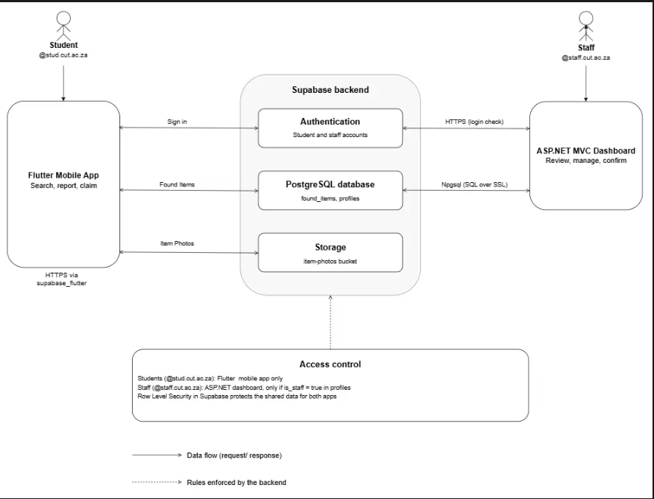

Architecture Explanation

- Students use the Flutter mobile application to search for lost items, view item details, and submit a claim when they believe an item found on campus belongs to them.
- Protection Services staff use the ASP.NET web application to view all reported items, review pending claims, and confirm when an item has been verified and collected in person.
- Supabase is responsible for the shared backend: it stores all data in a single PostgreSQL database (the found_items table), handles user authentication so only CUT email addresses can sign in, and provides secure storage for item photos.
- Flutter communicates with Supabase directly over HTTPS using the supabase_flutter package. When a student searches for an item or submits a claim, the app sends a request to Supabase's auto-generated API, which reads from or writes to the found_items table and returns the result as JSON.
- ASP.NET communicates with Supabase using the Npgsql library, connecting directly to the same PostgreSQL database with a secure connection string. When staff view the dashboard or confirm a collection, the application queries or updates the same found_items table that the Flutter app uses.
- Because both applications read from and write to the same Supabase database, they form one integrated solution: an item reported as found on the Flutter app appears immediately on the ASP.NET staff dashboard, and a status change made by staff (such as confirming an item has been collected) is reflected back to the student's app in real time. Supabase therefore acts as the shared backend that connects the mobile and web applications into a single working system.

9
Use Case Diagram

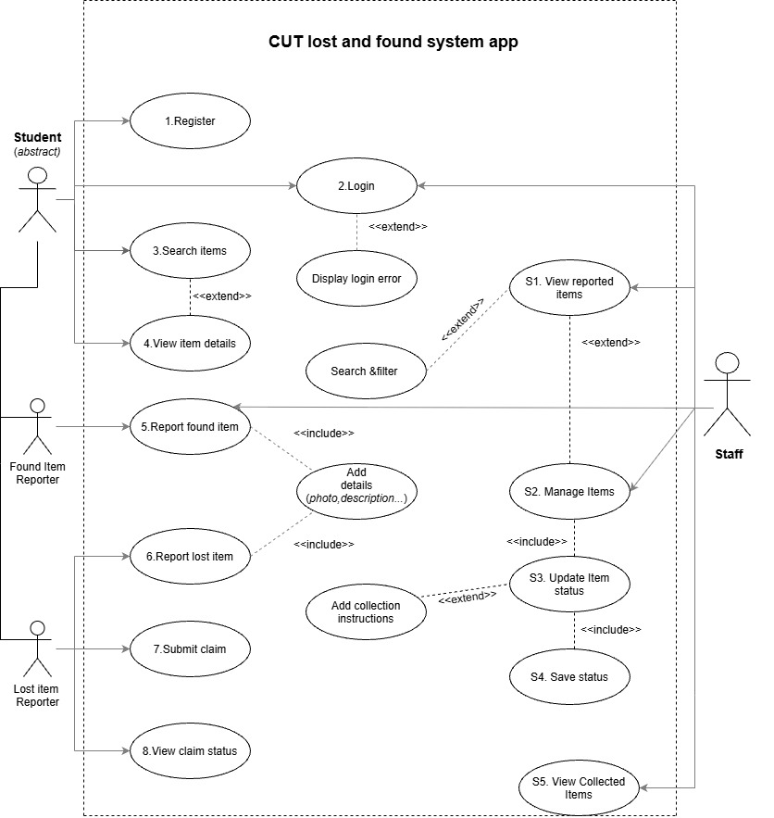

The use case diagram illustrates how students, found item reporters, lost item reporters, and Protection Services staff interact with the CUT Lost and Found System. The Student is represented as an abstract actor because the different types of users share common functions, such as registering, logging in, searching for items, viewing item details and submitting claims. Found Item Reporters can report items they have found by providing important information, including the item's description, location and photograph. Similarly, Lost Item Reporters can report missing items to help others identify and return them to their owners. Students can also submit claims for items they believe belong to them and track the status of their claims through the system.
Protection Services staff are responsible for managing the information submitted through the application. They can view reported items, manage item records, update and save item statuses, and view collected items. When a student or staff member reports an item, the information can be reviewed and managed to ensure that the records remain accurate and up to date. The diagram also includes relationships between use cases. The include relationship represents a function that must be performed as part of another use case, while the extend relationship represents additional or conditional behaviour, such as displaying a login error when authentication fails. Overall, the use case diagram provides an overview of the system's main functions and the responsibilities of each actor. It demonstrates how the proposed solution aims to improve communication between students and Protection Services, simplify the reporting and claiming process, and make it easier to track lost and found items at the Central University of Technology (CUT).
All diagrams link: https://drive.google.com/file/d/1jUf4sz407lEsMpRIQ-8PAvUKHrbFmza3/view?usp=sharing
10
Database Design/ERD

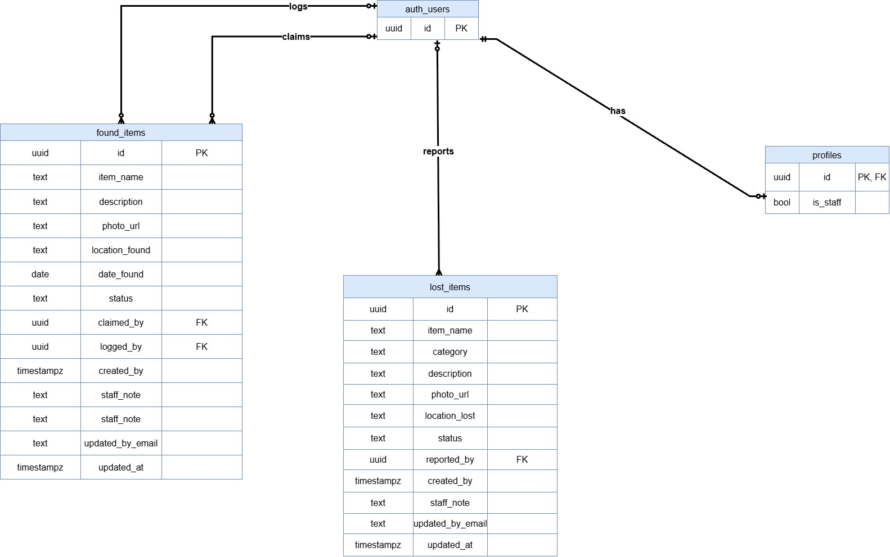

The Entity Relationship Diagram (ERD) illustrates the database structure of the CUT Lost and Found Management System and shows how its four main entities, USERS, ITEMS, CLAIMS, and ITEM_STATUS_HISTORY, are connected. The USERS entity stores user information such as email, full name, role and account creation date. The ITEMS entity records details about lost and found items, including their type, title, description, category, location, image, status and reporting date. The CLAIMS entity stores information about users claiming items, including their reasons, proof descriptions, claim status and verification dates. The ITEM_STATUS_HISTORY entity records changes to an item's status, including the previous status, new status, date of change and notes. Primary keys (PKs) uniquely identify records, while foreign keys (FKs) connect related entities.
The relationships show that one user can report many items, submit multiple claims and be associated with multiple status history records. Similarly, one item can have multiple claims and several status history records as its status changes over time. These relationships help maintain organised and consistent data, allowing students to report and search for items while enabling Protection Services officers to review claims and track item progress. Overall, the ERD provides a blueprint for designing the system's database and supports efficient item management, claim verification and status tracking at CUT.

11
Sequence Diagrams
12
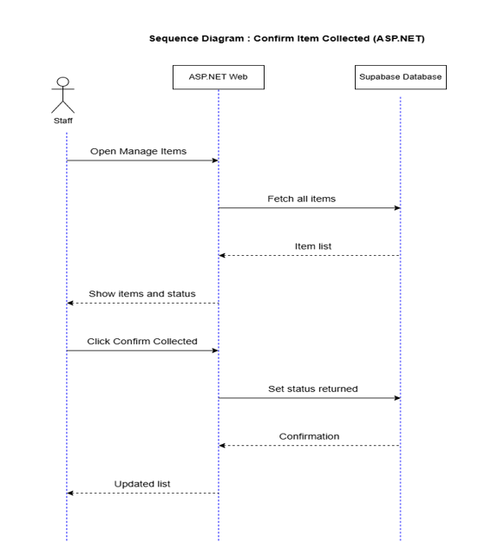

Staff member logs in then:
- Opens Manage items on the ASP.NET admin dashboard, then the app fetches all items from Supabase database and returns the item list.
- Items and status are then displayed on the admin dashboard then admin can change the status and set status is sent to Supabase database and a confirmation is returned with an updated list displayed to the staff.

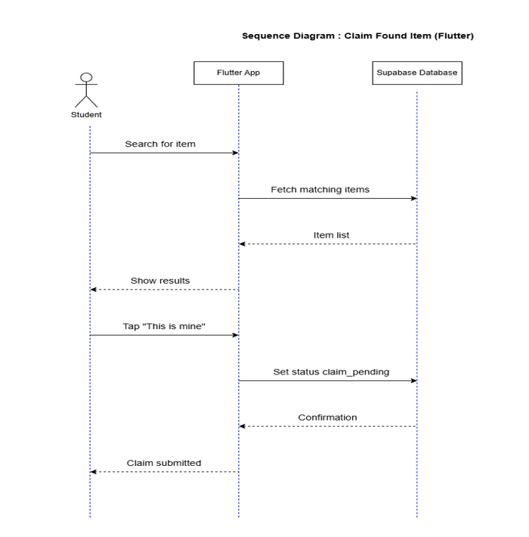
After logging in the flutter mobile application the student:
- Searches for an item they lost, then the matching items are fetched from supabase database and an item list is returned to the app.
- Results are displayed on the app for the student, then the student can tap “This is mine” and a status is set to claim pending.
- A confirmation is then returned from Supabase database and a “claim submitted” is displayed for the student.

After the student has logged in on the flutter mobile application to report a found item the student:
- Enters details and a photo in the flutter mobile application, then the app uploads the photo to Supabase storage and gets a URL back
- The flutter app then saves the item record to the Supabase database and receives a confirmation from Supabase
- The confirmation is then displayed to the student on the flutter app
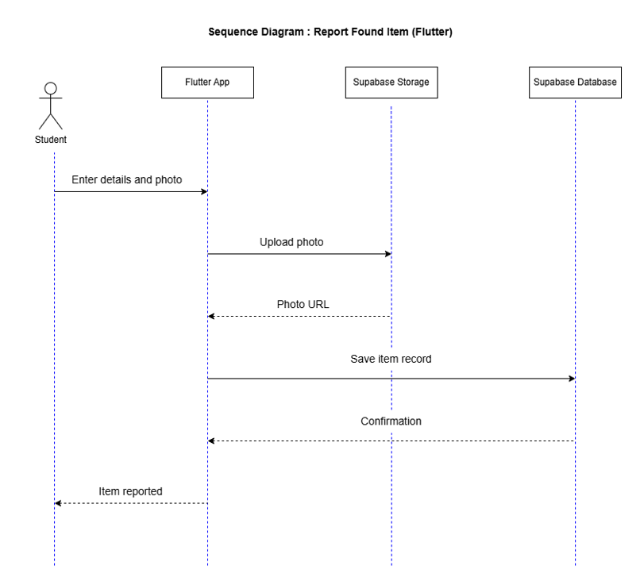
USER INTERFACE DESIGN
https://www.figma.com/design/iH2FHvAu1GyWl1omXsGrkg/Untitled?node-id=0-1&p=f&t=VJFqjvYIY7H1048D-0
Flutter Mobile Interface - https://www.figma.com/proto/iH2FHvAu1GyWl1omXsGrkg/Untitled?node-id=1-12&p=f&t=hpHo1vUoep7Ty6BT-1&scaling=scale-down&content-scaling=fixed&page-id=0%3A1&starting-point-node-id=1%3A12

ASP.NET CORE Admin Dashboard - https://www.figma.com/design/iH2FHvAu1GyWl1omXsGrkg/Untitled?node-id=37-399&p=f&t=VJFqjvYIY7H1048D-0
13
This is the screen where you are going to see all your claims and requests, all in one and see their statuses.
When you click a certain item, it displays the item’s information and an allowance for you to submit a claim.
Once you are signed in you are going to see the dashboard screen. There are recent reports, report found item, report lost item and it allows you to search the item you might be looking for.
This is the Login page into the app. You don’t have to create another account if you already have one. You can just sign in.
This is the Sign In/Register page if you don’t already have an account. You enter the required details for your account to be created.
This is the first screen that is going to be displayed immediately you click onto the app. You choose whether you want to Sign in or Login.
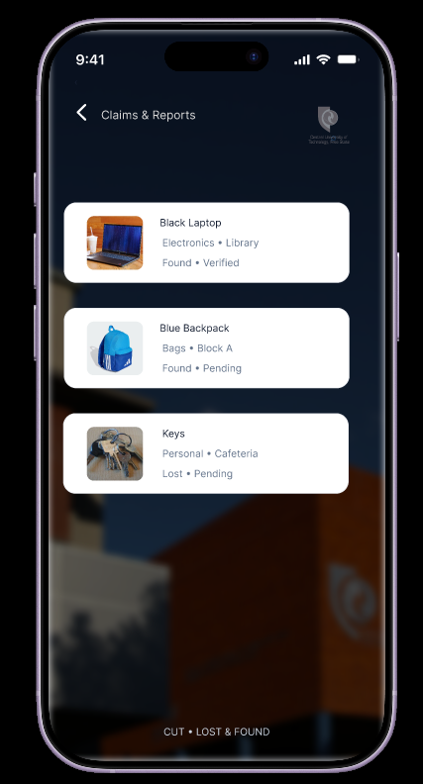
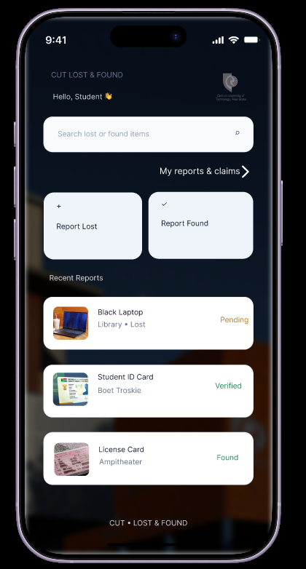
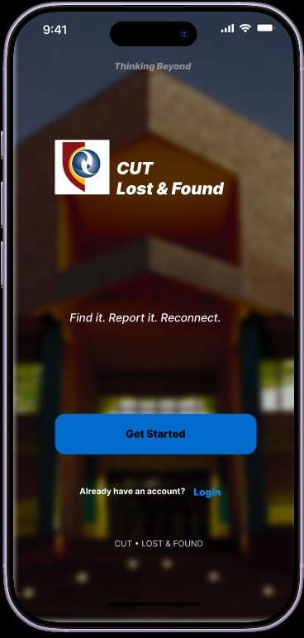
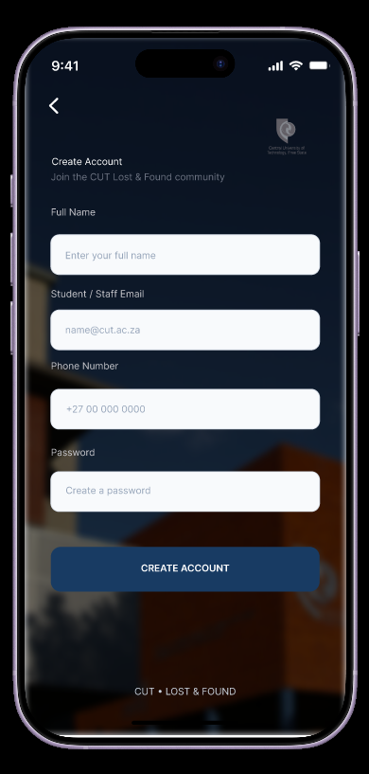
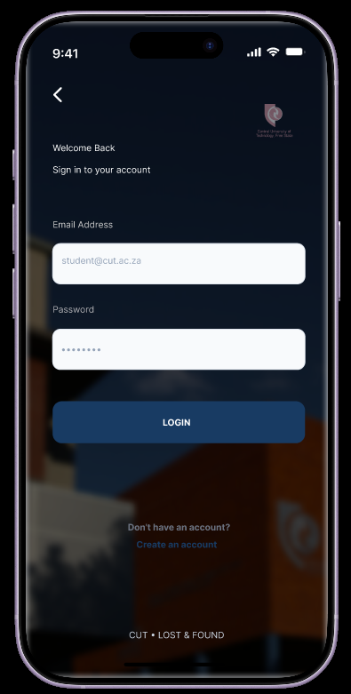
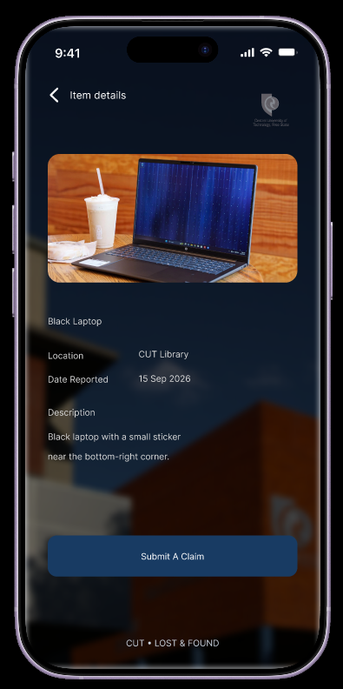

https://www.figma.com/proto/iH2FHvAu1GyWl1omXsGrkg/Untitled?node-id=41-416&p=f&t=QwFROZYS5RCZMvru-1&scaling=scale-down&content-scaling=fixed&page-id=37%3A399&starting-point-node-id=41%3A416

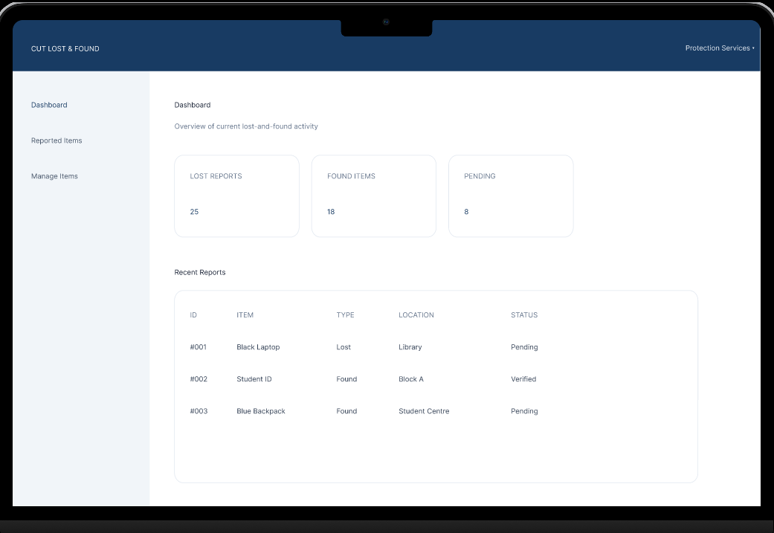
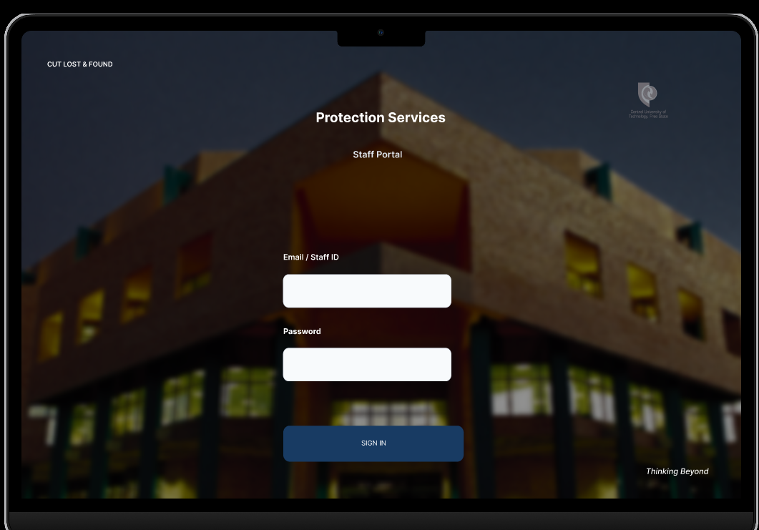

This screen shows all of the reported items and their statuses.
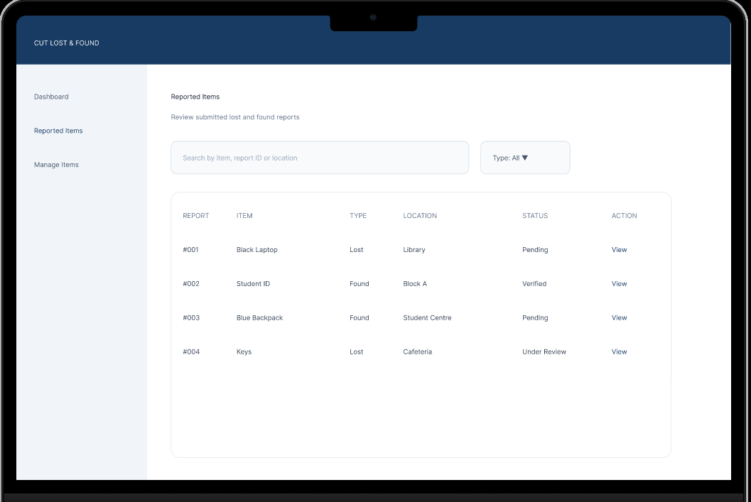
This is Admin Dashboard. The first screen is going to be the Login screen for the Staff
This is the Dashboard. It shows the Number of Lost Items report, Number of Found reports and the ones that are pending. It also shows the recent reports.
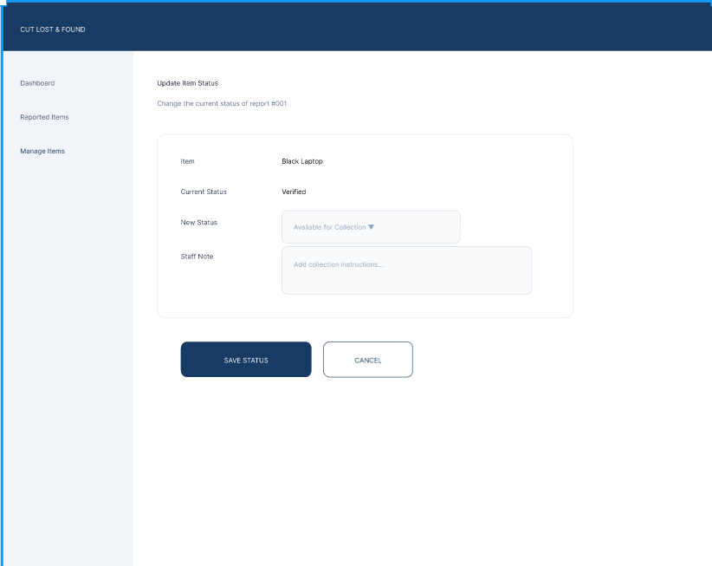
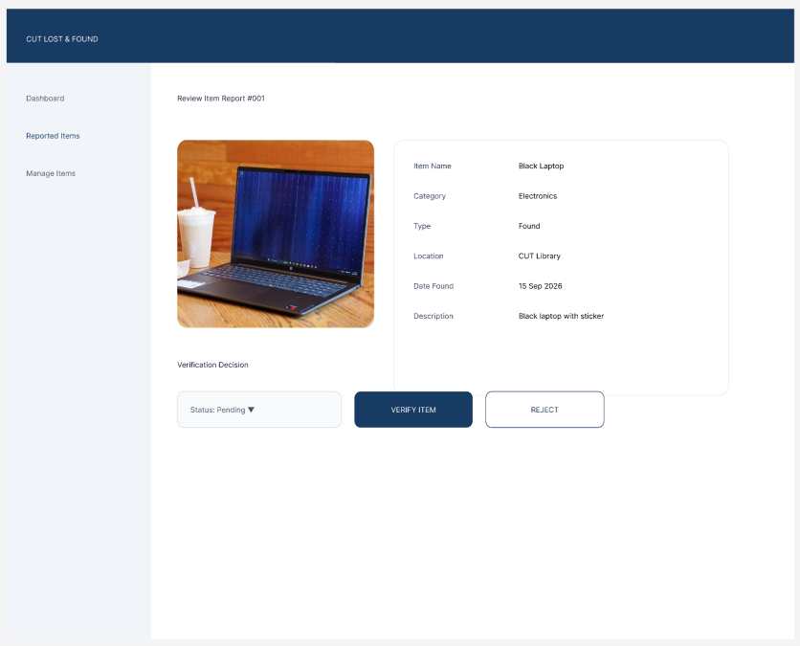

This is where the staff member will write the feedback if it matched, then the feedback will be “Ready for collection” and then that status will be saved.
This screen shows the details of the items if they match according to the person who may have lost or found it.

14
IMPLEMENTATION AND FINAL PROTOTYPE

Implementation Overview: Flutter is the student-facing interface and uses supabase_flutter to authenticate users and read or update Lost & Found records. ASP.NET Core MVC is the staff-facing web dashboard and uses cookie authentication and Npgsql to query and update the same Supabase PostgreSQL database. Implementation architecture clarification: the submitted code does not route Flutter requests through an ASP.NET REST API as originally proposed. Flutter communicates directly with Supabase through the Supabase Flutter SDK, while ASP.NET MVC connects to the same Supabase PostgreSQL database through Npgsql. Supabase is the shared data source. This description replaces the earlier proposed API flow where it describes the implemented prototype. The prototype consists of a Flutter student application, an ASP.NET Core MVC Protection Services dashboard and one shared Supabase PostgreSQL backend.

Component | Implementation evidenced | Responsibility
Flutter Mobile Application | Flutter/Dart, supabase_flutter, image_picker; screens, models, service and reusable widgets. | Student authentication, reporting lost/found items, browsing/search, item details, claims and personal report tracking
ASP.NET WebApp | ASP.NET Core MVC, C#, Razor views, cookie authentication and Npgsql | Staff login, dashboard summaries, report review, status management and staff feedback/notes
Supabase | Supabase Auth, PostgreSQL and Storage integration. | Central authentication, shared item records and itemphoto storage.

Final Flutter Mobile Application – Interface & Changes
The final Flutter source expands the original prototype with separate lost-item and found-item reporting, stronger form validation, photo selection, personal report history and live found-item status display. The interface also uses reusable CUT branding, campus backgrounds, fade/slide transitions and consistent status indicators to improve the experience across screens.

Screen / Area | Final Prototype behaviour
Splash / Welcome | Animated CUT-branded opening sequence, campus-themed background, CUT logo, feature slideshow and navigation to sign-in or registration
Sign-in / Registration | Combined sign-in and sign-up modes. Registration collects full name, CUT email, phone, password and confirmation. Validation checks name, email format, CUT domains (cut.ac.za and subdomains), phone format and password confirmation.
Home / Reports | Shows recent reports, supports all reports, combines found-item and lost-item records, sorts by date and provides item-name search. Navigation leads to lost/found reporting and personal claims/reports.
Report Found Item | Collects item name, category, description and found location. User can take a photo or select from gallery. Image is uploaded to Supabase Storage before the report is saved
Report Lost Item | Separate form for item name, category, description and lost location, with gallery photo selection and submission
Item Details | Displays found-item details, image and status. Uses a stream on the relevant found_items record so staff-side status changes can appear in the mobile view. Eligible items can be claimed
My claims & reports | Combines the signed-in user’s claims, found-item reports and lost-item reports. Displays statuses including awaiting review, available for collection, collected and unsuccessful report.
Photo and status components | Includes a photo viewer, reusable status chips/timeline, animated transitions and success feedback

15
Final ASP.NET Core Admin Dashboard – Interface and Changes
The ASP.NET Core MVC source contains a staff login page, protected dashboard, shared admin layout and separate reportmanagement pages. It handles both found-item records and lost-item reports. The final prototype also allows authorised Protection Services staff to create and submit a found-item report directly from the admin dashboard. Staff no longer need to open the Flutter student application to register an item they have received or found. The dashboard reporting workflow enables staff to enter the found-item information through the web interface and save the report to the shared system. This provides an alternative reporting route for found property: students can use the Flutter app, while Protection Services staff can use the ASP.NET dashboard. The staff-created report becomes part of the central found-item records and can be managed alongside other reports. This change improves the practical workflow at the Protection Services office. When a staff member finds an item, they can record it immediately from the dashboard instead of switching to a student-facing application. The dashboard therefore supports both the administration of existing reports and the direct registration of found property by staff.
Screen / Area | Final prototype behaviour
Staff Login | Cookie-based staff authentication; protected dashboard controller actions require an authenticated session
Admin Dashboard | Shows counts for lost reports, found reports and reports requiring attention, plus the ten most recent combined reports.
Reported Items | Combined list of lost and found reports with search and report-type filtering; opens item review/details.
Manage Items | Lists report reference, item, type, location, status, updater and an action to edit status
Item Details / Review | Displays available report details, description and photo for staff review
Update Item Status | Allows staff to select a status and enter feedback/notes. Saves the update to the database and shows confirmation.
Shared Admin Layout | Consistent top bar, sidebar navigation, active-page indication and logout control.
Report Found Item | The staff can report an item they found around campus and can report it on the Admin dashboard without actually switching to the Student App

Shared Supabase Backend and Data Flow
The Flutter service reads and writes found_items and accesses lost-item report records. The ASP.NET FoundItemService retrieves found-item and lost-item records from the same Supabase PostgreSQL database. Found-item fields used by the source include item_name, description, photo_url, location_found, date_found, status, claimed_by, logged_by and staff_note. The lost-item model includes item name, category, description, photo URL, lost location, status, reporter and update information. Found-item reports submitted through the admin dashboard are also saved into the shared found-item data source, so the staff reporting route and the student reporting route contribute to one central set of found-item records. The updated data flow is: a student submits a report through Flutter or a staff member submits a found-item report through the ASP.NET dashboard; the relevant application writes the record to Supabase; and the other application can retrieve the shared record for viewing and further management. This is a shared-database integration, not an ASP.NET REST API call from Flutter. Flutter uses Supabase Auth for student sign-up/sign-in and Supabase Storage for item photographs. ASP.NET uses Npgsql for PostgreSQL access and cookie authentication for staff pages.
Shared Process | Workflow | Implementation evidence / status
Student report to staff dashboard | Student submits a found-item report in Flutter with details and optional photo. The app uploads the photo and inserts the record in Supabase. ASP.NET queries the same database and displays the report. | Code paths are present; demonstrate a new dummy report and retrieve the same record in the staff dashboard.
Staff update to student app | Staff opens a report in ASP.NET, changes status and adds feedback. ASP.NET updates the shared database. Flutter item details listens to the found_items record stream | Code paths are present for found_items; demonstrate a staff status change and show the updated status in Flutter.
Student claim submissio | Student claims an eligible found item. Flutter sets status to claim_pending and records claimed_by. The personal claims screen retrieves items claimed by the signed-in user. | Implemented in source for found items; demonstrate the claim and corresponding staff review/status workflow.
16

Requirement-to-Implementation Traceability
Found-item reporting from the staff dashboard: authorised staff can create and submit a found-item report directly through the ASP.NET admin dashboard without using the Flutter app. This is an additional reporting option alongside found-item reporting in the student application. “Implemented in source” means the relevant code path is present in the submitted files; it is not a claim that formal testing has been completed

Requirement | Implemented function / source | Status from supplied files
FR1 – CUT student registration/login | Flutter login screen validates CUT email domains and uses Supabase Auth. | Implemented in source.
FR2 – Found-item report with description, location and photo | Flutter found-item form, camera/gallery picker, Supabase Storage upload and database insert. | Implemented in source.
FR3 – Search and browse reports | Home screen combines lost/found reports, supports search and recent/all report views. | Implemented in source.
FR4 – Submit a claim | Item details screen submits claim; service updates status and claimed_by. | Implemented for found items.
FR5 – Staff review, verify ownership and confirm collection | ASP.NET review/details and status-update pages with staff notes. | Partially represented; verify all claim/collection transitions in live demonstration.
NFR1 – Usable interface | Separate student/staff interfaces, reusable widgets/layouts, validation and status indicators. | Present in source; usability to be demonstrated
NFR2 – Secure access | Supabase Auth for students; ASP.NET cookie authentication and [Authorize] protection. | Present in source; confirm deployed policies and staff provisioning.
NFR3 - Performance | Flutter search debounce and paginated retrieval helper; dashboard database queries. | Code present; no performance benchmark supplied.
NFR4 - Availability | Depends on internet, Supabase and application hosting | Service dependent; no uptime evidence supplied.
NFR5 – Data consistency | Both applications access the shared Supabase PostgreSQL database. | Integration path present; demonstrate consistent records.
IR1 - Integration | Flutter uses Supabase SDK; ASP.NET uses Npgsql against same database. | Integration paths present; demonstrate two shared processes.

Final Prototype Demonstration Plan

Step | Action for assessment panel | Expected result
Student authentication | Open Flutter and sign in with a demonstration CUT account; optionally show registration validation. | Student reaches home; invalid/non-CUT email is rejected by client-side validation.
Student report | Submit a found-item report with description, location and photo. | App confirms submission and record is stored in Supabase
Cross-application retrieval | Open ASP.NET dashboard and locate the new report. | Same item details appear to authorised staff.
Staff review/update | Open report details, update status and enter staff feedback. | Dashboard saves update to Supabase and shows confirmation.
Student sees update | Return to Flutter item details or refresh the relevant view. | Student sees updated status for the shared record
Claim workflow | Claim an eligible dummy found item and show it in Claims & My Reports; show the staff review/status workflow. | Claim status and claimant information are stored and can be reviewed by staff.

17
GitHub Repository Link: https://github.com/Hope3780/lost-and-found--app
Microsoft Project Update
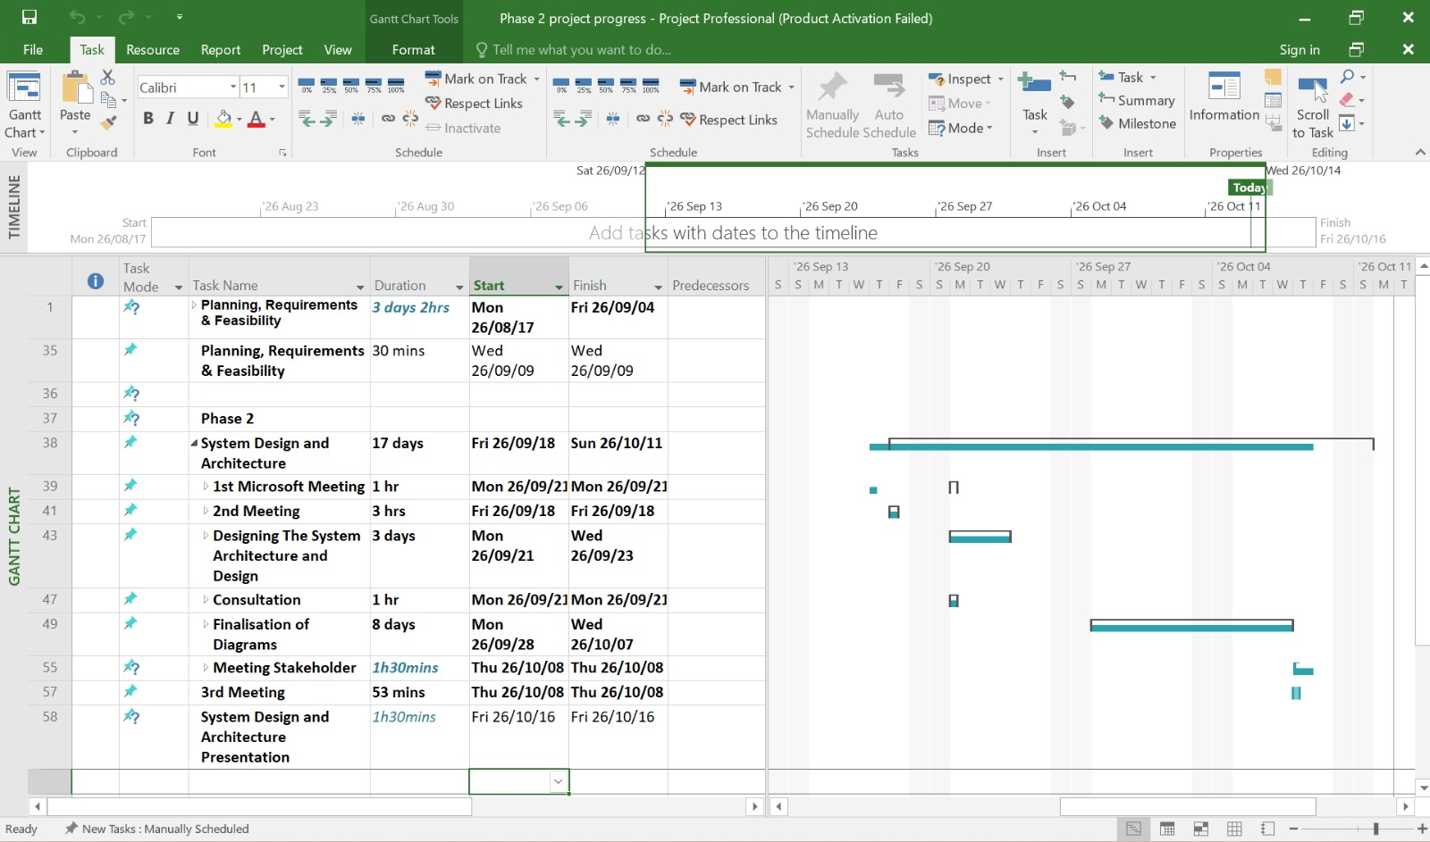

Stakeholder Evidence
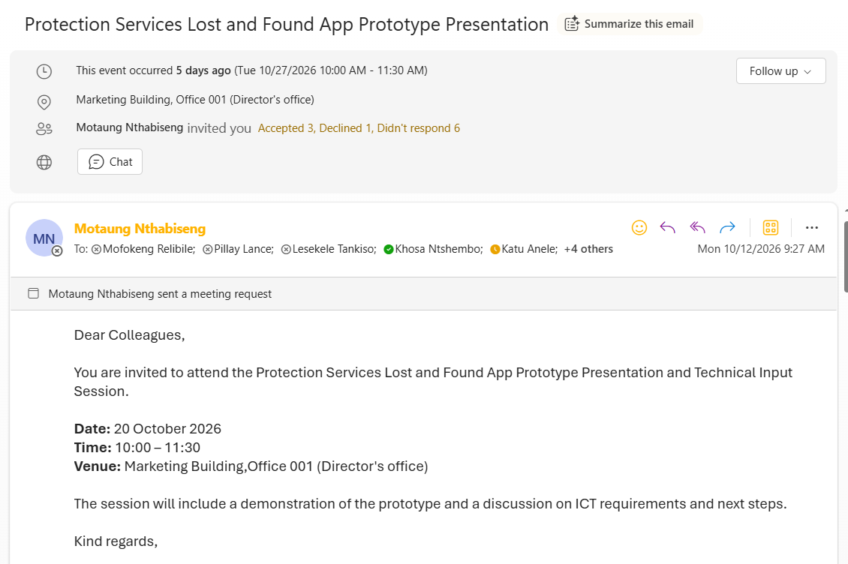
We had a meeting on the 27th of October with our stakeholder and his colleagues, Dr Leandra Jordaan the Deputy Director of Communications and Marketing and Mr Tankiso who works in the Computer Services.
18
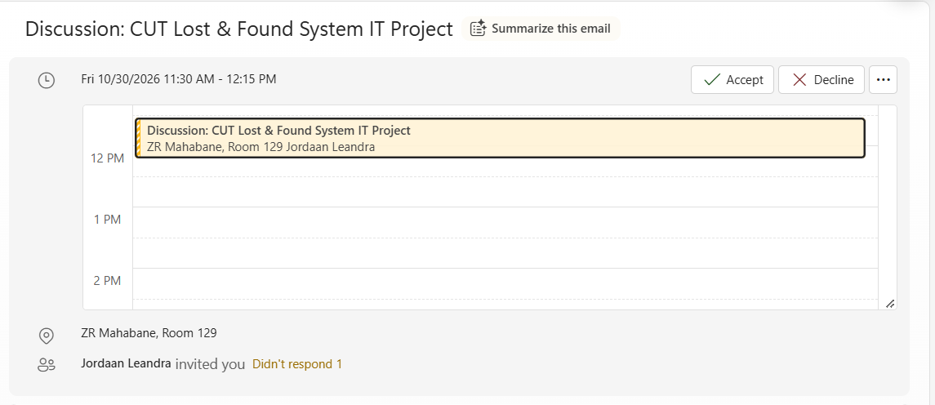
We also had a meeting with Dr Leandra on the 30th of October

Conclusion
Phase 3 focused on the development, implementation and finalisation of the CUT Lost & Found Management System. The main objective was to transform the proposed designs and prototypes into functional software that addresses the challenges identified during Phase 1 and Phase 2. The development resulted in two main components: a Flutter mobile application for students and an ASP.NET web-based admin dashboard for Protection Services staff. Both components are connected to a shared Supabase database for centralised information management. The Flutter mobile application allows students to register, log in, report lost items, view and search for found items, access item details and submit claims.
Students can also monitor their submitted reports and claims, reducing the need to visit the Protection Services office for enquiries. The ASP.NET admin dashboard allows Protection Services staff to manage item records, view reports, search for items and update item statuses. An important improvement introduced during this phase is the ability for staff to report found items directly through the dashboard without needing to use the Flutter application. This makes the system more convenient for daily office operations.The integration with Supabase ensures that information submitted through both components is stored in one central database. Found items reported by staff can be viewed by students through the mobile application, while student reports and claims are accessible to staff through the dashboard. This helps maintain consistent information across the system.
Overall, Phase 3 successfully brought together the planning, research, design and development activities completed throughout the project. The CUT Lost & Found Management System provides a more organised alternative to the previous manual process by introducing digital reporting, item searching, claim submission and staff management. Although future improvements may still be introduced, the completed Flutter application, ASP.NET dashboard and Supabase database establish a functional foundation for improving how lost and found items are managed at the Central University of Technology.

19

