/*
MP3Encoder project has two dependencies in both Unix and Windows platforms.
O.S: Linux
Tool: cmake v >2.8
Tool: lame v3.100

O.S: Windows 10
Tool: pthreadWin v2.9.1
Tool: lame v3.100

Platform: X86(32-bit)
Build Type: Debug(Win32) / Release(Linux)

GUI:
MP3EncoderGUI – QT5.5.1 – Linux Platform only

Console:
MP3Encoder was built on Windows 10, 32 bit, Visual Studio 2012 Ultimate with Debug Mode
and on Ubuntu 16.04, 32 bit, cmake with Release Mode.

Environmental variables are not used, so keep the folder hierarchy.
All paths in build files are relative paths.

This instruction manual is prepared for developers :)
*/

********************START BUILD && RUN *****************************************
if (isOSLinux())
{
if (not isCMakeInstalled())
{
cd scripts
run “. installcmake.sh”
cd usr/local/bin
ls -al

if terminal output is like
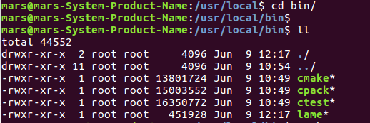

goodNews(cmake is just installed to your system);
}

if (not isLameInstalled())
{
cd scripts
run “. installlame.sh”
cd usr/local/lib
ls -al

if terminal output is like
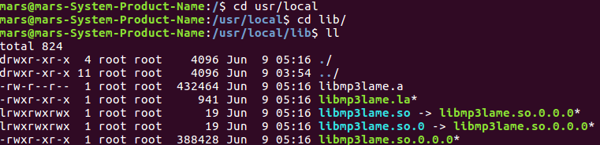

goodNews(lame is just installed to your system);
}

cd MP3Encoder/build
run “. easyRebuild.sh”

cd bin/release
./MP3Encoder <dirPath>
}
***********************************************************************************
bool isCMakeInstalled()
{
open terminal
run “cmake” command

if terminal output is like
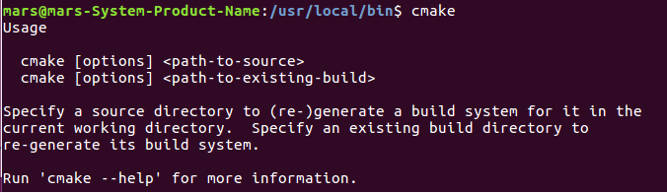

{
goodNews(System has CMAKE already);
return true;
}
else
{
badNews(System has not CMAKE);
return false;
}
}

***********************************************************************************
bool isLameInstalled()
{
open terminal
run “lame” command

if terminal output is like
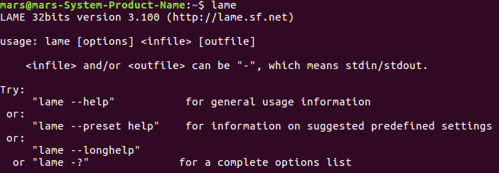

{
goodNews(System has LAME already);
return true;
}
else
{
badNews(System has not LAME);
return false;
}
}
To run this software
cd linux\MP3Encoder\bin\release
MP3Encoder dirPath

If you want to use this software via simple GUI,
cd linux/MP3EncoderGUI
./MP3EncoderGUI
***********************************************************************************

if (isOSWindows())
{
cd windows\MP3Encoder\build\debug
open project file via VS2010+
all required include and lib folder exist
just click Rebuild
}

To run this software
cd windows\MP3Encoder\bin\debug
MP3Encoder dirPath

