

UNDERGRADUATE PROJECT PROGRESS REPORT

|  |  |
| --- | --- |
| **Project Title:** | **CDUT Sino-British Student Information**  **Management System Based on WeChat Mini Program** |
| **Surname:** | **Wang** |
| **First Name:** | **Hao** |
| **Student Number:** | **201918020320** |
| **Supervisor Name:** | **Gore** |
| **Module Code:** | **CHC 6096** |
| **Module Name:** | **Project** |
| **Date Submitted:** | **2023/01/13** |

**Table of Contents**

1 Introduction 1

1.1 Background 1

1.2 Aim 1

1.3 Objectives 1

1.4 Project Overview 2

1.4.1 Scope 2

1.4.2 Audience 2

2 Background Review 2

3 Project Technical Progress 6

3.1 Methodology 6

3.1.1 Approach 6

3.1.2 Technology 8

3.2 Testing and Evaluation 8

3.3 Design and Implementation 8

3.3.1 Page Building 9

3.3.2 Page Jumping 11

3.3.3 Word Translation 12

3.3.4 Map Tracking 15

4 Project Management 18

4.1 Activities 19

4.2 Schedule 20

4.3 Project Version Management 20

4.4 Project Data Management 21

4.5 Project Deliverables 21

5 Professional Issues and Risk: 21

5.1 Risk Analysis 21

5.2 Professional Issues 22

6 References 23

# Introduction

## Background

Under the background of the constantly developing information technology, the information management technology used in the student management system has been constantly applied and promoted [1]. In particular, with the continuous expansion of the scale of colleges and universities and the continuous increase of the number of students in school, the personal information management of students has become more and more complex. As a result, a number of student information management systems have emerged to standardize management, make scientific statistics and fast queries, so as to greatly reduce the time cost of managing students[2] [3].

On the other hand, although mobile applications have been driving the development of digital business models. However, smartphone users are increasingly reluctant to download traditional mobile applications [4]. The WeChat mini program is an application that can be used without downloading and installing and does not use the phone memory [5].

On this premise, in order to reduce the cost of information query and management, and make the system easy to obtain without downloading, the project aims to design a CDUT Sino-British student information management system based on WeChat mini program, which has the functions of querying basic personal information, current information, grades, words, and school maps and other additional functions, to achieve simple, conventional, and systematic management of student information purposes and promotions.

## Aim

The project is developed in the form of WeChat mini program, so that students who use the system do not need to log in the browser or download mobile applications separately but use the mini program that does not need to be downloaded to query the information belonging to the student website, to achieve the goal of systematic management of data, reduce the time for query and use, and facilitate the use.

## Objectives

The project will be divided into five objectives to achieve my goals, and the contents are shown below.

1. Objective 1: Complete the background review of the existing WeChat mini

program development and student information management system.

(2) Objective 2: Complete Requirements gathering.

(3) Objective 3: Use the correct technology and framework to develop pages.

(4) Objective 4: Evaluate the project using appropriate testing techniques.

(5) Objective 5: Show the works to different audiences.

Among them, objective 1 and objective 2 have been completed and will be reflected in the final paper and deliverables.

## Project Overview

### Scope

The user can scan the QR code provided or search the corresponding name of the WeChat mini program to use all the functions of the relevant application on the WeChat interface without downloading and installing [4]. After successfully entering the WeChat mini program, the applet will provide you with various query functions of user information.

### Audience

The audience of this project is students from CDUT Sino-British. Using this WeChat mini program, they can more easily obtain personal information and learning information and improve their learning efficiency.

# Background Review

For the management of student information, the most traditional mode is mainly to manually input and maintain student information by the branch of the academic administration department of each major of the college [2]. However, because the unified management is not carried out through the system, the management personnel spend a lot on data processing, the workload of data processing is high, the overall management speed is slow, and even there are problems such as data loss and statistical errors [2]. Because of manual processing, data interconnection and duplication may also occur [6]. Therefore, many student information management systems based on Web development have appeared on the market. Chu [2] mentioned the development of student information management system based on browser/server mode, and realized the basic functions of managing personal information, teacher management, curriculum information management, etc. And its security system uses the classification of students, teachers, and managers to control. However, for this system, the information in the database may not be secure, and the database may be subject to SQL injection attacks, leading to data leakage or database crash. The same problem also exists in the research of Gomathy et al. [7] and Yue [3]. In the research and design of Wu et al. [1], it was mentioned that on the premise of browser/server mode, the Client/Server mode was added, and on the premise of using QT quick to develop clients, WeChat mini program was used to solve the problem that different clients in the Client/Server mode need to develop different platforms. However, using QML to develop applications has high learning costs, lack of relevant online materials, and larger memory space than other languages in the development process. If it is used in WeChat mini program development, it may become more difficult to subcontract programs at the end. However, most of the services used in Jain et al.'s [6] research require money to use, and the Google Firebase they use cannot be used normally in China, so it is very difficult to use these technologies in this project.

For WeChat mini program development, it is the development method selected for this project. In 2017, WeChat mini program was officially launched. Its main feature is that users can access the system by scanning QR code or searching the name of the mini program from WeChat applications without downloading and registering in advance and use all the functions of relevant applications without occupying the memory of the phone, fully demonstrating its "micro, light, and small" features [1] [4] [5] [8] [9] [10]. When developing WeChat mini program, MINA is its framework, as shown in figure 1. It divides the whole system into two parts: the view layer and the logic layer (App Service). The View layer is all .wxml (WeiXin Markup language) file and a collection of .wxss (WeiXin Style Sheet) files, similar to HTML and CSS. In addition, .wxml is used to describe the page structure and .wxss is used to describe page styles, while the logic layer (App Service) is written by JavaScript. Using MINA, developers can easily modify data in the logical layer to keep data synchronized with views [8] [11]. Wu et al. [8] also mentioned the use of Tencent Elastic Compute Service to communicate with WeChat mini program, so that WeChat mini program does not need to connect to the database through interfaces and use a complete authentication session management service to ensure account security and improve the efficiency of WeChat mini program development.

Fig. 1. WeChat Mini Program Framework Diagram. Adapted from [8]

In order to reduce the development cost and learning cost, DCloud Company has developed a uni app front-end framework, which uses Vue.js for programming, and can be compatible with and call any WeChat mini program API. That is, it supports native rendering, and can also use its built-in components, expand components and APIs. Its performance is better than other frameworks in the market [12]. In order to match with uni app, DCloud has also developed uniCloud, which provides developers with a cloud development platform based on serverless mode and js programming. That is, programmers can easily handle the overall business of the front and back office with familiar js language, without worrying about the operation, maintenance and security of the server, and directly deploy cloud functions, cloud databases, cloud files, etc. on it, thereby reducing development costs and improving development efficiency [13]. On this premise, DCloud has also developed HBuilderX tool to improve the overall development efficiency. HBuilderX is lighter than ordinary editors, but its functions are comparable to those of IDEs. It has greatly optimized Vue development, and its tool has more than 4000 rich plug-ins, making it very easy to launch WeChat mini program [14].

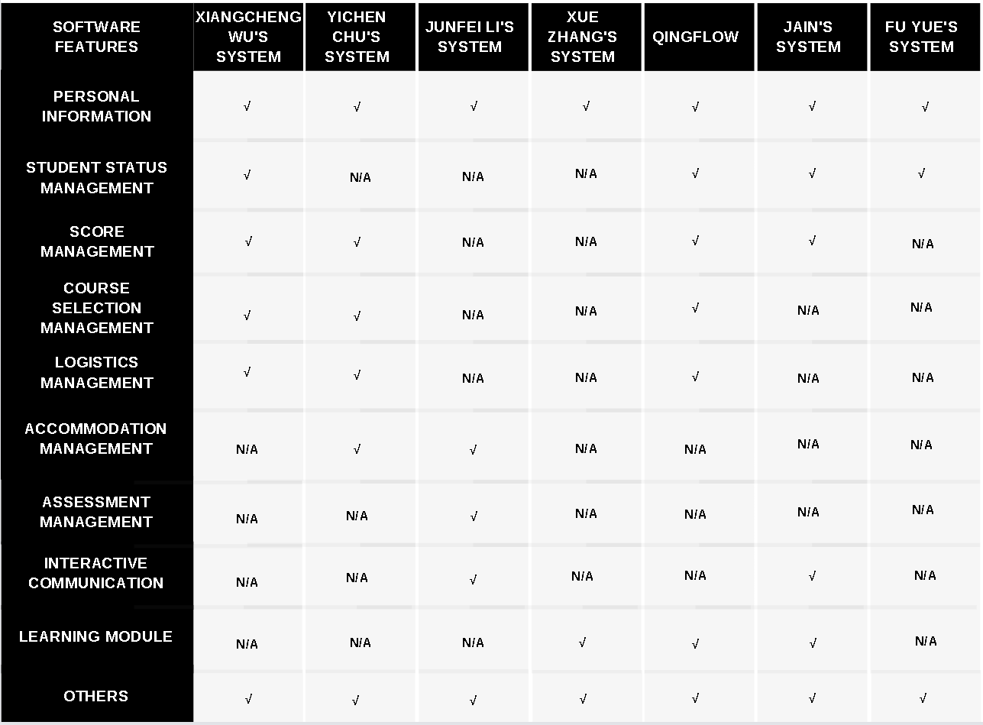

Fig. 2. Summary of Software Features

As for the research on system's features, it can be seen from figure 2 that the functions involved in some student information management systems investigated are mainly personal information management, course management, score management, logistics management, etc. Compared with other systems, the system of Zhang[10] ,qingflow[15] and Jain [6] includes learning modules, which can help students learn efficiently. Li's[9] system even includes daily assessment management and communication area, which can facilitate students to upload their own homework and exchange learning experience. Because this project is developed for CDUT Sino-British students, after analysis and comparison, during demand collection, the questionnaire questions will focus on course management, score management and personal information in terms of functions, and then compare with the common functions on student websites to make corresponding analysis.

# Project Technical Progress

## Methodology

### Approach

Approach will be divided into the following four aspects:

1. Software development model: As shown in figure 3, this project will be developed and maintained in a waterfall model.

Fig. 3. Schematic Diagram of Waterfall Development Model

1. requirements gathering method: this project will use the form of questionnaire to collect and sort out the demand for students of CDUT Sino British.

Fig. 4. Questionnaire Results and Data Analysis

As can be seen from Figure 4, 106 CDUT Sino British students from different levels were finally investigated in this questionnaire, and the number of times they visited the student website, the purpose of visiting the student website, the function of the student website, the number of times they encountered the server crash of the student website, whether they used WeChat applet, and whether they were willing to use the student information website of WeChat applet version, And the functions that they want to use. The survey found that 70% of the students use student websites almost every day, and most of them are used to consult learning materials, lesson schedules and grades. More than half of the students think that the content of the student websites is very rich, but still half of the students think that they need to improve. Ninety percent of students have experienced the collapse of student websites. All students have used WeChat mini program. And up to 92.45% of the students are willing to use the WeChat small program version of the student information system to query grades, schedules and materials.

After analysis and summary, this project will build the basic functions of personal information management, score query, curriculum query, and add additional functions such as translation words, map query, chat room to enrich the entire system.

(3) Test method: execute unit testing, integration testing and system testing according to the rules of waterfall model.

(4) Evaluation process: on the premise of waterfall model, upload the corresponding deliverables of each completed section to the tutor for review and show all the contents to the final tutor during the final assessment.

### Technology

The technology used in the project is divided into three aspects: front-end, back-end and testing. The main contents are as follows:

(1) Front-end: "uni-app" is a front-end framework based on WeChat mini program development (its main method is Vue.js).

(2) Back-end (server side): "uniCloud" is a cloud development platform based on Serverless mode and JavaScript programming.

(3) Test: "Minium" is WeChat mini program automation test framework.

## Testing and Evaluation

This project will adopt a test-driven development style. Under the premise of waterfall model, unit testing will be carried out for each function, and integration testing and system testing will be carried out after the completion of the project.

Unit testing: In unit test, when each function is implemented, the results of successful running of this function on the failed running are stored in the form of a form and presented in the form of a deliverable.

Integration testing: after the project code is written and the unit test is completed, the integration test is carried out to show the test process in the form of video and generate deliverables.

System testing: before system testing, the functions in the completed project need to be expressed in the form of use cases, and all scenarios under the use case are listed and tested one by one, finally generating a deliverable word document.

Evaluation: conduct self-assessment, summarize the success and failure during the test, and evaluate the generated evidence.

## Design and Implementation

According to the Gantt Chart, the functions of page building, page jumping, word translation and map tracking have been completed. The following will describe its details according to the above completed functions.

### Page Building

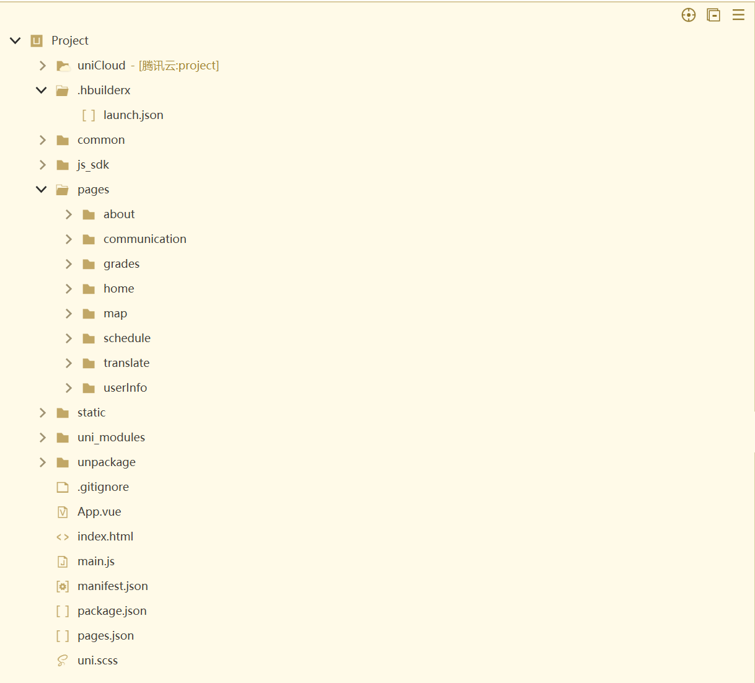

Fig. 5. Code Directory

As can be seen from Figure 5, the project uses ECS, and the ECS provider is Tencent Cloud, on which all cloud functions and databases of the project will be deployed ".hbuilderx" is the configuration folder, "common" and "js_sdk" are plug-in folders, and "static" folder stores the pictures required by the project "uni_modules" is a built-in component of the tool. In order to build pages with all functions, "about", "communication", "grades", "home", "map", "schedule", "translate" and "userInfo" are declared in the "pages" folder. Each folder stores the corresponding Vue files. The page functions will be implemented in its Vue files.

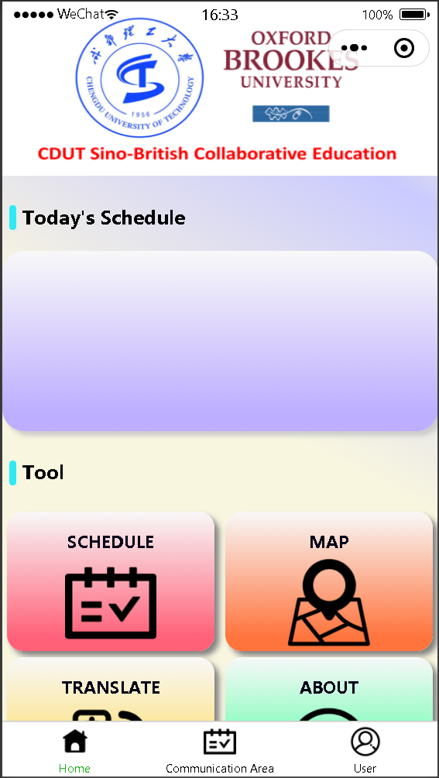

Fig. 6. WeChat Mini Program Homepage Preview

From Figure 6, user can see the contents of the home page of the whole system, including four big buttons, which will jump to the page of the corresponding function, and the lower navigation bar will also jump to the page of the corresponding function. Some parts of the home page are empty because there are still unfinished functions.

### Page Jumping

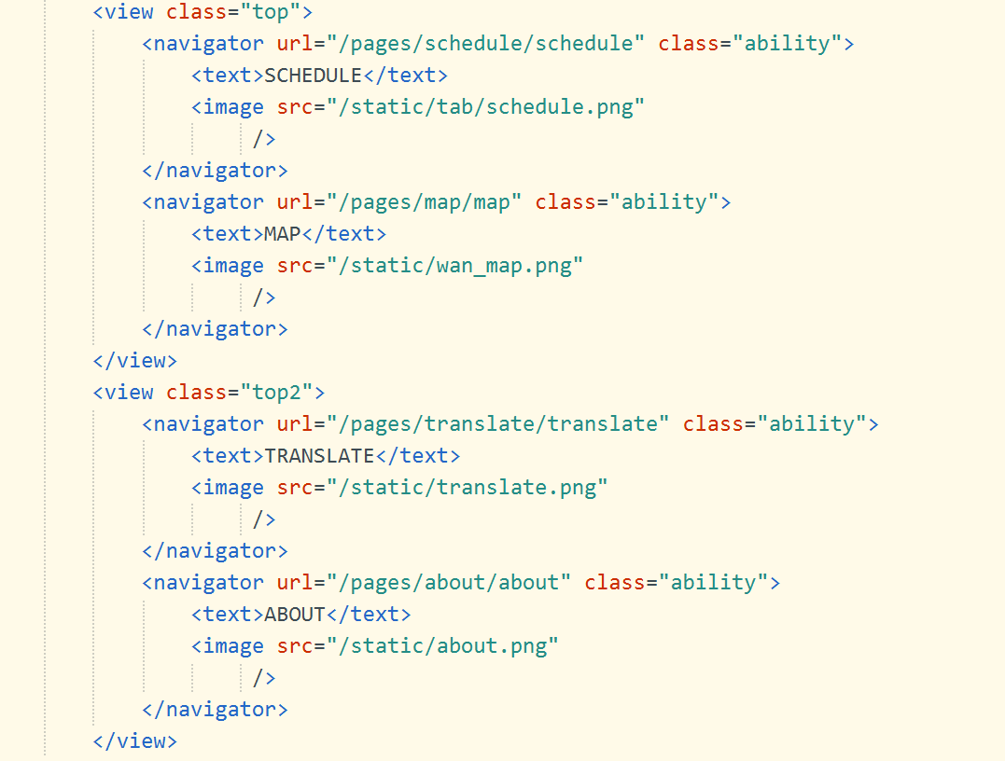

Fig. 7. Page Jump Core Code

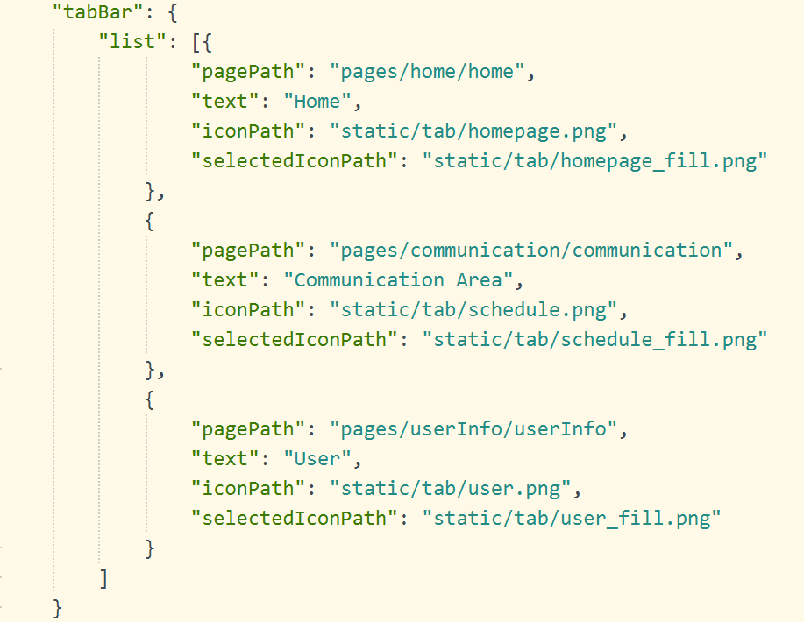

Fig. 8. Navigation Bar Jump Core Code

Figures 7 and 8 show the core code for page jump. When a page jumps, you need to declare the jump path in the vue file of the home page to achieve the purpose of jump. For navigation bar jump, you need to configure the navigation bar and its corresponding path in the pages.json file of the entire project.

### Word Translation

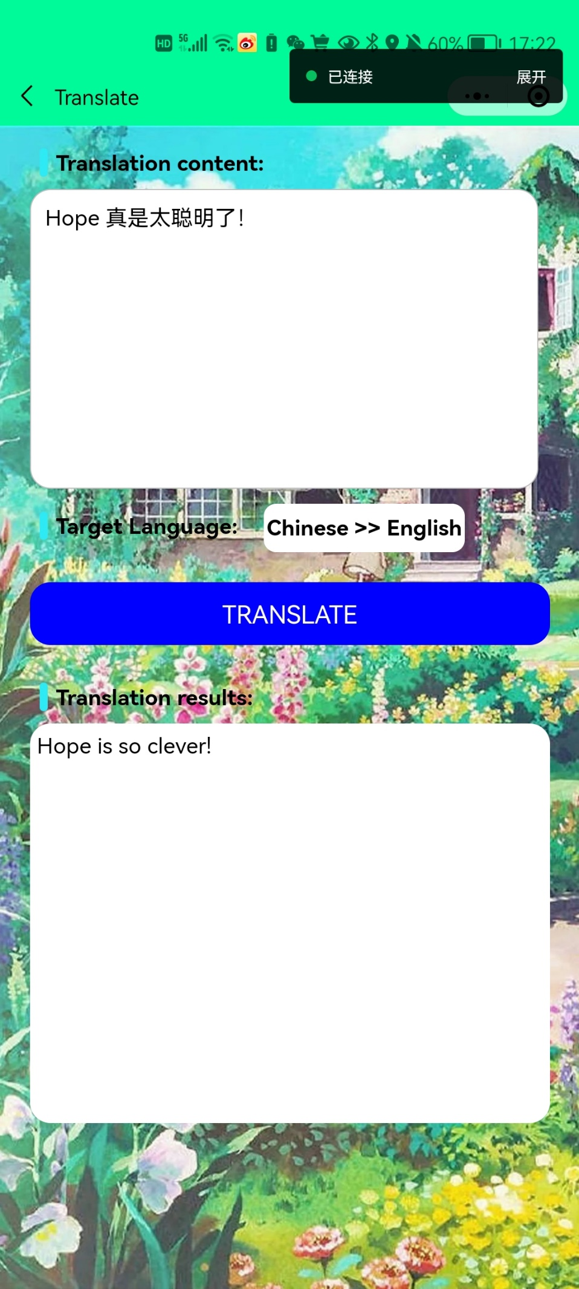

Fig. 9. Word Translation Function Preview

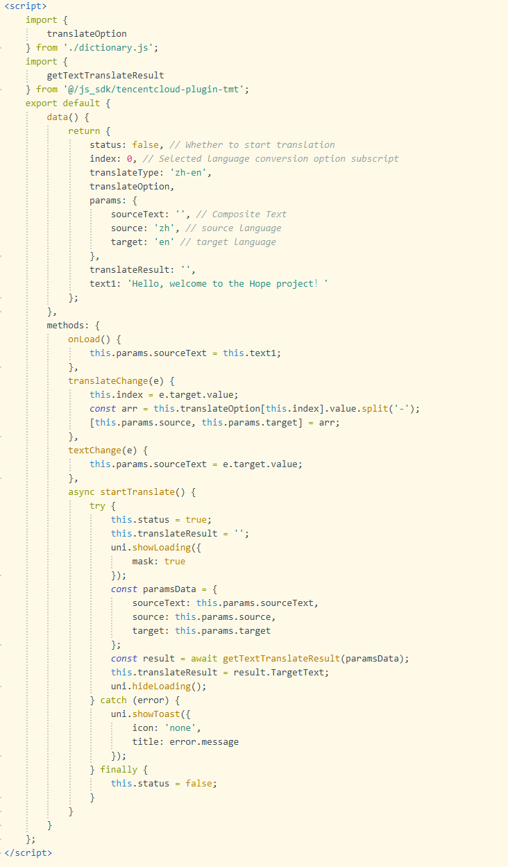

Fig. 10. Word Translation Core Code

In order to achieve the purpose of text translation, the Tencent Cloud Open-Source Application Plug in, called Tencent Cloud Machine Translation Plug in, is called here. Its main functions are deployed on the ECS. Figure 9 shows the results after using this function, and Figure 10 shows the core js code to implement this function. In the code, first initialize the required data, and declare the onload life function, language selection function, text change function and translation function in the following methods. Because the plug-in can also translate other languages, the "dictionary. js" file is added to the "translate" folder during the development process, allowing users to select the language to translate.

### Map Tracking

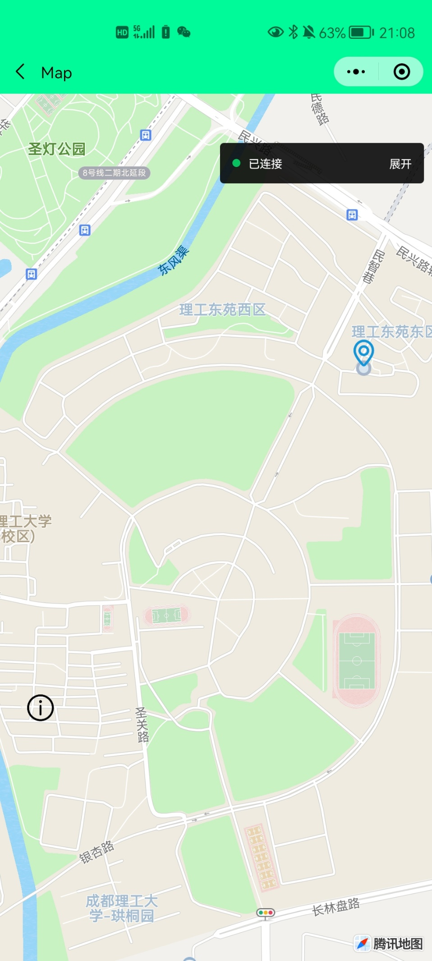

Fig. 11. Map Tracking Function Preview

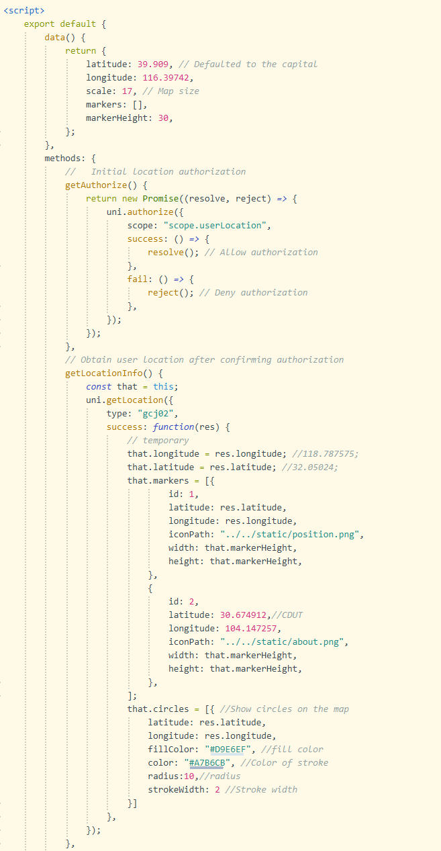

Fig. 12. Map Tracking Core Code Part one

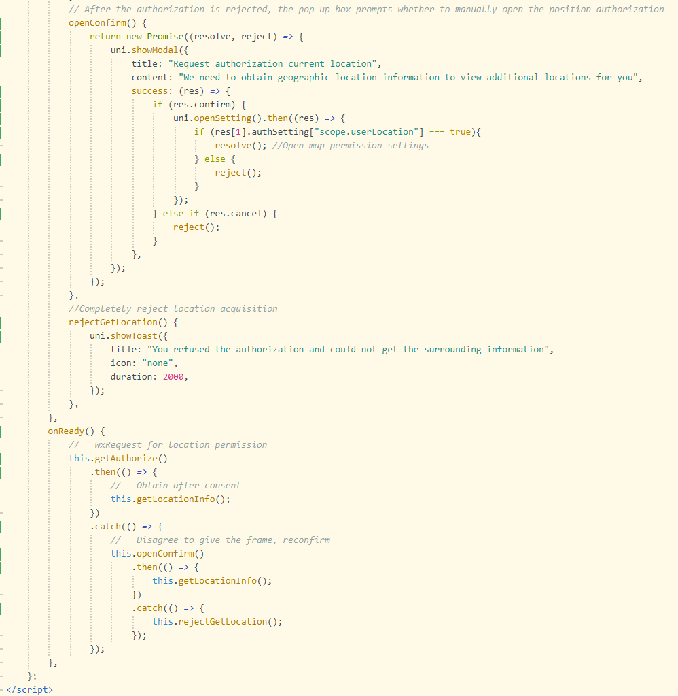

Fig. 13. Map Tracking Core Code Part Two

As can be seen from Figure 11, the map tracking function of the system can locate your current location and display the main buildings nearby. However, due to the time conflict with other projects, this function needs to be improved. Figure 12 and Figure 13 show the core code of map tracking. The map uses the Tencent map component built in uni-app. First, the default location is defined as the capital of Beijing, and the location authorization method is declared to obtain the user's geographic information, which will be located in the center of the user's location. After that, it also states various situations in the authorization process to ensure the integrity of the authorization information.

# Project Management

Fig. 14. Product (technology) roadmap

As shown in figure 14, it shows the product roadmap for the completion of this project.

## Activities

Fig. 15. Schematic Figure of Detailed Activities Corresponding to Each Objective

As shown in figure 15, to ensure that the task objectives can be completed, all objectives are subdivided into many activities to make the objectives more specific. Among them, objective 1 and objective 2 have been completed and displayed in this paper and deliverable. Objective 3 has completed the first four sub-tasks, which are also reflected in this paper.

## Schedule

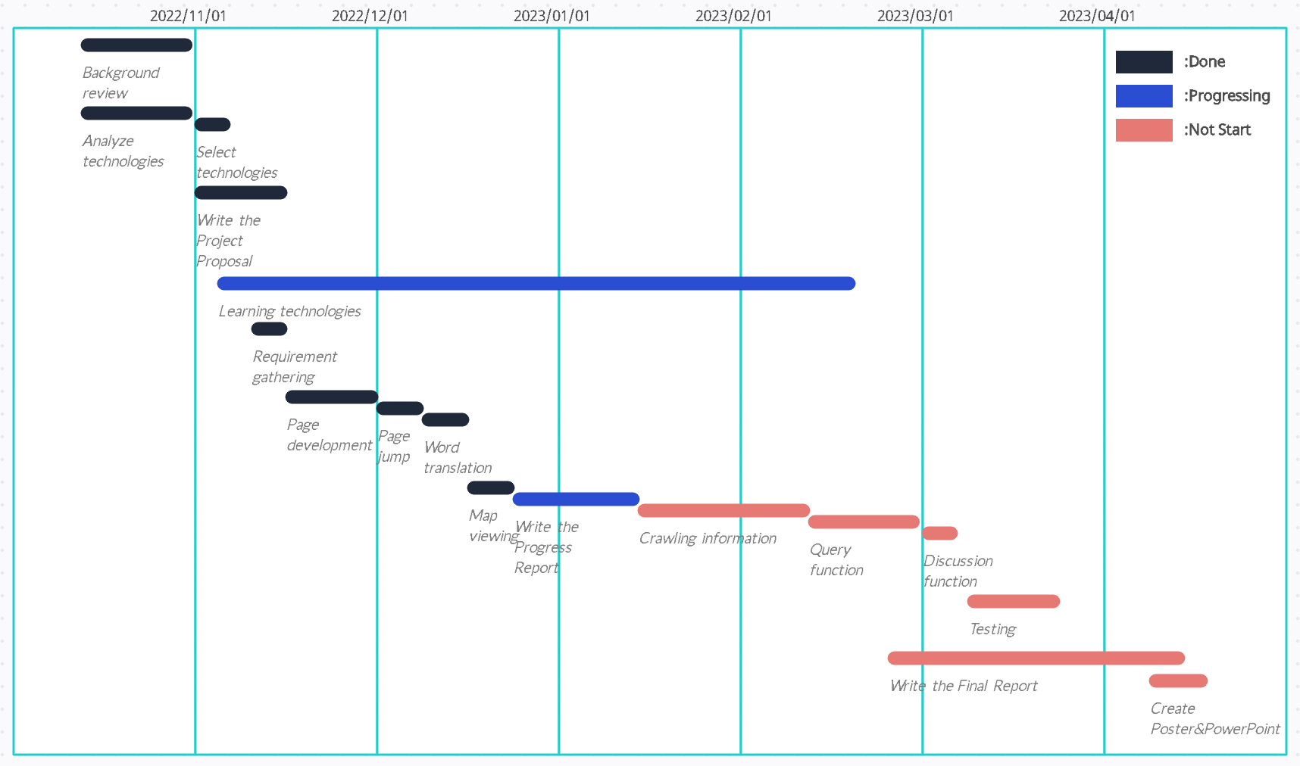

Fig. 16. Project Gantt Chart

The Gantt chart of the project can be seen from Figure 16, and the planned time of each activity can be seen from it. The Gantt Chart has been updated and the status of each task is differentiated by color.

## Project Version Management

图形用户界面

Fig. 17. GitHub Repository of This Project

As can be seen from Figure 17, use Git repository to save my project source code and other deliverables, push them to remote branches by creating local branches, and finally save them to GitHub repository.

## Project Data Management

As mentioned in 4.3, the source code of the project and other deliverables, including documents and reports, will be uploaded to the GitHub repository for storage to facilitate subsequent preview and acceptance.

## Project Deliverables

The deliverables of the project will consist of the following parts and will be delivered within the specified time:

Submitted: Project proposal.

Upcoming submission: Progress report, Software progress demonstration video.

Not yet submitted: Final report, Project source code, Questionnaire data, Full software demonstration video, Poster, PowerPoint of project.

# Professional Issues and Risk:

## Risk Analysis

1. The replacement of the computer led to the replacement of the Git local warehouse, and the version of the remote warehouse could not be updated in time.

Due to the replacement of notebook computers during the project, Git has not been started on the new computer and the old computer is not around, so the code version on GitHub cannot be updated in time. It is necessary to wait until the beginning of next semester to upload the code of each version to the remote warehouse one by one.\

1. At present, the main package size of WeChat applet is more than 2M, and the code may not be uploaded if it is released in the future.

It is necessary to compress and subcontract WeChat mini program code before uploading, so that the size of a single package does not exceed 2M, and the size of all sub-packages does not exceed 20M.

## Professional Issues

According to the analysis and research, the project has professional issues in the following two aspects.

1. Legal

According to the ACM Code of Ethics and Professional Conduct, the project development needs to understand and respect the existing rules related to professional work [16]. Therefore, the investigation found that the use of python crawler technology in development needs to comply with the Robots Exclusion Standard. This standard is that website owners use the/robots. txt file to provide instructions about their websites to network robots to exclude so-called robots. The txt file contains directories that can be crawled and directories that cannot be crawled [17].

1. Ethical

According to the ACM Code of Ethics and Professional Conduct, privacy needs to be respected. That is, when python crawls to the relevant data, it needs to keep the data confidential, prevent the disclosure of the required information, and use the data legally and reasonably without infringing its rights [16].

# References

[1] X. Wu, B. Feng, and W. Qi, “Design and Implementation of a Novel Student Information Management System,” in *Proceedings of 2020 IEEE 3rd International Conference on Information Systems and Computer Aided Education, ICISCAE 2020*, Sep. 2020, pp. 637–639. doi: 10.1109/ICISCAE51034.2020.9236801.

[2] Y. Chu, “Construction of student personal information management system relying on computer,” in *Journal of Physics: Conference Series*, May 2021, vol. 1915, no. 4. doi: 10.1088/1742-6596/1915/4/042080.

[3] G. Chen, J. Peng, Institute of Electrical and Electronics Engineers. Beijing Section, and Institute of Electrical and Electronics Engineers, *Proceedings of 2016 IEEE International Conference of Online Analysis and Computing Science (ICOACS 2016) : May 28-29, 2016, Chongqing, China*. 2016.

[4] K. Cheng, M. Schreieck, M. Wiesche, and H. Krcmar, “Emergence of a Post-App Era – An Exploratory Case Study of the WeChat Mini-Program Ecosystem,” in *WI2020 Zentrale Tracks*, GITO Verlag, 2020, pp. 1444–1458. doi: 10.30844/wi_2020_n1-cheng.

[5] L. Hao, F. Wan, N. Ma, and Y. Wang, “Analysis of the Development of WeChat Mini Program,” in *Journal of Physics: Conference Series*, Oct. 2018, vol. 1087, no. 6. doi: 10.1088/1742-6596/1087/6/062040.

[6] IEEE Staff, *2017 International Conference on Smart Technologies for Smart Nation (SmartTechCon)*. IEEE, 2017.

[7] Dr. C. K. GOMATHY, “STUDENT INFORMATION MANAGEMENT SYSTEM,” *INTERANTIONAL JOURNAL OF SCIENTIFIC RESEARCH IN ENGINEERING AND MANAGEMENT*, vol. 06, no. 03, Mar. 2022, doi: 10.55041/IJSREM11816.

[8] X. Wu, Y. Zhang, J. Zhang, and R. Cui, “Design and Implementation of College Online Learning System Based on WeChat Mini Program,” in *Proceedings - 9th International Conference on Information Technology in Medicine and Education, ITME 2018*, Dec. 2018, pp. 447–451. doi: 10.1109/ITME.2018.00106.

[9] L. Junfei and Z. Longhai, “Research on Student Management of Higher Vocational Colleges Based on Mobile WeChat Mini Program,” 2021.

[10] X. Zhang, X. Yu, and W. Sun, “Design and Implementation of intelligent Learning Companion System Based on WeChat Mini Program,” in *Proceedings - 2020 International Conference on Artificial Intelligence and Education, ICAIE 2020*, Jun. 2020, pp. 24–27. doi: 10.1109/ICAIE50891.2020.00013.

[11] “Weixin Docs.” https://developers.weixin.qq.com/miniprogram/dev/framework/ (accessed Nov. 10, 2022).

[12] DCloud, “What is uni-app?,” 2023. https://en.uniapp.dcloud.io/ (accessed Jan. 07, 2023).

[13] DCloud, “What is uniCloud,” 2023. https://en.uniapp.dcloud.io/uniCloud/ (accessed Jan. 07, 2023).

[14] DCloud, “HBuilderX.” https://hx.dcloud.net.cn/ (accessed Jan. 07, 2023).

[15] Zhiyuan Bo, “Qingflow.” https://qingflow.com/ (accessed Nov. 10, 2022).

[16] Don Gotterbarn *et al.*, “ACM Code of Ethics and Professional Conduct,” *Association for Computing Machinery*, 2018. https://www.acm.org/code-of-ethics#:~:text=ACM%20Code%20of%20Ethics%20and%20Professional%20Conduct%201,WITH%20THE%20CODE.%20A%20computing%20professional%20should...%20 (accessed Jan. 08, 2023).

[17] Martijn Koster, “A Standard for Robot Exclusion,” 1994. http://www.robotstxt.org/orig.html (accessed Jan. 08, 2023).