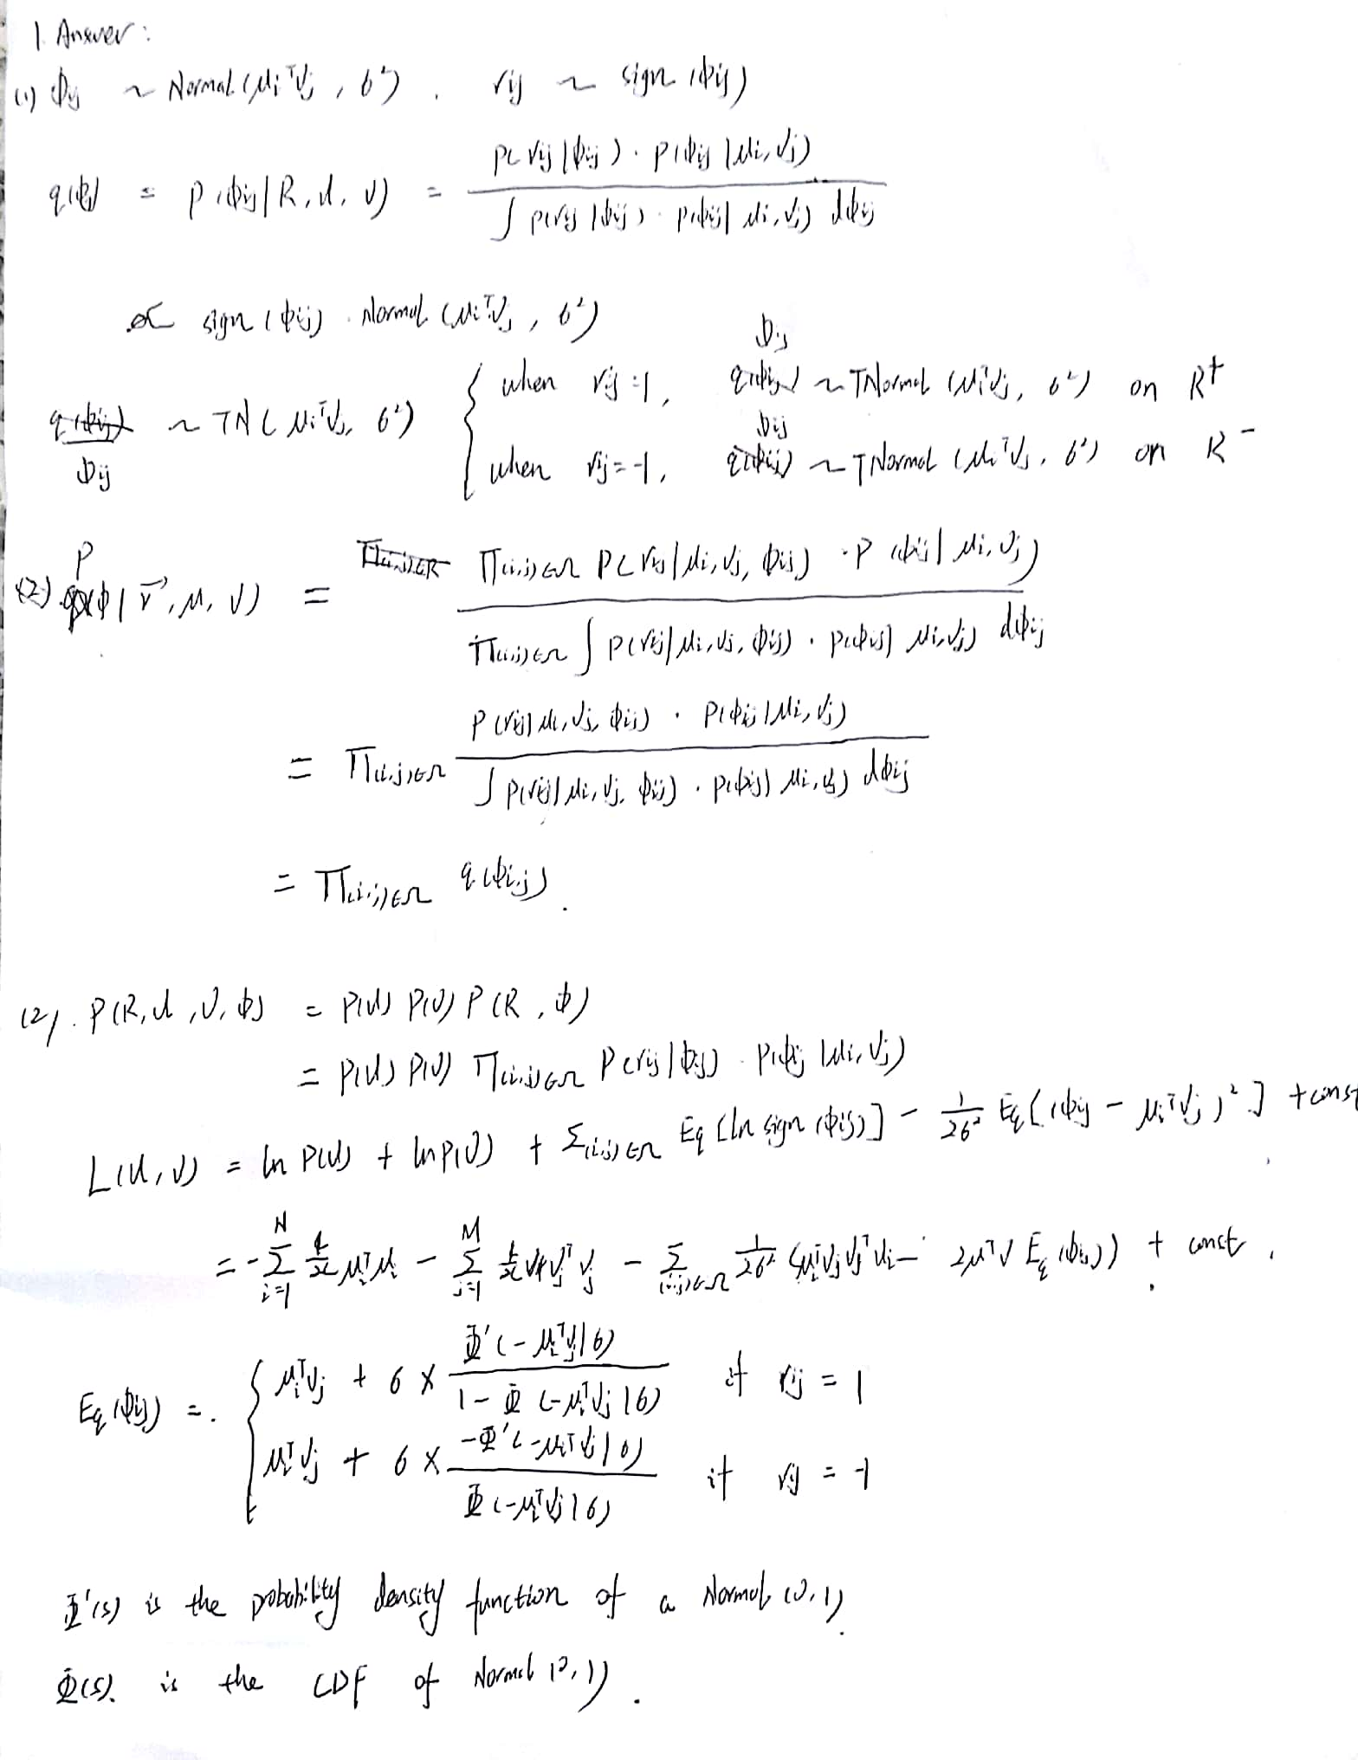

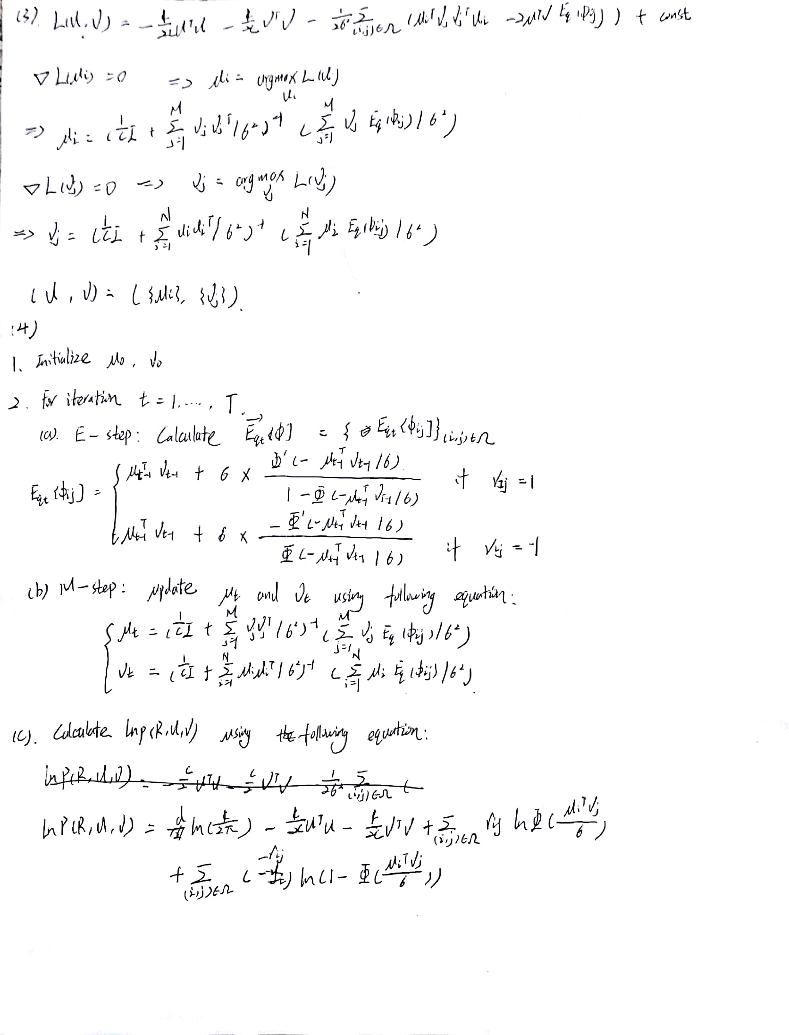

1. Run your algorithm for 100 iterations and plot ln p(R;U;V ) for iterations 2 through 100.

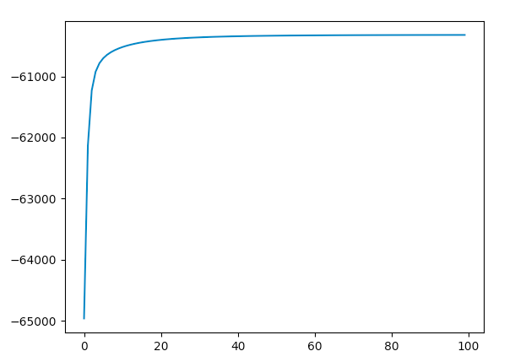

2. Plot 5 different objective functions for iterations 20 through 100

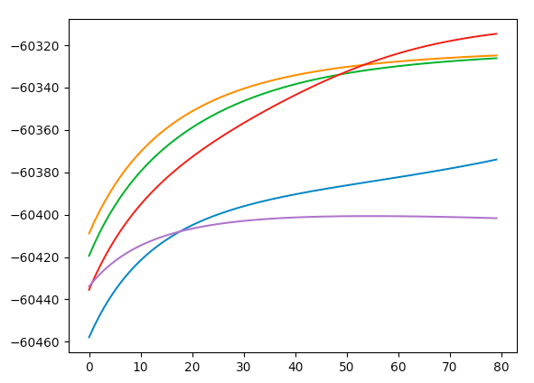

3. Predict the values given in the test set Like Dislike

|  |  |  |
| --- | --- | --- |
|  | Test as 1 | Test as -1 |
| Predict as 1 | 2150 | 988 |
| Predict as -1 | 584 | 1278 |

Accuracy = 68.56