1. Answer：
2. False. Piggybacking is used when both sides have to send data to each other, so that the receiver will send one packet instead of two (ACK and data packet). When Host B doesn’t send any data, it will still send an ACK with next sequence number in sequence-number filed as expected.
3. False. rwnd is used to show how much buffer left, so the amount of unacknowledged TCP data varies with the rwnd.
4. True. TCP is not permitted to overflow the allocated receiver buffer. Hence when the rwnd is 0, the sender cannot send anymore data for all buffer would have unacknowledged data.
5. False. The sequence number is the first byte’s byte-streaming number, so the next sequence number is the current sequence number plus the data segment size, which may larger than 1.
6. True. Every TCP segment has a current value of rwnd in the receiver window.
7. True. EstimatedRTT is a weighted average of SampleRTT, the latter being the amount of time between when the segment is sent and when it’r received. TimeoutInterval >= EstimatedRTT, so the TimeoutInterval >= average(SampleRTT) = EstimatedRTT = 1 sec
8. True. The sequence number for a segment is the byte-stream number of the first byte in the segment as given 38, and the acknowledged segment is the next byte expected as 38 + 4 = 42. So it’s right.
9. Answer:

0 1 0 1 0 0 1 1

+ 0 1 1 0 0 1 1 0

= 1 0 1 1 1 0 0 1

+ 0 1 1 1 0 1 0 0

= 0 0 1 0 1 1 0 1

+ 1(carry)

= 0 0 1 0 1 1 1 0

~ 0 0 1 0 1 1 1 0

= 1 1 0 1 0 0 0 1

1. The receiver adds all the 16-bit words of the segment with checksum to detect errors, and the result should be all 1s. If some of the bit is 0, the receiver knows that there is an error here.
2. 1-bit-error will cause the specific bit to convert (1 -> 0, 0-> 1), so the error will be detected.

2-bits-error may not be detected. In two of the bytes with the same position, the two bits exchanges (10 + 01 => 11 + 00), so the checksum will not be affected. But it’s an error.

1. Answer:

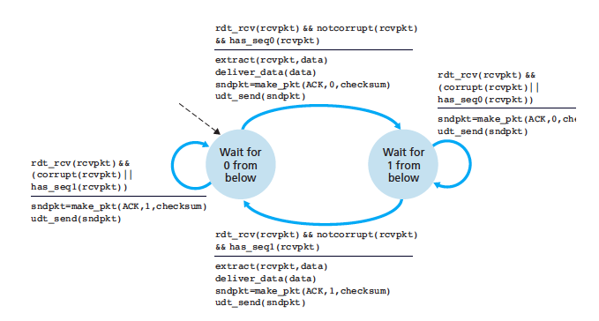

1. Answer:

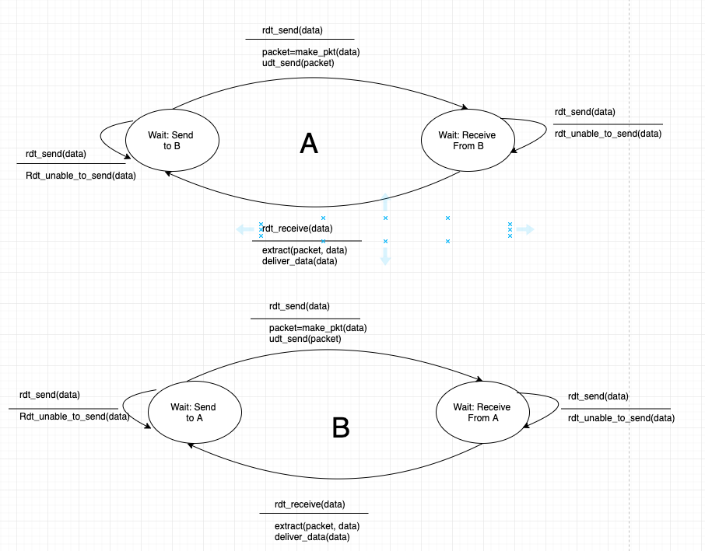

1. Answer:
2. True. Suppose the sender has a window size of 2 and sends packet 1,2 at t0. At t1, the receiver acknowledges packet 1,2. At t2, the sender times out and resends packet 1,2, At t3, the receiver receives packet 1,2 again and re-acknowledges 1,2. At t4 the sender receives acknowledge of 1,2 and move the windows towards 3,4. At t5 the sender receive the re-acknowledge of 1,2 again, but 1,2 are out of its current window.
3. True. The same argument as a)
4. True. When window size is 1, there won’t be out-of-order packets within one window, a cumulative ACK is just an ordinary ACK in this situation.
5. True. The same argument as c)
6. Answer:

${Estimated}^{1}={SampleRTT}^{1}$

${Estimated}^{2}={∂*SampleRTT}^{1}+\left(1-∂\right)*{SampleRTT}^{2}$

${Estimated}^{3}={∂*{SampleRTT}^{1}+\left(1-∂\right)*{[∂*SampleRTT}^{2}+\left(1-∂\right)*SampleRTT}^{2}=∂*{SampleRTT}^{1}+\left(1-∂\right)∂*{SampleRTT}^{2}+{\left(1-∂\right)}^{2}*{SampleRTT}^{3}$

${Estimated}^{4}=∂*{SampleRTT}^{1}+\left(1-∂\right)*{Estimated}^{3}=∂*{SampleRTT}^{1}+\left(1-∂\right)∂*{SampleRTT}^{2}+{\left(1-∂\right)}^{2}∂*{SampleRTT}^{3}+{\left(1-∂\right)}^{3}*{SampleRTT}^{4}$

${EstimatedRTT}^{n}=∂Σ_{j=1}^{n}{\left(1-∂\right)}^{j-1}*{SampleRTT}^{j}+{ \left(1-∂\right)}^{n}*{SampleRTT}^{n}$

${EstimatedRTT}^{∞}=\frac{∂}{1-∂}Σ_{j=1}^{∞}{\left(1-∂\right)}^{j}*{SampleRTT}^{j}=\frac{1}{9}Σ_{j=1}^{∞}{\left(0.9\right)}^{j}* {SampleRTT}^{j}$

2. Answer:
3. L is the ration of the lost packets over the sent packets. So in a circle, if one packet lost, the packets sent are:

$$\frac{W}{2}+\left(\frac{W}{2}+1\right)+…+W=Σ_{n=0}^{\frac{W}{2}}\left(\frac{W}{2}+n\right)=\left(\frac{W}{2}+1\right)*\frac{W}{2}+Σ_{n=0}^{\frac{W}{2}}n=\frac{3}{8}W^{2}+\frac{3}{4}W$$

So the loss rate is;

$$\frac{1}{\frac{3}{8}W^{2}+\frac{3}{4}W}$$

1. For W large enough, $\frac{3}{8}W^{2}≫\frac{3}{4}W$, so $L≈\frac{8}{3}W^{2}$

$$Average throughput=\frac{3}{4}\sqrt{\frac{8}{3L}}*\frac{MSS}{RTT}≈\frac{1.22*MSS}{RTT*√L}$$