HW1 hz2558 Haopeng Zhang

1. Answer:

Bandwidth in the cable Internet access is shared among homes. On the downstream stream, the packets are enumerated from one single source, the head end. So there are no collisions on the downstream channel.

1. Answer:

(a). In circuit switching, the circuit guarantees the full bandwidth of the channel and remains connected for the duration of the communication session. So we can only support 2 users because each user will require half of the link bandwidth.

(b). When less than two users are using the link, the bandwidth(2Mbps) can support both users’ transmission (2 \* 1Mbps = 2Mbps), so there will be no queuing delay. But when three users are transmitting, the 3Mbps bandwidth is required, which is more than given 2Mbps. So there will be queuing delaying.

(c). Probability that a user is transmitting = 0.2.

$\left(\begin{aligned}3 \\ 4\end{aligned}\right)*p^{3}{\left(1-p\right)}^{1}+\left(\begin{aligned}4 \\ 4\end{aligned}\right)* p^{4}$ = 0.0272

The queue grows when more than two users are transmitting, so the fraction of time is 0.0272.

1. Answer:

(a). $t=3*(\frac{L}{R}+\frac{d}{s} )$

(b). $t=3*\frac{d}{s}+\frac{L}{R}$

1. Answer:

(a). For every packet, it will require $\frac{L}{R}$ time to transmit. So, for packet i, it will require $\left(i-1\right)* \frac{L}{R}$ queuing delay. $Average time=\frac{\left(0+ \frac{L}{R}+\frac{2L}{R}+⋯+\frac{\left(N-1\right)L}{R}\right)}{N}=\frac{\left(N-1\right)L}{2R}$

(b) The last packet of N packets need to wait for $\frac{\left(N-1\right)L}{R}$ time, which is less than $\frac{NL}{R}$. Therefore, for every N packets arrive, the queue is empty because the last batch if packets have been transmitted. So the average time is equal to every packet’s average queuing delay. $Average time=\frac{\left(N-1\right)L}{2R}$

Answer:

(a).

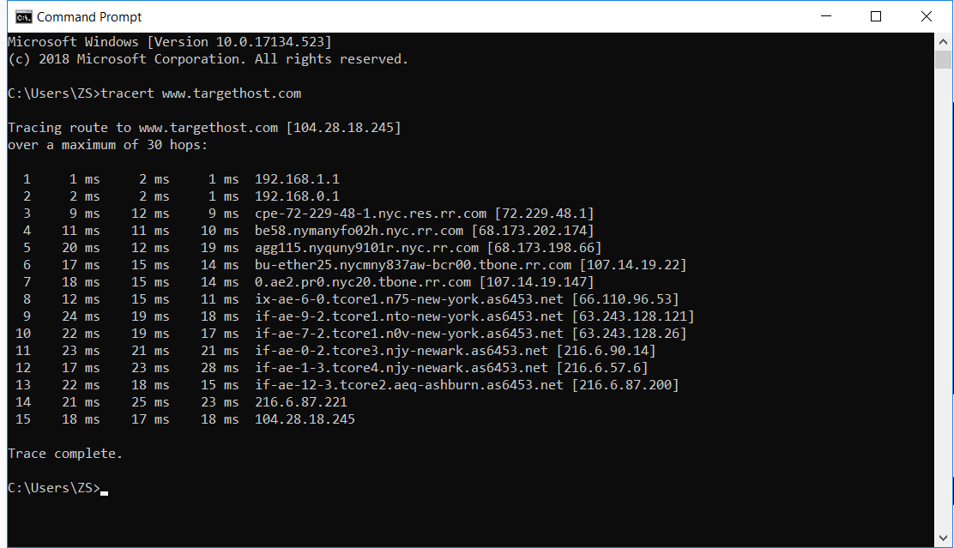

Average round-trip delay: $\frac{18+17+18}{3}ms=17.67ms$

Number of routers: 14

Number of ISP Network: 6

(b).

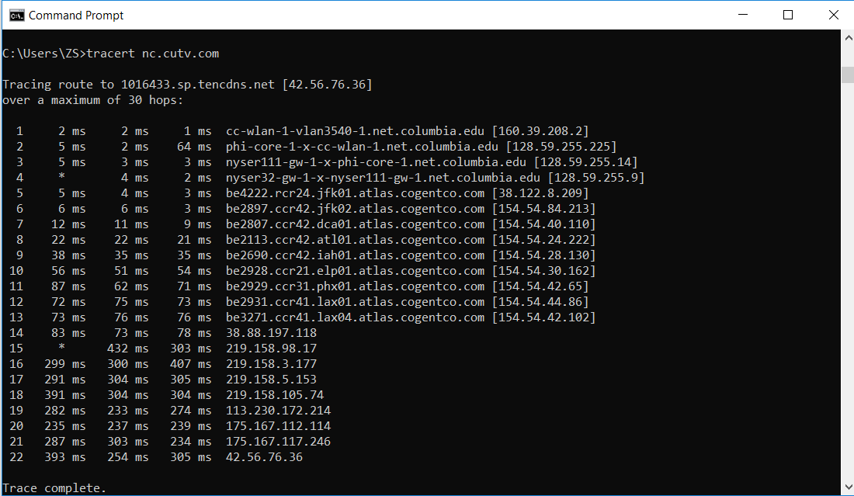

Average round-trip delay: $\frac{393+253+305}{3}ms=317.33ms$

Number of routers: 21

ISP Network: 7