1. Answer:

We will use UDP. Assume file transmission time is the same, for TCP, we need extra 2RTTs (One for the TCP connection set-up, the other for client to send request to sever and sever to send back). But for UDP, we only need RTT(the client sends the transaction request into a UDP socket, and the sever sends the reply back to the client’s UDP socket). So the UDP is faster.

1. Answer:

Transport Layer provides services such as connection-oriented communication, reliability, flow control, and multiplexing. The two most important protocols in the Transport Layer are Transmission Control Protocol (TCP) and User Datagram Protocol (UDP). Both protocols deliver data between the Application Layer and the Internet Layer.

TCP provides reliable data delivery service with end-to-end error detection and correction.

UDP provides low-overhead, connectionless datagram delivery service.

But both of them don’t provide minimum throughput guarantee or delay.

1. Answer:

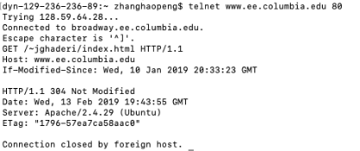

Cannot identify my IP address.

1. Answer:

The user will get first chunk as a result of being selected by one of his neighbors as a result of an “optimistically unchoke” for sending out chunks to him. Every 30 secs, a peer will select one of its neighbors randomly as a peer for uploading no matter whether this neighbor is uploading data to it or not.

1. Answer:

Every time, we need 2RTT to setup TCP connection, request and receive HTML file.

1. Non-persistent HTTP requires 2 RTTs per object.

So we need 2RTT + 8 \* 2RTT = 18RTT

1. We need 2RTT + (8 // 5) \* 2RTT = 6RTT
2. Server leaves connection open after sending response so that subsequent HTTP message between same client/server can be sent over open connection, and client will send request as soon as it encounters the reference objects.

So we need 2RTT + RTT = 3RTT

1. Answer:

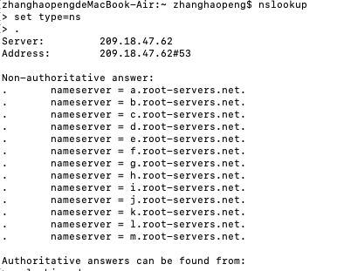

There are 13 root DNS servers.

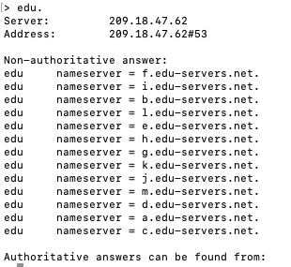

There are 13 TLD DNS servers for edu

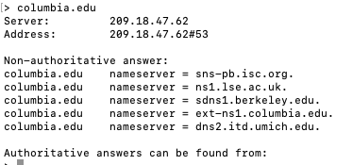

Only 5 authoritative DNS servers for that organization.

1. Answer:
2. In this distribution scheme, the server will send the file to N clients at a rate of , which is larger than client’s download rate, so the receiveing rate will also be . Because , so . The distribution time will be:
3. In this distribution scheme, the server will send the file to N clients at a rate of , and the total rate is . The client’s receiving rate can be . Because , so . The distribution time will be:
4. Distribution time(DT) >=

If , we get DT >=

From part a, we know that DT =

so DT =

If , we get DT >=

From part b, we know that DT =

so DT =

Above all, DT =