1. **Download & Install**: maven & allure & JDK version 17
2. Go to **Desktop**, select **This PC/My PC**, right click & select **properties**, then click **advanced system settings**, then click **environment variables**. ***OR*** Go to **Start button** then select **settings**, click **system**, then select **about**, then click **advanced system settings**, then click **environment variables**.

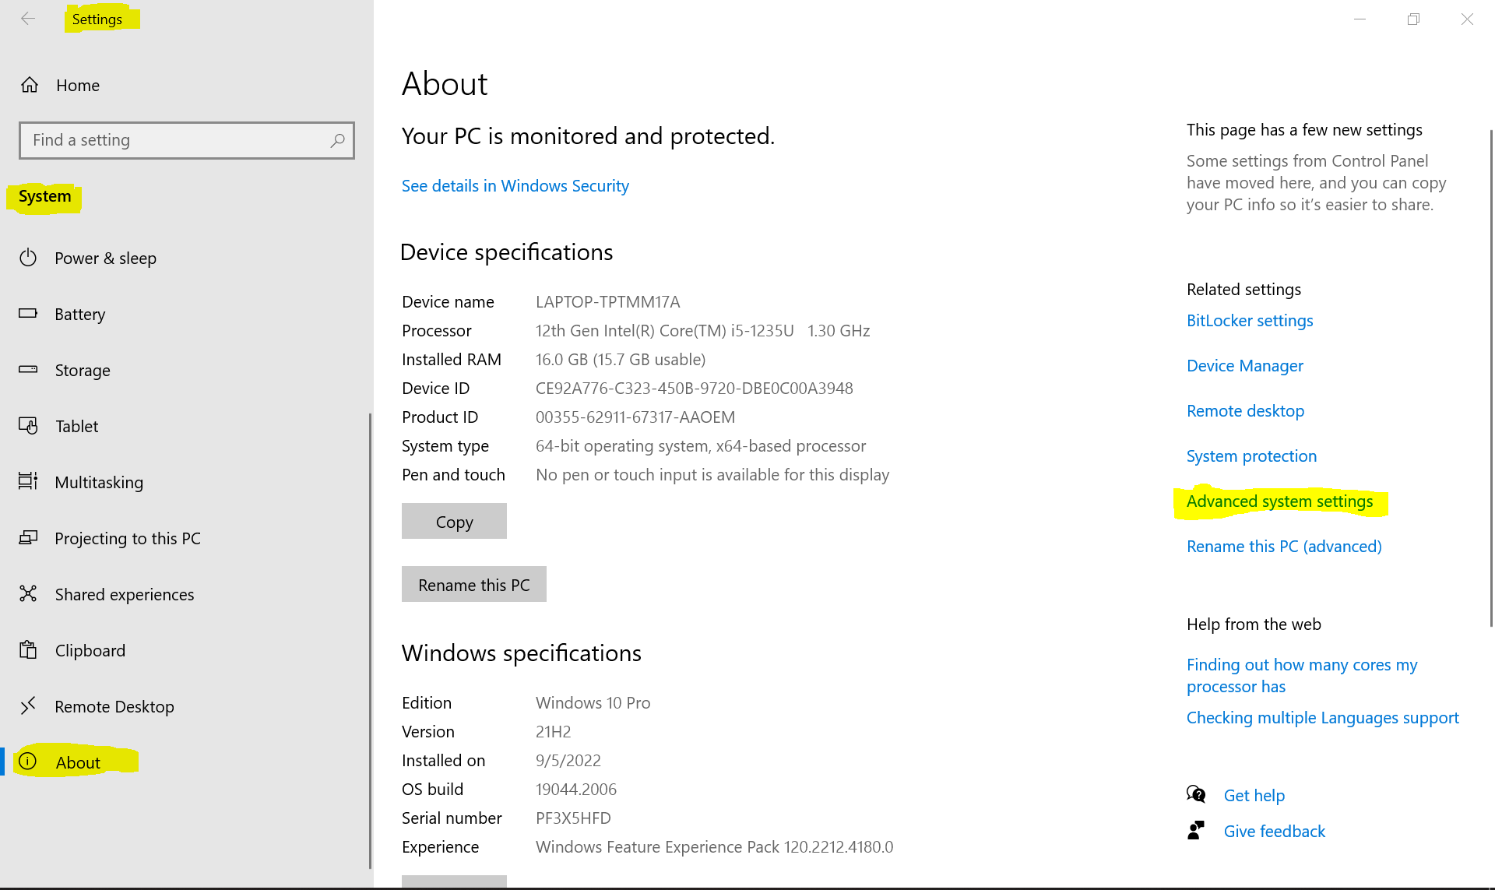

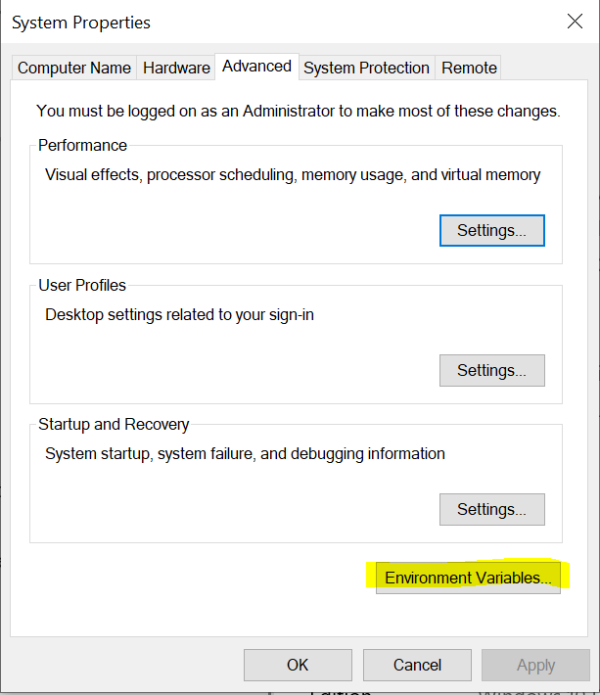

1. Add **MAVEN_HOME** in **system variables**. Click **new button** then add **MAVEN_HOME** and **maven path**, then click **OK**.

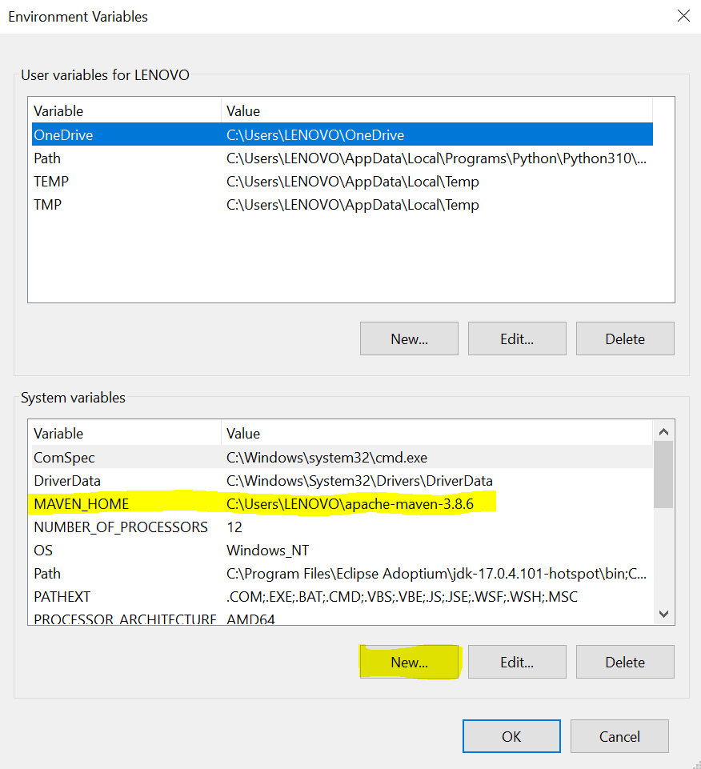

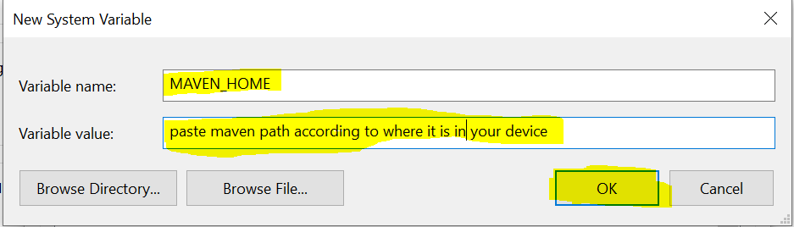

1. Click **path** in **system variables**, then Click **edit button**.

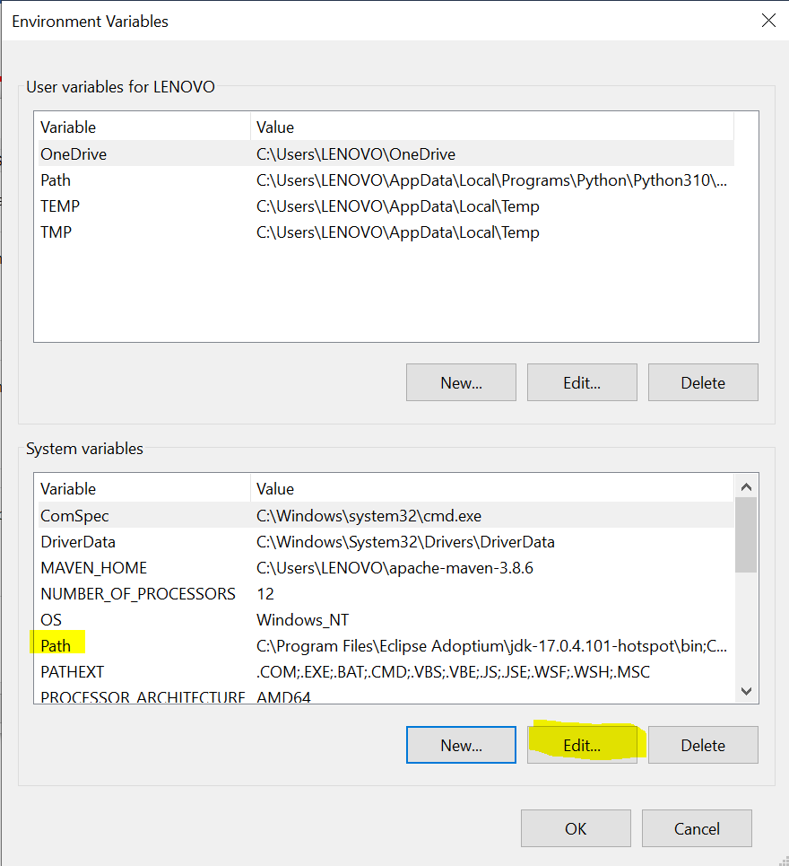

1. Add **JDK\bin** path, **%MAVEN_HOME%\bin** path**, allure\bin** path, **python** path, and **python\Scripts** path. Click **new button** then **paste the path** then **click enter** to add it. Then click **OK button**. You can run this command in command prompt 🡪 **pip --version. Result something like this: pip 22.2.2 from C:\Users\LENOVO\AppData\Local\Programs\Python\Python310\lib\site-packages\pip (python 3.10), then GO to C:\Users\LENOVO\AppData\Local\Programs\Python\Python310**

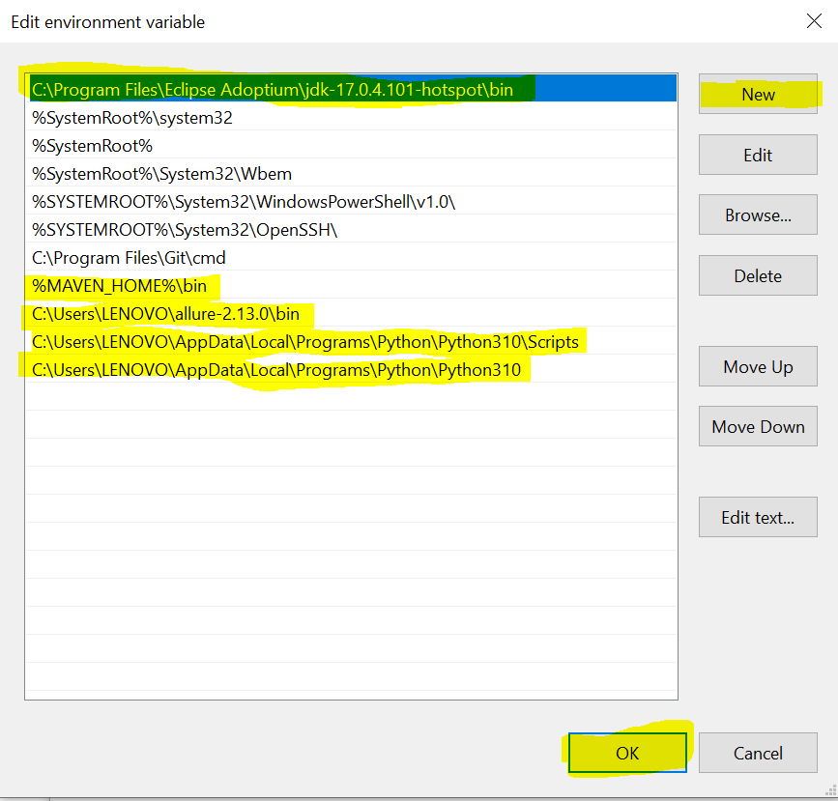

1. Then go to **services**, and **restart Jenkins**.
2. Go to [**Dashboard [Jenkins]**](http://localhost:8080/). Click **manage Jenkins**, then click **manage plugins**. Click **available plugins**. Install **TestNG** & **Allure** plugins. Then click **global tool configurations**, and edit **allure command line**. Then click **Apply** & **Save buttons**.

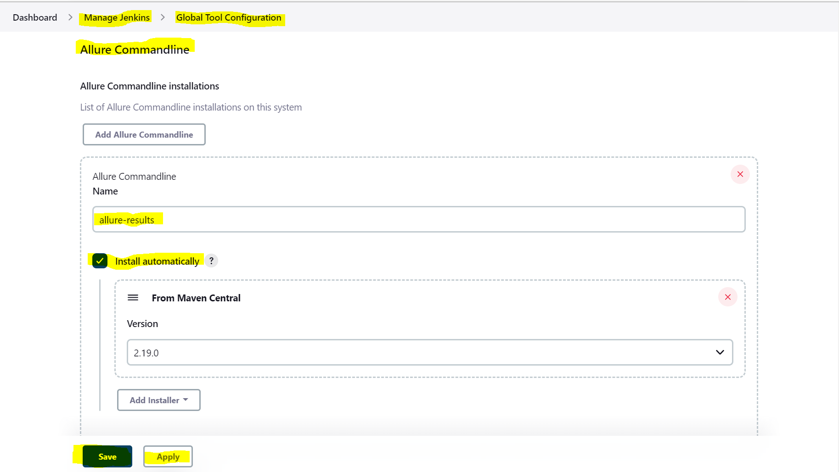

1. Go to **your project in Jenkins**. Click **Configure**, add **Description**, you can **add parameters** by clicking on **this project is parameterized** and **choosing its type and other details**. Select **Git**, paste **your repository URL** and select **your credentials**, select **Your Branch**. Select **Delete workspace before build starts** & **add timestamps to the console output**. Add **Execute Windows batch command.** Add **allure report**. Then Click **Apply** & **Save buttons**. ***Finally, Build your project ☺.***

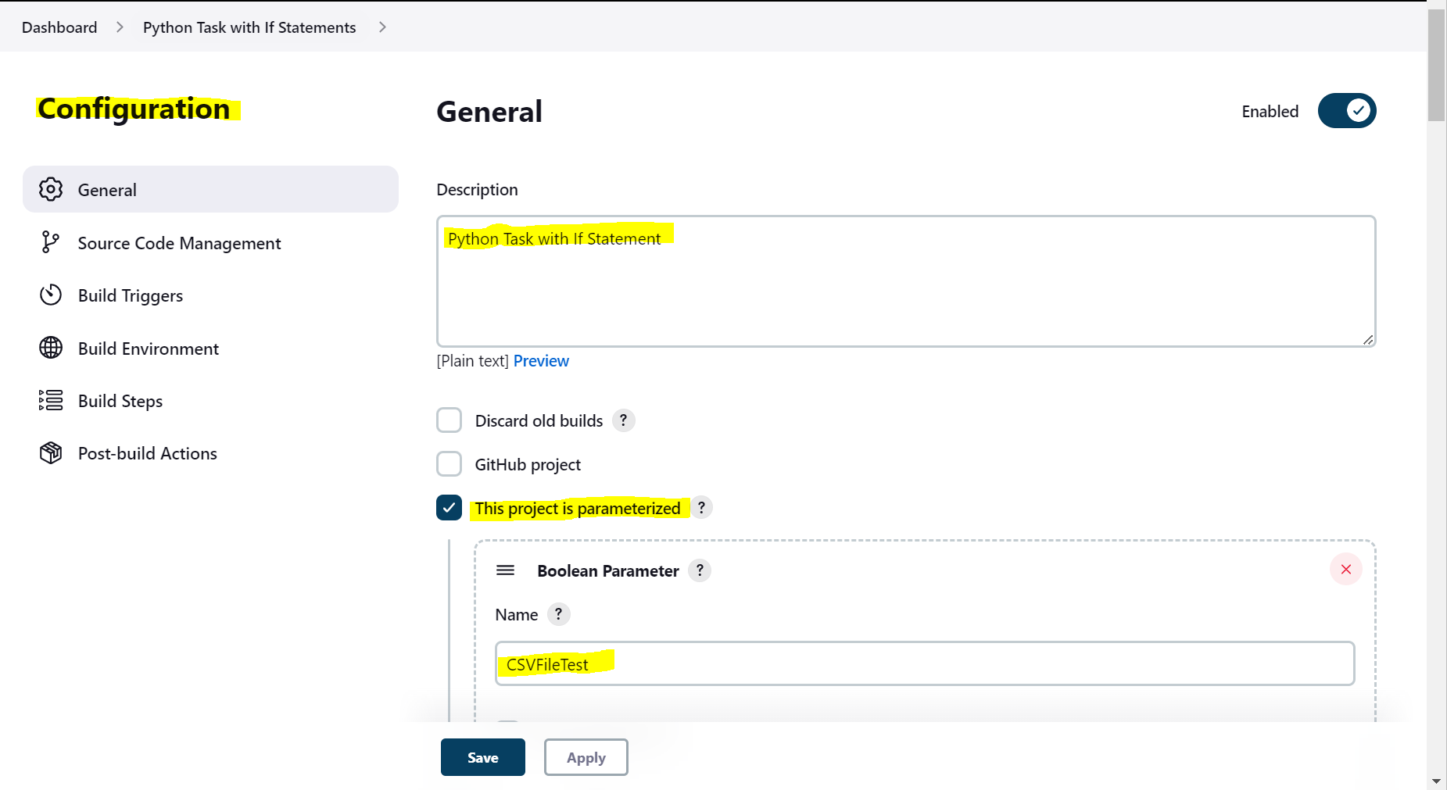

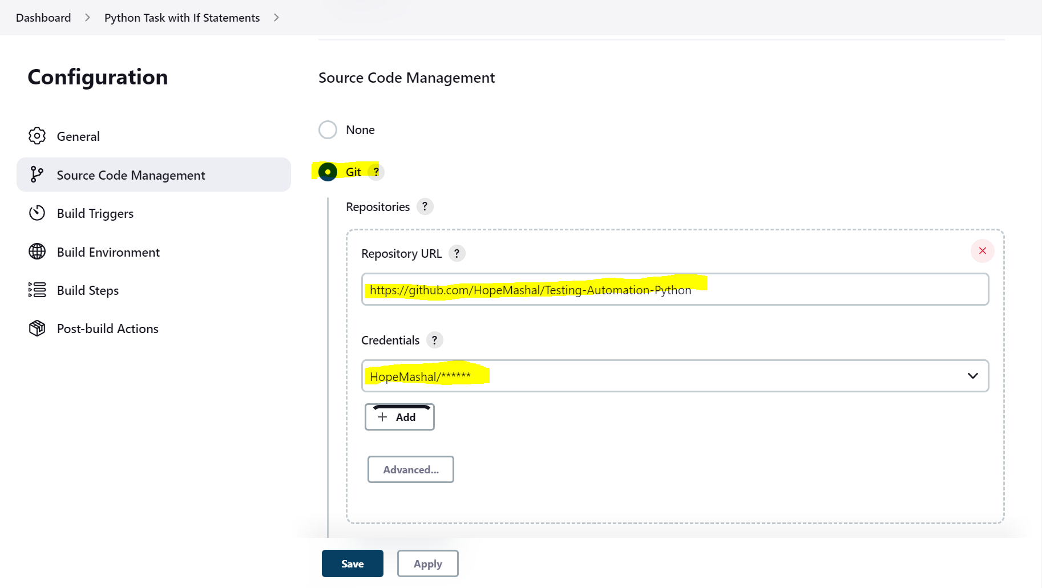

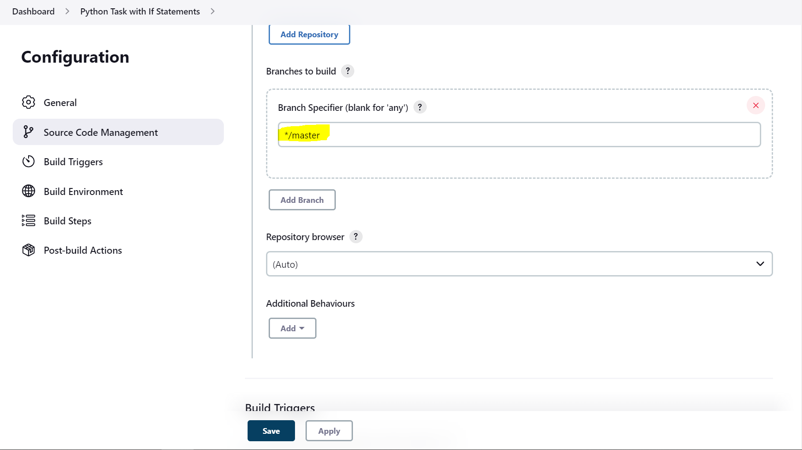

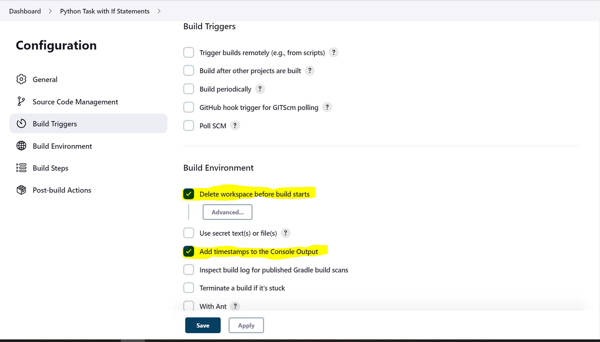

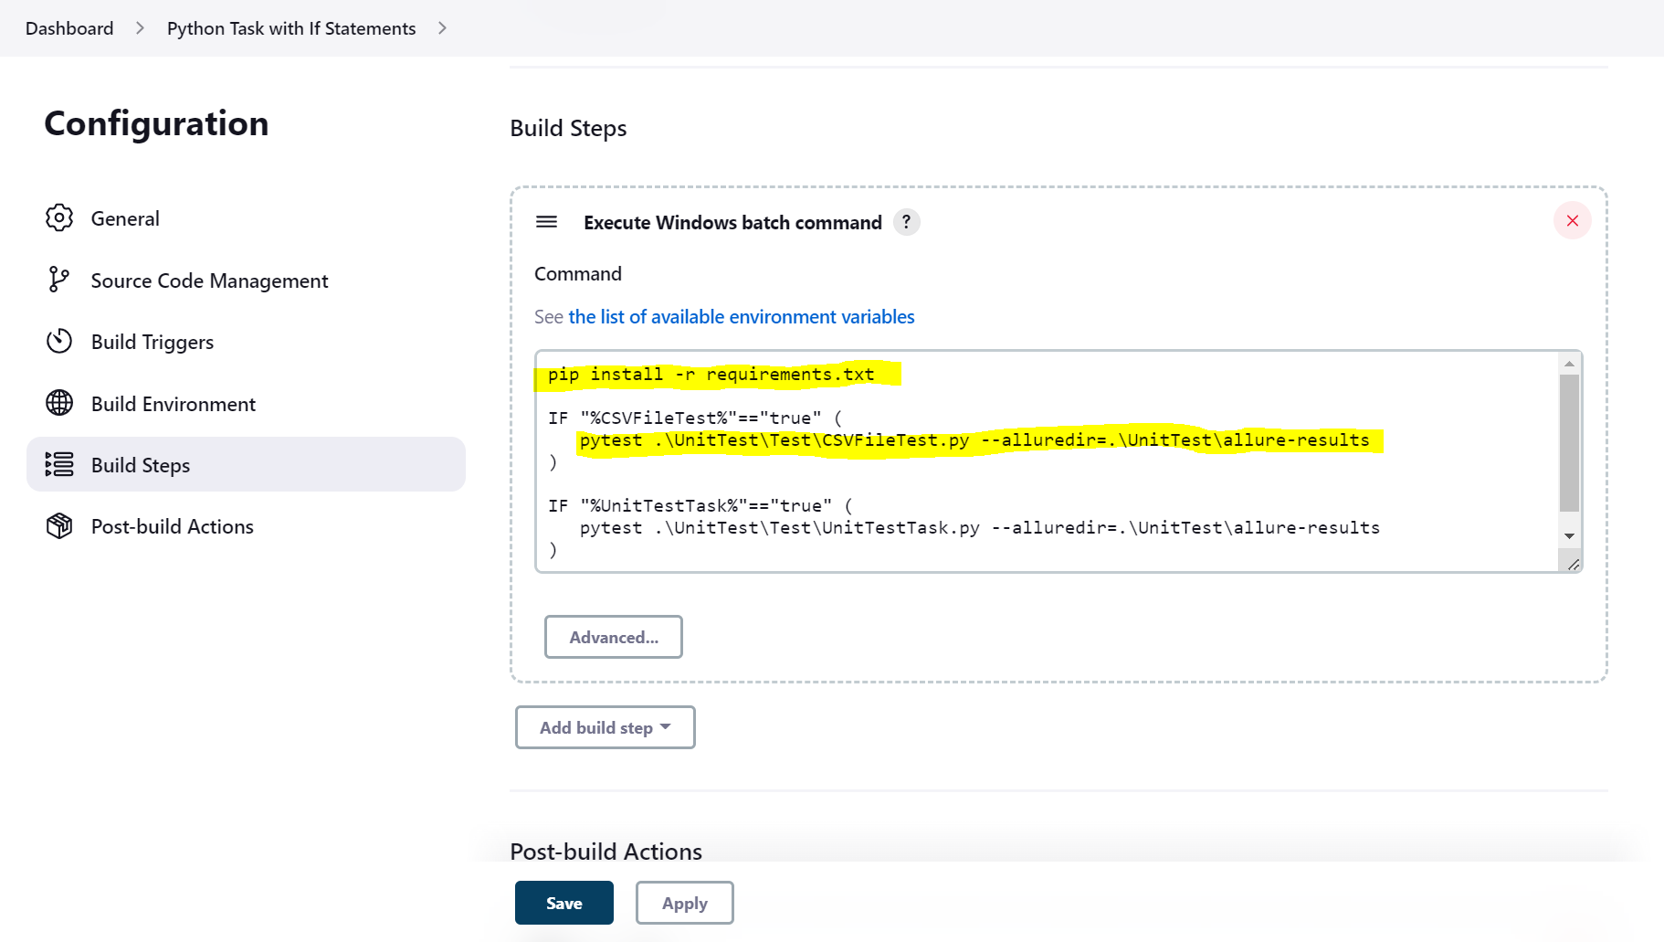

pip install -r requirements.txt

pytest .\UnitTest\Test\CSVFileTest.py --alluredir=.\**UnitTest\allure-results** 🡪 **Change it according to your project.**

