League Ledger
A Guide for GMs
hopefullyitwill.work
Contracts, the cap, the auction, trades and your nightly lineup
Everything in this guide is something you can do yourself. Nothing here needs the commissioner.

Contents

1. Before you start
League Ledger is the ledger for our nine-team dynasty league. It holds every contract, works out the cap and the tax for you, runs the auction and the rookie draft, takes trade offers between clubs, and sets your nightly lineup once the season is live.
It is one web page. There is nothing to install, it works on a phone, and everything you do is shared with the whole league the moment you do it.

Signing in
- Open hopefullyitwill.work and press Sign in at the top right.
- Pick your club from the list.
- Type the PIN the commissioner gave you and press Sign in.
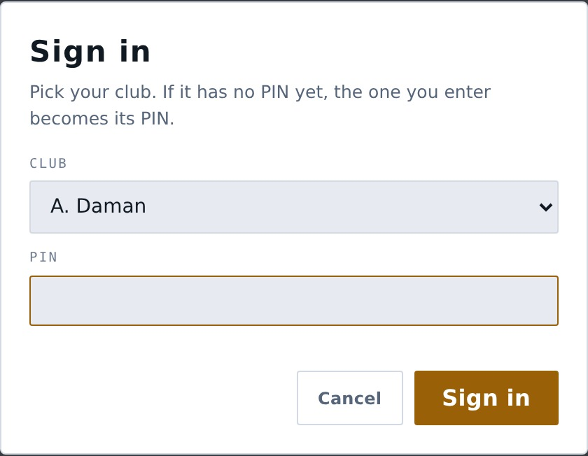
The sign-in box. Pick your club, type your PIN.
Your browser remembers you, so you should only have to do this once per device. You can change your PIN yourself later — see Settings at the end of this guide.
Be honest — the PINs are not real security
Anyone who views the page source can read every PIN. They exist to prevent accidents and to keep an audit trail, not to stop a determined league-mate. Every move you make is written to the transaction log with your club’s name against it, and everyone can read it.

2. Finding your way around
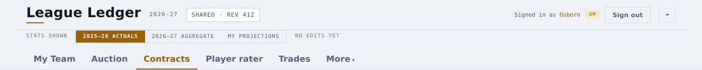
The top of every page.
Three lines sit above every screen:
- The top line — the app name, the league year, a connection chip, who you are signed in as, Sign out, and a button that switches between the light and dark look.
- Stats shown — the most useful control in the app. See below.
- The tabs — six main ones, and everything else under More.
Check the connection chip
Next to the league year it should read “shared · rev …”. That means you are connected to the league database and everyone can see your moves. If it ever says “this device only”, stop and tell the commissioner — your changes are not reaching anybody.

The “Stats shown” switch
This changes the numbers in every table in the app at once. Three choices:
Setting | What you are looking at
2025–26 actuals | What actually happened last season. The record.
2026–27 aggregate | The commissioner’s projection set for the season ahead. The same numbers for every GM, so an argument about a player is an argument about the same figures.
My projections | Your own edits, laid on top. Only you see these. Numbers you have changed are marked in amber.

Whichever you pick follows you around the app — the rater, the auction, the trade machine and the what-if roster all use it.

Tabs come and go with the season
The app knows whether the league is in the offseason or in season, and hides what does not apply:
Only in the offseason | Only in season
Auction | Quick sign
Free agent classes
Rookie draft

If a tab you were expecting is missing, that is why.

3. My Team
This is the tab you will live in. It is your club: your cap position, your roster, your bids, your lineup and the free agents you can sign. Everything you can actually do to your team is on this one page.
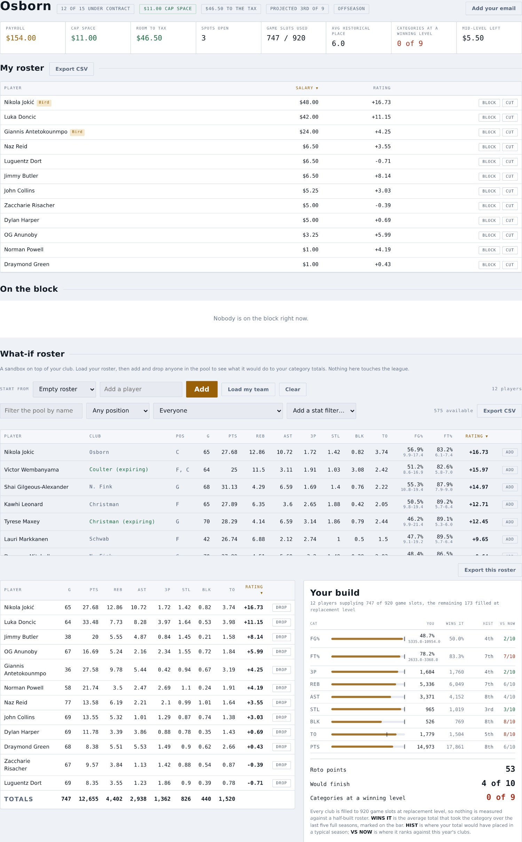
My Team, in the offseason.

3.1 Your cap position
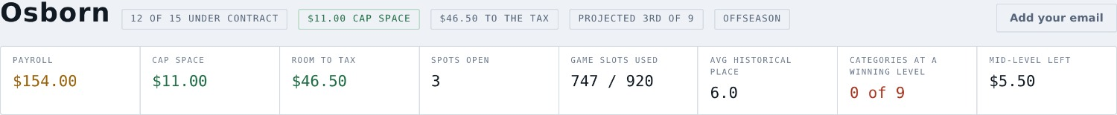
The strip at the top of My Team is the summary you will check most often:
- Salary cap ($165.00) — a soft cap. You may go past it, but only using Bird rights, Early Bird, the mid-level exception, or minimum contracts.
- Luxury tax ($200.50) — a hard cap. Nothing beats it. Not Bird rights, not anything. The app will refuse a move that would take you past it.
- Spots open — you may carry 15 players. In season you may carry a sixteenth, but only while one of them is on the injured reserve.
- Game slots used — see the box below. This one is easy to forget.
The 920-game cap
Each club is capped at 920 total player-games in a season. That means a player’s per-game rate matters far more than how many games he plays: once you are at the cap, the extra games are simply thrown away. A 78-game player is worth very little more than a 70-game player if your slots are already full.

3.2 My roster
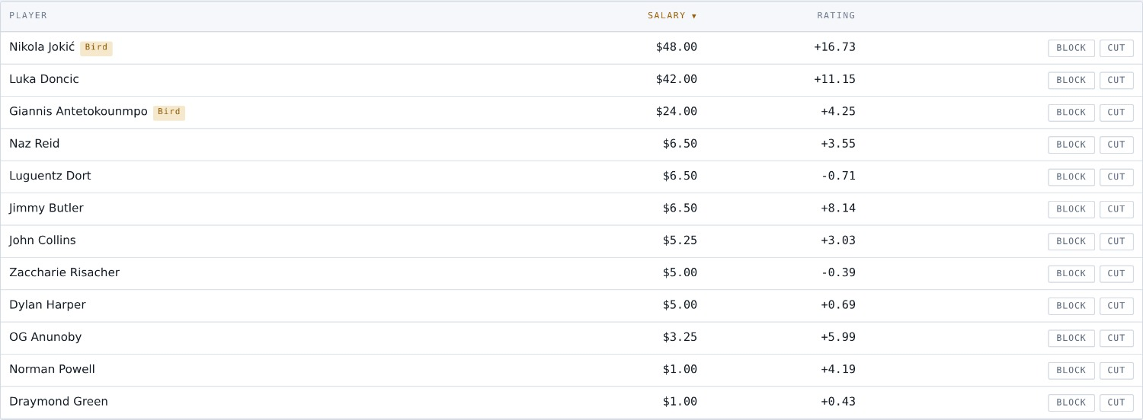
Every player you have signed, with the buttons that act on him.
Click any column heading to sort. Each row carries the moves you can make:
- Cut — releases the player. Read the next box before you use it.
- Block — lists him on the league-wide trade block so other GMs know he is available. It is only an advertisement; it does not commit you to anything, and it does not follow him if he is traded.
- IR — in season only, moves him to the injured reserve.
- Export CSV — your roster as a spreadsheet.
Cutting a player has consequences — read this before you do it
In season, his salary stays on your cap until the season ends. In the offseason it comes off immediately and the remaining years are voided. And if you release a man for MORE than the league minimum, you cannot sign him back for the rest of that season or the offseason that follows — cutting a $13.75 contract and buying it back at $1.00 is a renegotiation, not a release. Every other club may sign him freely. The app will tell you exactly why if you try.

3.3 Tonight’s lineup (in season)
Once the season is live, a block appears on My Team for the night’s lineup. Fifteen players start: one C, four G, four F and six UTIL. Everyone else sits on the bench, and the injured reserve is separate again.
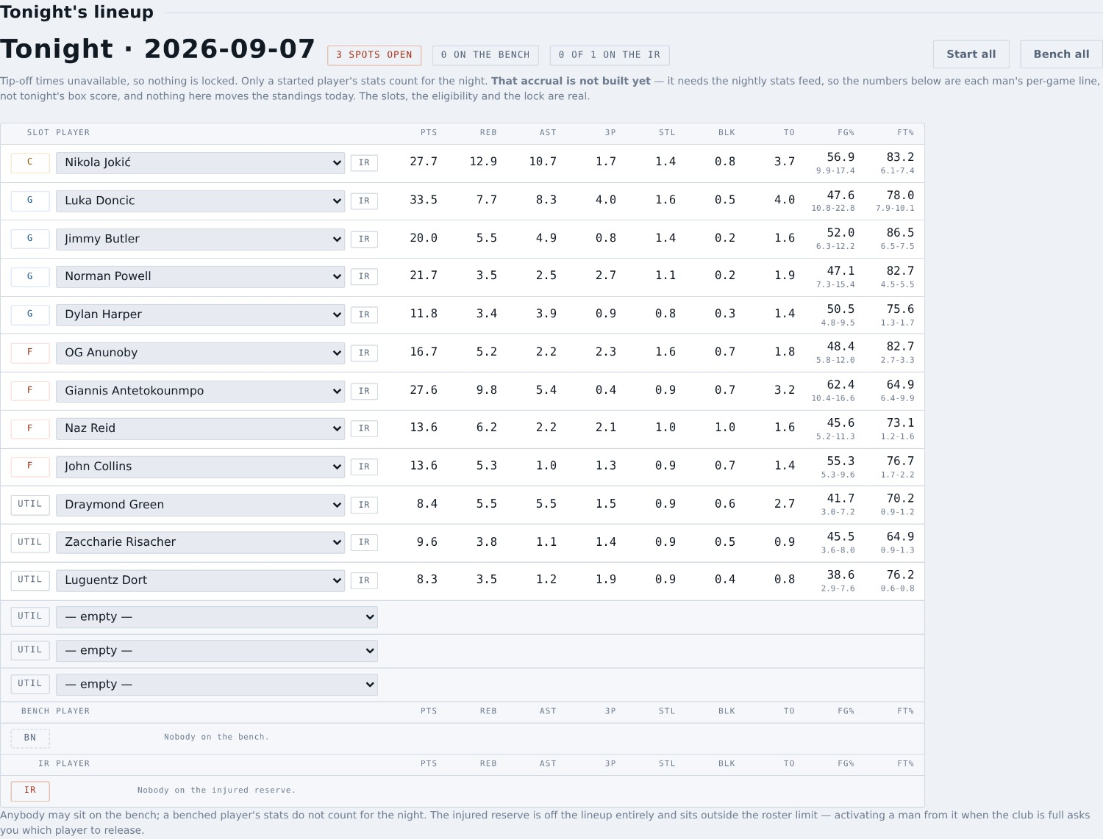
Tonight’s lineup. Slots at the top, bench below, IR at the bottom.

How to set it
- Use the dropdown in each slot to pick an eligible player. A guard can fill a G slot; UTIL takes anybody.
- Start all fills every open slot from your bench, scarcest position first. Bench all is the opposite.
- A bench player’s dropdown offers only the slots he actually fits. If none fit, it says so rather than giving you a control that cannot work.
- The IR button on any row moves a player to the injured reserve and clears his slot in the same step.
The lock is per game, not league-wide
A player freezes the moment HIS OWN game tips off. A five o’clock game locks that man at five and leaves his team-mate on a half-seven game free for another two and a half hours. A locked player is shown as plain text with no dropdown. An unlocked starter shows his tip-off time, so you know your deadline without doing the arithmetic.
Your lineup carries forward until you change it — you do not have to set it again every night, which is what you want when you are away.
Nightly stat accrual is not built yet
The slots, the eligibility and the lock are all real. But nothing yet counts a night’s box score against your started players — that needs the nightly stats feed. The numbers beside each player are his per-game line, not tonight’s box score, and the screen says so. Setting your lineup does not move the standings today.

3.4 On the block — what he would do to your club
When a player is up for auction, this panel answers the question My Team is the right place to answer: what would he do to my nine categories, at the price it is at now. Green is better, red is worse, and it shows the roto points the change would be worth.
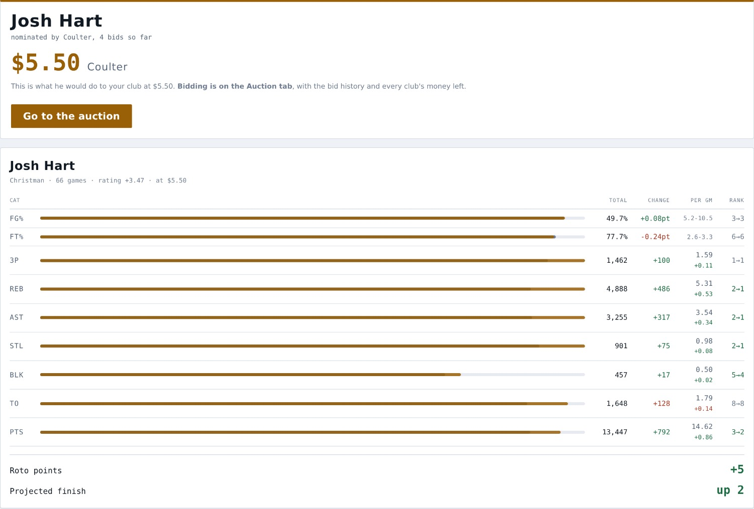
What the player on the block would do to your categories.
You bid on the Auction tab, not here
The controls used to sit on this page, two tabs away from the bid history, the money left and the player himself — so a GM bidding was reading one screen and typing into another. They now sit under the player on the Auction tab. This panel keeps the part that is about YOUR club, and there is a button here that takes you straight across.
If you have written the player onto your strategy board, this panel also shows the row you wrote — where you ranked him, the priority, your max and your comment — and turns it red once the bidding reaches or passes the figure you set. See 4.

3.5 What-if roster
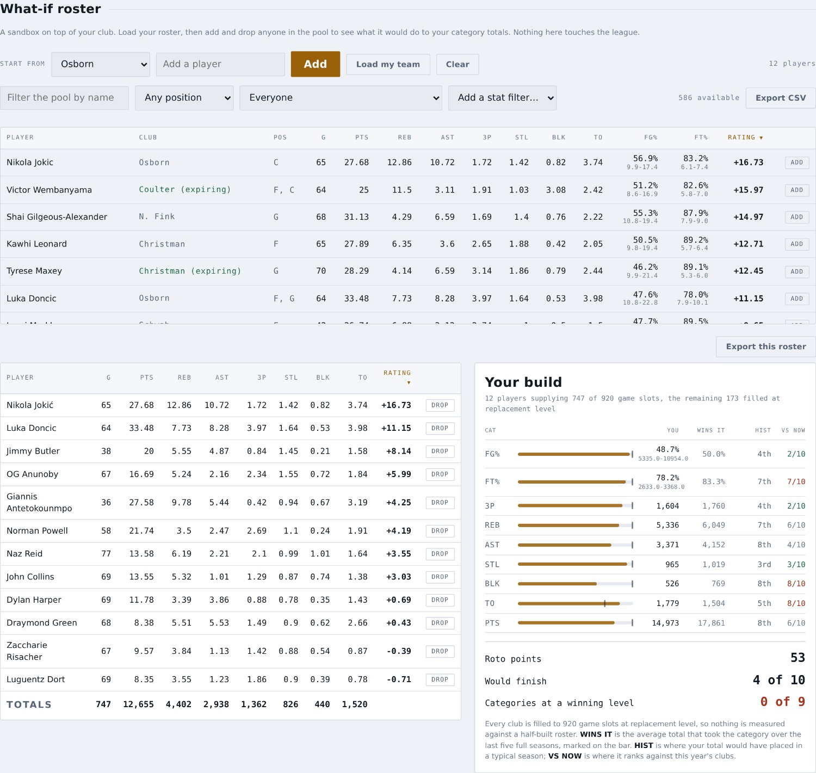
A sandbox on top of your club. Nothing here touches the league.
Load your roster with Load my team, then add and drop anyone in the pool to see what it would do to your category totals. Use it to answer “if I win this man, where does that leave me?” before you spend the money. Nothing you do here is saved to the league or visible to anybody else.

3.6 Available free agents
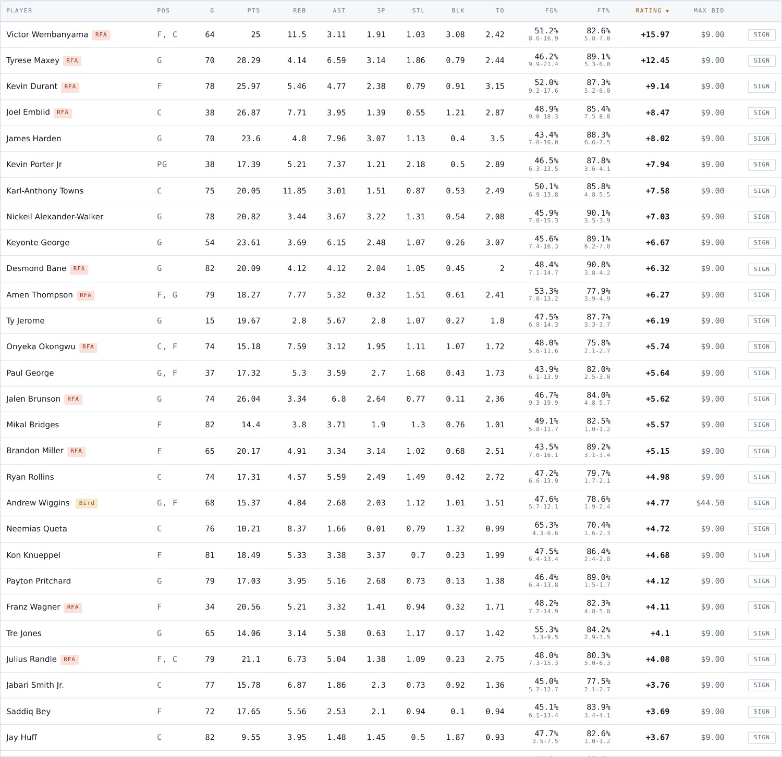
The free agent list, with the Sign button on the right of each row.
Search, filter by position, or add a stat filter. Click any player to open his full card. The Max bid column shows what you could commit to him.
In season, each row carries a Sign button. Every such signing is one year at the league minimum, and the calendar decides what rights you get:
When you sign him | What you get
Before the trade deadline | Early Bird rights — you finish the year with him, and that is what the rulebook asks of Early Bird.
After the trade deadline | Nothing. A rental: one year, no rights, gone in the summer.

In the offseason there is no Sign button, and that is deliberate
In the offseason a club adds players by winning them at auction or drafting them. Signing one directly would be going round the room, so the app does not offer it.

4. Auction
Offseason only. The auction room: who is on the block, what the bidding has done, what every club has left to spend, and your own private target board. This is also where you bid — the controls sit under the player, beside the bid history and the money left, so everything you need is on one screen. My Team keeps the panel showing what he would do to your club (3.4).
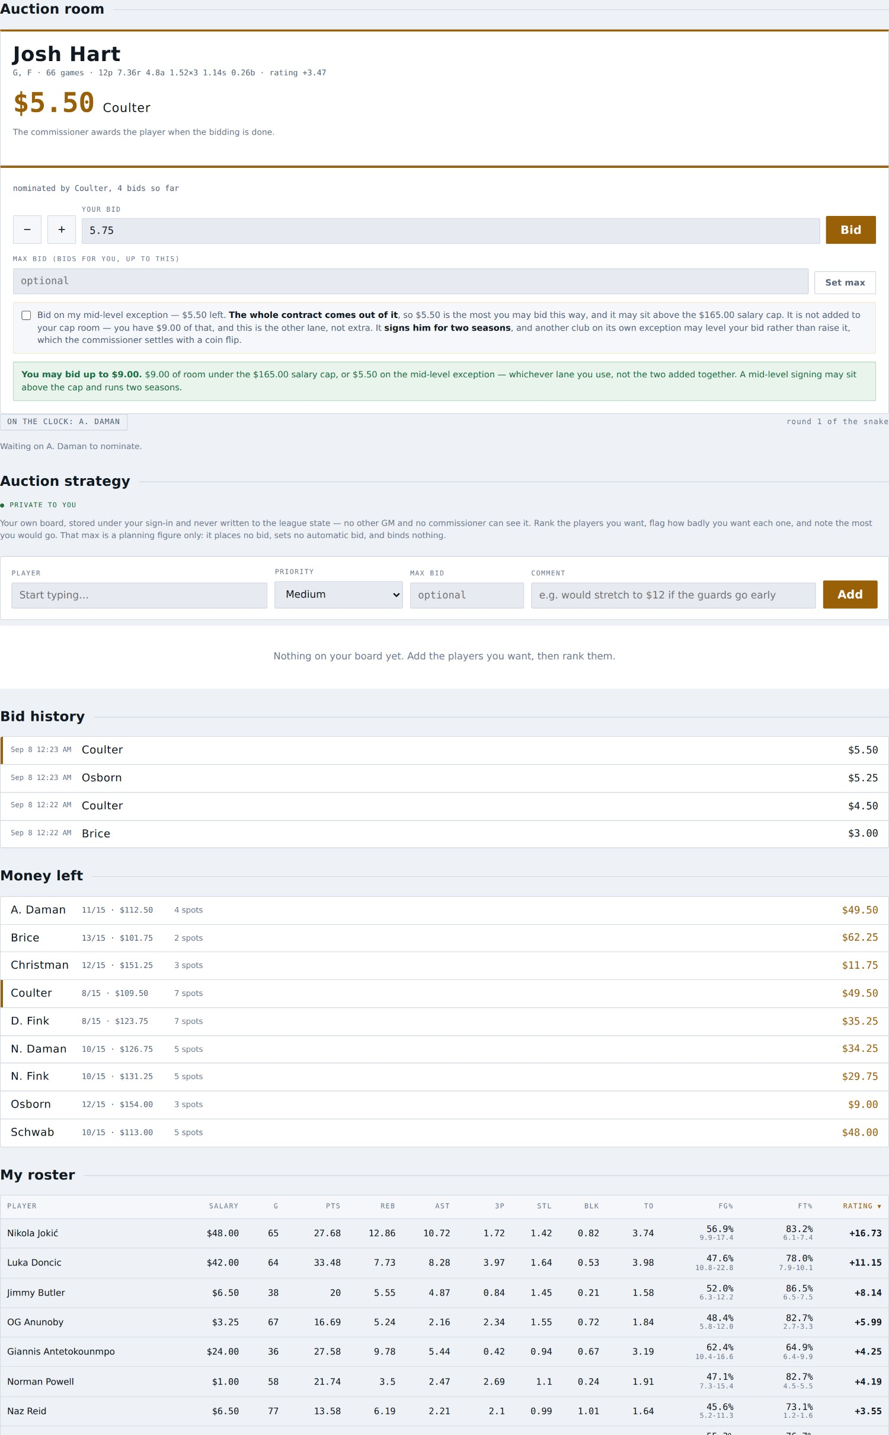
The auction room.

The commissioner opens the auction
Nobody can nominate or bid until he does. Until then the tab is open to read — the free agent class, the barred list, your own board — but there is no nomination form and no bid box, and the panel says so.
That means you can prepare whenever you like
Fill in your projections and write your whole strategy board days early. None of it places a bid, and nothing you do before the room opens can start the auction by accident. That is the point of the switch.

Nominating
The order is a snake. The commissioner sets round one; round two runs backwards, round three forwards again, so the club at each end nominates twice in a row.
- The chip tells you who is on the clock and which round it is.
- Only the club on the clock may put a player up. When it is your turn a box appears: type a name, set an opening bid, and press Put on the block.
- A club already carrying 15 players is skipped rather than waited on — it cannot sign anybody, so blocking the room on it would stall the auction.
- You cannot nominate a player you would not be allowed to sign. A nomination opens with your own bid, so a club that could not honour the contract cannot put him up.
- The form also takes an optional max bid, so a nominator who already knows his ceiling does not have to sit on the tab defending the lot — and the mid-level tick, because an opening bid is a bid like any other.

Bidding
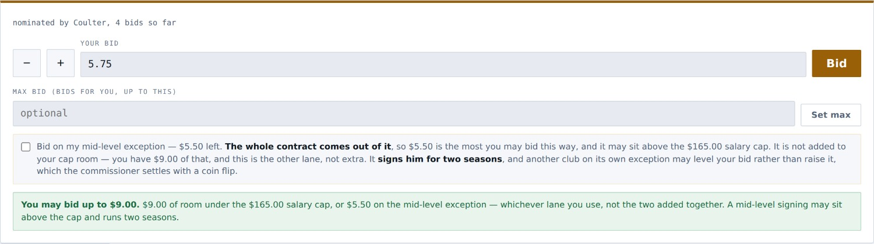
The bid controls sit under the player, on this tab.
- Move your bid in 25-cent steps and press Bid.
- Max bid is a proxy: type the most you would go and the app bids for you, one step at a time, only as far as it needs to. It never bids past the runner-up. Every step it takes for you is written into the bid history under your club, so nobody has to guess who moved.
- The line above the box tells you the most you may bid on this player and which wall it is — the salary cap, the hard cap, your exception, a release bar or a full roster. If you may not bid at all it says why.
You cannot bid against yourself
If you already hold the high bid the app says so rather than take your money twice.

Bidding on your mid-level exception
The exception lets you go over the salary cap for a player — not over the hard cap, which nothing beats. It is a pot, not a coupon: the commissioner sets the figure, and it splits across as many players as it covers, so what matters is what you have left.
There is a tick box on both the bid form and the nomination form. Tick it and:
- The whole contract comes out of the pot, not just the part above your cap room. So a $5.50 exception buys a $5.50 player — you cannot add it to $20.00 of cap room and pay $25.50.
- It signs him for two seasons, flat.
- The signing is stamped with the offseason that paid for it, so the ledger still answers "why is he on the books over the cap" a year later.
Two clubs on the exception is a coin flip, not a bidding war
Neither of you can go past the same pot, so a mid-level bid may LEVEL a standing bid rather than raise it — you match the price instead of adding a quarter. The lot then carries a tie, and the commissioner flips a coin at the award and writes the result into the bid history. Only the winner’s pot is charged.

Who wins him
When the bidding is done the commissioner awards the player. GMs do not close their own lots. If the player is restricted, the club holding matching rights is asked first — and that question is put to that GM in the app, with Match and Decline buttons. Bidding is closed while he decides.

Your strategy board
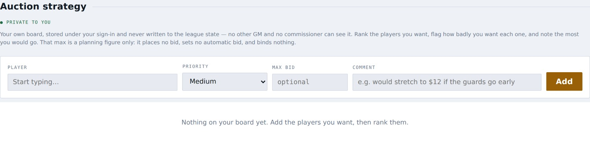
Private to you.
Rank the players you want, flag how badly you want each one, and note the most you would go. That max is a planning figure only — it places no bid, sets no automatic bid and binds nothing. The board is stored under your sign-in and follows you between your phone and your laptop, encrypted with a key derived from your club PIN — a league-mate who goes looking at the raw data gets scrambled text.
Be realistic about how private that is
The PINs themselves live in the league data, and anyone who views the page source can read them. Treat your board as "nobody will stumble across it" — the same honour system the whole site runs on — rather than as a vault. If a max bid would genuinely cost you to have read, keep that one in your head.
Each row is tagged with the club that holds the player and what it holds him with — Bird, Early Bird or restricted — so you can rank him against the right you would be bidding into.

5. Contracts
Every club’s payroll on one screen, and then any single club in full. This is the tab to open when you want to know who can afford what.
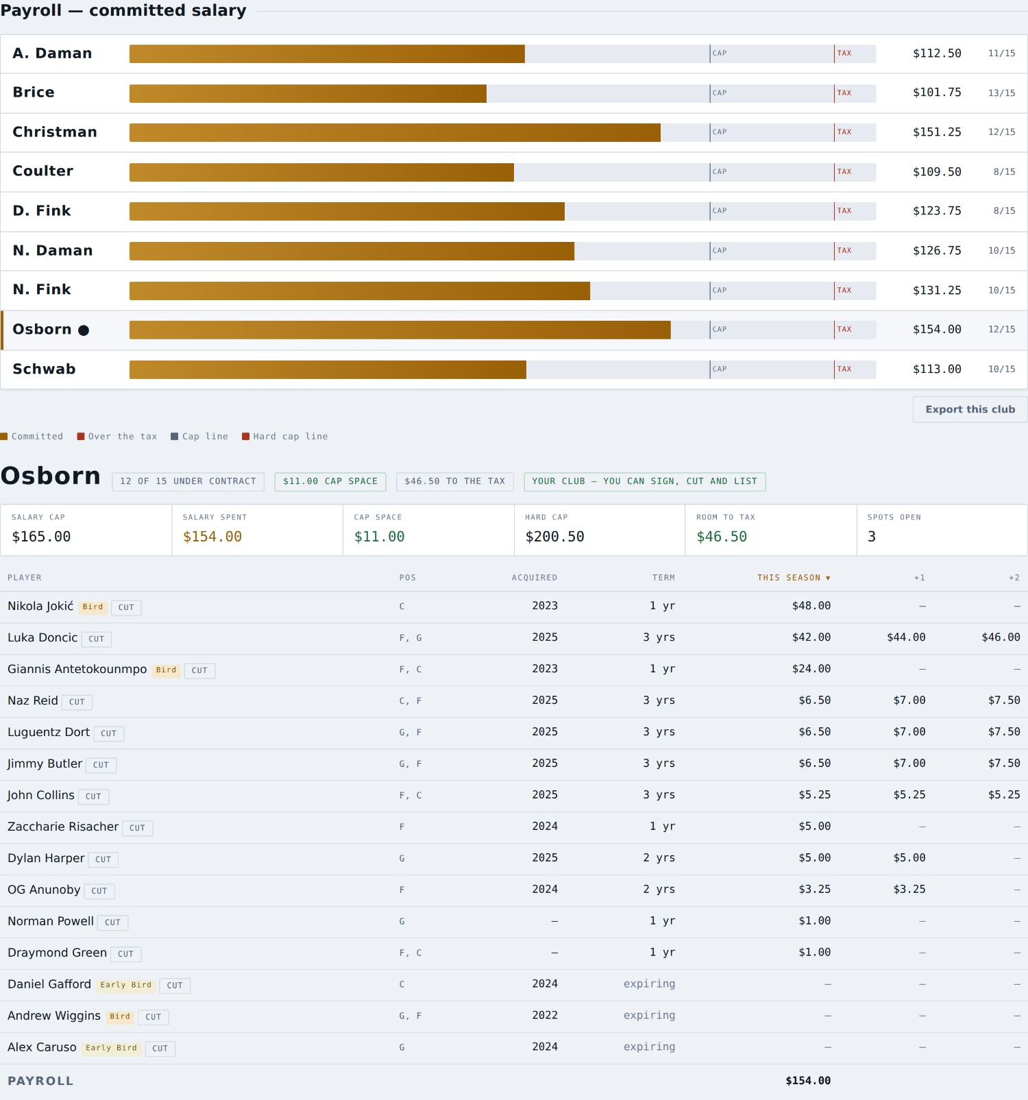
Payroll bars for all nine clubs, then the club you clicked.
- Each bar shows committed salary against the cap line and the hard-cap line, with the headcount on the right.
- Click a club to see its full contract table underneath: salary this season and the two after, term, the year the player was acquired, and his rights.
- expiring means nobody has committed a dollar to him for next season — he is in the auction pool even though he is sitting on a roster today.
- On your own club the rows also carry Cut and Block. On anybody else’s they do not.

6. Player rater
Every player in the pool, sortable on any column, with a rating that puts all nine categories on one scale.
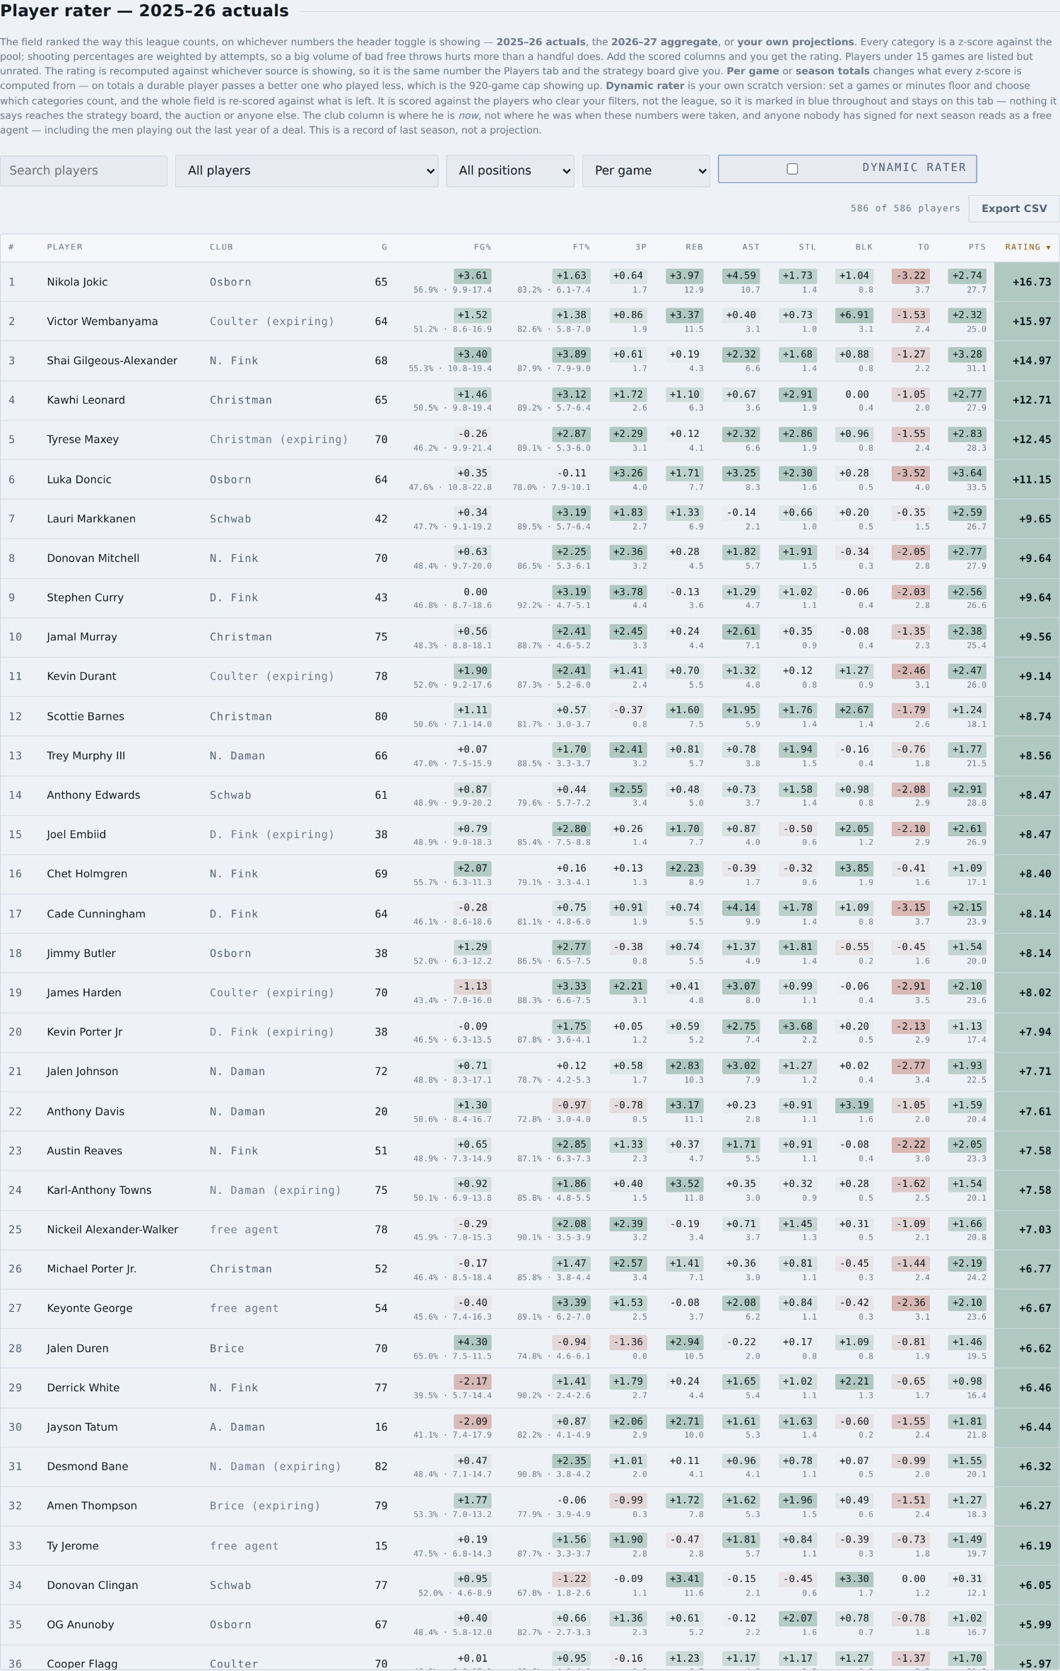
The rater. Click any heading to sort; click any name for the card.
The rating is a nine-category z-score against the whole pool, with FG% and FT% weighted by attempts — so a high volume of bad free throws hurts you proportionally, which is how it actually works in a roto league. Positive is above the pool average.
The pool is every player who appeared in 2025–26 — no games or minutes cutoff — so the man who played nine games in March is in here too. Under 15 games he is listed but not rated: a handful of games is not a season.

Three switches, and they stack
Switch | What it does
Stats shown (header) | Ranks the field on 2025–26 actuals, the 2026–27 aggregate, or your own projections. The heading names whichever one you are looking at.
Per game / Season totals | Changes what every z-score is computed from. On totals, a durable player passes a better one who played less — which is the 920-game cap showing up in the ranking.
Dynamic rater | Your own scratch field: set a games or minutes floor, or switch categories off, and the whole field is re-scored against what is left.

The dynamic rater is marked in blue on purpose
It is scored against the players who clear YOUR filters, not against the league, so it is not the league’s rating and it says so — blue rails, a banner naming the field, and a DYN# rank column. Nothing it says leaves that tab: it never reaches the strategy board, the auction, or anybody else’s screen.
Switching categories off is how you plan a punt build. Turn off the two you are conceding and the table re-ranks on the seven you actually intend to win.
Click any player name, anywhere in the app, to open his card:
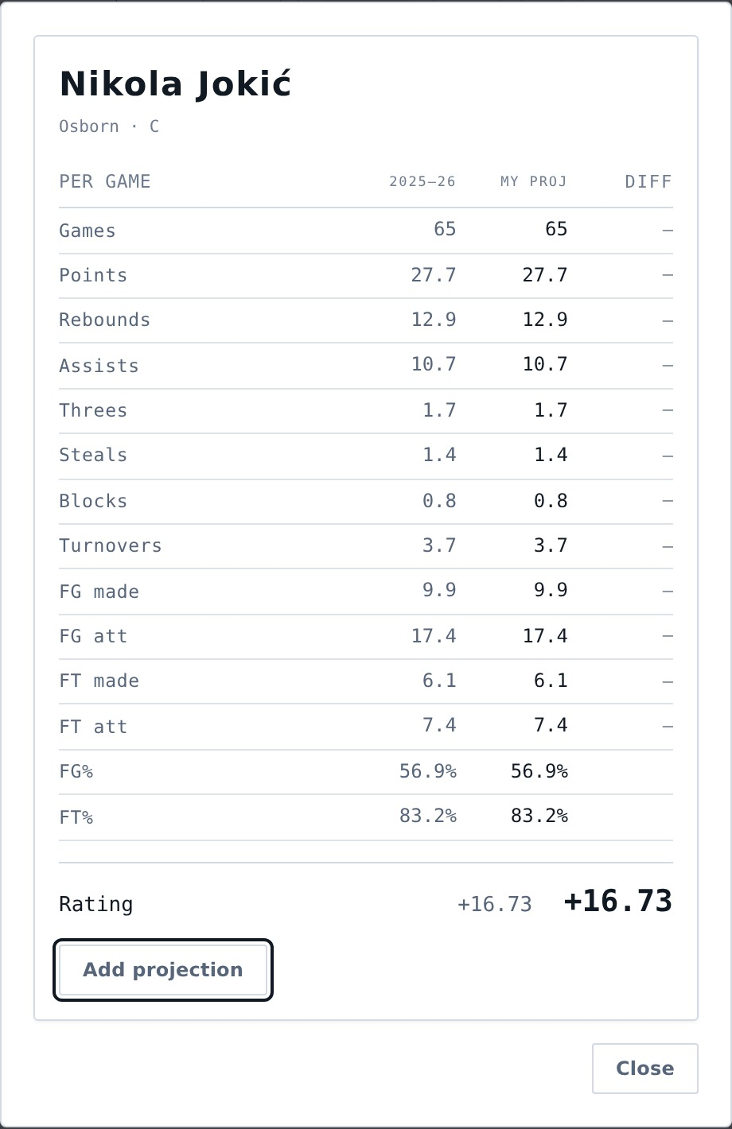
The player card, reachable from every table.
The card shows his line, his rating, who holds him, and lets you type your own projection for him. Those edits are yours alone and feed the My projections setting in the header.

7. Trades
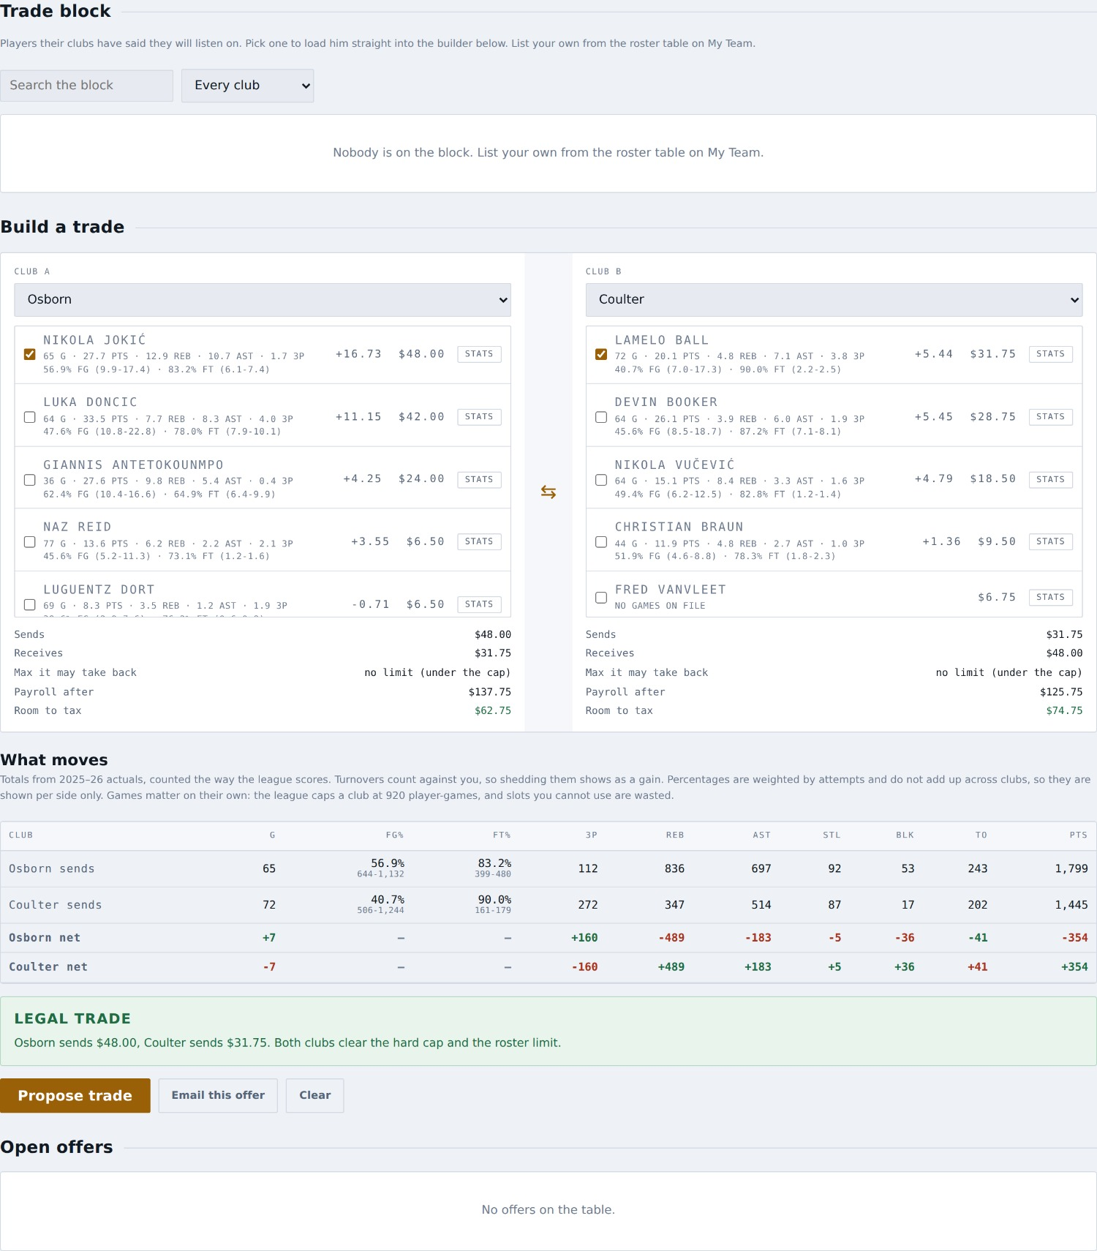
The trade machine.

Building one
- The tab opens with the league-wide trade block. Filter it by club or name, and press Add to trade on anybody who interests you — his club goes on the far side and yours on the near one, so you are always looking at what you would give up.
- Or pick the two clubs yourself and tick players and picks on each side.
- Press Stats on any row to open that player’s card without losing your place.
- Watch the two footers: what each side sends, the most it may take back, its payroll after, and its room to the tax.
- Below the builder, the category table shows what each side sends across all nine categories and the net swing for each club.
Two things about the category table
Turnovers invert — a club shedding them is gaining ground, so the colours are the other way round for TO. And percentages do not net: FG% and FT% are attempt-weighted and cannot be added across clubs, so they are shown per side and the net row is deliberately blank.

Proposing one
You may build any trade you like, including one between two other clubs — working out what a rival deal would do is as useful as working out your own. But you may only propose,1 a trade your own club is in. The Propose button is switched off otherwise and says why.
Once you propose it, the other GM sees it on his Trades tab under Open offers. He can accept, reject, or counter. You can also email the offer to him as a nudge.
Trades are re-checked when they are accepted
Rosters move between an offer being made and answered, so the app validates salary matching, the hard cap, the roster limit and every pick again at the moment of acceptance. An offer that was legal on Monday can be refused on Wednesday, and it will tell you why.
Salary matching is off unless the commissioner turns it on
By default a deal needs only the hard cap and the roster limit — the two rules nothing beats. If the commissioner switches matching on, the old bands apply to a club over the cap, and the builder will tell you which one you are in.
You can trade the rights you hold to an expiring player — Bird, Early Bird or restricted — and the rights travel with him. Those players move $0, so they do not touch salary matching. You can also trade rookie draft picks, this year’s and future ones, and the club sending a future pick sets any protection on it in the builder.

8. Free agent classes
Offseason only. The whole free agent class, sorted into groups, so you can plan the auction rather than react to it.
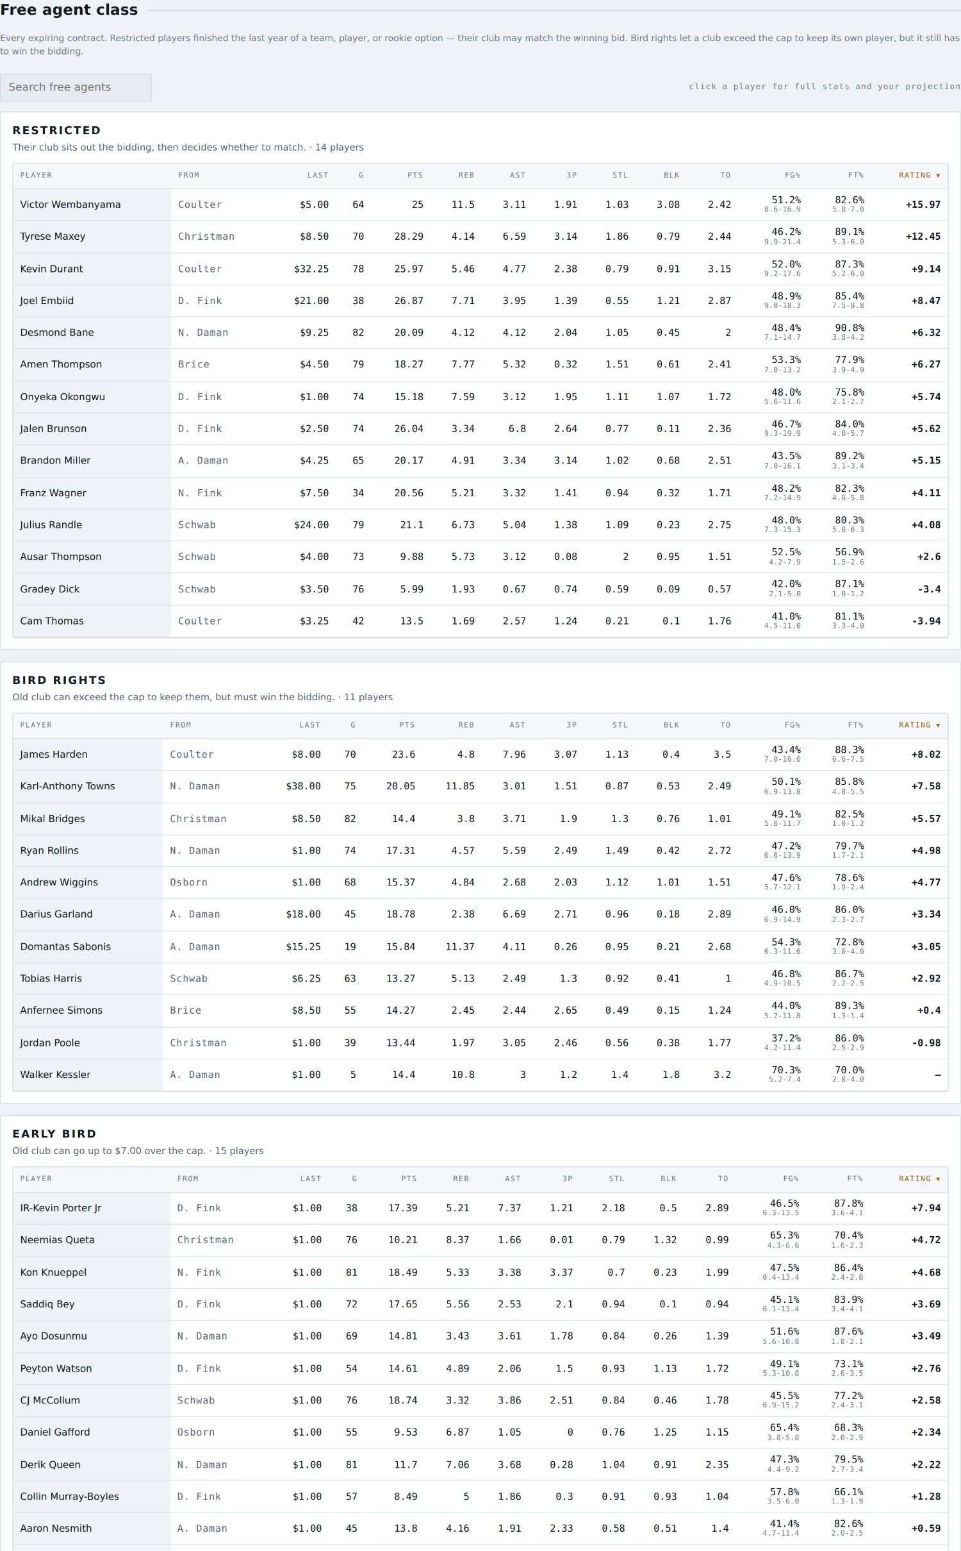
Every expiring contract, grouped.
A player is a free agent when nobody has committed a dollar to him for next season — which includes the players sitting on a roster today in the last year of a deal. Those are the ones worth knowing about, and they are easy to miss.
- Restricted players finished the last year of a team, player or rookie option. Their club sits out the bidding and then decides whether to match the winning bid.
- Bird and Early Bird tags tell you the club can exceed the cap to keep him, so expect to pay more than his rating suggests.
- Click any row for the full card.

9. Rookie draft
Offseason only. One pick each, in reverse order of finish — the champion picks last.
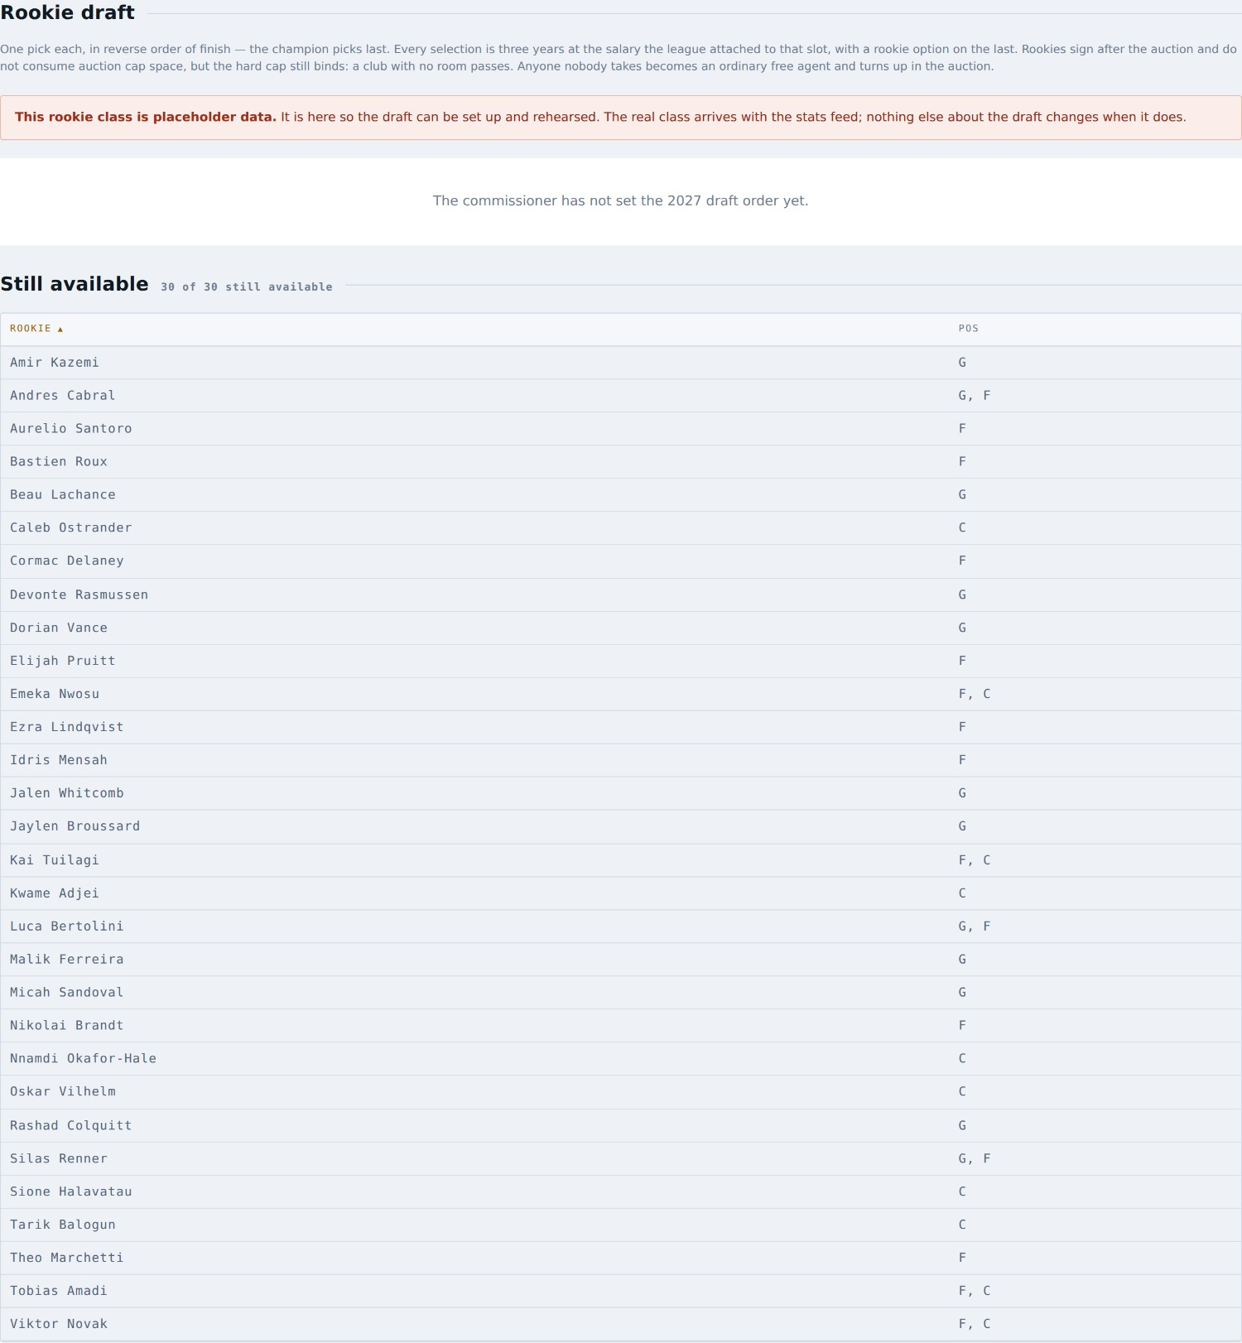
The rookie draft board and the players still available.
- Every selection is three years at the salary attached to that slot, with a rookie option on the last year.
- Rookies sign after the auction and do not consume auction cap space — but the hard cap still binds, so a club with no room passes.
- Anyone nobody takes becomes an ordinary free agent and turns up in the auction.
- When you are on the clock, pick your man from the list. If you cannot fit the pick, you pass, and passing consumes the pick.
The rookie class you can see is placeholder data
It is there so the draft can be set up and rehearsed. The real class arrives with the stats feed; nothing else about the draft changes when it does.

10. Quick sign
In season only. A faster way to make the same in-season signing you can make from My Team — useful when you know exactly who you want.
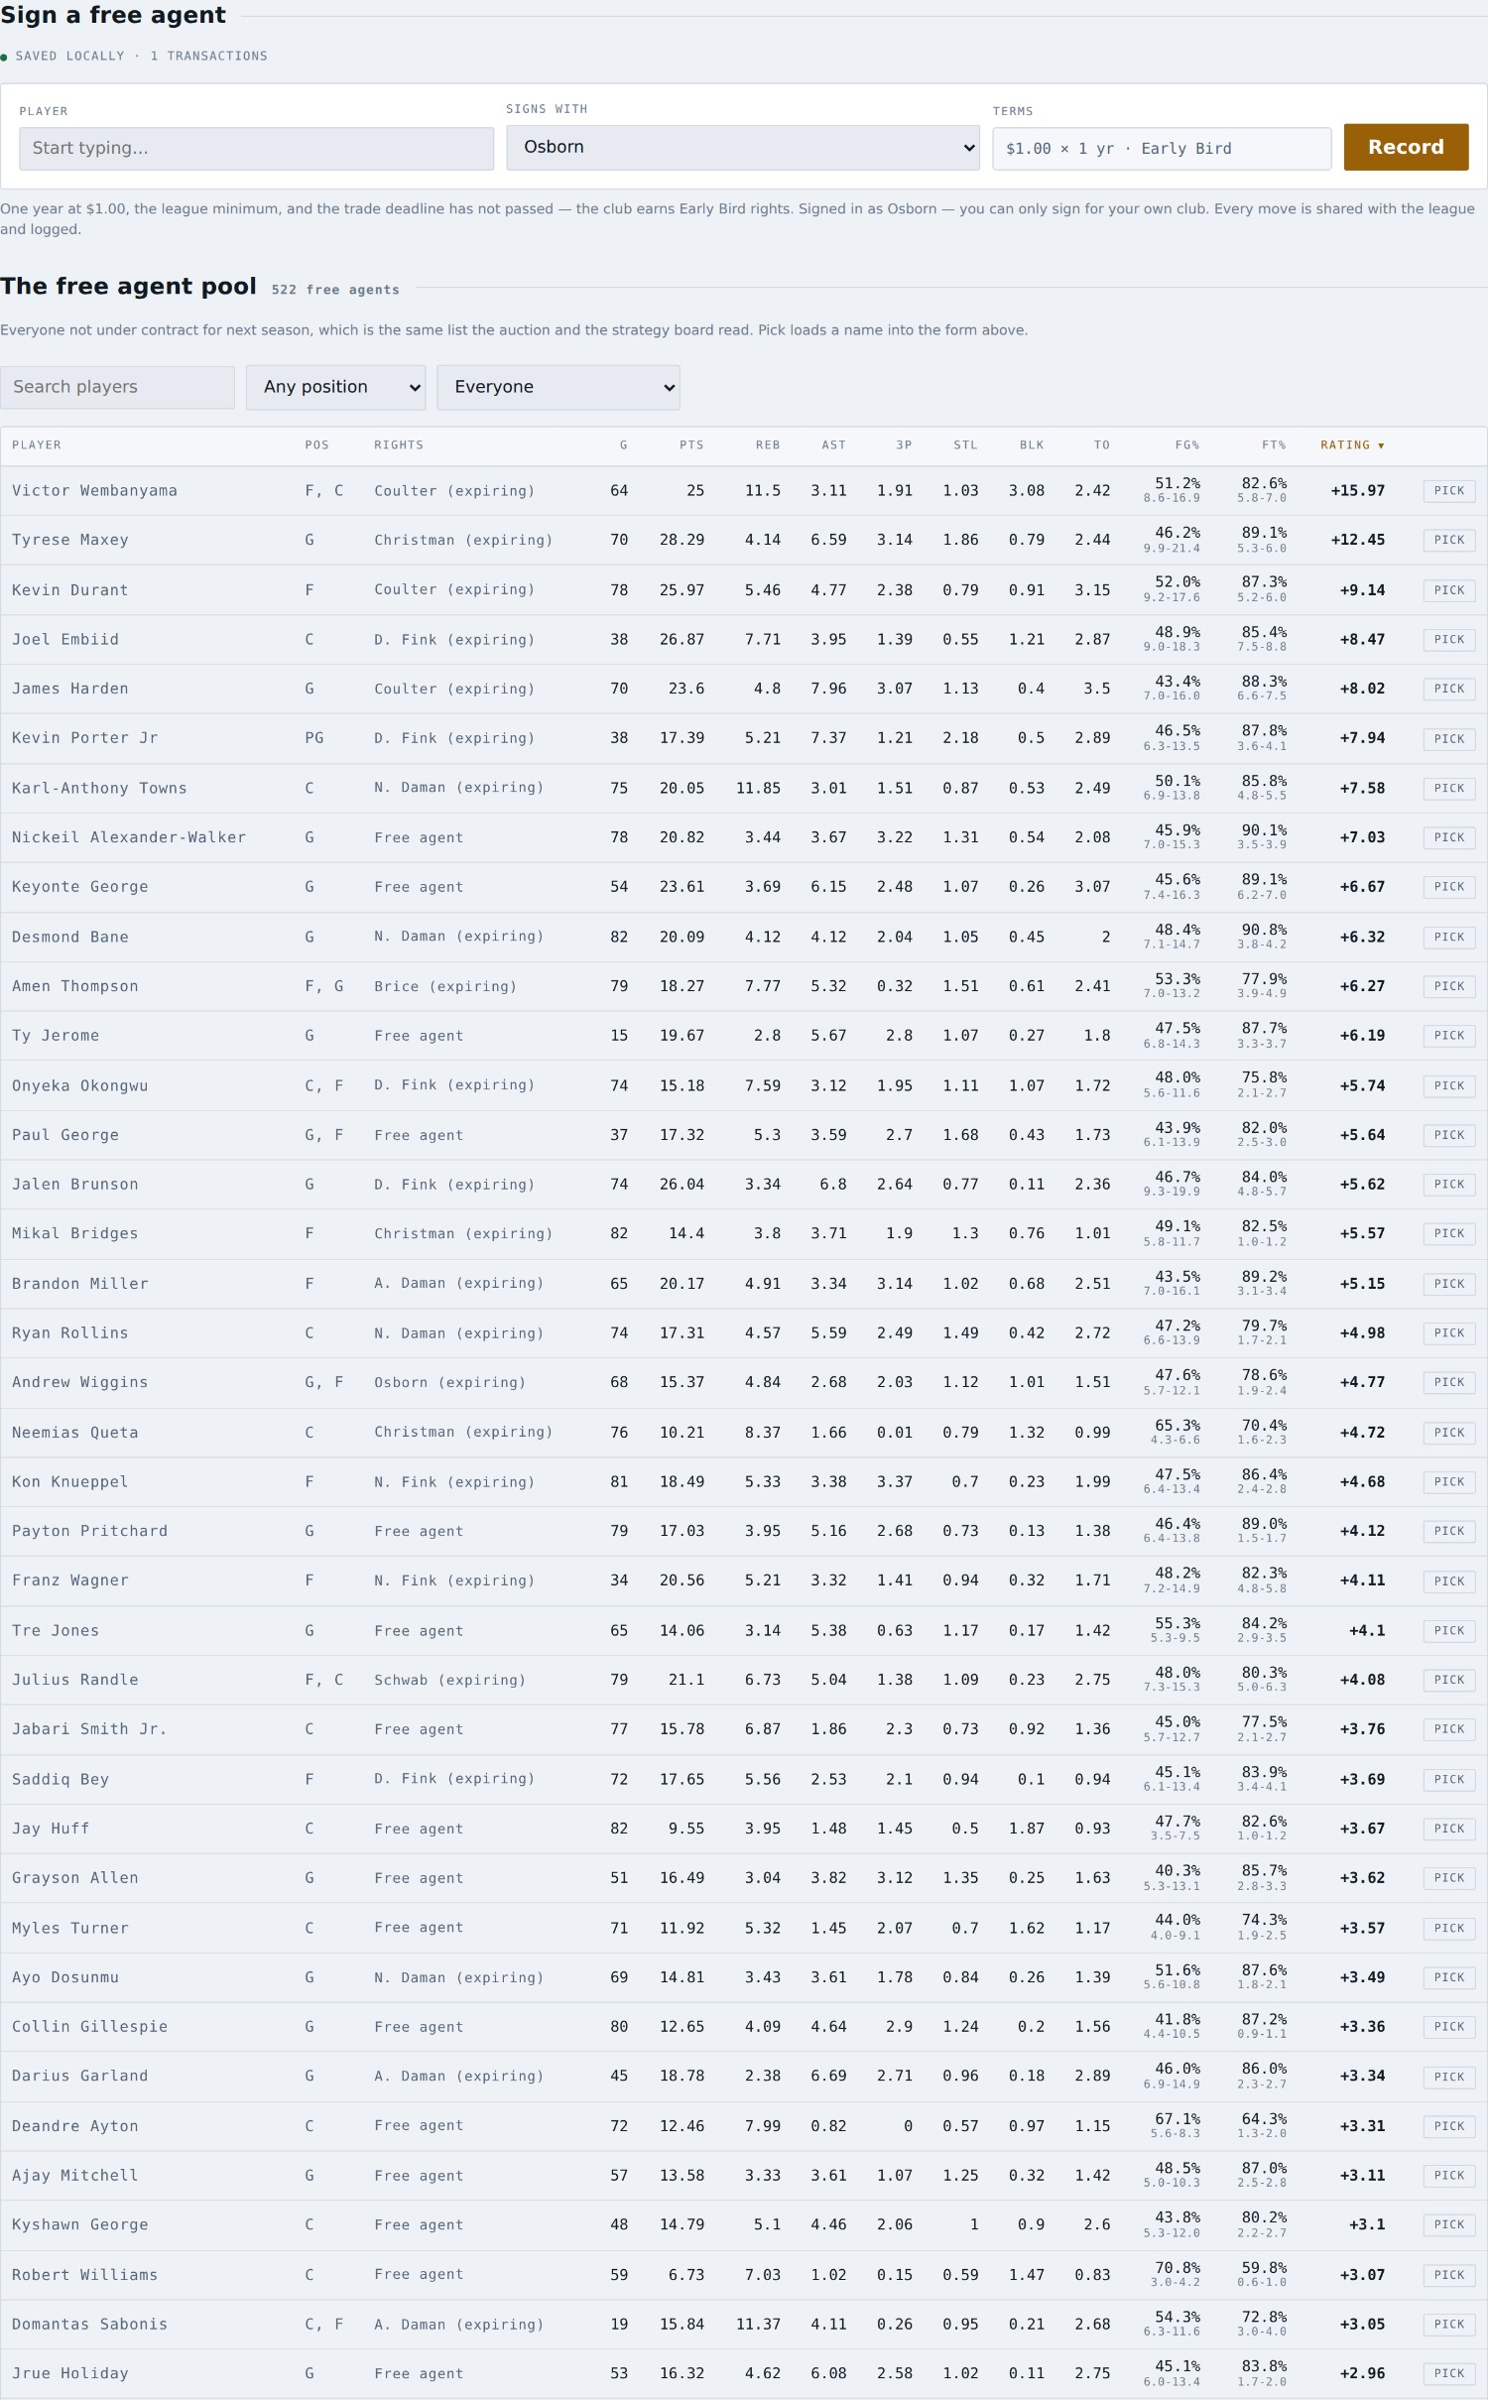
Quick sign: the player, the club, and terms you cannot change.
There is nothing to negotiate, so there is nothing to type: an in-season signing is one year at the league minimum, and the calendar decides whether it carries Early Bird rights. The form shows you the terms and the pool below is searchable and filterable.

11. Chat & notes
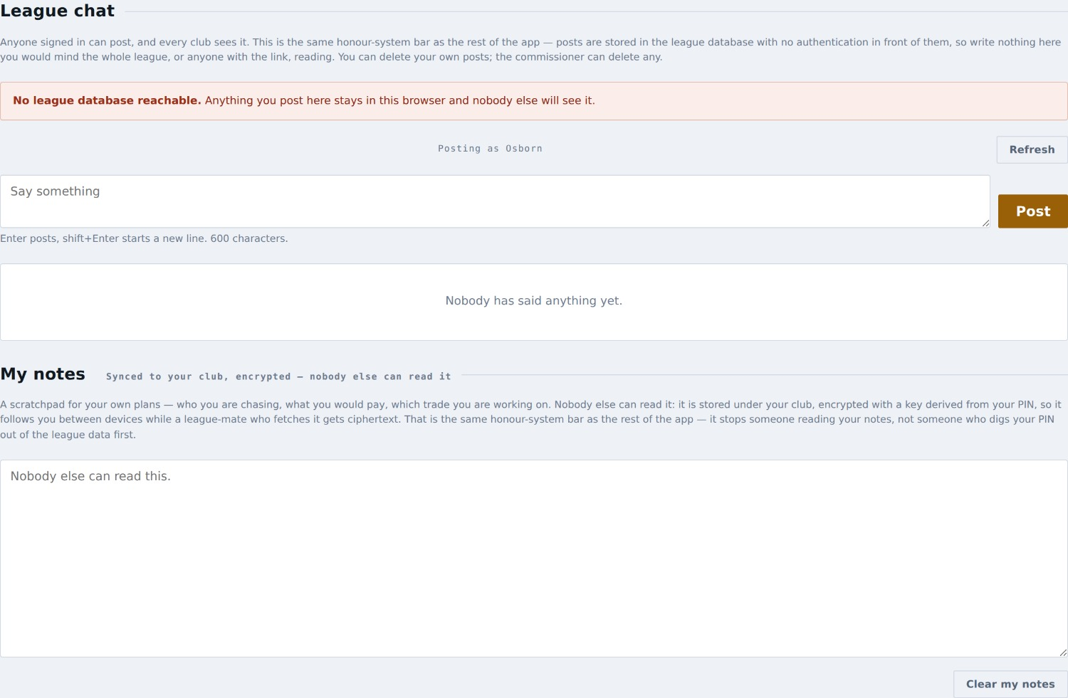
League chat above, your own notes below.
Two things share this tab, and the split is the point.
- League chat is public to everybody who can open the app. Talk trash, float trades, argue about the rater. You can delete your own posts.
- My notes is the opposite: nobody else can read it. It is stored under your sign-in and follows you between devices, so you can start a thought on your phone and finish it on your laptop.

12. My projections
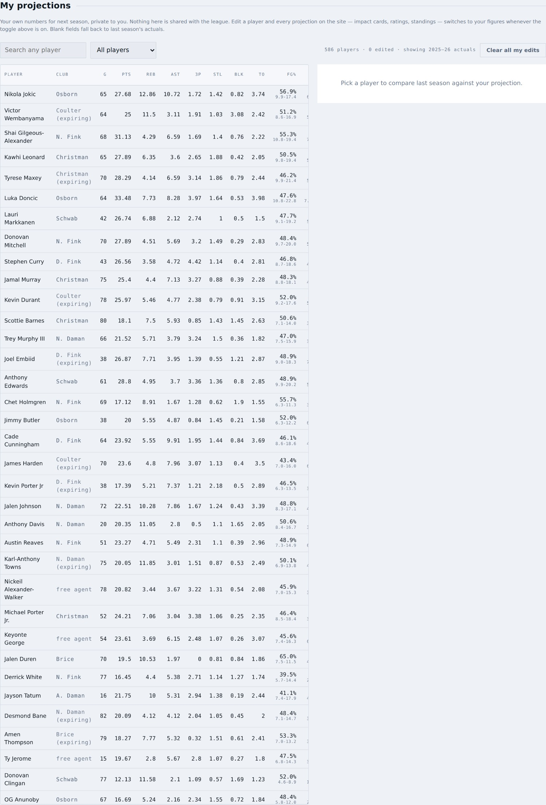
Your own numbers, for every player you care to edit.
Edit any player’s line and the whole app will use your number wherever you have the header set to My projections. Everything you have changed is marked in amber so you can always tell your guess from the record.
Like your notes and your auction board, your projections follow you between devices — type them on your phone and they are on your laptop — and they go up encrypted under a key derived from your club PIN, so a league-mate reading the raw data gets scrambled text. The same honesty applies as to the strategy board: PINs live in the league data and can be read by anyone who views the page source, so this stops someone reading your work by accident, not someone determined to.

13. Team trends
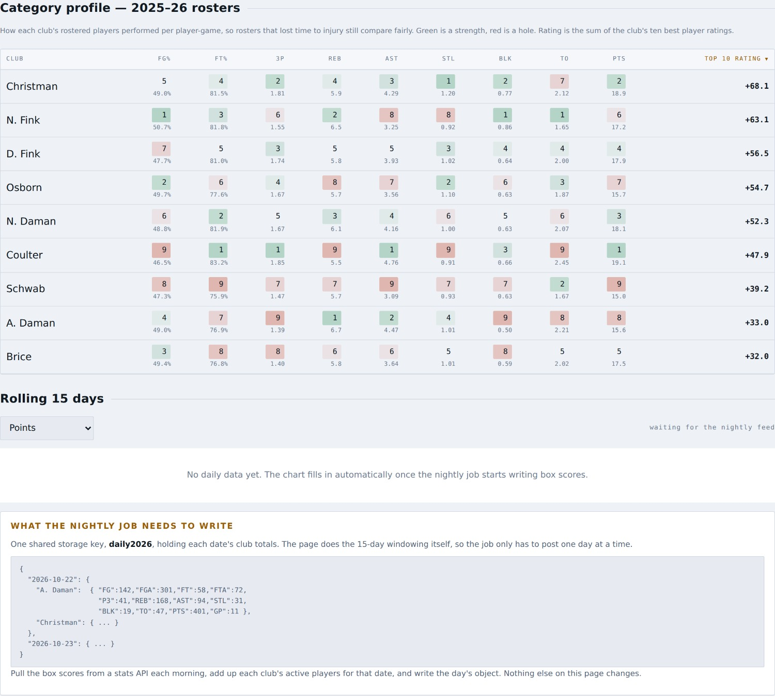
Where every club is strong and where it has a hole.
The category profile ranks all nine clubs in each of the nine categories, per player-game so that rosters which lost time to injury still compare fairly. Green is a strength, red is a hole. The rating on the right is the sum of a club’s ten best players.
Read it before the auction to find out what the league is short of — that is usually where the value is.
The rolling 15-day chart below it is built and waiting on the nightly stats feed. It will fill in on its own once that lands.

14. League history
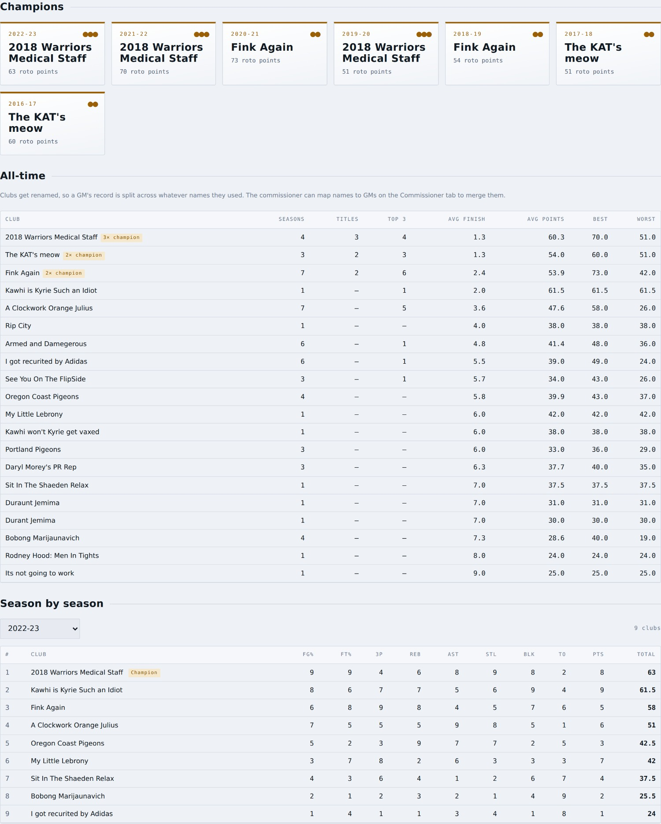
Every season the league has played.
Champions, banners, and an all-time table: seasons played, titles, top-three finishes, average finish and roto points. Settle an argument with it.

15. Transactions
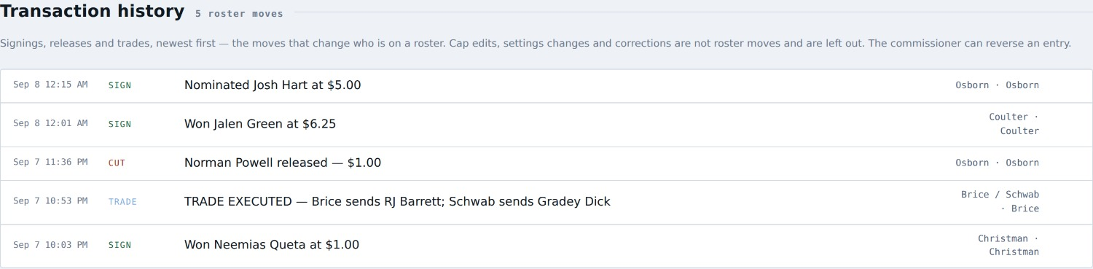
The league’s append-only record.
Every signing, cut, trade, nomination and award, newest first, with the club that did it and when. Nothing is ever quietly changed: if it happened, it is here.

16. Cap rules
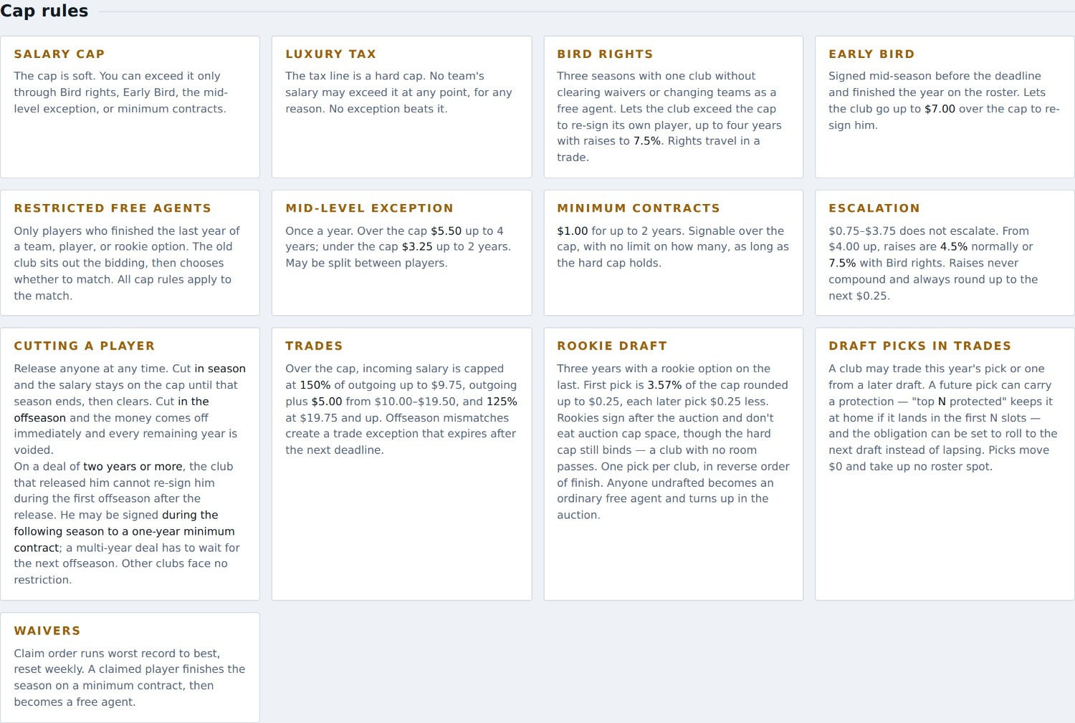
The rulebook, as the app enforces it.
The rules in plain language, in the app, so you never have to go looking for the rulebook mid-auction.

17. Settings
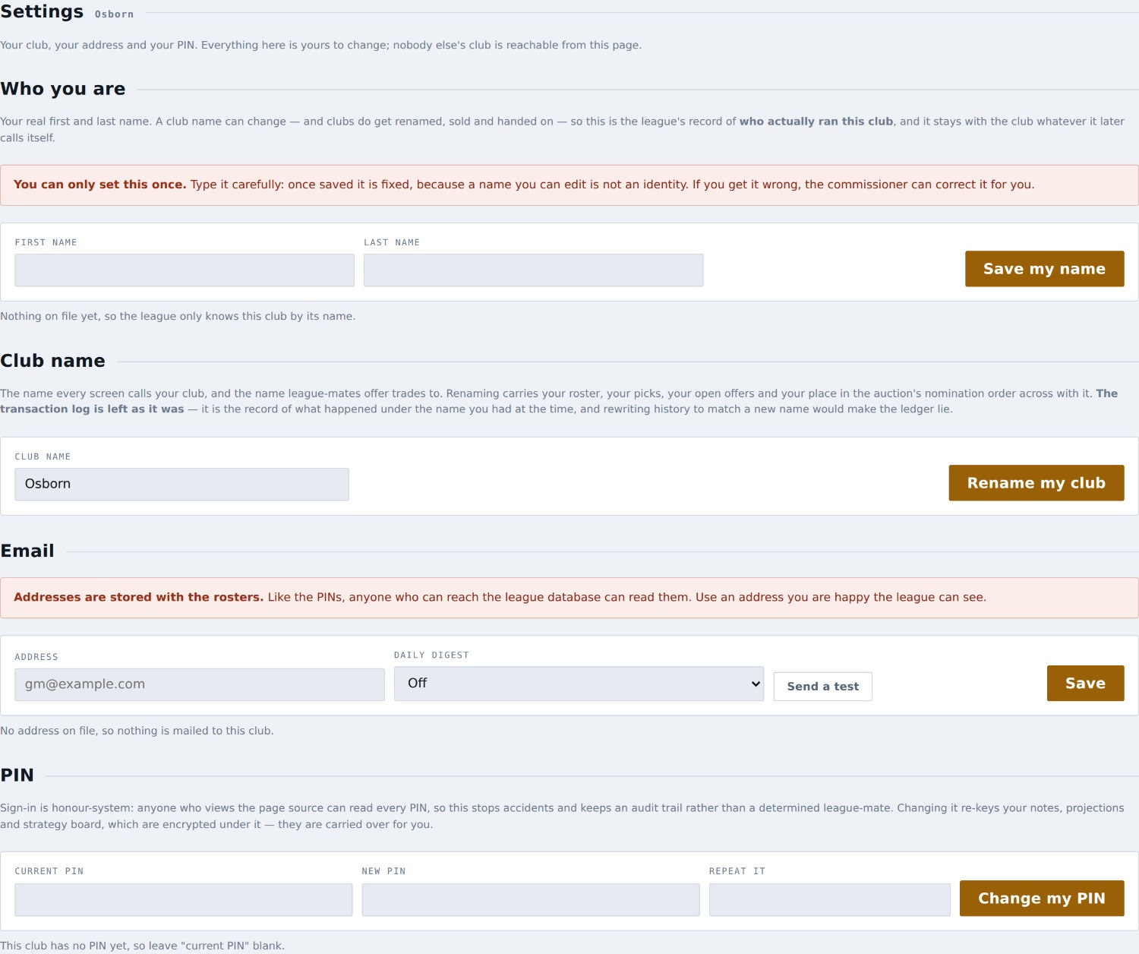
Your club’s name, your email and your PIN.
- Club name — rename your club. Your roster, your picks, your open offers and your place in the nomination order all come with you. The transaction log keeps the old name, because it is the record of what happened at the time.
- Email — the address the league writes to, and whether you want the daily digest of the previous day’s moves. Press Send a test to check it works.
- PIN — change your own. You need your current one; if you have forgotten it, the commissioner can reset it for you.
Email addresses are stored with the rosters
Like the PINs, anyone who can reach the league database can read them. Use an address you are happy for the league to see, not one tied to anything else.

18. The rules the app enforces for you
You do not have to memorise these — the app refuses moves that break them and tells you why. They are here so the refusal makes sense when you see it.
Rule | How it works
Salary cap — $165.00 | Soft. Exceed it only via Bird rights, Early Bird, the mid-level exception, or minimum contracts.
Luxury tax — $200.50 | A hard cap. Nothing beats it, including Bird rights.
Roster | 15 active. In season you may carry a 16th only while one man is on the IR. Activating him when you are full asks you which player to release.
Bird rights | Three completed seasons with one club. It does not matter how he arrived — free agency, the rookie draft or the auction all start the clock. The rights travel with him in a trade; any other change of club starts the clock again.
Early Bird | Signed mid-season before the deadline and finished the year with you. Worth $7.00 over the cap.
Restricted free agents | Only players who finished the last year of a team, player or rookie option. Their club sits out the bidding, then chooses whether to match.
Mid-level exception | Once a year. $5.50 over the cap, $3.25 under. Consumed when used.
Trade matching | Over the cap, what you can take back is limited by what you send: 150% of outgoing up to $9.75; outgoing + $5.00 from $10.00 to $19.50; 125% from $19.75 up.
Cutting — in season | His salary stays on your cap until the season ends, then clears. It never carries into the next year.
Cutting — offseason | Salary comes off immediately and the remaining years are voided.
Buying back a man you cut | If you released him above the minimum, you cannot sign him back for the rest of that season or the offseason that follows. Every other club may.
920 player-games | Each club is capped at 920 total player-games in a season. Per-game rate beats availability.

19. Things that catch people out

I cannot find where to bid.
Bids are placed on My Team, under “On the block”. The Auction tab is the room — who is up, the bid history, what everyone has left, and your private board.

A tab has disappeared.
Auction, Free agent classes and Rookie draft are offseason-only. Quick sign is in-season only. The app hides what does not apply.

A player on somebody’s roster is listed as a free agent.
That is right. A player is a free agent when nobody has committed money to him for NEXT season, even though he is on a roster today. Those expiring men are in the auction pool, and they are the ones most people forget to plan for.

The app says I cannot sign a player I cut.
If you released him for more than the league minimum, you cannot buy him back for the rest of that season or the offseason after it. Every other club can. Your barred players are listed on the Auction tab so you know before you plan around one.

My club shows Bird rights on a player and the app disagrees.
Bird rights are earned by three completed seasons with your club, counted from the year he was acquired — not by what the old spreadsheet’s rights column says. If the two disagree for one of your players, tell the commissioner and he can correct the year acquired.

The Propose button is greyed out.
Either the trade is not legal yet — check the two footers for the reason — or it is a trade your club is not in. You may build any trade, but only propose one of your own.

I set my lineup and the standings did not move.
They will not yet. The slots, the eligibility and the lock are all real, but counting a night’s box score against your starters needs the nightly stats feed, which is not built. The screen says so rather than pretending otherwise.

I cannot move a player in my lineup.
His game has tipped off. The lock is per game — a player freezes when HIS game starts, not at some league-wide deadline. Locked players show as plain text instead of a dropdown.

Do I have to set my lineup every night?
No. It carries forward until you change it.

Can anyone see my projections, my notes or my auction board?
No. All three are private to you and follow you between your devices. Everything else you do — signings, cuts, bids, trades, chat — is shared with the whole league and logged.

About this guide
Written for the GMs of the league. It covers only what a GM can do; the commissioner’s tools are deliberately left out.
The screenshots are taken from the real app, signed in as a GM, in both the offseason and a live season. They were captured by docs/build-gm-guide.js and the shooting scripts alongside it, so the guide can be rebuilt whenever a screen changes.
Numbers in the screenshots are the seed data, not the live league — treat them as an illustration of the layout, not as anybody’s real payroll.

