# Assignment 1

Joakim Ginste

Question 3:

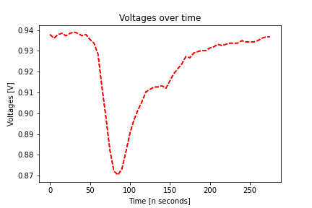

*Figure 1: Voltage over time.*

Figure 1 was made by importing the data into python, using the give equation for a pulse (this is pulse at index 0) and printing it/saving it using matplotlib. Figure 1 shows the voltage over time in nanoseconds.

Question 5:

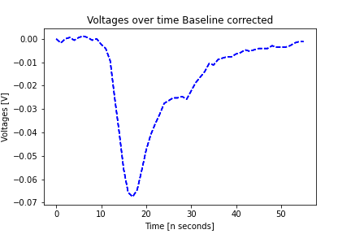

*Figure 2: Baseline corrected Voltage over time.*

Figure two was made in the same way as figure 1 but here the voltage values were firstly subtracted with and the mean value of the first 10 element of each pulse. This pulse is also at index 0 to be able to compare the two, as can be seen they have the same shape, but the voltage values is baseline corrected in figure 2.

Question 6:

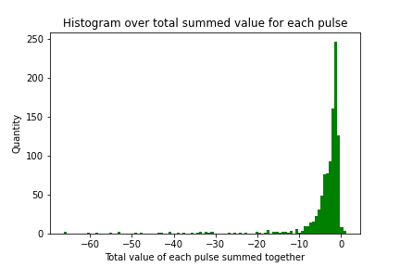

*Figure 3: Histogram over pulse values summed together.*

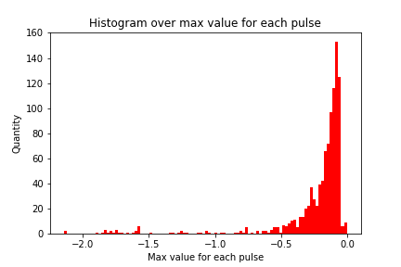

*Figure 4: Histogram over the max value for each pulse.*

Figures 3 and 4 were made using histograms in matplotlib. The list used to make these histogram were made using numpy.min() to find the “max value” for each pulse in figure 4, whilst numpy.sum() were used to get the summed up value of a pulse for each pulse to be used in figure 3.

Figure 3 shows the number of values different from the baseline to the length of the signal, whilst figure 4 shows the maximum value of the detected signal voltages. As can be seen in figures 3 and 4 they both have very similar distribution with large number of pulses having low maximum value as well as low total maximum values. As these values are related to the amplitude and the area enclosed by each pulse corresponds to the deposited energy into the detector, the area under the histograms could give a hint over how much energy that is put into the detector.