# Assignment 2

Joakim Ginste

**Question 1:**

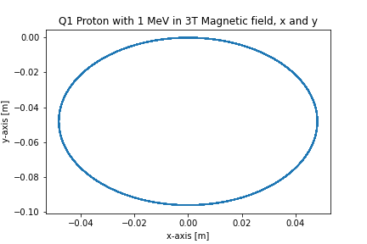

To solve the differential equation odeint was used, where an array of 6 elements were inputted as well as the timespan. The array contained the starting position in x, y and z, as well as the velocity for each direction x, y and z. Using this data and the equation for general motion of a charged particle the solution to the differential equation could be found and used to get the plots above. Following the proton for one microsecond with an starting velocity in x direction, it can is seen that it moves in a circular motion in the x and y axis, whilst in the z axis it stays constant.

**Question 2:**

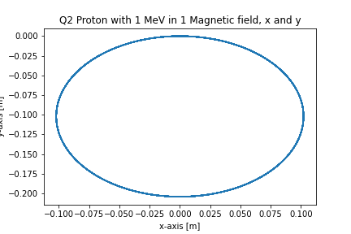

For question 2 the same method was used, it can be seen in the figure above that the circular motion in x and y is similar as to question 1, but due to the starting velocity in both x and z axis, the proton now moves upward in the z direction, rotating around the z axis (see question 4, for 3D image).

**Question 3:**

For question 3, the results can be seen above. The proton has an starting position at [3,3,0] and moves in the x and y plane back and forth in an line. Looking at the dependencies between x and z axis it can be seen that the proton downward in the z direction in a spiral (see question 5 for 3D image). To solve this question for the function used in the differential equation changes to the magnetic field is made inside the function and does not stay constant, as it changed depending on the radius. The radius is calculated from the previous positions of the proton. As the magnetic field are around the z axis, the use of polar coordinates was made, to solve for the magnitude of the magnetic field in x and y direction.

**Question 4:**

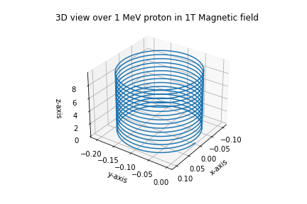

With the use of mplot3D, the 3d plot of question 2 is shown above, and as can be seen the portion is rotating around the z axis in a circular motion.

**Question 5:**

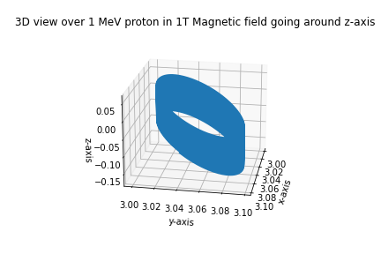

As in question 4, with the use of mplot3D, the figure above shows the 3D plot over question 3. As can be seen the portion moves around in a circular motion in x and y axis, whilst in z axis moving downwards.

**Question 6:**

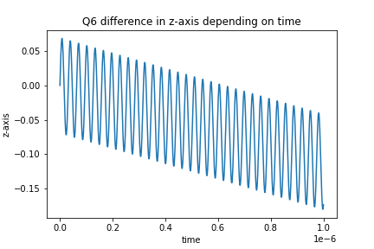

To calculate the drag speed in the z axis in question 3, firstly the data was found where one full rotation (coming back to the start values in x and y, [3,3]) was made. Dividing the difference in z position from the start value and after one rotation to the time one rotation took, the drift speed in z direction was calculated. The figure above shows the z values in question 3 depending on time.

**Drift speed in z direction: 107815 m/s**