注意：cmd要用管理员权限运行

1. 安装JAVA8+，然后下载neo4j，地址：<https://neo4j.com/download-center/#releases>
2. 解压文件后和JAVA一样配置下环境变量
3. cmd运行：neo4j.bat console

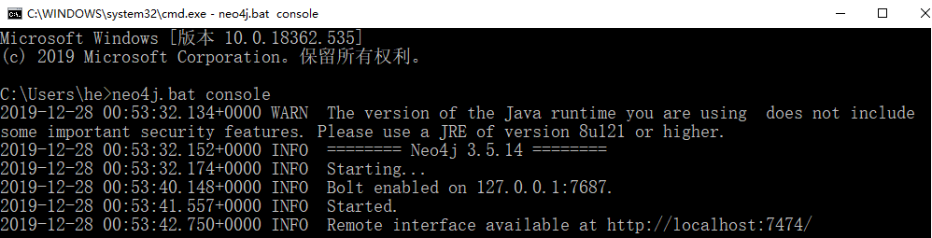

1. 访问数据库，浏览器输入：<http://localhost:7474，默认账号和密码都是neo4j，然后会提示修改密码，这里简单点，密码修改为admin>

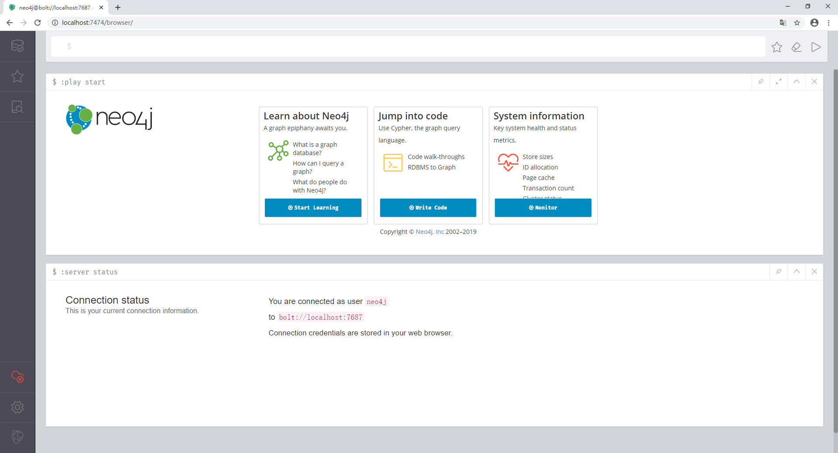

1. 关闭第3步的cmd窗口，然后注册neo4j服务，cmd输入：neo4j install-service



1. neo4j的启动、停止、重启、状态查询

neo4j start

neo4j stop

neo4j restart

neo4j status

1. 测试数据

点击“write code”->“create a graph”，然后输入代码：

CREATE

(p1:Person {name:'胡兴炯', born:1991, interest:'mac,ios,旅游', goodat:'java,swift,objectiveC'}),

(p2:Person {name:'张勇', born:1990, interest:'android', goodat:'java,android'}),

(p3:Person {name:'成文龙', born:1990, interest:'linux,hadoop', goodat:'linux,java,android'}),

(p4:Person {name:'王昕', born:1978, interest:'wpf,noSQL,旅游', goodat:'java,c#'}),

(p5:Person {name:'周开琪', born:1977 , interest:'管理', goodat:'管理,'}),

(p6:Person {name:'徐锦亮', born:1985, interest:'前端', goodat:'前端，html5,hadoop'}),

(p7:Person {name:'张三', born:1993, interest:'大数据', goodat:'hadoop，html5,java,lucene,elasticsearch,solr'}),

(p8:Person {name:'徐辉霞', born:1990, interest:'管理,旅游', goodat:'管理,采购'}),

(p9:Person {name:'黄廷鹏', born:1992, interest:'OA', goodat:'java'}),

(p10:Person {name:'史乐乐', born:1991, interest:'OA,旅游', goodat:'管理'}),

(p1)-[:认识]->(p2),

(p1)-[:认识]->(p3),

(p1)-[:认识]->(p4),

(p1)-[:认识]->(p5),

(p1)-[:认识]->(p9),

(p2)-[:认识]->(p1),

(p2)-[:认识]->(p3),

(p2)-[:认识]->(p4),

(p2)-[:认识]->(p5),

(p2)-[:认识]->(p9),

(p3)-[:认识]->(p1),

(p3)-[:认识]->(p2),

(p3)-[:认识]->(p4),

(p3)-[:认识]->(p5),

(p3)-[:认识]->(p7),

(p4)-[:认识]->(p1),

(p4)-[:认识]->(p2),

(p4)-[:认识]->(p3),

(p4)-[:认识]->(p5),

(p4)-[:认识]->(p9),

(p5)-[:认识]->(p1),

(p5)-[:认识]->(p2),

(p5)-[:认识]->(p3),

(p5)-[:认识]->(p4),

(p5)-[:认识]->(p6),

(p5)-[:认识]->(p8),

(p5)-[:管理]->(p1),

(p5)-[:管理]->(p2),

(p5)-[:管理]->(p3),

(p5)-[:管理]->(p4),

(p5)-[:管理]->(p6),

(p6)-[:认识]->(p5),

(p6)-[:认识]->(p4),

(p6)-[:夫妻]->(p8),

(p9)-[:认识]->(p1),

(p9)-[:认识]->(p2),

(p9)-[:认识]->(p3),

(p9)-[:认识]->(p10),

(p9)-[:喜欢]->(p10),

(p10)-[:认识]->(p9),

(p10)-[:同事]->(p7)

产生的结果如下：

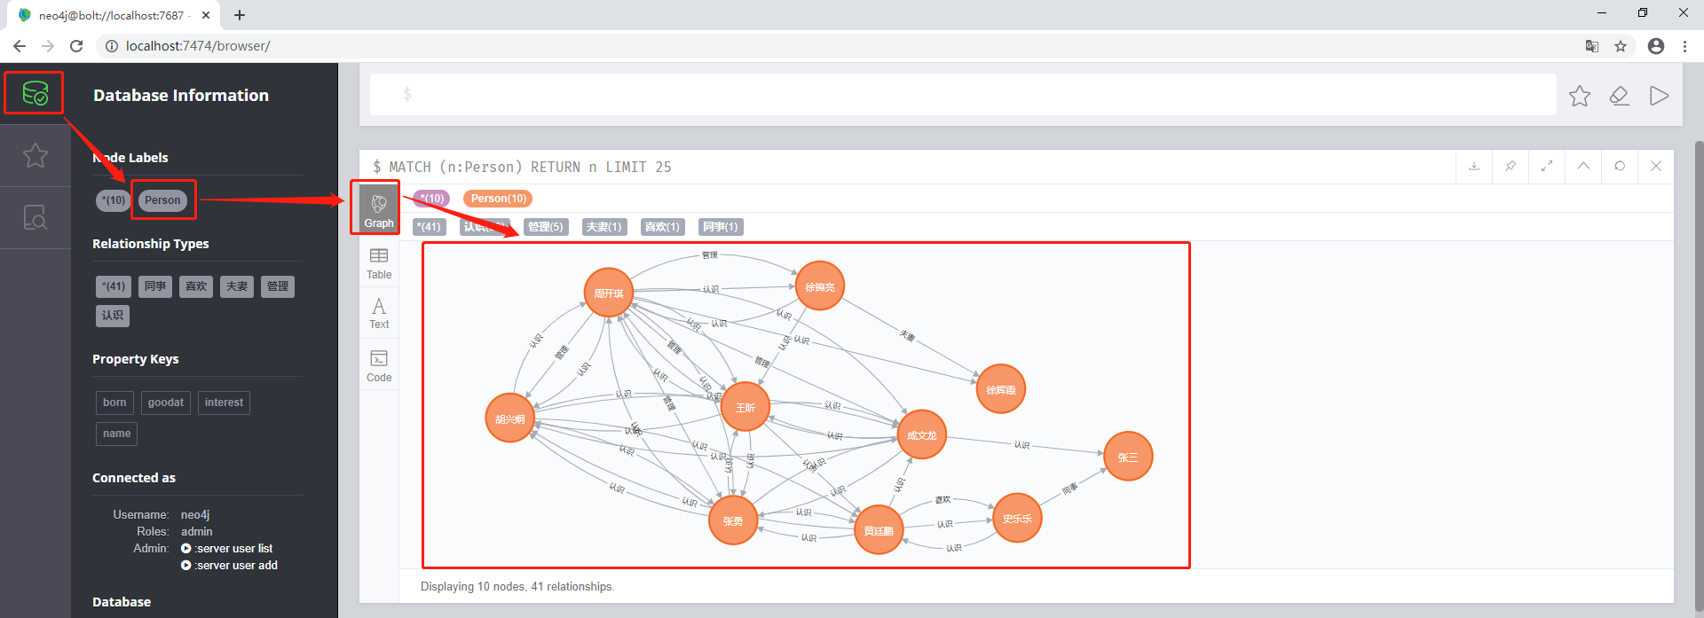

1. neo4j概览

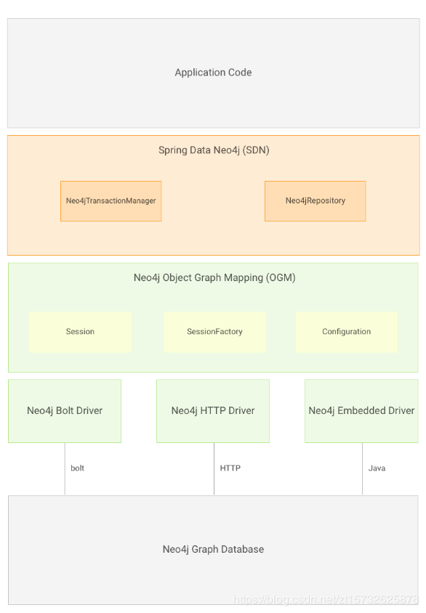

语句参考：<https://www.cnblogs.com/jpfss/p/10874001.html>

注：可以结合d3.js使用