**Camp Planning Sign off________________**

Patrol__________________ Patrol Leader__________________ Assistant Patrol Leader______________

Food Buyer______________Chaplain Aide____________Additional Scouts_______________________________

|  |  |  |  |  |
| --- | --- | --- | --- | --- |
| **Meal** | **Food** | **Who is Preparing** | **Who is Cleaning** | **Additional Supplies (charcoal, etc.)** |
|  |  |  |  |  |
|  |  |  |  |  |
|  |  |  |  |  |
|  |  |  |  |  |
|  |  |  |  |  |
|  |  |  |  |  |
|  |  |  |  |  |

|  |  |
| --- | --- |
| Tent | Scouts |
|  |  |
|  |  |
|  |  |
|  |  |

Scouts Own Service – Contribution: (Call to Worship – Song – Reading – Prayer – Meditation - Benediction)__________

CampFire - Contribution: (MC – Song – Skit --Cheer – Other Requirement)_____________________________________

Example 1

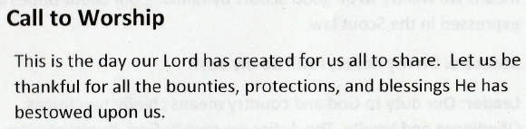

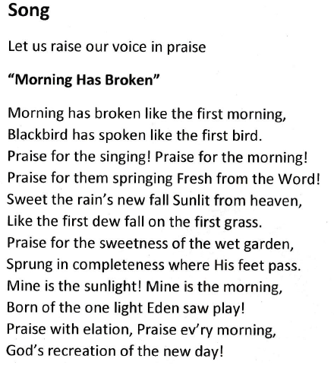

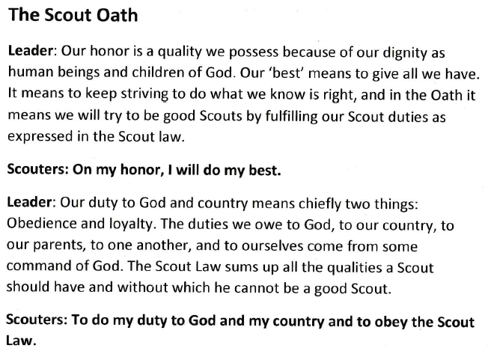 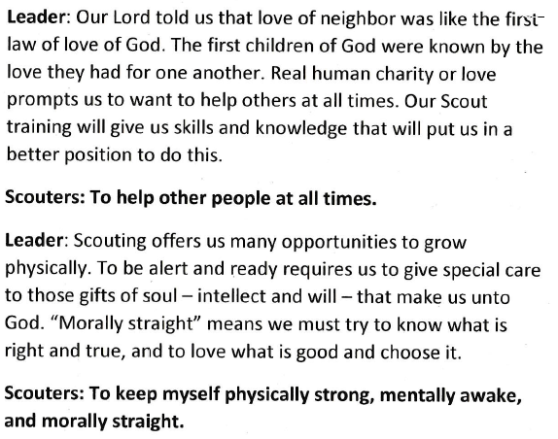

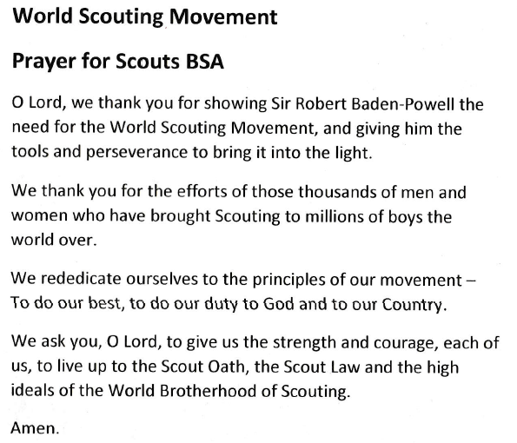

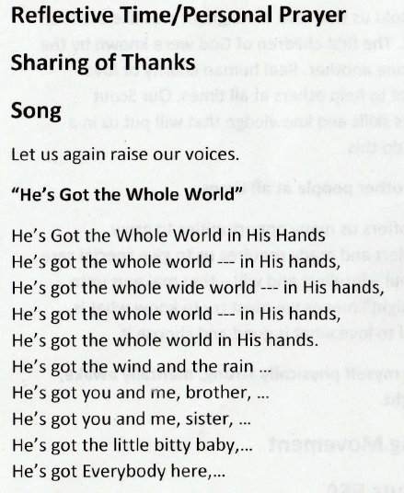

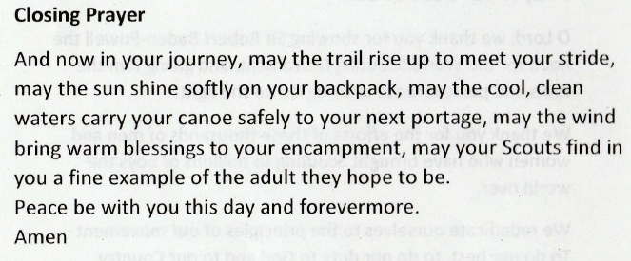

A SCOUT IS REVERENT

“He is reverent toward God. He is faithful in his religious duties. He respects the beliefs of others.”

Calls to Worship

Come let us sing unto the Lord: Let us make a joyful noise to the Lord, all the lands. Let us serve the Lord with gladness and came into his presence with singing. --Psalm 100

Invocations

May the time be not too distant, O God, when all your children will understand that they are brothers and sisters, so that, one in spirit and one in fellowship, they may be forever united before you. Then shall your kingdom be established on earth, and the word of your prophet shall be fulfilled: " The Lord will reign forever and ever." --From the Jewish Service of the Heart

Responsive Readings

I. The Scout Oath

Reader: Our honor is a quality we possess because of our dignity as human beings and children of God. Our 'best' means to give all we have. It means to keep striving to do what we know is right, and in the Oath it means we will try to be good Scouts by fulfilling our Scout duties as expressed in the Scout Law.

People: ON MY HONOR I WILL DO MY BEST

Reader: Our duty to God and country means chiefly two things: obedience and loyalty. The duties we owe to God, to our country, to our parents, to one another, and to ourselves come from some command of God. The Scout Law sums up all the qualities a Scout should have and without which he cannot be a good Scout.

People: TO DO MY DUTY TO GOD AND MY COUNTRY AND TO OBEY THE SCOUT LAW.

Reader: Our Lord told us that love of neighbor was like the first law of love of God. The first children of God were known by the love they had for one another. Real human charity or love prompts us to want to help others at all times. Our Scout training will give us skills and knowledge that will put us in a better position to do this.

People: TO HELP OTHER PEOPLE AT ALL TIMES

Reader: Scouting offers us many opportunities to grow physically. To be alert and ready requires us to give special care to those gifts of soul - intellect and will - that make us unto God. 'Morally straight' means we must try to know what is right and true, and to love what is good and choose it.

People: TO KEEP MYSELF PHYSICALLY STRONG, MENTALLY AWAKE, AND MORALLY STRAIGHT.

II. The Scout Law

Reader: A true and worthy person recognizes his obligations and does them without being watched or compelled.

People: A SCOUT IS TRUSTWORTHY.

Reader: We owe much to many - to home, school, community, nation, and to God.

People: A SCOUT IS LOYAL.

Reader: The good Samaritan showed the spirit of doing a Good Turn.

People: A SCOUT IS HELPFUL.

Reader: Courtesy is the mark of all faiths. It is shown in thoughtful acts and kindly respect for everyone.

People: A SCOUT IS COURTEOUS.

Reader: Kindliness is the way people show respect for others.

People: A SCOUT IS KIND.

Reader: Life is filled with things that we must do whether we like them or not. One of the marks of growing up is our readiness to accept responsibilities willingly.

People: A SCOUT IS OBEDIENT.

Reader: Our moods make our days. If we are grouchy, our day is gloomy. If we are happy, our day is always happier.

People: A SCOUT IS CHEERFUL.

Reader: The world offers many gifts. a wise person uses them with care.

People: A SCOUT IS THRIFTY.

Reader: To each of us comes danger, difficult tasks, and temptations. In choice of courage or cowardice, may we be brave.

People: A SCOUT IS BRAVE.

Reader: Cleanliness is next to Godliness. To have a clean body, a clean mind, and a clean record is a rewarding achievement.

People: A SCOUT IS CLEAN.

Reader: Character is determined by the things we worship. If we respect ourselves and our brothers and sisters, and see them as gifts of the goodness of God, we live on a high plain.

People: A SCOUT IS REVERENT.

All: GIVE US CLEAN HANDS, CLEAN WORDS, AND CLEAN THOUGHTS, 0 GOD. TEACH US TO WORK HARD AND PLAY FAIRLY. FORGIVE US WHEN WE ARE UNKIND AND HELP US TO HELP OTHERS. SEND US STRENGTH TO DO A GOOD TURN EACH DAY AND SO LIVE AFTER THY WILL.

Prayers

A SCOUTER'S PRAYER

Build me a Scout, 0 Lord, who will be strong enough to know when he is weak and brave enough to face himself when he is afraid; one who will be proud and unbending in honest defeat, and humble and gentle in victory...

Build me a Scout whose wishes will not take the place of deeds; a Scout who himself is the foundation stone of knowledge. . .

Lead him, I pray, not in the path of ease and comfort, but under the stress and spur of difficulties and challenge. Here let him learn to stand up in the storm; here let him learn compassion for those who fail...

Build me a Scout whose heart will be clear, whose goals will be high. A Scout who will master himself before he seeks to master others, one who will march into the future, yet never forget the past...

And after all these things are his, add, I pray, enough of a sense of humor so that he may always be serious, yet never take himself too seriously. Give him humility, so that he may always remember the simplicity of true wisdom, and the meekness of true strength... Then I, a Scouter who knew him, will dare to whisper, 'I have not lived in vain.'

Inspirational Thoughts and Messages

The Scout Beatitudes

Blessed are the Scouts who are taught to see beauty in all things around them... for their world will be a place of grace and wonder.

Blessed are the Scouts who are led with patience and understanding... for they will learn the strength of endurance and the gift of tolerance.

Blessed are the Scouts who are provided a home where family members dwell in harmony and close communion... for they shall become the peacemakers of the world.

Blessed are the Scouts who are taught the value and power of truth... for they shall search for knowledge and use it with wisdom and discernment.

Blessed are the Scouts who are guided by those with faith in a loving God... for they will find Him early and will walk with Him through life.

Blessed are the Scouts who are loved and know that they are loved... for they shall sow seeds of love in the world and reap joy for themselves and others.

Songs and Hymns

"America the Beautiful"

O beautiful for spacious skies For amber waves of grain, For purple mountain majesties Above the fruited plain

America! America! God shed his grace on thee, And crown thy good with brotherhood from sea to shining sea!

O beautiful for patriot dream That sees beyond the years Thine alabaster cities gleam, Undimmed by human tears!

America! America! God shed His grace on thee, And crown thy good with brotherhood from sea to shining sea!

The Scout is Reverent Book -- 29 -- Table of Contents

Poems

The Concord Hymn Ralph Waldo Emerson (1837) By the rude bridge that arched the flood, Their flag to April's breeze unfurled; Here once the embattled farmers stood; And fired the shot heard round the world.

The foe long since in silence slept; Alike the conqueror silent sleeps, And Time the ruined bridge has swept Down the dark stream that seaward creeps.

On this green bank, by this soft stream, We place with joy a votive stone, That memory may their deeds redeem, When, like our sires, our sons are gone.

O Thou who made those heroes dare To die, and leave their children free, -- Bid Time and Nature gently spare The shaft we raised to them and Thee.

Benedictions;

The Lord bless you and keep you, The Lord make His face to shine upon you, And give you peace. --Traditional