Software Design Document
Moderated Learning Management System (LMS)
CS4433 Software Engineering
Version 1.0
Phase 3 deliverable (Gate 2)
19 October 2026
By: Ts’iu Hopolang

1. Introduction
This document explains how the Moderated LMS described in the Software Requirements Specification (SRS v1.0) will be built. It covers the architecture, the class design and design patterns, the behavioural models and the database design. It is the document reviewed at Gate 2, and implementation starts from it.

2. Architecture

2.1 Chosen style: layered architecture
The system has four layers. Each layer talks only to the layer directly beneath it, as shown in Figure 1.
Layer | Responsibility | Main parts
Presentation | Menus, input and messages. No business rules | ConsoleUI with one menu per role
Application | One service per group of use cases. Checks that the user's role allows the action | AuthService, AdminService, AssignmentService, SubmissionService, AssessmentService
Domain | Entities and rules | User and its four roles, Course, Assignment, Submission, penalty policy
Data access | Reads and writes the database | Repository interfaces, SQLite repositories, PasswordHasher

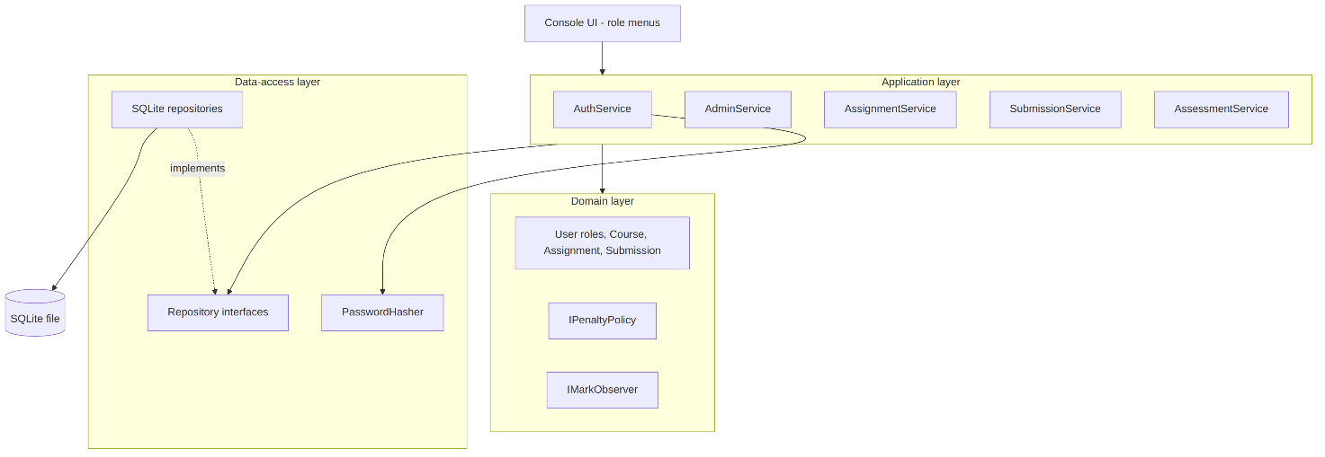
The services depend on the repository interfaces, not on SQLite. The concrete SQLite classes are chosen once, in main(), and passed in. This lets the business logic be unit-tested with in-memory fake repositories and no database.

2.2 Rationale and rejected alternatives
Layering was chosen for four reasons. It makes NFR-10 (no SQL outside the data-access layer) true by construction. It lets the business logic be tested on its own, which is needed for the 70% coverage target. It is simple enough for one developer to finish in the two implementation weeks. And its cost, a few extra interface classes, is negligible next to 800 users on a local database.
Three alternatives were considered and rejected.
Rejected alternative | Why it was rejected
Model-View-Controller | MVC is built around views that observe a model and refresh when it changes. A console program has one view and no such events, so the controller would only duplicate the application layer. The model would still need the same internal layering to keep SQL out of it
Client-server (web application) | Contradicts the offline requirement and the out-of-scope list (no web or mobile interfaces), and needs a server the school does not have
Single-layer program | Quickest to start, but SQL, rules and menus would be mixed together, which breaks NFR-10 and makes the code hard to test and hard to change

3. Class design

3.1 Class diagram
The class diagram is shown in two parts to keep it readable. Figure 2 shows the domain model: the user roles, courses, assignments, extensions and submissions. Figure 3 shows the design patterns and the services that use them.
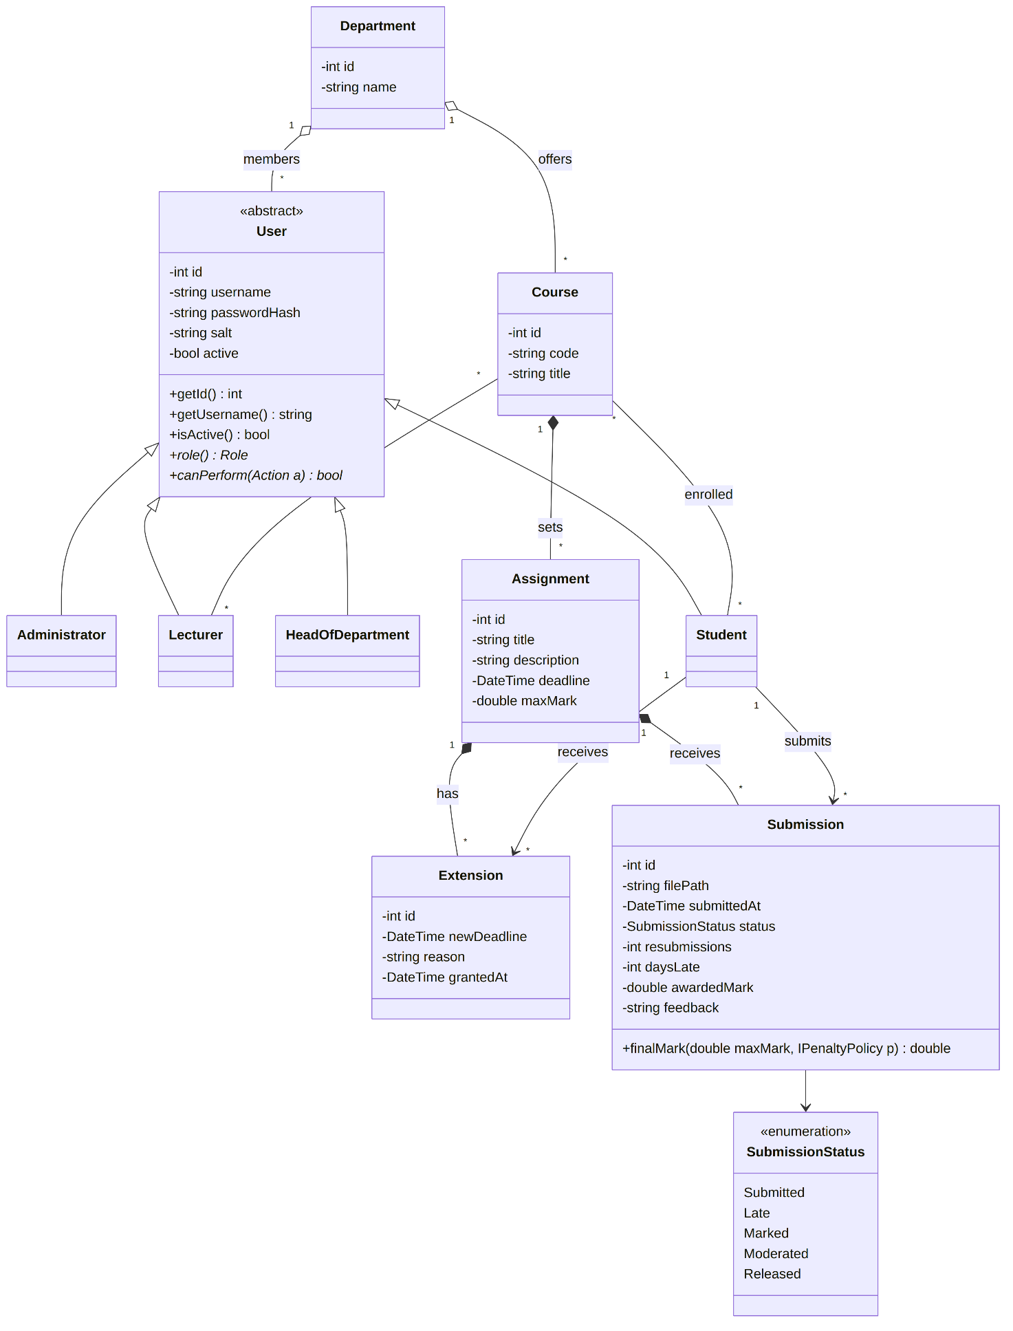
Figure 2: Class diagram, part 1: domain model
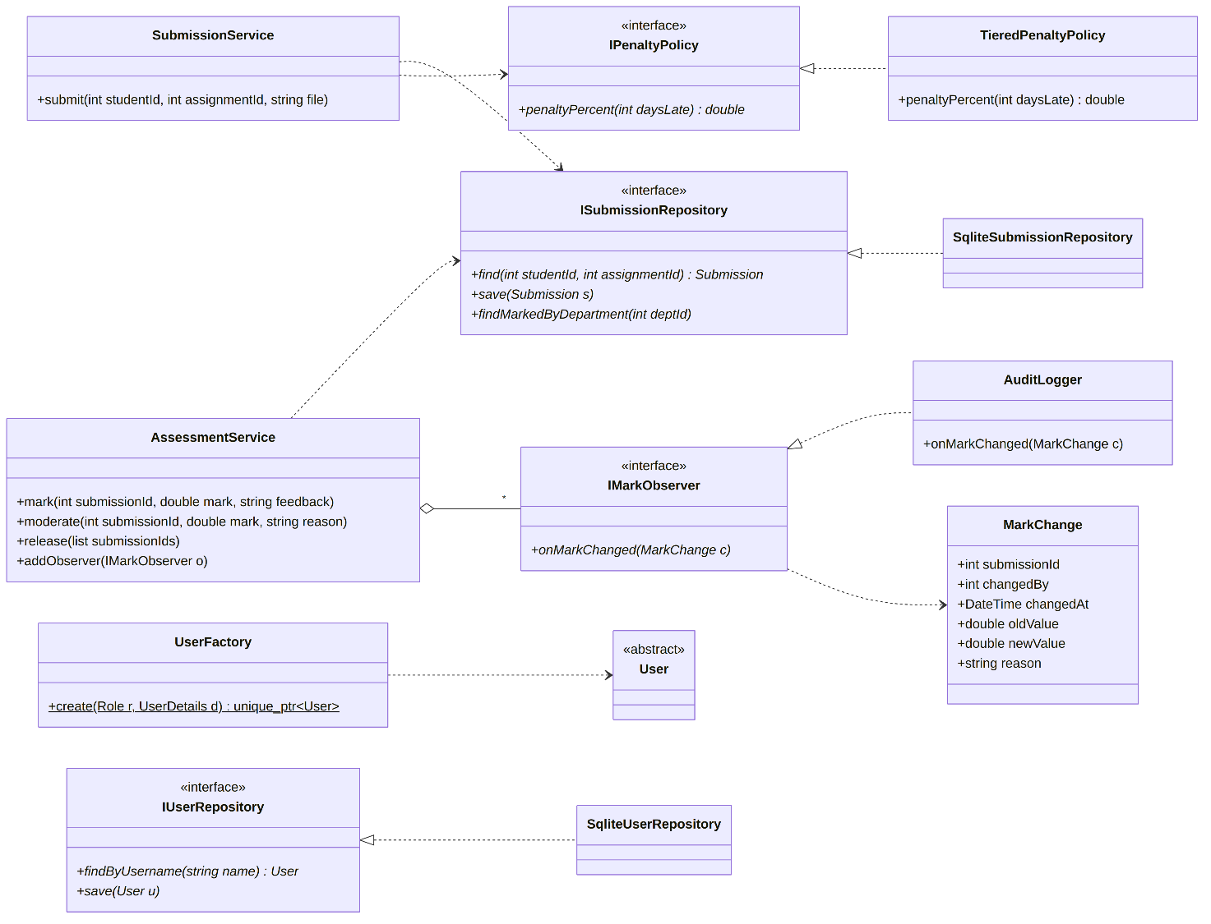
Figure 3: Class diagram, part 2: design patterns and services
Notes on the diagram:
- The Assignment and Course repositories (IAssignmentRepository, ICourseRepository) and the audit repository (IAuditRepository) follow the same interface-plus-SQLite pattern as the two shown. They are left out only to keep the diagram readable.
- Attributes are private and reached through getters. Interfaces and services expose only public operations.
- Submission does not store its final mark. finalMark() works it out from the awarded mark, the days late and the penalty policy.
- Errors use one base class LmsException with ValidationError, AuthorisationError, NotFoundError and DatabaseError below it.

3.2 Design patterns
Pattern | Where it is used | Why it was chosen
Strategy | IPenaltyPolicy and TieredPenaltyPolicy | The HoD's rule (10%, 20%, 30%, then zero) is the part most likely to change. The rule is kept behind an interface so a new rule is a new class and no existing class changes
Repository | I...Repository interfaces and their SQLite classes | Keeps all SQL in one layer (NFR-10), makes parameterised queries the only way in, and lets tests use fake repositories
Observer | IMarkObserver and AuditLogger | Every mark change must be logged (FR-29). Marking and moderation code announces a change and the logger reacts. The marking code does not need to know the audit log exists
Factory | UserFactory::create | Four roles are created in the same way from the administrator's menu. One place decides which subclass to build, so the rest of the code never uses new on a role class

3.3 SOLID principles
Principle | How the design follows it
Single responsibility | Each service covers one group of use cases. AuditLogger only logs. PasswordHasher only hashes passwords
Open/closed | A new penalty rule is a new IPenaltyPolicy class. SubmissionService and AssessmentService do not change
Liskov substitution | Any User subclass can be used where a User is expected. Any repository implementation, including an in-memory test fake, can replace the SQLite one
Interface segregation | Interfaces are small: IMarkObserver has one operation, and there is one repository interface per kind of data instead of one large database interface
Dependency inversion | Services depend on interfaces. The concrete SQLite and policy classes are created in main() and passed in

- Passwords are hashed through an IPasswordHasher interface. The planned library is libsodium (Argon2id), which is widely reviewed, creates a unique salt per password and builds with CMake. A second recognised library is kept as a fallback if it will not build on the school's computers.
- Every SQL statement is a prepared statement with bound parameters. Statements and transactions are wrapped in small classes so they are always closed, even when an exception is thrown.

4. Behavioural models

4.1 Submission state machine
Figure 4 shows the life cycle of a submission. It matches business rule BR-08 in the SRS.
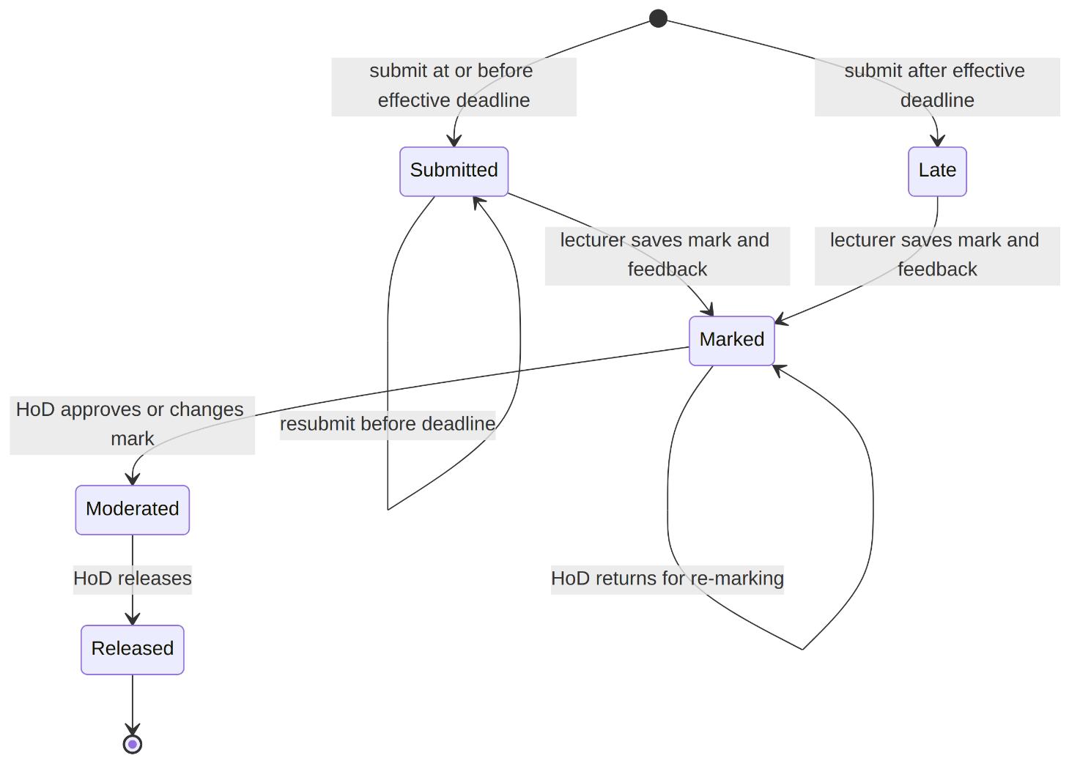
Figure 4: State machine diagram for the Submission life cycle

4.2 Activity diagram with swimlanes
Figure 5 shows the process from a student's submission to the released mark, with one lane for each participant.
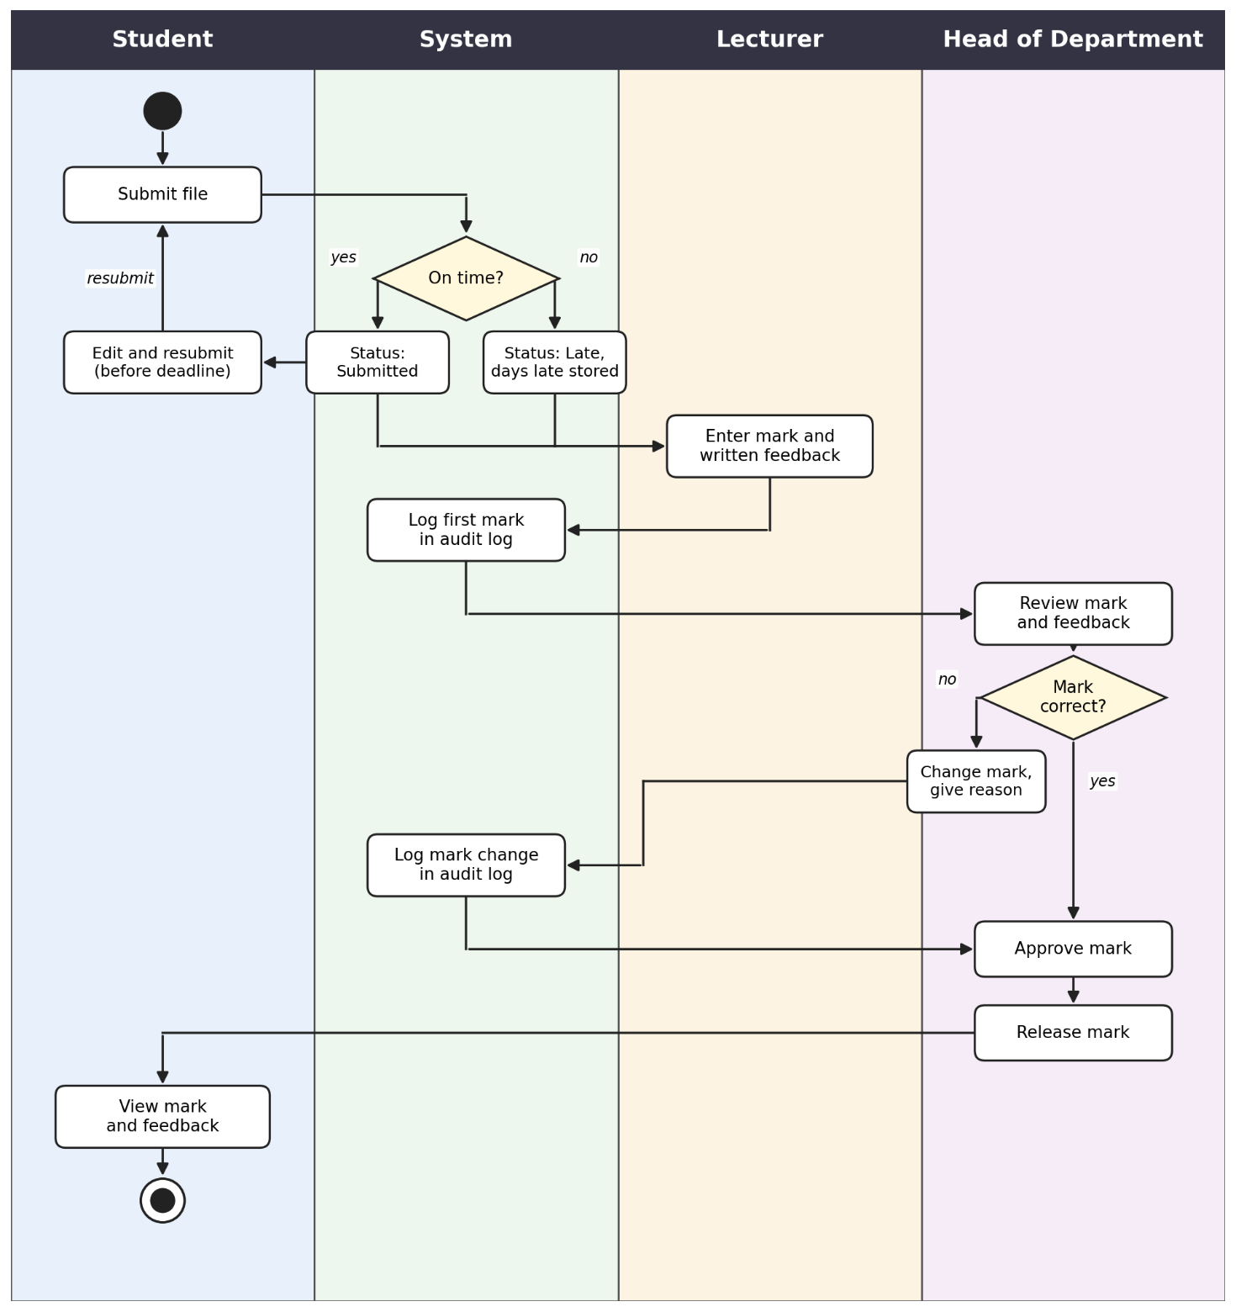
Figure 5: Activity diagram with swimlanes, from submission to released mark

4.3 Sequence diagram: Submit assignment
Figure 6 shows the normal path, the late path and the resubmission path, and the case where resubmission is refused (business rules BR-05 and BR-06).
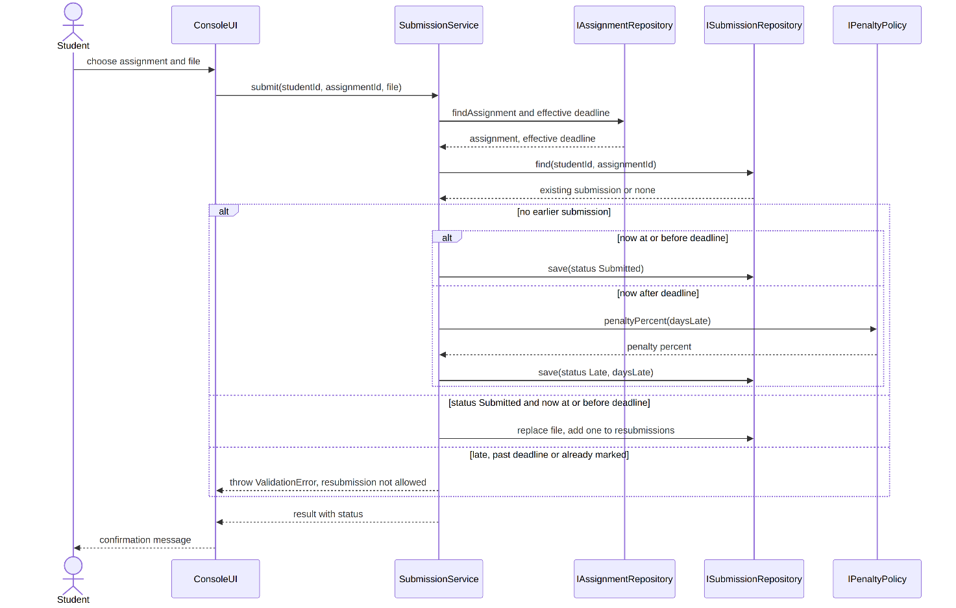
Figure 6: Sequence diagram for Submit assignment, including late and resubmission paths

4.4 Sequence diagram: Moderate and release marks
Figure 7 shows the HoD approving or changing a mark and then releasing it. A changed mark is passed to the audit logger, which saves the audit entry.
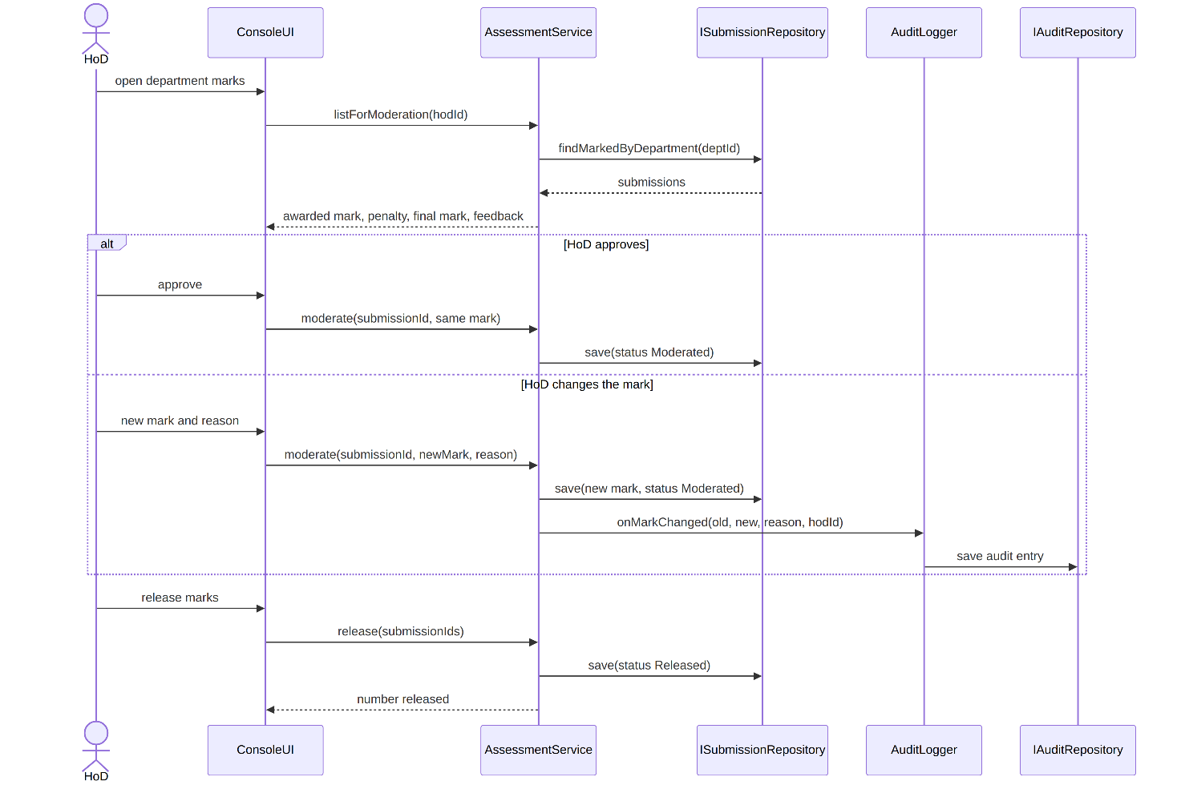
Figure 7: Sequence diagram for Moderate and release marks

5. Database design

5.1 Entity relationship diagram
Figure 8 shows the nine tables, their keys and the relationships between them.
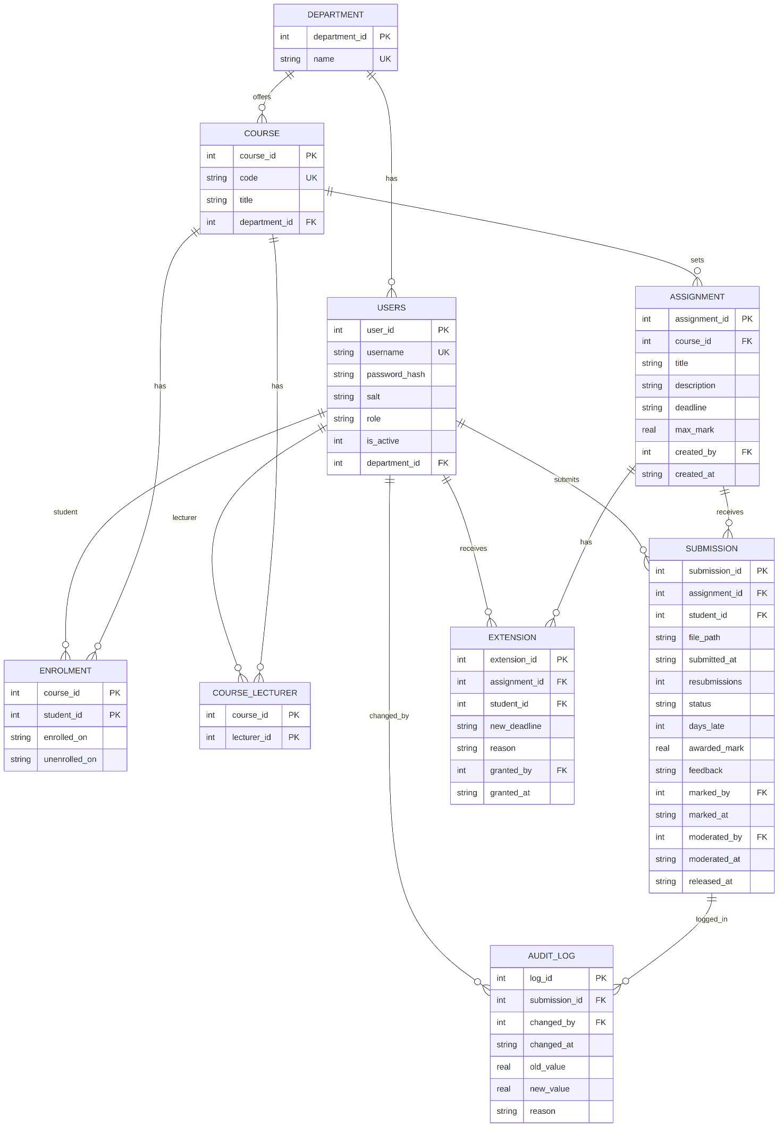
Figure 8: Entity relationship diagram of the SQLite database

5.2 Normalisation
The schema is in Third Normal Form.
- First normal form: every column holds a single value. Enrolments and lecturer assignments, which could have been repeating lists, are separate tables.
- Second normal form: enrolment and course_lecturer have composite keys and no other facts that depend on only part of the key. The enrolment dates depend on the whole (course, student) pair.
- Third normal form: no column depends on another non-key column. A department's name lives only in department, a course's title only in course. The penalty percentage and the final mark are not stored because they can be worked out from days_late, awarded_mark and the assignment's max_mark. Storing them would create exactly the kind of dependency 3NF removes, and they could drift out of step with the real mark.

5.3 Data dictionary
Table | Column | Type | Rules and meaning
department | department_id | INTEGER | Primary key
department | name | TEXT | Required, unique
users | user_id | INTEGER | Primary key
users | username | TEXT | Required, unique login name
users | password_hash | TEXT | Required. Salted hash, never the password
users | salt | TEXT | Required. Per-user random salt
users | role | TEXT | ADMIN, LECTURER, HOD or STUDENT
users | is_active | INTEGER | 1 active, 0 deactivated. Default 1
users | department_id | INTEGER | Foreign key to department. Required for every role except ADMIN
course | course_id | INTEGER | Primary key
course | code | TEXT | Required, unique course code
course | title | TEXT | Required
course | department_id | INTEGER | Required foreign key to department
enrolment | course_id, student_id | INTEGER | Composite primary key, both foreign keys
enrolment | enrolled_on | TEXT | Required date and time
enrolment | unenrolled_on | TEXT | Empty while the student is enrolled
course_lecturer | course_id, lecturer_id | INTEGER | Composite primary key, both foreign keys
assignment | assignment_id | INTEGER | Primary key
assignment | course_id | INTEGER | Required foreign key to course
assignment | title | TEXT | Required
assignment | description | TEXT | Optional
assignment | deadline | TEXT | Required, yyyy-mm-dd hh:mm
assignment | max_mark | REAL | Required, greater than 0
assignment | created_by, created_at | INTEGER, TEXT | Lecturer who created it, and when
extension | extension_id | INTEGER | Primary key
extension | assignment_id, student_id | INTEGER | Foreign keys. The effective deadline is the latest new_deadline, or the assignment deadline if there is none
extension | new_deadline | TEXT | Required
extension | reason | TEXT | Required
extension | granted_by, granted_at | INTEGER, TEXT | Lecturer and time
submission | submission_id | INTEGER | Primary key
submission | assignment_id, student_id | INTEGER | Foreign keys. The pair is unique: one submission per student per assignment
submission | file_path | TEXT | Required. Location of the stored file
submission | submitted_at | TEXT | Required. Time of the latest submission
submission | resubmissions | INTEGER | Default 0
submission | status | TEXT | SUBMITTED, LATE, MARKED, MODERATED or RELEASED
submission | days_late | INTEGER | Default 0, not negative
submission | awarded_mark | REAL | Empty until marked. Updated by the lecturer or the HoD. Not negative
submission | feedback | TEXT | Empty until marked
submission | marked_by, marked_at | INTEGER, TEXT | Lecturer and time
submission | moderated_by, moderated_at | INTEGER, TEXT | HoD and time
submission | released_at | TEXT | Empty until released
audit_log | log_id | INTEGER | Primary key
audit_log | submission_id | INTEGER | Required foreign key to submission
audit_log | changed_by | INTEGER | Required foreign key to users
audit_log | changed_at | TEXT | Required
audit_log | old_value | REAL | Empty for the first mark
audit_log | new_value | REAL | Required
audit_log | reason | TEXT | Required

5.4 SQL schema
PRAGMA foreign_keys = ON;

CREATE TABLE department (
department_id INTEGER PRIMARY KEY AUTOINCREMENT,
name TEXT NOT NULL UNIQUE
);

CREATE TABLE users (
user_id INTEGER PRIMARY KEY AUTOINCREMENT,
username TEXT NOT NULL UNIQUE,
password_hash TEXT NOT NULL,
salt TEXT NOT NULL,
role TEXT NOT NULL CHECK (role IN ('ADMIN','LECTURER','HOD','STUDENT')),
is_active INTEGER NOT NULL DEFAULT 1 CHECK (is_active IN (0,1)),
department_id INTEGER REFERENCES department(department_id),
CHECK (role = 'ADMIN' OR department_id IS NOT NULL)
);
CREATE UNIQUE INDEX one_hod_per_department
ON users(department_id) WHERE role = 'HOD';

CREATE TABLE course (
course_id INTEGER PRIMARY KEY AUTOINCREMENT,
code TEXT NOT NULL UNIQUE,
title TEXT NOT NULL,
department_id INTEGER NOT NULL REFERENCES department(department_id)
);

CREATE TABLE enrolment (
course_id INTEGER NOT NULL REFERENCES course(course_id),
student_id INTEGER NOT NULL REFERENCES users(user_id),
enrolled_on TEXT NOT NULL,
unenrolled_on TEXT,
PRIMARY KEY (course_id, student_id)
);

CREATE TABLE course_lecturer (
course_id INTEGER NOT NULL REFERENCES course(course_id),
lecturer_id INTEGER NOT NULL REFERENCES users(user_id),
PRIMARY KEY (course_id, lecturer_id)
);

CREATE TABLE assignment (
assignment_id INTEGER PRIMARY KEY AUTOINCREMENT,
course_id INTEGER NOT NULL REFERENCES course(course_id),
title TEXT NOT NULL,
description TEXT,
deadline TEXT NOT NULL,
max_mark REAL NOT NULL CHECK (max_mark > 0),
created_by INTEGER NOT NULL REFERENCES users(user_id),
created_at TEXT NOT NULL
);

CREATE TABLE extension (
extension_id INTEGER PRIMARY KEY AUTOINCREMENT,
assignment_id INTEGER NOT NULL REFERENCES assignment(assignment_id),
student_id INTEGER NOT NULL REFERENCES users(user_id),
new_deadline TEXT NOT NULL,
reason TEXT NOT NULL,
granted_by INTEGER NOT NULL REFERENCES users(user_id),
granted_at TEXT NOT NULL
);

CREATE TABLE submission (
submission_id INTEGER PRIMARY KEY AUTOINCREMENT,
assignment_id INTEGER NOT NULL REFERENCES assignment(assignment_id),
student_id INTEGER NOT NULL REFERENCES users(user_id),
file_path TEXT NOT NULL,
submitted_at TEXT NOT NULL,
resubmissions INTEGER NOT NULL DEFAULT 0,
status TEXT NOT NULL CHECK (status IN
('SUBMITTED','LATE','MARKED','MODERATED','RELEASED')),
days_late INTEGER NOT NULL DEFAULT 0 CHECK (days_late >= 0),
awarded_mark REAL CHECK (awarded_mark >= 0),
feedback TEXT,
marked_by INTEGER REFERENCES users(user_id),
marked_at TEXT,
moderated_by INTEGER REFERENCES users(user_id),
moderated_at TEXT,
released_at TEXT,
UNIQUE (assignment_id, student_id)
);

CREATE TABLE audit_log (
log_id INTEGER PRIMARY KEY AUTOINCREMENT,
submission_id INTEGER NOT NULL REFERENCES submission(submission_id),
changed_by INTEGER NOT NULL REFERENCES users(user_id),
changed_at TEXT NOT NULL,
old_value REAL,
new_value REAL NOT NULL,
reason TEXT NOT NULL
);
CREATE TRIGGER audit_no_update BEFORE UPDATE ON audit_log
BEGIN SELECT RAISE(ABORT, 'audit log is read-only'); END;
CREATE TRIGGER audit_no_delete BEFORE DELETE ON audit_log
BEGIN SELECT RAISE(ABORT, 'audit log is read-only'); END;

CREATE INDEX idx_enrolment_student ON enrolment(student_id);
CREATE INDEX idx_submission_student ON submission(student_id);
CREATE INDEX idx_assignment_course ON assignment(course_id);

Rules the database cannot express, such as a mark not exceeding the assignment's maximum or a user in enrolment having the STUDENT role, are checked by the services before saving (BR-09 and BR-12).

5.5 Mapping from classes to tables
Class | Table | Notes and justified differences
User and its four subclasses | users | One table with a role column. The subclasses add no attributes of their own, so separate tables would only repeat the same columns. UserFactory chooses the subclass from role
Department | department | Direct
Course | course | Direct
Student and Course association | enrolment | The many-to-many link becomes a table, with dates added so unenrolling keeps history
Lecturer and Course association | course_lecturer | Link table
Assignment | assignment | Direct
Extension | extension | Direct
Submission | submission | The status enumeration is stored as text. finalMark() is not stored because it is derived. Marking, moderation and release times are added columns for traceability
MarkChange | audit_log | A value object saved by AuditLogger. Database triggers keep it read-only
IPenaltyPolicy, services, repositories, UserFactory, PasswordHasher | none | Behaviour classes that hold no stored state

The salt column is kept separately so that the data dictionary shows the salted-hash requirement explicitly.

6. Traceability to the SRS
Design element | Requirements it supports
Layered architecture, repository interfaces | NFR-10, NFR-08, NFR-01
users table, PasswordHasher, AuthService | FR-01, FR-02, FR-03 to FR-05, NFR-02
UserFactory | FR-03
department, course, enrolment and course_lecturer tables, AdminService | FR-06 to FR-09
assignment and extension tables, AssignmentService | FR-10, FR-11, FR-21
IPenaltyPolicy and TieredPenaltyPolicy | FR-20, BR-02, BR-03
Submission state machine and Submit assignment sequence | FR-15 to FR-19, FR-22, FR-23, BR-05, BR-06, BR-08
AssessmentService, marking and moderation sequences | FR-12 to FR-14, FR-24 to FR-28
AuditLogger, audit_log table and triggers | FR-29, FR-30, FR-31
Exception hierarchy and prepared statements | NFR-05, NFR-02

The full traceability matrix, which adds source files and test cases, will be built from this table as those artefacts are produced.

