Query 1: Retrieve All Students in a Specific Course
Purpose:
Find all students enrolled in "Introduction to Programming" (CS101)
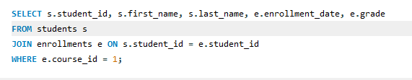

Explanation:
- Joins students and enrollments tables using student_id
- Filters for course_id = 1 (CS101)
- Returns:
  - Student identification details
  - Enrollment date
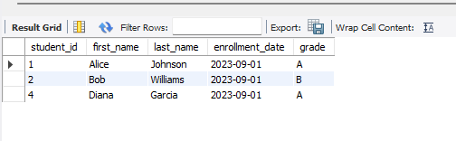
  - Current grade (if assigned)

Query 2: Find Faculty in a Department
Purpose:
List all Computer Science department faculty
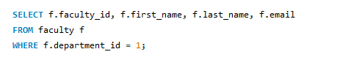

Explanation:
- Scans the faculty table
- Filters for department_id = 1
- Returns faculty contact information

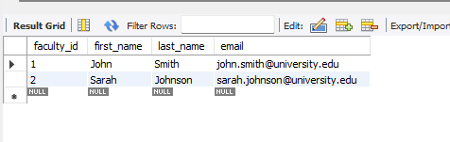

Query 3: List Courses for a Student
Purpose:
Show all courses taken by Alice Johnson (student_id=1)
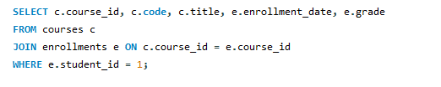

Explanation:
- Joins courses and enrollments tables
- Filters for student_id = 1
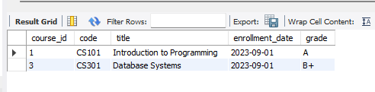
- Returns course details with grades

Query 4: Find Unenrolled Students
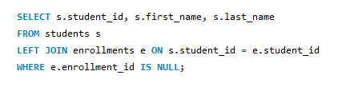
Purpose:
Identify students not registered for any courses

Explanation:
- Left join preserves all students
- IS NULL finds records with no enrollment
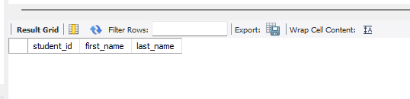
- Returns basic student info

Query 5: Calculate Course Average Grade
Purpose:
Compute grade average for CS101
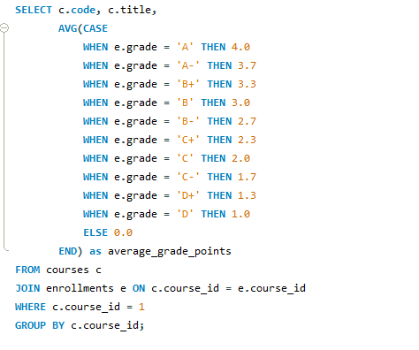

Explanation:
- Converts letter grades to numeric values
- Calculates weighted average
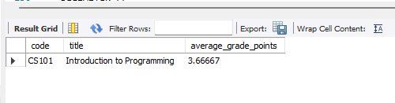
- Returns single-row summary

