Evaluating the Long-term Impact of COVID-19 Pandemic on For-Hire Vehicle Dynamics: A New York City Case Study

1 Introduction 1

1.1 For-Hire Vehicle (FHV) 1

1.2 Study Aera: New York City (NYC) 1

2 Literature Review 2

2.1 The Long-term impact of COVID-19 on transportation 2

2.1.1 Direct Impact 2

2.1.2 Indirect Impact 2

2.2 Existing research on the impact of COVID-19 on the transportation system of New York City. 2

2.3 Research Questions 2

3 Data Source and Methodology 2

3.1 Data Source 3

3.2 Methodologies 3

3.2.1 Before-and-After Analysis 3

3.2.2 Multilevel Analysis 3

3.2.3 Quantitative Analysis 3

3.3 Approach for Research Questions 3

4 Results 3

4.1 Macroscopic Perspective on the Comparison of For-Hire Vehicle Trips in New York City: 2023 versus 2019 3

4.2 Meso-level Analysis of Differences in FHV Metrics: Temporal and Spatial Factors 3

4.3 Key Influence Factors Analysis: Land Use, Population, and Trip Characteristics 3

4.4 Model Fit 3

5 Conclusion and Discussion 3

5.1 Key Findings and Conclusion 3

5.2 Limitations 3

Reference 3

# 1 Introduction

# A brief introduction about the COVID-19 pandemic and its impact on transportation, at the last mention the For Hire Vehicle.

## 1.1 For-Hire Vehicle (FHV)

# What is the For-Hire Vehicle?

# A Venn diagram of public transport systems, Taxi, FHV and private car. (Figure)

# The history of FHV

# The advantage of FHV (Emphasizing its contribution to ameliorating the inequalities in mobility).

# The drawbacks and ensuing controversies of FHV (Critical thinking)

As an integral part of urban transportation systems, FHV suffered severe impacts during the initial phase of the pandemic. Despite the gradual recovery of socio-economic aspects over time, the enduring influence that the pandemic has exerted on people is indelible. More than three years have passed since the outbreak of COVID-19, thus making the analysis and summary of its long-term impact on FHV a pressing issue. Considering this, the research objectives of this paper are as follows:

1. To investigate the extent of recovery in the For-Hire Vehicle (FHV) industry from the impacts of the COVID-19 pandemic.
2. To explore the presence of temporal and spatial disparities in the long-term effects of COVID-19 on the FHV industry.
3. To identify and analyze the factors that have played a significant role in influencing the FHV industry's recovery from the pandemic's impacts.

Given the vastness and regional differences of the For-Hire Vehicle (FHV) industry worldwide, it is impractical to meticulously analyze the entire sector. As stated in (citation), case studies are powerful tools for addressing issues in social sciences. Therefore, a reasonable alternative is to select a suitable case for an in-depth study. Considering several factors, this research chooses New York City as the case for study.

## 1.2 Study Aera: New York City (NYC)

# Why choice NYC as study case?

# A Brief Review of For-Hire Vehicle in NYC

# Introduce the following sections. Project code for data analysis and visualization is available at ......

# 2 Literature Review

## 2.1 The Long-term impact of COVID-19 on transportation

### 2.1.1 Direct Impact

# COVID-19 Number of cases, deaths in relation to transportation (Considering the mode choice)

# The temporary or permanent policy impacts on transportation brought about by the COVID-19 pandemic.

# Show a timeline of traffic-related decrees issued by the New York City government during the COVID-19 pandemic. (Figure)

### 2.1.2 Indirect Impact

|  |  |  |  |
| --- | --- | --- | --- |
|  | Key word | Impact | Citation |
| Negative Impact |  |  |  |
|  |  |  |
| Positive Impact |  |  |  |
|  |  |  |

## 2.2 Existing research on the impact of COVID-19 on the transportation system of New York City.

# Introducing (Bian et.al., 2022) and (Li et.al., 2022), conclude their works.

While these studies have investigated NYC's taxi and FHV services, they are limited by their research timeline, focusing only on the early impacts after the outbreak of COVID-19. As the vaccination rates increase and the pandemic becomes more normalized, the situation regarding FHVs has evolved. Furthermore, these studies primarily concentrate on Manhattan, lacking analysis of other regions in New York City. However, considering the impact of COVID-19 on urban morphology, it is essential to consider other areas of New York City. Therefore, it is necessary to conduct a comprehensive and in-depth analysis of FHV in New York City using the most recent data.

## 2.3 Research Questions

Taking into consideration the aforementioned factors, this paper will conduct research on the long-term impact of the COVID-19 pandemic on For-Hire Vehicles (FHV) in New York City. The specific research questions of this paper are as follows:

1. Has there been changes in the number of For-Hire Vehicles (FHV) in New York during the period of February to April 2023 compared to the same period in 2019?
2. If there have been changes, have these been evenly distributed temporally and spatially?
3. What are the main influencing factors for any changes?

# 3 Data Source and Methodology

## 3.1 Data Source

* NYC Taxi and Limousine Commission (TLC) Trip Record Data
* The American Community Survey (ACS) and Primary Land Use Tax Lot Output (PLUTO) data

## 3.2 Methodologies

### 3.2.1 Before-and-After Analysis

### 3.2.2 Multilevel Analysis

### 3.2.3 Quantitative Analysis

## 3.3 Approach for Research Questions

# 4 Results

## 4.1 Macroscopic Perspective on the Comparison of For-Hire Vehicle Trips in New York City: 2023 versus 2019

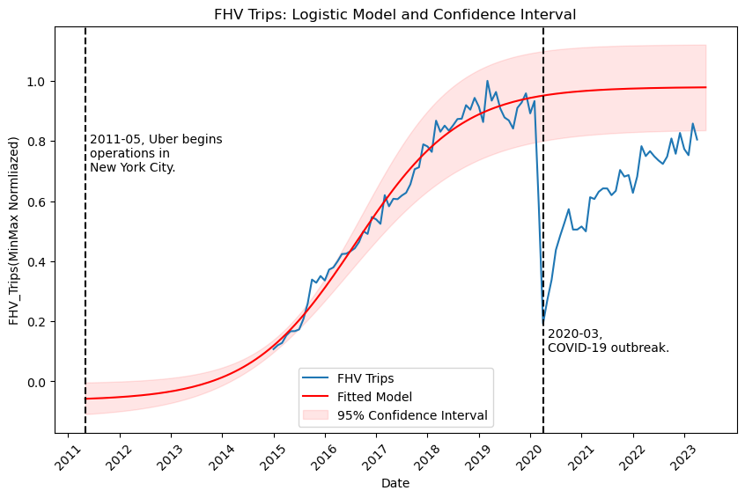

Fitting the trip volume with logistic distuibution

## 4.2 Meso-level Analysis of Differences in FHV Metrics: Temporal and Spatial Factors

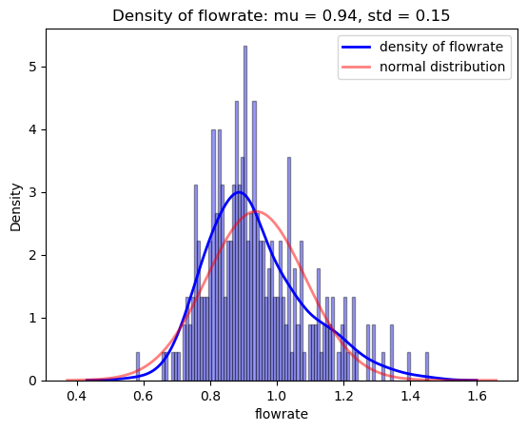

The density of 2023/2019 trip volume rate.

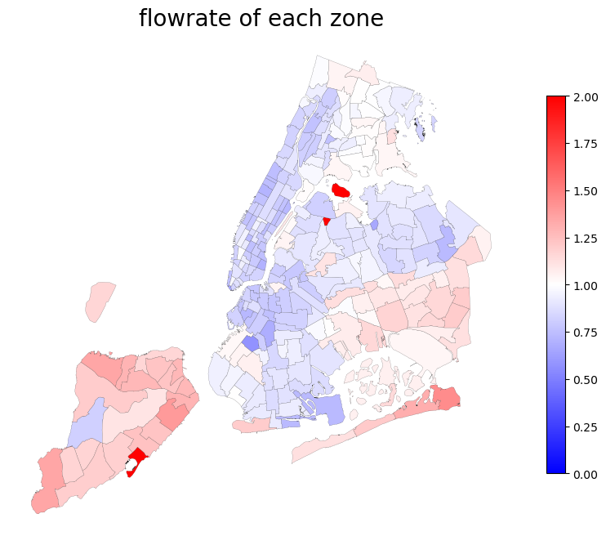

The trip volume rate by taxi zones.

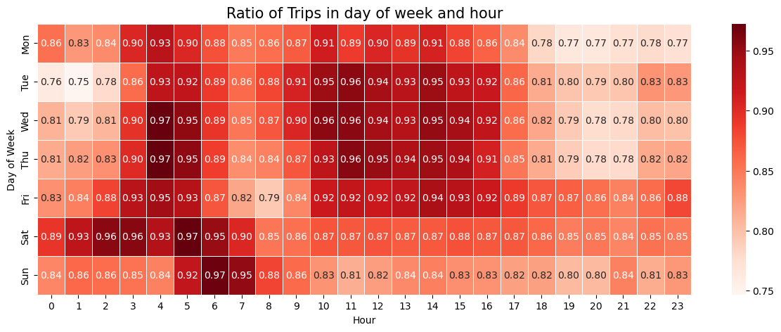

Displacement of relative demand between Feb. To Apl. of 2019 and 2023, by hour and day of the week.

## 4.3 Key Influence Factors Analysis: Land Use, Population, and Trip Characteristics

## 4.4 Model Fit

# 5 Conclusion and Discussion

## 5.1 Key Findings and Conclusion

Through the analysis of New York City's For-Hire Vehicle (FHV) data from February to April in both 2019 and 2023, this study has primarily identified the following findings:

* # Findings about Q1
* # Findings about Q2
* # Findings about Q3

# Summarizing the Long-term Impact of the Covid-19 Pandemic on FHV in New York City

This paper has meticulously analyzed the For-Hire Vehicle data in New York City, employing a variety of visualization techniques, statistical modeling, and testing methods. It has examined the long-term spatiotemporal impact of COVID-19 on NYC's FHV from both macro and meso-level perspectives. These analytical tools offer valuable references for similar data analyses in the future.

Analysis of this case should not be confined to the case itself but should also provide recommendations for future major public health emergencies of this kind.

For many countries and regions, such large-scale epidemics are unprecedented. Therefore, the lack of experience in dealing with such incidents was one of the primary factors contributing to the chaotic management in the early stages of the outbreak (citation needed). From this perspective, the case study findings on For-Hire Vehicles (FHV) in New York City suggest that...

In addition, this study also provides an experiential analysis for the future development of Shared Autonomous Vehicles (SAV). Briefly, Shared Autonomous Vehicles (SAV) are vehicles that operate autonomously and are shared by multiple users, either simultaneously or at different times (citation needed). Research indicates that the audience for SAVs is more likely to be current taxi and FHV users (citation needed). Analyzing FHV can largely reveal the potential circumstances SAVs might face in the future. For instance, like FHV, SAVs in areas with a higher residential density may experience more extensive and profound impacts...

## 5.2 Limitations.

# Due to the insufficiency of data precision, future research could consider utilizing For-Hire Vehicle (FHV) trip data with precise longitude and latitude coordinates. This would facilitate combination with Point of Interest (POI) data, thereby allowing for further analysis of differences among various types of Origin-Destination (OD) pairs. (There is a lack of micro-level analysis.)

# The research methodology could be enhanced. Methods such as Design Survey could be applied to this study to further analyze the long-term impacts of the COVID-19 pandemic on different sectors participating in FHV transportation, including transportation companies, drivers, and service users. This approach would also allow for the analysis of differences brought about by factors like population characteristics.

# Based on the flow diagram of FHV, there is still an upward trend in FHV traffic as of the time of this research. Thus, it cannot be definitively concluded that the existing gap will persist in the long term. A retrospective review of this issue in a few years might yield new findings.

# Reference