PROCUREMENT
SOURCING PLATFORM
Project Overview & Technical Documentation
A web application concept for managing sourcing requests and supplier price offers
Technology: Python • Django • SQLite (local development)
Source code: https://github.com/HoriaCT/procurement-sourcing-platform

1. Project Overview
The Procurement Sourcing Platform is a portfolio project designed to explore how a digital workflow can support sourcing activities by bringing requesters and suppliers together in one place. The intended workflow is to publish a Request for Quotation (RFQ), invite eligible suppliers, collect price offers, and review submissions to support a transparent supplier-selection process.
The project is being developed incrementally. Features described as intended below should be considered part of the proposed workflow until they have been fully implemented and tested.

2. Goals and Intended Benefits
- Centralize sourcing requests and supplier responses.
- Provide a structured way to capture supplier price offers and delivery information.
- Make offer review and comparison easier for the requester.
- Create a foundation for role-based workflows for clients and suppliers.
- Demonstrate the application of Python and Django to a practical procurement use case.

3. Intended User Roles

Client / Requester
Creates an RFQ with a title, description, deadline, and relevant requirements; invites suitable suppliers; reviews submitted offers; and records a selection when the workflow supports it.

Supplier
Views RFQs for which the supplier has been invited and submits an offer containing pricing, currency, delivery lead time, and optional comments.

Administrator
Uses Django administration capabilities to inspect and manage application records during development.

4. Core Workflow
- Create an RFQ — The client defines the requirement and submission deadline.
- Invite suppliers — The RFQ is made available to selected suppliers.
- Submit offers — Invited suppliers provide prices and supporting details.
- Review submissions — The client compares price, currency, delivery time, and comments.
- Select an offer — The client records the preferred offer according to the project's selection rules.

5. Technology Stack
Technology | Purpose
Python | Primary programming language
Django | Web framework, request handling, models, and administration
SQLite | Local development database; not intended to be committed with this public repository
HTML / CSS | Page structure and presentation for the current interface
Git and GitHub | Version control and public source-code hosting

6. Application Structure
The repository currently follows a standard Django project layout:
- manage.py Django command-line entry point.
- testsite/ Project configuration, including settings.py and URL routing.
- sourcing/ Application code, including models, views, admin configuration, tests, and migrations.
- sourcing/templates/ HTML templates used by the application.
- .gitignore Rules for excluding local and generated files from version control.

7. Data Model (Current Design)

RequestForQuotation
Represents a sourcing request. The current model design includes fields for a title, description, client, invited suppliers, deadline, creation timestamp, and whether the request is open.

Offer
Represents a supplier response to an RFQ. The current model design includes the related RFQ and supplier, price, currency, delivery days, comments, submission timestamp, and a selection indicator. A uniqueness constraint is intended to prevent duplicate offers from the same supplier for the same RFQ.

8. Running the Project Locally
The following steps describe a typical local setup. Exact dependency versions may need to be adjusted to the development environment.
- Install a supported Python version and Git.
- Clone the repository: git clone https://github.com/HoriaCT/procurement-sourcing-platform.git
- Open a terminal in the project folder.
- Create and activate a virtual environment.
- Install Django and any additional dependencies required by the project.
- Configure a local Django SECRET_KEY using an environment variable or a local-only settings file.
- Run database migrations with: python manage.py migrate
- Create an administrator account with: python manage.py createsuperuser
- Start the development server with: python manage.py runserver
- Open http://127.0.0.1:8000/ in a browser.

9. Security and Privacy Notes
- Never commit a real production SECRET_KEY, passwords, API tokens, or credentials.
- Do not publish a database containing personal, supplier, customer, or company-confidential information.
- Use environment variables for sensitive configuration in any deployed environment.
- DEBUG should be disabled in production, and ALLOWED_HOSTS should be configured for the deployment domain.
- Apply authentication, authorization, CSRF protection, input validation, and permission checks before using the application with real users.
- This is an independent portfolio project and is not presented as an official company system. Do not use employer logos, confidential workflows, or internal data without authorization.

10. Current Scope and Future Improvements
- Complete and test RFQ creation, invitation, and offer-submission workflows.
- Add robust login, role-based access control, and supplier/client permissions.
- Build an offer-comparison view with clear criteria and status tracking.
- Add automated tests for models, views, form validation, and access restrictions.
- Create a dependency file (for example, requirements.txt) and improve setup instructions.
- Add a professional README and screenshots of the interface.
- Deploy a demo environment using production-safe settings and a suitable database.
- Add audit history, notifications, and export options where appropriate.

11. Screenshots and Visual Evidence
Insert screenshots in the spaces below to illustrate the application interface. Use sample data only; do not include credentials, personal information, or confidential company information.
Figure 1. Application home / dashboard
[Insert screenshot here]
Figure 2. Supplier interface
[Insert screenshot here]
Figure 3. RFQ details or creation form
[Insert screenshot here]
Figure 4. Supplier offer submission
[Insert screenshot here]
Figure 5. Offer comparison view
[Insert screenshot here]

12. Repository
Public source repository: https://github.com/HoriaCT/procurement-sourcing-platform
This document is a project overview for portfolio and learning purposes. Update the feature descriptions as the implementation evolves, and ensure that the documentation accurately reflects the current code.

Application Screenshots
The screenshots below show the current visual interface of the application: the landing page, the client interface, and the supplier registration/profile interface.
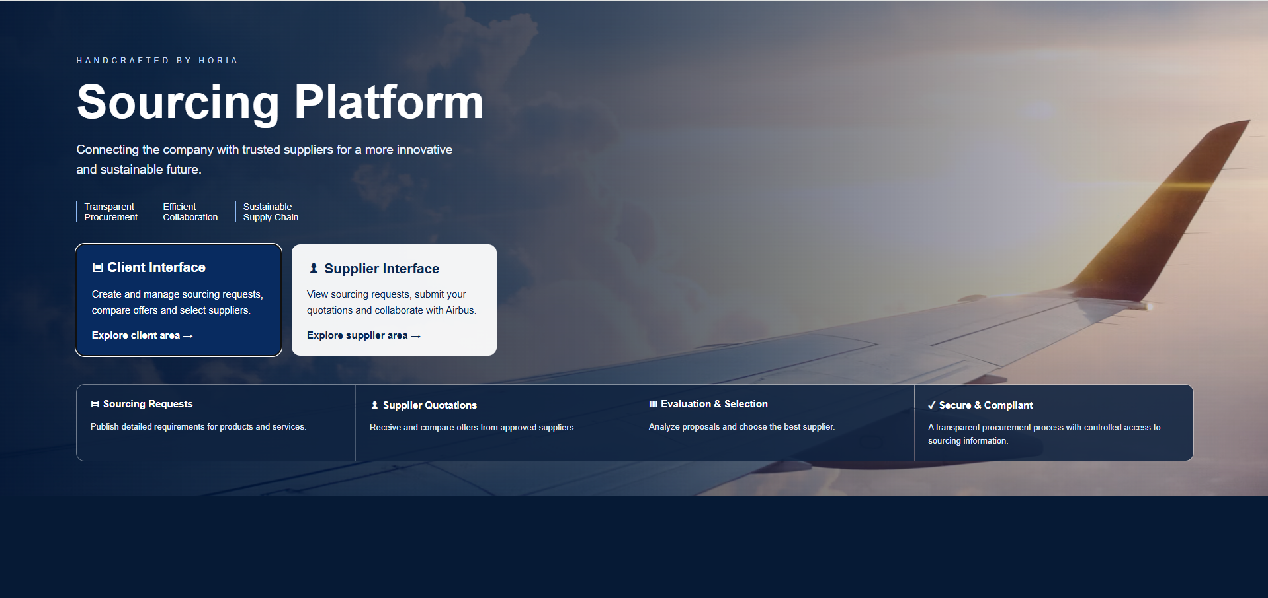
Figure 1. Platform landing page
The landing page introduces the sourcing platform and provides separate entry points for the client and supplier areas. It also summarizes the main sourcing workflow.
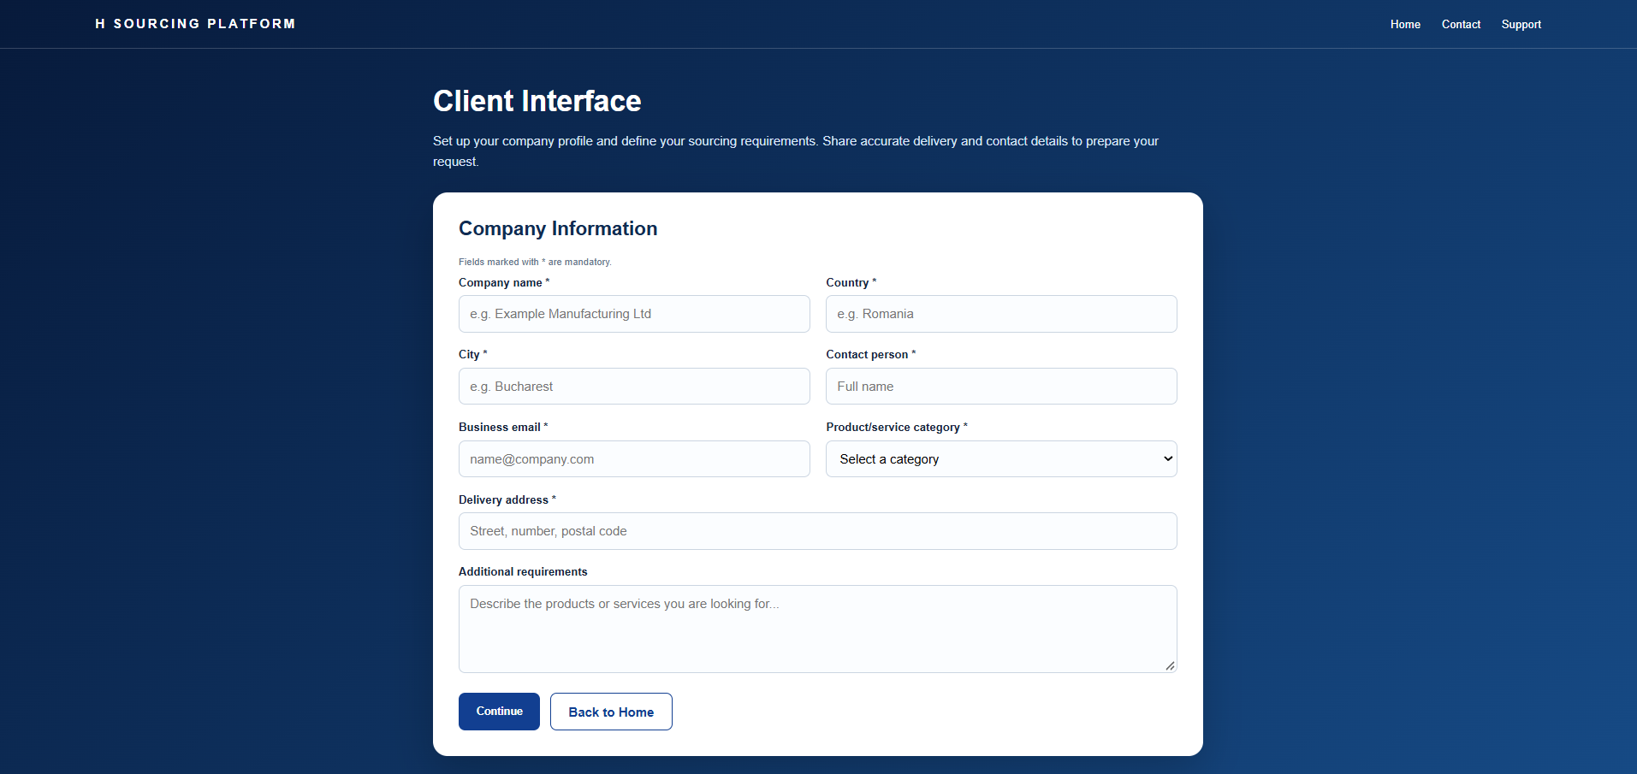
Figure 2. Client interface
The client interface presents a company information form for entering company details, contact information, product or service category, delivery address, and additional requirements.
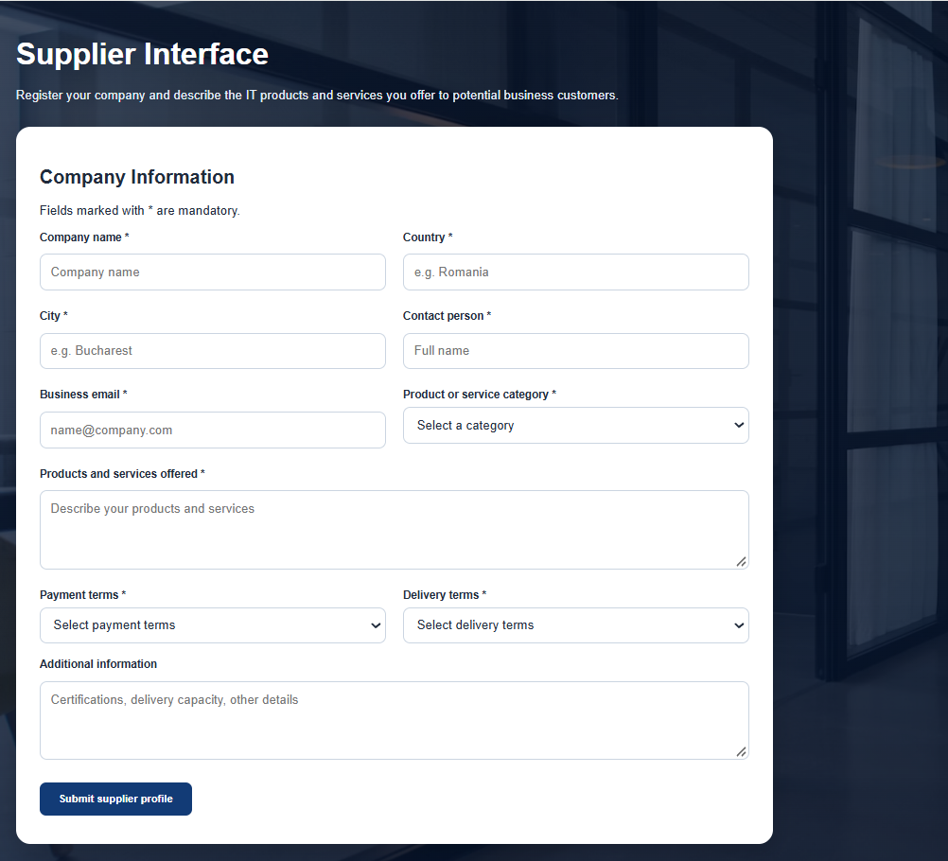
Figure 3. Supplier interface
The supplier interface presents a supplier profile form covering company details, offered products and services, payment terms, delivery terms, and additional information.

Future Development and Planned Implementation
The current version demonstrates the main visual areas of the sourcing workflow. A planned next development step is to implement a complete account creation and authentication area for both clients and suppliers.

Account creation and user access
- Create separate registration flows for client companies and supplier companies.
- Allow users to create an account using an email address and a secure password.
- Add email verification and password reset functionality.
- Associate each account with a company profile and the appropriate user role (client or supplier).
- Implement login and logout, session management, and role-based access restrictions.
- Provide account/profile management so users can update company and contact information.
- Add administrative approval or verification of supplier accounts before they can participate in sourcing events, if required by the business workflow.

Additional planned improvements
- Connect client sourcing requests with eligible supplier accounts and invitations.
- Enable suppliers to submit, edit, and track quotations for sourcing requests.
- Provide a structured comparison view for client users to evaluate submitted offers.
- Add notifications for invitations, quotation submissions, deadlines, and selection decisions.
- Strengthen validation, permissions, audit logging, and automated tests.
Implementation status: account creation and the related authentication workflow are planned features and should not be considered completed in the current version.

