Assignment 2 Documantation

Rusu Horia Gabriel

Group 30431

1. Database Diagram

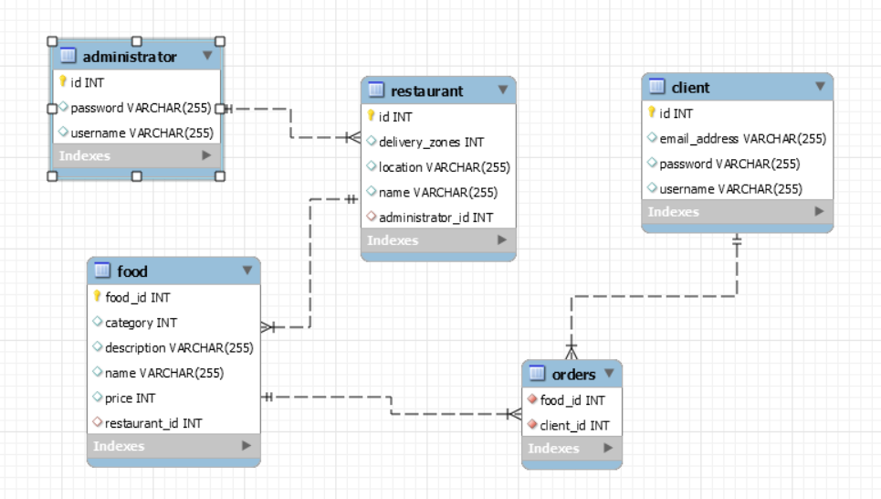

1. Use Case Diagram

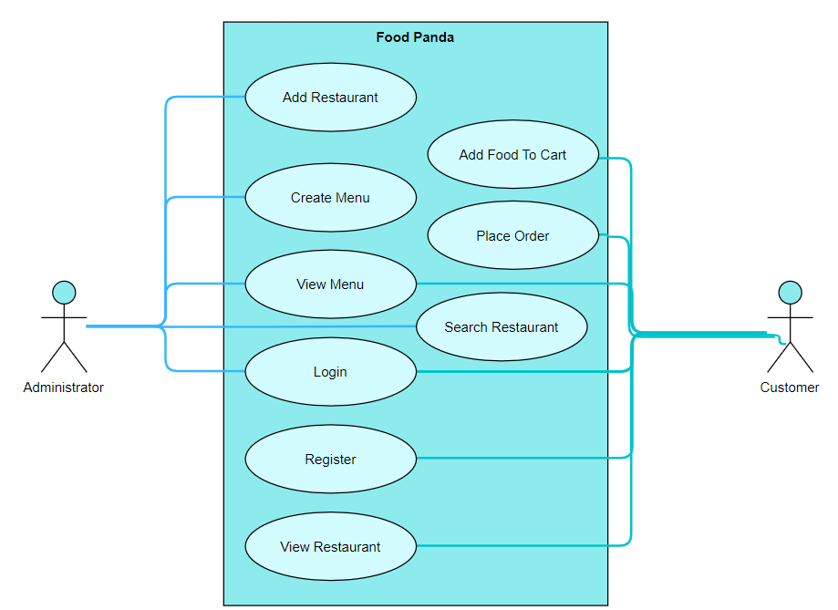

1. Class Diagram

