5CCS2INT – Introduction to Artificial Intelligence

EU Economics domain – modelling a basic economic environment with PDDL

Luca-Dorin Anton: k1764103 - 1710700

Horia Tudor Pavel-Simon: k1763970 - 1731038

**Description**

We have modelled the basic EU structure with six countries. Extending the number of countries results in different behaviour, so our approach is characterised by adding one country at a time and observe the changes. As the number of countries increases, the planner needs more steps to compute the optimal solution. Trades between countries are made, economies and funds grow and hence the quality of life is boosted.

**Problem files**

We defined a set of problem files, each one according to several countries in the European Union. Our problem file space includes eleven different challenges for the planner to solve. The problem files are sorted according to their difficulty.

**Planner**

We have used exclusively Optic for Windows. It gave us relevant and informative output for our problem files. For more information please refer to the *statistics* section below.

**Statistics**

We can observe that the cost increases with the number of countries. However, it has regions where it stagnates. This happens because in our domain, if there are more countries, this means more opportunities for trading, some of them resulting in lower prices and thus less overhead. Whenever the European Union grows in the number of countries, the economic & quality of life thresholds are achieved much more rapidly.

1. **Number of countries / cost**

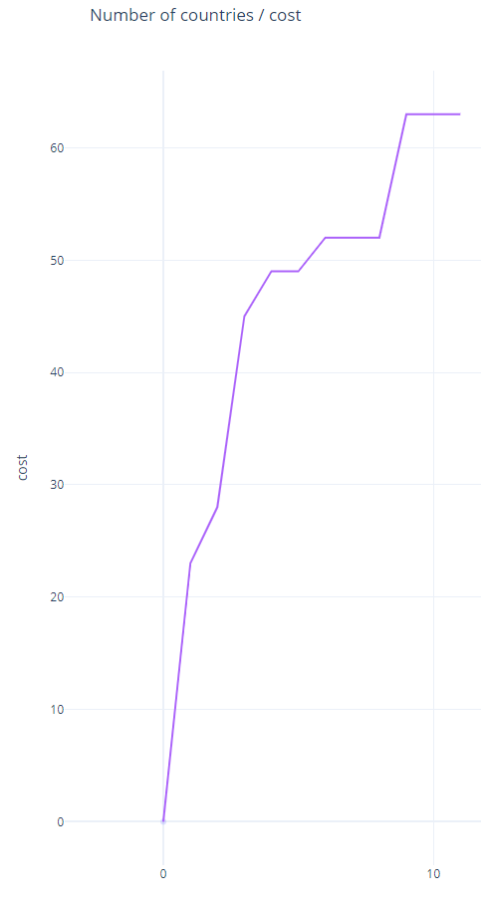 As we can see in this figure the planner increases its cost of work only at times where the new country added creates overhead.

We say that a new country ‘helps’ the EU, if it’s inclusion in the economic area, doesn’t increase the overall cost of the algorithm.

This means that the new country added was the ‘best deal’ for that current state of the European Union.

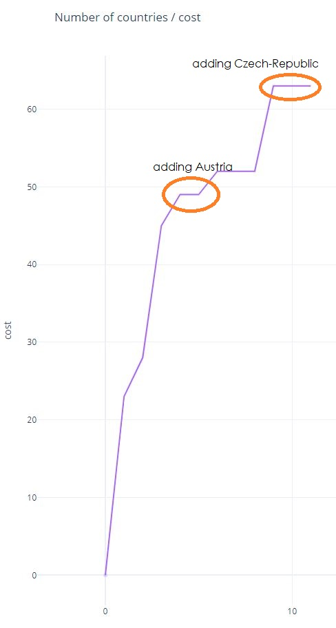

***figure 1.***

As you can see from ***figure 2,*** including Austria and Czech-Republic will not affect the cost of achieving the desired result.

We call Austria and Czech-Republic to be ‘best deals’ at their time of inclusion in the EU.

***figure 2.***

1. **Number of countries in the problem file / Number of states evaluated**

As we have analysed in the previous section, adding a new country to the EU, may result in a stagnation of cost within the planning process. This is not the case when considering the states explored by the planner.

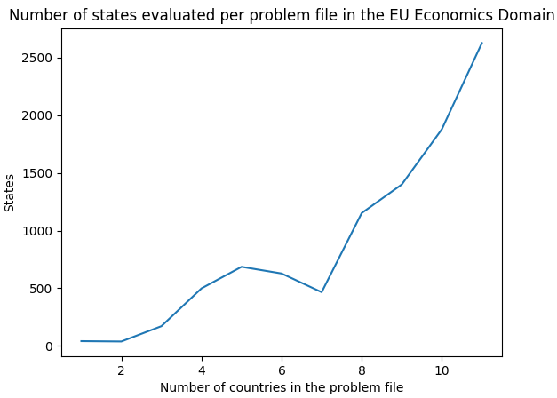

***figure 3.***

In figure 3, we it is clear enough that the number of states explored when EU has 5 countries is greater than the number of states explored when EU has 7 countries.

1. **Number of countries / time needed by the planner to find the solution**

Intuitively, the time will depend on the state space so the graph in *figure 4* will look similar to the one in *figure 3* as the inputs are proportional. The time decreases when we have 7 countries in the problem file and then it increases exponentially when more than 8 countries are in the EU.

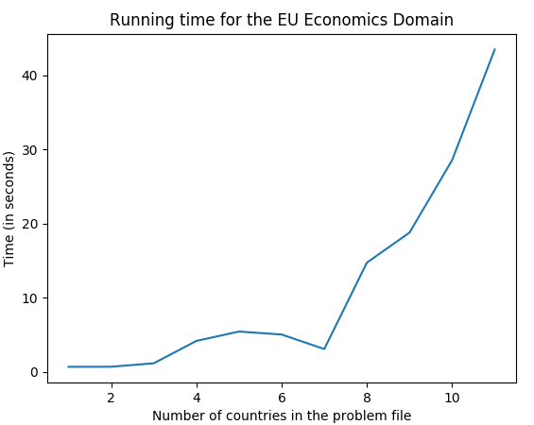

***figure 4.***

**Appendix:**problem1.pddl

; problem file -- includes only a template for

; how countries are going to be represented in

; their initial state.

;

; Problem file 1 - includes 1 EU countries

(define (problem problem2)

(:domain EU_economics)

(:objects Belgium - Country)

(:init

; -- Variables --

(=(resources-sector Belgium) 4) ; "resources": 4

(=(industry-sector Belgium) 108) ; "industry": 108

(=(services-sector Belgium) 400) ; "services": 400

(=(funds Belgium) 536) ; "funds": 536

(=(quality-of-life-index Belgium) 162) ; "quality-of-life-index": 162

; -- Constants --

(=(resources-price Belgium) 20) ; "resources": 20

(=(industry-price Belgium) 4) ; "industry": 4

(=(services-price Belgium) 2) ; "services": 2

(=(economy-growth-price Belgium) 30) ; "economy growth: " : 30

; -- Economy growth --

(=(resources-growth Belgium) 5) ; "resources": 5

(=(industry-growth Belgium) 10) ; "industry": 10

(=(services-growth Belgium) 15) ; "services": s15

; -- Quality of life growth --

(=(quality-index-resources-cost Belgium) 2) ; "resources": 2

(=(quality-index-industry-cost Belgium) 8) ; "industry": 8

(=(quality-index-services-cost Belgium) 12) ; "services": 12

;predicates initialised ; -- Biases --

(is-not-resources-biased Belgium) ; resources: false

(is-not-industry-biased Belgium) ; industry: false

(not(is-not-services-biased Belgium)) ; services: true

; -- Technical --

(is-not-growing-economy Belgium) ; "growing-eco": false

(is-not-growing-quality-of-life Belgium) ; "growing-quality-of-life": false

)

(:goal (and

(>= (quality-of-life-index Belgium) 190)

)

)

)

problem2.pddl

; problem file -- includes only a template for

; how countries are going to be represented in

; their initial state.

;

; Problem file 2 - includes 2 EU countries

(define (problem problem2)

(:domain EU_economics)

(:objects Belgium Germany - Country)

(:init

; -- Variables --

(=(resources-sector Belgium) 4) ; "resources": 4

(=(industry-sector Belgium) 108) ; "industry": 108

(=(services-sector Belgium) 400) ; "services": 400

(=(funds Belgium) 536) ; "funds": 536

(=(quality-of-life-index Belgium) 162) ; "quality-of-life-index": 162

; -- Constants --

(=(resources-price Belgium) 20) ; "resources": 20

(=(industry-price Belgium) 4) ; "industry": 4

(=(services-price Belgium) 2) ; "services": 2

(=(economy-growth-price Belgium) 30) ; "economy growth: " : 30

; -- Economy growth --

(=(resources-growth Belgium) 5) ; "resources": 5

(=(industry-growth Belgium) 10) ; "industry": 10

(=(services-growth Belgium) 15) ; "services": s15

; -- Quality of life growth --

(=(quality-index-resources-cost Belgium) 2) ; "resources": 2

(=(quality-index-industry-cost Belgium) 8) ; "industry": 8

(=(quality-index-services-cost Belgium) 12) ; "services": 12

;predicates initialised ; -- Biases --

(is-not-resources-biased Belgium) ; resources: false

(is-not-industry-biased Belgium) ; industry: false

(not(is-not-services-biased Belgium)) ; services: true

; -- Technical --

(is-not-growing-economy Belgium) ; "growing-eco": false

(is-not-growing-quality-of-life Belgium) ; "growing-quality-of-life": false

; -- Variables --

(=(resources-sector Germany) 1856) ; "resources": 1856

(=(industry-sector Germany) 1622) ; "industry": 1622

(=(services-sector Germany) 885) ; "services": 885

(=(funds Germany) 4029) ; "funds": 4029

(=(quality-of-life-index Germany) 187) ; "quality-of-life-index": 187

; -- Constants --

(=(resources-price Germany) 2) ; "resources": 2

(=(industry-price Germany) 2) ; "industry": 2

(=(services-price Germany) 15) ; "services": 15

(=(economy-growth-price Germany) 377) ; "economy growth: " : 377

; -- Economy growth --

(=(resources-growth Germany) 150) ; "resources": 150

(=(industry-growth Germany) 150) ; "industry": 150

(=(services-growth Germany) 100) ; "services": s100

; -- Quality of life growth --

(=(quality-index-resources-cost Germany) 126) ; "resources": 126

(=(quality-index-industry-cost Germany) 114) ; "industry": 114

(=(quality-index-services-cost Germany) 155) ; "services": 155

;predicates initialised ; -- Biases --

(not(is-not-resources-biased Germany)) ; resources: true

(is-not-industry-biased Germany) ; industry: false

(is-not-services-biased Germany) ; services: false

; -- Technical --

(is-not-growing-economy Germany) ; "growing-eco": false

(is-not-growing-quality-of-life Germany) ; "growing-quality-of-life": false

)

(:goal (and

(>= (quality-of-life-index Belgium) 190)

(>= (quality-of-life-index Germany) 190)

)

)

)

problem2.pddl cont’d

; -- Economy growth --

(=(resources-growth Germany) 150) ; "resources": 150

(=(industry-growth Germany) 150) ; "industry": 150

(=(services-growth Germany) 100) ; "services": s100

; -- Quality of life growth --

(=(quality-index-resources-cost Germany) 126) ; "resources": 126

(=(quality-index-industry-cost Germany) 114) ; "industry": 114

(=(quality-index-services-cost Germany) 155) ; "services": 155

;predicates initialised ; -- Biases --

(not(is-not-resources-biased Germany)) ; resources: true

(is-not-industry-biased Germany) ; industry: false

(is-not-services-biased Germany) ; services: false

; -- Technical --

(is-not-growing-economy Germany) ; "growing-eco": false

(is-not-growing-quality-of-life Germany) ; "growing-quality-of-life": false

)

(:goal (and

(>= (quality-of-life-index Belgium) 190)

(>= (quality-of-life-index Germany) 190)

)

)

)

problem11.pddl

; problem file -- includes only a template for

; how countries are going to be represented in

; their initial state.

;

; Problem file 2 - includes 2 EU countries

(define (problem problem2)

(:domain EU_economics)

(:objects Belgium Germany - Country)

(:init

; -- Variables --

(=(resources-sector Belgium) 4) ; "resources": 4

(=(industry-sector Belgium) 108) ; "industry": 108

(=(services-sector Belgium) 400) ; "services": 400

(=(funds Belgium) 536) ; "funds": 536

(=(quality-of-life-index Belgium) 162) ; "quality-of-life-index": 162

; -- Constants --

(=(resources-price Belgium) 20) ; "resources": 20

(=(industry-price Belgium) 4) ; "industry": 4

(=(services-price Belgium) 2) ; "services": 2

(=(economy-growth-price Belgium) 30) ; "economy growth: " : 30

; -- Economy growth --

(=(resources-growth Belgium) 5) ; "resources": 5

(=(industry-growth Belgium) 10) ; "industry": 10

(=(services-growth Belgium) 15) ; "services": s15

; -- Quality of life growth --

(=(quality-index-resources-cost Belgium) 2) ; "resources": 2

(=(quality-index-industry-cost Belgium) 8) ; "industry": 8

(=(quality-index-services-cost Belgium) 12) ; "services": 12

;predicates initialised ; -- Biases --

(is-not-resources-biased Belgium) ; resources: false

(is-not-industry-biased Belgium) ; industry: false

(not(is-not-services-biased Belgium)) ; services: true

; -- Technical --

(is-not-growing-economy Belgium) ; "growing-eco": false

(is-not-growing-quality-of-life Belgium) ; "growing-quality-of-life": false

; -- Variables --

(=(resources-sector Germany) 1856) ; "resources": 1856

(=(industry-sector Germany) 1622) ; "industry": 1622

(=(services-sector Germany) 885) ; "services": 885

(=(funds Germany) 4029) ; "funds": 4029

(=(quality-of-life-index Germany) 187) ; "quality-of-life-index": 187

; -- Constants --

(=(resources-price Germany) 2) ; "resources": 2

(=(industry-price Germany) 2) ; "industry": 2

(=(services-price Germany) 15) ; "services": 15

(=(economy-growth-price Germany) 377) ; "economy growth: " : 377

; -- Economy growth --

(=(resources-growth Germany) 150) ; "resources": 150

(=(industry-growth Germany) 150) ; "industry": 150

(=(services-growth Germany) 100) ; "services": s100

; -- Quality of life growth --

(=(quality-index-resources-cost Germany) 126) ; "resources": 126

(=(quality-index-industry-cost Germany) 114) ; "industry": 114

(=(quality-index-services-cost Germany) 155) ; "services": 155

;predicates initialised ; -- Biases --

(not(is-not-resources-biased Germany)) ; resources: true

(is-not-industry-biased Germany) ; industry: false

(is-not-services-biased Germany) ; services: false

; -- Technical --

(is-not-growing-economy Germany) ; "growing-eco": false

(is-not-growing-quality-of-life Germany) ; "growing-quality-of-life": false

)

(:goal (and

(>= (quality-of-life-index Belgium) 190)

(>= (quality-of-life-index Germany) 190)

)

)

)

problem11.pddl cont’d

; -- Economy growth --

(=(resources-growth Germany) 150) ; "resources": 150

(=(industry-growth Germany) 150) ; "industry": 150

(=(services-growth Germany) 100) ; "services": s100

; -- Quality of life growth --

(=(quality-index-resources-cost Germany) 126) ; "resources": 126

(=(quality-index-industry-cost Germany) 114) ; "industry": 114

(=(quality-index-services-cost Germany) 155) ; "services": 155

;predicates initialised ; -- Biases --

(not(is-not-resources-biased Germany)) ; resources: true

(is-not-industry-biased Germany) ; industry: false

(is-not-services-biased Germany) ; services: false

; -- Technical --

(is-not-growing-economy Germany) ; "growing-eco": false

(is-not-growing-quality-of-life Germany) ; "growing-quality-of-life": false

; -- Variables --

(=(resources-sector France) 1254) ; "resources": 1254

(=(industry-sector France) 1126) ; "industry": 1126

(=(services-sector France) 809) ; "services": 809

(=(funds France) 2795) ; "funds": 2795

(=(quality-of-life-index France) 158) ; "quality-of-life-index": 158

; -- Constants --

(=(resources-price France) 2) ; "resources": 2

(=(industry-price France) 3) ; "industry": 3

(=(services-price France) 12) ; "services": 12

(=(economy-growth-price France) 154) ; "economy growth: " : 154

; -- Economy growth --

(=(resources-growth France) 100) ; "resources": 100

(=(industry-growth France) 100) ; "industry": 100

(=(services-growth France) 71) ; "services": s71

; -- Quality of life growth --

(=(quality-index-resources-cost France) 45) ; "resources": 45

(=(quality-index-industry-cost France) 55) ; "industry": 55

(=(quality-index-services-cost France) 62) ; "services": 62

;predicates initialised ; -- Biases --

(not(is-not-resources-biased France)) ; resources: true

(not(is-not-industry-biased France)) ; industry: true

(is-not-services-biased France) ; services: false

; -- Technical --

(is-not-growing-economy France) ; "growing-eco": false

(is-not-growing-quality-of-life France) ; "growing-quality-of-life": false

; -- Variables --

(=(resources-sector Italy) 703) ; "resources": 703

(=(industry-sector Italy) 1208) ; "industry": 1208

(=(services-sector Italy) 602) ; "services": 602

(=(funds Italy) 2087) ; "funds": 2087

(=(quality-of-life-index Italy) 146) ; "quality-of-life-index": 146

; -- Constants --

(=(resources-price Italy) 7) ; "resources": 7

(=(industry-price Italy) 2) ; "industry": 2

(=(services-price Italy) 8) ; "services": 8

(=(economy-growth-price Italy) 70) ; "economy growth: " : 70

; -- Economy growth --

(=(resources-growth Italy) 42) ; "resources": 42

(=(industry-growth Italy) 88) ; "industry": 88

(=(services-growth Italy) 23) ; "services": s23

; -- Quality of life growth --

(=(quality-index-resources-cost Italy) 40) ; "resources": 40

(=(quality-index-industry-cost Italy) 50) ; "industry": 50

(=(quality-index-services-cost Italy) 31) ; "services": 31

problem11.pddl cont’d

; -- Constants --

(=(resources-price Italy) 7) ; "resources": 7

(=(industry-price Italy) 2) ; "industry": 2

(=(services-price Italy) 8) ; "services": 8

(=(economy-growth-price Italy) 70) ; "economy growth: " : 70

; -- Economy growth --

(=(resources-growth Italy) 42) ; "resources": 42

(=(industry-growth Italy) 88) ; "industry": 88

(=(services-growth Italy) 23) ; "services": s23

; -- Quality of life growth --

(=(quality-index-resources-cost Italy) 40) ; "resources": 40

(=(quality-index-industry-cost Italy) 50) ; "industry": 50

(=(quality-index-services-cost Italy) 31) ; "services": 31

;predicates initialised ; -- Biases --

(is-not-resources-biased Italy) ; resources: false

(is-not-industry-biased Italy) ; industry: false

(not(is-not-services-biased Italy)) ; services: true

; -- Technical --

(is-not-growing-economy Italy) ; "growing-eco": false

(is-not-growing-quality-of-life Italy) ; "growing-quality-of-life": false

; -- Variables --

(=(resources-sector Luxembourg) 22) ; "resources": 22

(=(industry-sector Luxembourg) 28) ; "industry": 28

(=(services-sector Luxembourg) 46) ; "services": 46

(=(funds Luxembourg) 69) ; "funds": 69

(=(quality-of-life-index Luxembourg) 181) ; "quality-of-life-index": 181

; -- Constants --

(=(resources-price Luxembourg) 2) ; "resources": 2

(=(industry-price Luxembourg) 2) ; "industry": 2

(=(services-price Luxembourg) 2) ; "services": 2

(=(economy-growth-price Luxembourg) 5) ; "economy growth: " : 5

; -- Economy growth --

(=(resources-growth Luxembourg) 2) ; "resources": 2

(=(industry-growth Luxembourg) 3) ; "industry": 3

(=(services-growth Luxembourg) 2) ; "services": s2

; -- Quality of life growth --

(=(quality-index-resources-cost Luxembourg) 4) ; "resources": 4

(=(quality-index-industry-cost Luxembourg) 4) ; "industry": 4

(=(quality-index-services-cost Luxembourg) 4) ; "services": 4

;predicates initialised ; -- Biases --

(is-not-resources-biased Luxembourg) ; resources: false

(is-not-industry-biased Luxembourg) ; industry: false

(is-not-services-biased Luxembourg) ; services: false

; -- Technical --

(is-not-growing-economy Luxembourg) ; "growing-eco": false

(is-not-growing-quality-of-life Luxembourg) ; "growing-quality-of-life": false

; -- Variables --

(=(resources-sector Netherlands) 120) ; "resources": 120

(=(industry-sector Netherlands) 312) ; "industry": 312

(=(services-sector Netherlands) 540) ; "services": 540

(=(funds Netherlands) 910) ; "funds": 910

(=(quality-of-life-index Netherlands) 189) ; "quality-of-life-index": 189

; -- Constants --

(=(resources-price Netherlands) 11) ; "resources": 11

(=(industry-price Netherlands) 5) ; "industry": 5

(=(services-price Netherlands) 4) ; "services": 4

(=(economy-growth-price Netherlands) 25) ; "economy growth: " : 25

problem11.pddl cont’d

; -- Variables --

(=(resources-sector Netherlands) 120) ; "resources": 120

(=(industry-sector Netherlands) 312) ; "industry": 312

(=(services-sector Netherlands) 540) ; "services": 540

(=(funds Netherlands) 910) ; "funds": 910

(=(quality-of-life-index Netherlands) 189) ; "quality-of-life-index": 189

; -- Constants --

(=(resources-price Netherlands) 11) ; "resources": 11

(=(industry-price Netherlands) 5) ; "industry": 5

(=(services-price Netherlands) 4) ; "services": 4

(=(economy-growth-price Netherlands) 25) ; "economy growth: " : 25

; -- Economy growth --

(=(resources-growth Netherlands) 3) ; "resources": 3

(=(industry-growth Netherlands) 10) ; "industry": 10

(=(services-growth Netherlands) 15) ; "services": s15

; -- Quality of life growth --

(=(quality-index-resources-cost Netherlands) 15) ; "resources": 15

(=(quality-index-industry-cost Netherlands) 57) ; "industry": 57

(=(quality-index-services-cost Netherlands) 225) ; "services": 225

;predicates initialised ; -- Biases --

(is-not-resources-biased Netherlands) ; resources: false

(is-not-industry-biased Netherlands) ; industry: false

(not(is-not-services-biased Netherlands)) ; services: true

; -- Technical --

(is-not-growing-economy Netherlands) ; "growing-eco": false

(is-not-growing-quality-of-life Netherlands) ; "growing-quality-of-life": false

; -- Variables --

(=(resources-sector Austria) 7) ; "resources": 7

(=(industry-sector Austria) 14) ; "industry": 14

(=(services-sector Austria) 443) ; "services": 443

(=(funds Austria) 464) ; "funds": 464

(=(quality-of-life-index Austria) 191) ; "quality-of-life-index": 191

; -- Constants --

(=(resources-price Austria) 13) ; "resources": 13

(=(industry-price Austria) 5) ; "industry": 5

(=(services-price Austria) 1) ; "services": 1

(=(economy-growth-price Austria) 12) ; "economy growth: " : 12

; -- Economy growth --

(=(resources-growth Austria) 2) ; "resources": 2

(=(industry-growth Austria) 12) ; "industry": 12

(=(services-growth Austria) 24) ; "services": s24

; -- Quality of life growth --

(=(quality-index-resources-cost Austria) 5) ; "resources": 5

(=(quality-index-industry-cost Austria) 35) ; "industry": 35

(=(quality-index-services-cost Austria) 155) ; "services": 155

;predicates initialised ; -- Biases --

(is-not-resources-biased Austria) ; resources: false

(is-not-industry-biased Austria) ; industry: false

(not(is-not-services-biased Austria)) ; services: true

problem11.pddl cont’d

(is-not-resources-biased Austria) ; resources: false

(is-not-industry-biased Austria) ; industry: false

(not(is-not-services-biased Austria)) ; services: true

; -- Technical --

(is-not-growing-economy Austria) ; "growing-eco": false

(is-not-growing-quality-of-life Austria) ; "growing-quality-of-life": false

; -- Variables --

(=(resources-sector Bulgaria) 8) ; "resources": 8

(=(industry-sector Bulgaria) 45) ; "industry": 45

(=(services-sector Bulgaria) 110) ; "services": 110

(=(funds Bulgaria) 162) ; "funds": 162

(=(quality-of-life-index Bulgaria) 130) ; "quality-of-life-index": 130

; -- Constants --

(=(resources-price Bulgaria) 5) ; "resources": 5

(=(industry-price Bulgaria) 5) ; "industry": 5

(=(services-price Bulgaria) 4) ; "services": 4

(=(economy-growth-price Bulgaria) 3) ; "economy growth: " : 3

; -- Economy growth --

(=(resources-growth Bulgaria) 19) ; "resources": 19

(=(industry-growth Bulgaria) 25) ; "industry": 25

(=(services-growth Bulgaria) 32) ; "services": s32

; -- Quality of life growth --

(=(quality-index-resources-cost Bulgaria) 18) ; "resources": 18

(=(quality-index-industry-cost Bulgaria) 24) ; "industry": 24

(=(quality-index-services-cost Bulgaria) 31) ; "services": 31

;predicates initialised ; -- Biases --

(is-not-resources-biased Bulgaria) ; resources: false

(is-not-industry-biased Bulgaria) ; industry: false

(is-not-services-biased Bulgaria) ; services: false

; -- Technical --

(is-not-growing-economy Bulgaria) ; "growing-eco": false

(is-not-growing-quality-of-life Bulgaria) ; "growing-quality-of-life": false

; -- Variables --

(=(resources-sector Croatia) 187) ; "resources": 187

(=(industry-sector Croatia) 249) ; "industry": 249

(=(services-sector Croatia) 357) ; "services": 357

(=(funds Croatia) 290) ; "funds": 290

(=(quality-of-life-index Croatia) 165) ; "quality-of-life-index": 165

; -- Constants --

(=(resources-price Croatia) 8) ; "resources": 8

(=(industry-price Croatia) 5) ; "industry": 5

(=(services-price Croatia) 4) ; "services": 4

(=(economy-growth-price Croatia) 3) ; "economy growth: " : 3

; -- Economy growth --

(=(resources-growth Croatia) 6) ; "resources": 6

(=(industry-growth Croatia) 6) ; "industry": 6

(=(services-growth Croatia) 8) ; "services": s8

; -- Quality of life growth --

(=(quality-index-resources-cost Croatia) 9) ; "resources": 9

(=(quality-index-industry-cost Croatia) 10) ; "industry": 10

(=(quality-index-services-cost Croatia) 14) ; "services": 14

problem11.pddl cont’d

; -- Quality of life growth --

(=(quality-index-resources-cost Croatia) 9) ; "resources": 9

(=(quality-index-industry-cost Croatia) 10) ; "industry": 10

(=(quality-index-services-cost Croatia) 14) ; "services": 14

;predicates initialised ; -- Biases --

(is-not-resources-biased Croatia) ; resources: false

(is-not-industry-biased Croatia) ; industry: false

(is-not-services-biased Croatia) ; services: false

; -- Technical --

(is-not-growing-economy Croatia) ; "growing-eco": false

(is-not-growing-quality-of-life Croatia) ; "growing-quality-of-life": false

; -- Variables --

(=(resources-sector Cyprus) 12) ; "resources": 12

(=(industry-sector Cyprus) 24) ; "industry": 24

(=(services-sector Cyprus) 45) ; "services": 45

(=(funds Cyprus) 65) ; "funds": 65

(=(quality-of-life-index Cyprus) 152) ; "quality-of-life-index": 152

; -- Constants --

(=(resources-price Cyprus) 7) ; "resources": 7

(=(industry-price Cyprus) 6) ; "industry": 6

(=(services-price Cyprus) 6) ; "services": 6

(=(economy-growth-price Cyprus) 1) ; "economy growth: " : 1

; -- Economy growth --

(=(resources-growth Cyprus) 3) ; "resources": 3

(=(industry-growth Cyprus) 4) ; "industry": 4

(=(services-growth Cyprus) 5) ; "services": s5

; -- Quality of life growth --

(=(quality-index-resources-cost Cyprus) 1) ; "resources": 1

(=(quality-index-industry-cost Cyprus) 1) ; "industry": 1

(=(quality-index-services-cost Cyprus) 1) ; "services": 1

;predicates initialised ; -- Biases --

(is-not-resources-biased Cyprus) ; resources: false

(is-not-industry-biased Cyprus) ; industry: false

(is-not-services-biased Cyprus) ; services: false

; -- Technical --

(is-not-growing-economy Cyprus) ; "growing-eco": false

(is-not-growing-quality-of-life Cyprus) ; "growing-quality-of-life": false

; -- Variables --

(=(resources-sector Czech-Republic) 150) ; "resources": 150

(=(industry-sector Czech-Republic) 321) ; "industry": 321

(=(services-sector Czech-Republic) 679) ; "services": 679

(=(funds Czech-Republic) 475) ; "funds": 475

(=(quality-of-life-index Czech-Republic) 159) ; "quality-of-life-index": 159

; -- Constants --

(=(resources-price Czech-Republic) 9) ; "resources": 9

(=(industry-price Czech-Republic) 4) ; "industry": 4

(=(services-price Czech-Republic) 6) ; "services": 6

(=(economy-growth-price Czech-Republic) 12) ; "economy growth: " : 12

; -- Economy growth --

(=(resources-growth Czech-Republic) 9) ; "resources": 9

(=(industry-growth Czech-Republic) 26) ; "industry": 26

(=(services-growth Czech-Republic) 11) ; "services": s11

problem11.pddl cont’d

(=(economy-growth-price Czech-Republic) 12) ; "economy growth: " : 12

; -- Economy growth --

(=(resources-growth Czech-Republic) 9) ; "resources": 9

(=(industry-growth Czech-Republic) 26) ; "industry": 26

(=(services-growth Czech-Republic) 11) ; "services": s11

; -- Quality of life growth --

(=(quality-index-resources-cost Czech-Republic) 9) ; "resources": 9

(=(quality-index-industry-cost Czech-Republic) 19) ; "industry": 19

(=(quality-index-services-cost Czech-Republic) 20) ; "services": 20

;predicates initialised ; -- Biases --

(is-not-resources-biased Czech-Republic) ; resources: false

(not(is-not-industry-biased Czech-Republic)) ; industry: true

(is-not-services-biased Czech-Republic) ; services: false

; -- Technical --

(is-not-growing-economy Czech-Republic) ; "growing-eco": false

(is-not-growing-quality-of-life Czech-Republic) ; "growing-quality-of-life": false

)

(:goal (and

(>= (quality-of-life-index Belgium) 190)

(>= (quality-of-life-index Germany) 190)

(>= (quality-of-life-index France) 190)

(>= (quality-of-life-index Italy) 190)

(>= (quality-of-life-index Luxembourg) 190)

(>= (quality-of-life-index Netherlands) 190)

(>= (quality-of-life-index Austria) 190)

(>= (quality-of-life-index Bulgaria) 190)

(>= (quality-of-life-index Croatia) 190)

(>= (quality-of-life-index Cyprus) 190)

(>= (quality-of-life-index Czech-Republic) 190)

)

)

)