Data Analysis for Investments Prof. Zhou
HW 2 (2 pages)
Problem I): (for Lecture 3)

Bases on the program L3_Allocation5.ipynb (you have to make some changes) and the data, Indu10_July26_July11.xlsx, answer the following questions:
- With the same risk aversion parameter 3, what are the optimal portfolio weights on the 10 industry assets?

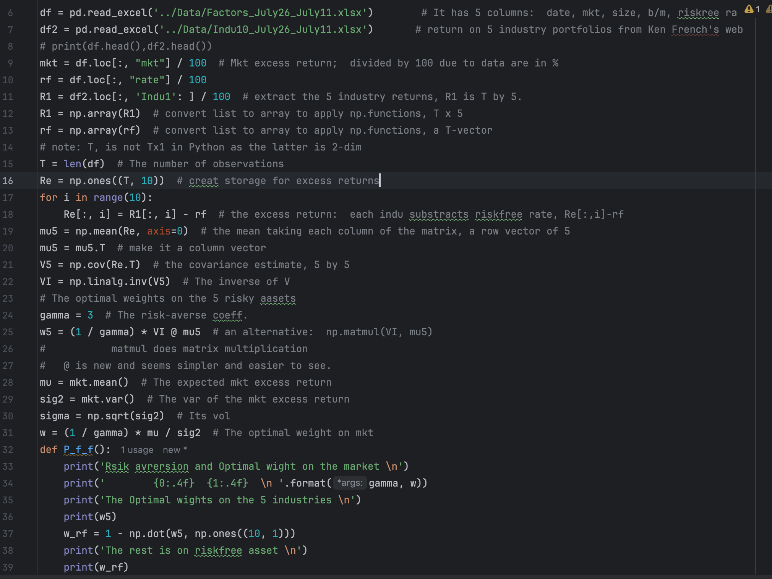

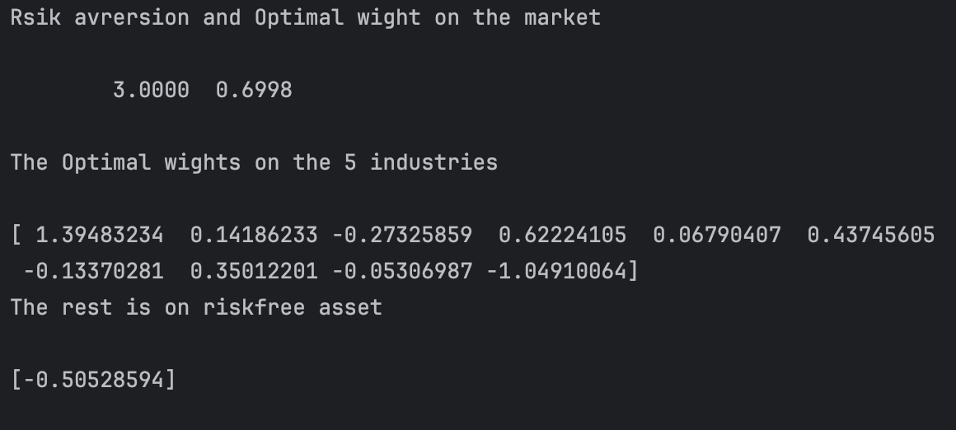

2) What are the mean, std and Sharpe ratio of the optimal portfolio?

3) What are the mean, std and Sharpe ratio of the mkt index portfolio?

4) What are the accumulative returns of investing $1 into the mkt index portfolio and the optimal portfolio respectively for the relevant time period?

5) (Optional) Compute the optimal weights in 1) recursively or more realistically by modifying L3_Allocation1_Recursive.ipynb.

6) (Optional) Compute the accumulative return with use of the optimal weights in 5).

Problem II):

- (optional) Read Cochrane (2007, 2014) for further understanding of the mean-variance portfolio theory.

Problem III): (for Lecture 4)

Bases on the program L4_Allocation5CC.ipynb (you have to make some changes) and the data, Indu10_July1926_July11.xlsx, answer the following questions:

1) With the same risk aversion parameter 3, what are the optimal portfolio weights on the 10 industry assets once we impose restrictions on the weights that they are nonnegative (no short sell) and be no greater than 30% (never invest more than 30% of your money into any of the assets)?

2) What are the mean, std and Sharpe ratio of the constrained optimal portfolio?

3) What are the mean, std and Sharpe ratio of the unconstrained optimal portfolio?

4) What are the mean, std and Sharpe ratio of the mkt index portfolio?

5) What are the accumulative returns of investing $1 into the mkt index portfolio, the constrained optimal portfolio, and the unconstrained optimal portfolio respectively for the relevant time period?

Problem IV): (optional)

- Read Grinold (1989) and Clarke, et al (2006) on the fundamental law.

- Read Dybvig and Pezzo (2019), and Novy-Marx_and Velikov (2015) about transaction costs.

- Read DeMiguel et al (2009), Tu and Zhou (2011), Ao, Li, Zheng (2019), Pedersen, Babu, and Levine (2021), and Kan, et al (2022) on estimation errors.

