Data Analysis for Investments Prof. Zhou
HW 4

( only Problem I) of Part A requires turning-in )

Part A: for Lecture 7
Problem I):
Based on the program L7_PCA_Indu5.* (you have to make some changes) and the Indu10.* (the time length already matches), answer the following questions:
- What are the eigenvalues and eigenvectors of the sample covariance matrix ?

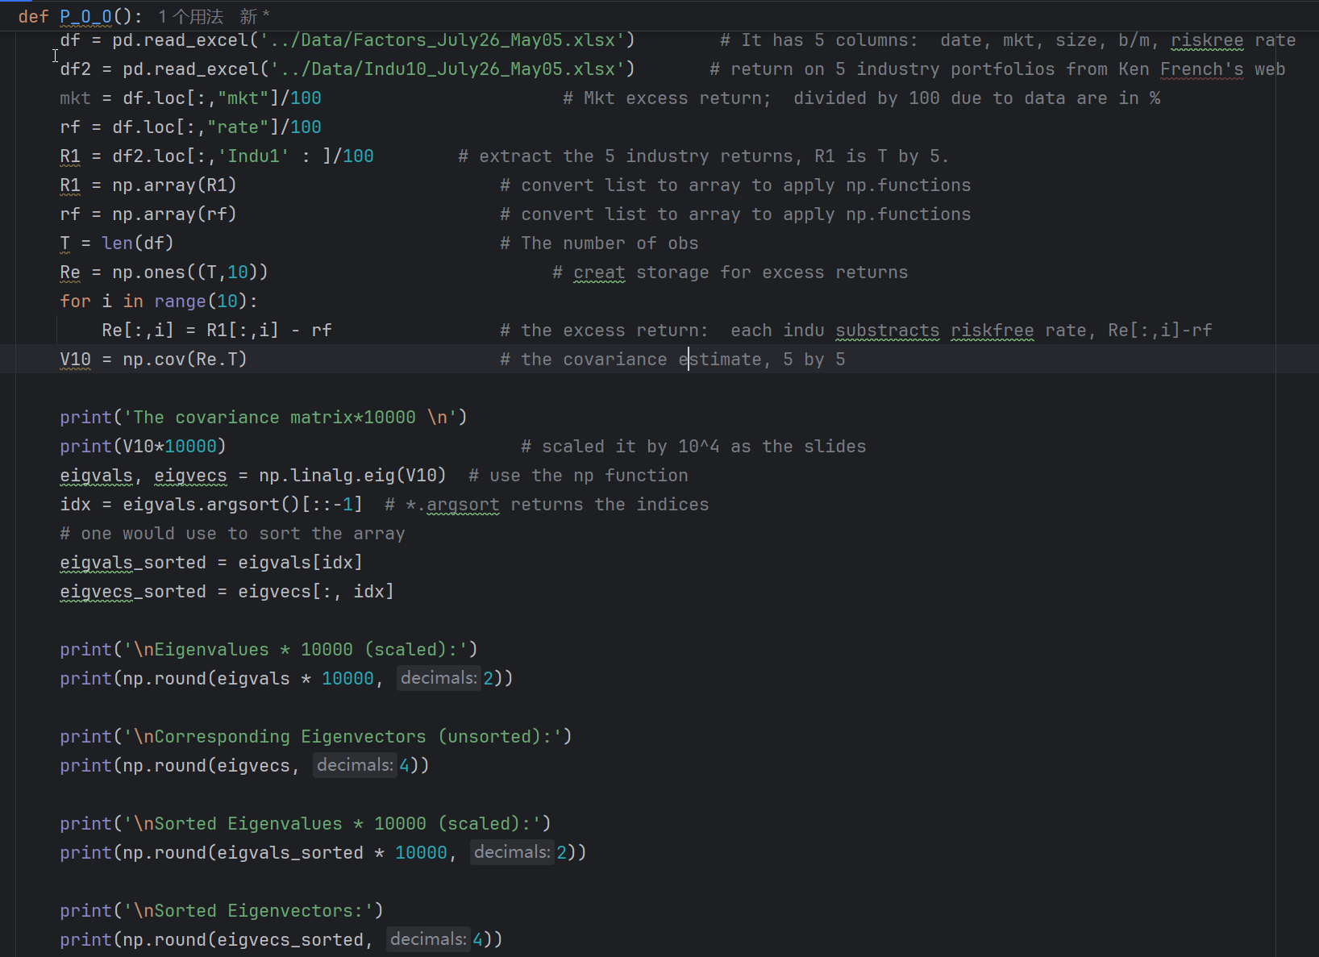

eigenvalues as below :

eigenvectors of the indu10 sample covariance matrix

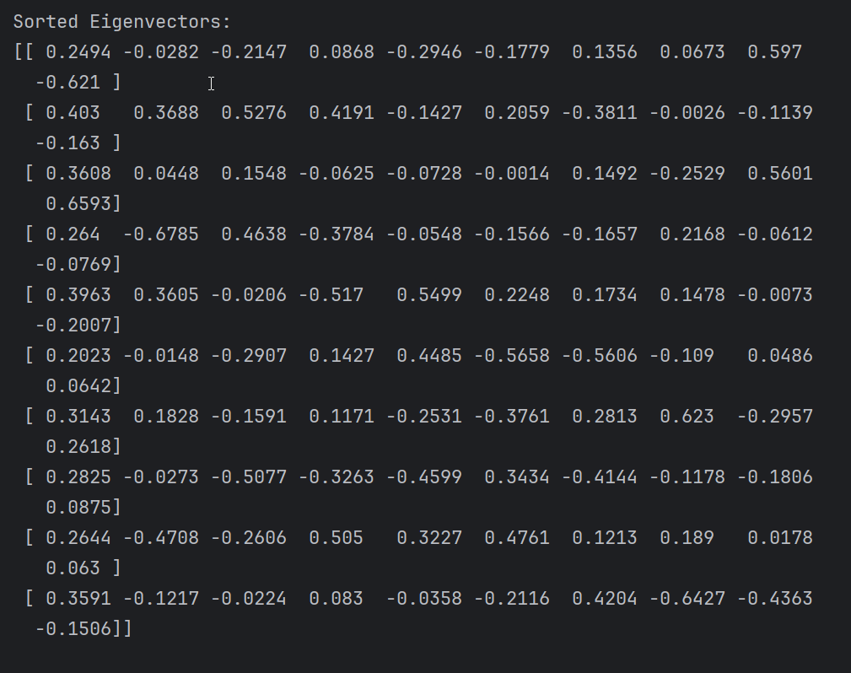

- Which are the coefficients for the first PCA?

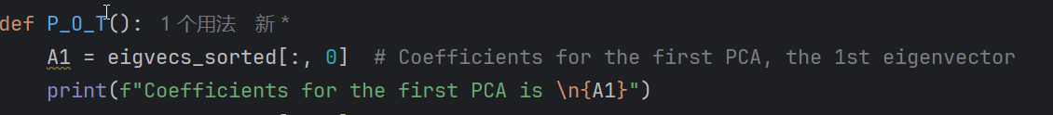

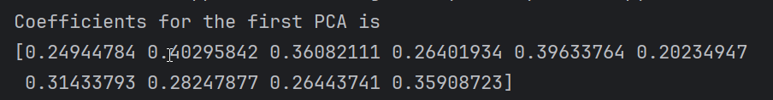

- What is the R-squared of the regression of the industry returns on the first PCA?

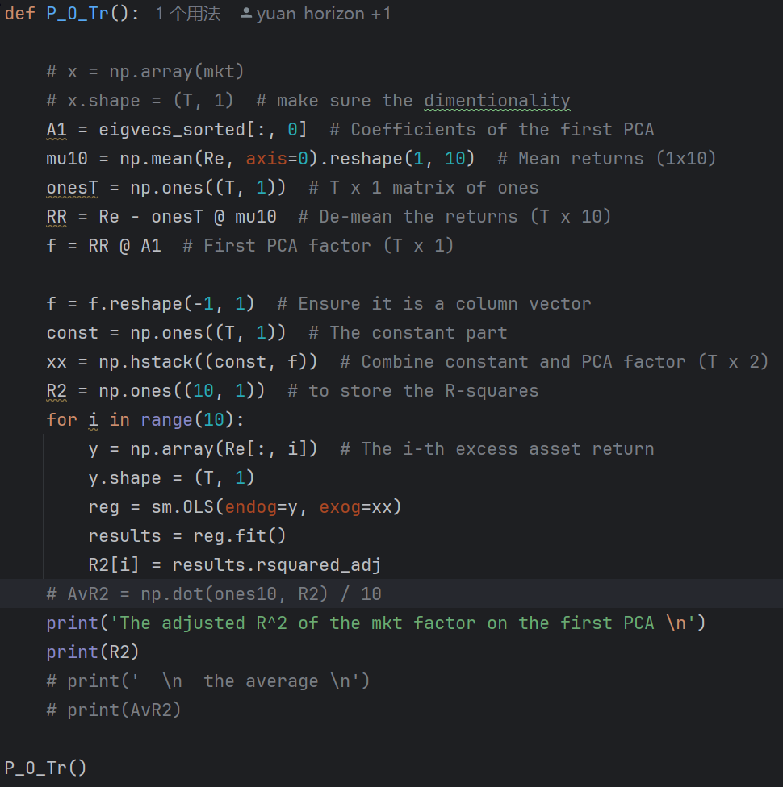

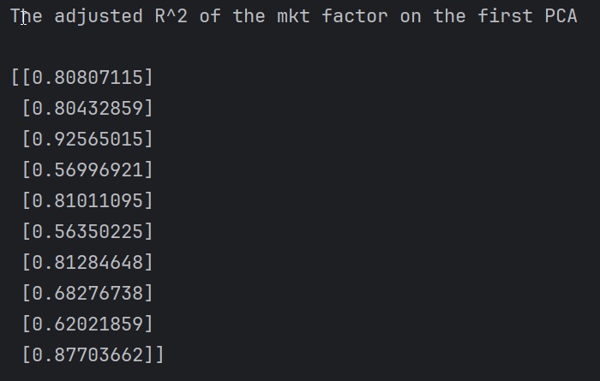

- In comparison with regression on the market index, is the PCA better or worse in terms of the value of the R-squared ?

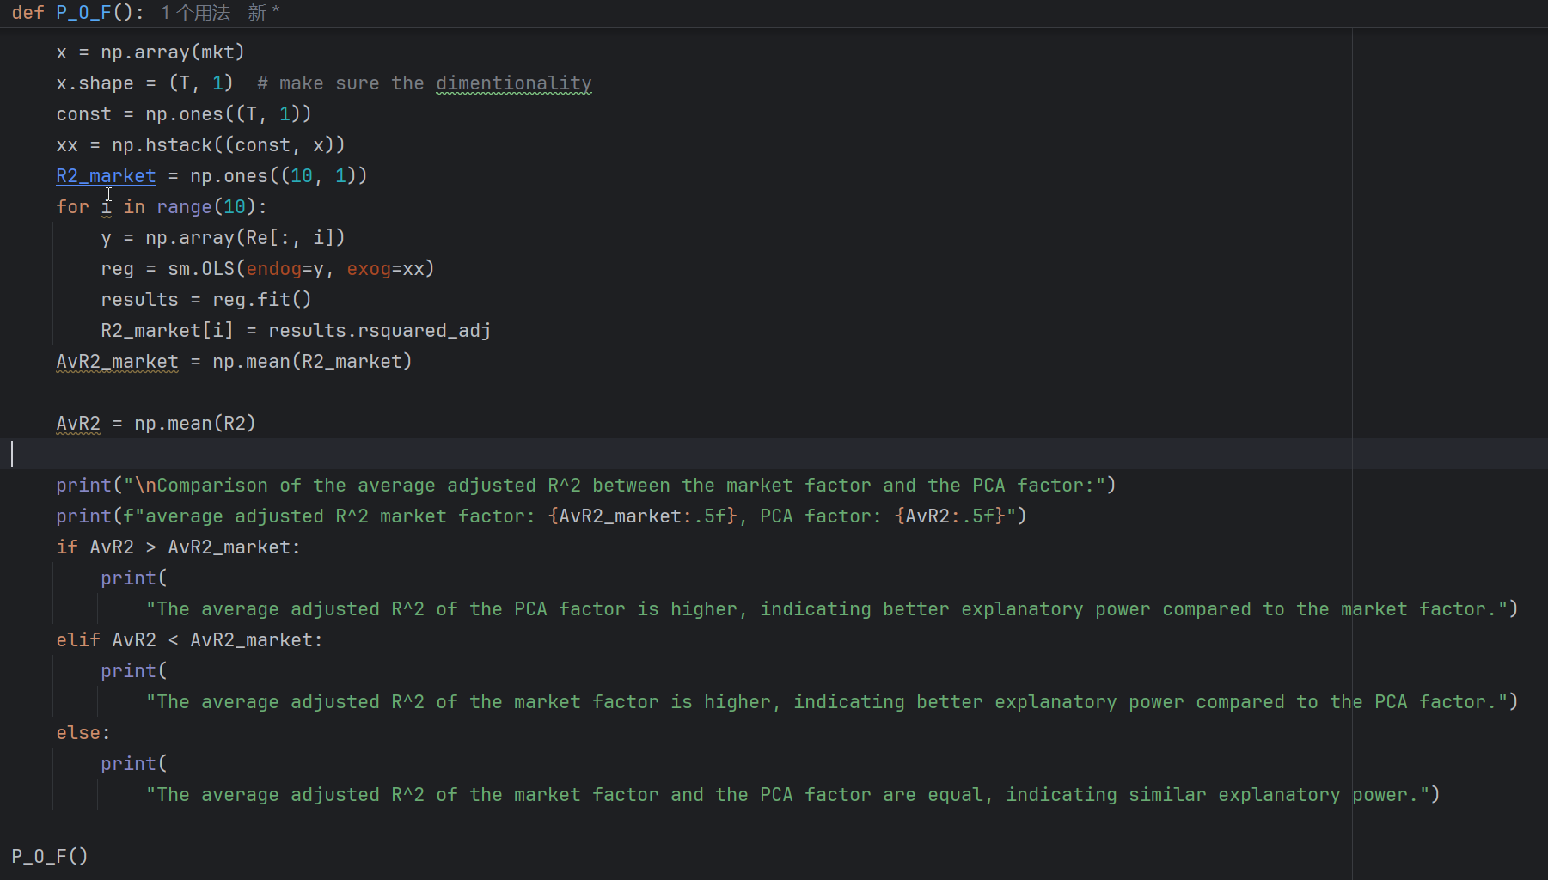

5）(optional) Check how well the PCA factor works for your favorite stocks.

