Data Analysis for Investments Prof. Zhou
HW 5
Part A: For Lecture 9
Problem I): Predictive regressions

- Get the returns on one of your favorite stocks (or use the IBM data if you do not have a stock in mind). Run a regression on the market, Rt on Rmkt,t. Verify that the beta is significant or not.
(Note: what you are doing is to use the mkt to explain your stock. If your stock is a large one, chances are the beta is significant)

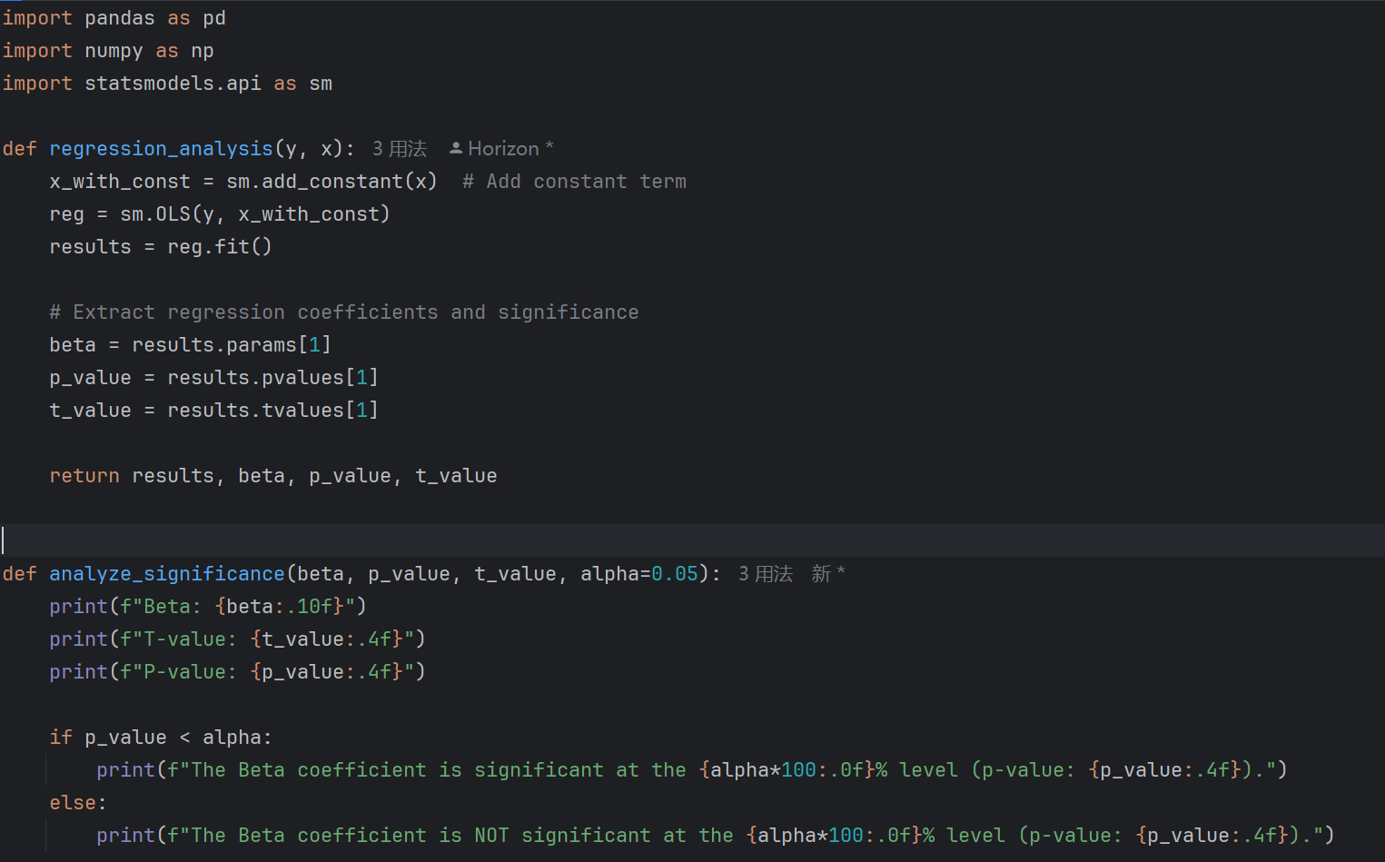

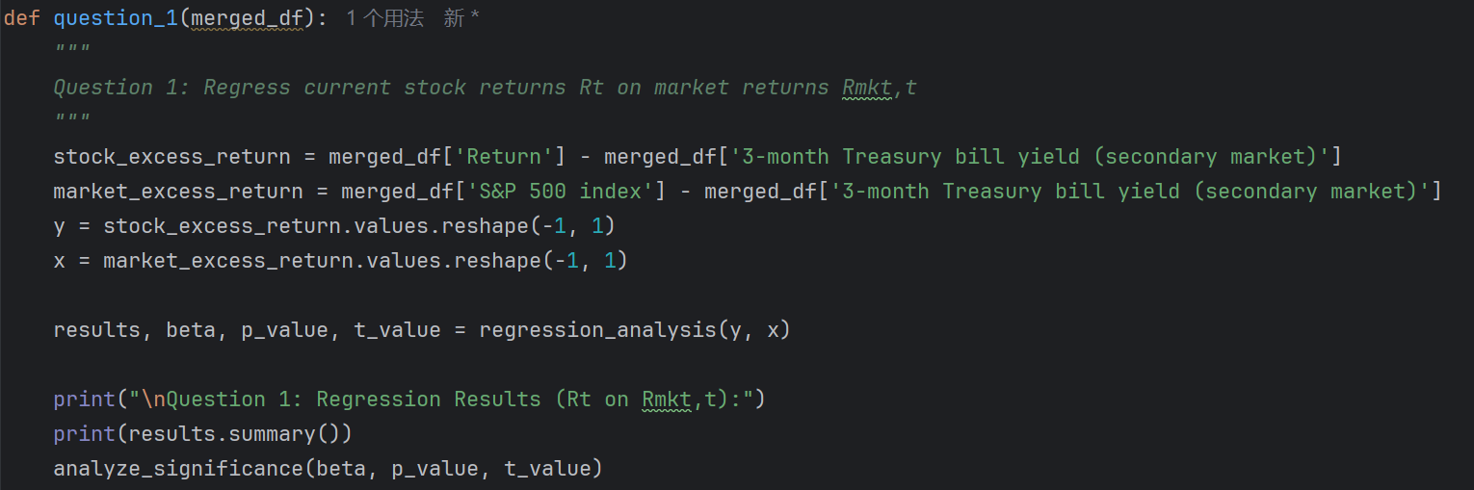
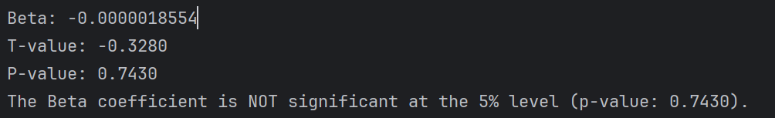

- Now you run a predictive regression of Rt on Rmkt,t-1. See if now the regression coefficient on the market, the predictive slope, is significant or not.
(Note: you use the mkt to predict the return on your stock. Chances are that the beta is insignificant)

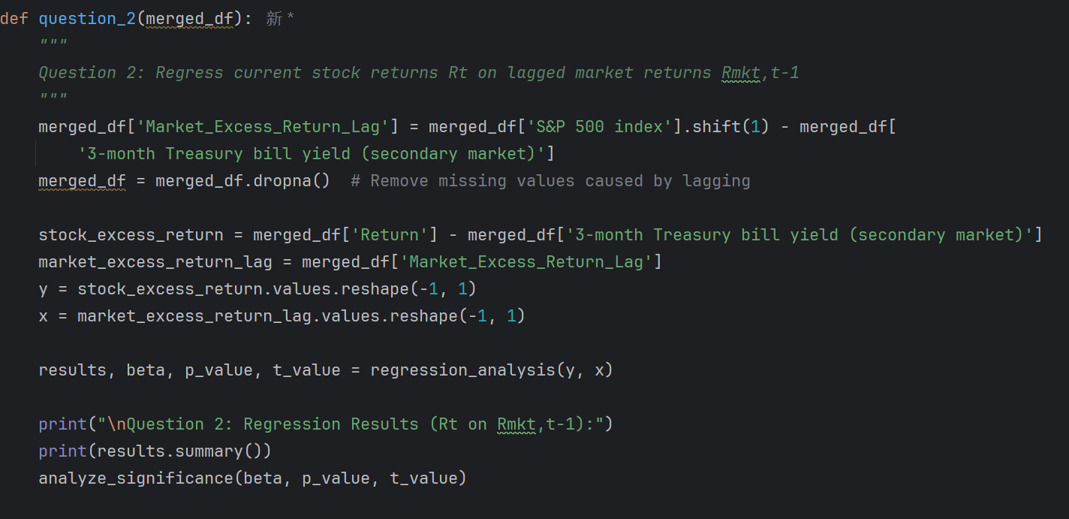

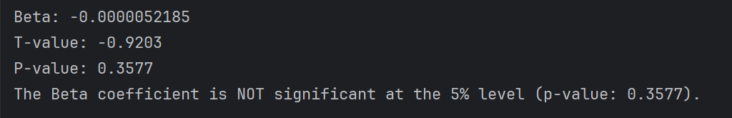
- Further, you run a predictive regression of Rt on Rt-1. See if now the regression coefficient on the market, the predictive slope, is significant or not.
(Note: when you use the past return to predict the future return on your stock. chances are that the beta is insignificant, highlighting the difficulty of prediction)
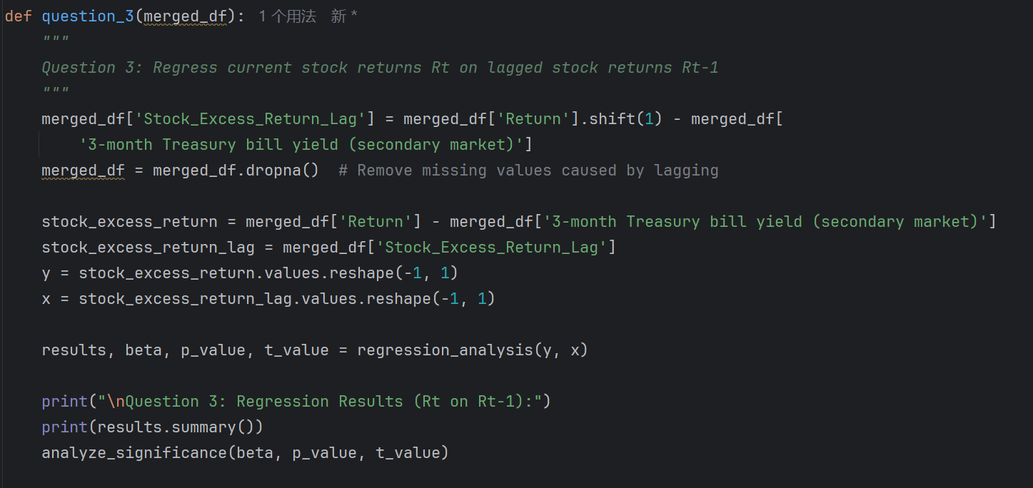

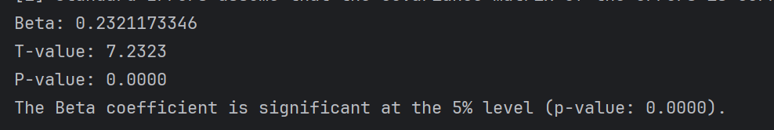

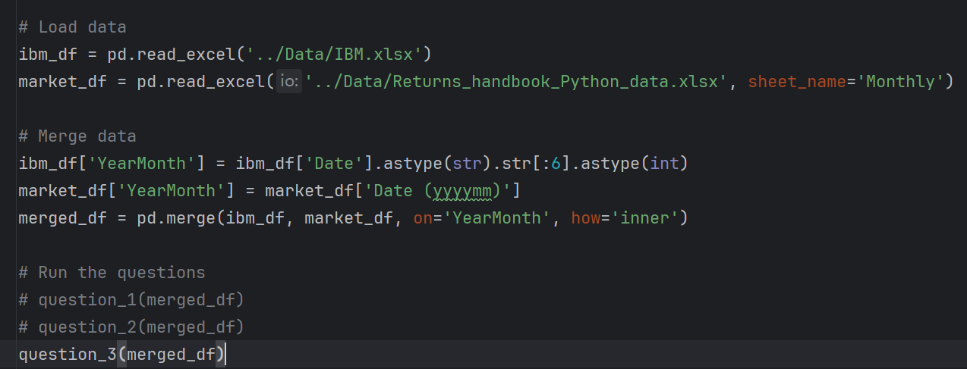

Problem II): (optional)

- (highly recommended) Get the data and Python code, from my web, for the review paper “Forecasting Stock Returns”, and run it, going over the details. Then you will be able to write a prediction paper yourself!

- (a challenge) write the Python code for the Random-feature bridge method, and compare the results with those from Question 1).

- Read Welch and Goyal (2008) and Rapach et al (2010) on early predictability studies.

- Read the review papers by Rapach and Zhou (2022) and Goyal, Welch and Zafirov (2023) on recent advances in time series.
Part B: For Lecture 10
Problem I):

- In the LASSO program, assume that the first three true coefficients are 1, 2, and -2, respectively, and the rest are zeros. See what happens.
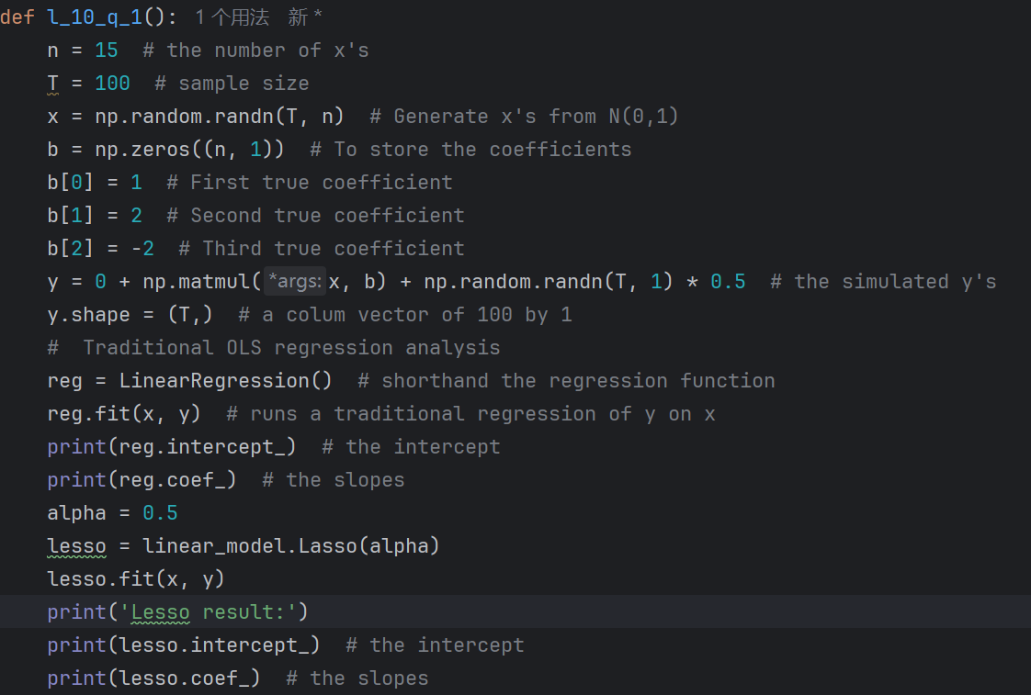

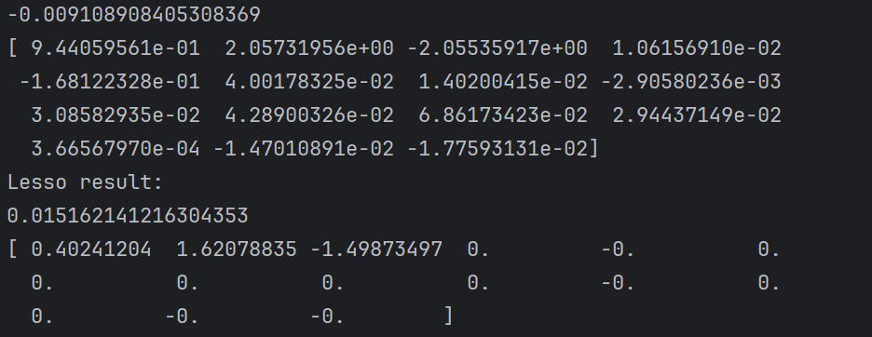

- What will the results be if you have n=20 instead of n=15?

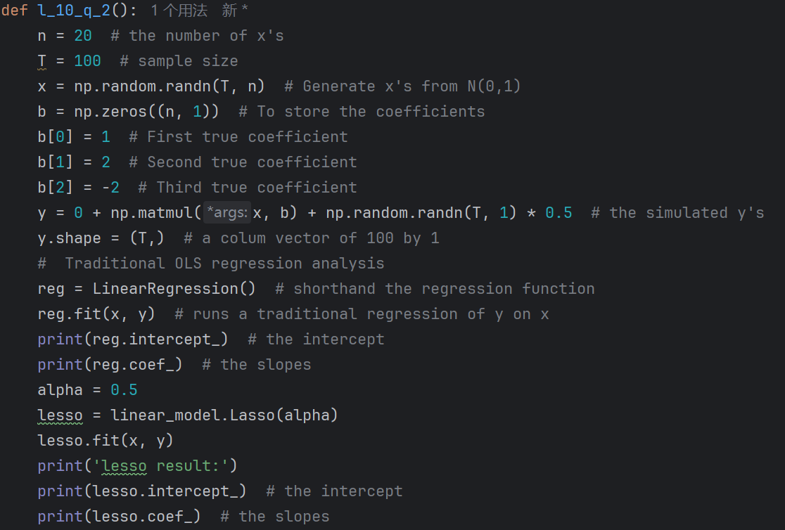

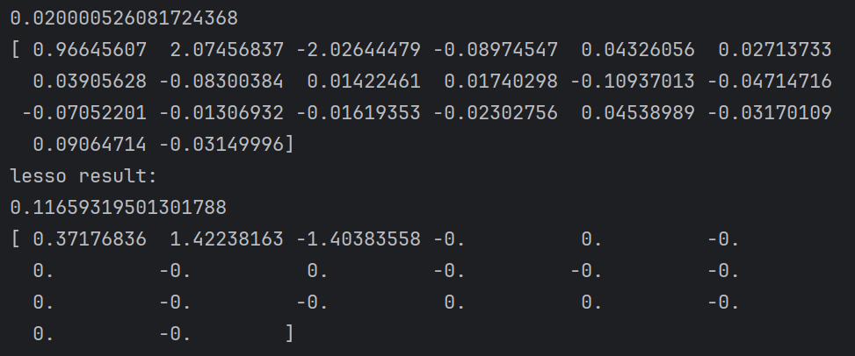

- Run the Ridge program with the above parameters and compare the results with Lasso.
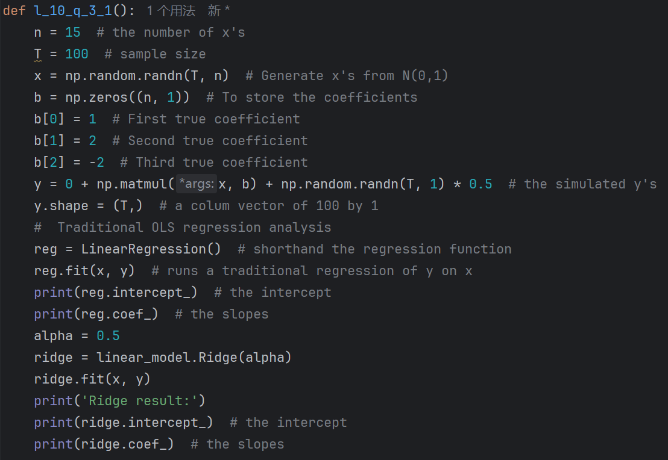

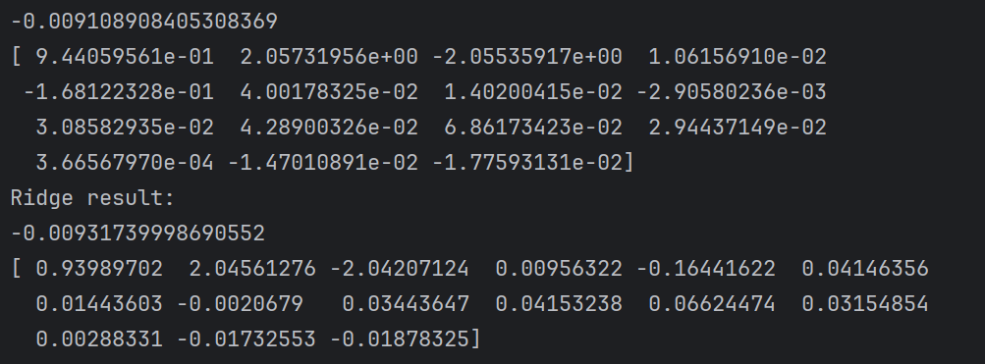

n=20 using Ridge
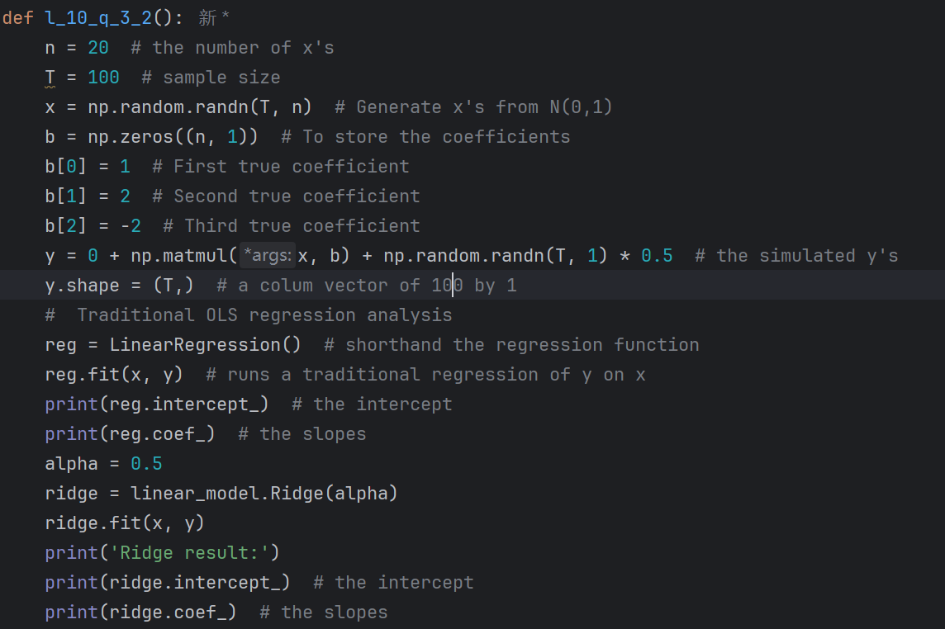

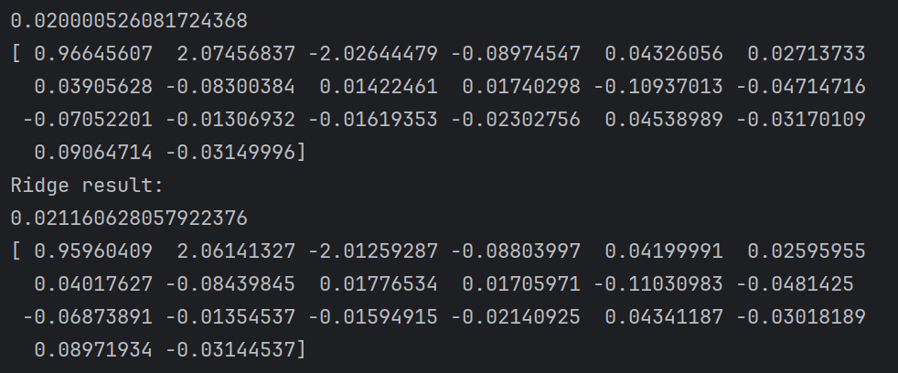

- Following the previous programs, do the same tasks with the Enet.
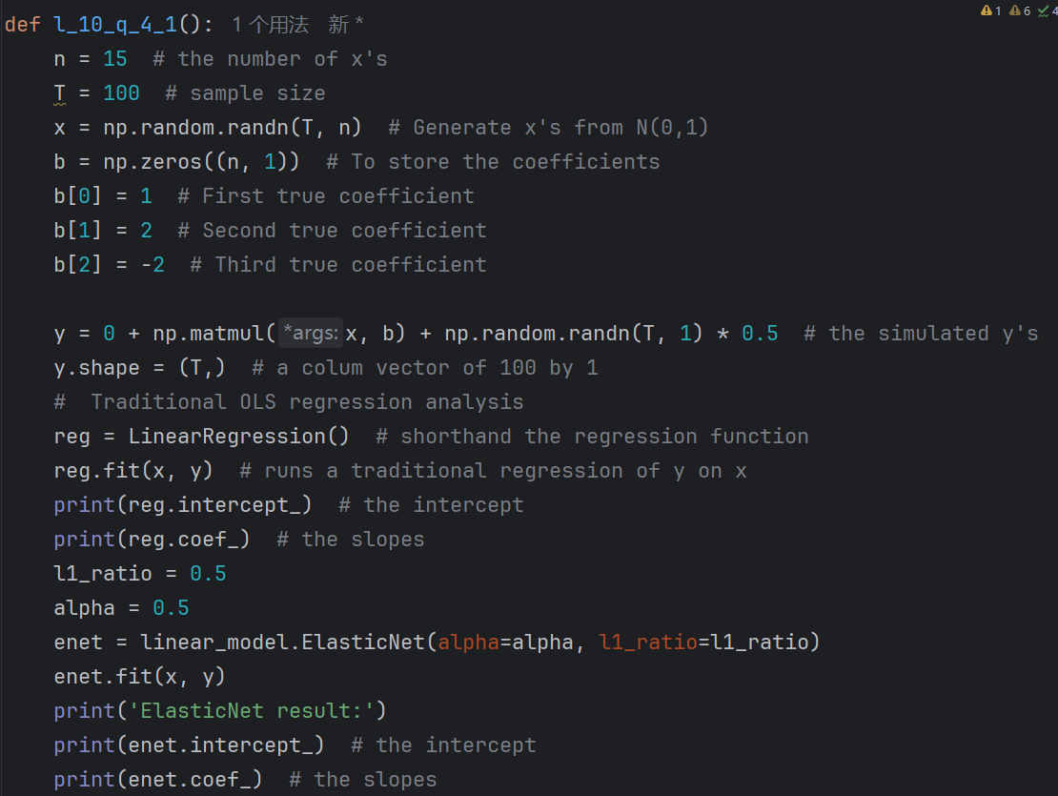

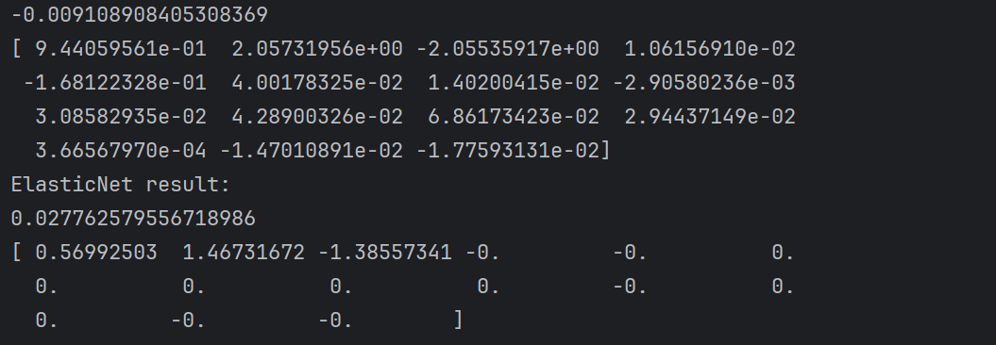

n=20 using Enet

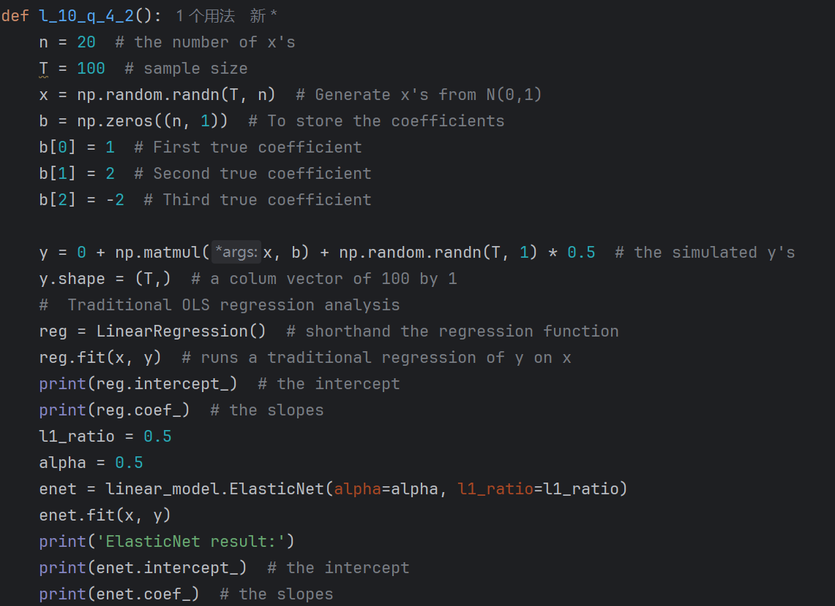

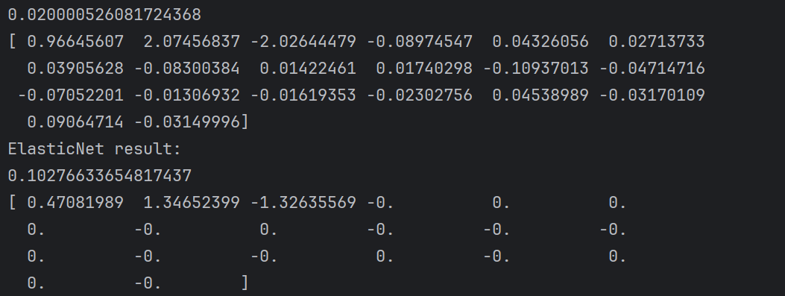

Problem II): (Optional)

- Try the Python codes that replicate Gu, Kelly and Xiu (2020) with a smaller data set than the original paper. In particular, you see how neural network is used in finance, which typically requires a lot of data and a lot of computational time.

- Read the papers on ML, to know the general ideas and application areas. In particular, read the review papers by Zaffaroni and Zhou (2023), and Kelly and Xie (2023).

- Read Avramov, Cheng, Metzker (2021) to see that the potential profits of current ML strategies can go down at least by 50%, once realistic economic restrictions are imposed. So one should apply existing ML methods with caution and develop new methods with finance objectives and practical implementations in mind.

