ZEDEX CLOTHING PVT. LTD.
TRIM CHART

COLOR-1 COLOR-2
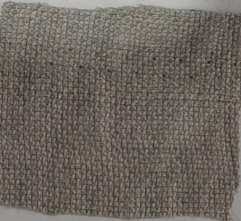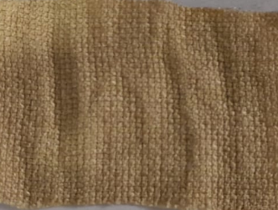

MAIN LABEL SIZE LABEL
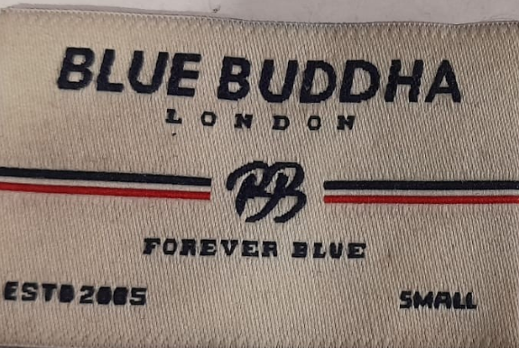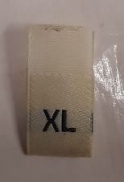
WASH CARE LABEL
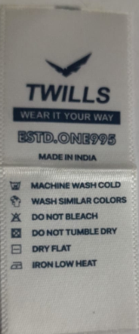
THREAD NUMBER
ZEN- 70TKT -8238
WOOLLY-70TKT - 151

