**实验（实习）报告**

1. 实验目的

掌握卷积网络相关基础知识点。掌握不同神经网络架构的设计原理，熟悉使用MindSpore框架实验的一般流程，以及最后将模型部署上线。

1. 实验任务

1）初级实验：①花卉图像分类卷积网络训练验证实验；

2）中级实验：②正则化实验；③Fashion Mnist卷积网络正则化前后对比；

3）高级实验：④基于Lenet的手写数字识别；⑤图像识别全流程代码实战；⑥前沿网络案例Yolov3/ Deeplabv3。

1. 实验步骤
2. 花卉图像分类实验
   1. 导入实验环境

步骤 1 导入相应的模块

Glob模块主要用于查找符合特定规则的文件路径名，类似使用windows下的文件搜索； os模块主要用于处理文件和目录，比如：获取当前目录下文件，删除制定文件，改变目录，查看文件大小等；MindSpore是目前业界流行的深度学习框架之一，在图像，语音，文本，目标检测等领域都有深入的应用，也是该实验的核心，主要用于定义占位符，定义变量，创建卷积神经网络模型；numpy是一个基于python的科学计算包，在该实验中主要用来处理数值运算。

#easydict模块用于以属性的方式访问字典的值

from easydict import EasyDict as edict

#glob模块主要用于查找符合特定规则的文件路径名，类似使用windows下的文件搜索

import glob

#os模块主要用于处理文件和目录

import os

import numpy as np

import matplotlib.pyplot as plt

import mindspore

#导入mindspore框架数据集

import mindspore.dataset as ds

#vision.c_transforms模块是处理图像增强的高性能模块，用于数据增强图像数据改进训练模型。

import mindspore.dataset.vision.c_transforms as CV

#c_transforms模块提供常用操作，包括OneHotOp和TypeCast

import mindspore.dataset.transforms.c_transforms as C

from mindspore.common import dtype as mstype

from mindspore import context

#导入模块用于初始化截断正态分布

from mindspore.common.initializer import TruncatedNormal

from mindspore import nn

from mindspore.train import Model

from mindspore.train.callback import ModelCheckpoint, CheckpointConfig, LossMonitor, TimeMonitor

from mindspore.train.serialization import load_checkpoint, load_param_into_net

from mindspore import Tensor

# 设置MindSpore的执行模式和设备

context.set_context(mode=context.GRAPH_MODE, device_target="Ascend")

步骤 2 定义变量

cfg = edict({

    'data_path': 'flower_photos',

    'data_size':3670,

    'image_width': 100,  # 图片宽度

    'image_height': 100,  # 图片高度

    'batch_size': 32,

    'channel': 3,  # 图片通道数

    'num_class':5,  # 分类类别

    'weight_decay': 0.01,

    'lr':0.0001,  # 学习率

    'dropout_ratio': 0.5,

    'epoch_size': 400,  # 训练次数

    'sigma':0.01,

    'save_checkpoint_steps': 1,  # 多少步保存一次模型

    'keep_checkpoint_max': 1,  # 最多保存多少个模型

    'output_directory': './',  # 保存模型路径

    'output_prefix': "checkpoint_classification"  # 保存模型文件名字

})

* 1. 数据集获取与预处理

该数据集是开源数据集，总共包括5种花的类型：分别是daisy（雏菊，633张），dandelion（蒲公英，898张），roses（玫瑰，641张），sunflowers（向日葵，699张），tulips（郁金香，799张），保存在5个文件夹当中，总共3670张，大小大概在230M左右。为了在模型部署上线之后进行测试，数据集在这里分成了flower_train和flower_test两部分。

步骤 1获取数据集

# 解压数据集，只需要第一次运行时解压，第二次无需再解压

wget https://ascend-professional-construction-dataset.obs.myhuaweicloud.com/deep-learning/flower_photos.zip

unzip flower_photos.zip

步骤 2数据预处理

#从目录中读取图像的源数据集。

de_dataset = ds.ImageFolderDataset(cfg.data_path,

                                   class_indexing={'daisy':0,'dandelion':1,'roses':2,'sunflowers':3,'tulips':4})

#解码前将输入图像裁剪成任意大小和宽高比。

transform_img = CV.RandomCropDecodeResize([cfg.image_width,cfg.image_height], scale=(0.08, 1.0), ratio=(0.75, 1.333))  #改变尺寸

#转换输入图像；形状（H, W, C）为形状（C, H, W）。

hwc2chw_op = CV.HWC2CHW()

#转换为给定MindSpore数据类型的Tensor操作。

type_cast_op = C.TypeCast(mstype.float32)

#将操作中的每个操作应用到此数据集。

de_dataset = de_dataset.map(input_columns="image", num_parallel_workers=8, operations=transform_img)

de_dataset = de_dataset.map(input_columns="image", operations=hwc2chw_op, num_parallel_workers=8)

de_dataset = de_dataset.map(input_columns="image", operations=type_cast_op, num_parallel_workers=8)

de_dataset = de_dataset.shuffle(buffer_size=cfg.data_size)

步骤 3划分训练集与测试集

#划分训练集测试集

(de_train,de_test)=de_dataset.split([0.8,0.2])

#设置每个批处理的行数

#drop_remainder确定是否删除最后一个可能不完整的批（default=False）。

#如果为True，并且如果可用于生成最后一个批的batch_size行小于batch_size行，则这些行将被删除，并且不会传播到子节点。

de_train=de_train.batch(cfg.batch_size, drop_remainder=True)

#重复此数据集计数次数。

de_test=de_test.batch(cfg.batch_size, drop_remainder=True)

print('训练数据集数量：',de_train.get_dataset_size()*cfg.batch_size)#get_dataset_size()获取批处理的大小。

print('测试数据集数量：',de_test.get_dataset_size()*cfg.batch_size)

data_next=de_dataset.create_dict_iterator(output_numpy=True).__next__()

print('通道数/图像长/宽：', data_next['image'].shape)

print('一张图像的标签样式：', data_next['label'])  # 一共5类，用0-4的数字表达类别。

plt.figure()

plt.imshow(data_next['image'][0,...])

plt.colorbar()

plt.grid(False)

plt.show()

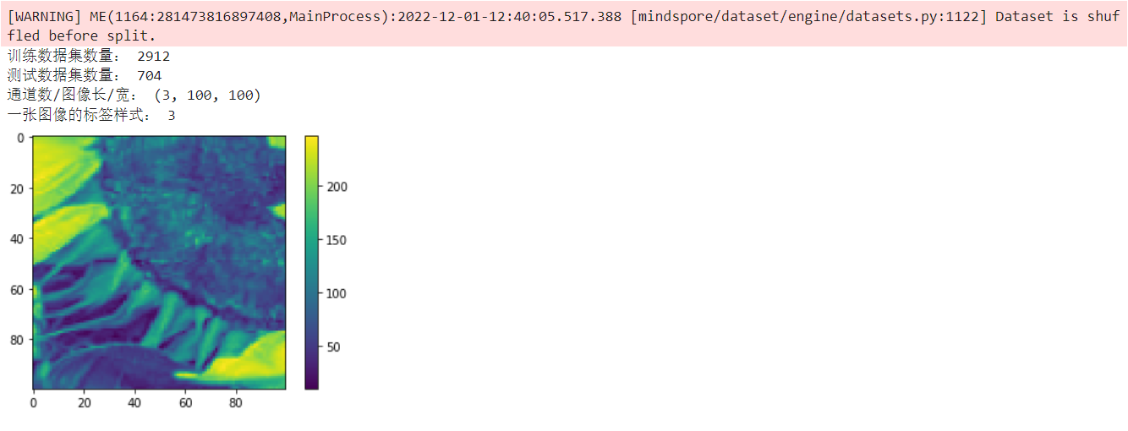

* 1. 构建CNN图像识别模型

步骤 1 定义图像识别模型

# 定义CNN图像识别网络

class Identification_Net(nn.Cell):

    def __init__(self, num_class=5,channel=3,dropout_ratio=0.5,trun_sigma=0.01):  # 一共分五类，图片通道数是3

        super(Identification_Net, self).__init__()

        self.num_class = num_class

        self.channel = channel

        self.dropout_ratio = dropout_ratio

        #设置卷积层

        self.conv1 = nn.Conv2d(self.channel, 32,

                               kernel_size=5, stride=1, padding=0,

                               has_bias=True, pad_mode="same",

                               weight_init=TruncatedNormal(sigma=trun_sigma),bias_init='zeros')

        #设置ReLU激活函数

        self.relu = nn.ReLU()

        #设置最大池化层

        self.max_pool2d = nn.MaxPool2d(kernel_size=2, stride=2,pad_mode="valid")

        self.conv2 = nn.Conv2d(32, 64,

                               kernel_size=5, stride=1, padding=0,

                               has_bias=True, pad_mode="same",

                               weight_init=TruncatedNormal(sigma=trun_sigma),bias_init='zeros')

        self.conv3 = nn.Conv2d(64, 128,

                               kernel_size=3, stride=1, padding=0,

                               has_bias=True, pad_mode="same",

                               weight_init=TruncatedNormal(sigma=trun_sigma),bias_init='zeros')

        self.conv4 = nn.Conv2d(128, 128,

                               kernel_size=3, stride=1, padding=0,

                               has_bias=True, pad_mode="same",

                               weight_init=TruncatedNormal(sigma=trun_sigma), bias_init='zeros')

        self.flatten = nn.Flatten()

        self.fc1 = nn.Dense(6*6*128, 1024,weight_init =TruncatedNormal(sigma=trun_sigma),bias_init = 0.1)

        self.dropout = nn.Dropout(self.dropout_ratio)

        self.fc2 = nn.Dense(1024, 512, weight_init=TruncatedNormal(sigma=trun_sigma), bias_init=0.1)

        self.fc3 = nn.Dense(512, self.num_class, weight_init=TruncatedNormal(sigma=trun_sigma), bias_init=0.1)

    #构建模型

    def construct(self, x):

        x = self.conv1(x)

        #print(x.shape)

        x = self.relu(x)

        x = self.max_pool2d(x)

        x = self.conv2(x)

        x = self.relu(x)

        x = self.max_pool2d(x)

        x = self.conv3(x)

        x = self.max_pool2d(x)

        x = self.conv4(x)

        x = self.max_pool2d(x)

        x = self.flatten(x)

        x = self.fc1(x)

        x = self.relu(x)

        #print(x.shape)

        x = self.dropout(x)

        x = self.fc2(x)

        x = self.relu(x)

        x = self.dropout(x)

        x = self.fc3(x)

        return x

步骤 2 模型训练、测试、预测

net=Identification_Net(num_class=cfg.num_class, channel=cfg.channel, dropout_ratio=cfg.dropout_ratio)

#计算softmax交叉熵。

net_loss = nn.SoftmaxCrossEntropyWithLogits(sparse=True, reduction="mean")

#opt

fc_weight_params = list(filter(lambda x: 'fc' in x.name and 'weight' in x.name, net.trainable_params()))

other_params=list(filter(lambda x: 'fc' not in x.name or 'weight' not in x.name, net.trainable_params()))

group_params = [{'params': fc_weight_params, 'weight_decay': cfg.weight_decay},

                {'params': other_params},

                {'order_params': net.trainable_params()}]

#设置Adam优化器

net_opt = nn.Adam(group_params, learning_rate=cfg.lr, weight_decay=0.0)

#net_opt = nn.Adam(params=net.trainable_params(), learning_rate=cfg.lr, weight_decay=0.1)

model = Model(net, loss_fn=net_loss, optimizer=net_opt, metrics={"acc"})

loss_cb = LossMonitor(per_print_times=de_train.get_dataset_size()*10)

config_ck = CheckpointConfig(save_checkpoint_steps=cfg.save_checkpoint_steps,

                             keep_checkpoint_max=cfg.keep_checkpoint_max)

ckpoint_cb = ModelCheckpoint(prefix=cfg.output_prefix, directory=cfg.output_directory, config=config_ck)

print("============== Starting Training ==============")

model.train(cfg.epoch_size, de_train, callbacks=[loss_cb, ckpoint_cb], dataset_sink_mode=True)

# 使用测试集评估模型，打印总体准确率

metric = model.eval(de_test)

print(metric)

============== Starting Training ==============

epoch: 10 step: 91, loss is 1.1753120422363281

epoch: 20 step: 91, loss is 1.0859466791152954

epoch: 30 step: 91, loss is 0.5677516460418701

epoch: 40 step: 91, loss is 0.9325251579284668

epoch: 50 step: 91, loss is 0.8652545213699341

epoch: 60 step: 91, loss is 0.6390314102172852

epoch: 70 step: 91, loss is 0.7013850212097168

epoch: 80 step: 91, loss is 0.6687897443771362

epoch: 90 step: 91, loss is 0.603812575340271

epoch: 100 step: 91, loss is 0.6513016223907471

epoch: 110 step: 91, loss is 0.33892685174942017

epoch: 120 step: 91, loss is 0.5725375413894653

epoch: 130 step: 91, loss is 0.3894873857498169

epoch: 140 step: 91, loss is 0.3057480454444885

epoch: 150 step: 91, loss is 0.6159017086029053

epoch: 160 step: 91, loss is 0.3429974913597107

epoch: 170 step: 91, loss is 0.4333230257034302

epoch: 180 step: 91, loss is 0.546169638633728

epoch: 190 step: 91, loss is 0.3887840509414673

epoch: 200 step: 91, loss is 0.36199477314949036

epoch: 210 step: 91, loss is 0.4250497817993164

epoch: 220 step: 91, loss is 0.37851858139038086

epoch: 230 step: 91, loss is 0.3388608694076538

epoch: 240 step: 91, loss is 0.6281015276908875

epoch: 250 step: 91, loss is 0.5210052728652954

epoch: 260 step: 91, loss is 0.3364684283733368

epoch: 270 step: 91, loss is 0.2803938388824463

epoch: 280 step: 91, loss is 0.3913695216178894

epoch: 290 step: 91, loss is 0.8158993124961853

epoch: 300 step: 91, loss is 0.22055236995220184

epoch: 310 step: 91, loss is 0.3294251561164856

epoch: 320 step: 91, loss is 0.48163872957229614

epoch: 330 step: 91, loss is 0.1272602677345276

epoch: 340 step: 91, loss is 0.229139044880867

epoch: 350 step: 91, loss is 0.2894950211048126

epoch: 360 step: 91, loss is 0.19915755093097687

epoch: 370 step: 91, loss is 0.19907592236995697

epoch: 380 step: 91, loss is 0.42353999614715576

epoch: 390 step: 91, loss is 0.14113196730613708

epoch: 400 step: 91, loss is 0.22388432919979095

{'acc': 0.9176136363636364}

* 1. 图像分类模型验证

步骤 1 加载训练模型

#加载模型

import os

CKPT = os.path.join(cfg.output_directory,cfg.output_prefix+'-'+str(cfg.epoch_size)+'_'+str(de_train.get_dataset_size())+'.ckpt')

net = Identification_Net(num_class=cfg.num_class, channel=cfg.channel, dropout_ratio=cfg.dropout_ratio)

load_checkpoint(CKPT, net=net)

model = Model(net)

步骤 2 验证推理

# 预测

class_names = {0:'daisy',1:'dandelion',2:'roses',3:'sunflowers',4:'tulips'}

test_ = de_test.create_dict_iterator().__next__()

test = Tensor(test_['image'], mindspore.float32)

predictions = model.predict(test)

predictions = predictions.asnumpy()

true_label = test_['label'].asnumpy()

#显示预测结果

for i in range(10):

    p_np = predictions[i, :]

    pre_label = np.argmax(p_np)

    print('第' + str(i) + '个sample预测结果：', class_names[pre_label], '   真实结果：', class_names[true_label[i]])

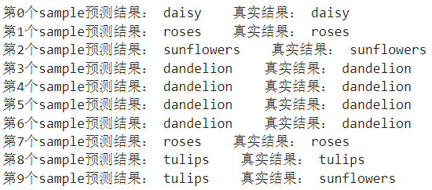

1. 正则化实验

2.1 下载调用包

import random

import numpy as np

import matplotlib.pyplot as plt

#导入mindspore框架

import mindspore as ms

#导入mindspore中Neural Networks(nn)模块，包含预先定义的构建块或计算单元来构建神经网络。

from mindspore import nn

#导入mindspore中context模块，用于配置当前执行环境，包括执行模式等特性。

from mindspore import context

#导入参数初始化模块

from mindspore.common.initializer import Normal

from IPython.display import clear_output

%matplotlib inline

# 设置MindSpore的执行模式和设备

context.set_context(mode=context.GRAPH_MODE, device_target='Ascend')

2.2 超参数设定

N_SAMPLES = 40 #样本数

BATCH_SIZE = 40  #批量大小

NOISE_RATE = 0.2  #噪声率

INPUT_DIM = 1  #输入维度

HIDDEN_DIM = 100  #隐藏层维度

OUTPUT_DIM = 1   #输出维度

N_LAYERS = 6 #隐藏层数目

ITERATION = 1500   #最大输入迭代

LEARNING_RATE = 0.003  #学习率

DROPOUT_RATE = 0.7

WEIGHT_DECAY = 1e-4  #L2正则化惩罚数值

MAX_COUNT = 20  #最早终止参数

ACTIVATION = nn.LeakyReLU #激活函数

#固定结果

def fix_seed(seed=1):

    # reproducible

    random.seed(seed)

np.random.seed(seed)

# 小批量样本索引

def sample_idx(m, n):

    A = np.random.permutation(m)

    idx = A[:n]

    return idx

2.3 建立数据集

#建立数据集x值，y值

fix_seed(5)

data_x = np.linspace(-1, 1, num=int(N_SAMPLES*2.5))[:, np.newaxis]

data_y = np.cos(np.pi*data_x)

p = np.random.permutation(len(data_x))

#建立训练集，测试集，验证集

train_x, train_y = data_x[p[0:N_SAMPLES]], data_y[p[0:N_SAMPLES]]

test_x, test_y = data_x[p[N_SAMPLES:N_SAMPLES*2]], data_y[p[N_SAMPLES:N_SAMPLES*2]]

validate_x, validate_y = data_x[p[N_SAMPLES*2:]], data_y[p[N_SAMPLES*2:]]

#设置y值噪声

noise = np.random.normal(0, NOISE_RATE, train_y.shape)

train_y += noise

2.4 建立网络

2.4.1 模型定义

#自定义Cosine网络

class CosineNet(nn.Cell):

    def __init__(self, batchnorm, dropout):

        super(CosineNet, self).__init__()

        layers = []

        if batchnorm:

            layers.append(nn.BatchNorm2d(INPUT_DIM))

        # 初始化隐含层

        for l_n in range(N_LAYERS):

            in_channels = HIDDEN_DIM if l_n > 0 else INPUT_DIM

            # 这里使用1x1Conv代替全连接算子，可以与BatchNorm2d算子配合的更好

            conv = nn.Conv2d(in_channels, HIDDEN_DIM, kernel_size=1, pad_mode='valid', has_bias=True, weight_init=Normal(0.01))

            layers.append(conv)

            if batchnorm:

                layers.append(nn.BatchNorm2d(HIDDEN_DIM))

            if dropout:

                layers.append(nn.Dropout(DROPOUT_RATE))

            layers.append(ACTIVATION())

        self.layers = nn.SequentialCell(layers)

        # 初始化输出层

        self.flatten = nn.Flatten() # 将(N,C,H,W)4维数据转为(N,C*H*W)2维

        self.fc = nn.Dense(HIDDEN_DIM, OUTPUT_DIM, weight_init=Normal(0.1), bias_init='zeros')

    def construct(self, x):

        # 构建隐含层

        x = self.layers(x)

        # 构建输出层

        x = self.flatten(x)

        x = self.fc(x)

        return x

2.4.2 针对集中正则化方法，创建不同的训练任务

def build_fn(batchnorm, dropout, l2):

    # 实例化网络、Loss、optimizer

    net = CosineNet(batchnorm=batchnorm, dropout=dropout)

    loss = nn.loss.MSELoss()

    opt = nn.optim.Adam(net.trainable_params(), learning_rate=LEARNING_RATE, weight_decay=WEIGHT_DECAY if l2 else 0.0)

    # 构建计算loss和训练用的模块

    with_loss = nn.WithLossCell(net, loss)

    train_step = nn.TrainOneStepCell(with_loss, opt).set_train()

    return train_step, with_loss, net

# 针对5种不同设置，创建不同的训练任务

fc_train, fc_loss, fc_predict = build_fn(batchnorm=False, dropout=False, l2=False) # 默认任务

dropout_train, dropout_loss, dropout_predict = build_fn(batchnorm=False, dropout=True, l2=False) # 实验dropout功能

bn_train, bn_loss, bn_predict = build_fn(batchnorm=True, dropout=False, l2=False) # 实验batchnorm功能

l2_train, l2_loss, l2_predict = build_fn(batchnorm=False, dropout=False, l2=True) # 实验l2 regularization功能

early_stop_train, early_stop_loss, early_stop_predict = build_fn(batchnorm=False, dropout=False, l2=False) # 实验Early Stop功能

# 辅助函数，用于设置网络是否为train状态，用于batchnorm，dropout等算子判断是否处于train状态。

nets_train = [fc_train, dropout_train, bn_train, l2_train, early_stop_train]

nets_loss = [fc_loss, dropout_loss, bn_loss, l2_loss, early_stop_loss]

nets_predict = [fc_predict, dropout_predict, bn_predict, l2_predict, early_stop_predict]

def set_train(nets, mode=True):

    for net in nets:

        net.set_train(mode=mode)

2.5 启动训练

2.5.1 将数据转为4维，并转为MindSpore Tensor类型

# 将喂给网络的数据由(N,C)2维转为将(N,C,H,W)4维

data_xt, data_yt = ms.Tensor(data_x.reshape(data_x.shape + (1, 1)), ms.float32), ms.Tensor(data_y, ms.float32)

test_xt, test_yt = ms.Tensor(test_x.reshape(test_x.shape + (1, 1)), ms.float32), ms.Tensor(test_y, ms.float32)

validate_xt, validate_yt = ms.Tensor(validate_x.reshape(validate_x.shape + (1, 1)), ms.float32), ms.Tensor(validate_y, ms.float32)

2.5.2 启动训练并通过plot观察各模型拟合效果

# 设置提前终止(Early Stop)用到的一些指标

early_stop = False # 为True时，终止相关的训练

min_val_loss = 1 # 足够大的初始值，训练过程中用于记录最小的验证loss

count = 0 # 训练迭代过程中，验证loss连续多少次大于min_val_loss

for it in range(ITERATION):

    # 每个迭代随机从训练集中选择一个batch的样本，当batch_size==N_SAMPLES时，仅作了shuffle

    mb_idx = sample_idx(N_SAMPLES, BATCH_SIZE)

    x_batch, y_batch = train_x[mb_idx, :], train_y[mb_idx, :]

    x_batch, y_batch = ms.Tensor(x_batch.reshape(x_batch.shape + (1, 1)), ms.float32), ms.Tensor(y_batch, ms.float32)

    set_train(nets_train, True) # 将网络设置为train状态

    fc_train(x_batch, y_batch)

    dropout_train(x_batch, y_batch)

    bn_train(x_batch, y_batch)

    l2_train(x_batch, y_batch)

    # 为True时，终止相关的训练

    if not early_stop:

        early_stop_train(x_batch, y_batch)

    if it % 20 == 0:

        set_train(nets_loss+nets_predict, False) # 将网络设置为非train状态

        # 计算各模型在测试集上的loss

        loss_fc = fc_loss(test_xt, test_yt)

        loss_dropout = dropout_loss(test_xt, test_yt)

        loss_bn = bn_loss(test_xt, test_yt)

        loss_l2 = l2_loss(test_xt, test_yt)

        loss_early_stop = early_stop_loss(test_xt, test_yt)

        # 计算各模型在全量样本上的预测值，用于评估模型的拟合效果

        all_fc = fc_predict(data_xt)

#         all_fc = fc_predict.predict(data_xt)

        all_dropout = dropout_predict(data_xt)

        all_bn = bn_predict(data_xt)

        all_l2 = l2_predict(data_xt)

        all_early_stop = early_stop_predict(data_xt)

        # 对于Early Stop任务，当验证集loss连续MAX_COUNT次大于min_val_loss时，终止该任务的训练

        if not early_stop:

            val_loss = early_stop_loss(validate_xt, validate_yt)

            if val_loss > min_val_loss:

                count += 1

            else:

                min_val_loss = val_loss

                count = 0

            if count == MAX_COUNT:

                early_stop = True

                print('='*10, 'early stopped', '='*10)

        # 画图

        plt.figure(1, figsize=(15,10))

        plt.cla()

        plt.scatter(train_x, train_y, c='magenta', s=50, alpha=0.3, label='train samples')

        plt.scatter(test_x, test_y, c='cyan', s=50, alpha=0.3, label='test samples')

        plt.plot(data_x, all_fc.asnumpy(), 'r', label='overfitting')

        plt.plot(data_x, all_l2.asnumpy(), 'y', label='L2 regularization')

        plt.plot(data_x, all_early_stop.asnumpy(), 'k', label='early stopping')

        plt.plot(data_x, all_dropout.asnumpy(), 'b', label='dropout({})'.format(DROPOUT_RATE))

        plt.plot(data_x, all_bn.asnumpy(), 'g', label='batch normalization')

        plt.text(-0.1, -1.2, 'overfitting loss=%.4f' % loss_fc.asnumpy(), fontdict={'size': 20, 'color': 'red'})

        plt.text(-0.1, -1.5, 'L2 regularization loss=%.4f' % loss_l2.asnumpy(), fontdict={'size': 20, 'color': 'y'})

        plt.text(-0.1, -1.8, 'early stopping loss=%.4f' % loss_early_stop.asnumpy(), fontdict={'size': 20, 'color': 'black'})

        plt.text(-0.1, -2.1, 'dropout loss=%.4f' % loss_dropout.asnumpy(), fontdict={'size': 20, 'color': 'blue'})

        plt.text(-0.1, -2.4, 'batch normalization loss=%.4f' % loss_bn.asnumpy(), fontdict={'size': 20, 'color': 'green'})

        plt.legend(loc='upper left');

        plt.ylim((-2.5, 2.5));

        clear_output(wait=True)

        plt.show()

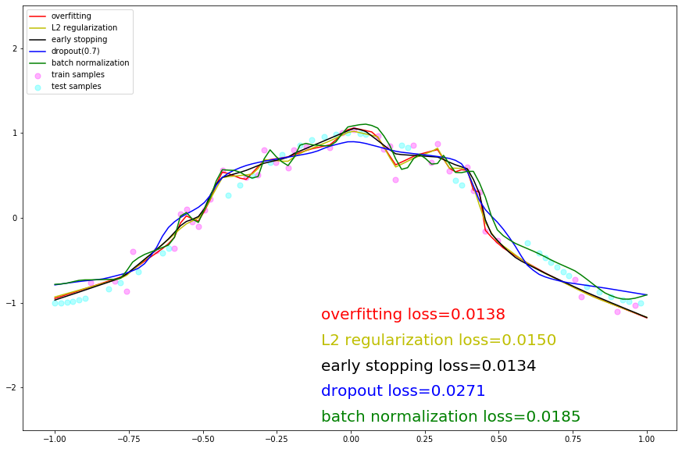

1. 基于Lenet的手写数字识别

3.1 导入实验环境

import os

import numpy as np

import mindspore as ms

import mindspore.context as context

import mindspore.dataset.transforms.c_transforms as C

import mindspore.dataset.vision.c_transforms as CV

from mindspore import nn

from mindspore.train import Model

from mindspore.train.callback import LossMonitor

context.set_context(mode=context.GRAPH_MODE, device_target='Ascend') # Ascend, CPU, GPU

3.2 数据处理

步骤 1获取数据集

!wget https://ascend-professional-construction-dataset.obs.myhuaweicloud.com/deep-learning/MNIST.zip

!unzip MNIST.zip

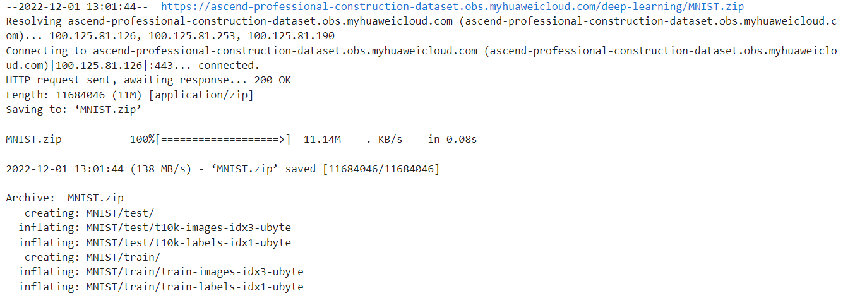

步骤 2对数据进行预处理。

def create_dataset(data_dir, training=True, batch_size=32, resize=(32, 32),

                   rescale=1/(255*0.3081), shift=-0.1307/0.3081, buffer_size=64):

    data_train = os.path.join(data_dir, 'train') # 训练集信息

    data_test = os.path.join(data_dir, 'test') # 测试集信息

    ds = ms.dataset.MnistDataset(data_train if training else data_test)

    ds = ds.map(input_columns=["image"], operations=[CV.Resize(resize), CV.Rescale(rescale, shift), CV.HWC2CHW()])

    ds = ds.map(input_columns=["label"], operations=C.TypeCast(ms.int32))

    # When `dataset_sink_mode=True` on Ascend, append `ds = ds.repeat(num_epochs) to the end

ds = ds.shuffle(buffer_size=buffer_size).batch(batch_size, drop_remainder=True)

    return ds

步骤 3 对其中几张图片进行可视化，可以看到图片中的手写数字，图片的大小为32x32。

import matplotlib.pyplot as plt

ds = create_dataset('MNIST', training=False)

data = ds.create_dict_iterator().__next__()

images = data['image'].asnumpy()

labels = data['label'].asnumpy()

for i in range(1, 5):

    plt.subplot(2, 2, i)

    plt.imshow(images[i][0])

    plt.title('Number: %s' % labels[i])

    plt.xticks([])

plt.show()

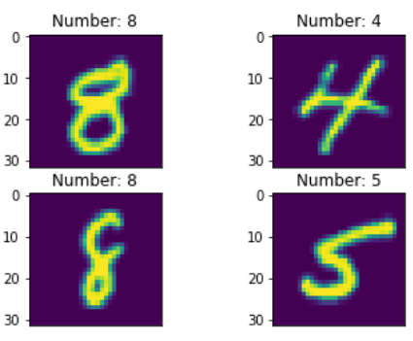

3.3 定义模型

class LeNet5(nn.Cell):

    def __init__(self):

        super(LeNet5, self).__init__()

        self.conv1 = nn.Conv2d(1, 6, 5, stride=1, pad_mode='valid')

        self.conv2 = nn.Conv2d(6, 16, 5, stride=1, pad_mode='valid')

        self.relu = nn.ReLU()

        self.pool = nn.MaxPool2d(kernel_size=2, stride=2)

        self.flatten = nn.Flatten()

        self.fc1 = nn.Dense(400, 120)

        self.fc2 = nn.Dense(120, 84)

        self.fc3 = nn.Dense(84, 10)

    def construct(self, x):

        x = self.relu(self.conv1(x))

        x = self.pool(x)

        x = self.relu(self.conv2(x))

        x = self.pool(x)

        x = self.flatten(x)

        x = self.fc1(x)

        x = self.fc2(x)

        x = self.fc3(x)

        return x

3.4 训练

def train(data_dir, lr=0.01, momentum=0.9, num_epochs=3):

    ds_train = create_dataset(data_dir)

    ds_eval = create_dataset(data_dir, training=False)

    net = LeNet5()

    loss = nn.loss.SoftmaxCrossEntropyWithLogits(sparse=True, reduction='mean')

    opt = nn.Momentum(net.trainable_params(), lr, momentum)

loss_cb = LossMonitor(per_print_times=ds_train.get_dataset_size())

    model = Model(net, loss, opt, metrics={'acc', 'loss'})

    # dataset_sink_mode can be True when using Ascend

    model.train(num_epochs, ds_train, callbacks=[loss_cb], dataset_sink_mode=True)

    metrics = model.eval(ds_eval, dataset_sink_mode=True)

print('Metrics:', metrics)

train('MNIST')

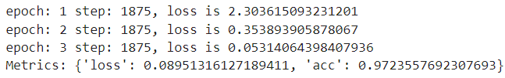

1. 实验结果







1. 实验总结

本章对实验实验做了详尽的剖析。阐明了整个实验功能、结构与流程是如何设计的，详细解释了如何解析数据、如何构建深度学习模型、如何保存模型等内容。部署后的实验多个类别图片下进行测试，结果表明实验实验具有较快的推断速度和较好的识别性能。

构建简单的cosine模型并且加入正则化技术形成动态图。可以看到：带有dropout和l2正则化的两个模型在全量数据集上拟合的曲线更平滑，更接近真实的cosine曲线；不带任何正则化的模型以及带有batchnorm的两个模型对训练数据的拟合程度太高，曲线多曲折，属于过拟合现象；带有Early Stop的模型处于折中的状态。

通过对LeNet5模型做几代的训练，然后使用训练后的LeNet5模型对手写数字进行识别，识别准确率大于95%。即LeNet5学习到了如何进行手写数字识别。