MVC5_Products_CRUD_Tutorial
Youtube link：https://www.youtube.com/watch?v=NAKLrsvBC6g
Abstract：use MVC skills to implement products model, CRUD functions.
Key words： CRUD, MVC5

1 NEW PROJECT
Visual Studio 2015 is an IDE, or integrated development environment. Just like you use Microsoft Word to write documents, you'll use an IDE to create applications. In Visual Studio there's a toolbar along the top showing various options available to you. There's also a menu that provides another way to perform tasks in the IDE. (For example, instead of selecting New Project from the Start page, you can use the menu and selectFile > New Project.)
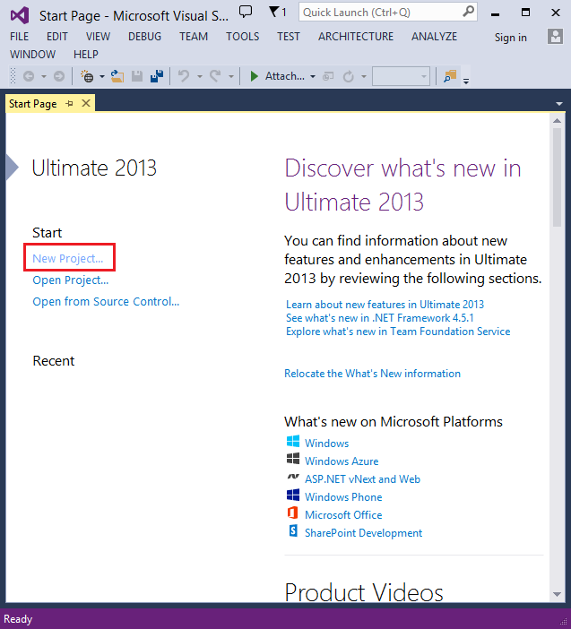

Creating Your First Application
Click New Project, then select Visual C# on the left, then Web and then select ASP.NET Web Application. Name your project "MvcMovie" and then click OK.
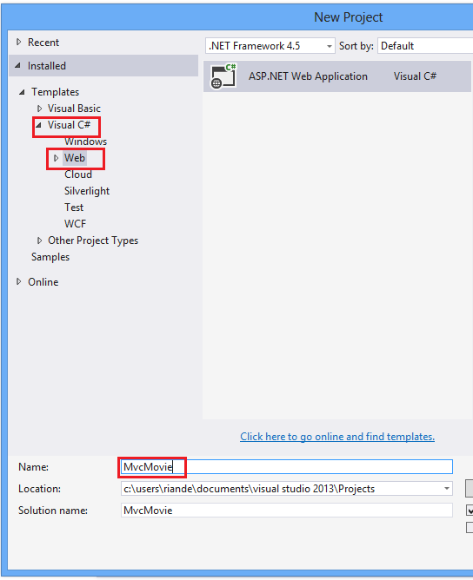
In the New ASP.NET Project dialog, click MVC and then click OK.
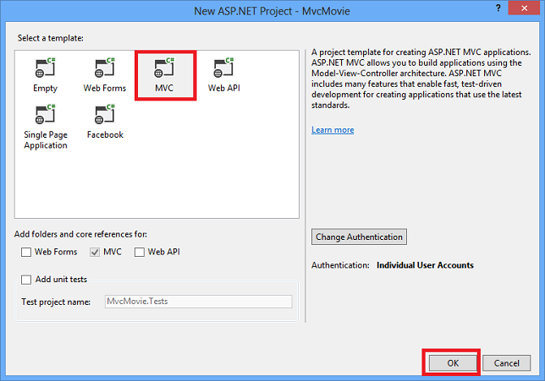
Visual Studio used a default template for the ASP.NET MVC project you just created, so you have a working application right now without doing anything! This is a simple "Hello World!" project, and it's a good place to start your application.
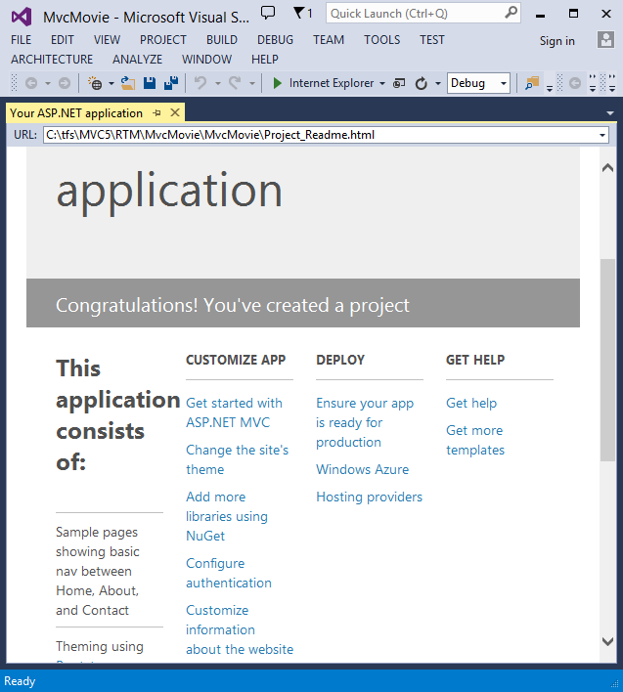
Click F5 to start debugging. F5 causes Visual Studio to start IIS Express and run your web app. Visual Studio then launches a browser and opens the application's home page. Notice that the address bar of the browser says localhost:port# and not something like example.com. That's because localhost always points to your own local computer, which in this case is running the application you just built. When Visual Studio runs a web project, a random port is used for the web server. In the image below, the port number is 1234. When you run the application, you'll see a different port number.
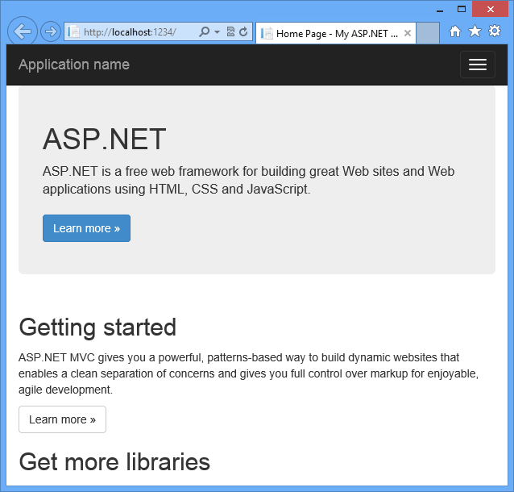
Right out of the box this default template gives you Home, Contact and About pages. The image above doesn't show the Home, About andContact links. Depending on the size of your browser window, you might need to click the navigation icon to see these links.

2 Product CRUD
2.1 Add Model
Add Model of ProductRepository,IProductRepository and Product.

public class Product
{
public int Id { get; set; }
public string Name { get; set; }
public string Category { get; set; }
public decimal Price { get; set; }
}
----------------------------------
public interface IProductRepository
{
IEnumerable<Product> GetAll();
Product Get(int id);
Product Add(Product item);
void Remove(int id);
bool Update(Product item);
}
-------------------------------------------
public class ProductRepository : IProductRepository
{
private List<Product> products = new List<Product>();
private int _indexId = 1;

public ProductRepository()
{
products.Add(new Product { Id = 1, Name = "Tomato soup", Category = "Groceries", Price = 1.39M });
products.Add(new Product { Id = 2, Name = "Yo-yo", Category = "Toys", Price = 3.75M });
products.Add(new Product { Id = 3, Name = "Hammer", Category = "Hardware", Price = 16.99M });
}
public IEnumerable<Product> GetAll()
{
return products;
}
public Product Get(int id)
{
return products.Find(p => p.Id == id);
}
public Product Add(Product item)
{
if (item == null)
{
throw new ArgumentNullException("item");
}
item.Id = _indexId++;
products.Add(item);
return item;
}

public bool Update(Product item)
{
if (item == null)
{
throw new ArgumentNullException("item");
}
int index = products.FindIndex(p => p.Id == item.Id);
if (index == -1)
{
return false;
}
products.RemoveAt(index);
products.Add(item);
return true;
}

public void Remove(int id)
{
products.RemoveAll(p => p.Id == id);
}
}
2.2 Add Controller
MVC stands for model-view-controller. MVC is a pattern for developing applications that are well architected, testable and easy to maintain. MVC-based applications contain:
- Models: Classes that represent the data of the application and that use validation logic to enforce business rules for that data.
- Views: Template files that your application uses to dynamically generate HTML responses.
- Controllers: Classes that handle incoming browser requests, retrieve model data, and then specify view templates that return a response to the browser.
We'll be covering all these concepts in this tutorial series and show you how to use them to build an application.
Let's begin by creating a controller class. In Solution Explorer, right-click the Controllers folder and then click Add, then Controller.

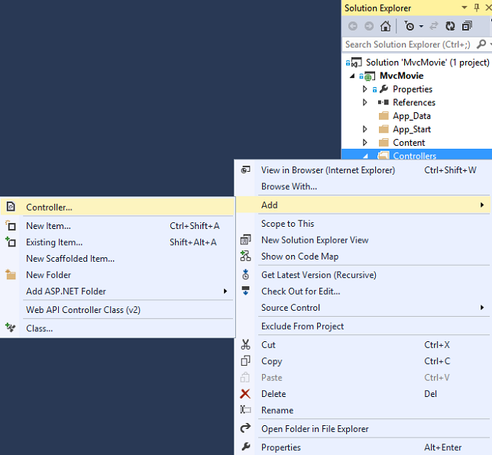
In the Add Scaffold dialog box, click MVC 5 Controller with read/write actions, and then click Add.
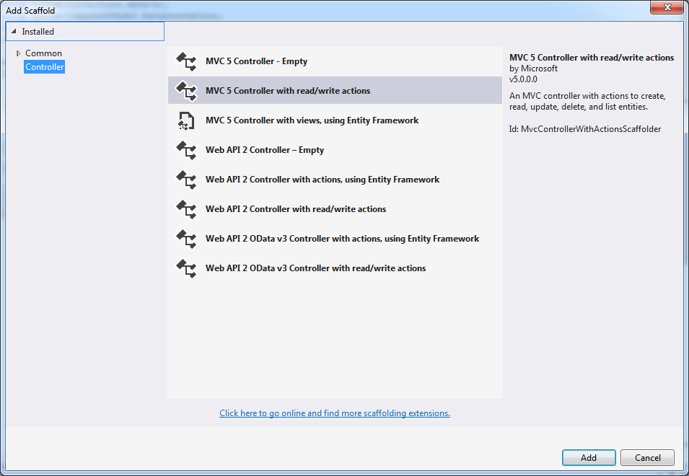
Click Add Button.
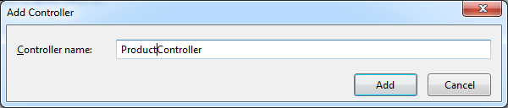
Then, we can get a controller with methods of Index, Details, Create*2, Edit *2, Delete*2.

2.3 Add View(Index)
Right click in the function of Index(), and choose “Add View”.
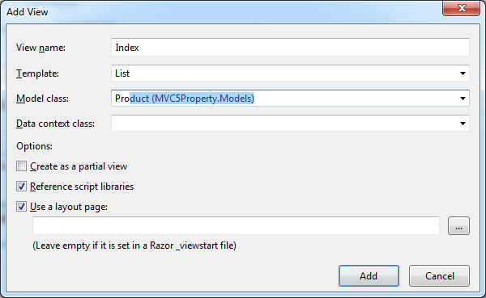
Template: List; Model: Product;
Then you will get the generated View automatically.

2.4 Change the RouteConfig
Change controller to Product. Then, we can see it as a homepage.
public static void RegisterRoutes(RouteCollection routes)
{
routes.IgnoreRoute("{resource}.axd/{*pathInfo}");

routes.MapRoute(
name: "Default",
url: "{controller}/{action}/{id}",
defaults: new { controller = "Product", action = "Index", id = UrlParameter.Optional }
);
}

2.5 CRUD
Notice:Create, Edit, Delete need 2 step to finish.
Take Create as an example,
First,
// GET: Product/Create
public ActionResult Create()
{
return View();
}
Second,
// POST: Product/Create
[HttpPost]
public ActionResult Create(Product product)
{
try
{
//TODO: Add insert logic here
if(ModelState.IsValid)//whether input data is valid
{
repository.Add(product);
return RedirectToAction("Index");
}
return View(product);
}
catch
{
return View();
}
}

3 Summary
In this article, I used MVC5 implemented CRUD functions for products.

MVC HTML辅助类常用方法记录
（1）@Html.DisplayNameFor(model => model.Title)是显示列名，
（2）@Html.DisplayFor(modelItem => item.Title)是显示列的内容
（3）@Html.ActionLink("Create New", "Create")是超链接，跳转到model中的create页面，引用的是controller中create方法；
（4）@Html.ActionLink("Edit", "Edit", new { id=item.ID })编辑页面；
（5）@using (Html.BeginForm()) { @Html.ValidationSummary(true)}用于客户端验证，其Html.BeginForm()表示在本页显示
（6）<div class="editor-label">
@Html.LabelFor(model => model.Time)标签</div>
<div class="editor-field">
@Html.EditorFor(model => model.Time)编辑框
@Html.ValidationMessageFor(model => model.Time)验证合法性错误显示</div>

